# 1要干什么?

监控性能:

1）白屏时间

2）首屏时间(定义到哪儿算是首屏) 下载的资源大小，百分比（都有什么东西）

3）用户可操作时间

4）总下载时间

# 2怎么实现

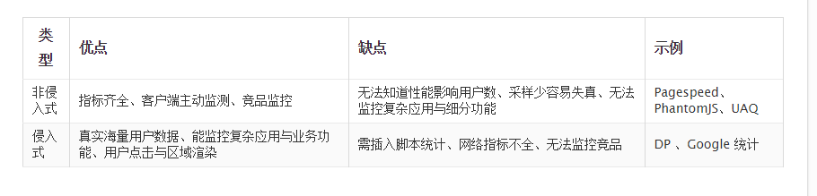

# 3工具对比：

## 3.1 webpageTest

数据较全：本地示例：E:\mon\不同工具示例\WebPagetest Test Result - Dulles _ money.163.com_ - 09_05_16 10_08_32.html

## 3.2 https://gtmetrix.com/

包含pageSpeed， yslow等多个工具集成的在线测试工具。

3.3 berserkJs

国人基于phantomJs开发的检测工具。

介绍：<http://wenku.it168.com/d_000434396.shtml>

3.4chrome TimeLine

# 4我的计划

1. 先用berserkJs弄出个大概来，
2. 通过Chrome timeLine工具研究浏览器加载
3. 学习该网址的文档

<http://fex.baidu.com/blog/2014/05/build-performance-monitor-in-7-days/>

# 5 W3c相关接口学习

### 5.1 相关规范文档

[HR-TIME-2]

<https://www.w3.org/TR/hr-time-2/>

[PERFORMANCE-TIMELINE]

<https://www.w3.org/TR/performance-timeline/>

<https://www.w3.org/TR/performance-timeline-2/>

[RESOURCE-TIMING]

<https://www.w3.org/TR/2014/CR-resource-timing-20140325/> 稳定推荐状态

<https://www.w3.org/TR/resource-timing>

[NAVIGATION-TIMING]

<https://www.w3.org/TR/navigation-timing/>

<https://www.w3.org/TR/navigation-timing-2/> 不稳定

[USER-TIMING]

<https://www.w3.org/TR/user-timing/>

<https://www.w3.org/TR/resource-timing-1/>

[SERVER-TIMING]

<https://www.w3.org/TR/server-timing/>移到了网络平台孵化器组

[FRAME-TIMING]

<https://www.w3.org/TR/frame-timing/> 移到了网络平台孵化器组

网络性能工作组的说明文档

<https://w3c.github.io/perf-timing-primer/>

### 5.2 说明图当前性能监控规范情况：

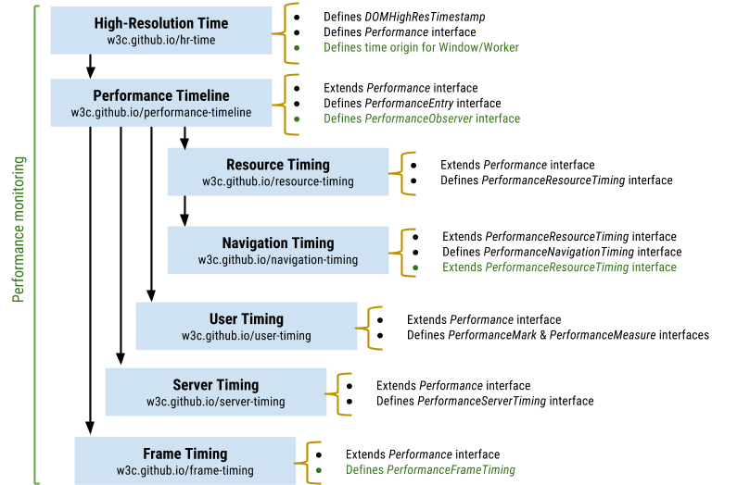

hight-resolution Time：

1.定义了比毫秒更低的时间单位，并且不会受系统影响，来供给所有相关规范使用

2.定义了performance接口和performance接口的now方法  
3.定义一个全局对象performance，是perfomance接口的实例。

performance timeline

1. 定义了perfomanceEntity接口

要求resouceTiming,usertiming接口都继承perfomanEntity接口（拥有方法

readonly attribute DOMString name;

readonly attribute DOMString entryType;

readonly attribute DOMHighResTimeStamp startTime;

readonly attribute DOMHighResTimeStamp duration

）

还要求这些接口必须支持getEntries, getEntriesByType, and getEntriesByName 方法。

1. 拓展了performance接口（就是navigation实现的接口）

getEntries, getEntriesByType, and getEntriesByName

其中entryType有：

"frame"

"mark"

"measure"

"navigation"

"resource"

"server"

resource timing：定义资源的接收时间

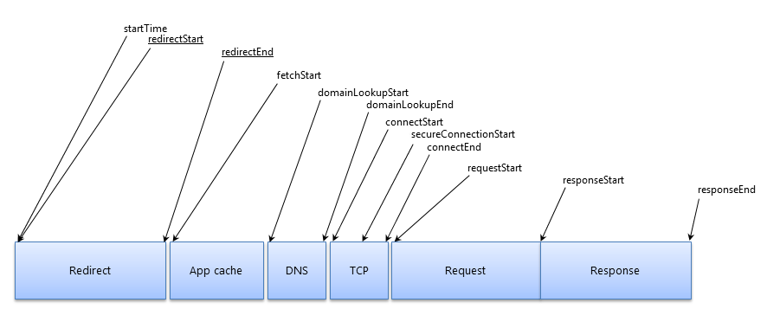

navigation timing

旧版规范定义：

1. PerformanceTiming interface
2. PerformanceNavigation interface
3. Performance接口，里头有两个属性timeing和navigation分别继承上边两个接口
4. window.performance，继承perfomance接口

interface **PerformanceTiming** {

readonly attribute unsigned long long [navigationStart](https://www.w3.org/TR/navigation-timing/#dom-performancetiming-navigationstart);

readonly attribute unsigned long long [unloadEventStart](https://www.w3.org/TR/navigation-timing/#dom-performancetiming-unloadeventstart);

readonly attribute unsigned long long [unloadEventEnd](https://www.w3.org/TR/navigation-timing/#dom-performancetiming-unloadeventend);

readonly attribute unsigned long long [redirectStart](https://www.w3.org/TR/navigation-timing/#dom-performancetiming-redirectstart);

readonly attribute unsigned long long [redirectEnd](https://www.w3.org/TR/navigation-timing/#dom-performancetiming-redirectend);

readonly attribute unsigned long long [fetchStart](https://www.w3.org/TR/navigation-timing/#dom-performancetiming-fetchstart);

readonly attribute unsigned long long [domainLookupStart](https://www.w3.org/TR/navigation-timing/#dom-performancetiming-domainlookupstart);

readonly attribute unsigned long long [domainLookupEnd](https://www.w3.org/TR/navigation-timing/#dom-performancetiming-domainlookupend);

readonly attribute unsigned long long [connectStart](https://www.w3.org/TR/navigation-timing/#dom-performancetiming-connectstart);

readonly attribute unsigned long long [connectEnd](https://www.w3.org/TR/navigation-timing/#dom-performancetiming-connectend);

readonly attribute unsigned long long [secureConnectionStart](https://www.w3.org/TR/navigation-timing/#dom-performancetiming-secureconnectstart);

readonly attribute unsigned long long [requestStart](https://www.w3.org/TR/navigation-timing/#dom-performancetiming-requeststart);

readonly attribute unsigned long long [responseStart](https://www.w3.org/TR/navigation-timing/#dom-performancetiming-responsestart);

readonly attribute unsigned long long [responseEnd](https://www.w3.org/TR/navigation-timing/#dom-performancetiming-responseend);

readonly attribute unsigned long long [domLoading](https://www.w3.org/TR/navigation-timing/#dom-performancetiming-domloading);

readonly attribute unsigned long long [domInteractive](https://www.w3.org/TR/navigation-timing/#dom-performancetiming-dominteractive);

readonly attribute unsigned long long [domContentLoadedEventStart](https://www.w3.org/TR/navigation-timing/#dom-performancetiming-domcontenteventstart);

readonly attribute unsigned long long [domContentLoadedEventEnd](https://www.w3.org/TR/navigation-timing/#dom-performancetiming-domcontenteventend);

readonly attribute unsigned long long [domComplete](https://www.w3.org/TR/navigation-timing/#dom-performancetiming-domcomplete);

readonly attribute unsigned long long [loadEventStart](https://www.w3.org/TR/navigation-timing/#dom-performancetiming-loadstart);

readonly attribute unsigned long long [loadEventEnd](https://www.w3.org/TR/navigation-timing/#dom-performancetiming-loadend);

};

interface **PerformanceNavigation** {

const unsigned short [TYPE_NAVIGATE](https://www.w3.org/TR/navigation-timing/#dom-performancenavigation-typenavigate) = 0;

const unsigned short [TYPE_RELOAD](https://www.w3.org/TR/navigation-timing/#dom-performancenavigation-typereload) = 1;

const unsigned short [TYPE_BACK_FORWARD](https://www.w3.org/TR/navigation-timing/#dom-performancenavigation-typebackforward) = 2;

const unsigned short [TYPE_RESERVED](https://www.w3.org/TR/navigation-timing/#dom-performancenavigation-typereserved) = 255;

readonly attribute unsigned short [type](https://www.w3.org/TR/navigation-timing/#dom-performancenavigation-type);

readonly attribute unsigned short [redirectCount](https://www.w3.org/TR/navigation-timing/#dom-performancenavigation-redirectcount);

};

interface **Performance** {

readonly attribute [PerformanceTiming](https://www.w3.org/TR/navigation-timing/#performancetiming) **timing**;

readonly attribute [PerformanceNavigation](https://www.w3.org/TR/navigation-timing/#performancenavigation) **navigation**;

};

partial interface Window {

[Replaceable] readonly attribute [Performance](https://www.w3.org/TR/navigation-timing/#performance) **performance**;

};

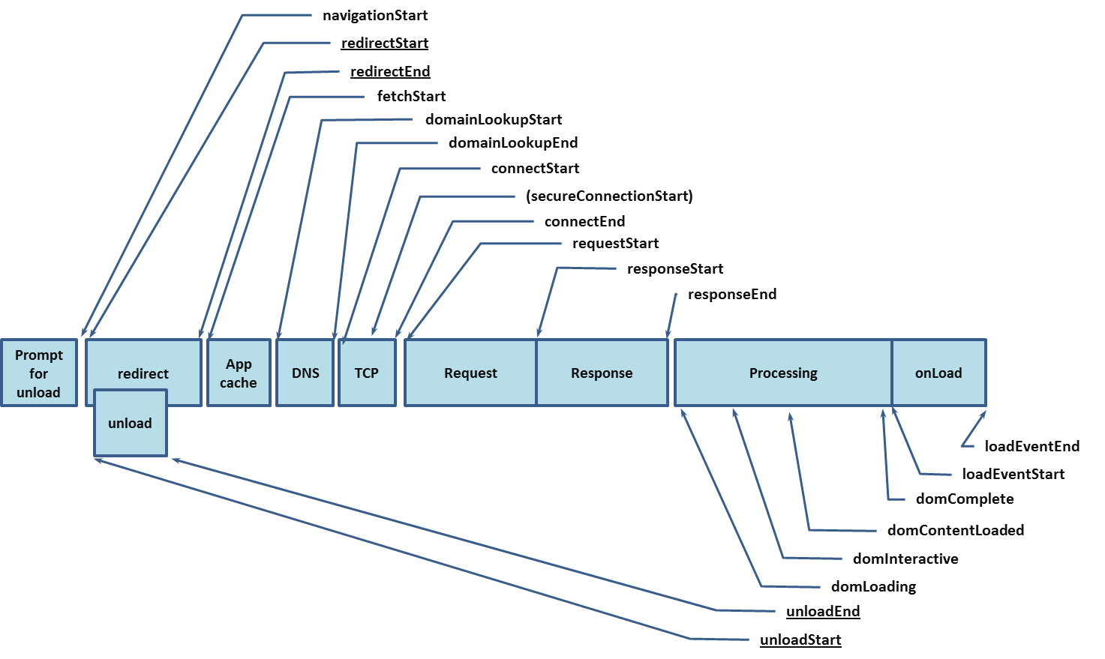

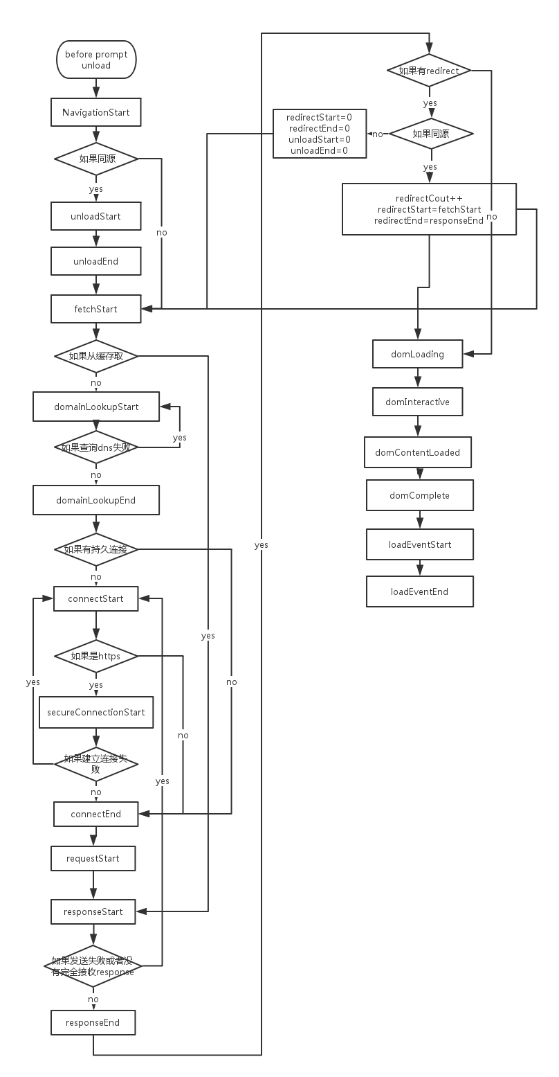

其中

navigation-timing-2

还不稳定

server timing ，FRAME-TIMING移到了

[**Web Platform Incubator Community Group**](https://www.w3.org/community/wicg/)**.工作组**

# 6读懂webPageTest瀑布图 <http://my.oschina.net/u/1475616/blog/499214>