**Content Management Systems Learning journal**

**Week 1: Introduction and web design**

**Learning Activities & Resources:**

Lecture recording

Presentation and lecture notes

Practical one: Basic web design

<https://github.com/CP3402/subject/wiki/Calendar>

**Estimated Hours: 6 hours**

**Content Insights**

I went through the power point presentation for Introduction, Review Web Design & Development. I went through description and subject learning outcomes.

I answered the following questions:

1. Which one of the following is a CSS style rule that could be described as: “The content of the element will be red, with 20 pixels of space the same colour as the element background, then a yellow border.”

Answer:

**color: red;**

**padding:20px;**

**border:solid yellow;**

color: red; sets the text color of the element to red.

padding: 20px; adds 20 pixels of space around the content

border: solid yellow; creates a solid yellow border around the element.

1. Write a CSS style rule for a class called “warning” with white text, a red background colour and 2 em of padding on the top and bottom sides.

**.warning { color: white; background-color: red; padding-top: 2em; padding-bottom: 2em; }**

**css**

**.warning {**

**color: white;**

**background-color: red;**

**padding-top: 2em;**

**padding-bottom: 2em;**

**}**

I learnt about JPEG and GIF image formats.

JPEG (Joint Photographic Expert Group) is equal to 24-bit

GIF (Graphics Interchange Format) = animation and transparency

I wrote HTML code for a simple website

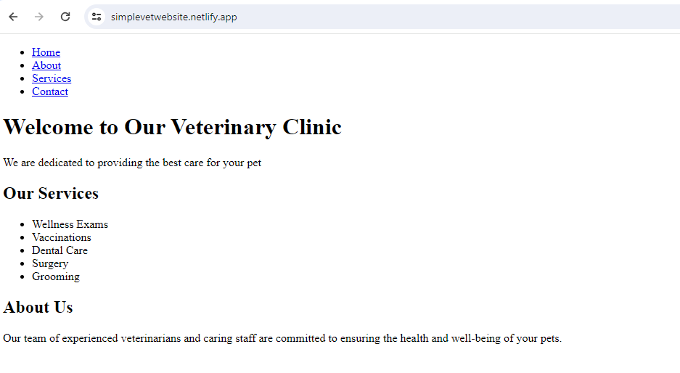

**Career/Employability/Learning Insights**

This week’s lessons enabled me get practical experience for use in programming, running and fixing bugs.