效果图

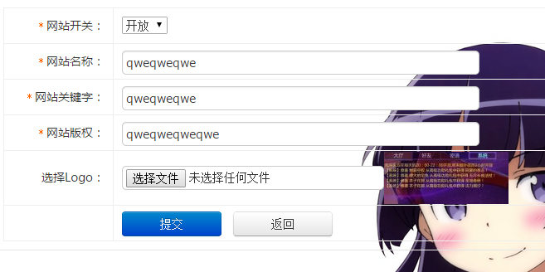

/*

*我的做法是，

*在cmd中先创建一个有值的表单，

*然后在后台修改表单中的值

*/

//后台点击连接

<a href="/zhan/create">

//显示界面路由

Route::rule('/zhan/create','admin/PeizhiController/create');

/*

*界面只有一个，

*点开让他默认是我创建的表单中的值

*控制器在下面

*/

public function create()

{

//

//echo "string";

$quan = Peizhi::where('id','=','2')-> select();

//dump($quan);

//echo "string";

$zhan = $quan['0'];

//echo 'tou';

//dump($zhan['head']);

$arr = explode('/',$zhan['logo']);

$str = implode('/ms_',$arr);

//dump($str);

$zhan['logo'] = $str;

session('zhanPeizhi' , $zhan);

//dump(session('zhanPeizhi.head'));

return view('peizhi/create' , ['zhan' => $zhan]);

}

/*

*浏览器中

*完整form表单

*直接修改表单的值

*没有创建选项

*/

<form action="/zhan/update{//$user.id}" method="post" id="myform" name="myform" enctype="multipart/form-data">

<input type="hidden" name="id" value="2">

<table class="insert-tab" width="100%">

<tbody><tr>

<th width="120"><i class="require-red">*</i>网站开关：</th>

<td>

<select name="open" id="catid" class="required">

<option value="open"{if $zhan.open == 'open'}selected{/if}>开放</option>

<option value="guan"{if $zhan.open == 'guan'}selected{/if}>维护</option>

</select>

</td>

</tr>

<tr>

<th><i class="require-red">*</i>网站名称：</th>

<td>

<input class="common-text required" id="title" name="head" size="50" value="{$zhan.head}" type="text">

</td>

</tr>

<tr>

<th><i class="require-red">*</i>网站关键字：</th>

<td>

<input class="common-text required" id="title" name="title" size="50" value="{$zhan.title}" type="text">

</td>

</tr>

<tr>

<th><i class="require-red">*</i>网站版权：</th>

<td>

<input class="common-text required" id="title" name="kami" size="50" value="{$zhan.kami}" type="text">

</td>

</tr>

<tr>

<th>选择Logo：</th>

<td><input class="common-text" name="logo" size="50" type="file" vilue="{//:config('disp_path').$zhan.logo}"><img src="{:config('disp_path').$zhan.logo}"></td>

</tr>

{//$user.pic}

<tr>

<th></th>

<td>

<input class="btn btn-primary btn6 mr10" value="提交" type="submit">

<input class="btn btn6" onclick="history.go(-1)" value="返回" type="button">

</td>

</tr>

</tbody></table>

</form>

//路由

Route::rule('/zhan/update','admin/PeizhiController/update');

/*

*提交后直接修改表单中的值

*

*提交修改后返回显示界面

*

*

*/

public function update(Request $request, $id)

{

//

$form_data = $request -> post();

$files = $request -> file('logo');

if(!is_null($files)){

$fInfo = $files -> move(config('app.save_path'));

$filename = $fInfo -> getSaveName();

$form_data['logo'] = $filename;

$uPicImage = Image::open(config('app.save_path').$filename);

$arr = explode('/' , $filename);

$sfname = implode('/ms_',$arr);

$uPicImage -> thumb(150,65) -> save(config('app.save_path').$sfname);

}

try {

Peizhi::update($form_data, ['id' => $id], true);

} catch(\Exception $e){

return $this -> error('修改失败', '/zhan/create');

}

return $this -> success("修改成功", "/zhan/create");

}