
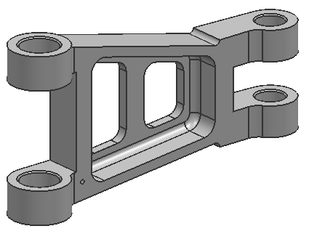
Part Design Specification

Part Number LG-HF34-6-3
“Landing Gear Linkage Type HF34”

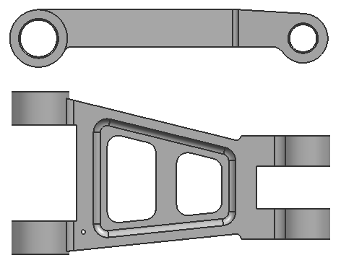
Part will be machined from A7075-T6 aircraft structural aluminum billet.

Dimensional accuracy is to be measured as
per spec DIM-957238.

Center-to-center mounting distance will be 193mm. (±0.02mm)

Total part mass shall be no more than 1.86kg.

Part shall be shot peened as per PS-1201 using media in accordance with AMS 2431.

Center web area thickness shall be a minimum of 7mm. (±0.1mm)

Large end mounting holes shall be 27mm. (±0.04mm)

Small end mounting holes shall be 20mm. (±0.04mm)
