House prices: Lasso, XGBoost, and a detailed EDA

Table of Contents

# Executive Summary

I started this competition by just focusing on getting a good understanding of the dataset. The EDA is detailed and many visualizations are included. This version also includes modeling.

* Lasso regressions performs best with a cross validation RMSE-score of 0.1121. Given the fact that there is a lot of multicolinearity among the variables, this was expected. Lasso does not select a substantial number of the available variables in its model, as it is supposed to do.
* The XGBoost model also performs very well with a cross validation RMSE of 0.1162.
* As those two algorithms are very different, averaging predictions is likely to improve the predictions. As the Lasso cross validated RMSE is better than XGBoost’s CV score, I decided to weight the Lasso results double.

# Introduction

Kaggle describes this competition as [follows](https://www.kaggle.com/c/house-prices-advanced-regression-techniques):

Ask a home buyer to describe their dream house, and they probably won’t begin with the height of the basement ceiling or the proximity to an east-west railroad. But this playground competition’s dataset proves that much more influences price negotiations than the number of bedrooms or a white-picket fence.

With 79 explanatory variables describing (almost) every aspect of residential homes in Ames, Iowa, this competition challenges you to predict the final price of each home.

# Loading and Exploring Data

## Loading libraries required and reading the data into R

Loading R packages used besides base R.

library(knitr)  
library(ggplot2)  
library(plyr)  
library(dplyr)  
library(corrplot)  
library(caret)  
library(gridExtra)  
library(scales)  
library(Rmisc)  
library(ggrepel)  
library(randomForest)  
library(psych)  
library(xgboost)

Below, I am reading the csv’s as dataframes into R.

train <- read.csv("/home/chenxi-zhang/Study/House_Price_Prediction/House-Price-Prediction/train.csv", stringsAsFactors = F)  
test <- read.csv("/home/chenxi-zhang/Study/House_Price_Prediction/House-Price-Prediction/test.csv", stringsAsFactors = F)

## Data size and structure

The train dataset consist of character and integer variables. Most of the character variables are actually (ordinal) factors, but I chose to read them into R as character strings as most of them require cleaning and/or feature engineering first. In total, there are 81 columns/variables, of which the last one is the response variable (SalePrice). Below, I am displaying only a glimpse of the variables. All of them are discussed in more detail throughout the document.

dim(train)

## [1] 1460 81

str(train[,c(1:10, 81)]) #display first 10 variables and the response variable

## 'data.frame': 1460 obs. of 11 variables:  
## $ Id : int 1 2 3 4 5 6 7 8 9 10 ...  
## $ MSSubClass : int 60 20 60 70 60 50 20 60 50 190 ...  
## $ MSZoning : chr "RL" "RL" "RL" "RL" ...  
## $ LotFrontage: int 65 80 68 60 84 85 75 NA 51 50 ...  
## $ LotArea : int 8450 9600 11250 9550 14260 14115 10084 10382 6120 7420 ...  
## $ Street : chr "Pave" "Pave" "Pave" "Pave" ...  
## $ Alley : chr NA NA NA NA ...  
## $ LotShape : chr "Reg" "Reg" "IR1" "IR1" ...  
## $ LandContour: chr "Lvl" "Lvl" "Lvl" "Lvl" ...  
## $ Utilities : chr "AllPub" "AllPub" "AllPub" "AllPub" ...  
## $ SalePrice : int 208500 181500 223500 140000 250000 143000 307000 200000 129900 118000 ...

#Getting rid of the IDs but keeping the test IDs in a vector. These are needed to compose the submission file  
test_labels <- test$Id  
test$Id <- NULL  
train$Id <- NULL

test$SalePrice <- NA  
all <- rbind(train, test)  
dim(all)

## [1] 2919 80

Without the Id’s, the dataframe consists of 79 predictors and our response variable SalePrice.

# Exploring some of the most important variables

## The response variable; SalePrice

As you can see, the sale prices are right skewed. This was expected as few people can afford very expensive houses. I will keep this in mind, and take measures before modeling.

ggplot(data=all[!is.na(all$SalePrice),], aes(x=SalePrice)) +  
 geom_histogram(fill="blue", binwidth = 10000) +  
 scale_x_continuous(breaks= seq(0, 800000, by=100000), labels = comma)

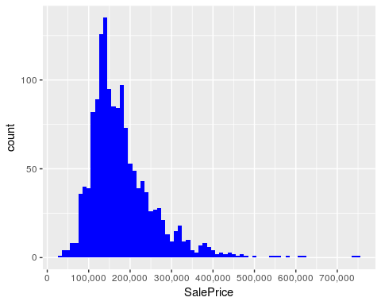

summary(all$SalePrice)

## Min. 1st Qu. Median Mean 3rd Qu. Max. NA's   
## 34900 129975 163000 180921 214000 755000 1459

## The most important numeric predictors

The character variables need some work before I can use them. To get a feel for the dataset, I decided to first see which numeric variables have a high correlation with the SalePrice.

### Correlations with SalePrice

Altogether, there are 10 numeric variables with a correlation of at least 0.5 with SalePrice. All those correlations are positive.

numericVars <- which(sapply(all, is.numeric)) #index vector numeric variables  
numericVarNames <- names(numericVars) #saving names vector for use later on  
cat('There are', length(numericVars), 'numeric variables')

## There are 37 numeric variables

all_numVar <- all[, numericVars]  
cor_numVar <- cor(all_numVar, use="pairwise.complete.obs") #correlations of all numeric variables  
  
#sort on decreasing correlations with SalePrice  
cor_sorted <- as.matrix(sort(cor_numVar[,'SalePrice'], decreasing = TRUE))  
 #select only high corelations  
CorHigh <- names(which(apply(cor_sorted, 1, function(x) abs(x)>0.5)))  
cor_numVar <- cor_numVar[CorHigh, CorHigh]  
  
corrplot.mixed(cor_numVar, tl.col="black", tl.pos = "lt")

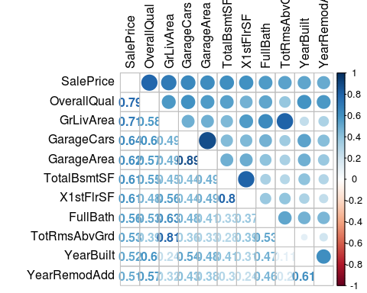

In the remainder of this section, I will visualize the relation between SalePrice and the two predictors with the highest correlation with SalePrice; Overall Quality and the ‘Above Grade’ Living Area (this is the proportion of the house that is not in a basement; [link](http://www.gimme-shelter.com/above-grade-50066/)).

It also becomes clear the multicollinearity is an issue. For example: the correlation between GarageCars and GarageArea is very high (0.89), and both have similar (high) correlations with SalePrice. The other 6 six variables with a correlation higher than 0.5 with SalePrice are: -TotalBsmtSF: Total square feet of basement area -1stFlrSF: First Floor square feet -FullBath: Full bathrooms above grade -TotRmsAbvGrd: Total rooms above grade (does not include bathrooms) -YearBuilt: Original construction date -YearRemodAdd: Remodel date (same as construction date if no remodeling or additions)

### Overall Quality

Overall Quality has the highest correlation with SalePrice among the numeric variables (0.79). It rates the overall material and finish of the house on a scale from 1 (very poor) to 10 (very excellent).

ggplot(data=all[!is.na(all$SalePrice),], aes(x=factor(OverallQual), y=SalePrice))+  
 geom_boxplot(col='blue') + labs(x='Overall Quality') +  
 scale_y_continuous(breaks= seq(0, 800000, by=100000), labels = comma)

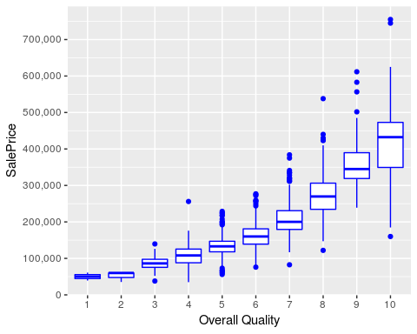

The positive correlation is certainly there indeed, and seems to be a slightly upward curve. Regarding outliers, I do not see any extreme values. If there is a candidate to take out as an outlier later on, it seems to be the expensive house with grade 4.

### Above Grade (Ground) Living Area (square feet)

The numeric variable with the second highest correlation with SalesPrice is the Above Grade Living Area. This make a lot of sense; big houses are generally more expensive.

ggplot(data=all[!is.na(all$SalePrice),], aes(x=GrLivArea, y=SalePrice))+  
 geom_point(col='blue') + geom_smooth(method = "lm", se=FALSE, color="black", aes(group=1)) +  
 scale_y_continuous(breaks= seq(0, 800000, by=100000), labels = comma) +  
 geom_text_repel(aes(label = ifelse(all$GrLivArea[!is.na(all$SalePrice)]>4500, rownames(all), '')))

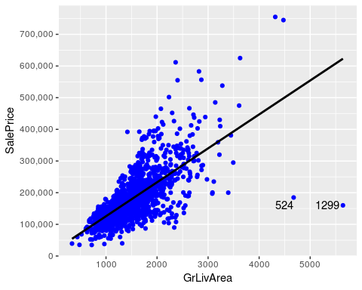

Especially the two houses with really big living areas and low SalePrices seem outliers (houses 524 and 1299, see labels in graph). I will not take them out yet, as taking outliers can be dangerous. For instance, a low score on the Overall Quality could explain a low price. However, as you can see below, these two houses actually also score maximum points on Overall Quality. Therefore, I will keep houses 1299 and 524 in mind as prime candidates to take out as outliers.

all[c(524, 1299), c('SalePrice', 'GrLivArea', 'OverallQual')]

## SalePrice GrLivArea OverallQual  
## 524 184750 4676 10  
## 1299 160000 5642 10

# Missing data, label encoding, and factorizing variables

## Completeness of the data

First of all, I would like to see which variables contain missing values.

NAcol <- which(colSums(is.na(all)) > 0)  
sort(colSums(sapply(all[NAcol], is.na)), decreasing = TRUE)

## PoolQC MiscFeature Alley Fence SalePrice   
## 2909 2814 2721 2348 1459   
## FireplaceQu LotFrontage GarageYrBlt GarageFinish GarageQual   
## 1420 486 159 159 159   
## GarageCond GarageType BsmtCond BsmtExposure BsmtQual   
## 159 157 82 82 81   
## BsmtFinType2 BsmtFinType1 MasVnrType MasVnrArea MSZoning   
## 80 79 24 23 4   
## Utilities BsmtFullBath BsmtHalfBath Functional Exterior1st   
## 2 2 2 2 1   
## Exterior2nd BsmtFinSF1 BsmtFinSF2 BsmtUnfSF TotalBsmtSF   
## 1 1 1 1 1   
## Electrical KitchenQual GarageCars GarageArea SaleType   
## 1 1 1 1 1

cat('There are', length(NAcol), 'columns with missing values')

## There are 35 columns with missing values

Of course, the 1459 NAs in SalePrice match the size of the test set perfectly. This means that I have to fix NAs in 34 predictor variables.

## Imputing missing data

In this section, I am going to fix the 34 predictors that contains missing values. I will go through them working my way down from most NAs until I have fixed them all. If I stumble upon a variable that actually forms a group with other variables, I will also deal with them as a group. For instance, there are multiple variables that relate to Pool, Garage, and Basement.

As I want to keep the document as readable as possible, I decided to use the “Tabs” option that knitr provides. You can find a short analysis for each (group of) variables under each Tab. You don’t have to go through all sections, and can also just have a look at a few tabs. If you do so, I think that especially the Garage and Basement sections are worthwhile, as I have been carefull in determing which houses really do not have a basement or garage.

Besides making sure that the NAs are taken care off, I have also converted character variables into ordinal integers if there is clear ordinality, or into factors if levels are categories without ordinality. I will convert these factors into numeric later on by using one-hot encoding (using the model.matrix function).

### Pool variables

**Pool Quality and the PoolArea variable**

The PoolQC is the variable with most NAs. The description is as follows:

PoolQC: Pool quality

Ex Excellent  
 Gd Good  
 TA Average/Typical  
 Fa Fair  
 NA No Pool

So, it is obvious that I need to just assign ‘No Pool’ to the NAs. Also, the high number of NAs makes sense as normally only a small proportion of houses have a pool.

all$PoolQC[is.na(all$PoolQC)] <- 'None'

It is also clear that I can label encode this variable as the values are ordinal. As there a multiple variables that use the same quality levels, I am going to create a vector that I can reuse later on.

Qualities <- c('None' = 0, 'Po' = 1, 'Fa' = 2, 'TA' = 3, 'Gd' = 4, 'Ex' = 5)

Now, I can use the function ‘revalue’ to do the work for me.

all$PoolQC<-as.integer(revalue(all$PoolQC, Qualities))  
table(all$PoolQC)

##   
## 0 2 4 5   
## 2909 2 4 4

However, there is a second variable that relates to Pools. This is the PoolArea variable (in square feet). As you can see below, there are 3 houses without PoolQC. First, I checked if there was a clear relation between the PoolArea and the PoolQC. As I did not see a clear relation (bigger of smaller pools with better PoolQC), I am going to impute PoolQC values based on the Overall Quality of the houses (which is not very high for those 3 houses).

all[all$PoolArea>0 & all$PoolQC==0, c('PoolArea', 'PoolQC', 'OverallQual')]

## PoolArea PoolQC OverallQual  
## 2421 368 0 4  
## 2504 444 0 6  
## 2600 561 0 3

all$PoolQC[2421] <- 2  
all$PoolQC[2504] <- 3  
all$PoolQC[2600] <- 2

**Please return to the 5.2 Tabs menu to select other (groups of) variables**

### Miscellaneous Feature

**Miscellaneous feature not covered in other categories**

Within Miscellaneous Feature, there are 2814 NAs. As the values are not ordinal, I will convert MiscFeature into a factor. Values:

Elev Elevator  
 Gar2 2nd Garage (if not described in garage section)  
 Othr Other  
 Shed Shed (over 100 SF)  
 TenC Tennis Court  
 NA None

all$MiscFeature[is.na(all$MiscFeature)] <- 'None'  
all$MiscFeature <- as.factor(all$MiscFeature)  
  
ggplot(all[!is.na(all$SalePrice),], aes(x=MiscFeature, y=SalePrice)) +  
 geom_bar(stat='summary', fun.y = "median", fill='blue') +  
 scale_y_continuous(breaks= seq(0, 800000, by=100000), labels = comma) +  
 geom_label(stat = "count", aes(label = ..count.., y = ..count..))

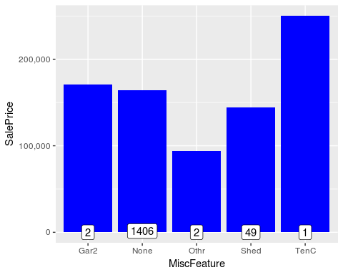

table(all$MiscFeature)

##   
## Gar2 None Othr Shed TenC   
## 5 2814 4 95 1

When looking at the frequencies, the variable seems irrelevant to me. Having a shed probably means ‘no Garage’, which would explain the lower sales price for Shed. Also, while it makes a lot of sense that a house with a Tennis court is expensive, there is only one house with a tennis court in the training set.

**Please return to the 5.2 Tabs menu to select other (groups of) variables**

### Alley

**Type of alley access to property**

Within Alley, there are 2721 NAs. As the values are not ordinal, I will convert Alley into a factor. Values:

Grvl Gravel  
 Pave Paved  
 NA No alley access

all$Alley[is.na(all$Alley)] <- 'None'  
all$Alley <- as.factor(all$Alley)  
  
ggplot(all[!is.na(all$SalePrice),], aes(x=Alley, y=SalePrice)) +  
 geom_bar(stat='summary', fun.y = "median", fill='blue')+  
 scale_y_continuous(breaks= seq(0, 200000, by=50000), labels = comma)

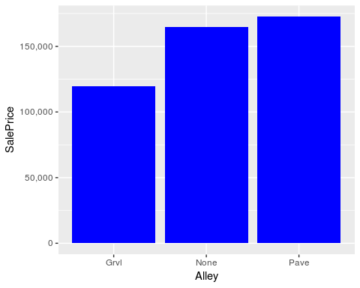

table(all$Alley)

##   
## Grvl None Pave   
## 120 2721 78

**Please return to the 5.2 Tabs menu to select other (groups of) variables**

### Fence

**Fence quality**

Within Fence, there are 2348 NAs. The values seem to be ordinal. Values:

GdPrv Good Privacy  
 MnPrv Minimum Privacy  
 GdWo Good Wood  
 MnWw Minimum Wood/Wire  
 NA No Fence

all$Fence[is.na(all$Fence)] <- 'None'  
table(all$Fence)

##   
## GdPrv GdWo MnPrv MnWw None   
## 118 112 329 12 2348

all[!is.na(all$SalePrice),] %>% group_by(Fence) %>% summarise(median = median(SalePrice), counts=n())

## # A tibble: 5 x 3  
## Fence median counts  
## <chr> <dbl> <int>  
## 1 GdPrv 167500 59  
## 2 GdWo 138750 54  
## 3 MnPrv 137450 157  
## 4 MnWw 130000 11  
## 5 None 173000 1179

My conclusion is that the values do not seem ordinal (no fence is best). Therefore, I will convert Fence into a factor.

all$Fence <- as.factor(all$Fence)

**Please return to the 5.2 Tabs menu to select other (groups of) variables**

### Fireplace variables

**Fireplace quality, and Number of fireplaces**

Within Fireplace Quality, there are 1420 NAs. Number of fireplaces is complete.

**Fireplace quality**

The number of NAs in FireplaceQu matches the number of houses with 0 fireplaces. This means that I can safely replace the NAs in FireplaceQu with ‘no fireplace’. The values are ordinal, and I can use the Qualities vector that I have already created for the Pool Quality. Values:

Ex Excellent - Exceptional Masonry Fireplace  
 Gd Good - Masonry Fireplace in main level  
 TA Average - Prefabricated Fireplace in main living area or Masonry Fireplace in basement  
 Fa Fair - Prefabricated Fireplace in basement  
 Po Poor - Ben Franklin Stove  
 NA No Fireplace

all$FireplaceQu[is.na(all$FireplaceQu)] <- 'None'  
all$FireplaceQu<-as.integer(revalue(all$FireplaceQu, Qualities))  
table(all$FireplaceQu)

##   
## 0 1 2 3 4 5   
## 1420 46 74 592 744 43

**Number of fireplaces**

Fireplaces is an integer variable, and there are no missing values.

table(all$Fireplaces)

##   
## 0 1 2 3 4   
## 1420 1268 219 11 1

sum(table(all$Fireplaces))

## [1] 2919

**Please return to the 5.2 Tabs menu to select other (groups of) variables**

### Lot variables

3 variables. One with 1 NA, and 2 complete variables.

**LotFrontage: Linear feet of street connected to property**

486 NAs. The most reasonable imputation seems to take the median per neigborhood.

ggplot(all[!is.na(all$LotFrontage),], aes(x=as.factor(Neighborhood), y=LotFrontage)) +  
 geom_bar(stat='summary', fun.y = "median", fill='blue') +  
 theme(axis.text.x = element_text(angle = 45, hjust = 1))

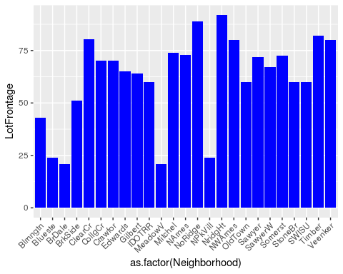

for (i in 1:nrow(all)){  
 if(is.na(all$LotFrontage[i])){  
 all$LotFrontage[i] <- as.integer(median(all$LotFrontage[all$Neighborhood==all$Neighborhood[i]], na.rm=TRUE))   
 }  
}

**LotShape: General shape of property**

No NAs. Values seem ordinal (Regular=best)

Reg Regular   
 IR1 Slightly irregular  
 IR2 Moderately Irregular  
 IR3 Irregular

all$LotShape<-as.integer(revalue(all$LotShape, c('IR3'=0, 'IR2'=1, 'IR1'=2, 'Reg'=3)))  
table(all$LotShape)

##   
## 0 1 2 3   
## 16 76 968 1859

sum(table(all$LotShape))

## [1] 2919

**LotConfig: Lot configuration**

No NAs. The values seemed possibly ordinal to me, but the visualization does not show this. Therefore, I will convert the variable into a factor.

Inside Inside lot  
 Corner Corner lot  
 CulDSac Cul-de-sac  
 FR2 Frontage on 2 sides of property  
 FR3 Frontage on 3 sides of property

ggplot(all[!is.na(all$SalePrice),], aes(x=as.factor(LotConfig), y=SalePrice)) +  
 geom_bar(stat='summary', fun.y = "median", fill='blue')+  
 scale_y_continuous(breaks= seq(0, 800000, by=100000), labels = comma) +  
 geom_label(stat = "count", aes(label = ..count.., y = ..count..))

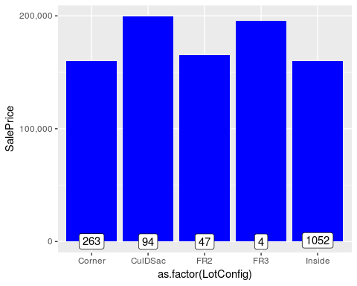

all$LotConfig <- as.factor(all$LotConfig)  
table(all$LotConfig)

##   
## Corner CulDSac FR2 FR3 Inside   
## 511 176 85 14 2133

sum(table(all$LotConfig))

## [1] 2919

**Please return to the 5.2 Tabs menu to select other (groups of) variables**

### Garage variables

**Altogether, there are 7 variables related to garages**

Two of those have one NA (GarageCars and GarageArea), one has 157 NAs (GarageType), 4 variables have 159 NAs.

First of all, I am going to replace all 159 missing **GarageYrBlt: Year garage was built** values with the values in YearBuilt (this is similar to YearRemodAdd, which also defaults to YearBuilt if no remodeling or additions).

all$GarageYrBlt[is.na(all$GarageYrBlt)] <- all$YearBuilt[is.na(all$GarageYrBlt)]

As NAs mean ‘No Garage’ for character variables, I now want to find out where the differences between the 157 NA GarageType and the other 3 character variables with 159 NAs come from.

#check if all 157 NAs are the same observations among the variables with 157/159 NAs  
length(which(is.na(all$GarageType) & is.na(all$GarageFinish) & is.na(all$GarageCond) & is.na(all$GarageQual)))

## [1] 157

#Find the 2 additional NAs  
kable(all[!is.na(all$GarageType) & is.na(all$GarageFinish), c('GarageCars', 'GarageArea', 'GarageType', 'GarageCond', 'GarageQual', 'GarageFinish')])

|  |  |  |  |  |  |  |
| --- | --- | --- | --- | --- | --- | --- |
|  | GarageCars | GarageArea | GarageType | GarageCond | GarageQual | GarageFinish |
| 2127 | 1 | 360 | Detchd | NA | NA | NA |
| 2577 | NA | NA | Detchd | NA | NA | NA |

The 157 NAs within GarageType all turn out to be NA in GarageCondition, GarageQuality, and GarageFinish as well. The differences are found in houses 2127 and 2577. As you can see, house 2127 actually does seem to have a Garage and house 2577 does not. Therefore, there should be 158 houses without a Garage. To fix house 2127, I will imputate the most common values (modes) for GarageCond, GarageQual, and GarageFinish.

#Imputing modes.  
all$GarageCond[2127] <- names(sort(-table(all$GarageCond)))[1]  
all$GarageQual[2127] <- names(sort(-table(all$GarageQual)))[1]  
all$GarageFinish[2127] <- names(sort(-table(all$GarageFinish)))[1]  
  
#display "fixed" house  
kable(all[2127, c('GarageYrBlt', 'GarageCars', 'GarageArea', 'GarageType', 'GarageCond', 'GarageQual', 'GarageFinish')])

|  |  |  |  |  |  |  |  |
| --- | --- | --- | --- | --- | --- | --- | --- |
|  | GarageYrBlt | GarageCars | GarageArea | GarageType | GarageCond | GarageQual | GarageFinish |
| 2127 | 1910 | 1 | 360 | Detchd | TA | TA | Unf |

**GarageCars and GarageArea: Size of garage in car capacity and Size of garage in square**

Both have 1 NA. As you can see above, it is house 2577 for both variables. The problem probably occured as the GarageType for this house is “detached”, while all other Garage-variables seem to indicate that this house has no Garage.

#fixing 3 values for house 2577  
all$GarageCars[2577] <- 0  
all$GarageArea[2577] <- 0  
all$GarageType[2577] <- NA  
  
#check if NAs of the character variables are now all 158  
length(which(is.na(all$GarageType) & is.na(all$GarageFinish) & is.na(all$GarageCond) & is.na(all$GarageQual)))

## [1] 158

Now, the 4 character variables related to garage all have the same set of 158 NAs, which correspond to ‘No Garage’. I will fix all of them in the remainder of this section

**GarageType: Garage location**

The values do not seem ordinal, so I will convert into a factor.

2Types More than one type of garage  
 Attchd Attached to home  
 Basment Basement Garage  
 BuiltIn Built-In (Garage part of house - typically has room above garage)  
 CarPort Car Port  
 Detchd Detached from home  
 NA No Garage

all$GarageType[is.na(all$GarageType)] <- 'No Garage'  
all$GarageType <- as.factor(all$GarageType)  
table(all$GarageType)

##   
## 2Types Attchd Basment BuiltIn CarPort Detchd No Garage   
## 23 1723 36 186 15 778 158

**GarageFinish: Interior finish of the garage**

The values are ordinal.

Fin Finished  
 RFn Rough Finished   
 Unf Unfinished  
 NA No Garage

all$GarageFinish[is.na(all$GarageFinish)] <- 'None'  
Finish <- c('None'=0, 'Unf'=1, 'RFn'=2, 'Fin'=3)  
  
all$GarageFinish<-as.integer(revalue(all$GarageFinish, Finish))  
table(all$GarageFinish)

##   
## 0 1 2 3   
## 158 1231 811 719

**GarageQual: Garage quality**

Another variable than can be made ordinal with the Qualities vector.

Ex Excellent  
 Gd Good  
 TA Typical/Average  
 Fa Fair  
 Po Poor  
 NA No Garage

all$GarageQual[is.na(all$GarageQual)] <- 'None'  
all$GarageQual<-as.integer(revalue(all$GarageQual, Qualities))  
table(all$GarageQual)

##   
## 0 1 2 3 4 5   
## 158 5 124 2605 24 3

**GarageCond: Garage condition**

Another variable than can be made ordinal with the Qualities vector.

Ex Excellent  
 Gd Good  
 TA Typical/Average  
 Fa Fair  
 Po Poor  
 NA No Garage

all$GarageCond[is.na(all$GarageCond)] <- 'None'  
all$GarageCond<-as.integer(revalue(all$GarageCond, Qualities))  
table(all$GarageCond)

##   
## 0 1 2 3 4 5   
## 158 14 74 2655 15 3

**Please return to the 5.2 Tabs menu to select other (groups of) variables**

### Basement Variables

**Altogether, there are 11 variables that relate to the Basement of a house**

Five of those have 79-82 NAs, six have one or two NAs.

#check if all 79 NAs are the same observations among the variables with 80+ NAs  
length(which(is.na(all$BsmtQual) & is.na(all$BsmtCond) & is.na(all$BsmtExposure) & is.na(all$BsmtFinType1) & is.na(all$BsmtFinType2)))

## [1] 79

#Find the additional NAs; BsmtFinType1 is the one with 79 NAs  
all[!is.na(all$BsmtFinType1) & (is.na(all$BsmtCond)|is.na(all$BsmtQual)|is.na(all$BsmtExposure)|is.na(all$BsmtFinType2)), c('BsmtQual', 'BsmtCond', 'BsmtExposure', 'BsmtFinType1', 'BsmtFinType2')]

## BsmtQual BsmtCond BsmtExposure BsmtFinType1 BsmtFinType2  
## 333 Gd TA No GLQ <NA>  
## 949 Gd TA <NA> Unf Unf  
## 1488 Gd TA <NA> Unf Unf  
## 2041 Gd <NA> Mn GLQ Rec  
## 2186 TA <NA> No BLQ Unf  
## 2218 <NA> Fa No Unf Unf  
## 2219 <NA> TA No Unf Unf  
## 2349 Gd TA <NA> Unf Unf  
## 2525 TA <NA> Av ALQ Unf

So altogether, it seems as if there are 79 houses without a basement, because the basement variables of the other houses with missing values are all 80% complete (missing 1 out of 5 values). I am going to impute the modes to fix those 9 houses.

#Imputing modes.  
all$BsmtFinType2[333] <- names(sort(-table(all$BsmtFinType2)))[1]  
all$BsmtExposure[c(949, 1488, 2349)] <- names(sort(-table(all$BsmtExposure)))[1]  
all$BsmtCond[c(2041, 2186, 2525)] <- names(sort(-table(all$BsmtCond)))[1]  
all$BsmtQual[c(2218, 2219)] <- names(sort(-table(all$BsmtQual)))[1]

Now that the 5 variables considered agree upon 79 houses with ‘no basement’, I am going to factorize/hot encode them below.

**BsmtQual: Evaluates the height of the basement**

A variable than can be made ordinal with the Qualities vector.

Ex Excellent (100+ inches)   
 Gd Good (90-99 inches)  
 TA Typical (80-89 inches)  
 Fa Fair (70-79 inches)  
 Po Poor (<70 inches  
 NA No Basement

all$BsmtQual[is.na(all$BsmtQual)] <- 'None'  
all$BsmtQual<-as.integer(revalue(all$BsmtQual, Qualities))  
table(all$BsmtQual)

##   
## 0 2 3 4 5   
## 79 88 1285 1209 258

**BsmtCond: Evaluates the general condition of the basement**

A variable than can be made ordinal with the Qualities vector.

Ex Excellent  
 Gd Good  
 TA Typical - slight dampness allowed  
 Fa Fair - dampness or some cracking or settling  
 Po Poor - Severe cracking, settling, or wetness  
 NA No Basement

all$BsmtCond[is.na(all$BsmtCond)] <- 'None'  
all$BsmtCond<-as.integer(revalue(all$BsmtCond, Qualities))  
table(all$BsmtCond)

##   
## 0 1 2 3 4   
## 79 5 104 2609 122

**BsmtExposure: Refers to walkout or garden level walls**

A variable than can be made ordinal.

Gd Good Exposure  
 Av Average Exposure (split levels or foyers typically score average or above)   
 Mn Mimimum Exposure  
 No No Exposure  
 NA No Basement

all$BsmtExposure[is.na(all$BsmtExposure)] <- 'None'  
Exposure <- c('None'=0, 'No'=1, 'Mn'=2, 'Av'=3, 'Gd'=4)  
  
all$BsmtExposure<-as.integer(revalue(all$BsmtExposure, Exposure))  
table(all$BsmtExposure)

##   
## 0 1 2 3 4   
## 79 1907 239 418 276

**BsmtFinType1: Rating of basement finished area**

A variable than can be made ordinal.

GLQ Good Living Quarters  
 ALQ Average Living Quarters  
 BLQ Below Average Living Quarters   
 Rec Average Rec Room  
 LwQ Low Quality  
 Unf Unfinshed  
 NA No Basement

all$BsmtFinType1[is.na(all$BsmtFinType1)] <- 'None'  
FinType <- c('None'=0, 'Unf'=1, 'LwQ'=2, 'Rec'=3, 'BLQ'=4, 'ALQ'=5, 'GLQ'=6)  
  
all$BsmtFinType1<-as.integer(revalue(all$BsmtFinType1, FinType))  
table(all$BsmtFinType1)

##   
## 0 1 2 3 4 5 6   
## 79 851 154 288 269 429 849

**BsmtFinType2: Rating of basement finished area (if multiple types)**

A variable than can be made ordinal with the FinType vector.

GLQ Good Living Quarters  
 ALQ Average Living Quarters  
 BLQ Below Average Living Quarters   
 Rec Average Rec Room  
 LwQ Low Quality  
 Unf Unfinshed  
 NA No Basement

all$BsmtFinType2[is.na(all$BsmtFinType2)] <- 'None'  
FinType <- c('None'=0, 'Unf'=1, 'LwQ'=2, 'Rec'=3, 'BLQ'=4, 'ALQ'=5, 'GLQ'=6)  
  
all$BsmtFinType2<-as.integer(revalue(all$BsmtFinType2, FinType))  
table(all$BsmtFinType2)

##   
## 0 1 2 3 4 5 6   
## 79 2494 87 105 68 52 34

**Remaining Basement variabes with just a few NAs**

I now still have to deal with those 6 variables that have 1 or 2 NAs.

#display remaining NAs. Using BsmtQual as a reference for the 79 houses without basement agreed upon earlier  
all[(is.na(all$BsmtFullBath)|is.na(all$BsmtHalfBath)|is.na(all$BsmtFinSF1)|is.na(all$BsmtFinSF2)|is.na(all$BsmtUnfSF)|is.na(all$TotalBsmtSF)), c('BsmtQual', 'BsmtFullBath', 'BsmtHalfBath', 'BsmtFinSF1', 'BsmtFinSF2', 'BsmtUnfSF', 'TotalBsmtSF')]

## BsmtQual BsmtFullBath BsmtHalfBath BsmtFinSF1 BsmtFinSF2 BsmtUnfSF  
## 2121 0 NA NA NA NA NA  
## 2189 0 NA NA 0 0 0  
## TotalBsmtSF  
## 2121 NA  
## 2189 0

It should be obvious that those remaining NAs all refer to ‘not present’. Below, I am fixing those remaining variables.

**BsmtFullBath: Basement full bathrooms**

An integer variable.

all$BsmtFullBath[is.na(all$BsmtFullBath)] <-0  
table(all$BsmtFullBath)

##   
## 0 1 2 3   
## 1707 1172 38 2

**BsmtHalfBath: Basement half bathrooms**

An integer variable.

all$BsmtHalfBath[is.na(all$BsmtHalfBath)] <-0  
table(all$BsmtHalfBath)

##   
## 0 1 2   
## 2744 171 4

**BsmtFinSF1: Type 1 finished square feet**

An integer variable.

all$BsmtFinSF1[is.na(all$BsmtFinSF1)] <-0

**BsmtFinSF2: Type 2 finished square feet**

An integer variable.

all$BsmtFinSF2[is.na(all$BsmtFinSF2)] <-0

**BsmtUnfSF: Unfinished square feet of basement area**

An integer variable.

all$BsmtUnfSF[is.na(all$BsmtUnfSF)] <-0

**TotalBsmtSF: Total square feet of basement area**

An integer variable.

all$TotalBsmtSF[is.na(all$TotalBsmtSF)] <-0

**Please return to the 5.2 Tabs menu to select other (groups of) variables**

### Masonry variables

**Masonry veneer type, and masonry veneer area**

Masonry veneer type has 24 NAs. Masonry veneer area has 23 NAs. If a house has a veneer area, it should also have a masonry veneer type. Let’s fix this one first.

#check if the 23 houses with veneer area NA are also NA in the veneer type  
length(which(is.na(all$MasVnrType) & is.na(all$MasVnrArea)))

## [1] 23

#find the one that should have a MasVnrType  
all[is.na(all$MasVnrType) & !is.na(all$MasVnrArea), c('MasVnrType', 'MasVnrArea')]

## MasVnrType MasVnrArea  
## 2611 <NA> 198

#fix this veneer type by imputing the mode  
all$MasVnrType[2611] <- names(sort(-table(all$MasVnrType)))[2] #taking the 2nd value as the 1st is 'none'  
all[2611, c('MasVnrType', 'MasVnrArea')]

## MasVnrType MasVnrArea  
## 2611 BrkFace 198

This leaves me with 23 houses that really have no masonry.

**Masonry veneer type**

Will check the ordinality below.

BrkCmn Brick Common  
 BrkFace Brick Face  
 CBlock Cinder Block  
 None None  
 Stone Stone

all$MasVnrType[is.na(all$MasVnrType)] <- 'None'  
  
all[!is.na(all$SalePrice),] %>% group_by(MasVnrType) %>% summarise(median = median(SalePrice), counts=n()) %>% arrange(median)

## # A tibble: 4 x 3  
## MasVnrType median counts  
## <chr> <dbl> <int>  
## 1 BrkCmn 139000 15  
## 2 None 143125 872  
## 3 BrkFace 181000 445  
## 4 Stone 246839 128

There seems to be a significant difference between “common brick/none” and the other types. I assume that simple stones and for instance wooden houses are just cheaper. I will make the ordinality accordingly.

Masonry <- c('None'=0, 'BrkCmn'=0, 'BrkFace'=1, 'Stone'=2)  
all$MasVnrType<-as.integer(revalue(all$MasVnrType, Masonry))  
table(all$MasVnrType)

##   
## 0 1 2   
## 1790 880 249

**MasVnrArea: Masonry veneer area in square feet**

An integer variable.

all$MasVnrArea[is.na(all$MasVnrArea)] <-0

**Please return to the 5.2 Tabs menu to select other (groups of) variables**

### MS Zoning

**MSZoning: Identifies the general zoning classification of the sale**

4 NAs. Values are categorical.

A Agriculture  
 C Commercial  
 FV Floating Village Residential  
 I Industrial  
 RH Residential High Density  
 RL Residential Low Density  
 RP Residential Low Density Park   
 RM Residential Medium Density

#imputing the mode  
all$MSZoning[is.na(all$MSZoning)] <- names(sort(-table(all$MSZoning)))[1]  
all$MSZoning <- as.factor(all$MSZoning)  
table(all$MSZoning)

##   
## C (all) FV RH RL RM   
## 25 139 26 2269 460

sum(table(all$MSZoning))

## [1] 2919

**Please return to the 5.2 Tabs menu to select other (groups of) variables**

### Kitchen variables

**Kitchen quality and numer of Kitchens above grade**

Kitchen quality has 1 NA. Number of Kitchens is complete.

**Kitchen quality**

1NA. Can be made ordinal with the qualities vector.

Ex Excellent  
 Gd Good  
 TA Typical/Average  
 Fa Fair  
 Po Poor

all$KitchenQual[is.na(all$KitchenQual)] <- 'TA' #replace with most common value  
all$KitchenQual<-as.integer(revalue(all$KitchenQual, Qualities))  
table(all$KitchenQual)

##   
## 2 3 4 5   
## 70 1493 1151 205

sum(table(all$KitchenQual))

## [1] 2919

**Number of Kitchens above grade**

An integer variable with no NAs.

table(all$KitchenAbvGr)

##   
## 0 1 2 3   
## 3 2785 129 2

sum(table(all$KitchenAbvGr))

## [1] 2919

**Please return to the 5.2 Tabs menu to select other (groups of) variables**

### Utilities

**Utilities: Type of utilities available**

2 NAs. Ordinal as additional utilities is better.

AllPub All public Utilities (E,G,W,& S)   
 NoSewr Electricity, Gas, and Water (Septic Tank)  
 NoSeWa Electricity and Gas Only  
 ELO Electricity only

However, the table below shows that only one house does not have all public utilities. This house is in the train set. Therefore, imputing ‘AllPub’ for the NAs means that all houses in the test set will have ‘AllPub’. This makes the variable useless for prediction. Consequently, I will get rid of it.

table(all$Utilities)

##   
## AllPub NoSeWa   
## 2916 1

kable(all[is.na(all$Utilities) | all$Utilities=='NoSeWa', 1:9])

|  |  |  |  |  |  |  |  |  |  |
| --- | --- | --- | --- | --- | --- | --- | --- | --- | --- |
|  | MSSubClass | MSZoning | LotFrontage | LotArea | Street | Alley | LotShape | LandContour | Utilities |
| 945 | 20 | RL | 82 | 14375 | Pave | None | 2 | Lvl | NoSeWa |
| 1916 | 30 | RL | 109 | 21780 | Grvl | None | 3 | Lvl | NA |
| 1946 | 20 | RL | 64 | 31220 | Pave | None | 2 | Bnk | NA |

all$Utilities <- NULL

**Please return to the 5.2 Tabs menu to select other (groups of) variables**

### Home functionality

**Functional: Home functionality**

1NA. Can be made ordinal (salvage only is worst, typical is best).

Typ Typical Functionality  
 Min1 Minor Deductions 1  
 Min2 Minor Deductions 2  
 Mod Moderate Deductions  
 Maj1 Major Deductions 1  
 Maj2 Major Deductions 2  
 Sev Severely Damaged  
 Sal Salvage only

#impute mode for the 1 NA  
all$Functional[is.na(all$Functional)] <- names(sort(-table(all$Functional)))[1]  
  
all$Functional <- as.integer(revalue(all$Functional, c('Sal'=0, 'Sev'=1, 'Maj2'=2, 'Maj1'=3, 'Mod'=4, 'Min2'=5, 'Min1'=6, 'Typ'=7)))  
table(all$Functional)

##   
## 1 2 3 4 5 6 7   
## 2 9 19 35 70 65 2719

sum(table(all$Functional))

## [1] 2919

**Please return to the 5.2 Tabs menu to select other (groups of) variables**

### Exterior variables

**There are 4 exterior variables**

2 variables have 1 NA, 2 variables have no NAs.

**Exterior1st: Exterior covering on house**

1 NA. Values are categorical.

AsbShng Asbestos Shingles  
 AsphShn Asphalt Shingles  
 BrkComm Brick Common  
 BrkFace Brick Face  
 CBlock Cinder Block  
 CemntBd Cement Board  
 HdBoard Hard Board  
 ImStucc Imitation Stucco  
 MetalSd Metal Siding  
 Other Other  
 Plywood Plywood  
 PreCast PreCast   
 Stone Stone  
 Stucco Stucco  
 VinylSd Vinyl Siding  
 Wd Sdng Wood Siding  
 WdShing Wood Shingles

#imputing mode  
all$Exterior1st[is.na(all$Exterior1st)] <- names(sort(-table(all$Exterior1st)))[1]  
  
all$Exterior1st <- as.factor(all$Exterior1st)  
table(all$Exterior1st)

##   
## AsbShng AsphShn BrkComm BrkFace CBlock CemntBd HdBoard ImStucc MetalSd   
## 44 2 6 87 2 126 442 1 450   
## Plywood Stone Stucco VinylSd Wd Sdng WdShing   
## 221 2 43 1026 411 56

sum(table(all$Exterior1st))

## [1] 2919

**Exterior2nd: Exterior covering on house (if more than one material)**

1 NA. Values are categorical.

AsbShng Asbestos Shingles  
 AsphShn Asphalt Shingles  
 BrkComm Brick Common  
 BrkFace Brick Face  
 CBlock Cinder Block  
 CemntBd Cement Board  
 HdBoard Hard Board  
 ImStucc Imitation Stucco  
 MetalSd Metal Siding  
 Other Other  
 Plywood Plywood  
 PreCast PreCast  
 Stone Stone  
 Stucco Stucco  
 VinylSd Vinyl Siding  
 Wd Sdng Wood Siding  
 WdShing Wood Shingles

#imputing mode  
all$Exterior2nd[is.na(all$Exterior2nd)] <- names(sort(-table(all$Exterior2nd)))[1]  
  
all$Exterior2nd <- as.factor(all$Exterior2nd)  
table(all$Exterior2nd)

##   
## AsbShng AsphShn Brk Cmn BrkFace CBlock CmentBd HdBoard ImStucc MetalSd   
## 38 4 22 47 3 126 406 15 447   
## Other Plywood Stone Stucco VinylSd Wd Sdng Wd Shng   
## 1 270 6 47 1015 391 81

sum(table(all$Exterior2nd))

## [1] 2919

**ExterQual: Evaluates the quality of the material on the exterior**

No NAs. Can be made ordinal using the Qualities vector.

Ex Excellent  
 Gd Good  
 TA Average/Typical  
 Fa Fair  
 Po Poor

all$ExterQual<-as.integer(revalue(all$ExterQual, Qualities))

## The following `from` values were not present in `x`: None, Po

table(all$ExterQual)

##   
## 2 3 4 5   
## 35 1798 979 107

sum(table(all$ExterQual))

## [1] 2919

**ExterCond: Evaluates the present condition of the material on the exterior**

No NAs. Can be made ordinal using the Qualities vector.

Ex Excellent  
 Gd Good  
 TA Average/Typical  
 Fa Fair  
 Po Poor

all$ExterCond<-as.integer(revalue(all$ExterCond, Qualities))

## The following `from` values were not present in `x`: None

table(all$ExterCond)

##   
## 1 2 3 4 5   
## 3 67 2538 299 12

sum(table(all$ExterCond))

## [1] 2919

**Please return to the 5.2 Tabs menu to select other (groups of) variables**

### Electrical system

**Electrical: Electrical system**

1 NA. Values are categorical.

SBrkr Standard Circuit Breakers & Romex  
 FuseA Fuse Box over 60 AMP and all Romex wiring (Average)   
 FuseF 60 AMP Fuse Box and mostly Romex wiring (Fair)  
 FuseP 60 AMP Fuse Box and mostly knob & tube wiring (poor)  
 Mix Mixed

#imputing mode  
all$Electrical[is.na(all$Electrical)] <- names(sort(-table(all$Electrical)))[1]  
  
all$Electrical <- as.factor(all$Electrical)  
table(all$Electrical)

##   
## FuseA FuseF FuseP Mix SBrkr   
## 188 50 8 1 2672

sum(table(all$Electrical))

## [1] 2919

**Please return to the 5.2 Tabs menu to select other (groups of) variables**

### Sale Type and Condition

**SaleType: Type of sale**

1 NA. Values are categorical.

WD Warranty Deed - Conventional  
 CWD Warranty Deed - Cash  
 VWD Warranty Deed - VA Loan  
 New Home just constructed and sold  
 COD Court Officer Deed/Estate  
 Con Contract 15% Down payment regular terms  
 ConLw Contract Low Down payment and low interest  
 ConLI Contract Low Interest  
 ConLD Contract Low Down  
 Oth Other

#imputing mode  
all$SaleType[is.na(all$SaleType)] <- names(sort(-table(all$SaleType)))[1]  
  
all$SaleType <- as.factor(all$SaleType)  
table(all$SaleType)

##   
## COD Con ConLD ConLI ConLw CWD New Oth WD   
## 87 5 26 9 8 12 239 7 2526

sum(table(all$SaleType))

## [1] 2919

**SaleCondition: Condition of sale**

No NAs. Values are categorical.

Normal Normal Sale  
 Abnorml Abnormal Sale - trade, foreclosure, short sale  
 AdjLand Adjoining Land Purchase  
 Alloca Allocation - two linked properties with separate deeds, typically condo with a garage unit   
 Family Sale between family members  
 Partial Home was not completed when last assessed (associated with New Homes)

all$SaleCondition <- as.factor(all$SaleCondition)  
table(all$SaleCondition)

##   
## Abnorml AdjLand Alloca Family Normal Partial   
## 190 12 24 46 2402 245

sum(table(all$SaleCondition))

## [1] 2919

**Please return to the 5.2 Tabs menu to select other (groups of) variables**

## Label encoding/factorizing the remaining character variables

At this point, I have made sure that all variables with NAs are taken care of. However, I still need to also take care of the remaining character variables that without missing values. Similar to the previous section, I have created Tabs for groups of variables.

Charcol <- names(all[,sapply(all, is.character)])  
Charcol

## [1] "Street" "LandContour" "LandSlope" "Neighborhood"  
## [5] "Condition1" "Condition2" "BldgType" "HouseStyle"   
## [9] "RoofStyle" "RoofMatl" "Foundation" "Heating"   
## [13] "HeatingQC" "CentralAir" "PavedDrive"

cat('There are', length(Charcol), 'remaining columns with character values')

## There are 15 remaining columns with character values

### Foundation

**Foundation: Type of foundation**

BrkTil Brick & Tile  
 CBlock Cinder Block  
 PConc Poured Contrete   
 Slab Slab  
 Stone Stone  
 Wood Wood

#No ordinality, so converting into factors  
all$Foundation <- as.factor(all$Foundation)  
table(all$Foundation)

##   
## BrkTil CBlock PConc Slab Stone Wood   
## 311 1235 1308 49 11 5

sum(table(all$Foundation))

## [1] 2919

**Please return to the 5.3 Tabs menu to select other (groups of) variables**

### Heating and airco

There are 2 heating variables, and one that indicates Airco Yes/No.

**Heating: Type of heating**

Floor Floor Furnace  
 GasA Gas forced warm air furnace  
 GasW Gas hot water or steam heat  
 Grav Gravity furnace   
 OthW Hot water or steam heat other than gas  
 Wall Wall furnace

#No ordinality, so converting into factors  
all$Heating <- as.factor(all$Heating)  
table(all$Heating)

##   
## Floor GasA GasW Grav OthW Wall   
## 1 2874 27 9 2 6

sum(table(all$Heating))

## [1] 2919

**HeatingQC: Heating quality and condition**

Ex Excellent  
 Gd Good  
 TA Average/Typical  
 Fa Fair  
 Po Poor

#making the variable ordinal using the Qualities vector  
all$HeatingQC<-as.integer(revalue(all$HeatingQC, Qualities))

## The following `from` values were not present in `x`: None

table(all$HeatingQC)

##   
## 1 2 3 4 5   
## 3 92 857 474 1493

sum(table(all$HeatingQC))

## [1] 2919

**CentralAir: Central air conditioning**

N No  
 Y Yes

all$CentralAir<-as.integer(revalue(all$CentralAir, c('N'=0, 'Y'=1)))  
table(all$CentralAir)

##   
## 0 1   
## 196 2723

sum(table(all$CentralAir))

## [1] 2919

**Please return to the 5.3 Tabs menu to select other (groups of) variables**

### Roof

There are 2 variables that deal with the roof of houses.

**RoofStyle: Type of roof**

Flat Flat  
 Gable Gable  
 Gambrel Gabrel (Barn)  
 Hip Hip  
 Mansard Mansard  
 Shed Shed

#No ordinality, so converting into factors  
all$RoofStyle <- as.factor(all$RoofStyle)  
table(all$RoofStyle)

##   
## Flat Gable Gambrel Hip Mansard Shed   
## 20 2310 22 551 11 5

sum(table(all$RoofStyle))

## [1] 2919

**RoofMatl: Roof material**

ClyTile Clay or Tile  
 CompShg Standard (Composite) Shingle  
 Membran Membrane  
 Metal Metal  
 Roll Roll  
 Tar&Grv Gravel & Tar  
 WdShake Wood Shakes  
 WdShngl Wood Shingles

#No ordinality, so converting into factors  
all$RoofMatl <- as.factor(all$RoofMatl)  
table(all$RoofMatl)

##   
## ClyTile CompShg Membran Metal Roll Tar&Grv WdShake WdShngl   
## 1 2876 1 1 1 23 9 7

sum(table(all$RoofMatl))

## [1] 2919

**Please return to the 5.3 Tabs menu to select other (groups of) variables**

### Land

2 variables that specify the flatness and slope of the propoerty.

**LandContour: Flatness of the property**

Lvl Near Flat/Level   
 Bnk Banked - Quick and significant rise from street grade to building  
 HLS Hillside - Significant slope from side to side  
 Low Depression

#No ordinality, so converting into factors  
all$LandContour <- as.factor(all$LandContour)  
table(all$LandContour)

##   
## Bnk HLS Low Lvl   
## 117 120 60 2622

sum(table(all$LandContour))

## [1] 2919

**LandSlope: Slope of property**

Gtl Gentle slope  
 Mod Moderate Slope   
 Sev Severe Slope

#Ordinal, so label encoding  
all$LandSlope<-as.integer(revalue(all$LandSlope, c('Sev'=0, 'Mod'=1, 'Gtl'=2)))  
table(all$LandSlope)

##   
## 0 1 2   
## 16 125 2778

sum(table(all$LandSlope))

## [1] 2919

**Please return to the 5.3 Tabs menu to select other (groups of) variables**

### Dwelling

2 variables that specify the type and style of dwelling.

**BldgType: Type of dwelling**

1Fam Single-family Detached   
 2FmCon Two-family Conversion; originally built as one-family dwelling  
 Duplx Duplex  
 TwnhsE Townhouse End Unit  
 TwnhsI Townhouse Inside Unit

This seems ordinal to me (single family detached=best). Let’s check it with visualization.

ggplot(all[!is.na(all$SalePrice),], aes(x=as.factor(BldgType), y=SalePrice)) +  
 geom_bar(stat='summary', fun.y = "median", fill='blue')+  
 scale_y_continuous(breaks= seq(0, 800000, by=100000), labels = comma) +  
 geom_label(stat = "count", aes(label = ..count.., y = ..count..))

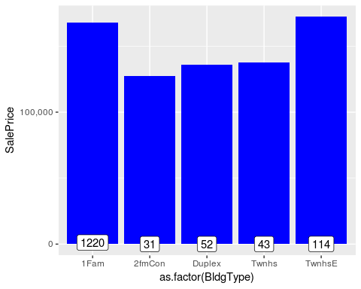

However, the visualization does not show ordinality.

#No ordinality, so converting into factors  
all$BldgType <- as.factor(all$BldgType)  
table(all$BldgType)

##   
## 1Fam 2fmCon Duplex Twnhs TwnhsE   
## 2425 62 109 96 227

sum(table(all$BldgType))

## [1] 2919

**HouseStyle: Style of dwelling**

1Story One story  
 1.5Fin One and one-half story: 2nd level finished  
 1.5Unf One and one-half story: 2nd level unfinished  
 2Story Two story  
 2.5Fin Two and one-half story: 2nd level finished  
 2.5Unf Two and one-half story: 2nd level unfinished  
 SFoyer Split Foyer  
 SLvl Split Level

#No ordinality, so converting into factors  
all$HouseStyle <- as.factor(all$HouseStyle)  
table(all$HouseStyle)

##   
## 1.5Fin 1.5Unf 1Story 2.5Fin 2.5Unf 2Story SFoyer SLvl   
## 314 19 1471 8 24 872 83 128

sum(table(all$HouseStyle))

## [1] 2919

**Please return to the 5.3 Tabs menu to select other (groups of) variables**

### Neighborhood and Conditions

3 variables that specify the physical location, and the proximity of ‘conditions’.

**Neighborhood: Physical locations within Ames city limits**

Note: as the number of levels is really high, I will look into binning later on.

Blmngtn Bloomington Heights  
 Blueste Bluestem  
 BrDale Briardale  
 BrkSide Brookside  
 ClearCr Clear Creek  
 CollgCr College Creek  
 Crawfor Crawford  
 Edwards Edwards  
 Gilbert Gilbert  
 IDOTRR Iowa DOT and Rail Road  
 MeadowV Meadow Village  
 Mitchel Mitchell  
 Names North Ames  
 NoRidge Northridge  
 NPkVill Northpark Villa  
 NridgHt Northridge Heights  
 NWAmes Northwest Ames  
 OldTown Old Town  
 SWISU South & West of Iowa State University  
 Sawyer Sawyer  
 SawyerW Sawyer West  
 Somerst Somerset  
 StoneBr Stone Brook  
 Timber Timberland  
 Veenker Veenker

#No ordinality, so converting into factors  
all$Neighborhood <- as.factor(all$Neighborhood)  
table(all$Neighborhood)

##   
## Blmngtn Blueste BrDale BrkSide ClearCr CollgCr Crawfor Edwards Gilbert   
## 28 10 30 108 44 267 103 194 165   
## IDOTRR MeadowV Mitchel NAmes NoRidge NPkVill NridgHt NWAmes OldTown   
## 93 37 114 443 71 23 166 131 239   
## Sawyer SawyerW Somerst StoneBr SWISU Timber Veenker   
## 151 125 182 51 48 72 24

sum(table(all$Neighborhood))

## [1] 2919

**Condition1: Proximity to various conditions**

Artery Adjacent to arterial street  
 Feedr Adjacent to feeder street   
 Norm Normal   
 RRNn Within 200' of North-South Railroad  
 RRAn Adjacent to North-South Railroad  
 PosN Near positive off-site feature--park, greenbelt, etc.  
 PosA Adjacent to postive off-site feature  
 RRNe Within 200' of East-West Railroad  
 RRAe Adjacent to East-West Railroad

#No ordinality, so converting into factors  
all$Condition1 <- as.factor(all$Condition1)  
table(all$Condition1)

##   
## Artery Feedr Norm PosA PosN RRAe RRAn RRNe RRNn   
## 92 164 2511 20 39 28 50 6 9

sum(table(all$Condition1))

## [1] 2919

**Condition2: Proximity to various conditions (if more than one is present)**

Artery Adjacent to arterial street  
 Feedr Adjacent to feeder street   
 Norm Normal   
 RRNn Within 200' of North-South Railroad  
 RRAn Adjacent to North-South Railroad  
 PosN Near positive off-site feature--park, greenbelt, etc.  
 PosA Adjacent to postive off-site feature  
 RRNe Within 200' of East-West Railroad  
 RRAe Adjacent to East-West Railroad

#No ordinality, so converting into factors  
all$Condition2 <- as.factor(all$Condition2)  
table(all$Condition2)

##   
## Artery Feedr Norm PosA PosN RRAe RRAn RRNn   
## 5 13 2889 4 4 1 1 2

sum(table(all$Condition2))

## [1] 2919

**Please return to the 5.3 Tabs menu to select other (groups of) variables**

### Pavement of Street & Driveway

2 variables

**Street: Type of road access to property**

Grvl Gravel   
 Pave Paved

#Ordinal, so label encoding  
all$Street<-as.integer(revalue(all$Street, c('Grvl'=0, 'Pave'=1)))  
table(all$Street)

##   
## 0 1   
## 12 2907

sum(table(all$Street))

## [1] 2919

**PavedDrive: Paved driveway**

Y Paved   
 P Partial Pavement  
 N Dirt/Gravel

#Ordinal, so label encoding  
all$PavedDrive<-as.integer(revalue(all$PavedDrive, c('N'=0, 'P'=1, 'Y'=2)))  
table(all$PavedDrive)

##   
## 0 1 2   
## 216 62 2641

sum(table(all$PavedDrive))

## [1] 2919

**Please return to the 5.3 Tabs menu to select other (groups of) variables**

## Changing some numeric variables into factors

At this point, all variables are complete (No NAs), and all character variables are converted into either numeric labels of into factors. However, there are 3 variables that are recorded numeric but should actually be categorical.

### Year and Month Sold

While oridinality within YearBuilt (or remodeled) makes sense (old houses are worth less), we are talking about only 5 years of sales. These years also include an economic crisis. For instance: Sale Prices in 2009 (after the collapse) are very likely to be much lower than in 2007. I wil convert YrSold into a factor before modeling, but as I need the numeric version of YrSold to create an Age variable, I am not doing that yet.

Month Sold is also an Integer variable. However, December is not “better” than January. Therefore, I will convert MoSold values back into factors.

str(all$YrSold)

## int [1:2919] 2008 2007 2008 2006 2008 2009 2007 2009 2008 2008 ...

str(all$MoSold)

## int [1:2919] 2 5 9 2 12 10 8 11 4 1 ...

all$MoSold <- as.factor(all$MoSold)

Although possible a bit less steep than expected, the effects of the Banking crises that took place at the end of 2007 can be seen indeed. After the highest median prices in 2007, the prices gradually decreased. However, seasonality seems to play a bigger role, as you can see below.

ys <- ggplot(all[!is.na(all$SalePrice),], aes(x=as.factor(YrSold), y=SalePrice)) +  
 geom_bar(stat='summary', fun.y = "median", fill='blue')+  
 scale_y_continuous(breaks= seq(0, 800000, by=25000), labels = comma) +  
 geom_label(stat = "count", aes(label = ..count.., y = ..count..)) +  
 coord_cartesian(ylim = c(0, 200000)) +  
 geom_hline(yintercept=163000, linetype="dashed", color = "red") #dashed line is median SalePrice  
  
ms <- ggplot(all[!is.na(all$SalePrice),], aes(x=MoSold, y=SalePrice)) +  
 geom_bar(stat='summary', fun.y = "median", fill='blue')+  
 scale_y_continuous(breaks= seq(0, 800000, by=25000), labels = comma) +  
 geom_label(stat = "count", aes(label = ..count.., y = ..count..)) +  
 coord_cartesian(ylim = c(0, 200000)) +  
 geom_hline(yintercept=163000, linetype="dashed", color = "red") #dashed line is median SalePrice  
  
grid.arrange(ys, ms, widths=c(1,2))

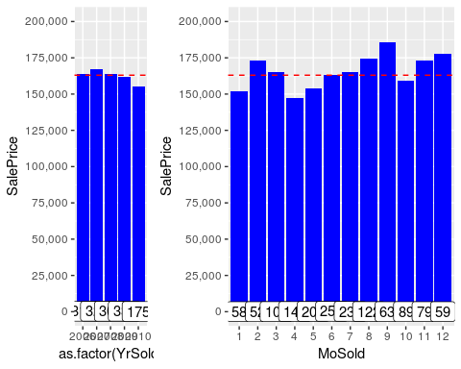

### MSSubClass

MSSubClass: Identifies the type of dwelling involved in the sale.

20 1-STORY 1946 & NEWER ALL STYLES  
 30 1-STORY 1945 & OLDER  
 40 1-STORY W/FINISHED ATTIC ALL AGES  
 45 1-1/2 STORY - UNFINISHED ALL AGES  
 50 1-1/2 STORY FINISHED ALL AGES  
 60 2-STORY 1946 & NEWER  
 70 2-STORY 1945 & OLDER  
 75 2-1/2 STORY ALL AGES  
 80 SPLIT OR MULTI-LEVEL  
 85 SPLIT FOYER  
 90 DUPLEX - ALL STYLES AND AGES  
 120 1-STORY PUD (Planned Unit Development) - 1946 & NEWER  
 150 1-1/2 STORY PUD - ALL AGES  
 160 2-STORY PUD - 1946 & NEWER  
 180 PUD - MULTILEVEL - INCL SPLIT LEV/FOYER  
 190 2 FAMILY CONVERSION - ALL STYLES AND AGES

These classes are coded as numbers, but really are categories.

str(all$MSSubClass)

## int [1:2919] 60 20 60 70 60 50 20 60 50 190 ...

all$MSSubClass <- as.factor(all$MSSubClass)  
  
#revalue for better readability  
all$MSSubClass<-revalue(all$MSSubClass, c('20'='1 story 1946+', '30'='1 story 1945-', '40'='1 story unf attic', '45'='1,5 story unf', '50'='1,5 story fin', '60'='2 story 1946+', '70'='2 story 1945-', '75'='2,5 story all ages', '80'='split/multi level', '85'='split foyer', '90'='duplex all style/age', '120'='1 story PUD 1946+', '150'='1,5 story PUD all', '160'='2 story PUD 1946+', '180'='PUD multilevel', '190'='2 family conversion'))  
  
str(all$MSSubClass)

## Factor w/ 16 levels "1 story 1946+",..: 6 1 6 7 6 5 1 6 5 16 ...

# Visualization of important variables

I have now finally reached the point where all character variables have been converted into categorical factors or have been label encoded into numbers. In addition, 3 numeric variables have been converted into factors, and I deleted one variable (Utilities). As you can see below, the number of numerical variables is now 56 (including the response variable), and the remaining 23 variables are categorical.

numericVars <- which(sapply(all, is.numeric)) #index vector numeric variables  
factorVars <- which(sapply(all, is.factor)) #index vector factor variables  
cat('There are', length(numericVars), 'numeric variables, and', length(factorVars), 'categoric variables')

## There are 56 numeric variables, and 23 categoric variables

## Correlations again

Below I am checking the correlations again. As you can see, the number of variables with a correlation of at least 0.5 with the SalePrice has increased from 10 (see section 4.2.1) to 16.

all_numVar <- all[, numericVars]  
cor_numVar <- cor(all_numVar, use="pairwise.complete.obs") #correlations of all numeric variables  
  
#sort on decreasing correlations with SalePrice  
cor_sorted <- as.matrix(sort(cor_numVar[,'SalePrice'], decreasing = TRUE))  
 #select only high corelations  
CorHigh <- names(which(apply(cor_sorted, 1, function(x) abs(x)>0.5)))  
cor_numVar <- cor_numVar[CorHigh, CorHigh]  
  
corrplot.mixed(cor_numVar, tl.col="black", tl.pos = "lt", tl.cex = 0.7,cl.cex = .7, number.cex=.7)

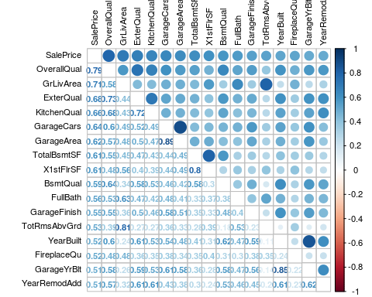

## Finding variable importance with a quick Random Forest

Although the correlations are giving a good overview of the most important numeric variables and multicolinerity among those variables, I wanted to get an overview of the most important variables including the categorical variables before moving on to visualization.

I tried to get the relative importance of variables with a quick linear regression model with the calc.relimp function of package , and also tried the boruta function of package boruta which separates the variables into groups that are important or not. However, these method took a long time. As I only want to get an indication of the variable importance, I eventually decided to keep it simple and just use a quick and dirty Random Forest model with only 100 trees. This also does the job for me, and does not take very long as I can specify a (relatively) small number of trees.

set.seed(2018)  
quick_RF <- randomForest(x=all[1:1460,-79], y=all$SalePrice[1:1460], ntree=100,importance=TRUE)  
imp_RF <- importance(quick_RF)  
imp_DF <- data.frame(Variables = row.names(imp_RF), MSE = imp_RF[,1])  
imp_DF <- imp_DF[order(imp_DF$MSE, decreasing = TRUE),]  
  
ggplot(imp_DF[1:20,], aes(x=reorder(Variables, MSE), y=MSE, fill=MSE)) + geom_bar(stat = 'identity') + labs(x = 'Variables', y= '% increase MSE if variable is randomly permuted') + coord_flip() + theme(legend.position="none")

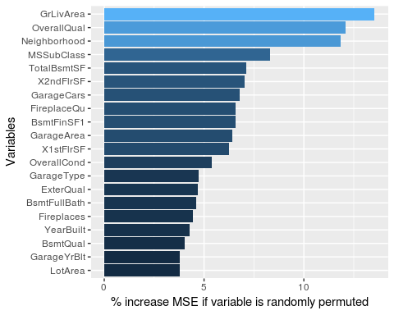

Only 3 of those most important variables are categorical according to RF; Neighborhood, MSSubClass, and GarageType.

### Above Ground Living Area, and other surface related variables (in square feet)

As I have already visualized the relation between the Above Ground Living Area and SalePrice in my initial explorations, I will now just display the distribution itself. As there are more ‘square feet’ surface measurements in the Top 20, I am taking the opportunity to bundle them in this section. Note: GarageArea is taken care of in the Garage variables section.

I am also adding ‘Total Rooms Above Ground’ (TotRmsAbvGrd) as this variable is highly correlated with the Above Ground Living Area(0.81).

s1 <- ggplot(data= all, aes(x=GrLivArea)) +  
 geom_density() + labs(x='Square feet living area')  
s2 <- ggplot(data=all, aes(x=as.factor(TotRmsAbvGrd))) +  
 geom_histogram(stat='count') + labs(x='Rooms above Ground')  
s3 <- ggplot(data= all, aes(x=X1stFlrSF)) +  
 geom_density() + labs(x='Square feet first floor')  
s4 <- ggplot(data= all, aes(x=X2ndFlrSF)) +  
 geom_density() + labs(x='Square feet second floor')  
s5 <- ggplot(data= all, aes(x=TotalBsmtSF)) +  
 geom_density() + labs(x='Square feet basement')  
s6 <- ggplot(data= all[all$LotArea<100000,], aes(x=LotArea)) +  
 geom_density() + labs(x='Square feet lot')  
s7 <- ggplot(data= all, aes(x=LotFrontage)) +  
 geom_density() + labs(x='Linear feet lot frontage')  
s8 <- ggplot(data= all, aes(x=LowQualFinSF)) +  
 geom_histogram() + labs(x='Low quality square feet 1st & 2nd')  
  
layout <- matrix(c(1,2,5,3,4,8,6,7),4,2,byrow=TRUE)  
multiplot(s1, s2, s3, s4, s5, s6, s7, s8, layout=layout)

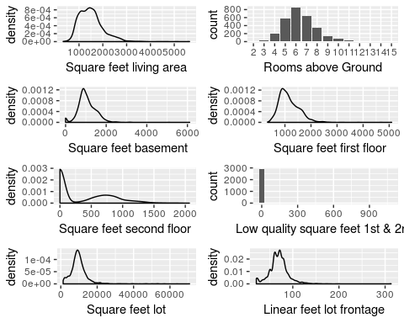

I will investigate several of these variables for outliers later on. For the lot visualization, I have already taken out the lots above 100,000 square feet (4 houses).

GrLivArea seemed to be just the total of square feet 1st and 2nd floor. However, in a later version, I discovered that there is also a variable called: LowQualFinSF: Low quality finished square feet (all floors). As you can see above (Low quality square feet 1st and 2nd) almost all houses have none of this (only 40 houses do have some). It turns out that these square feet are actually included in the GrLivArea. The correlation between those 3 variables and GrLivArea is exactely 1.

cor(all$GrLivArea, (all$X1stFlrSF + all$X2ndFlrSF + all$LowQualFinSF))

## [1] 1

head(all[all$LowQualFinSF>0, c('GrLivArea', 'X1stFlrSF', 'X2ndFlrSF', 'LowQualFinSF')])

## GrLivArea X1stFlrSF X2ndFlrSF LowQualFinSF  
## 52 1176 816 0 360  
## 89 1526 1013 0 513  
## 126 754 520 0 234  
## 171 1382 854 0 528  
## 186 3608 1518 1518 572  
## 188 1656 808 704 144

### The most important categorical variable; Neighborhood

Th first graph shows the median SalePrice by Neighorhood. The frequency (number of houses) of each Neighborhood in the train set is shown in the labels.

The second graph below shows the frequencies across all data.

n1 <- ggplot(all[!is.na(all$SalePrice),], aes(x=Neighborhood, y=SalePrice)) +  
 geom_bar(stat='summary', fun.y = "median", fill='blue') +  
 theme(axis.text.x = element_text(angle = 45, hjust = 1)) +  
 scale_y_continuous(breaks= seq(0, 800000, by=50000), labels = comma) +  
 geom_label(stat = "count", aes(label = ..count.., y = ..count..), size=3) +  
 geom_hline(yintercept=163000, linetype="dashed", color = "red") #dashed line is median SalePrice  
n2 <- ggplot(data=all, aes(x=Neighborhood)) +  
 geom_histogram(stat='count')+  
 geom_label(stat = "count", aes(label = ..count.., y = ..count..), size=3)+  
 theme(axis.text.x = element_text(angle = 45, hjust = 1))  
grid.arrange(n1, n2)

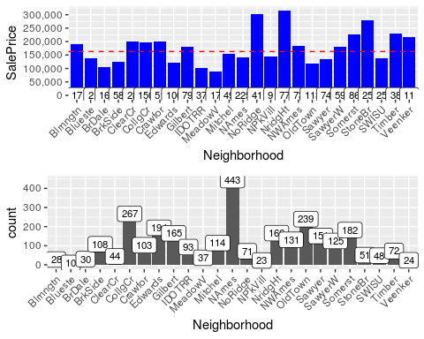

### Overall Quality, and other Quality variables

I have already visualized the relation between Overall Quality and SalePrice in my initial explorations, but I want to visualize the frequency distribution as well. As there are more quality measurements, I am taking the opportunity to bundle them in this section.

q1 <- ggplot(data=all, aes(x=as.factor(OverallQual))) +  
 geom_histogram(stat='count')  
q2 <- ggplot(data=all, aes(x=as.factor(ExterQual))) +  
 geom_histogram(stat='count')  
q3 <- ggplot(data=all, aes(x=as.factor(BsmtQual))) +  
 geom_histogram(stat='count')  
q4 <- ggplot(data=all, aes(x=as.factor(KitchenQual))) +  
 geom_histogram(stat='count')  
q5 <- ggplot(data=all, aes(x=as.factor(GarageQual))) +  
 geom_histogram(stat='count')  
q6 <- ggplot(data=all, aes(x=as.factor(FireplaceQu))) +  
 geom_histogram(stat='count')  
q7 <- ggplot(data=all, aes(x=as.factor(PoolQC))) +  
 geom_histogram(stat='count')  
  
layout <- matrix(c(1,2,8,3,4,8,5,6,7),3,3,byrow=TRUE)  
multiplot(q1, q2, q3, q4, q5, q6, q7, layout=layout)

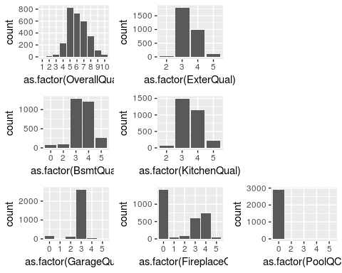

Overall Quality is very important, and also more granular than the other variables. External Quality is also improtant, but has a high correlation with Overall Quality (0.73). Kitchen Quality also seems one to keep, as all houses have a kitchen and there is a variance with some substance. Garage Quality does not seem to distinguish much, as the majority of garages have Q3. Fireplace Quality is in the list of high correlations, and in the important variables list. The PoolQC is just very sparse (the 13 pools cannot even be seen on this scale). I will look at creating a ‘has pool’ variable later on.

### The second most important categorical variable; MSSubClass

The first visualization shows the median SalePrice by MSSubClass. The frequency (number of houses) of each MSSubClass in the train set is shown in the labels.

The histrogram shows the frequencies across all data. Most houses are relatively new, and have one or two stories.

ms1 <- ggplot(all[!is.na(all$SalePrice),], aes(x=MSSubClass, y=SalePrice)) +  
 geom_bar(stat='summary', fun.y = "median", fill='blue') +  
 theme(axis.text.x = element_text(angle = 45, hjust = 1)) +  
 scale_y_continuous(breaks= seq(0, 800000, by=50000), labels = comma) +  
 geom_label(stat = "count", aes(label = ..count.., y = ..count..), size=3) +  
 geom_hline(yintercept=163000, linetype="dashed", color = "red") #dashed line is median SalePrice  
ms2 <- ggplot(data=all, aes(x=MSSubClass)) +  
 geom_histogram(stat='count')+  
 geom_label(stat = "count", aes(label = ..count.., y = ..count..), size=3) +  
 theme(axis.text.x = element_text(angle = 45, hjust = 1))  
grid.arrange(ms1, ms2)

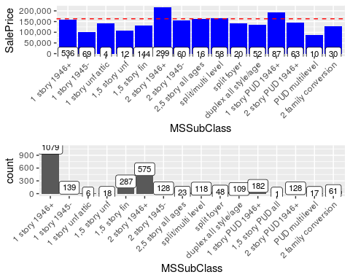

### Garage variables

Several Garage variables have a high correlation with SalePrice, and are also in the top-20 list of the quick random forest. However, there is multicolinearity among them and I think that 7 garage variables is too many anyway. I feel that something like 3 variables should be sufficient (possibly GarageCars, GarageType, and a Quality measurement), but before I do any selection I am visualizing all of them in this section.

#correct error  
all$GarageYrBlt[2593] <- 2007 #this must have been a typo. GarageYrBlt=2207, YearBuilt=2006, YearRemodAdd=2007.

g1 <- ggplot(data=all[all$GarageCars !=0,], aes(x=GarageYrBlt)) +  
 geom_histogram()  
g2 <- ggplot(data=all, aes(x=as.factor(GarageCars))) +  
 geom_histogram(stat='count')  
g3 <- ggplot(data= all, aes(x=GarageArea)) +  
 geom_density()  
g4 <- ggplot(data=all, aes(x=as.factor(GarageCond))) +  
 geom_histogram(stat='count')  
g5 <- ggplot(data=all, aes(x=GarageType)) +  
 geom_histogram(stat='count')  
g6 <- ggplot(data=all, aes(x=as.factor(GarageQual))) +  
 geom_histogram(stat='count')  
g7 <- ggplot(data=all, aes(x=as.factor(GarageFinish))) +  
 geom_histogram(stat='count')  
  
layout <- matrix(c(1,5,5,2,3,8,6,4,7),3,3,byrow=TRUE)  
multiplot(g1, g2, g3, g4, g5, g6, g7, layout=layout)

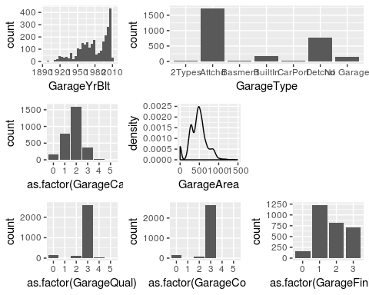

As already mentioned in section 4.2, GarageCars and GarageArea are highly correlated. Here, GarageQual and GarageCond also seem highly correlated, and both are dominated by level =3.

### Basement variables

Similar the garage variables, multiple basement variables are important in the correlations matrix and the Top 20 RF predictors list. However, 11 basement variables seems an overkill. Before I decide what I am going to do with them, I am visualizing 8 of them below. The 2 “Bathroom” variables are dealt with in Feature Engineering (section 7.1), and the “Basement square feet” is already discussed in section 6.2.1.

b1 <- ggplot(data=all, aes(x=BsmtFinSF1)) +  
 geom_histogram() + labs(x='Type 1 finished square feet')  
b2 <- ggplot(data=all, aes(x=BsmtFinSF2)) +  
 geom_histogram()+ labs(x='Type 2 finished square feet')  
b3 <- ggplot(data=all, aes(x=BsmtUnfSF)) +  
 geom_histogram()+ labs(x='Unfinished square feet')  
b4 <- ggplot(data=all, aes(x=as.factor(BsmtFinType1))) +  
 geom_histogram(stat='count')+ labs(x='Rating of Type 1 finished area')  
b5 <- ggplot(data=all, aes(x=as.factor(BsmtFinType2))) +  
 geom_histogram(stat='count')+ labs(x='Rating of Type 2 finished area')  
b6 <- ggplot(data=all, aes(x=as.factor(BsmtQual))) +  
 geom_histogram(stat='count')+ labs(x='Height of the basement')  
b7 <- ggplot(data=all, aes(x=as.factor(BsmtCond))) +  
 geom_histogram(stat='count')+ labs(x='Rating of general condition')  
b8 <- ggplot(data=all, aes(x=as.factor(BsmtExposure))) +  
 geom_histogram(stat='count')+ labs(x='Walkout or garden level walls')  
  
layout <- matrix(c(1,2,3,4,5,9,6,7,8),3,3,byrow=TRUE)  
multiplot(b1, b2, b3, b4, b5, b6, b7, b8, layout=layout)

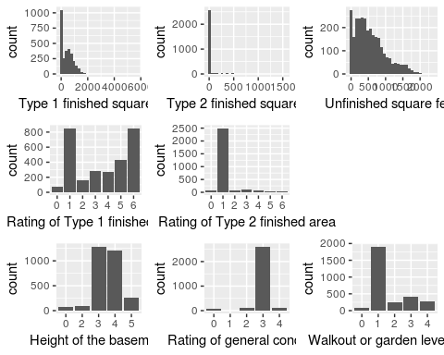

So it seemed as if the Total Basement Surface in square feet (TotalBsmtSF) is further broken down into finished areas (2 if more than one type of finish), and unfinished area. I did a check between the correlation of total of those 3 variables, and TotalBsmtSF. The correlation is exactely 1, so that’s a good thing (no errors or small discrepancies)!

Basement Quality is a confusing variable name, as it turns out that it specifically rates the Height of the basement.

# Feature engineering

## Total number of Bathrooms

There are 4 bathroom variables. Individually, these variables are not very important. However, I assume that I if I add them up into one predictor, this predictor is likely to become a strong one.

“A half-bath, also known as a powder room or guest bath, has only two of the four main bathroom components-typically a toilet and sink.” Consequently, I will also count the half bathrooms as half.

all$TotBathrooms <- all$FullBath + (all$HalfBath*0.5) + all$BsmtFullBath + (all$BsmtHalfBath*0.5)

As you can see in the first graph, there now seems to be a clear correlation (it’s 0.63). The frequency distribution of Bathrooms in all data is shown in the second graph.

tb1 <- ggplot(data=all[!is.na(all$SalePrice),], aes(x=as.factor(TotBathrooms), y=SalePrice))+  
 geom_point(col='blue') + geom_smooth(method = "lm", se=FALSE, color="black", aes(group=1)) +  
 scale_y_continuous(breaks= seq(0, 800000, by=100000), labels = comma)  
tb2 <- ggplot(data=all, aes(x=as.factor(TotBathrooms))) +  
 geom_histogram(stat='count')  
grid.arrange(tb1, tb2)

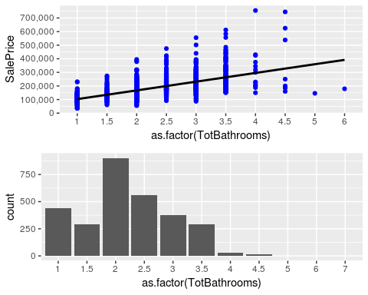

## Adding ‘House Age’, ‘Remodeled (Yes/No)’, and IsNew variables

Altogether, there are 3 variables that are relevant with regards to the Age of a house; YearBlt, YearRemodAdd, and YearSold. YearRemodAdd defaults to YearBuilt if there has been no Remodeling/Addition. I will use YearRemodeled and YearSold to determine the Age. However, as parts of old constructions will always remain and only parts of the house might have been renovated, I will also introduce a Remodeled Yes/No variable. This should be seen as some sort of penalty parameter that indicates that if the Age is based on a remodeling date, it is probably worth less than houses that were built from scratch in that same year.

all$Remod <- ifelse(all$YearBuilt==all$YearRemodAdd, 0, 1) #0=No Remodeling, 1=Remodeling  
all$Age <- as.numeric(all$YrSold)-all$YearRemodAdd

ggplot(data=all[!is.na(all$SalePrice),], aes(x=Age, y=SalePrice))+  
 geom_point(col='blue') + geom_smooth(method = "lm", se=FALSE, color="black", aes(group=1)) +  
 scale_y_continuous(breaks= seq(0, 800000, by=100000), labels = comma)

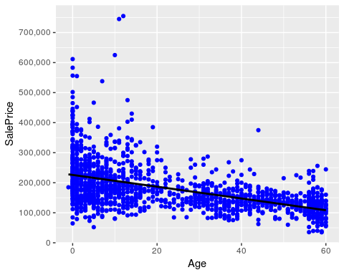

As expected, the graph shows a negative correlation with Age (old house are worth less).

cor(all$SalePrice[!is.na(all$SalePrice)], all$Age[!is.na(all$SalePrice)])

## [1] -0.5090787

As you can see below, houses that are remodeled are worth less indeed, as expected.

ggplot(all[!is.na(all$SalePrice),], aes(x=as.factor(Remod), y=SalePrice)) +  
 geom_bar(stat='summary', fun.y = "median", fill='blue') +  
 geom_label(stat = "count", aes(label = ..count.., y = ..count..), size=6) +  
 scale_y_continuous(breaks= seq(0, 800000, by=50000), labels = comma) +  
 theme_grey(base_size = 18) +  
 geom_hline(yintercept=163000, linetype="dashed") #dashed line is median SalePrice

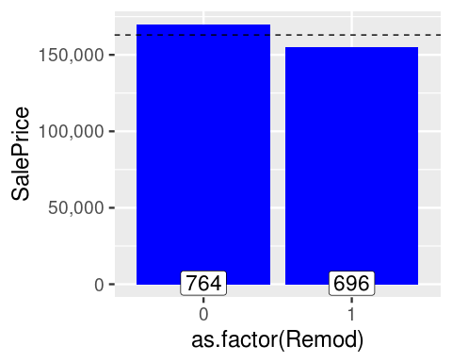

Finally, I am creating the IsNew variable below. Altogether, there are 116 new houses in the dataset.

all$IsNew <- ifelse(all$YrSold==all$YearBuilt, 1, 0)  
table(all$IsNew)

##   
## 0 1   
## 2803 116

These 116 new houses are fairly evenly distributed among train and test set, and as you can see new houses are worth considerably more on average.

ggplot(all[!is.na(all$SalePrice),], aes(x=as.factor(IsNew), y=SalePrice)) +  
 geom_bar(stat='summary', fun.y = "median", fill='blue') +  
 geom_label(stat = "count", aes(label = ..count.., y = ..count..), size=6) +  
 scale_y_continuous(breaks= seq(0, 800000, by=50000), labels = comma) +  
 theme_grey(base_size = 18) +  
 geom_hline(yintercept=163000, linetype="dashed") #dashed line is median SalePrice

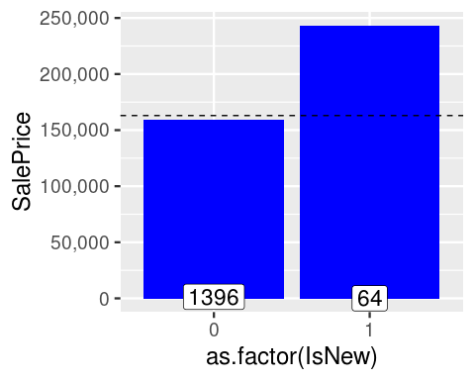

all$YrSold <- as.factor(all$YrSold) #the numeric version is now not needed anymore

## Binning Neighborhood

nb1 <- ggplot(all[!is.na(all$SalePrice),], aes(x=reorder(Neighborhood, SalePrice, FUN=median), y=SalePrice)) +  
 geom_bar(stat='summary', fun.y = "median", fill='blue') + labs(x='Neighborhood', y='Median SalePrice') +  
 theme(axis.text.x = element_text(angle = 45, hjust = 1)) +  
 scale_y_continuous(breaks= seq(0, 800000, by=50000), labels = comma) +  
 geom_label(stat = "count", aes(label = ..count.., y = ..count..), size=3) +  
 geom_hline(yintercept=163000, linetype="dashed", color = "red") #dashed line is median SalePrice  
nb2 <- ggplot(all[!is.na(all$SalePrice),], aes(x=reorder(Neighborhood, SalePrice, FUN=mean), y=SalePrice)) +  
 geom_bar(stat='summary', fun.y = "mean", fill='blue') + labs(x='Neighborhood', y="Mean SalePrice") +  
 theme(axis.text.x = element_text(angle = 45, hjust = 1)) +  
 scale_y_continuous(breaks= seq(0, 800000, by=50000), labels = comma) +  
 geom_label(stat = "count", aes(label = ..count.., y = ..count..), size=3) +  
 geom_hline(yintercept=163000, linetype="dashed", color = "red") #dashed line is median SalePrice  
grid.arrange(nb1, nb2)

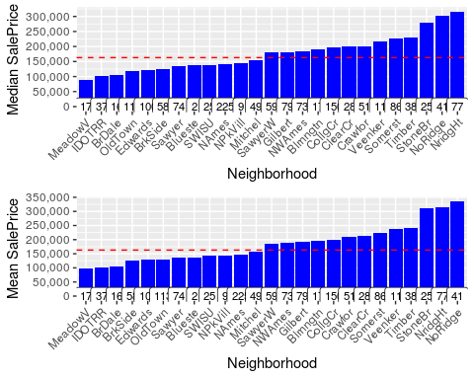

Both the median and mean Saleprices agree on 3 neighborhoods with substantially higher saleprices. The separation of the 3 relatively poor neighborhoods is less clear, but at least both graphs agree on the same 3 poor neighborhoods. Since I do not want to ‘overbin’, I am only creating categories for those ‘extremes’.

all$NeighRich[all$Neighborhood %in% c('StoneBr', 'NridgHt', 'NoRidge')] <- 2  
all$NeighRich[!all$Neighborhood %in% c('MeadowV', 'IDOTRR', 'BrDale', 'StoneBr', 'NridgHt', 'NoRidge')] <- 1  
all$NeighRich[all$Neighborhood %in% c('MeadowV', 'IDOTRR', 'BrDale')] <- 0

table(all$NeighRich)

##   
## 0 1 2   
## 160 2471 288

## Total Square Feet

As the total living space generally is very important when people buy houses, I am adding a predictors that adds up the living space above and below ground.

all$TotalSqFeet <- all$GrLivArea + all$TotalBsmtSF

ggplot(data=all[!is.na(all$SalePrice),], aes(x=TotalSqFeet, y=SalePrice))+  
 geom_point(col='blue') + geom_smooth(method = "lm", se=FALSE, color="black", aes(group=1)) +  
 scale_y_continuous(breaks= seq(0, 800000, by=100000), labels = comma) +  
 geom_text_repel(aes(label = ifelse(all$GrLivArea[!is.na(all$SalePrice)]>4500, rownames(all), '')))

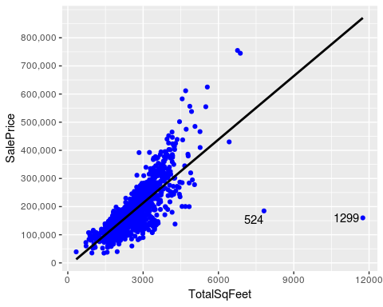

As expected, the correlation with SalePrice is very strong indeed (0.78).

cor(all$SalePrice, all$TotalSqFeet, use= "pairwise.complete.obs")

## [1] 0.7789588

The two potential outliers seem to ‘outlie’ even more than before. By taking out these two outliers, the correlation increases by 5%.

cor(all$SalePrice[-c(524, 1299)], all$TotalSqFeet[-c(524, 1299)], use= "pairwise.complete.obs")

## [1] 0.829042

## Consolidating Porch variables

Below, I listed the variables that seem related regarding porches.

* WoodDeckSF: Wood deck area in square feet
* OpenPorchSF: Open porch area in square feet
* EnclosedPorch: Enclosed porch area in square feet
* 3SsnPorch: Three season porch area in square feet
* ScreenPorch: Screen porch area in square feet

As far as I know, porches are sheltered areas outside of the house, and a wooden deck is unsheltered. Therefore, I am leaving WoodDeckSF alone, and are only consolidating the 4 porch variables.

all$TotalPorchSF <- all$OpenPorchSF + all$EnclosedPorch + all$X3SsnPorch + all$ScreenPorch

Although adding up these Porch areas makes sense (there should not be any overlap between areas), the correlation with SalePrice is not very strong.

cor(all$SalePrice, all$TotalPorchSF, use= "pairwise.complete.obs")

## [1] 0.1957389

ggplot(data=all[!is.na(all$SalePrice),], aes(x=TotalPorchSF, y=SalePrice))+  
 geom_point(col='blue') + geom_smooth(method = "lm", se=FALSE, color="black", aes(group=1)) +  
 scale_y_continuous(breaks= seq(0, 800000, by=100000), labels = comma)

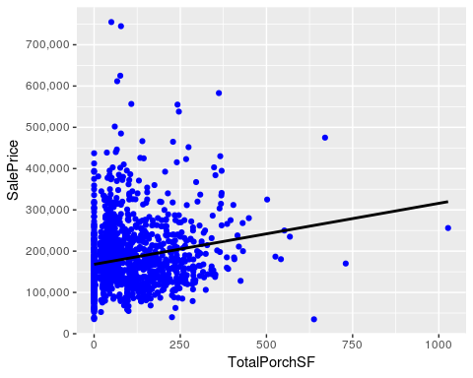

# Preparing data for modeling

## Dropping highly correlated variables

First of all, I am dropping a variable if two variables are highly correlated. To find these correlated pairs, I have used the correlations matrix again (see section 6.1). For instance: GarageCars and GarageArea have a correlation of 0.89. Of those two, I am dropping the variable with the lowest correlation with SalePrice (which is GarageArea with a SalePrice correlation of 0.62. GarageCars has a SalePrice correlation of 0.64).

dropVars <- c('YearRemodAdd', 'GarageYrBlt', 'GarageArea', 'GarageCond', 'TotalBsmtSF', 'TotalRmsAbvGrd', 'BsmtFinSF1')  
  
all <- all[,!(names(all) %in% dropVars)]

## Removing outliers

For the time being, I am keeping it simple and just remove the two really big houses with low SalePrice manually. However, I intend to investigate this more thorough in a later stage (possibly using the ‘outliers’ package).

all <- all[-c(524, 1299),]

## PreProcessing predictor variables

Before modeling I need to center and scale the ‘true numeric’ predictors (so not variables that have been label encoded), and create dummy variables for the categorical predictors. Below, I am splitting the dataframe into one with all (true) numeric variables, and another dataframe holding the (ordinal) factors.

numericVarNames <- numericVarNames[!(numericVarNames %in% c('MSSubClass', 'MoSold', 'YrSold', 'SalePrice', 'OverallQual', 'OverallCond'))] #numericVarNames was created before having done anything  
numericVarNames <- append(numericVarNames, c('Age', 'TotalPorchSF', 'TotBathrooms', 'TotalSqFeet'))  
  
DFnumeric <- all[, names(all) %in% numericVarNames]  
  
DFfactors <- all[, !(names(all) %in% numericVarNames)]  
DFfactors <- DFfactors[, names(DFfactors) != 'SalePrice']  
  
cat('There are', length(DFnumeric), 'numeric variables, and', length(DFfactors), 'factor variables')

## There are 30 numeric variables, and 49 factor variables

### Skewness and normalizing of the numeric predictors

**Skewness** Skewness is a measure of the symmetry in a distribution. A symmetrical dataset will have a skewness equal to 0. So, a normal distribution will have a skewness of 0. Skewness essentially measures the relative size of the two tails. As a rule of thumb, skewness should be between -1 and 1. In this range, data are considered fairly symmetrical. In order to fix the skewness, I am taking the log for all numeric predictors with an absolute skew greater than 0.8 (actually: log+1, to avoid division by zero issues).

for(i in 1:ncol(DFnumeric)){  
 if (abs(skew(DFnumeric[,i]))>0.8){  
 DFnumeric[,i] <- log(DFnumeric[,i] +1)  
 }  
}

**Normalizing the data**

PreNum <- preProcess(DFnumeric, method=c("center", "scale"))  
print(PreNum)

## Created from 2917 samples and 30 variables  
##   
## Pre-processing:  
## - centered (30)  
## - ignored (0)  
## - scaled (30)

DFnorm <- predict(PreNum, DFnumeric)  
dim(DFnorm)

## [1] 2917 30

### One hot encoding the categorical variables

The last step needed to ensure that all predictors are converted into numeric columns (which is required by most Machine Learning algorithms) is to ‘one-hot encode’ the categorical variables. This basically means that all (not ordinal) factor values are getting a seperate colums with 1s and 0s (1 basically means Yes/Present). To do this one-hot encoding, I am using the model.matrix() function.

DFdummies <- as.data.frame(model.matrix(~.-1, DFfactors))  
dim(DFdummies)

## [1] 2917 201

### Removing levels with few or no observations in train or test

In previous versions, I worked with Caret’s Near Zero Variance function. Although this works, it also is a quick fix and too much information got lost. For instance, by using the defaults, all Neighborhoods with less than 146 houses are omitted as (one-hot encoded) variables (frequency ratio higher than 95/5). Therefore, I have taken amore carefull manual approach in this version.

#check if some values are absent in the test set  
ZerocolTest <- which(colSums(DFdummies[(nrow(all[!is.na(all$SalePrice),])+1):nrow(all),])==0)  
colnames(DFdummies[ZerocolTest])

## [1] "Condition2RRAe" "Condition2RRAn" "Condition2RRNn"   
## [4] "HouseStyle2.5Fin" "RoofMatlMembran" "RoofMatlMetal"   
## [7] "RoofMatlRoll" "Exterior1stImStucc" "Exterior1stStone"   
## [10] "Exterior2ndOther" "HeatingOthW" "ElectricalMix"   
## [13] "MiscFeatureTenC"

DFdummies <- DFdummies[,-ZerocolTest] #removing predictors

#check if some values are absent in the train set  
ZerocolTrain <- which(colSums(DFdummies[1:nrow(all[!is.na(all$SalePrice),]),])==0)  
colnames(DFdummies[ZerocolTrain])

## [1] "MSSubClass1,5 story PUD all"

DFdummies <- DFdummies[,-ZerocolTrain] #removing predictor

Also taking out variables with less than 10 ‘ones’ in the train set.

fewOnes <- which(colSums(DFdummies[1:nrow(all[!is.na(all$SalePrice),]),])<10)  
colnames(DFdummies[fewOnes])

## [1] "MSSubClass1 story unf attic" "LotConfigFR3"   
## [3] "NeighborhoodBlueste" "NeighborhoodNPkVill"   
## [5] "Condition1PosA" "Condition1RRNe"   
## [7] "Condition1RRNn" "Condition2Feedr"   
## [9] "Condition2PosA" "Condition2PosN"   
## [11] "RoofStyleMansard" "RoofStyleShed"   
## [13] "RoofMatlWdShake" "RoofMatlWdShngl"   
## [15] "Exterior1stAsphShn" "Exterior1stBrkComm"   
## [17] "Exterior1stCBlock" "Exterior2ndAsphShn"   
## [19] "Exterior2ndBrk Cmn" "Exterior2ndCBlock"   
## [21] "Exterior2ndStone" "FoundationStone"   
## [23] "FoundationWood" "HeatingGrav"   
## [25] "HeatingWall" "ElectricalFuseP"   
## [27] "GarageTypeCarPort" "MiscFeatureOthr"   
## [29] "SaleTypeCon" "SaleTypeConLD"   
## [31] "SaleTypeConLI" "SaleTypeConLw"   
## [33] "SaleTypeCWD" "SaleTypeOth"   
## [35] "SaleConditionAdjLand"

DFdummies <- DFdummies[,-fewOnes] #removing predictors  
dim(DFdummies)

## [1] 2917 152

Altogether, I have removed 49 one-hot encoded predictors with little or no variance. Altough this may seem a significant number, it is actually much less than the number of predictors that were taken out by using caret’snear zero variance function (using its default thresholds).

combined <- cbind(DFnorm, DFdummies) #combining all (now numeric) predictors into one dataframe

## Dealing with skewness of response variable

skew(all$SalePrice)

## [1] 1.877427

qqnorm(all$SalePrice)  
qqline(all$SalePrice)

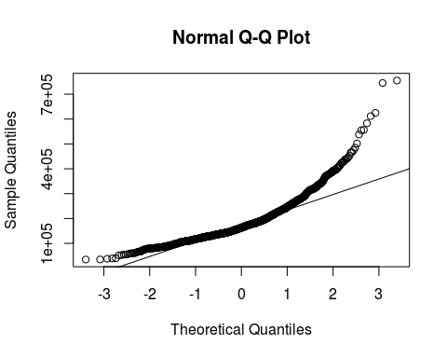

The skew of 1.87 indicates a right skew that is too high, and the Q-Q plot shows that sale prices are also not normally distributed. To fix this I am taking the log of SalePrice.

all$SalePrice <- log(all$SalePrice) #default is the natural logarithm, "+1" is not necessary as there are no 0's  
skew(all$SalePrice)

## [1] 0.1213182

As you can see,the skew is now quite low and the Q-Q plot is also looking much better.

qqnorm(all$SalePrice)  
qqline(all$SalePrice)

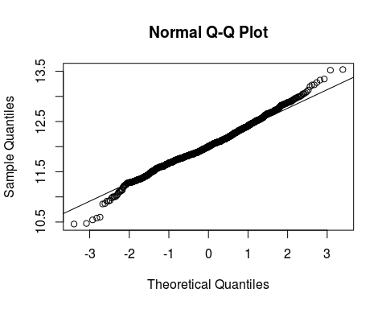

## Composing train and test sets

train1 <- combined[!is.na(all$SalePrice),]  
test1 <- combined[is.na(all$SalePrice),]

# Modeling

## Lasso regression model

I have also tried Ridge and Elastic Net models, but since lasso gives the best results of those 3 models I am only keeping the lasso model in the document.

The elastic-net penalty is controlled by alpha, and bridges the gap between lasso (alpha=1) and ridge (alpha=0). The tuning parameter lambda controls the overall strength of the penalty. It is known that the ridge penalty shrinks the coefficients of correlated predictors towards each other while the lasso tends to pick one of them and discard the others.

Below, I am using caret cross validation to find the best value for lambda, which is the only hyperparameter that needs to be tuned for the lasso model.

set.seed(27042018)  
my_control <-trainControl(method="cv", number=5)  
lassoGrid <- expand.grid(alpha = 1, lambda = seq(0.001,0.1,by = 0.0005))  
  
lasso_mod <- train(x=train1, y=all$SalePrice[!is.na(all$SalePrice)], method='glmnet', trControl= my_control, tuneGrid=lassoGrid)   
lasso_mod$bestTune

## alpha lambda  
## 4 1 0.0025

min(lasso_mod$results$RMSE)

## [1] 0.1136187

The documentation of the caret `varImp’ function says: for glmboost and glmnet the absolute value of the coefficients corresponding to the tuned model are used.

Although this means that a real ranking of the most important variables is not stored, it gives me the opportunity to find out how many of the variables are not used in the model (and hence have coefficient 0).

lassoVarImp <- varImp(lasso_mod,scale=F)  
lassoImportance <- lassoVarImp$importance  
  
varsSelected <- length(which(lassoImportance$Overall!=0))  
varsNotSelected <- length(which(lassoImportance$Overall==0))  
  
cat('Lasso uses', varsSelected, 'variables in its model, and did not select', varsNotSelected, 'variables.')

## Lasso uses 100 variables in its model, and did not select 82 variables.

So lasso did what it is supposed to do: it seems to have dealt with multicolinearity well by not using about 45% of the available variables in the model.

LassoPred <- predict(lasso_mod, test1)  
predictions_lasso <- exp(LassoPred) #need to reverse the log to the real values  
head(predictions_lasso)

## 1461 1462 1463 1464 1465 1466   
## 114351.8 162204.8 179455.3 197564.7 205952.8 169839.8

## XGBoost model

Initially, I just worked with the XGBoost package directly. The main reason for this was that the package uses its own efficient datastructure (xgb.DMatrix). The package also provides a cross validation function. However, this CV function only determines the optimal number of rounds, and does not support a full grid search of hyperparameters.

Although caret does not seem to use the (fast) datastructure of the xgb package, I eventually decided to do hyperparameter tuning with it anyway, as it at least supports a full grid search. As far as I understand it, the main parameters to tune to avoid overfitting are max_depth, and min_child_weight (see [XGBoost documentation](http://xgboost.readthedocs.io/en/latest/how_to/param_tuning.html)). Below I am setting up a grid that tunes both these parameters, and also the eta (learning rate).

xgb_grid = expand.grid(  
nrounds = 1000,  
eta = c(0.1, 0.05, 0.01),  
max_depth = c(2, 3, 4, 5, 6),  
gamma = 0,  
colsample_bytree=1,  
min_child_weight=c(1, 2, 3, 4 ,5),  
subsample=1  
)

The next step is to let caret find the best hyperparameter values (using 5 fold cross validation).

#xgb_caret <- train(x=train1, y=all$SalePrice[!is.na(all$SalePrice)], method='xgbTree', trControl= my_control, tuneGrid=xgb_grid)   
#xgb_caret$bestTune

As expected, this took quite a bit of time (locally). As I want to limit the running time on Kaggle, I disabled the code, and am just continuing with the results. According to caret, the ‘bestTune’ parameters are:

* Max_depth=3
* eta=0.05
* Min_child_weight=4

In the remainder of this section, I will continue to work with the xgboost package directly. Below, I am starting with the preparation of the data in the recommended format.

label_train <- all$SalePrice[!is.na(all$SalePrice)]  
  
# put our testing & training data into two seperates Dmatrixs objects  
dtrain <- xgb.DMatrix(data = as.matrix(train1), label= label_train)  
dtest <- xgb.DMatrix(data = as.matrix(test1))

In addition, I am taking over the best tuned values from the caret cross validation.

default_param<-list(  
 objective = "reg:linear",  
 booster = "gbtree",  
 eta=0.05, #default = 0.3  
 gamma=0,  
 max_depth=3, #default=6  
 min_child_weight=4, #default=1  
 subsample=1,  
 colsample_bytree=1  
)

The next step is to do cross validation to determine the best number of rounds (for the given set of parameters).

xgbcv <- xgb.cv( params = default_param, data = dtrain, nrounds = 500, nfold = 5, showsd = T, stratified = T, print_every_n = 40, early_stopping_rounds = 10, maximize = F)

## [1] train-rmse:10.955588+0.004477 test-rmse:10.955537+0.019106   
## Multiple eval metrics are present. Will use test_rmse for early stopping.  
## Will train until test_rmse hasn't improved in 10 rounds.  
##   
## [41] train-rmse:1.428274+0.000561 test-rmse:1.428515+0.011791   
## [81] train-rmse:0.219833+0.000801 test-rmse:0.230612+0.009490   
## [121] train-rmse:0.102497+0.001285 test-rmse:0.128856+0.008654   
## [161] train-rmse:0.090461+0.001218 test-rmse:0.122128+0.007505   
## [201] train-rmse:0.084142+0.001214 test-rmse:0.119557+0.007344   
## [241] train-rmse:0.079398+0.001195 test-rmse:0.118374+0.007088   
## [281] train-rmse:0.075716+0.001302 test-rmse:0.117645+0.006772   
## [321] train-rmse:0.072567+0.001139 test-rmse:0.117136+0.006720   
## [361] train-rmse:0.069770+0.001156 test-rmse:0.116745+0.006603   
## [401] train-rmse:0.067201+0.001059 test-rmse:0.116505+0.006574   
## [441] train-rmse:0.064814+0.001145 test-rmse:0.116386+0.006366   
## Stopping. Best iteration:  
## [454] train-rmse:0.063958+0.001067 test-rmse:0.116289+0.006326

Although it was a bit of work, the hyperparameter tuning definitly paid of, as the cross validated RMSE inproved considerably (from 0.1225 without the caret tuning, to 0.1162 in this version)!

#train the model using the best iteration found by cross validation  
xgb_mod <- xgb.train(data = dtrain, params=default_param, nrounds = 454)

XGBpred <- predict(xgb_mod, dtest)  
predictions_XGB <- exp(XGBpred) #need to reverse the log to the real values  
head(predictions_XGB)

## [1] 116386.8 162307.3 186494.0 187440.4 187258.3 166241.4

#view variable importance plot  
library(Ckmeans.1d.dp) #required for ggplot clustering  
mat <- xgb.importance (feature_names = colnames(train1),model = xgb_mod)  
xgb.ggplot.importance(importance_matrix = mat[1:20], rel_to_first = TRUE)

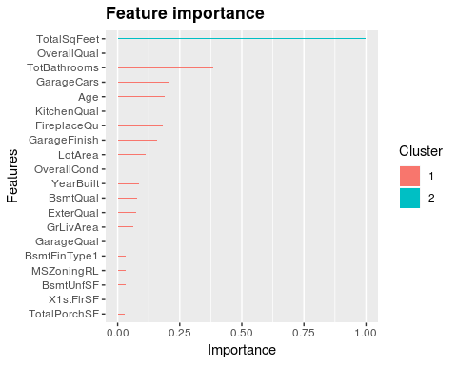

## Averaging predictions

Since the lasso and XGBoost algorithms are very different, averaging predictions likely improves the scores. As the lasso model does better regarding the cross validated RMSE score (0.1121 versus 0.1162), I am weigting the lasso model double.

sub_avg <- data.frame(Id = test_labels, SalePrice = (predictions_XGB+2*predictions_lasso)/3)  
head(sub_avg)

## Id SalePrice  
## 1461 1461 115030.1  
## 1462 1462 162238.9  
## 1463 1463 181801.5  
## 1464 1464 194189.9  
## 1465 1465 199721.3  
## 1466 1466 168640.3

write.csv(sub_avg, file = 'average.csv', row.names = F)