**Q.1 Coding: Calculating the Value of *π***

Calculate the value of π from the infinite series

Print a table that shows the value of π approximated by computing the first 200,000 terms of this series. How many terms do you have to use before you first get a value that begins with 3.14159?

**Q.2 Palindromes**

**Q.3**

Test your function with **power(3, 7)**.

**Q.4**

**Q.5**

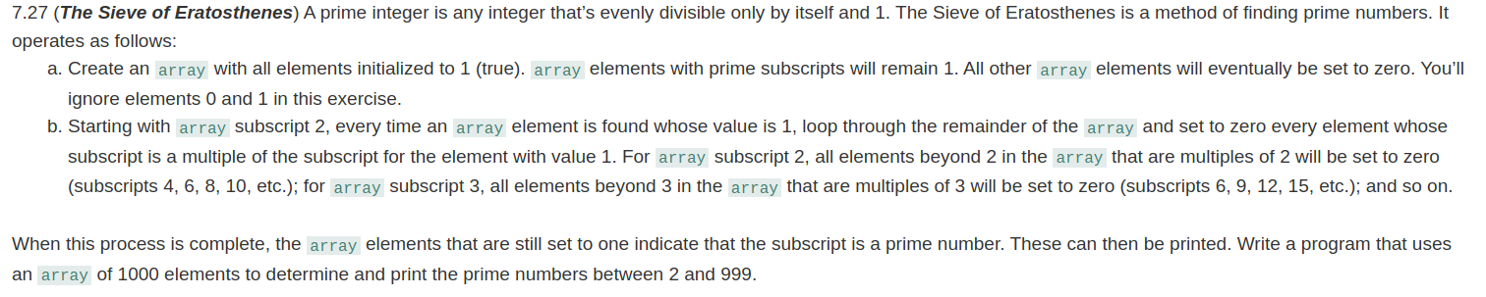

**Q.6**



**Q.7**

