2024

Qiu Jian Min (230177686)

Ma Zi Chao (230144317)

FONG Ka Lam (230226870)

IT114116

2024/11/29



Review from Property Transaction in UK

Table of Content

Introduction 2

Setting and Utilization of Github 3

Roles 3

Product Backlog items 3

Sprint Backlog items 4

Answering the client's concerns 5

Extra suggestion and Conclusion 9

Reference (if any) 9

# Introduction

Immigration to British has the raising concerns in recent years. The first consideration regards immigration is the recommendation. There is a growing market for property transactions. A client employed us to have a feasibility study on the circumstance of renting transactions in the UK, and your report is required to answer the following questions

1. Generate (Last 20 rows) processed renting post records. (2M)
2. What kind of property is having the most number of the reception on average? (5M)
3. What is the contribution of house type in the record? What is the most common type of property in the UK? (5M)
4. What is the value distribution of the number of bathroom between the flat house and terraced house? (5M)
5. What kind of property is contain the second most turnover? (7M)
6. Is there any relationship between the number of bedrooms, the number of bathrooms and the average price of a different property? (5M)

# Setting and Utilization of Github

Provide the link of your Github project and some screen capture, including treeviews and document changing capture.

# Roles

Member list

|  |  |  |
| --- | --- | --- |
| Name | Role | Responsibilities |
| FONG Ka Lam | Technology | Writing R code to clean dataset |
| Qiu Jian Min | Writ | Write a report to do data visualization |
| Ma Zi Chao | Technology | Writing SAS code to answer the question |

# Product Backlog items

|  |  |  |  |  |
| --- | --- | --- | --- | --- |
| **Sprint** | **Task** | **Category** | **priority** | **status** |
| 1 | Uploading data to SAS | DATA | LOW | Finish |
| 1 | Data Cleansing | DATA | HIGH | Finish |
| 2 | Relationship between price and bed room numbes | Modelling | Middle | Comitted |

# Sprint Backlog items

Use the template provided and make a screen capture for all sprint backlog item record

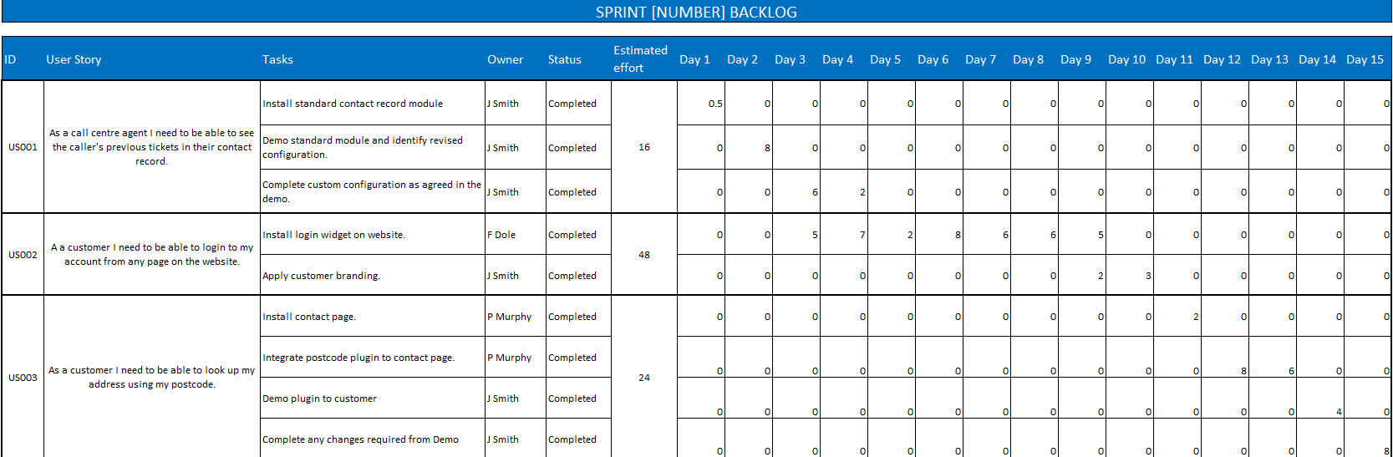

# Answering the client's concerns

**Generate (Last 20 rows) processed renting post records.**

**What kind of property is having the most number of the reception on average?**

**link-detached houses have the highest average number of guests**

**What is the contribution of house type in the record? What is the most common type of property in the UK?**

|  |  |
| --- | --- |
|  |  |

**The contribution of different house types in the records is essential for helping the audience understand average prices, sales trends, and market demand. When combined with other data, this information can be effectively visualized to provide clearer insights.**

**As can be seen from the data table on the left, link-detached house have the highest average occupancy. The bar graph is an aid in presenting this result.**

**What is the value distribution of the number of bathroom between the flat house and terraced house?**

**The average number of bathrooms in flat houses and terraced houses is calculated based on the figure above. The average number of bathrooms in a terraced house is 1.4, indicating that many terraced houses typically have two or more bathrooms. Compared with the average number of bathrooms in flat houses, which is 1.2, it is more.**

**What kind of property is contain the second most turnover?**

**According to the picture above, we can see that terraced house has the second largest trading volume. The transaction volume was 1,116.**

**Is there any relationship between the number of bedrooms, the number of bathrooms and the average price of a different property?**

**As can be seen from the above figure, when the number of beds and bathrooms is greater, the corresponding housing price will be more expensive, such as the property type of housing. But the flat house type is completely opposite. The more beds and bathrooms, the cheaper it is because this type of house is a space for multiple people to live together.**

# Extra suggestion and Conclusion

My suggestion is to make more use of flexible space design to increase the number of beds or bathrooms in future real estate development. You can adopt some strategies to achieve this, such as designing multi-functional rooms, such as combining the living room with the work area, or combining the bedroom with the Combine study areas to reduce unnecessary waste of space. Or use foldable or moveable furniture to allow residents to adjust the layout of the space as needed. The basic design can even be planned when the foundation is being laid.

# Reference (if any)

Zoopla.com