目录

语法规则 1

消除左递归 3

新的语法规则 4

抽象语法树 6

# 语法规则

Goal-> MainClass { ClassDeclaration } EOF

MainClass->**"class"** Identifier **"{"** **"public"** **"static"** **"void"** **"main"** **"("** **"String"** **"["** **"]"** Identifier **")"** **"{"** { VarDeclaration } Statement **"}"** **"}"**

ClassDeclaration->**"class"** Identifier [ **"extends"** Identifier ] **"{"** { VarDeclaration } { MethodDeclaration } **"}"**

VarDeclaration ->Type Identifier **";"**

MethodDeclaration->**"public"** Type Identifier **"("** [ Type Identifier { **","** Type Identifier } ] **")"** **"{"** { VarDeclaration } { Statement } **"return"** Expression **";"** **"}"**

Type->**"int"** **"["** **"]"**

|**"boolean"**

|**"int"**

| Identifier

Statement->**"{"** { Statement } **"}"**

|**"if"** **"("** Expression **")"** Statement **"else"** Statement

|**"while"** **"("** Expression **")"** Statement

|**"System.out.println"** **"("** Expression **")"** **";"**

| Identifier **"="** Expression **";"**

| Identifier **"["** Expression **"]"** **"="** Expression **";"**

Expression-> Expression ( " &&" | "<" | "+" | "-" | "*" ) Expression

| Expression **"["** Expression **"]"**

| Expression **"."** **"length"**

| Expression **"."** Identifier **"("** [ Expression { **","** Expression } ] **")"**

| IntegerLiteral

|**"true"**

|**"false"**

| Identifier

|**"this"**

|**"new"** **"int"** **"["** Expression **"]"**

|**"new"** Identifier "(" ")"

| **"!"** Expression

|**"("** Expression **")"**

# 消除左递归

由上式可知，只有最后一个表达式有左递归

Expression-> IntegerLiteral L

|**"true"** L

|**"false"** L

| Identifier L

|**"this"** L

|**"new"** **"int"** **"["** Expression **"]"** L

|**"new"** Identifier "(" ")" L

| **"!"** Expression L

|**"("** Expression **")"** L

L-> ( " &&" | "<" | "+" | "-" | "*" ) Expression L

| **"["** Expression **"]"** L

| **"."** **"length"** L

| **"."** Identifier **"("** [ Expression { **","** Expression } ] **")"** L

| ε

# 新的语法规则

Goal-> MainClass { ClassDeclaration } EOF

MainClass->**"class"** Identifier **"{"** **"public"** **"static"** **"void"** **"main"** **"("** **"String"** **"["** **"]"** Identifier **")"** **"{"** { VarDeclaration }Statement **"}"** **"}"**

ClassDeclaration->**"class"** Identifier [ **"extends"** Identifier ] **"{"** { VarDeclaration } { MethodDeclaration } **"}"**

VarDeclaration ->Type Identifier **";"**

MethodDeclaration->**"public"** Type Identifier **"("** [ Type Identifier { **","** Type Identifier } ] **")"** **"{"** { VarDeclaration } { Statement } **"return"** Expression **";"** **"}"**

Type->**"int"** **"["** **"]"**

|**"boolean"**

|**"int"**

| Identifier

Statement->**"{"** { Statement } **"}"**

|**"if"** **"("** Expression **")"** Statement **"else"** Statement

|**"while"** **"("** Expression **")"** Statement

|**"System.out.println"** **"("** Expression **")"** **";"**

| Identifier **"="** Expression **";"**

| Identifier **"["** Expression **"]"** **"="** Expression **";"**

Expression->IntegerLiteral L

|**"true"** L

|**"false"** L

| Identifier L

|**"this"** L

|**"new"** **"int"** **"["** Expression **"]"** L

|**"new"** Identifier "(" ")" L

| **"!"** Expression L

|**"("** Expression **")"** L

L-> ( " &&" | "<" | "+" | "-" | "*" ) Expression L

| **"["** Expression **"]"** L

| **"."** **"length"** L

| **"."** Identifier **"("** [ Expression { **","** Expression } ] **")"** L

| ε

# 抽象语法树

Goal-> MainClass { ClassDeclaration } EOF

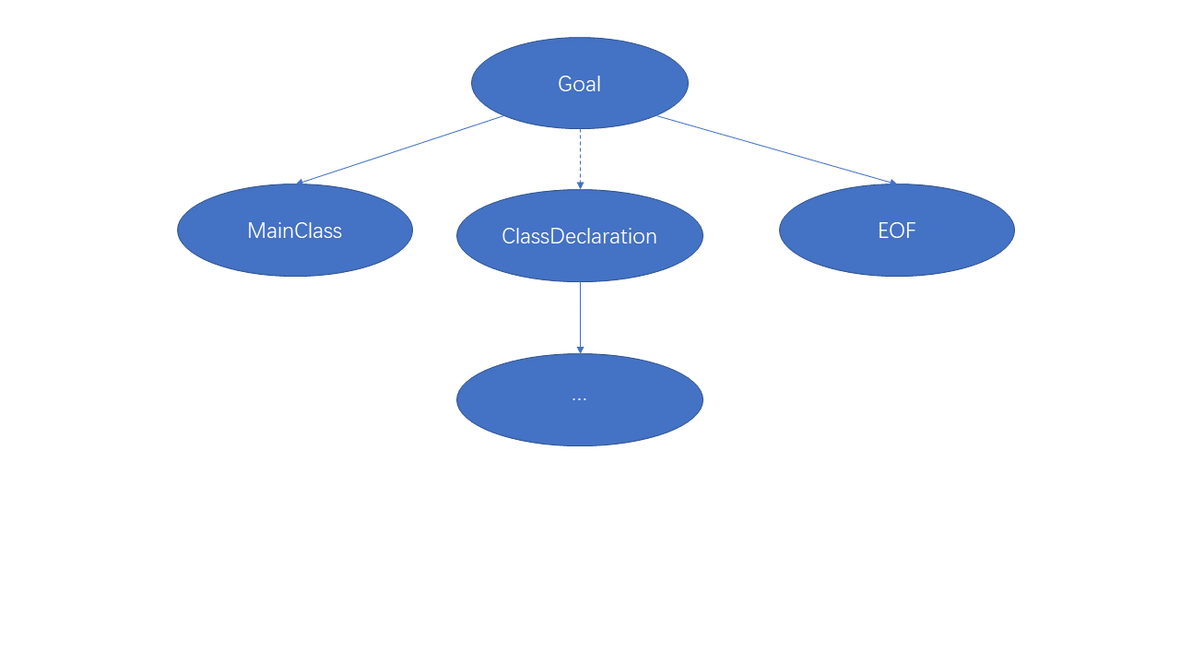

MainClass->**"class"** Identifier **"{"** **"public"** **"static"** **"void"** **"main"** **"("** **"String"** **"["** **"]"** Identifier **")"** **"{"** { VarDeclaration }Statement **"}"** **"}"**

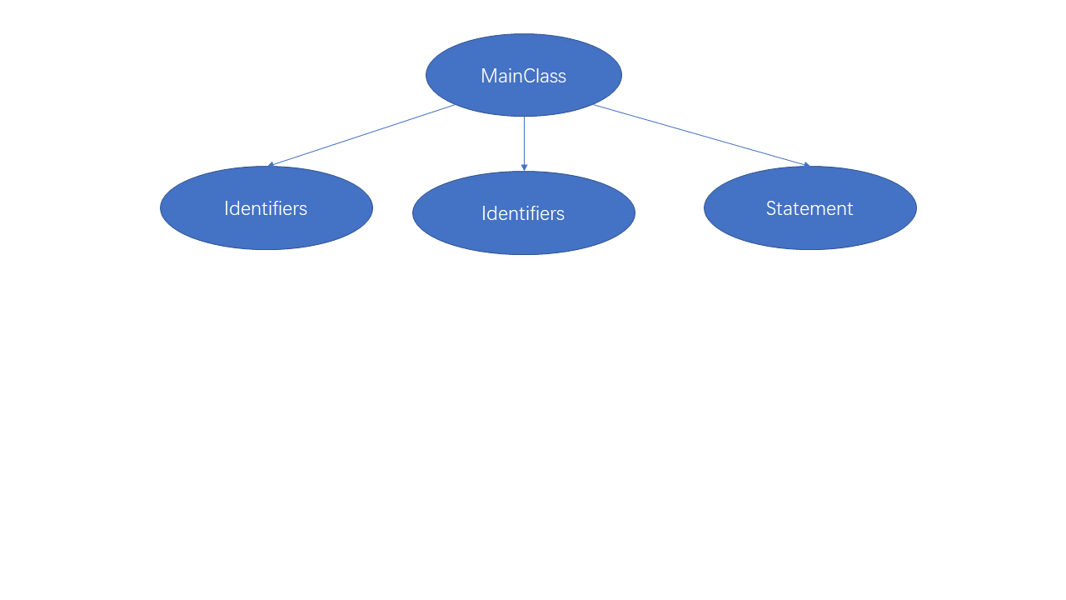

ClassDeclaration->**"class"** Identifier [ **"extends"** Identifier ] **"{"** { VarDeclaration } { MethodDeclaration } **"}"**

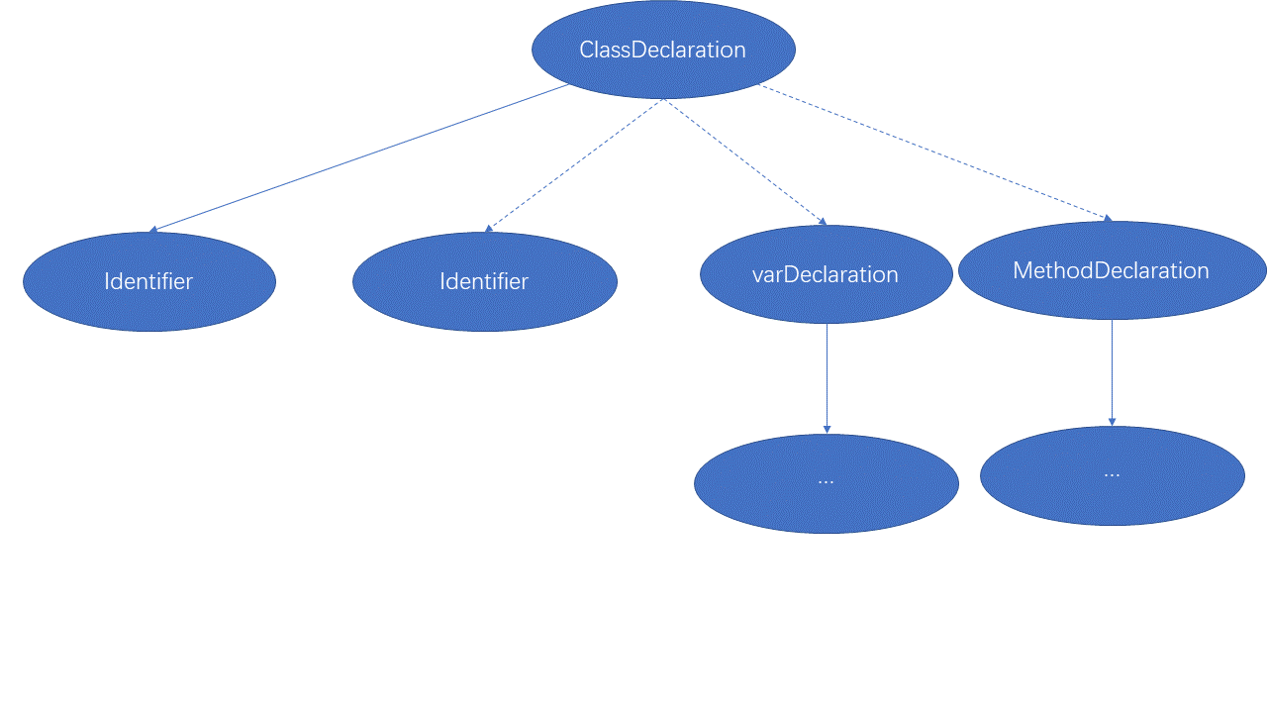

VarDeclaration ->Type Identifier **";"**

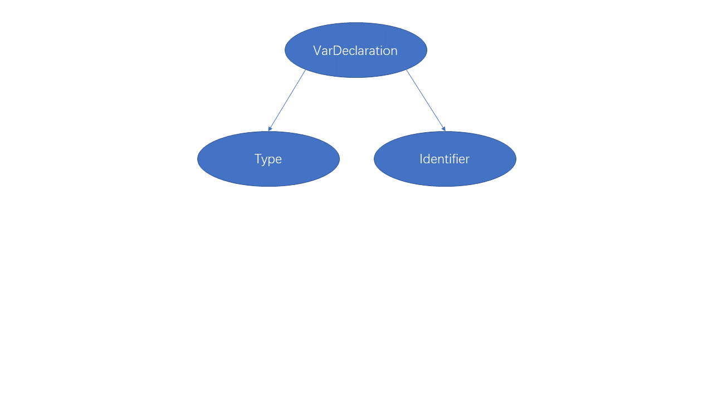

MethodDeclaration->**"public"** Type Identifier **"("** [ Type Identifier { **","** Type Identifier } ] **")"** **"{"** { VarDeclaration } { Statement } **"return"** Expression **";"** **"}"**

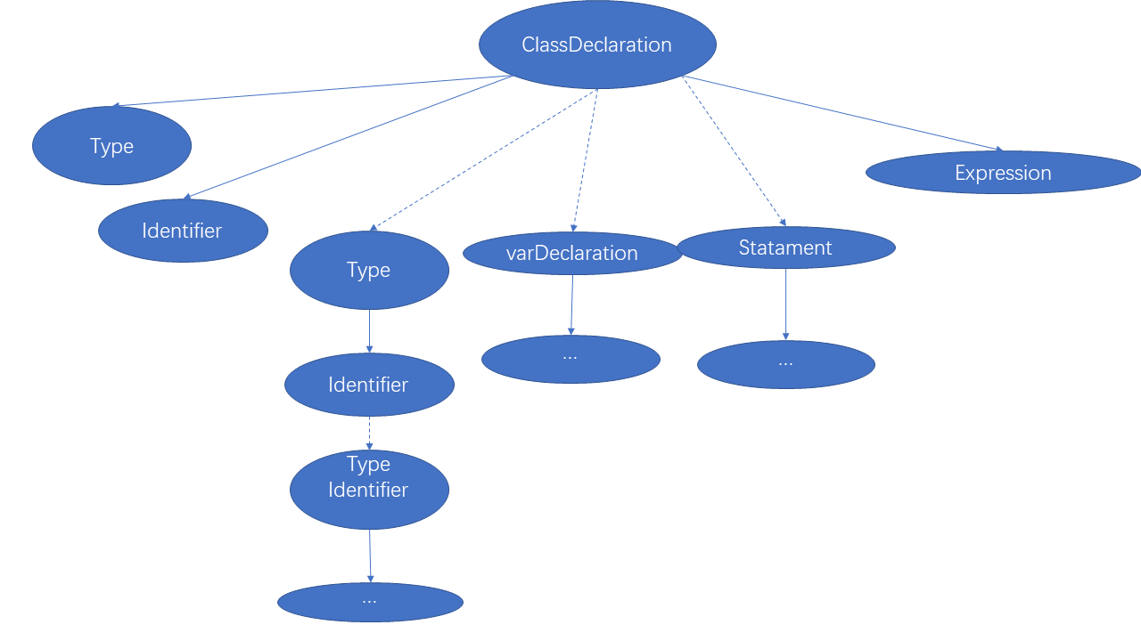

Type->**"int"** **"["** **"]"**

|**"boolean"**

|**"int"**

| Identifier

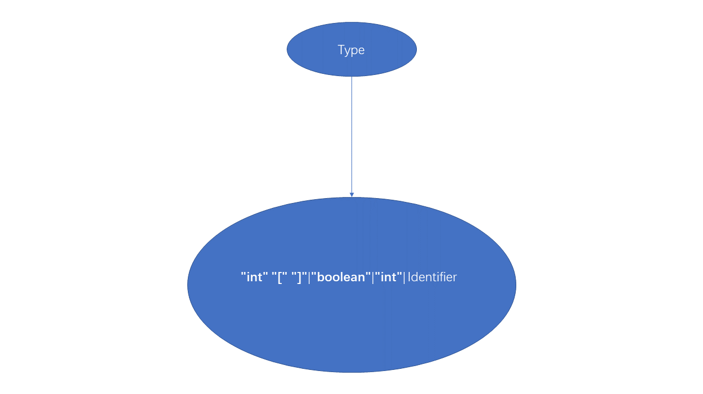

Statements->**"{"** { Statement } **"}"**

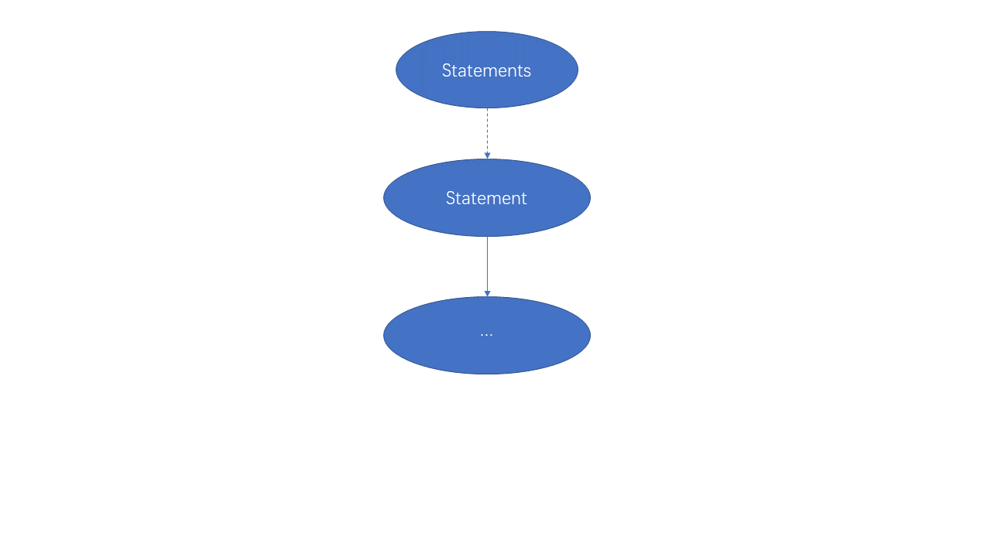

IfStatement ->**"if"** **"("** Expression **")"** Statement **"else"** Statement

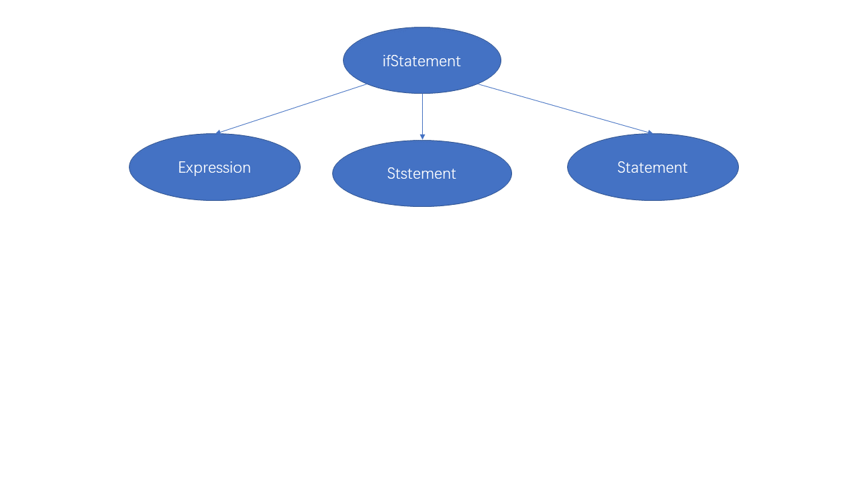

WhileStatement ->**"while"** **"("** Expression **")"** Statement

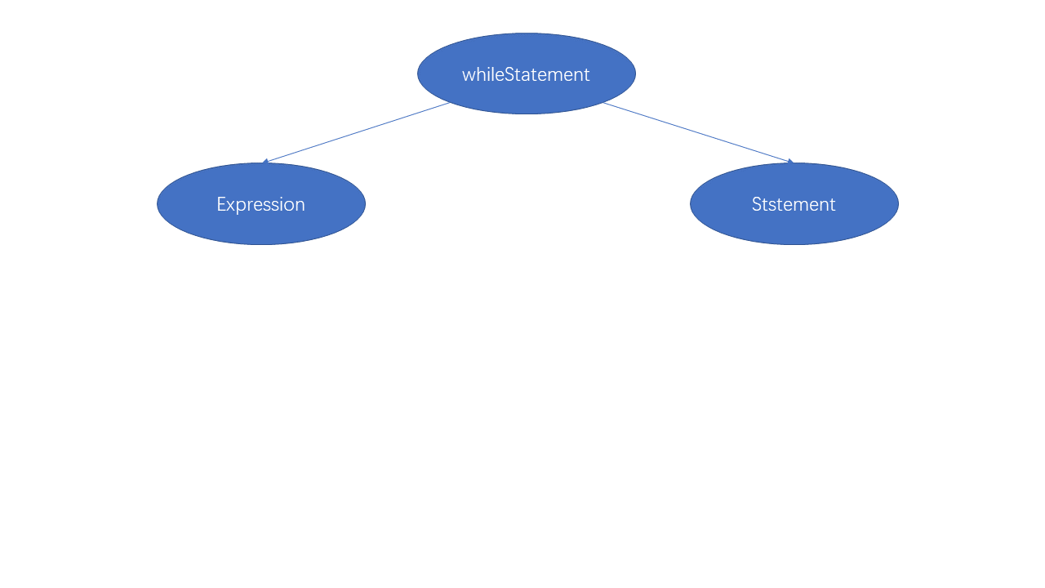

PrintStatement ->**"System.out.println"** **"("** Expression **")"** **";"**

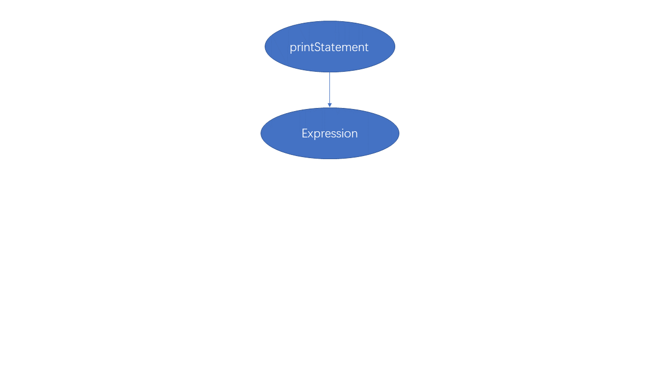

AssignStatement -> Identifier **"="** Expression **";"**

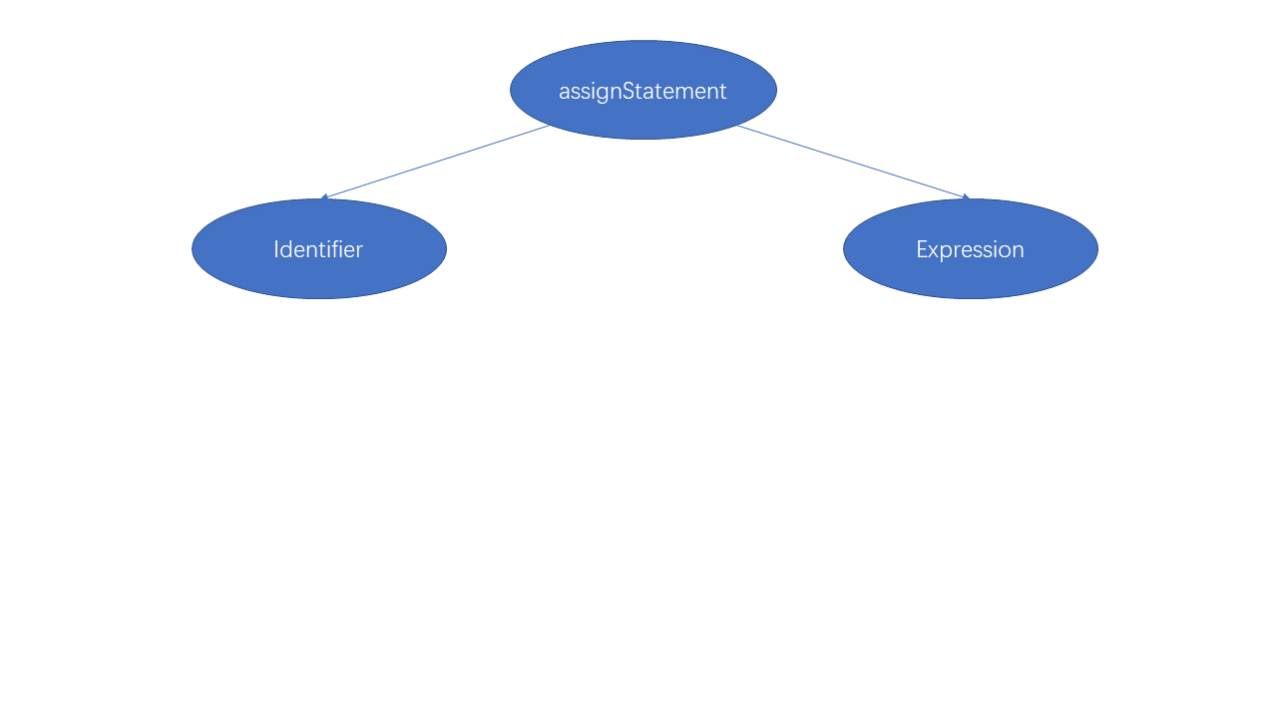

ArrayStatement -> Identifier **"["** Expression **"]"** **"="** Expression **";"**

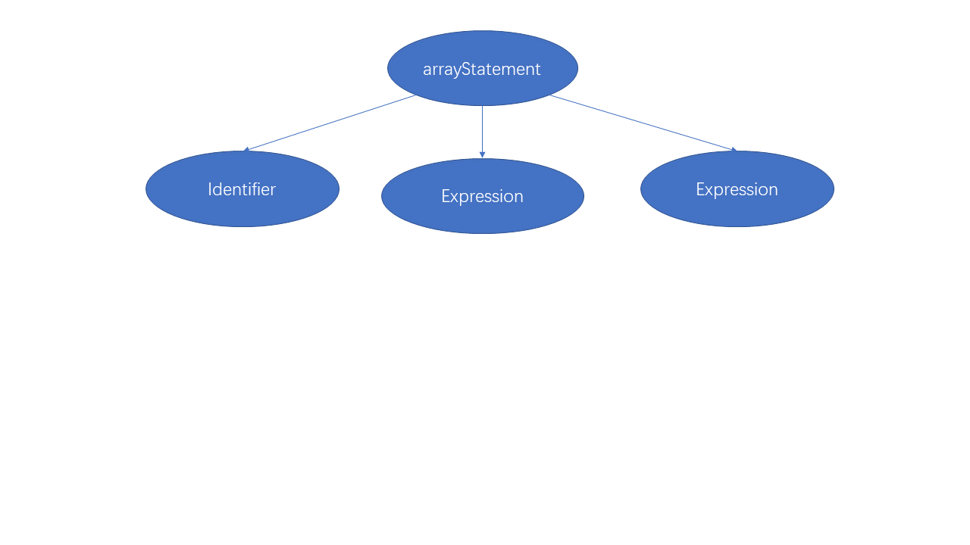

Statement-> Statements

| IfStatement

| WhileStatement

| PrintStatement

| AssignStatement

| ArrayStatement

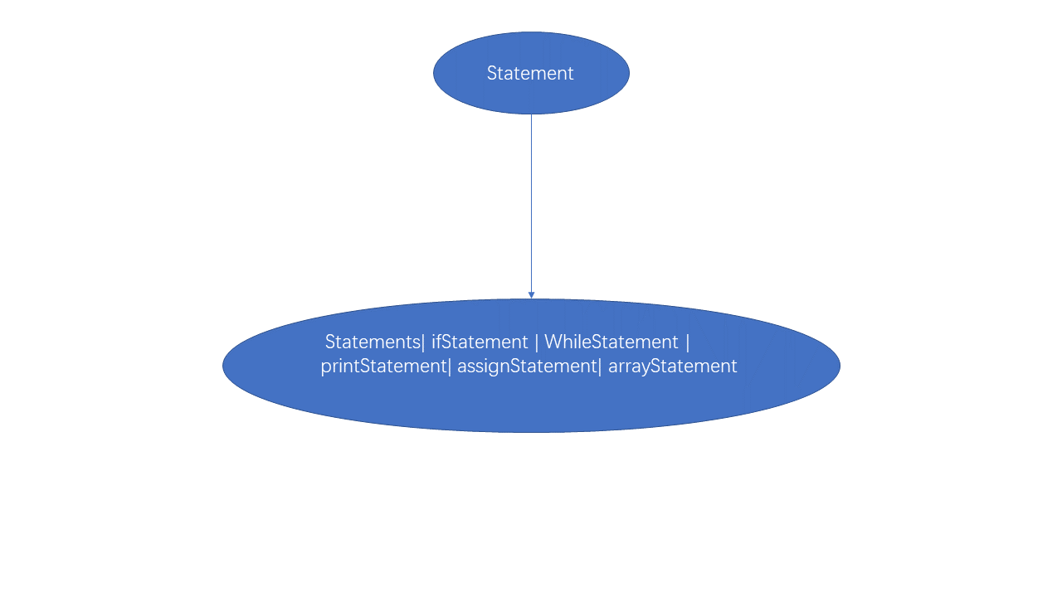

IntExpression-> IntegerLiteral L

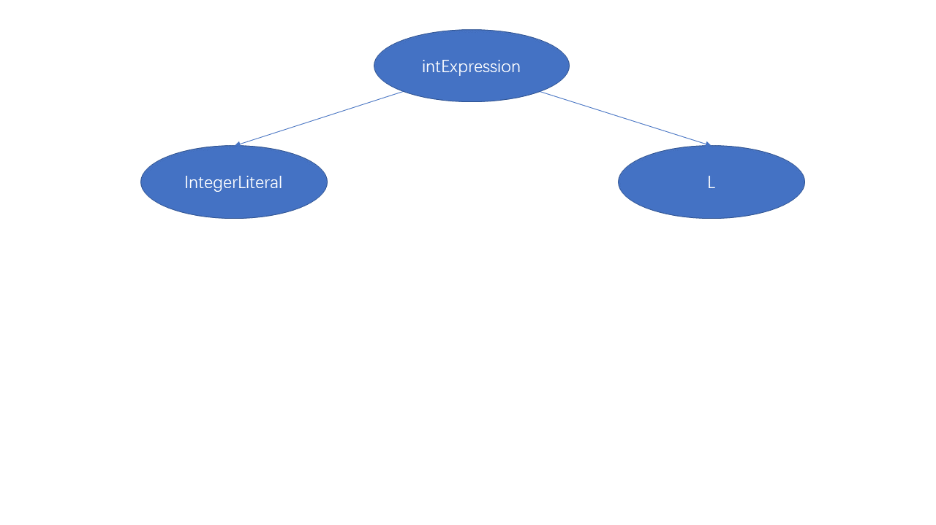

TrueExpression->**"true"** L

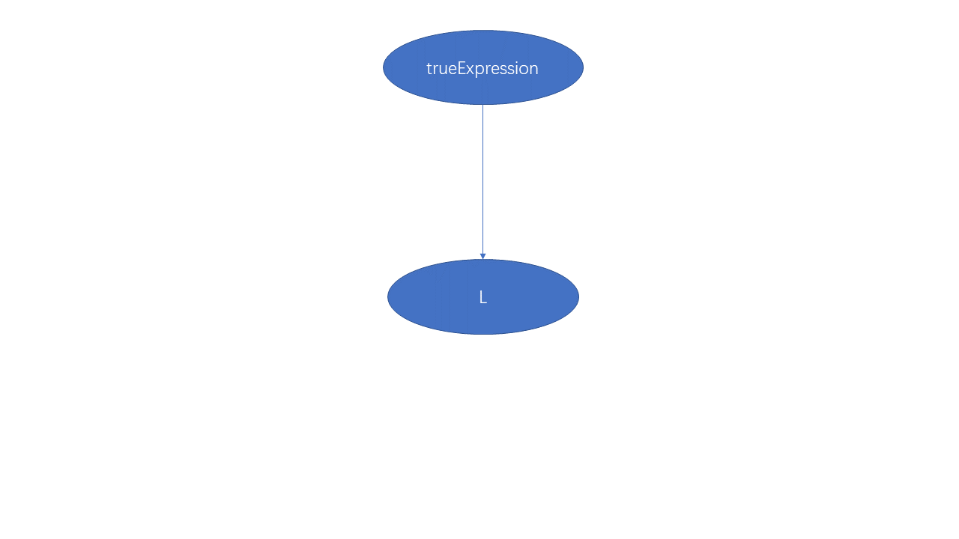

FalseExpression->**"false"** L

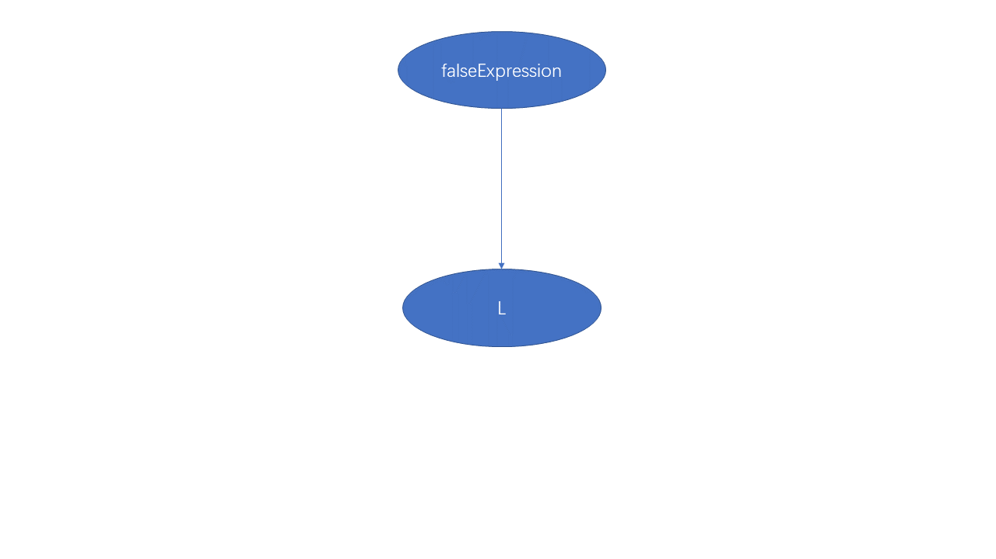

IdentifierExpression-> Identifier L

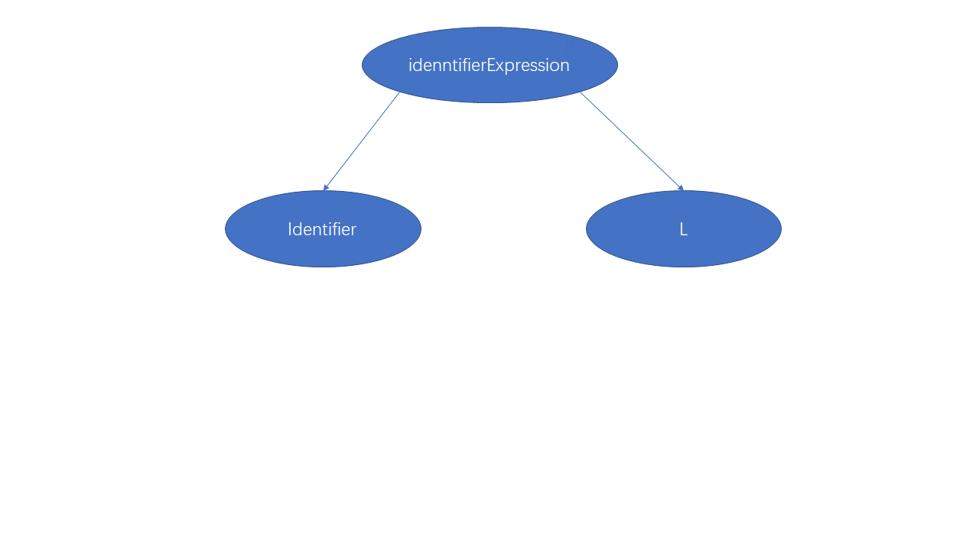

ThisExpression->**"this"** L

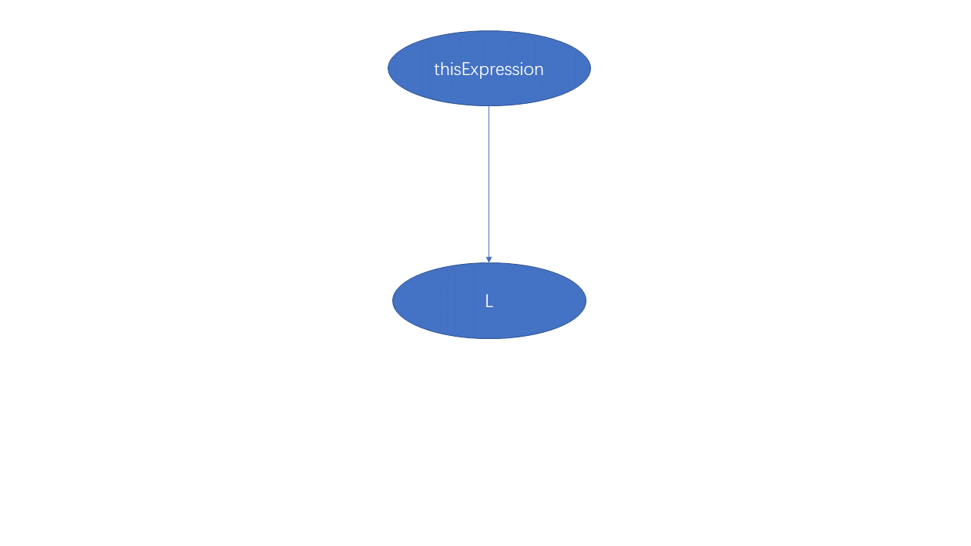

NewArrayExpression->**"new"** **"int"** **"["** Expression **"]"** L

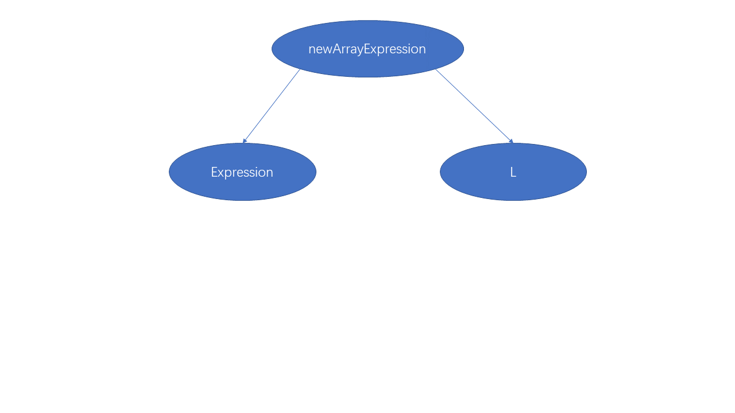

NewExpression->**"new"** Identifier "(" ")" L

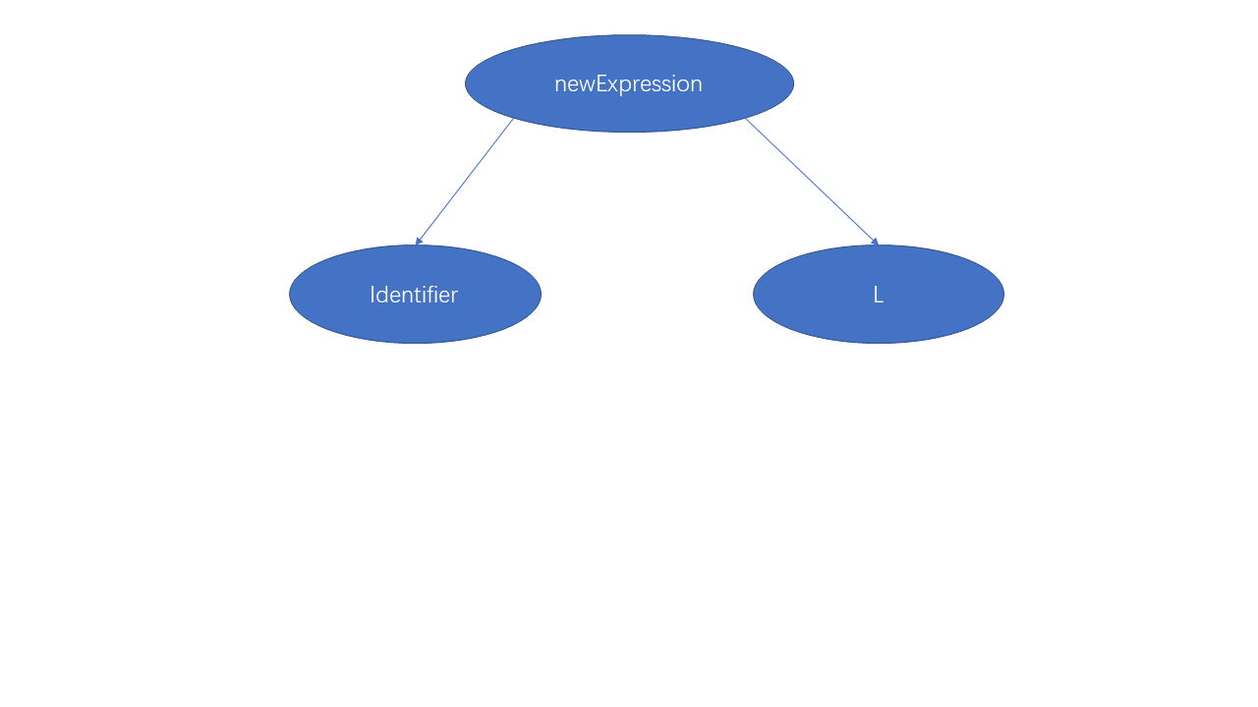

NoExpression-> **"!"** Expression L

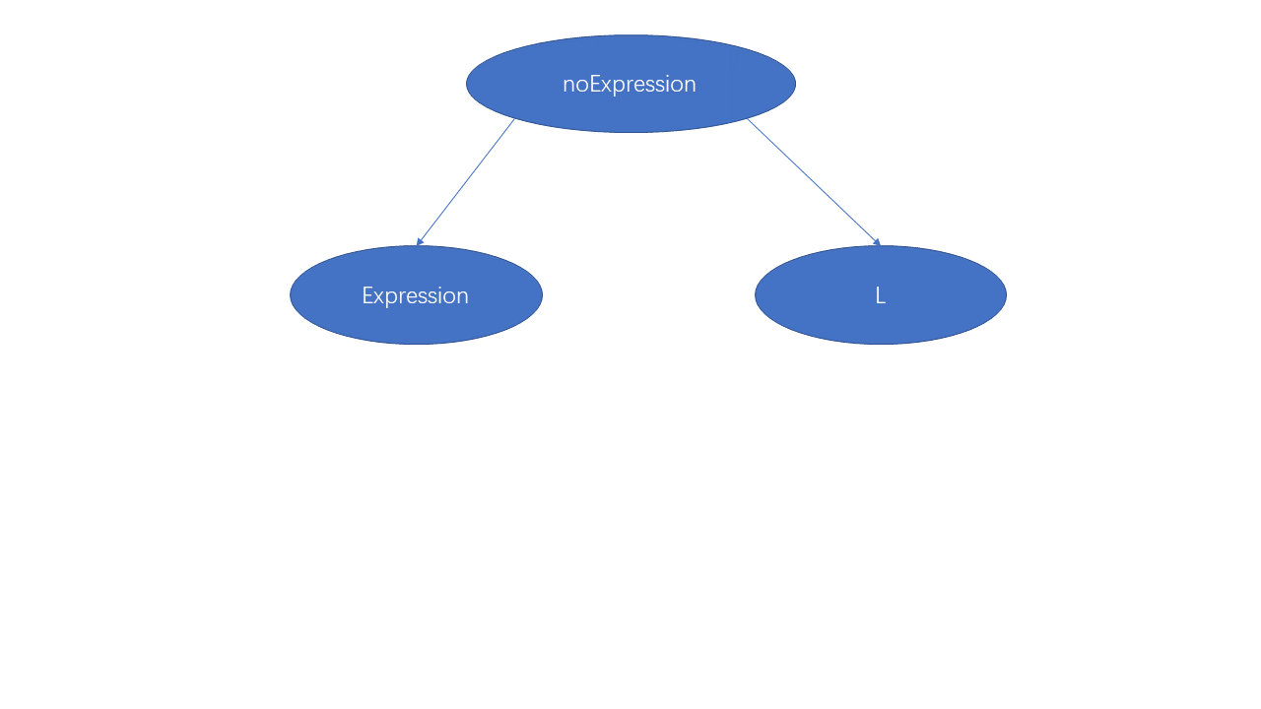

BraceExpression->**"("** Expression **")"** L

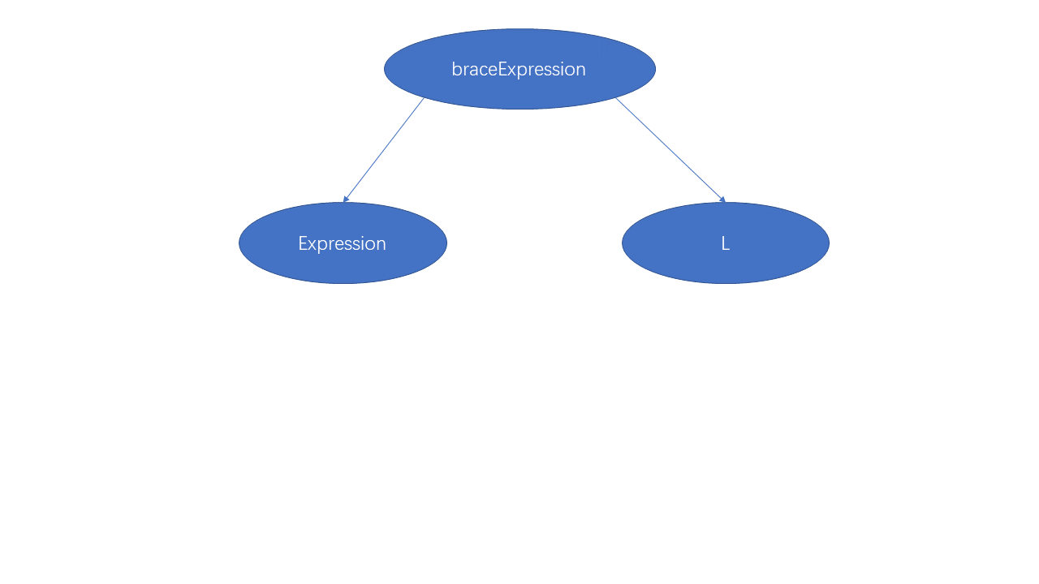

Expression-> IntExpression

| TrueExpression

| FalseExpression

|IdentifierExpression

| ThisExpression

| NewArrayExpression

| NewExpression

| NoExpression

| BraceExpression

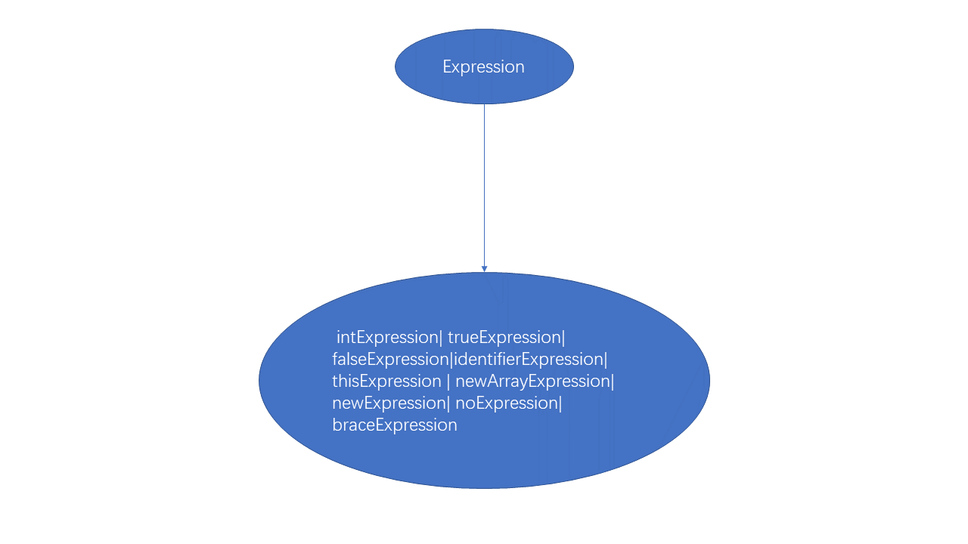

OPL->( " &&" | "<" | "+" | "-" | "*" ) Expression L

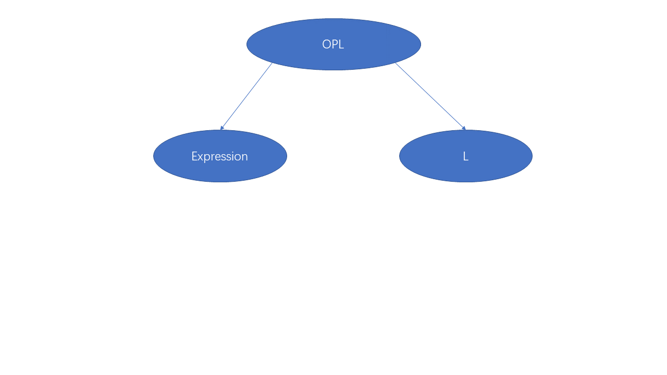

ExpressionL-> **"["** Expression **"]"** L

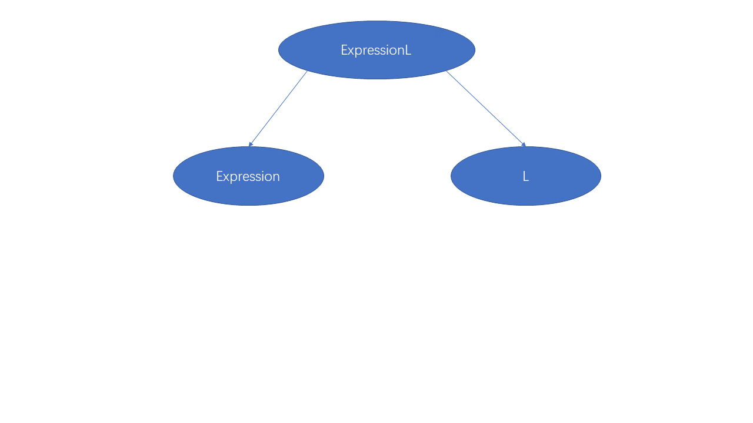

LengthL->**"."** **"length"** L

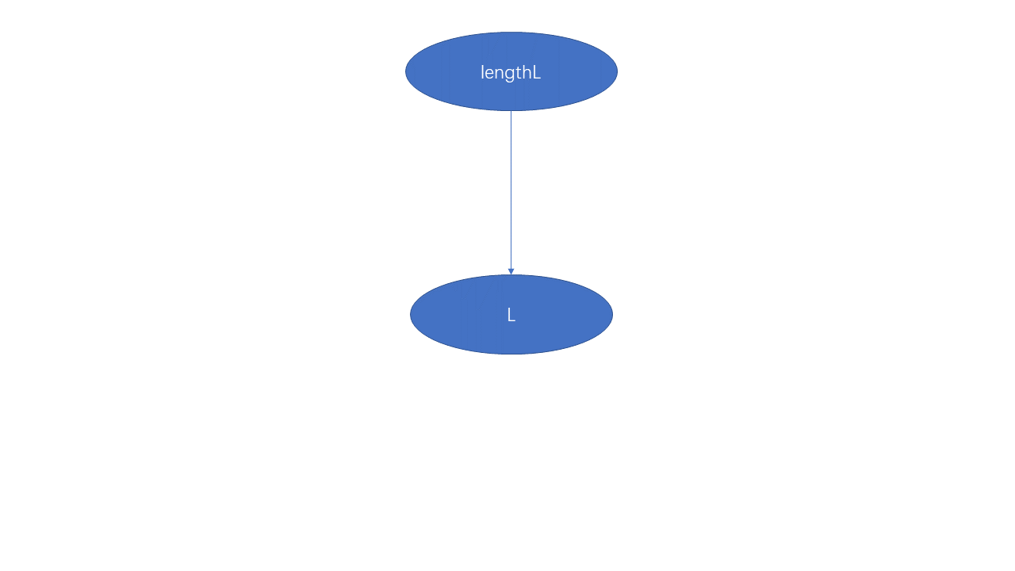

MethodL->**"."** Identifier **"("** [ Expression { **","** Expression } ] **")"** L

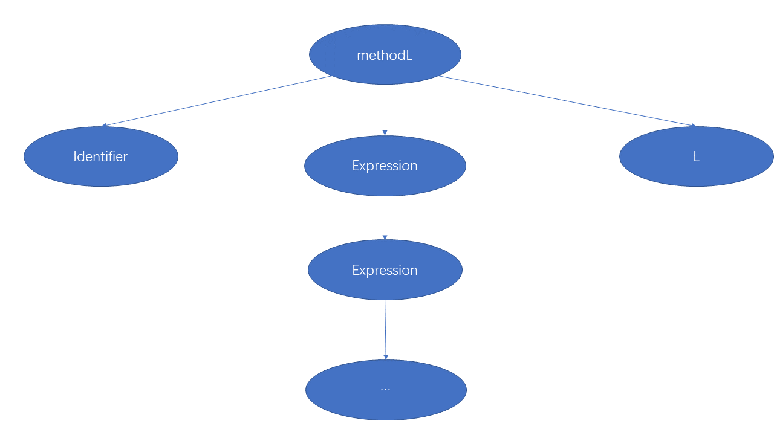

nullL->ε

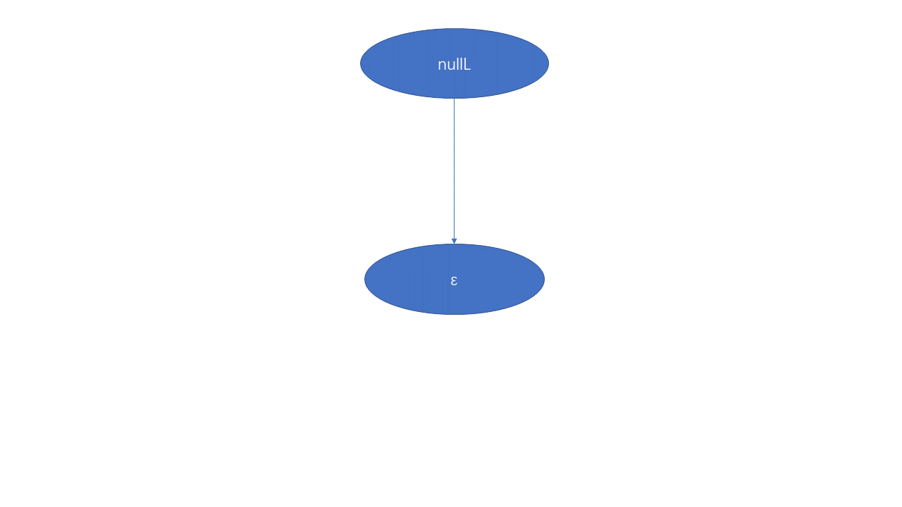

L-> OPL

|ExpressionL

|LengthL

| MethodL

| NullL

