P615-616

13：

According to exercise 9, let f(x,y)is that x and y are bit strings that agree in their first and third bits is an equivalence relation on the set of all bit strings of length three or more.

31：

a): The set of all bit strings of length 3

b): The set of all bit strings of length 4 that end with a 1

c): The set of all bit strings of length 5 that end 11

d): The set of all bit strings of length 8 that end 10101

P630-631

9：

no

13：

a): {(0, 0), (1, 0), (1, 1), (2, 0), (2, 1), (2, 2)};

b): (Z, >=);

c) : (P(Z), ⊇);

d): (Z+, |)

35：

a): {1,3,4}, {2,3,4};

b): {1}, {2}, {4};

c): no;

d): no;

e): {2, 4}, {2, 3, 4};

f): {2, 4};

g): {3, 4}, {4};

h): {3, 4};

P650-651

11:

If uRv, then there is an edge associated with {u, v}. But {u, v} = { v, u }, so this edge is associated with {v, u} and therefore vRu. Thus, by definition, R is a symmetric relation. A simple graph does not allow loops; therefore, uRu never holds, and so by definition R is irreflexive.

33:

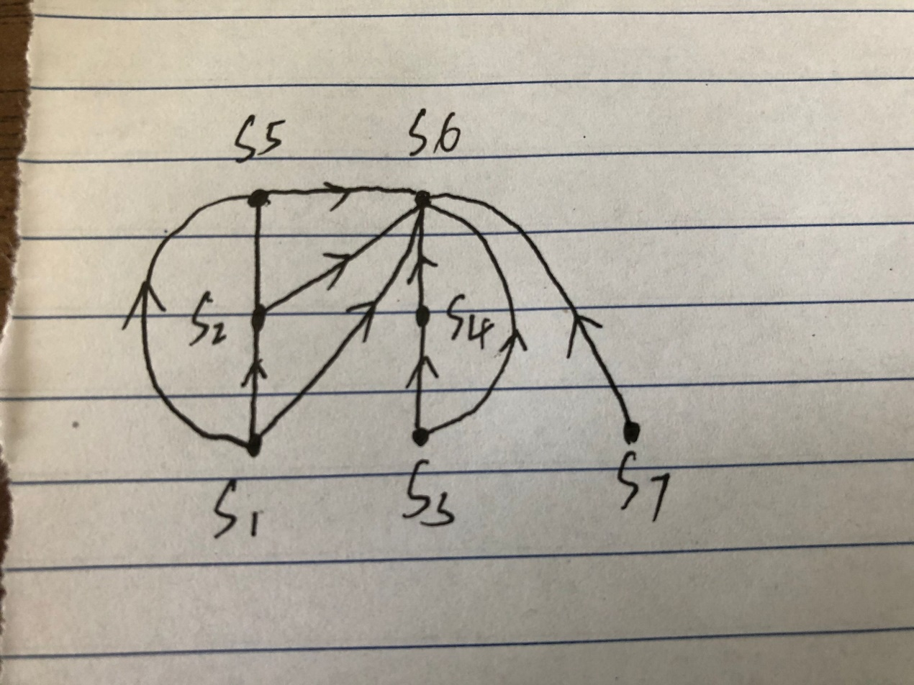

P666-667

25:

no

47:

不会。。