Following relational schema represent a campus card database, and a sample instance.

**card( cno:char(5), name:char(8), depart:char(10), balance:integer )**

**pos( pno:char(4), campus:char(8), location:char(10) )**

**detail( cno:char(5), pno:char(4), cdate:date, ctime:time, amount:integer,**

**remark:char(10) )**

|  |  |  |
| --- | --- | --- |
| **pno** | **campus** | **location** |
| p001 | 玉泉 | 教育超市 |
| p002 | 玉泉 | 四食堂 |
| p003 | 玉泉 | 四食堂 |
| p004 | 紫金港 | 教育超市 |
| p005 | 紫金港 | 教育超市 |
| p006 | 紫金港 | 一食堂 |

|  |  |  |  |
| --- | --- | --- | --- |
| **cno** | **name** | **depart** | **balance** |
| c0001 | 张帅 | CS | 100 |
| c0002 | 李丽 | EN | 200 |
| c0003 | 王浩 | CS | 300 |
| c0004 | 刘萌 | CS | 400 |
| c0005 | 赵亮 | MA | 500 |

|  |  |  |  |  |  |
| --- | --- | --- | --- | --- | --- |
| **cno** | **pno** | **cdate** | **ctime** | **amount** | **remark** |
| c0001 | p002 | 2018-07-01 | 08:10:10 | 6 | 餐饮 |
| c0001 | p002 | 2018-07-01 | 12:05:12 | 12 | 餐饮 |
| c0001 | p002 | 2018-07-01 | 17:30:20 | 20 | 餐饮 |
| c0001 | p001 | 2018-07-01 | 18:10:10 | 60 | 购物 |
| c0002 | p002 | 2018-07-02 | 08:10:10 | 8 | 餐饮 |
| c0002 | p001 | 2018-07-02 | 08:10:10 | 20 | 购物 |
| c0003 | p003 | 2018-07-02 | 08:10:10 | 25 | 餐饮 |

Given following SQL query on above relations：

**select cno, name**

**from card natural join detail**

**where depart= ‘CS’ and (cdate , pno) in**

**( select cdate, pno**

**from detail**

**where cno=‘c0002’ )**

Please answer following questions：

1. Transform above query to a SQL statement without nested subquery.
2. Transform above query to an equivalent relational algebra expression.
3. Write a SQL statement to find out cards consumed in only one campus in 2018.
4. Write a SQL statement to find out the pos in “紫金港” campus that has the maximum total amount of card consumption in 2018.
5. Write a sequence of SQL statements to complete following transaction:

card “c0002” consumes 20 at pos “p001” at 2018-07-02 08:08:08

(1)

select A.cno, A.name

from card, detail.A, detail.B

where depart = ‘CS’ and A.cno =card.cno and B.cno = ’c0002’ and A.cdate = B.cdate and A.pno = B.pno

(2)

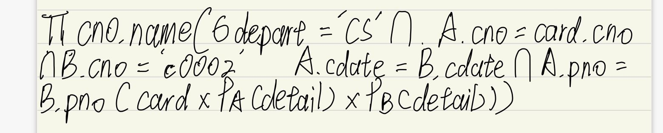

(3)

select cno

from card natural join detail natual join pos

group by cno

having count(distinct campus) =1

(4)

select pno

from pos natural join detail

group by pno

having sum(amount) >= all( select from(amount)

from detail

group by pno

where campus = ‘紫金港’)

(5)

Insert into detail

Values(‘c0002’, ‘p001’, ‘2018-07-02’, ’08:08:08’, 20, ‘购物’)