P550

23：

a): x^4\*(1 + x + x^2 + x^3)^2/(1-x)

b): 6

33：

Suppose that ak = a\*3^k + b, because a0 =1, a1 = 5,

ak = 2\*3^k – 1;’

P558

9：

507+292+312+344-211-213-43-14 = 974

P564-565

5：

Because 15\*15=225>200, only need to consider 2.3.5.7.11.13

Hence it is 46;

9：

[C(6,4) + C (6,3)\*C(3,2)]\*P(3,3) + C(6,2)\*C(4,2) = 540

P581-583

7:

a): symmetric;

b): symmetric, transitive;

c): symmetric;

d): reflexive, symmetric, transitive;

e): reflexive, transitive;

f): reflexive, symmetric, transitive;

g): antisymmetric;

h): antisymmetric, transitive;

31:

a): {(a,b) | a is required to read or has read b};

b): {(a,b) | a is required to read and has read b};

c): {(a,b) | either a is required to read b but has not read it or a has read b but is not required to};

d): {(a, b) | a is required to read b but has not read it} ;

e): {(a, b) | a has read b but is not required to};

55:

When n=1, it is true.

Assume that when n=k, Rk is reflexive and transitive.

By Theorem 1, Rk+1 ⊆ R. To see that R ⊆ Rk+1 =Rk◦R. Let (a,b)∈R. By the inductive hypothesis, Rk = R and hence, is reflexive. Thus (b,b)∈Rk. Therefore (a,b)∈Rk+1.

So it has been proved.

P597

21:

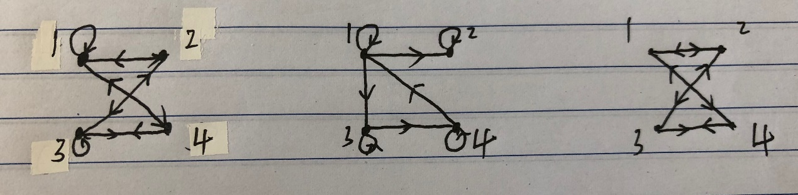

P607

25:

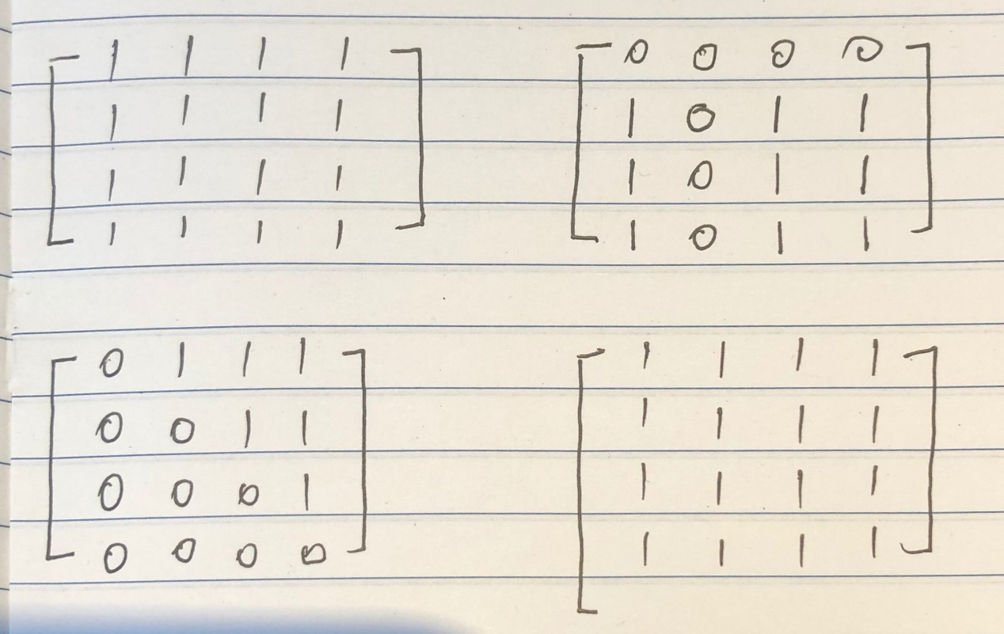

27:

Same to 25