P675-676

9：

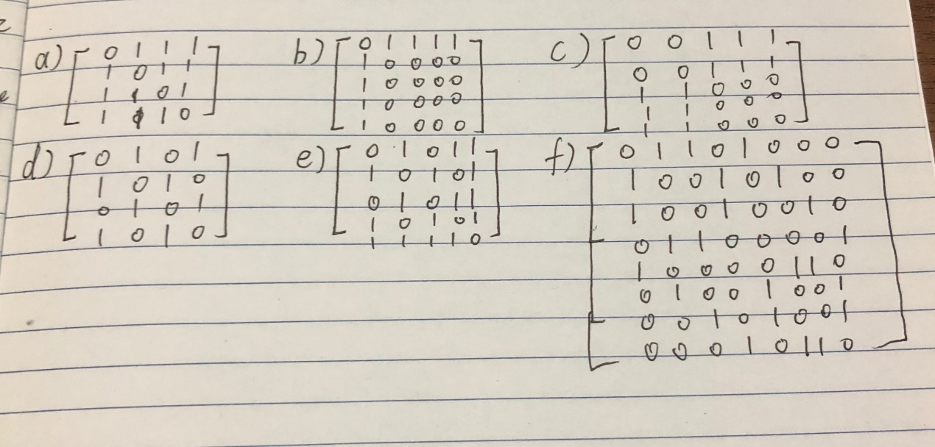

27：

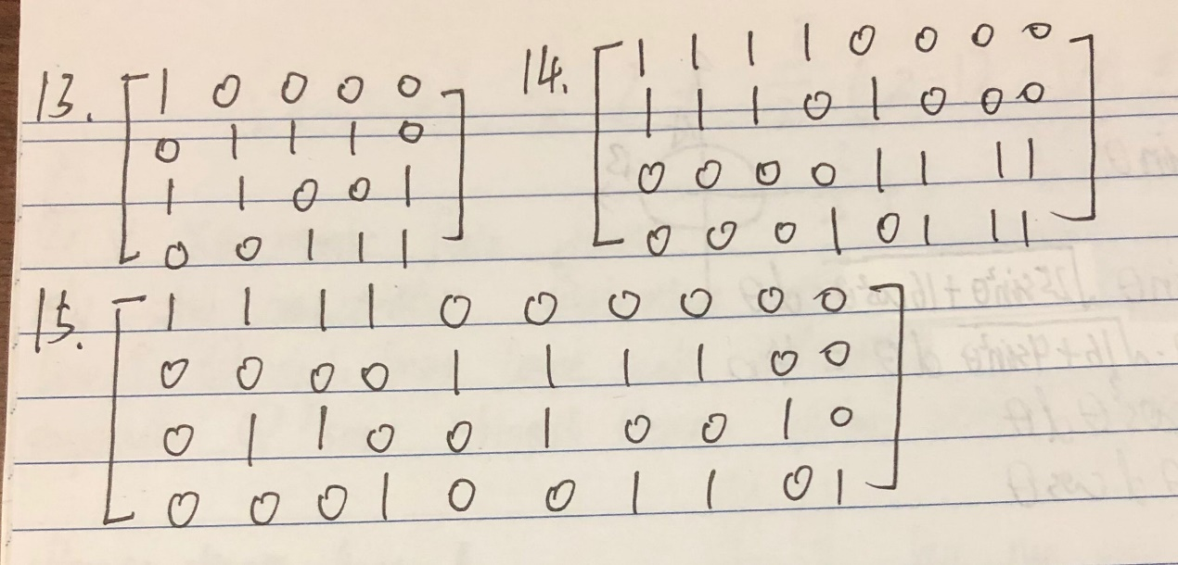

37：

Isomorphic

P690-692

15：

a): {a, b, f}, {c, d, e};

b): {a, b, c, d, e, h}, {f}, {g};

c): {a, b, d, e, f, g, h, i}, {c}

41：

A minimal set of people who collectively influence everyone.

P704-705

29：

exercise 1: 1;

exercise 2-7: 0.

35：

No Hamilton circuit exists, because every edge in the graph is incident.

P716-718

5:

exercise 2: a, b, e, d, z;

exercise 3: a, c, d, e, g, z;

exercise 4: a, b, e, h, l, m, p, s, z.

27:

San Francisco–Denver–Detroit–New York–Los Angeles–San Francisco.

P725-726

15:

不会。

23:

Planar.