P733

9：

ac、bde;

2.

13：

A graph without edges.

P755-756

13：

a): 3;

b): 9;

21：

Weeding out a person needs one game.

So 999.

P769-770

9：

3 times；

First divide them into 2 groups with same quantity; then it is same as the example.

21：

a: 000;

e: 001;

i: 01;

k: 1100;

o: 1101;

p: 11110;

u: 11111;

P784

17：

a): 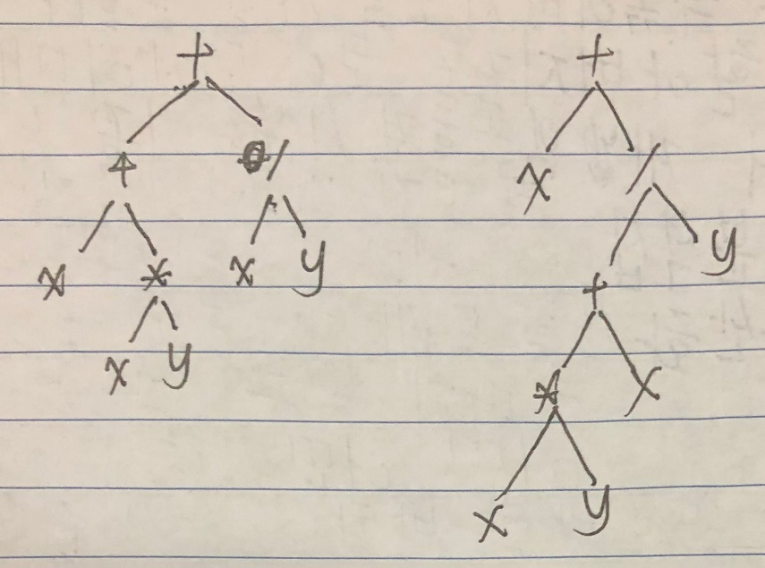

b): ++x \* xy / xy, +x /+∗ xyxy;

c): xxy ∗+ xy /+, xxy ∗ x+y /+;

d): ((x +(x ∗y))+(x/y)),(x +(((x ∗y)+x)/y));

27：

P796

21：

P802

5：

San Francisco→900 Denver；

San Francisco→1200 Chicago→700 Atlanta→8000 New York；