7004 A1

CHENGYANG ZHOU

3036167854



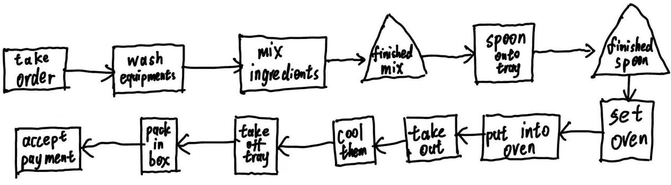

Flow units: an order

Resources: you, roommate, oven, mixer, tray

Tasks: take orders, wash out the bowl and beaters, mix ingredients, spoon cookies onto tray, set the oven, put cookies into oven, cool cookies, pack cookies in a box, accept the payment



|  |  |  |  |  |
| --- | --- | --- | --- | --- |
| Step | Raw processing time(min) | Who | Capacity  (per hour) | Is Bottleneck? |
| Take an order | 0 | nobody | ∞ |  |
| Wash & mix | 6 | you | 10 |  |
| Spoon onto tray | 2 | you | 30 |  |
| Set the oven | 1 | roommate | 60 |  |
| bake | 9 | nobody | 6.67 | Yes |
| Cool | 5 | nobody | 12 |  |
| Pack | 2 | roommate | 30 |  |
| Accept payment | 1 | roommate | 60 |  |



a rush order of one dozen cookies: **26 mins**;

Assume that the Company has enough trays:

Assuming that the time for the previous biscuit to be completed is K, no matter whether the next biscuit needs to be remixed or the already mixed one can be used, it will only require an additional 10 minutes.

The picture below demonstrates the situation:

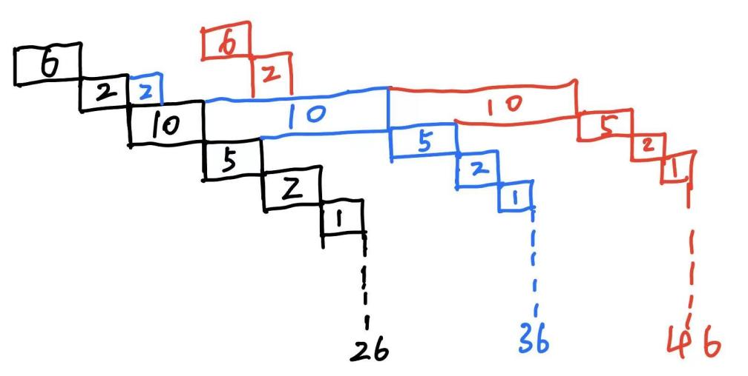

Hence K orders needs **10K+16** mins, when K is larger than 1.



Your own: 6+2= **8mins**

Roommate: 1+2+1= **4mins**



Since electric mixer can produce up to 3 products at one time, the quantity relationship between electric mixers and baking trays can be set to 3 times at most.

At the same time, electric mixer is idle for a long time after it is done, meaning that the Company only needs one.

**So 1 electric mixer and 3 baking trays are needed.**



You can launch a campaign where you can get discounts if you buy multiple servings of the same flavor, so that people will tend to buy multiple servings of the same product.

In this way, when using electric mixer, multiple cookies can be made at the same time, which reduces the use of electric mixer and then reduces the cost.