7004 A2

CHENGYANG ZHOU

3036167854

2. : Flow unit: **patient**
3. :
4. Pre-surgery examination, orientation, etc.: **admissions clerk, paper, equipment for blood and urine tests, laboratory, examination rooms, lounge, tea, cookies, dining room, beds**.
5. Surgery: **local anesthetic, operation rooms, operating table, surgeons, assistant surgeons, skin clips, operation equipment**.
6. Recovery: **patient recovery room, wheelchair, lounge, cookies, tea, beds**.
8. : weekly throughput rate: 30 * 5 = **150** patients / week
9. : average bed utilization: (30 * 5) / (30 * 7) = **71.43**%
10. :

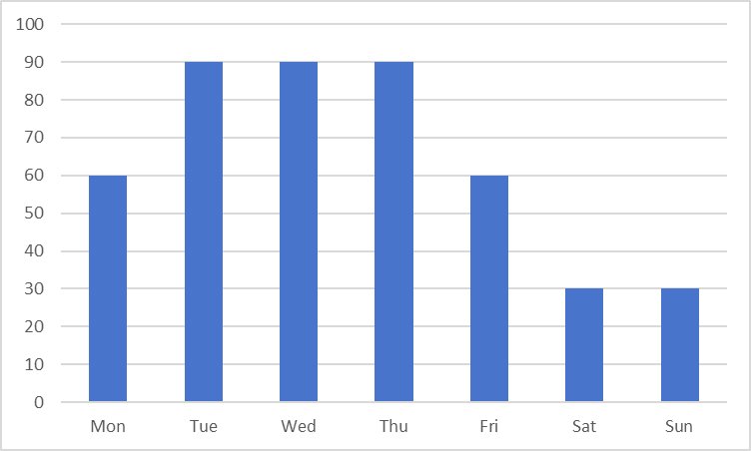

2. : average bed utilization: (60+90+90+90+60+30+30+30) / (90*7) = **85.71**%
3. :

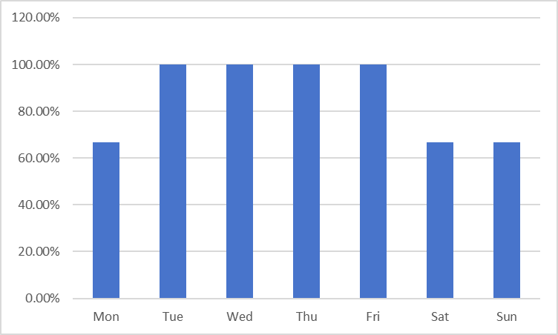

2. : consider the current capacity rate of each resources:

Surgeons: 12* 4 * 5 = 240

Operating rooms: 8 * 5 * 5 = 200

Beds: 30 * 5 = 150

So the beds are the bottleneck resource. The hospital needs to add more beds.

If the hospital wants to admit 180/5 = 36 patients every, both surgeons’ and operating rooms’ capacity rate is enough.

The hospital needs 36 * 3 = 108 beds.

Hence, 108 - 90 = **18** beds are needed to be added.

1. :

150 * 120% = 180 patients / week.

Because healthcare resources are expensive, the hospital can not add more of them.

So the maximum number of patients per day is 8* 5 = 40.

Daily capacity can be flexibly arranged according to the figure below:

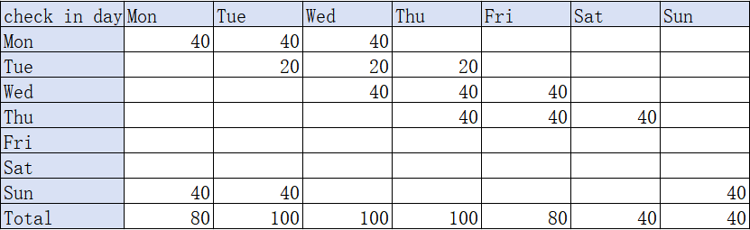

As shown in the figure, the maximum number of beds required is 100.

Hence, 100 - 90 = **10** more beds are needed.

1. :

Daily capacity can be flexibly arranged according to the figure below:

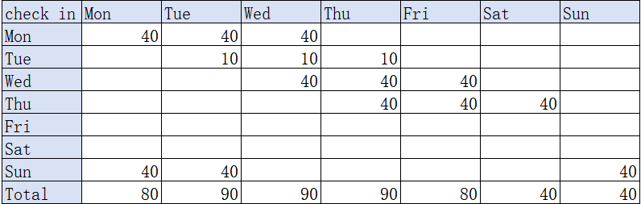

As shown in the figure, the maximum throughput rate is 40+ 10 + 40 + 40 + 40 = **170**