**Homework 2**

CSE 310 Fall 2021

Due date: **October 25, 2021; 11:59 PM** Submission via Blackboard.

# 1. TCP in action! (20 points)

The figure below plots the evolution of TCP's congestion window at the beginning of each time unit (where the unit of time is equal to the RTT). Consider the evolution of TCP's congestion window in this example and answer the following questions. The initial value of cwnd is 1 and the initial value of ssthresh (shown as a red +) is 8.

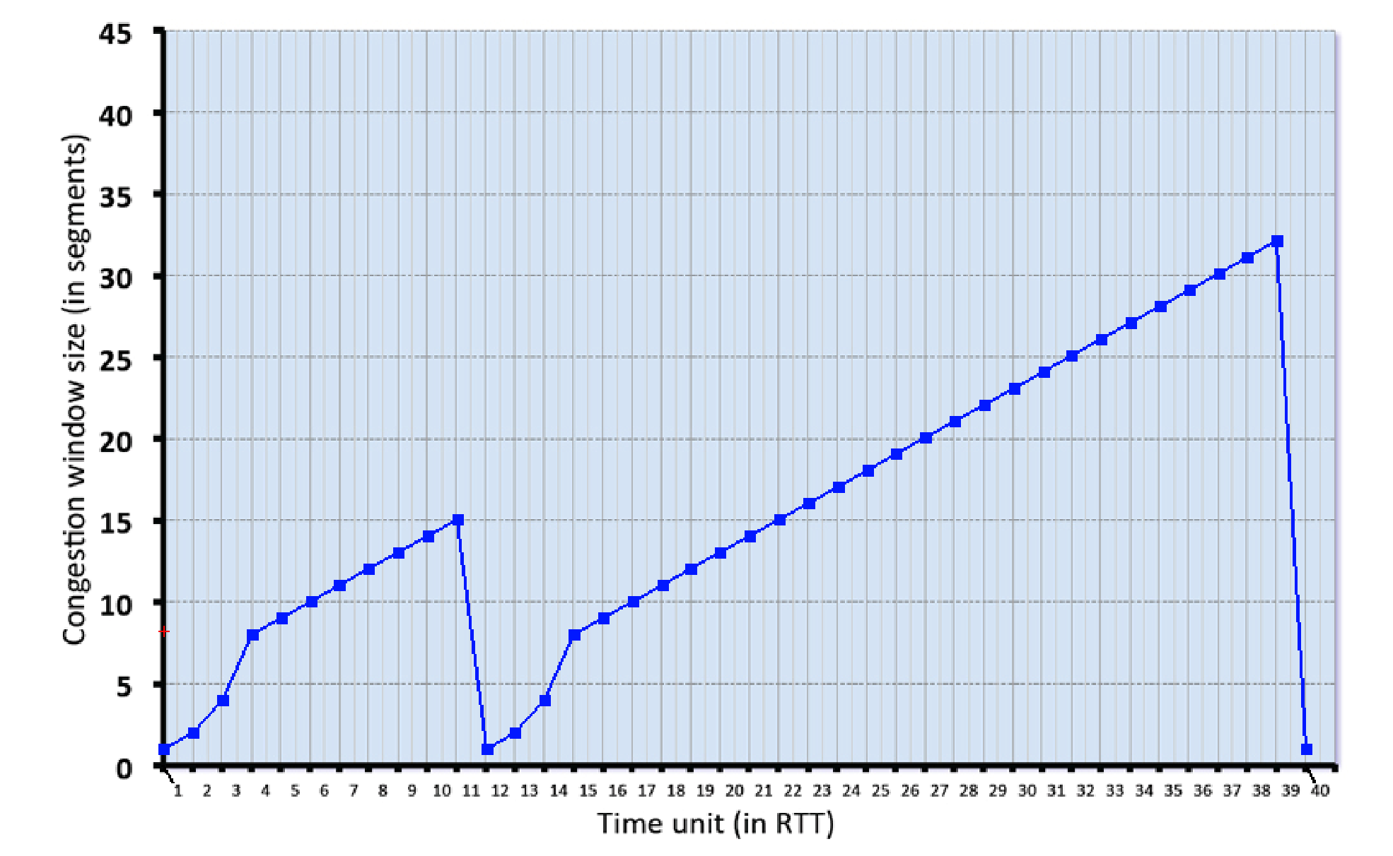

(Format your answer as: 1, 3, 5, 9)

1. Give the times at which TCP is in slow start.

1,2,3,12,13,14

1. Give the times at which TCP is in congestion avoidance

4,5,6,7,8,9,10,11,15,16,17,18,19,20,21,22,23,24,25,26,27,28,29,30,31,32,33,34,35,36,37,38,39

1. Give the times at which packets are lost via timeout.

11

1. Give the times at which packets are lost via triple ACK.

40

1. Give the times at which the value of ssthresh changes (if it changes between t=3 and t=4, use t=4 in your answer)

12 ,40

1. **Transport Layer protocols.** Give two scenarios where UDP may be preferred over TCP. Explain why. **(5 points)**

(1)Video streaming and (2)Games that doesn’t require real time update, both these don’t care about losing packages, they cares more about speed, you afford losing a frame in video streaming or losing a package in game. TCP is stable, but for these two scenarios we don’t need connection to be so stable, UDP is fast.

1. **True or false? Please provide a reasoning (1-2 sentences) for your answer. (5 points)** 
   1. The size of the TCP rwnd never changes throughout the duration of the connection.

**False**, size of receiver’s buffer will not change, however, size of the TCP rwnd will change depending on processing capability.

* 1. The TCP segment has a field in its header for *rwnd*.

**True**, rwnd is included in TCP header

* 1. Suppose Host A sends one segment with sequence number 38 and 4 bytes of data over a TCP connection to Host B. In this same segment the acknowledgment number is necessarily 42.

**False**, ack number acknowledge the data was last received from host B.

* 1. Host A is sending Host B a large file over a TCP connection. Assume Host B has no data to send Host A. Host B will not send acknowledgments to Host A because Host B cannot piggyback the acknowledgments on data.

**False**, Host will sent acknowledgments if there is no data to piggyback.

* 1. Suppose Host A is sending a large file to Host B over a TCP connection. If the sequence number for a segment of this connection is *m*, then the sequence number for the subsequent segment will necessarily be m+1.

**False**, it will be m+1 only if a *large* file are only 1 byte.

# 4. Sequence Numbers and ACKs (10 points)

Host A and B are communicating over a TCP connection, and Host B has already received from A all bytes up through byte 126. Suppose Host A then sends two segments to Host B back-to-back. The first and second segments contain 80 and 40 bytes of data, respectively. In the first segment, the sequence number is 127, the source port number is 302, and the destination port number is 80. Host B sends an acknowledgment whenever it receives a segment from Host A.

1. In the second segment sent from Host A to B, what are the sequence number, source port number, and destination port number?

Sequence number = 127+80 =207, source port number = 302, destination port number = 80.

1. If the first segment arrives before the second segment, in the acknowledgment of the first arriving segment, what is the acknowledgment number, the source port number, and the destination port number?

Acknowledgment number = 207, the source port number = 80 and the destination port number = 302.

1. If the second segment arrives before the first segment, in the acknowledgment of the first arriving segment, what is the acknowledgment number?

The acknowledgement number = 127

1. Suppose the two segments sent by A arrive in order at B. The first acknowledgment is lost and the second acknowledgment arrives after the first timeout interval. Draw a timing diagram, showing these segments and all other segments and acknowledgments sent. (Assume there is no additional packet loss.) For each segment in your figure, provide the sequence number and the number of bytes of data; for each acknowledgment that you add, provide the acknowledgment number.

Seq =127, bytes = 80



Seq =207, bytes = 40

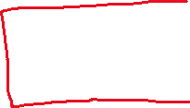

Ack =207



Ack =247



Seq =127, bytes = 80

Ack =247



# 5. IP Forwarding (10 points)

See the routing table below. Rewrite this table by writing the addresses in the “/” notation (the most probable “/” notation making any assumptions if needed).

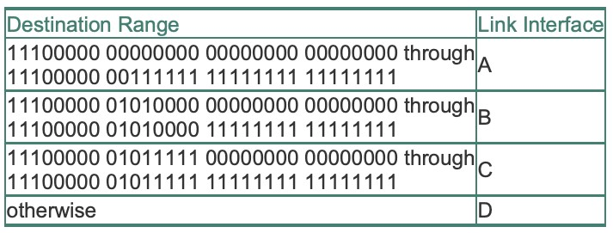

|  |  |
| --- | --- |
| Destination Range | Link Interface |
| 224.0.0.0 through 224.63.255.255  ->**224.0.0.0/10** | A |
| 224.80.0.0 through 224.80.255.255  ->**224.80.0.0/16** | B |
| 224.95.0.0 through 224.95.255.255  ->**224.95.0.0/16** | C |
| Otherwise | D |