# JAVA编程进阶上机报告



**学 院 智能与计算学部**

**专 业 软件工程**

**班 级 软件工程2班**

**学 号 3619058914**

**姓 名 周陈铮**

1. **实验要求**

(1)针对每个组件的每个品牌，设计一个类，并画成整体的类图

(2)设计计算机类（Computer.java），由上述四类组件组装而成，包括计算机的名称、计算机的描述（包括各个组件名）以及总价格等

(3)设计计算机销售主类（ComputerStore.java），包括3个由不同组件组装在一起的计算机实例，可实现计算机商品一览表，可展示每台计算机的描述、价格、工作等。

(4)设计时基于抽象类和接口，要尽可能的实现高内聚、低耦合。

1. **源代码**
2. 相关接口与类的设计

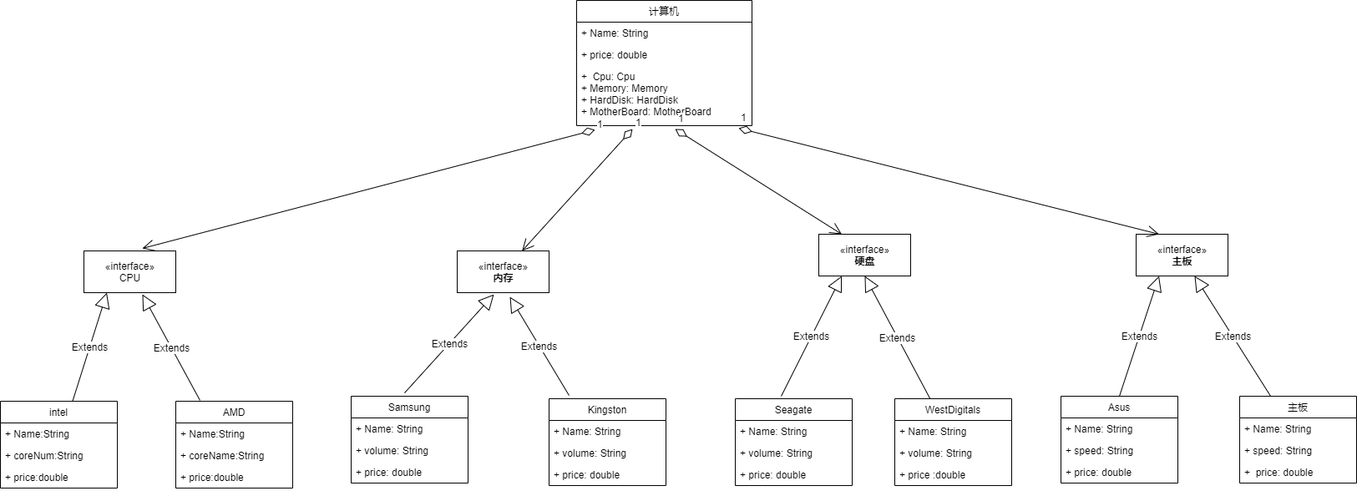

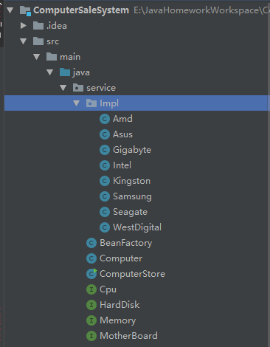

1. **实验结果**

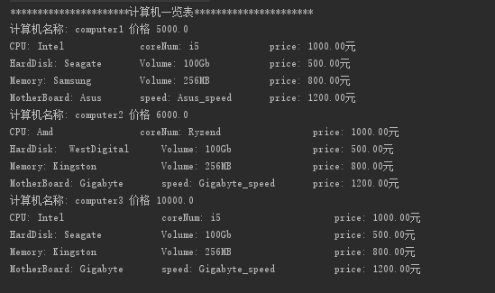

**附源码:**

package service**.**Impl**;**

**import** service**.**Cpu**;**

public class Amd **implements** Cpu**{**

private String Name **=** "Amd"**;**

private String coreNum **=** "Ryzend"**;**

private double price **=** 1000.0**;**

public String getName**()** **{**

**return** Name**;**

**}**

public String getCoreNum**()** **{**

**return** coreNum**;**

**}**

public double getPrice**()** **{**

**return** price**;**

**}**

**}**

package service**.**Impl**;**

**import** service**.**MotherBoard**;**

public class Asus **implements** MotherBoard **{**

private String Name **=** "Asus"**;**

private String speed **=** "Asus_speed"**;**

private double price **=** 1200.0**;**

public String getName**()** **{**

**return** Name**;**

**}**

public String getSpeed**()** **{**

**return** speed**;**

**}**

public double getPrice**()** **{**

**return** price**;**

**}**

**}**

package service**.**Impl**;**

**import** service**.**Memory**;**

**import** service**.**MotherBoard**;**

public class Gigabyte **implements** MotherBoard **{**

private String Name **=** "Gigabyte"**;**

private String speed **=** "Gigabyte_speed"**;**

private double price **=** 1200.0**;**

public String getName**()** **{**

**return** Name**;**

**}**

public String getSpeed**()** **{**

**return** speed**;**

**}**

public double getPrice**()** **{**

**return** price**;**

**}**

**}**

package service**.**Impl**;**

**import** service**.**Cpu**;**

**import** javax**.**naming**.**Name**;**

public class Intel **implements** Cpu **{**

private String Name **=** "Intel"**;**

private String coreNum **=** "i5"**;**

private double price **=** 1000.0**;**

public String getName**()** **{**

**return** Name**;**

**}**

public String getCoreNum**()** **{**

**return** coreNum**;**

**}**

public double getPrice**()** **{**

**return** price**;**

**}**

**}**

package service**.**Impl**;**

**import** service**.**Cpu**;**

**import** service**.**Memory**;**

public class Kingston **implements** Memory **{**

private String Name **=** "Kingston"**;**

private String volume **=**"256MB"**;**

private double price **=** 800.0**;**

public String getName**()** **{**

**return** Name**;**

**}**

public String getVolume**()** **{**

**return** volume**;**

**}**

public double getPrice**()** **{**

**return** price**;**

**}**

**}**

package service**.**Impl**;**

**import** service**.**Memory**;**

**import** java**.**util**.**Map**;**

public class Samsung **implements** Memory **{**

private String Name **=** "Samsung"**;**

private String volume **=**"256MB"**;**

private double price **=** 800.0**;**

public String getName**()** **{**

**return** Name**;**

**}**

public String getVolume**()** **{**

**return** volume**;**

**}**

public double getPrice**()** **{**

**return** price**;**

**}**

**}**

package service**.**Impl**;**

**import** service**.**HardDisk**;**

**import** service**.**Memory**;**

public class Seagate **implements** HardDisk **{**

private String Name **=** "Seagate"**;**

private String volume **=**"100Gb"**;**

private double price **=** 500.0**;**

public String getName**()** **{**

**return** Name**;**

**}**

public String getVolume**()** **{**

**return** volume**;**

**}**

public double getPrice**()** **{**

**return** price**;**

**}**

**}**

package service**.**Impl**;**

**import** service**.**HardDisk**;**

public class WestDigital **implements** HardDisk **{**

private String Name **=** " WestDigital"**;**

private String volume **=**"100Gb"**;**

private double price **=** 500.0**;**

public String getName**()** **{**

**return** Name**;**

**}**

public String getVolume**()** **{**

**return** volume**;**

**}**

public double getPrice**()** **{**

**return** price**;**

**}**

**}**

package service**;**

public interface Cpu **{**

**default** public void work**(){**

System**.**out**.**println**(**"cpu work"**);**

**}**

**}**

package service**;**

public interface HardDisk **{**

**default** public void work**(){**

System**.**out**.**println**(**"harddisk work"**);**

**};**

**}**

package service**;**

public interface Memory **{**

**default** public void work**(){**

System**.**out**.**println**(**"memory work"**);**

**}**

**}**

package service**;**

public interface MotherBoard **{**

**default** public void work**(){**

System**.**out**.**println**(**"motherboard work"**);**

**}**

**}**

package service**;**

**import** service**.**Impl**.**Seagate**;**

**import** java**.**io**.**InputStream**;**

**import** java**.**util**.**Enumeration**;**

**import** java**.**util**.**HashMap**;**

**import** java**.**util**.**Map**;**

**import** java**.**util**.**Properties**;**

public class BeanFactory **{**

private static Properties pro**;**

private static Map**<**String**,** Object**>** beans**;**

static **{**

**try** **{**

pro **=** **new** Properties**();**

InputStream in **=** BeanFactory**.**class**.**getClassLoader**().**getResourceAsStream**(**"BeanFactory.properties"**);**

pro**.**load**(**in**);**

Enumeration keys **=** pro**.**keys**();**

beans **=** **new** HashMap**<**String**,** Object**>();**

**while(**keys**.**hasMoreElements**()){**

String key **=** keys**.**nextElement**().**toString**();**

String beanPath **=** pro**.**getProperty**(**key**);**

Object value **=** Class**.**forName**(**beanPath**).**newInstance**();**

beans**.**put**(**key**,** value**);**

**}**

**}catch(**Exception e**){**

**throw** **new** ExceptionInInitializerError**(**"初始化失败"**);**

**}**

**}**

public static Object getBean**(**String key**){**

**return** beans**.**get**(**key**);**

**}**

**}**

package service**;**

public class Computer **{**

private String Name**;**

private double price**;**

private Cpu cpu**;**

private HardDisk hardDisk**;**

private Memory memory**;**

private MotherBoard motherBoard**;**

private Computer**(**String name**,** double price**,**String cpu**,** String hardDisk**,**String memory**,**String motherBoard**){**

**this.**cpu **=** **(**Cpu**)** BeanFactory**.**getBean**(**cpu**);**

**this.**hardDisk **=** **(**HardDisk**)** BeanFactory**.**getBean**(**hardDisk**);**

**this.**memory **=** **(**Memory**)** BeanFactory**.**getBean**(**memory**);**

**this.**motherBoard **=** **(**MotherBoard**)** BeanFactory**.**getBean**(**motherBoard**);**

**this.**Name **=** name**;**

**this.**price **=** price**;**

**}**

public String getName**()** **{**

**return** Name**;**

**}**

public double getPrice**()** **{**

**return** price**;**

**}**

public Cpu getCpu**()** **{**

**return** cpu**;**

**}**

public HardDisk getHardDisk**()** **{**

**return** hardDisk**;**

**}**

public Memory getMemory**()** **{**

**return** memory**;**

**}**

public MotherBoard getMotherBoard**()** **{**

**return** motherBoard**;**

**}**

public static Computer getComputer**(**String name**,** double price**,** String cpu**,** String hardDisk**,** String memory**,** String motherBoard**){**

**return** **new** Computer**(**name**,**price**,**cpu**,**hardDisk**,**memory**,**motherBoard**);**

**}**

public String toString**()** **{**

**return** "Computer{" **+**

"Name='" **+** Name **+** '\'' **+**

", price=" **+** price **+**

", cpu=" **+** cpu **+**

", hardDisk=" **+** hardDisk **+**

", memory=" **+** memory **+**

", motherBoard=" **+** motherBoard **+**

'}'**;**

**}**

**}**

package service**;**

**import** service**.**Impl**.*;**

public class ComputerStore **{**

private Computer computer1 **=** Computer**.**getComputer**(**"computer1"**,** 5000.0**,**"Intel"**,**"Seagate"**,**"Samsung"**,**"Asus"**);**

private Computer computer2 **=** Computer**.**getComputer**(**"computer2"**,** 6000.0**,**"Amd"**,**"WestDigital"**,**"Kingston"**,**"Gigabyte"**);**

private Computer computer3 **=** Computer**.**getComputer**(**"computer3"**,** 10000.0**,**"Intel"**,**"Seagate"**,**"Kingston"**,**"Gigabyte"**);**

public void printComputer**(){**

System**.**out**.**println**(**"**********************计算机一览表**********************"**);**

System**.**out**.**println**(**"计算机名称: "**+**computer1**.**getName**()+**" 价格 "**+**computer1**.**getPrice**());**

Intel intel **=** **(**Intel**)**computer1**.**getCpu**();**

Seagate seagate **=** **(**Seagate**)**computer1**.**getHardDisk**();**

Samsung samsung **=** **(**Samsung**)** computer1**.**getMemory**();**

Asus asus **=** **(**Asus**)**computer1**.**getMotherBoard**();**

System**.**out**.**printf**(**"CPU: %s\t\t\t\tcoreNum: %s\t\t\t\tprice: %.2f元%n"**,**intel**.**getName**(),**intel**.**getCoreNum**(),**intel**.**getPrice**());**

System**.**out**.**printf**(**"HardDisk: %s\t\tVolume: %s\t\t\tprice: %.2f元%n"**,**seagate**.**getName**(),**seagate**.**getVolume**(),**seagate**.**getPrice**());**

System**.**out**.**printf**(**"Memory: %s\t\t\tVolume: %s\t\t\tprice: %.2f元%n"**,**samsung**.**getName**(),**samsung**.**getVolume**(),**samsung**.**getPrice**());**

System**.**out**.**printf**(**"MotherBoard: %s\t\tspeed: %s\t\tprice: %.2f元%n"**,**asus**.**getName**(),**asus**.**getSpeed**(),**asus**.**getPrice**());**

System**.**out**.**println**(**"计算机名称: "**+**computer2**.**getName**()+**" 价格 "**+**computer2**.**getPrice**());**

Amd amd **=** **(**Amd**)**computer2**.**getCpu**();**

WestDigital westDigital**=** **(**WestDigital**)**computer2**.**getHardDisk**();**

Kingston kingston**=** **(**Kingston**)** computer2**.**getMemory**();**

Gigabyte gigabyte **=** **(**Gigabyte**)**computer2**.**getMotherBoard**();**

System**.**out**.**printf**(**"CPU: %s\t\t\t\tcoreNum: %s\t\t\t\t\tprice: %.2f元%n"**,**amd**.**getName**(),**amd**.**getCoreNum**(),**amd**.**getPrice**());**

System**.**out**.**printf**(**"HardDisk: %s\t\tVolume: %s\t\t\t\tprice: %.2f元%n"**,**westDigital**.**getName**(),**westDigital**.**getVolume**(),**westDigital**.**getPrice**());**

System**.**out**.**printf**(**"Memory: %s\t\t\tVolume: %s\t\t\t\tprice: %.2f元%n"**,**kingston**.**getName**(),**kingston**.**getVolume**(),**kingston**.**getPrice**());**

System**.**out**.**printf**(**"MotherBoard: %s\t\tspeed: %s\t\tprice: %.2f元%n"**,**gigabyte**.**getName**(),**gigabyte**.**getSpeed**(),**gigabyte**.**getPrice**());**

System**.**out**.**println**(**"计算机名称: "**+**computer3**.**getName**()+**" 价格 "**+**computer3**.**getPrice**());**

Intel intel1 **=** **(**Intel**)**computer3**.**getCpu**();**

Seagate seagate1**=** **(**Seagate**)**computer3**.**getHardDisk**();**

Kingston kingston1**=** **(**Kingston**)** computer3**.**getMemory**();**

Gigabyte gigabyte1 **=** **(**Gigabyte**)**computer3**.**getMotherBoard**();**

System**.**out**.**printf**(**"CPU: %s\t\t\t\t\tcoreNum: %s\t\t\t\t\t\tprice: %.2f元%n"**,**intel1**.**getName**(),**intel1**.**getCoreNum**(),**intel1**.**getPrice**());**

System**.**out**.**printf**(**"HardDisk: %s\t\t\tVolume: %s\t\t\t\t\tprice: %.2f元%n"**,**seagate1**.**getName**(),**seagate1**.**getVolume**(),**seagate1**.**getPrice**());**

System**.**out**.**printf**(**"Memory: %s\t\t\tVolume: %s\t\t\t\t\tprice: %.2f元%n"**,**kingston1**.**getName**(),**kingston1**.**getVolume**(),**kingston1**.**getPrice**());**

System**.**out**.**printf**(**"MotherBoard: %s\t\tspeed: %s\t\t\tprice: %.2f元%n"**,**gigabyte1**.**getName**(),**gigabyte1**.**getSpeed**(),**gigabyte1**.**getPrice**());**

**}**

public static void main**(**String**[]** args**)** **{**

/* new ComputerStore().printComputer();*/

**new** ComputerStore**().**printComputer**();**

**}**

**}**