Decision Science Complete Notes
OUC AU Haide Decision Science 2026 Autumn
Complete merged edition with original figures, formulas, tables and diagrams
Source order: Modules 1 to 6
修订：翟常喆
2026.10

说明：本版本按课程原始顺序合并六个模块，保留原始英文正文、课程图片、公式、表格和示意图。网页中的导航按钮、答题交互控件和纯界面图标已去除，以便连续阅读。
目录
阅读建议 7
课程目录 8
1. Introduction to Using Randomness in Simulation 9
Module 1 Overview 9
1.1 Introduction to Using Randomness in Simulation 10
1.1.1 Introduction to Using Randomness in Simulation 10
1.1.2. Applications of Simulations 11
1.1.3. Determinism and Randomness 12
1.1.4. Monte Carlo v Las Vegas 13
Optional vocabulary exercise (1.1) 14
1.2 Recap of Simple Probability 14
1.2.1. Introduction 14
1.2.2. Random variables & sample spaces 15
1.2.3. Notation 16
1.2.4. Defining a random variable, CDF and PDF 17
1.2.5. Example distributions 20
1.2.6. Discrete distributions 20
1.2.7. Continuous distributions 23
1.2.8. Expectation 28
1.2.9. Variance 30
1.2.10. Independence 31
Optional vocabulary exercises (1.2) 32
1.3 Generating Random Numbers 32
1.3.1 Generating random numbers (Part 1) 32
1.3.2 Generating random numbers (Part 2) 34
1.3.3 Generating random numbers (Part 3) 37
Random sequences 37
Including external influences 38
Random seeds 39
Question 39
Optional vocabulary exercise (1.3) 40
1.4 Programming Tools for Creating Random Simulations 40
1.4.1. Programming Tools for Creating Random Simulations 40
1.4.2. Introduction to Julia 41
1.4.3. Getting started in Julia 41
1.4.4. Packages for Julia 43
1.4.5. Random numbers in Julia (Part 1) 44
1.4.6. Random numbers in Julia (Part 2) 46
1.4.7. Random numbers in Julia (Part 3) 46
Optional vocabulary exercise (1.4) 48
2. Discrete-Event Simulation 49
Module 2 Overview 49
Module 2 Overview 49
2.1 Definitions and assumptions 49
2.1 Definitions and assumptions 49
2.1.1 Discrete-Event Simulations 50
2.1.2 DES Components 51
2.1.3 DES Components - Assumptions 55
2.1.4 Other Parts of Simulation Terminology 55
2.1.5 Modelling principles 60
2.1.6 Queues Part 1 64
2.1.7 Queues Part 2 65
2.1.8 Queues Part 3 67
2.1.9 Lists 70
Optional vocabulary exercise (2.1) 71
2.2 Discrete-Event Models 71
2.2 Discrete-Event Models 71
2.2.1 A Simulation on Paper 72
2.2.2 Example 1 76
2.2.3 Example 2 - A Car Park 80
2.2.4 Example 2 - A Car Park Continued 82
2.2.5 Example 3 - An Emergency Department 86
2.3 How to Create DES 89
2.3 How to Create DES 89
2.3.1 Control Flow 89
2.3.2 Data Structures 92
2.3.3 Arrays 93
2.3.4 Arrays (continued) 95
2.3.5 Growing Arrays 96
2.3.6 Shrinking Arrays 96
2.3.7 Queues 97
2.3.8 Stack 98
2.3.9 Deque 99
2.3.10 Priority Queue 99
2.3.11 Composite Types 101
2.3.12 DES Example - An Emergency Department 102
2.3.13 DES Example - An Emergency Department - Writing the Simulation 105
2.4 Advanced DES 106
2.4 Advanced DES 106
2.4.1 Advanced DES and Examples 106
2.4.2 Stationarity 107
2.4.3 Example 4 - Beach Volleyball 108
2.4.4 Example 5 - A Twitter Cascade or a Simple Epidemic 112
2.4.5 Example 5 - A Twitter Cascade or a Simple Epidemic (continued) 115
3. Instrumentation, Test & Validation 118
Module 3 Overview 118
3.1 How to Extract and Work with Data from a Simulation 118
3.1.1 Instrumenting a Simulation 118
3.1.2 Event-Driven Instrumentation 120
3.1.3 Entity-Driven Simulation 121
3.1.4 Storing the Output 122
3.1.5 Directory Structure and File Naming 123
3.1.6 Ensuring You Measure What You Wanted 125
3.1.7 Activity - Measurement 127
3.1.8 DES Example in Julia - Part 1 129
3.1.9 DES Example in Julia - Part 2 131
3.1.10 DES Example in Julia - Part 3 133
3.1.11 DES Example in Julia - Part 4 134
3.2 Test and Validation of a Simulation 136
3.2.1 Test and Validation of a Simulation 136
3.2.2 Verification 137
3.2.3 Verification — Performance Testing 139
3.2.4 Verification in Julia 141
3.2.5 Validation 142
3.2.6 Accreditation and Acceptance 144
3.2.7 3 Ds of Accreditation — Description 145
3.2.8 3 Ds of Accreditation — Documentation 151
3.2.9 3 Ds of Accreditation — Demonstration 151
3.2.10 Other Issues in Accreditation 152
4. Exploration 153
Module 4 Overview 153
Module 4 Overview 153
4.1 Exploring Possibility Spaces 154
4.1 Exploring Possibility Spaces 154
4.1.1 Possibility Spaces - Hypothesis and Parameters 154
4.1.2 Possibility Space 155
4.1.3 Exploration and Parameter Sweeping 156
4.1.4 Exploration and Parameter Sweeping — Example 157
4.1.5 Iterative Approaches 161
4.1.6 Search Algorithms and Optimisation 164
4.1.7 Search Algorithms and Optimisation — Example 165
4.2 Simulation Harnesses 167
4.2 Simulation Harnesses 167
4.2.1 Tools to Automate Simulation 167
4.2.2 Parallel Processing 168
4.2.3 Data 170
4.3 Complexity Analysis for Simulations 171
4.3 Complexity Analysis for Simulations 171
4.3.1 Complexity Analysis for Simulations 171
4.3.2 Big-O Notation 173
4.3.3 Manipulating Big-O Notation 175
4.3.4 Back of the Envelope Analysis 177
4.3.5 Testing Performance 178
4.4 Including Data into Simulations 181
4.4 Including Data into Simulations 181
4.4.1 Including Data into Simulations 181
4.4.2 The QQ-plot 185
4.4.3 The Use of QQ-plots 185
4.4.4 Choosing Your Parameters 186
4.4.5 Some Examples of Moments 187
4.4.6 MMM in Action 187
4.4.7 MMM Exercise 189
4.4.8 MMM Exercise — Solutions 189
5. Statistical Analysis of Simulation Data 190
Module 5 Overview 190
Module 5 Overview 190
5.1 Summary Statistics 190
5.1 Summary Statistics 190
5.1.1 Summary Statistics 191
5.1.2 What Is Being Measured - Time or State? 191
5.1.3 Sample, Mean and Variance 193
5.1.4 Time Averages versus Ensemble Averages 196
5.1.5 Converting from Irregular Samples to Uniform Samples 197
5.1.6 Burn-In and Cool-Down 199
5.2 Estimation and Errors 201
5.2 Estimation and Errors 201
5.2.1 Estimation 201
5.2.2 Errors – Bias and Variance of Estimators 202
5.2.3 Error Bounds and Confidence Intervals 204
5.2.4 Constructing a Confidence Interval 206
5.2.5 Confidence Intervals — An Example 210
5.2.6 Confidence Intervals — The Assumptions 211
5.2.7 An Extension — Comparing Two Samples 211
5.3 Improving Accuracy 212
5.3 Improving Accuracy 212
5.3.1 Improving accuracy 212
5.3.2 Independent Realisations 213
5.3.3 Variance Reduction 213
Common Random Numbers 214
6. Applications 216
Module 6 Overview 216
Module 6 Overview 216
6.1 How to Build a Simulation with Confidence 216
6.1 How to Build a Simulation with Confidence 216
Simulation Workflow — The Waterfall Model 216
6.1.1 Simulation Workflow — The Waterfall Model 216
Simulation Workflow — The Spiral Model 217
6.1.2 Simulation Workflow — The Spiral Model 217
Activity 219
Additional Concepts and Notes 220
6.1.3 Additional Concepts and Notes 220
Reporting and Communicating 221
6.1.4 Reporting and Communicating 221
6.2 Case Studies 223
6.2 Case Studies 223
Telecommunication Network Models 223
6.2.1 Telecommunication Network Models 223
Risks to Communication Networks 228
6.2.2 Risks to Communication Networks 228
Managing Risks in Telecommunications 231
6.2.3 Managing Risks in Telecommunications 231
The Final Model 233
6.2.4 The Final Model 233
6.3 Simulation Packages 234
6.3 Simulation Packages 234
General Purpose Simulation Packages and Simulation Programming Languages 234
6.3.1 General Purpose Simulation Packages and Simulation Programming Languages 234
Packages that are Part of a Larger Programming Language 235
6.3.2 Packages that are Part of a Larger Programming Language 235
Application Specific Software Packages 238
6.3.3 Application Specific Software Packages 238
Alternatives to DES 240
6.3.4 Alternatives to DES 240

阅读建议
- 第一次阅读：按 Module 1 到 Module 6 顺序通读，先理解课程的整体逻辑。
- 第二次复习：用 Word 的导航窗格或目录跳到具体小节，重点回看公式、模型流程、队列、验证和统计分析。
- 考试准备：结合“应试复习讲义”使用；完整版用于查原文和图表，应试版用于理解、归纳和答题。
- 公式说明：原网页中的数学表达已转为可读文本，并使用 Cambria Math 字体呈现；若需要原始 LaTeX 源码，可在 00_原始资料 HTML 中查阅。

课程目录
模块 | 主要内容
Module 1 | 1.1 Randomness in Simulation; 1.2 Probability; 1.3 Generating Random Numbers; 1.4 Julia and Simulation Tools
Module 2 | 2.1 Definitions and Assumptions; 2.2 DES Models; 2.3 Creating DES; 2.4 Advanced DES
Module 3 | 3.1 Instrumentation and Data; 3.2 Test, Verification, Validation and Accreditation
Module 4 | 4.1 Possibility Spaces; 4.2 Simulation Harnesses; 4.3 Complexity; 4.4 Data in Simulations
Module 5 | 5.1 Summary Statistics; 5.2 Estimation and Errors; 5.3 Improving Accuracy
Module 6 | 6.1 Simulation Workflow; 6.2 Case Studies; 6.3 Simulation Packages and Alternatives to DES

提示：Word 中可打开“导航窗格”按章节跳转；PDF 中可使用书签或搜索章节编号。

1. Introduction to Using Randomness in Simulation

Module 1 Overview

module banner

: Introduction to Using Randomness in Simulation
In this , Professor Matthew Roughan provides an outline of Module 1 and gives an overview of the importance of simulation as part of the decision-making processes for business, industry and government.

Getting started with Decision Science
Making good decisions in industry, finance, health care, and the government is becoming more challenging. As our world becomes more connected, the complex interrelationships between systems make it difficult to anticipate the consequences of changes. The world is full of examples of unintended consequences leading to bad outcomes.
Using data well is a big part of decision-making. Data can inform decisions and lead to better outcomes. However, there are many situations that don’t yet have good data and other situations where data would be too dangerous or expensive to collect. What can be done then?
The principal idea of this course is to use simulation to create the missing data. Simulation creates a virtual system, a digital twin to the real-world system. It allows you to conduct experiments about hypothetical choices to answer ‘what if?’ questions; questions that you don’t (yet) have data for because you haven’t made the changes.
Simple examples involve planning for a new system, such as a new telecommunications network or a new hospital, where you need to anticipate a set of complex interactions and ensure that the system’s structure and resources are adequate for the demands it will face. More complex examples involve management decisions such as changing policies or resource allocations.
In this course, you will discover a particular type of simulation that uses randomness to model the uncertainties present in any prediction of the future. This week’s content concentrates on the foundations you need; namely, how and why randomness is used in a computing environment.

Check your understanding
Scroll through Questions 1 & 2 below, to check your understanding of the paragraphs above.

Learning outcomes for Module 1
On successful completion of this module, you will be able to:
- create pseudo-random numbers according to standard statistical distributions,
- contrast alternative strategies for modelling real-world systems,
- devise methods for using programming tools in the context of simulation.

Activities
In this module, you will:

- learn about randomness in simulation.
- discuss the role of simulation in the industry.
- explore various concepts relating to probability and random variables.
- use the programming language, Julia, to create streams of (pseudo) random numbers to use in future simulations.
- complete quizzes to check your understanding of random simulations, probability, pseudo-random numbers, random numbers and sequences, and random numbers in Julia.

Readings (optional)
PDFs coming soon!
These readings will provide you with an understanding of how the use of discrete-event simulations has been growing rapidly in healthcare applications, and provide some high-level examples of simulation being used in a real-world problem.
Liu S, Li Y, Triantis KP, Xue H, Wang Y. The Diffusion of Discrete Event Simulation Approaches in Health Care Management in the Past Four Decades: A Comprehensive Review. MDM Policy & Practice. January 2020. doi:10.1177/2381468320915242
Case Study: Crude-By-Rail Transload Terminal Simulation
Case Study: Strategies to reduce the burden of cardiovascular disease in Australia
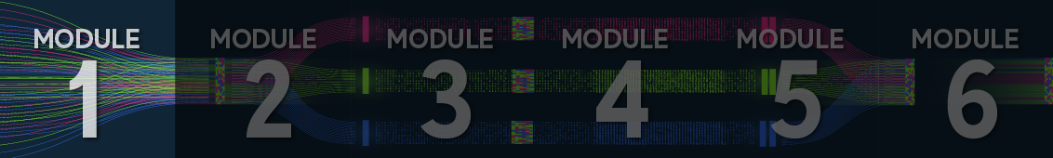

1.1 Introduction to Using Randomness in Simulation
This section introduces the idea that randomness can be very useful in creating simulations of real world problems.
Read through the following pages in order, taking notes as you go and running any example code (if applicable). An optional vocabulary exercise is provided to help you check your understanding.

1.1.1 Introduction to Using Randomness in Simulation
Simulation is a big word, with many meanings across science and engineering. In general, it refers to creating an imitation of a system or process. In the context of this course, that simulation would be in silico; that is, in a virtual environment on a computer.
Simulations play many valuable roles in industry, finance, and government and are key tools in science and engineering. They allow you to perform experiments to answer ‘what if?’ questions and to explore scenarios. In the context of data science, you can examine systems for which you don’t have complete data (yet). For instance, you might use simulation in the green fields design of a new telecommunications network. You can also use simulation to extend the datasets that are available to train machine learning algorithms.
In this course, discrete event simulations (DES) will be of primary interest. You will hear a lot more about these. It should be obvious from the name that these simulations involve simulating a set of events, and that these are discrete in the sense that they are separate and discontinuous. What is not so obvious from the name is that they are simulations that involve randomness, which is introduced in a controlled manner.
Randomness is a powerful tool even for understanding deterministic systems. It is a means to abstract complexity and results in simulations that are easier to build and easier to interpret.
A very simple random simulation might be a simulation of a gambling game. At each time, you bet 1 dollar on the outcome of a coin toss. If a Head appears, you win, and if the coin shows Tails, you lose. The simulation tracks the amount of money you have left until (i) you go broke, or (ii) you have won one hundred dollars.

Know the Starting Point
You may notice that some details have been left out here. Notably, in a gambling simulation, you should know the starting point, i.e. how much money you start with. All simulations need to have a starting state.
This simulation is very simple in concept, but it has all of the pieces needed. It uses randomness in a controlled way to understand a process. It keeps track of state (the amount of money in your bank), and it can answer questions of the form, ‘what is the chance that you go broke?’ The simulations you will work with are bigger and more complicated, but qualitatively the same.

1.1.2. Applications of Simulations
Simulations are used where:
1. you have a new system, and you want to understand it prior to physically implementing it, such as:
- purchasing new equipment to justify the purchase
- trying new strategies, methods, or layouts.
Simulations are particularly helpful to find hidden interactions between elements of a complicated process.
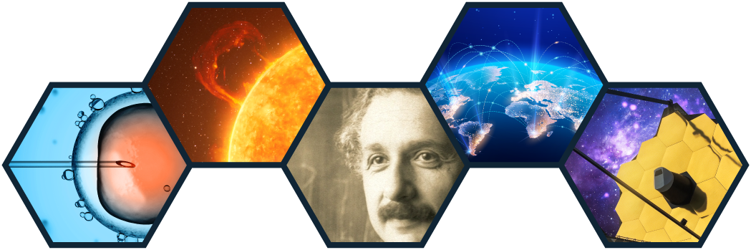
2. it might be very expensive, dangerous or even impossible to gather data, such as:
- to understand the inside of a star (like the sun)
- to model a worldwide network (like the internet)
- to study if there is the potential for harm in a medical intervention
3. you want to quickly explore possibilities without all the hassle of designing and conducting real-world experiments.


Many industries use simulation:
Health providers(hospitals, ambulance services) often use simulation to improve the efficiency and speed of patient treatments. Telecommunications providers frequently use simulation to plan their networks to improve efficiency, reliability and performance. Logistics and supply companies use simulation as part of their process to improve delivery times and to optimise costs. Transportation planners(public transport, highways departments) use simulations to plan new services; for example, a new bus route or the positioning of potential new traffic lights or turn lanes. Power and energy companies use simulation to improve their network’s reliability; for instance, by planning redundant capacity to allow for some outages. Defence organisations use simulation to ‘wargame’ complex combat scenarios.
Scientists also use simulations frequently to test a theory either directly by comparing a model to reality or by generating data that can be tested through new experiments. However, this course is called Decision Science because it applies the scientific method to decision-making to help decision-makers make choices that are carefully justified and informed by systematic and quantitative results.

The Scientific Method
The scientific method is not one concept, but rather a complex series of processes and philosophies about how to use data to provide rigorously justified theories. The method is commonly associated with the idea of posing questions (hypotheses) that are tes through experiments that collect precisely controlled data. In this course of study, the data you use is generated by in silico experiments, but in many other respects, your activities resemble traditional science.
In many of the applications described here, simulations are used a side mathematics and data science.
Simulation is increasingly used in conjunction with machine learning as a means to expand the training datasets needed by heavy-weight machine learning techniques like deep networks.
The discussion on the next page will give you the opportunity to further explore the application of simulations in a real-world context.

1.1.3. Determinism and Randomness
A deterministic system is one in which, given the initial state, you can, in principle, determine all future states of the system.
Many real-world systems are deterministic. In fact, there are millions of deterministic systems, but the interesting ones are the ones that we think are random, but are, in fact, deterministic. For example, flipping a coin or rolling a die.
If you were given the exact velocity and starting point when rolling a die, you could use mathematics and physics to predict where it will collide (say, with your desk) and how that will affect subsequent motions and hence other collisions. However, you know that such a calculation is actually impossible. The die’s motion might be deterministic, but it is so complicated that you can never perform these calculations in practice.

The historical study of randomness
The serious mathematical study of randomness started in the 16th century with mathematicians who wanted to understand gambling, among other topics. Pioneers like Gerolamo Cardano, Blaise Pascal and Pierre de Fermat showed how these ideas could be applied to winning dice games. So, it should not be surprising that one of the most common means to provide intuition about random systems is through analogies to gambling games.
When systems become too complicated to predict exactly, you often resort to modelling them as random. This is not the same as saying they are random. A model is a useful mathematical tool that abstracts unneeded detail to focus on what is essential.
It is always useful to keep in mind George Box's quote:“All models are wrong, but some are useful.”
Whenever real natural phenomena are modelled, particularly at the micro-scale, this modelling tends to use some form of randomness (sometimes referred to as stochasticity). A simple example is the spread of a disease across a population. The exact mechanics of transmission can be very complex. Sometimes, they are not fully known. The simplest mathematical models use concepts like exponential growth to model the overall trend of the spread of a disease. But crude, large-scale models did not capture many interesting aspects, such as flattening the curve by adopting prevention measures. To understand these phenomena, epidemiologists use micro-scale models that considered individuals and how a disease might jump from one to another. Those models included randomness because people are so complicated that you cannot predict their individual actions, even ignoring all the details of their environment.
Random simulations have limitations. Most notably, the results are not fixed. Thus, you cannot hope to understand a scenario through a single instance of a simulation. You must run ensembles of simulations and use careful statistical methods to analyse the results. In order to do so, you must apply randomness carefully. You must have just the right amount of controlled variation. That is, enough random variation to allow for the complex interactions in the system being studied, but enough control to make yours in silico experiments analysable and reproducible.

1.1.4. Monte Carlo v Las Vegas
Simulations that include a random element are often called Monte Carlo simulations after the city famous for its casinos. There are other cities famous for their gambling—Las Vegas being chief among them—and hence other names are used to hint at subtle differences in the simulation world. It is instructive to think a little about these before starting to build such simulations.
The standard terminology has it that:
- Monte Carlo simulations perform a fixed number of random steps. The final state is random, but the time at which you finish is deterministic.
- Las Vegas simulations perform a random number of (random) steps, but, in doing so, remove some element of randomness from the final state.
For instance, consider the earlier example of betting on the outcome of a coin toss.
- A Monte Carlo simulation would simulate a fixed number of coin tosses. The final state might be that you ran out of money (or went into debt) or earned some random amount of winnings.
- A Las Vegas simulation of the same process might run until you run out of money. The time until you run out of money is random, but the final state is not (i.e. you have zero money left).
Neither approach is universally superior. Each takes a different amount of computing power and each answers different questions. What this demonstrates is that the first design choice you need to make when building a simulation requires you to think about the question you want to be answered. For example, do you want to know the average amount of money you will have after 10 bets, or do you want to know how you can keep betting?
The design of simulations is a big topic—large enough to fill this course at least—so you won’t touch on all of the issues right now. What you should take from this is that when you use randomness (in any context), there are some deep thought processes needed. Notably, the design of a simulation should be linked to the questions you want to be answered. We will return to this theme several times in the course.

Questions
1. Imagine you are running a call centre and you want to estimate the proportion of time that your operators are answering calls. Which type of simulation would be best to use—Monte Carlo or Las Vegas?
SELECT TO VIEW ANSWER
Monte Carlo simulations are ideal for estimating behaviour of ongoing systems. The simulation can be run for a fixed amount of time, determined by the statistical accuracy required.

2. Imagine you work for a car manufacturer and you are contemplating replacing an old model of car with a new car. You aim to use a simulation to estimate how it will take to sell off all the old models. Which type of simulation would be best to use—Monte Carlo or Las Vegas?
SELECT TO VIEW ANSWER
Las Vegas. Las Vegas simulations are ideal for estimating the time until the “end” of some process. The length of the simulation will be random, but when it finishes, it will be in the end-state (with all of the old inventory sold).

Optional vocabulary exercise (1.1)

1.2 Recap of Simple Probability
This section revises some fundamental concepts from probability. These are assumed knowledge for this course.
- Read through the following pages in order, taking notes as you go and running any example code (if applicable).
- An optional vocabulary exercise is provided to help you check your understanding.

1.2.1. Introduction

Recap of Simple Probability
In this section, we will review the basics of probability and statistics that will be useful throughout the rest of this course.
Probability is the branch of mathematics that deals with randomness. I recommend that you work through this to make sure you are familiar with these concepts.


Probability and statistics are two linked concepts that also have a wealth of applications outside of this course. Every government office uses statistics in some way. Every well-founded health or medical study uses statistics. A large number of engineers use statistical tests every day. Statistics is used to analyse data, so it lies underneath all of data science. Probability provides the theory on which statistics is based so it is even more fundamental. The two together are a powerhouse of modern applied mathematical sciences.
The two together are a powerhouse of modern applied mathematical sciences.
In this topic, you will:
- learn about a random variable,
- tackle some of the notation and definitions that will be used throughout the course,
- cover useful sample statistics to use in data,
- encounter the distributions you will use in this course,
- learn about expectations and variances.
Now, it is time to get your thinking cap on! Are you ready for some statistics?

1.2.2. Random variables & sample spaces
Firstly, have a look at randomness and how you can use this to create simulations of the real outside world.
In mathematics, the concept of randomness can be captured by a random variable. A random variable is just a scary name that is given to a quantity that can take a lot of different values with some probability.
For instance, if you toss a coin three times, you do not know how many Heads you are going to see. In this sense, the number of Heads you are going to see is random.
Random variables pop up in all sorts of situations:
- You might count the number of red cars you see drive past on a stretch of road in an hour. The number of red cars would then be a random variable.
- You might be interested in how you have to wait until you see another patient arrive in the emergency department. The times between each arrival are random variables.
- You might be launching a satellite, and want to want to model the errors in a rocket trajectory. Rocket motors are violent engines, and so they don’t produce a perfectly designed amount of thrust. The random variable could be the height of the orbit of the satellite.
- You might count the number of people who want to buy new clothes on an online clothing website on a given day.
- You might measure the rainfall during one day at a given location.

A probability is a number between 0 and 1 that provides a measure of how often you expect to see a certain outcome for a particular random variable. For instance, you might have a probability of 0.5 of seeing one red car in one hour, so you expect to see one red car about 50%of the time. The notion of probability allows you to capture how uncertain you are of a particular number (or collection of numbers).
- For instance, if you toss a coin three times, the possible outcomes could be that you see one Head (H), then two Tails (T), which you could denote as HTT. You could also see two Tails, and then a Head, which you could denote as TTH. Following on from this idea, you could write down all possible outcomes and the sample space would look something like this:
- Another example of a sample space would be how many red cars you see in an hour. This always has to be a positive, whole number and could range anywhere from seeing 0 red cars, to seeing infinitely many (this can’t happen in real life, but it can in theory). So, your sample space would look like this:
Random variables and sample spaces appear in a whole bunch of interesting areas, and they provide a great way to model and estimate random events that you want to occur in your simulations.
Now that you are thoroughly confused, it’s time to take a dive into some definitions and examples to clarify all these ideas.

1.2.3. Notation
First up, a clarification of how notation is used. A random variable will always be denoted by an upper-case letter, usually a W, X, Y, or Z. If you want to represent an actual number you have observed for this random variable, you will denote this by a lower-case letter, e.g. x is an observed value (actual number) of the random variable X.
This can get a bit tricky to follow, but just remember that big letters mean that it is random (i.e. you don’t know what it is yet), and little letters mean that it has been observed (i.e. you have an actual number for it).
Check your understanding
When you want to talk about the probability of a value being seen, you use something that looks like P(X = x). For instance, if you let X be a random variable, you would denote the probability that X is equal to the number 5 by P(X = 5), and you would denote the probability that X is equal to the number 0.1 by P(X = 0.1). This gives you a succinct way to communicate the probabilities you want to talk about.
Now, you will commonly see a sample space denoted by either S or Omega(the Greek letter omega). Remember, this is just the set of all possible values you can see for your random variable. For your random variable X, you might write something like:
S = x : P(X = x) gt 0 .

Set Notation
All that notation you see on the right-hand side of this equation is known as set notation. A set is simply a collection of objects which you usually wrap in curly brackets. For example, Apple, Orange, Potato i s a set. The colon (:) is read as ‘such that’ in set notation. So, you can read this expression as ‘The set of all x values such that the probability that X is equal to x is greater than 0’. All set notation is doing is giving us as Data Scientists a concise way to express lengthy sentences about possible data values.
You can get fancy with your set notation. If you have multiple different random variables you are talking about, you may want to specify the sample space for which variable you are referring to. You can denote this by a subscript of the random variable. For instance, if you have two random variables X and Y you could denote the sample space of X by S_X and the sample space of Y by S_Y.

Summary
There is some notation for you: capital letters for random variables and lower-case letters for observed variables, not to mention P s for probabilities and S s for sample spaces. You can now use this notation to start defining random numbers, or random variables, as they will be called. Once you have some random variables defined, you’ll be able to do some calculations.

1.2.4. Defining a random variable, CDF and PDF
There are two categories of random variables, and they are a little different. First, an explanation, and then you will get to the nuts and bolts(or details).

Categories of random variables

Broadly speaking, random variables come in one of two flavours: (i) discrete random variables or (ii) continuous random variables.


counting things.
A discrete random variable is a random variable that deals with counting things. For instance:
- If you count how many Heads you see when you flip a coin three times.
- If you count how many red cars you see in one hour.
- If you count how many calls a service centre receives in a day.

continuous random variable objects
A continuous random variable can be thought of as measuring something. For instance:
- If you measure the height of a 10-year-old girl, the girl’s height is a continuous random variable.
- If you measure how you have to wait for a patient to arrive in the emergency room, the time you have to wait is a continuous random variable.
- If you measure how many minutes are between each phone call in a service centre, the number of minutes is a continuous random variable.

So, what is the difference between a continuous random variable and a discrete random variable?
In all honesty, there isn’t a lot, but you do have to treat them slightly differently. These differences make themselves most apparent in the probability density function (PDF). Before you get to that, you will learn about the cumulative density function (CDF).

Cumulative density function (CDF)
Scientists, mathematicians and engineers need formal definitions; that is, equations that express an idea precisely. The formal definition of a given random variable starts either with the probability density function(PDF) or the cumulative density function(CDF). You will start here with the CDF.
Formal mathematical definitions elevate your level of precision and rigour in expressing a complex idea. Formal arguments abstract the details so that we can see the “form” of the argument and assess its truth (or falsity) without all of the everyday baggage that can lead to confusing arguments. So formal arguments are much more rigorous than heuristic or intuitive arguments. To put it another way, often formal mathematics is written in algebraic terms, e.g., X or Y, that fill in for real objects or quantities. This means when manipulating X and Y in an abstract way, we are not confused by their meaning and our personal values in the way we might if X meant “kittens” and Y meant “poison gas”. This allows us to see the pure form of the argument. The cumulative density function tells you the probability that a random variable lies below some level, i.e. the CDF F(x) is the probability
F(x) = P(X ≤ x).
You may find this definition isn’t completely obvious, but you’re starting here because it works for both discrete and continuous random variables. The function has several properties: For all x you must have 0 ≤ F(x) ≤ 1 which follows because it must be a probability. It is a non-decreasing function, which follows because as x increases, the probability can’t get smaller. The CDF (as defined here) works for discrete and continuous random variables, but it will look different. For a continuous random variable, it will be a smooth curve (from 0 up to 1), but for a discrete random variable, it will be made up of a set of steps, with each step at one of the possible values of the variable.
Closely related to the CDF is the PDF.

Probability density function (PDF)
A probability density function is a function that helps you describe how likely you are to see values for a certain random variable. Basically, given a value from your sample space, the PDF will tell you how often you can expect to see that value. For a discrete distribution, which takes values i(which are whole numbers), you might write these using several different notations:
p_i = p(i)= P(X = i).

Probability Mass Function
If you go searching on the Internet, you will commonly see the PDF for a discrete random variable referred to as a probability mass function. This is just different terminology for the same thing.

You have to be a little more careful about continuous distributions. For a continuous distribution, the PDF is denoted by f(·) and defined in terms of the CDF as
f(x) = (dF) / (dx),
that is, it is the derivative of the CDF. You have started here with the definition of a CDF, but you could start by first defining the PDFs and then working out CDFs using integration.
When defining random variables, use whichever approach is most intuitive for the particular case. This often means starting from the PDF.
The definitions are a bit loose here. For a continuous random variable Y, the PDF f(y) does not directly give the probability of seeing the value y. This is because, in the continuous setting, it does not make much sense to talk about the probability of seeing a single value. You don’t need to get bogged down in this, but you should definitely be aware of it.

1.2.5. Example distributions
The definitions of CDF and PDF are probably a little hard to visualise so, on this page, there are some standard examples of random variables. The idea of a random variable is very flexible. It can encompass almost any sort of random behaviour, but, most of the time, you will work with a very small set of random-variable families, which are called distributions. Consider 1.1, which provides a set of example distributions.

Distribution | Class | Parameters | CDF | PDF
Discrete Uniform | Discrete | n | x/n | 1/n
Bernoulli | Discrete | p | p,1 | (1-p), p
Binomial | Discrete | n and p | - | nchoose x p^x (1-p)^n - x
Uniform | Continuous | a and b | (x-a) / (b-a) | (1) / (b-a)
Exponential | Continuous | θ | 1 - e^-(x) / (θ) | (1) / (θ) e^-(x) / (θ)
Pareto | Continuous | α and β | 1 - (β^α) / (x^α) | (α β^α) / (x^α + 1)
Normal | Continuous | μ and σ^2 | - | (1) / (sqrt(2 π) σ) e^-((x - μ)^2) / (2σ^2)

NOTE: It doesn’t really matter what symbol you use for a parameter. You could use σ for the parameter in the exponential distribution. However, the choices in this are pretty common.
A feature of each distribution, which you can see in 1.1, is a set of parameters.
Each type of distribution is a family, each with similar PDF/CDF definitions, but variations in some numerical details captured in these parameters (note some elements of the are a little complex to write down, so I have omitted them).
So, although only a few distributions have been defined, these can be used to create a wide range of simulations.
On the next page, you will learn why and how you would use each of these common cases.

1.2.6. Discrete distributions
Finally, you get to deep dive into some lovely distributions. I’d like to introduce three discrete distributions that often appear in nature: (i) the discrete uniform distribution, (ii) the Bernoulli distribution, and (iii) the Binomial distribution.
I chose these three because they are the standard starting point in any course on probability, but also because these three will be used in this course. The uniform distribution is used for modelling simple random events like dice. The Bernoulli distribution is used when you have a yes-no or true-false question. And the Binomial distribution is used in analysing many types of statistical data. There are many other examples of interest in a broader course on probability and statistics, but these three are enough for you to work with simulations.

1. The discrete uniform distribution
Let X be a random variable. Suppose that the sample space S of X is finite, that is, you can explicitly write down every single element of the sample space (even if it takes a while). Further, suppose that each element in the sample space is equally likely to occur. Then X is said to follow a discrete uniform distribution, and the PDF of X is given by:
p(x) = (1) / (n) ,
for all x in S, where n is the number of elements in S. Figure 1.1 illustrates the PDF and CDF for a uniform distribution over the set 1,2,3.
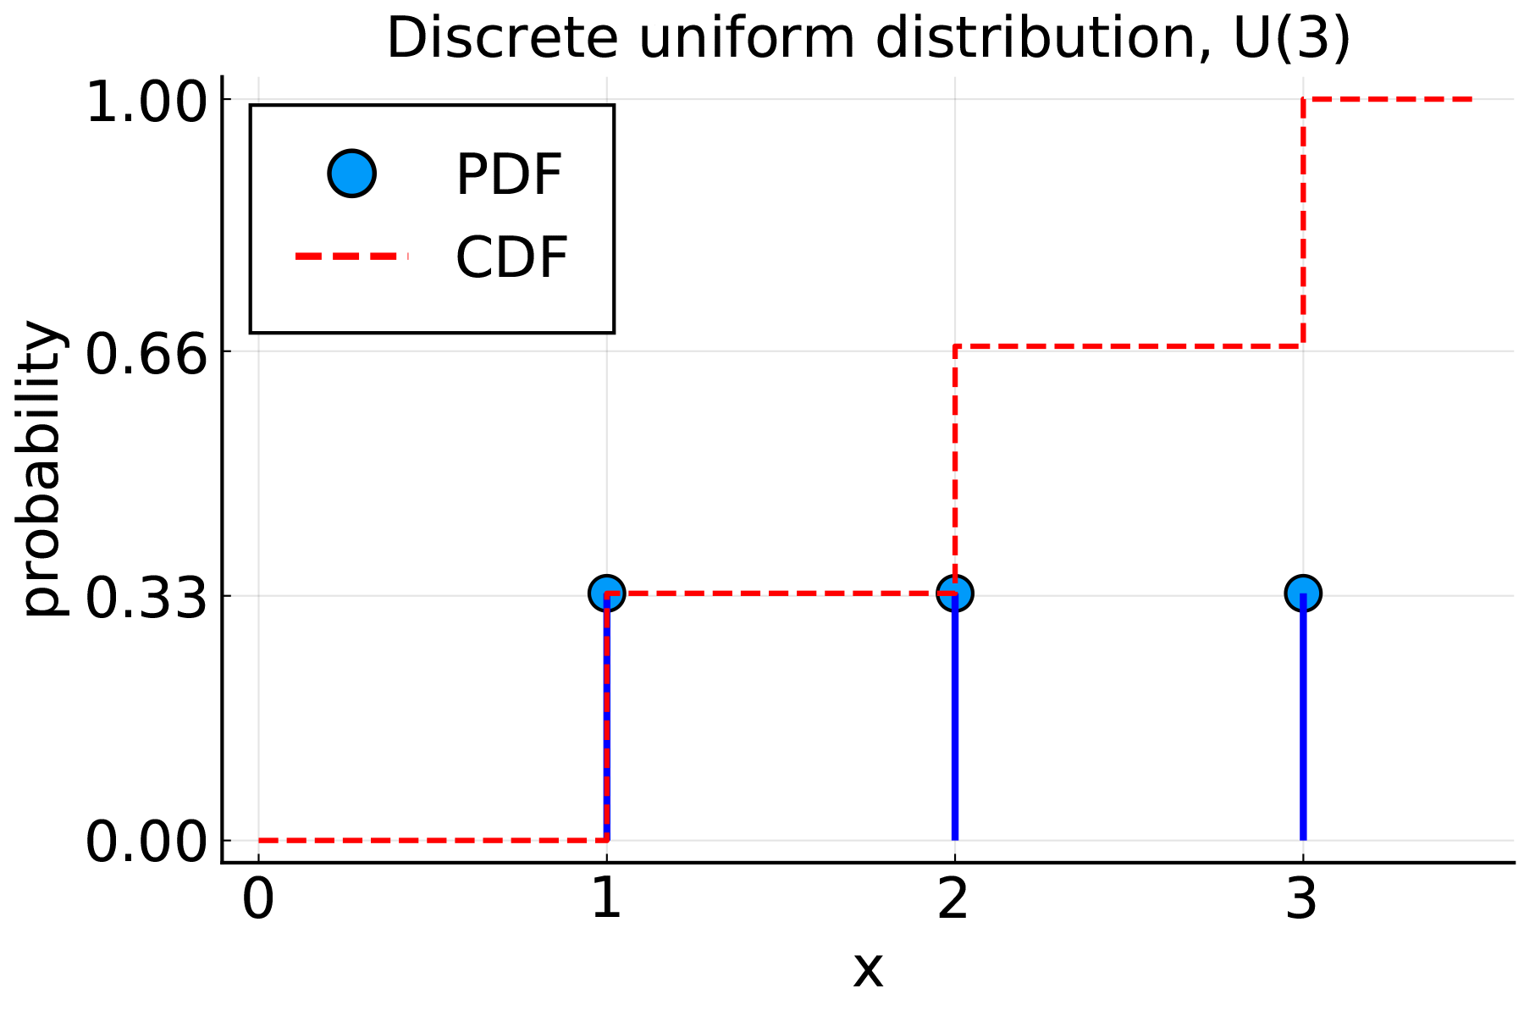
Discrete uniform distribution
X-axis is labelled 0, 1, 2, 3. Y-axis (probability) is labelled 0.00, 0.33, 0.66, 1.00.
CDF is represented by a step wise dotted line beginning at(0, 0.00),(1, 0.00),(1, 0.33),(2, 0.33),(2, 0.66),(3, 0.66),(3, 1.00). PDF is shown as three points:(1, 0.33),(2, 0.33),(3, 0.33).
The discrete uniform distribution is super useful in real life. Most of the time with real data, you will not know the underlying distribution, so a discrete uniform distribution gives a nice way of treating a sample as everything you may see, and deriving probabilities based on this. So it’s the standard model for dice—assume the faces of a 6-sided die all occur with equal probability unless there is some data that shows that the die is biased.
You may have noticed that this is called a discrete uniform distribution. You may have guessed that there is a continuous version of this random variable, which you will see later.

2. The Bernoulli distribution
- You ask someone to marry you, and they say Yes or No.
- You flip a coin and see either a Head or Tail.

Bernoulli model assumptions
Technically, it is possible for a coin to land on its edge. Our Bernoulli model assumes that this is so unlikely that you don’t have to include it in the model. Likewise, I am assuming that your proposal can only receive a Yes or No, not a “Maybe”. If you need to include Maybe, then you need a bigger model.
In each of these situations, you can denote the outcome you are interested in (i.e. you see a Head) as the value 1, and the outcome you are not interested in (i.e. you see a Tail) as 0. Let X be the random variable that is 1 if you see the outcome you are interested in, and 0 otherwise. Then X is said to be a Bernoulli random variable. If p is the probability that you see the outcome you are interested in, then the PDF of X is given by:
p(x) = cases: p & if x = 1 , 1-p & otherwise .
You use the notation Y ~ Ber(p) to say that Y is a Bernoulli random variable with parameter p, as defined above.

3. The Binomial distribution
- You may flip a coin three times, and see either a Head or Tail on each flip.
- You may ask 10 people on a date, and they say Yes or No (assuming one person saying Yes or No does not affect what any of the other 10 people will say).
- B: There is a B inomial outcome for each trial, i.e. a yes/no kind of situation.
- I: Each trial is I ndependent, i.e. the result of one trial does not affect another (more on independence soon).
- N: There is a fixed N umber n of trials, i.e. you may have 5 trials.
- S: There is a fixed probability p of S uccess, i.e. each trial has the same probability of seeing the outcome you are interested in.
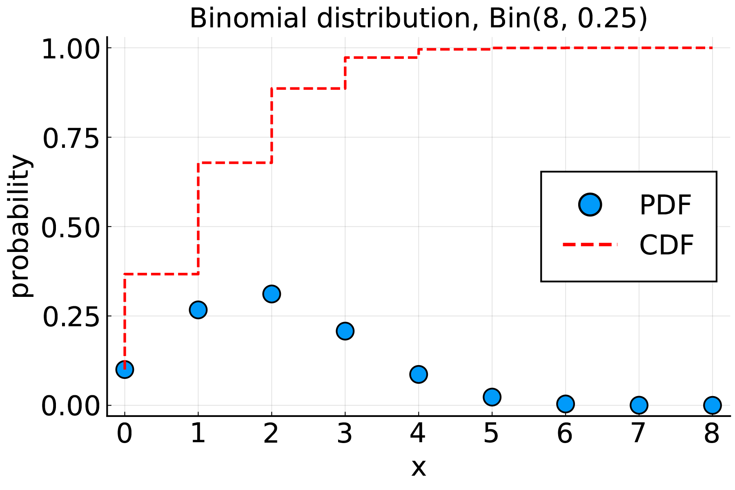
CDF and PDF of the binomial distribution
X-axis is labelled 0, 1, 2, 3, 4, 5, 6, 7, 8. Y-axis (probability) is labelled 0.00, 0.25, 0.50, 0.75, 1.00.
CDF is represented by a step wise dotted line beginning at(0, 0.10),(0, 0.375),(1, 0.375),(1, 0.70),(2, 0.70),(2, 0.875),(3, 0.875),(3, 0.95),(4, 0.95),(4, 1.00),(5, 1.00),(6, 1.00),(7, 1.00),(8, 1.00). PDF is shown as nine points:(0, 0.10),(1, 0.25),(2, 0.33),(3, 0.25),(4, 0.12),(5, 0.075),(6, 0.025),(7, 0.025),(8, 0.025).

Binomial Coefficient
Notice the funny symbol n choose x. This is read as n choose x, and is known as the binomial coefficient. It counts how many ways you can see x objects out of n total choices, and is defined by
n choose x = (n!) / (x!(n-x)!),
where!denotes the factorial.
So, that is a small set of discrete distributions. There are many more: the Poisson distribution, the geometric distribution, and so on, but you won’t be using those in this course. Next up, I’ll introduce some of the continuous distributions you will work with.

1.2.7. Continuous distributions
Continuous distributions are fundamental in so many real-world applications. Their behaviour lets you capture many things you would like to measure in the world, for example waiting times or distance travelled.
Here, I will introduce four useful distributions: the uniform distribution, the exponential distribution, the Pareto distribution, and the normal distribution.

1. The uniform distribution
The uniform distribution is finally back. Previously, you learnt about having a finite set of observations and saying each element has an equal chance of being observed. The continuous uniform distribution is very similar but stretches this out to an infinite set of possible observations.
To define the uniform distribution, you set the bounds by giving two real numbers a and b with a < b. Then the random variable Y has a uniform distribution if it has the PDF:
f(y) = cases: (1) / (b - a) & for a ≤ y ≤ b , 0 & otherwise .
You can see from this definition how the uniform distribution generalises the discrete case. That is, it assigns all values of y between a and b the same probability of occurring. It can be said then that the random variable Y follows the uniform distribution the interval[a,b], or more succinctly Y ~ U(a,b).
A very useful case of the uniform distribution is the case when b = 1 and a = 0. Figure 1.3 illustrates the PDF and CDF of this case. An observation y of this uniform distribution is a value between 0 and 1, denoted by Y ~ U(0,1).
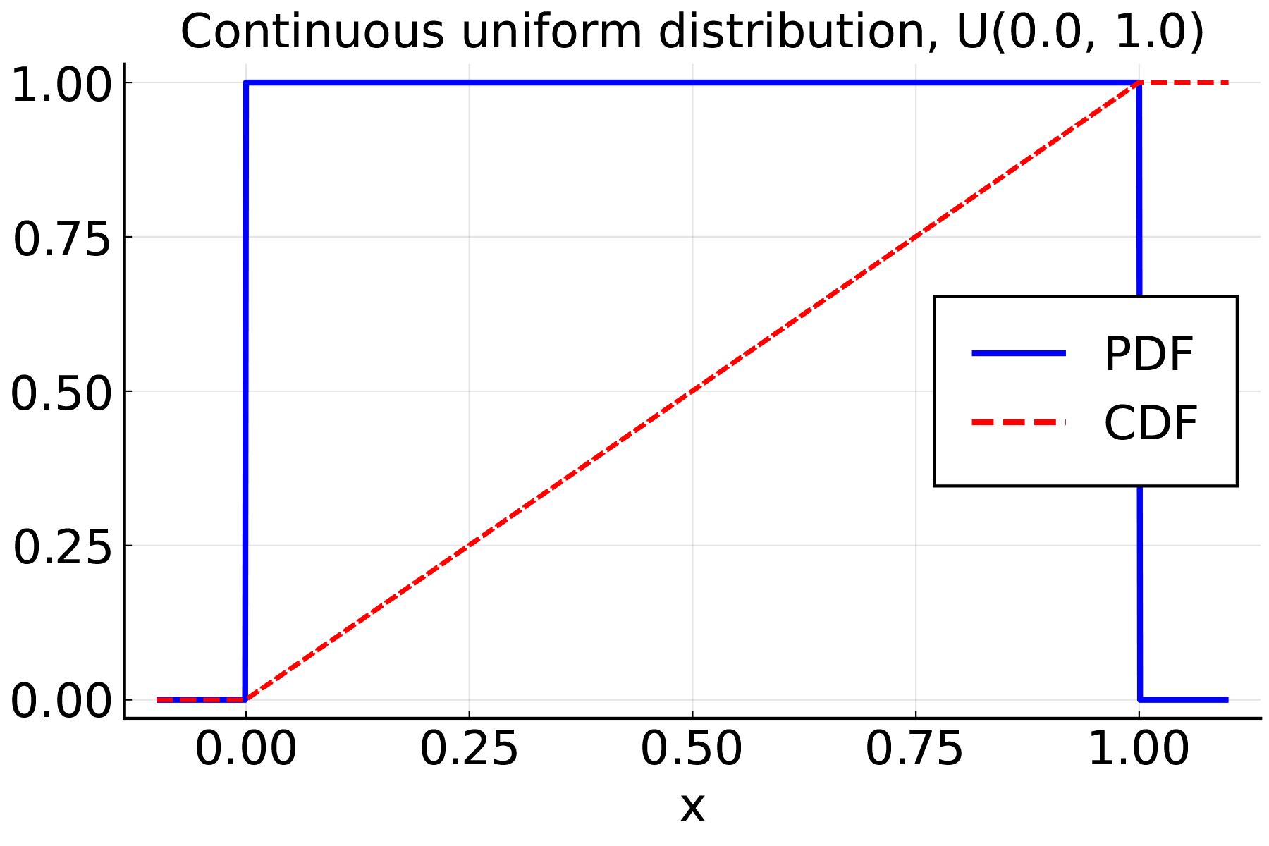
Plot of PDF and CDF for continuous uniform distribution U(0, 1)
X-axis is labelled 0.00, 0.25, 0.50, 0.75, 1.00. Y-axis is labelled 0.00, 0.25, 0.50, 0.75, 1.00.
CDF is represented by a dotted line commencing at(0.00, 0.00) and rising at a 45-degree angle to the point(1.00, 1.00). PDF is shown as a line commencing at(0.00, 0.00), rising straight up to(0.00, 1.00), then a horizontal line across to(1.00, 1.00) and then dropping vertically to the point(1.00, 0.00).
Uniform distributions are useful themselves, but also play a crucial role when you want to simulate more complicated distributions.

2. The exponential distribution
The exponential distribution is often used to measure how you will wait between some events. For instance, you might use an exponential time to measure how you have to wait between calls in a call service centre or between arrivals of patients at an emergency department.
Now, to define the exponential distribution, you need a mean parameter θ > 0 that describes the mean time you are interested in. If Y is a random variable with an exponential distribution, then the PDF of Y is given by:
f(y) = cases: (1) / (θ) e ^-(y) / (θ) & for y ≥ 0 , 0 & for y < 0 .
A key thing to note here is that the exponential distribution is only defined for positive values; that is, it can only be used to measure positive valued numbers like time. You often need to generate non-negative random variables in simulations.
This distribution has been defined in terms of its PDF, but I could equally well have started with its CDF:
F(y) = 1 - e^-(y) / (θ).
You can check that one is the derivative of the other, should you wish.
Figure 1.4 shows the CDF and PDF for the exponential distribution for the case θ=1.0.
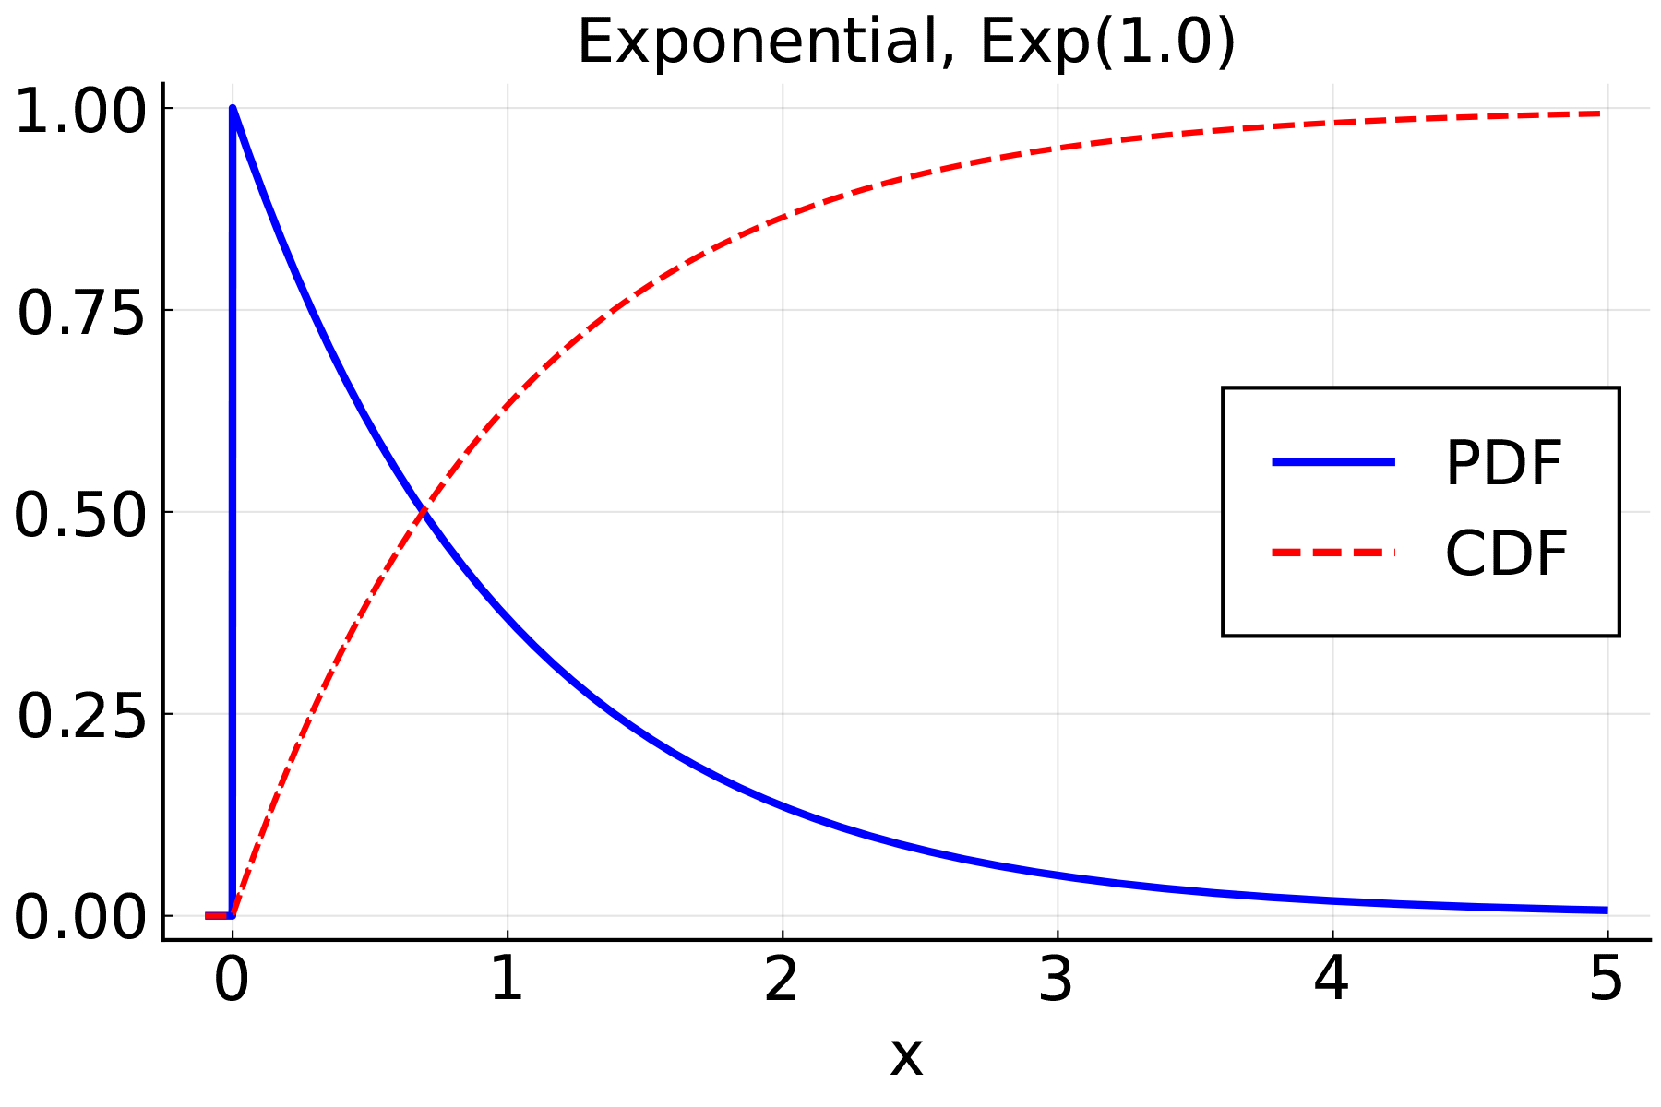
Plot of PDF and CDF for exponential distribution Exp(1.0)
X-axis is labelled 0.00, 0.25, 0.50, 0.75, 1.00. Y-axis is labelled 0.00, 0.25, 0.50, 0.75, 1.00.
CDF is represented by a dotted line commencing at(0.00, 0.00) and rising at a 45-degree angle to the point(1.00, 1.00). PDF is shown as a line commencing at(0.00, 0.00), rising straight up to(0.00, 1.00), then a horizontal line across to(1.00, 1.00) and then dropping vertically to the point(1.00, 0.00).
An exponential random variable Y is denoted by Y ~ Exp(θ).

3. The Pareto distribution
- human settlement sizes,
- file size distribution for Internet traffic,
- the amount of time you may spend playing different games on Steam.
Figure 1.5 illustrates the PDF and CDF for a Pareto distribution with α=β=1.0. Note that it looks superficially like the exponential distribution, albeit starting at 1.0 instead of 0.0, but the key difference is that the tail is much heavier.
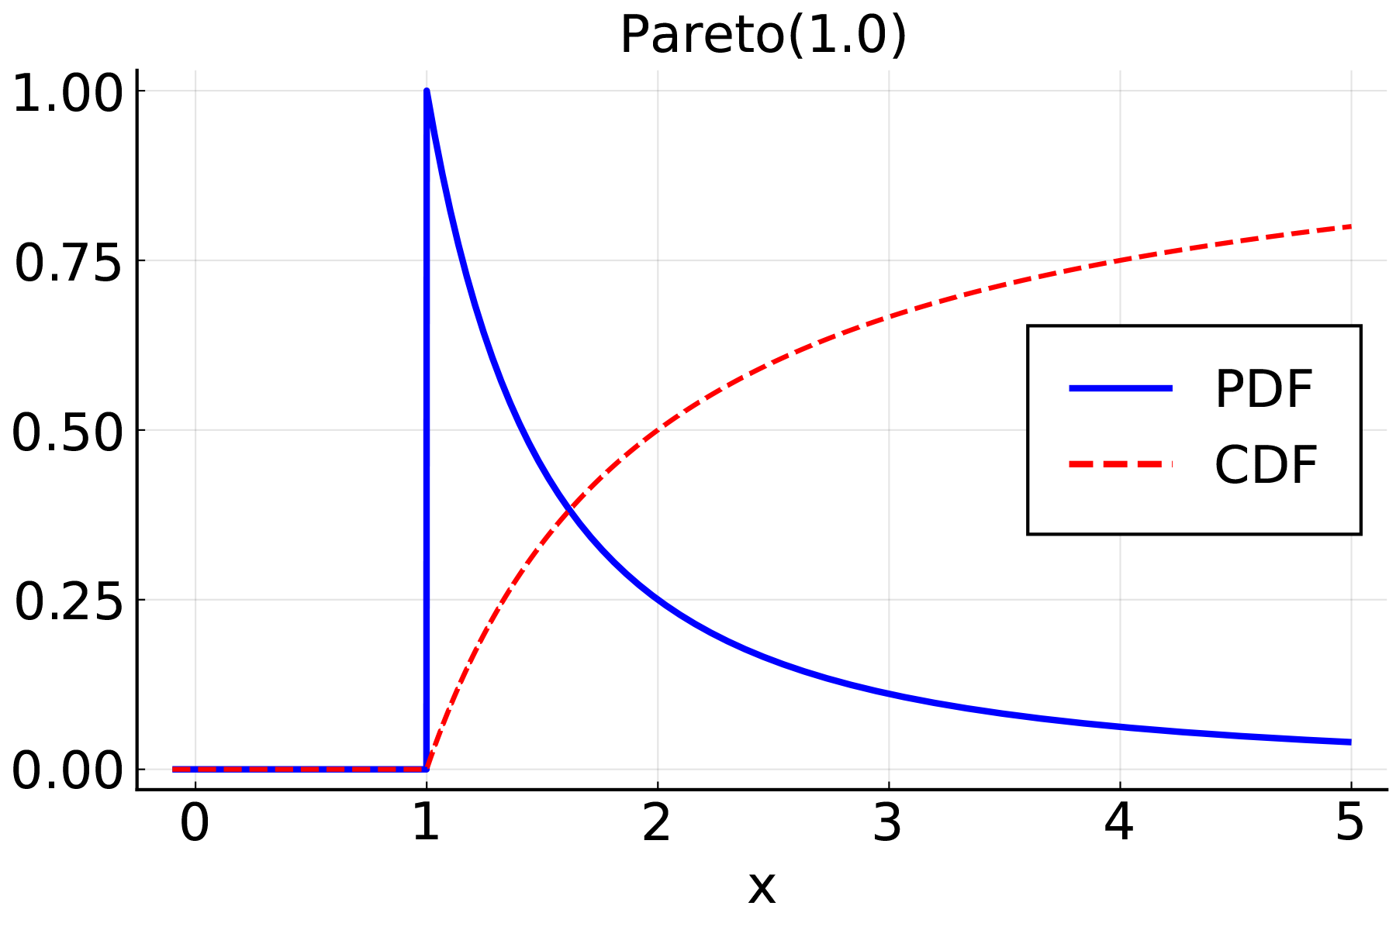
Plot of PDF and CDF for Pareto distribution, Pareto(1.0)
X-axis is labelled 0, 1, 2, 3, 4, 5. Y-axis is labelled 0.00, 0.25, 0.50, 0.75, 1.00.
CDF is represented by a dotted line commencing at(0, 0.00) a to point(1, 0.00), then rising in an arc through the points(2, 0.50),(3, 0.70),(4, 0.75),(5, 0.80). PDF is shown as a line commencing at(0, 0.00) a to point(1, 0.00) rising straight up to(1, 1.00), then dropping in an arc a the points(2, 0.25),(3, 0.125),(4, 0.10),(5, 0.075).
A Pareto random variable Y is denoted by Y ~ Par(α, β).
You may note that the Pareto distribution only generates numbers larger than β. There are actually variants of this distribution, and some start at zero, but then their PDF and CDF are more complicated, so the simple variant is used here.
The Pareto distribution has a very interesting property—it is heavy-tailed. There is a formal definition for heavy tails, but intuitively, it means that although very large events are unlikely, they can be so large that they are still important.
A simple case to consider is earthquakes: there are many, many more small earthquakes than large earthquakes. Most of the small events are not even felt. However, the large ones, while rare, are so damaging that they are of greater interest than the vast majority of small events. There are times in simulation when you would like to include this property, and the Pareto distribution is a natural way to do so.

4. The normal or Gaussian distribution
Finally, you come to the mother of all distributions. The normal distribution is a very widely used and much-loved distribution. It might be the first distribution you encounter in a typical course on statistics.
To describe a normal distribution, you need to know two parameters. You need the mean parameter μ, which can be any real number, and you need the variance parameter σ^2, which can be any positive real number. The mean parameter is very similar to the shape parameter of the Pareto distribution, and the variance parameter is similar to the scale parameter.
Now, if Y is a normally distributed random variable, then the PDF of Y is given by:
f(y) = (1) / (sqrt(2 π) σ) e^-((y - μ)^2) / (2σ^2) .
Notice how this PDF is defined for absolutely all possible values of y, that is, y can be any real number whatsoever. But don’t worry. In practice, you will only see values of y that are relatively close to the mean parameter μ.
Figure 1.6 illustrates a normal distribution with μ=0.0 and σ=1.0. You can see the characteristic bell-shaped curve of the PDF.
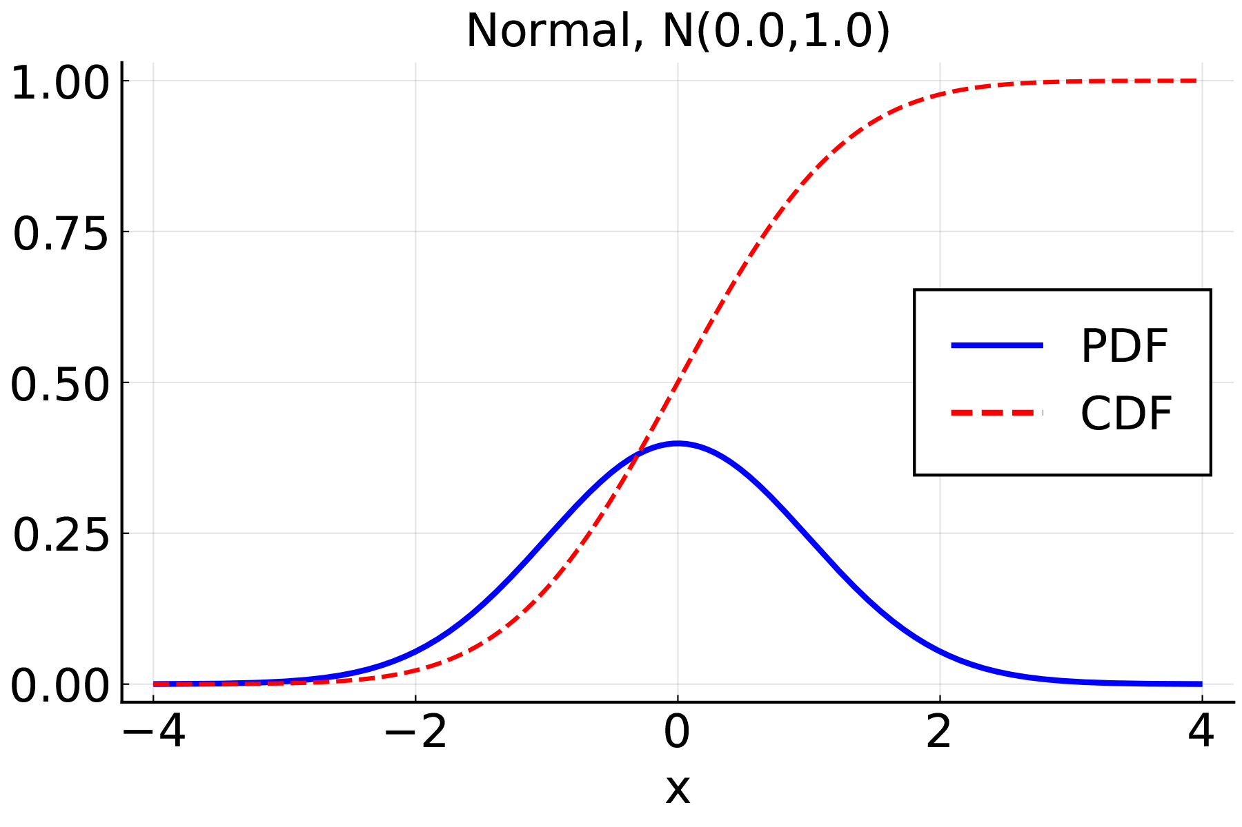
Plot of PDF and CDF for normal distribution, N(0,1)
X-axis is labelled -4, -2, 0, 2, 4. Y-axis is labelled 0.00, 0.25, 0.50, 0.75, 1.00.
CDF is represented by a dotted line commencing at(-4, 0.00) then rising in a sigmoid function through the points(-2, 0.050),(0, 0.50),(2, 0.95),(4, 1.00). PDF is shown as a bell curve starting at(-4, 0.00) passing through(-2, 0.10),(0, 0.375),(2, 0.10),(4, 0.00).
It is hard to write a formula for the CDF of the Normal distribution, but most numerical or statistical software has a standard routine to calculate this.
The normal distribution is very commonly seen in statistics, and indeed that is how you will use it here. You will use it to analyse the output statistics from your simulations.
So, there are a whole bunch of distributions for you to mull over. There are many more, but the ones introduced here will appear time and time again throughout the course.
Now, it’s time to dive into some of the things you can do with these distributions. In particular, you will see some of the properties known for these distributions. These properties will be useful for making quick, back-of-the-envelope estimates, and for analysing the results that come out of a simulation, but they are very general ideas and can be applied, for instance, to analyse data directly. You may have seen some of these discussed in prior modules.

1.2.8. Expectation
You started with defining random variables in terms of their CDF and PDF, but often you need to know other properties — most importantly, the expectation or mean or average.
Mathematicians use the word ‘expectation’ instead of mean or average. This is to make sure there is no confusion with the common meanings of words like ‘average’. Using the technical term ensures everyone understands what is meant.
A distribution is a complex object. It’s hard to visualise in full. People naturally want to simplify such complexities wherever possible, often down to a summary value. The expectation is the most common 1-number summary of a distribution. In the real world, expectations (often just called averages) are used to summarise everything from the price of petrol to the global temperature to the human life span.
The expectation or expected value of a random variable is not the value you expect to see most often. For a discrete distribution that only takes whole number values, the expectation can take non-integer values. (It is commonly noted, somewhat humorously, that the expected number of legs on a horse is less than four.)
The expected value of a random variable is the value you would expect to see as the average of a large number of samples of that random variable. You can obtain that value through mathematical formulae, but you won’t need to know them for this course. You only need to know some typical cases.
The expectation of a random variable is denoted by E[X]. This is read as ‘the expected value of X’.
In most situations in this course, you will not be asked to calculate an expected value from the definition, however, you are fully expected to be able to use them.
One of the most useful properties of the expected value is that it is linear. To explain this, let a and b be real numbers, and X and Y be random variables. Then you can define a new random variable by Z = aX + bY. Then, because the expected value is linear, you can find the expected value of Z as:
E[Z] & = E[aX + bY] & = aE[X] + b E[Y] .
So, with the expected value being linear, it can jump over sums and constant numbers (like a and b), and it will only ever see the random variables. More generally, if a_1, a_2, …, a_n are real numbers and X_1, X_2, …, X_n are random variables, then you have that:
E≤ft[ Σ_i = 1^n a_i X_i ] & = Σ_i = 1^n a_i E[X_i] .
As an example, suppose X and Y are random variables with E[X] = 3 and E[Y] = -5. Let a = 10 and b = 2. Then you can define Z = 10X + 2Y and have that:
E[Z] & = E[10X + 2Y] & = 10E[X] + 2 E[Y] & = 10 (3) + 2 (-5) & = 20 ,
so the expected value of Z is 20.
Notice how this example did not define whether X or Y were discrete or continuous. This is because it does not actually matter when it comes to using the linearity of the expected value. The only thing it changes is how you calculate the expected values from the PDFs.
Now, before you move on to variances, 1.2 outlines the expected values as promised.

Distribution | Parameters | Expected Value
Discrete Uniform | n | x̄
Bernoulli | p | p
Binomial | n and p | np
Uniform | a and b | (a + b) / (2)
Exponential | θ | θ
Pareto | α and β | (α β) / (α - 1) if α gt 1
Normal | μ and σ^2 | μ

Expectations are useful in many ways. For instance, imagine that you are using the exponential distribution to model the time between arrivals of patients to an emergency department. The average time between arrivals is just the expectation of your exponential distribution θ. A simple trick is to note that the rate of arrivals (per unit time) will be 1 / θ . Thus, you can estimate the average number of arrivals you might get/see in any given hour.
You will use tricks like this to fit your distributions to data, to make estimates that you can use in checking the validity of your simulations, and ultimately to analyse the output.

Questions
- Imagine that ambulances arrive at a rate of three per hour. What would be a reasonable estimate of the expected inter-arrival time in minutes?
SELECT TO VIEW ANSWER
60/3 = 20 minutes
2. You measure in a simulation that the average time a customer spends in a supermarket queue is 5 minutes. You believe that the times can be modelled as exponentially distributed. What is the parameter θ for the exponential distribution you would use in your model?
SELECT TO VIEW ANSWER
θ= 5
3. Calculate the expected value of the binomial distribution B(8, 0.25)
SELECT TO VIEW ANSWER
Using the formula from the : E[ B(n,p) ] = np = 8 × 0.25 The answer is 2.0.

1.2.9. Variance
Expectation looked at "the middle" of the distribution (in a very loose or general sense). Variance considers how spread out it is around this middle. Understanding variance is critical for controlling just how random a simulation is. You want to allow for some uncertainty, but if you are too random, you will just see noise in the output. An understanding of variance is crucial to controlling what you build.

Definition
Let X be a random variable. Then the variance of X is defined as
Var(X) = E[(X - E[X])^2] .
You have not been told how to evaluate something like E[(X - E[X])^2]. This is not an error; this is intentional.
You do not need to know explicitly how to calculate E[(X - E[X])^2] in this course. This definition is included more for completeness than anything.
The intuition of the variance is to try and capture how much you would expect the random variable X to change around the mean value E[X]. A random variable with a small variance stays close to its expectation, while one with a large variance varies wildly.
1.3 has some examples.
Distribution | Parameters | Variance
Discrete Uniform | n | s^2
Bernoulli | p | p(1-p)
Binomial | n and p | np(1-p)
Uniform | a and b | ((b - a)^2) / (12)
Exponential | θ | θ^2
Pareto | α and β | (β^2 α) / ((α - 1)^2(α - 2)) if α gt 2
Normal | μ and σ^2 | σ^2

It is often preferable to talk about standard deviation, the square root of the variance, as this is more intuitive for some people. For instance, the standard deviation of the normal distribution is just σ, so it is easier to work with. For your purposes, either will do, but you will tend to use variance.
Variance and expectation are just two of the properties that one might be interested in when considering random variables. There are others: skew, kurtosis, and so on, but you won’t need those in this course. Variance and expectation together form a very useful way to characterise randomness. You will need to be able to use the formulas from 1.3 to calculate these important quantities for the given distributions.
Later on, you will need to use them to help select the right random variables in your simulations and analyse the output from those simulations, but you have a few weeks of work to do before you get to that point.

Question
1: Calculate the variance of the exponential distribution Exp( 2.0 ) .
SELECT TO VIEW ANSWER
Use the formula from the : Var[ Exp(θ) ] = θ^2=4. Answer is 4.

1.2.10. Independence
Okay, so throughout this whole topic, you have regularly seen the term independence. But what does this really mean?
There are some nice mathematical definitions of the term, but for this course, we will focus on the more intuitive definition of independence.

Definition
The mathematical definition of independence is that the joint probability P(A,B) of two events or numbers A and B satisfies the relationship
P(A,B) = P(A) × P(B) .
Let X and Y be random variables. For X and Y to be independent, you want any knowledge of X to have absolutely no effect on Y. Basically, if you observe a value x of X, this value x won't give you an idea of what an observation of Y might look like.

- An example of some independent variables.
Suppose you toss a coin and roll a six-sided die. Let X be a 1 if the coin is a Head, and 0 if it is a Tail. Let Y be the number shown on the die. Then knowing whether X is a 1 or a 0 will not impact the value you see for Y. Similarly, knowing that a 6 showed up on the die will not impact whether you see a Head or a Tail. You can see here that X and Y are then independent random variables.
- An example of dependent random variables.
Let X be the number of serious traffic accidents in the past 24 hours, and let Y be the number of emergency patients in the ED in the past 24 hours. Then you would expect that if X was large; that is, if there are a lot of serious traffic accidents, then the number of emergency patients in the ED would also be large as people would be rushed from the accidents to the ED. In this sense, you can see that X and Y are not independent, since X influences Y.

To assume independence in the real world can be quite a big ask. In this course, you will see some formulation of the following:

- Let X and Y be independent random variables.

- Assume independence.

- Let x_1, x_2, …, x_n be a random sample.

In all of these situations, independence is reasonably implied. However, you also assume independence in some cases as a default, simply because there is nothing to connect the events. That’s why you assume that two separate dice rolls will be independent. You must be very careful about this type of assumption, though, as there can be many hidden connections.
So that is your crash course in probability theory. Before moving on to the next topic, Generating Random Numbers, give the example questions a go to test your understanding.

Question

Optional vocabulary exercises (1.2)
Key terms
Verbs and adjectives
Further exercises

1.3 Generating Random Numbers
This section goes through the theory of how to generate random (or strictly speaking, psuedo-random) numbers. This type of random number generation is a key element of the random simulations we will create in this course.
- Read through the following pages in order, taking notes as you go and running any example code (if applicable).
- An optional vocabulary exercise is provided to help you check your understanding.

1.3.1 Generating random numbers (Part 1)

Pseudo-random numbers
Most computers can’t generate truly random numbers. Remember that rolling a die is not really random; it is deterministic but so complicated that you can’t predict the outcome. You just need your computer to generate a sequence that is unpredic . (Note that the sequence is predic if you know how it is generated. When you call it unpredic , you are making the implicit assumption that you don’t know the generation details.)
Such number generators are called pseudo-random numb er generators.
To be unpredic , patterns must be avoided. Obvious patterns include:
- Patterns in time: A sequence like 1-0-1-0-1-0-1-0-1-0-1-0-1-0-1- is pretty poor.
- Relationships between multiple streams of random numbers: If you were generating the number of people arriving in an emergency department at a hospital, you may wish this to be independent of the type of health problems with which they arrive.

Linear congruential generators (LCG)
Pseudo-random number generators use mathematical tricks to avoid patterns. Some of the earliest pseudo-random number generators were linear congruential generators(LCG). They generate a sequence of numbers x_n such that
x_n+1 = (a x_n + c) mod m,
where the numbers a, c and m are fixed values that you choose at the start.
LCG pseudo-random number generators use modular arithmetic, sometimes known as ‘clock’ arithmetic because it resembles what happens on a clock, i.e. when you go past 12, you wrap back around to 1. In mathematics, the clock doesn’t always have 12 numbers, and you indicate both that you are doing modular arithmetic, and that the number of digits is m, by writing mod m at the end of the equation.
- 2 + 3 (mod 6) = 5,
- 2 + 5 (mod 6) = 1,
- 2 + 3 (mod 3) = 2.
- All three numbers must not be negative, and a and m can’t be zero either.
- The constant m, the modulus, is usually quite a large number. Common causes include very large (Mersenne) prime numbers like 2^61-1 or large powers of 2 such as 2^64, which are convenient for calculation. (Multiplying and dividing by 2 are low-cost operations on a binary computer.)
- The constant a is called the multiplier and can take many values, but must also be a large, positive number.
- The constant c is called the increment, and can also take many values. One of the most common cases is to take c=0. This is actually one of the earliest forms, originally defined by D Lehmer in 1951.

Lehmer pseudo-random number generators
The Lehmer pseudo-random number generators is one you will use here, and so here are some good and some bad examples. All of them use m = 16 = 2^4, and c=0. In the first sequence, you start at x_0=1 and a=3 you get the sequence:
mathbf x = (1, 3, 9, 11, 1, 3, 9, 11, 1, ...).

The good, the bad and the ugly
A ‘bad’ pseudo-random number sequence is predic . Essentially, you need to eliminate patterns, so a sequence that repeats isn’t ideal. However, if the period of repetition is enough, that won’t be a problem. Other patterns to avoid are sequences that increase (or decrease) at almost every step, or where there is some other obvious relationship between adjacent numbers. The really good pseudo-random number generators also avoid patterns between groups of three or even more nearby numbers.
Note that you will use standard lower-case letters to indicate scalar numbers, and boldface such as mathbf x to indicate vectors or sequences.
Note that the sequence periodically repeats. All pseudo-random number generators do that, but, ideally, the period (the length of the repeated sequence) is very so you won’t see the sequence repeat in any given experiment.
The case above isn’t good (its period is only 4), but you can’t do better unless you make m larger.
It can be worse though. For instance, if you start with x_0 = 2 and a=3, you get the sequence
mathbf x = (2, 6, 2, 6, ...),
which has a period of 2. Note also that the numbers aren’t evenly distributed over the possible values (from 1–15) and that they increase throughout each repeat, e.g., 1,3,9,11 or 2,6. You want, ideally, to avoid any patterns.
Try an alternative with a=11. Now at least the numbers look more random, though the period is only 4 still.
mathbf x = (1, 11, 9, 3, 1, 11, ...)
To get the values used, for instance, in the Lehmer pseudo-random number generator of the type you will use in this course, you take a around 5 × 10^18 and m = 2^64. Here is an example of the output ‘a realisation’with these parameters is given below. You can see that this sequence looks pretty random!
&2009227702, 1095761048, 1922387020, 696685943, 1321670020, -1182606647, ; &-30345931, -1494549498, -1709308420, -1783801841

Realisation
A realisation is a word used to describe a single instance of a random sequence (of numbers or events). You cannot say if a given realisation is random or not. For instance, it is possible that when you toss 10 coins you get the sequence H-H-H-H-H-H-H-H-H-H. It might not be very likely, but given a single realisation, you cannot say much. A set of realisations come from an ensemble, and the ultimate aim of a DES is to be able to generate such an ensemble.
These days, there are many other approaches, for instance, the Mersenne Twister pseudo-random number generator has become quite popular. You can, in most programming languages, find a library or a package that will let you create a pseudo-random number sequence. The default pseudo-random number generators in C, Python, Julia and Matlab all use a Mersenne Twister.
However, a Mersenne Twister is an appealing algorithm from the point of view of generating sequences that are very good at avoiding patterns, but it isn’t the cheapest from the point of view of computation cost. It requires a relatively large number of operations per number generated. An LCG is very fast and requires almost the minimum amount of memory you can imagine. If your simulation needs a very large number of random numbers (and some do), then the difference may matter.
There are many other approaches available and understanding the nature of their advantages and disadvantages puts you in a position of power.
LCGs have another advantage. They are much easier to program than advanced techniques such as the Mersenne Twister. You might ask, ‘If there are good packages to generate such sequences, why do I have to know how to program them?’
The answer is that when programming simulations, you must be extremely wary. It is all too easy for a tiny thing like a badly programmed pseudo-random number generator to cause artificial patterns that ripple through your simulation. If you use a (well-tested) LCG, it might not be perfect, but its flaws are well understood.
In this module, you will generate some pseudo-random number sequences from scratch to learn about how they work. As you progress, you will move to use a standard programming package to generate your pseudo-random numbers, but in order to do that safely, you need to understand how they work.

1.3.2 Generating random numbers (Part 2)

Generating numbers from a given distribution
An LCG random number generator will generate a set of numbers in the range 1-m(where m is the modulus). But not all numbers are possible (as you may recall in Generating Random Numbers — Part 1). More importantly, as m is very large, these raw numbers are often not that useful. You need to convert them into a form that you can use, and that depends on the type of distribution you want.
The easiest way to get something useful is to convert these (big) integer values into a U(0,1) distribution—a uniform distribution on the range(0,1). It might not be the best approach, but one simple way to achieve this is to divide by the maximum possible random number in your generator. That is, assuming the largest possible number was m, you would take:
y_n = (x_n) / (m).
The result is a sequence of pseudo-random numbers y_n that are approximately U(0,1) but note that in doing so, they must be converted from an integer x_n to a floating-point number y_n. It is, perhaps, easier to work with floating-point numbers all the way a , but that involves a few tricks that are beyond the scope of this course.
Once you have a uniform random number, you can generate other distributions. Discrete distributions are fairly easy: if they have a moderate number of entries, you can convert a uniform to a discrete by a lookup. For example, given a set of outcomes 1,2,3, …, k with probabilities p_i, you would construct a of values
P_i = Σ_j=1^i-1 p_j,
(with P_1=0) and map each value y_n to the set of outcomes by taking:
z_n = max_i i | P_i ≤ y_n .
That is, you search through the for the last point at which the uniform random variable y_n exceeds the entry.
There are other faster ways when you know more about the distribution. For instance, to generate a uniformly distributed random variable on the integers 1,2,3, …, k you multiple by k and round (up), i.e. take:
z_n = ceil( k × y_n).
The function ceil takes the next largest integer (it rounds up).
For discrete distributions that can take a large number of values, you might need some other tricks. For instance, some distributions can take an infinite number of possible values. That’s not as crazy as it sounds because most of those values will have a very, very small chance of happening.
However, it does mean that the tricks used above might use a very large amount of computational effort. You won’t need such tricks in this course, but, for example, you could look at how the Poisson distribution is generated.

Optional reading
Read this article if you would like to know more about where some of these ideas came from.
Atkinson, A. C.“The Computer Generation of Poisson Random Variables.”Journal of the Royal Statistical Society. Series C (Applied Statistics), vol. 28, no. 1, 1979, pp. 29–35. JSTOR. Accessed 31 May 2021.
You can also access all the readings for this course from the 'Course Readings' menu item on the left of your screen.

Inverse CDF method
The most common approach to generating a continuous random variable is the inverse CDF method. The Cumulative Distribution Function (CDF) of a random variable (as described in Defining a Random Variable: Cumulative Density Function and Probability Density Function earlier) is the function F(·) such that:
F(x) = P( X ≤ x).
The inverse CDF is just F^-1(y). The neat trick is that if you take z = F^-1(y) where y ~ U(0,1), then z will have the distribution given by F(z).That might seem a little confusing at first, but some examples should make it a little more concrete. The two most common distributions that use this method are the exponential and Pareto, as shown in 1.4.
1.4 I nverse CDF examples
Distribution | CDF | Inverse CDF
Exponential | F(x) = 1 - e^-(x) / (θ) | F^-1(y) = -θlog(1-y)
Pareto | F(x) = 1 - ≤ft((β) / (x))^α | F^-1(y) = (β) / ((1-y)^1/α)

Note, when generating these, you use another trick which is that a random variable 1 - U ~ U(0,1) is also uniform, so you can replace 1-y in the above formula with y. Some examples of random exponential variables (with θ=1) using this trick are in 1.5.
1.5 Example pseudo-random exponential random variables generated by the inverse CDF method.
y | F^-1(y)
0.20 | -log(y) ~eq 1.609
0.55 | -log(y) ~eq 0.598
0.99 | -log(y) ~eq 0.010

Note the natural log is used here, sometimes written as ln(·).

Accept–reject method
The final method to consider here is the accept–reject method. This uses a Las Vegas-style approach where you test numbers until you get the one you want. It is best illustrated by a simple example. Imagine you want to generate pairs of numbers uniformly distributed on a map of a country like Australia. This might involve some complicated math, or you could generate numbers that are uniformly distributed over a square, and stop when one of these numbers is inside the map.

Animation of random points in a square and checking whether they fall within a map of Australia
Figure 1.7: This animation illustrates the accept–reject method. A map of Australia sits in a square. Numbers are generated to fall on random points that either sit on the square but are outside the map of Australia or sit inside the map of Australia. Those that fall outside the map turn red. Those that fall inside, turn green.

Adjust the mean and variance
There are many other tricks for generating random numbers with particular distributions, but the approaches on this page cover almost everything you need.
However, one additional trick is that you can always adjust the mean and variance of a set of numbers using the rules
E[aX + b] = a E[X] + b
and
Var[aX] = a^2 Var[X].
With these, you can manipulate a set of numbers to alter it's mean and variance as needed.

1.3.3 Generating random numbers (Part 3)

Random sequences
An idealised pseudo-random number generator creates a sequence of independent, identically distributed (IID) random numbers. Each number in the sequence comes from the same distribution, and each number does not depend on any other number generated.
Even in this simple case, there are many types of processes you could consider. For instance, the random numbers might represent:
- the number of arrivals at an emergency department in some time interval
- the intervals between the arrivals at the emergency department.
You can see that the two are related, but not the same. Random numbers can also be used to allocate:
- the type of arrival, for example, the triage category of an emergency patient
- the amount of work each customer brings into a workload system.
Triage (in medicine) is the process of determining the priority of patients. More serious patients (e.g. heart attacks) need to be treated more quickly than other cases (e.g. blood noses). Triage in modern emergency departments could be quite complex, but, in essence, patients are grouped into priority classes, which is a concept that will be revisited later.
There are many approaches to generating random processes with more structure. Simple approaches include moving average, Markov chains and hierarchical processes. Here is a quick run through each of them.
Moving average(MA) models take an IID sequence and ‘smooth’ it by averaging over time. A simple example would be to generate an IID sequence x_0,x_1, x_2, ... and then form the moving averages:
y_n = (1) / (2) ≤ft( x_n + x_n-1).
The resulting process will have values that are correlated.
Moving averages are popular for modelling financial data, as shown in this example.
Markov chains are models where at each time point there is a transition (between a set of states) chosen randomly depending on the current state.
Some of the simulations in this course will create Markov chains and will be discussed further as you progress. For now, note that Markov chains are used to generate artificial text, music and art.
Hierarchical processes are those that use one random process to drive a second. For instance, you might start by flipping a coin. When it lands on Heads, you generate an exponential random number and when it lands on Tails, you generate a Pareto random number.
Sometimes called “doubly-stochastic random processes”, hierarchical processes are used in places where randomness begets randomness. Instances might include insurance claims; for example, a large (random) flood or earthquake causes many claims. This paper provides a very mathematical treatment of this example. In addition, this report discusses practical approaches to simulation, though also at a higher level than is needed here.
These tools can be used extensively, and in combination, to create very complex sequences, and so you can’t ignore them, but a general discussion would require an entire course on its own.

Including external influences
One final trick that you might need is to build some dependence between a sequence of numbers and some exogenous variables. For instance:
- the number of people arriving at an emergency department often exhibits a dependence on the time of day
- bushfires are sometimes caused by lightning, and lightning depends on the weather (and climate)
- road traffic depends on the time of day (commuters head into the CBD in the morning and home in the evening)
- flu infection rates are higher during the winter, but also more variable.
There are several approaches you can use to include exogenous variation in your random number simulation. The simplest, perhaps, is to change the mean and/or variance of the distribution from which your random numbers are drawn. You can change the mean and/or variance in the generator (by changing the parameters of the distribution) using the formulae:
E[ a + b X] = a + b E[X], and Var(a + b X) = b^2 Var[X].
Thus, you could start with some underlying random numbers, and add a fixed value, a, to increase the mean without changing the variance. Or, you could change the mean and variance by multiplying by b. The values of a and b might be a function of temperature, or time of day, or any other exogenous variable.

Random seeds
A pseudo-random number sequence is not really random. If you start the generator in the same initial state, then it will generate the same exact sequence of numbers.
The lack of true randomness in a pseudo-random number generator is not a flaw. In the context of simulations, you also desire repeatability; that is, the ability to repeat a simulation with exactly the same outcome. If the results were truly random, this would be impossible.
There are also variance reduction techniques that work by re-using the same number stream and, once again, it is useful to be able to recreate exactly the same sequence.
The initial state of a pseudo-random number generator is called the seed. Most such number generators allow you to ‘set the seed’ and therefore to recreate a given random number sequence. Or you can change the seed and generate a new realisation, and you can do that as many times as you like.

The seed
The seed is not the starting value of a sequence. It is the starting state. Not all starting values are good choices, so seeding usually involves an extra step that translates a seed value (an ordinary number) into a valid start state.
One of the valuable properties that a good pseudo-random number generator will have is that the sequence is (pseudo) independent of the seed. That is, even if you put in two seeds that are very close; for example 1 and 2, then the two output sequences have no (obvious) relationships.
Thus, using a seeded pseudo-random number generator is one of the CORE skills for a DES designer. Use the same seed when you want to repeat the same sequences, and change it (in a controlled manner) when you want to create different sequences.

Random seed
Sometimes you will hear someone talk about a ‘random seed’. There are two possible reasons for this: (i) they are using their random numbers in cryptography and really need randomness to defeat hackers, or (ii) they are abbreviating the ‘seed of a pseudo-random number generator’ down to ‘random seed’. This abbreviation is not helpful to you because in a DES the seed itself should never be random, but many programming languages make it seem this way; for instance, in Python you set the seed using the commandrandom.seed(S) where S is the seed value.

Question
Which of the following statements correctly identifies why seeds are used in pseudo-random number generators?
- Seeds are used to enhance reproducibility by allowing us to recreate the same pseudo-random sequences.
- Seeds are used to allow you to choose the seed that gives you the best results.
- Seeds are used because seeded pseudo-random number generators are more accurate than unseeded generators.

View answer
The correct answer is A.
Choosing the same seed will result in the same pseudo-random sequence, thus allowing you to reproduce the same simulation results.

Optional vocabulary exercise (1.3)

1.4 Programming Tools for Creating Random Simulations
This section introduces the Julia programming language, which will be used throughout the rest of the course. A focus of the examples is implementing various random generators.
- Read through the following pages in order, taking notes as you go and running any example code (if applicable).
- An optional vocabulary exercise is provided to help you check your understanding.

1.4.1. Programming Tools for Creating Random Simulations

Why code?
In this course, you will develop your own simulations in silico; that is, in a virtual environment on a computer. Coding simulations are a fast, reproducible and cheap way to perform experiments and test scenarios.
Recall the gambling game from earlier: $1 was bet on the outcome of a coin toss, if a "Head" appears you win, and if the coin shows "Tails", you lose. You could spend hours tossing coins to estimate the proportion of times you would win. Or, you could code up the scenario and run millions of coin tosses in milliseconds.

Why use Julia?
- it is free to download and use
- it is (relatively) easy to use—if you are familiar with Matlab and Python, you will find the syntax and usage quite similar
- it is fast: Julia has a speed comparable to C++. A popular tagline among the Julia community is that it ‘walks like Python, runs like C’.
If you have done any computing in Matlab or R, you might know that to make your code run faster, you should avoid loops because they are slow and try to vectorise your code wherever possible. In Julia, you don't have to do that.
Julia is natively fast, which means that things like loops are fast. When you write code in Julia, it is first compiled—which means that it is translated to machine code—before the computations are carried out.
The compilation needs to be done only once. There is a small overhead for compilation, but, once your code is running, it is rapid.
When coding simulations, there are many scenarios where it is favourable, or even necessary, to use loops rather than vectorise your code. Think about the gambling game where you bet $1 on the outcome of a coin toss: if a "Head" appears you win, and if the coin shows "Tails", you lose. This is clearly a sequential process, and it would be easiest to use a loop to code it up.
Reading comprehension check
Scroll through the following questions to check your understanding of the main points.

1.4.2. Introduction to Julia

Installation
You will use the programming language, Julia, in this course to implement your simulations.
Any programming language requires that you practice and experiment with it to become proficient. It is therefore important that you install Julia on a system that you have ready access to.
Julia comes as a standalone package. By itself, it is fully functional and can be accessed through the command prompt, on Windows, or the terminal, on Unix/macOS systems. However, most people find it easier to interact with Julia through an integrated development environment (IDE) (like RStudio is to R).
Here is a link to a document that provides some basic instructions to help you download and install Julia on Mac and Windows operating systems. Following that, there are some instructions to help you download and set up various IDEs (all of them are free). The IDEs are just suggestions—feel free to use Julia as you please.

Installation instructions
View the installation instructions for Julia (PDF).

The IDEs mentioned are (take your pick):
- Visual Studio Code (VS Code): this is most similar to the Matlab or RStudio IDEs.
- Jupyter notebook: In Jupyter notebooks you can write text (as markdown) between code chunks and plots. This can be good for tasks like presenting code; hence this is what I use for teaching, or for exploratory data analysis. However, you cannot ‘run’ a Jupyter notebook in Julia, and therefore cannot easily load code from other notebooks into the current workspace.

1.4.3. Getting started in Julia
Julia has a lot of similarities to other programming tools you will have used, such as Python or R. You can operate it in two modes: (i) you can enter commands directly, or (ii) write programs that you execute.
You will start out with the first approach while you are getting used to Julia, but remember, it is a fully-fledged programming language and it can do anything Python or R can do.
It's time to roll up your sleeves and get your hands dirty. Once you've installed Julia and got it running, make use of it by entering the code in Julia as you continue to work through this course.

Basic arithmetic operations in Julia
Arithmetic in Julia is just like many other tools. You can add, multiply, and so on. You could use Julia as a giant calculator. In these boxes are many examples for you to try out. The box will contain code, and after it is the expected output.
2+3 # addition 2*3 # multiplication 2-3 # subtract 2/3 # divide 2^3 # exponents (2+3)^4 # can use round parentheses to ensure the correct order of operations
625

Assigning variables
Often, you will want to store the result of your calculations. You assign a variable a value with the=symbol. Once assigned, you can refer to the value of the variable by its name.
a = 1+2 # assign the variable a b = 2*3 # assign the variable b c = a^b # use the values of a and b assigned above
729

Boolean operations
Julia has all of the usual Boolean operators, which are used for logical comparisons; for example, to test if two quantities are equal or one is larger, and to combine these into larger logical statements usingAND andOR. The most common ones you might use are:
1 == 1 # check if the LHS is equal to the RHS
true
1 != 1 # check if the LHS is not equal to the RHS
false
1 < 2 # check if the LHS is less than the RHS
true
1 <= 2 # check if the LHS is less than or equal to the RHS
true
1 > 2 # check if the LHS is greater than the RHS
false
1 >= 2 # check if the LHS is greater than or equal to the RHS
false
(1==1) && (1<2) # && is the AND operator, returns true if the LHS and RHS are both true
true
(1>2) || (1<2) # || is the OR operator, return true if either the LHS or RHS are true
true

Getting help from Julia
As is standard in many computing languages, Julia has its own built-in help menu. You can access the help menu by typing a?followed by the thing you want help with, that is? &&
? && search: &&
x && y circuiting boolean AND.
Alternatively, search your query on the internet—chances are, someone else out there has already had the same question as you, and someone has answered it.
Another good source of help is the online Julia documentation.

Julia conventions
Among the Julia community, there are some coding conventions that are implemented to help ensure consistency across different Julia packages. These conventions are not strict but are common. They can help you understand the usage or meaning of certain aspects of the code.
Some common conventions are as follows:
- Package names start with a capital letter.
- Types and their constructors (the functions you use to create instances of the types) start with a capital letter.
- Variables start with a lowercase letter.
- Functions with an exclamation mark at the end alter the input variables (for example,push!, see code below, andplot!).
a = [1] push!(a,2)
2-element VectorInt64: 1 2

1.4.4. Packages for Julia
There are many features already built into base Julia, but you can also get a vast array of other features by downloading packages.
Packages are basically other people’s codes that you can download and use. There is an ever-growing number of packages available for Julia which are distributed via GitHub, but you won’t need to use that because Julia’s package manager is very simple to use.
The package management system can be accessed either by hitting the] key in the REPL, or you can load the package management package, calledPkg with theusing command, that is:
using Pkg
Now thatPkg is loaded, you can download packages from GitHub by passing the name of the package as a String. For example, to download thePlots package, you can run:
Pkg.add("Plots")
Updating registry at `~/.julia/registries/General` Updating git-repo ` Resolving package versions... No Changes to `~/.julia/environments/v1.6/Project.toml` No Changes to `~/.julia/environments/v1.6/Manifest.toml`
Once the package has been downloaded, you can add it to the namespace with eitherusing orimport. The main difference betweenusing andimport is the way that you must refer to functions within a package. There are other differences too, but they are not important here.
If you load a package withimport, you must use dot-syntax to refer to functions within the package. For example, withimport, to access theplot() function within thePlots package you just downloaded, you use:
import Plots Plots.plot(); # notice the Plots. prefix
If you load a package withusing you do not need to use dot-syntax, that is:
using Plots plot();
You can also add only specified functions to the namespace by specifying which functions you would like after theusing orimport command, that is
using Plots: plot, scatter, plot!
This code would add only theplot(),scatter() andplot!() functions to the current namespace.
The first time you use a package, it builds anything needed, so creating your first plot may be slow, but it will be much quicker once you get started.

Useful packages
Some useful packages which you will use in this course are shown in the code block below. When you add them, Julia will add all of their dependencies, so it may take a while to download and install everything.
Pkg.add([ "LinearAlgebra"; # matrix manipulation etc "Plots"; # making plots "Distributions"; # working with probability distributions "S RNGs"; # generating random numbers which are consistent across all julia versions "DataFrames"; # the standard tool for woking with data "CSV"; # for reading and writing CSV files "StatsBase"; # basic statistical analysis "StatsPlots"; ])
The following output is an example from installing the packages on a particular OS and at a particular date. Your results may vary slightly. In particular, the packages that are already installed by default when you installed Julia may differ, and the specific version numbers may vary.
Resolving package versions... Installed AbstractFFTs ?????? v1.0.1 Installed Operations ??? v1.0.0 Installed KernelDensity ????? v0.6.2 Installed StatsPlots ???????? v0.14.19 Installed Distances ????????? v0.10.2 Installed OffsetArrays ?????? v1.6.2 Installed MultivariateStats ? v0.8.0 Installed Clustering ???????? v0.14.2 Installed Interpolations ???? v0.13.1 Updating `~/.julia/environments/v1.6/Project.toml` [860ef19b] + S RNGs v1.0.0 [2913bbd2] + StatsBase v0.33.5 [f3b207a7] + StatsPlots v0.14.19 [37e2e46d] + LinearAlgebra Updating `~/.julia/environments/v1.6/Manifest.toml` [621f4979] + AbstractFFTs v1.0.1 [7d9fca2a] + Arpack v0.4.0 [13072b0f] + AxisAlgorithms v1.0.0 [aaaa29a8] + Clustering v0.14.2 [e7dc6d0d] + DataValues v0.4.13 [b4f34e82] + Distances v0.10.2 [ffbed154] + DocStringExtensions v0.8.4 [7a1cc6ca] + FFTW v1.3.2 [a98d9a8b] + Interpolations v0.13.1 [5ab0869b] + KernelDensity v0.6.2 [6f286f6a] + MultivariateStats v0.8.0 [b8a86587] + NearestNeighbors v0.4.8 [510215fc] + Observables v0.3.3 [6fe1bfb0] + OffsetArrays v1.6.2 [c84ed2f1] + Ratios v0.4.0 [860ef19b] + S RNGs v1.0.0 [f3b207a7] + StatsPlots v0.14.19 [ab02a1b2] + Operations v1.0.0 [cc8bc4a8] + Widgets v0.6.2 [efce3f68] + WoodburyMatrices v0.5.3 [68821587] + Arpack_jll v3.5.0+3 [f5851436] + FFTW_jll v3.3.9+7 [1d5cc7b8] + IntelOpenMP_jll v2018.0.3+2 [856f044c] + MKL_jll v2021.1.1+1 [4af54fe1] + LazyArtifacts [4536629a] + OpenBLAS_jll Precompiling project... ? Ratios ? S RNGs ? AbstractFFTs ? OpenBLAS_jll ? WoodburyMatrices ? Observables ? Operations ? DocStringExtensions ? Distances ? OffsetArrays ? AxisAlgorithms ? FFTW_jll ? DataValues ? IntelOpenMP_jll ? Arpack_jll ? Widgets ? Arpack ? MKL_jll ? NearestNeighbors ? MultivariateStats ? Interpolations ? Clustering ? FFTW ? KernelDensity ? StatsPlots 25 dependencies successfully precompiled in 14 seconds (154 already precompiled)

1.4.5. Random numbers in Julia (Part 1)
For DES, you will need to generate many, many random numbers. There is some random number generation capability built into the base installation of Julia.
However, you will want to use the S RNGs.jl package for this course. That is so that everyone will be using the same random numbers and you can compare results.

Lots and lots of random numbers
In any statistical setting, you need enough data, and enough samples, to analyse a problem with sufficient accuracy. In the simulation, this is amplified.
Each sample in a simulation could be the result of a complex process. The process might involve many components, each of which needs many random numbers.

Consider the “gambler’s ruin” problem to estimate how it takes for a gambler to run out of money. Look at the Black Jack . Each round of Black Jack requires random events for every card drawn (there could be dozens). And Black Jack is reputed to be close to fair (the casino’s cut is small) so a gambler might be able to play many rounds (if they are careful). Each time you simulate until ruin, that is just one sample. You might need hundreds of such samples. The numbers multiply, say on average 20 cards drawn × 30 games × 100 simulations = 60,000 random numbers. And this is a pretty simple problem!
The packages Distributions.jl and Random.jl will let you create random number generators for all the common distributions (and some you have never heard of).

RNG basics
Therand command is built into base Julia and can be used to create pseudo-random numbers. There are many(at least 82) ways in which therand command can be used.
Ifrand is called with no input arguments, a single floating point pseudo-random number is generated using the Mersenne Twister algorithm, that is:
rand()
0.13183114431383625
Ifrand is called with a single integer, say n, as its first argument, a vector of n integers are created, that is:
rand(5)
5-element VectorFloat64: 0.11332897281212162 0.5383578462916598 0.1674270638617641 0.09035559500586521 0.11722332864835372
You can also tellrand which pseudo-random number generator to use by passing the random number generator as the first argument torand. To manipulate the pseudo-random number generator, you can use the Random.jl package.
using Random # to get the Random package, first run "using Pkg; Pkg.add("Random") rng = MersenneTwister(1234) # constructor for a MersenneTwister object with seed = 1234 rand(rng,5) # create a vector of 5 pseudo-random numbers with rng
5-element VectorFloat64: 0.5908446386657102 0.7667970365022592 0.5662374165061859 0.4600853424625171 0.7940257103317943
In the code above, the statementrng = MersenneTwister(1234) creates a MersenneTwister object and sets the seed to 1234. It is good practice to set the seed of the random number generator so that your results are reproducible. By setting the seed, the same sequence of random numbers can be generated.
Try it yourself.
Boolean random numbers (1s and 0s) can be generated with thebitrand() function from the Random.jl package;
bitrand(5)
5-element BitVector: 0 1 1 1 0

Question
How can you userand() to generate a pseudo-random number that takes the value 1 with a probability of 0.25, the value 2 with a probability of 0.4, and the value 3 with a probability of 0.35?
Hint: What is the probability thatrand()<0.25, or 0.25<rand()<0.65?
A uniformly distributed random variable such as created by rand() will take a value <0.25" id="MathJax-Element-7-Frame" role="presentation" style="position: relative;" tabindex="0"><0.25 with probability 0.25, a value between 0.25 and 0.65 with probability 0.4, and greater than 0.65 with probability 0.35, so you could solve the problem by testing the output of rand(). If it lies in the first range, return 1, if in the second, return 2, and if in the third, return 3.

1.4.6. Random numbers in Julia (Part 2)

S RNGs package
Reproducibility is a very important concept in simulation. You need to be able to reproduce and replicate your results so that they can be verified. This is particularly important in the sciences, where replication and reproduction are the cornerstones of scientific evidence.
But how are you supposed to make randomness reproducible? It sounds like an oxymoron!

An oxymoron is a sequence of words that are inherently contradictory. Famous examples are curved lines, working holidays and lead balloons.
One of the great advantages of pseudo-random number generators is that if you are given the algorithm and the seed of the random number generator, then exactly the same sequence of random numbers can be produced.
The seed of the random number generator is easy enough to store. However, as Julia develops, it is not guaranteed that it will keep its pseudo-random number generators exactly the same across versions — the S RNGs.jl package is designed to do just this.
In this course, you will use the S RNGs.jl package to generate random numbers.
The S RNGs.jl package implements one of the simpler random number generators, the linear congruential generator (LCG). It was chosen because it's fast, it's simple (and therefore it is less likely to have bugs) and has reasonably statistical properties (meaning that the sequence of pseudo-random numbers from the algorithm are statistically close to actual randomness).
To use S RNGs.jl you need to load the package into the namespace with eitherusing orimport(if you have not downloaded the S RNG package before you will need to runusing Pkg; Pkg.add("StableRNGs")). You can create aStableRNG type that you can pass to the rand command.
using S RNGs # load the S RNGs.jl package rng = S RNG(1234) # create a S RNG type with seed 1234 rand(rng,2) # generate two continuous uniform RVs
2-element VectorFloat64: 0.6151905408205645 0.6491201503794648

1.4.7. Random numbers in Julia (Part 3)

The Distributions.jl package
The Distributions.jl package can be used (among other things) to produce random numbers from a range of probability distributions.
In this course, you will regularly use uniform, Bernoulli, exponential, Pareto and normally distributed random numbers.
I have already covered how to generate uniform random numbers on[0,1], e.g.,rand(rng,1), and Bernoulli 0-1 random numbers, with e.g.,bitrand(rng,1).
You can use the Distributions.jl package to generate random numbers from the others.
A key concept of the Distributions.jl package is that you create a Distribution type to represent a theoretical probability distribution. You can then pass the Distribution object to various functions to; for example, generate random numbers from the distribution, or calculate the mean or variance of the distribution.
For example, to create a Normal random variable with μ=1 and σ=2, you first create aNormal(1,2) type:
using Distributions myNormal = Normal(1,2)
NormalFloat64(?=1.0, ?=2.0)
Then you pass the distribution to therand() function. The syntax is to pass the random number generator as the first argument, the distribution as the second argument, and the number of samples you want as the third argument, that is:
rand(rng,myNormal,5)
5-element VectorFloat64: -2.351322315819113 -1.589466888825481 -0.3687309417172653 -0.3723011095976221 1.1844727632159615
To check that everything is working as you expect, you can make histograms of your random samples with the StatsPlots.jl package.
using StatsPlots samples = rand(rng,myNormal,1000) histogram(samples, normalize = :pdf, label = "samples") plot!(myNormal, label = "pdf")
An explanation of the code:
- Thesamples = rand(rng,myNormal,1000) command generates 1000 samples frommyNormal using the random number generatorrng(which was set earlier to be aStableRNG(1234)).
- Thehistogram(samples, normalize = :pdf, label = "samples") function creates a histogram based on the datasamples(automatically assigning bin width based on the data); the optional argumentnormalize = :pdf normalises the heights of the bars so that they correspond to a probability density; thelabel = "samples"argument sets the corresponding entry in the legend.
- Theplot!(myNormal, label = "pdf") function overlays a plot of the pdf ofmyNormal; thelabel = "pdf"argument sets the corresponding entry in the legend. The exclamation mark in theplot!function means that you want to add to the current plot window.

Generating samples from other distributions
To generate Exp(2) random numbers:
myExponential = Exponential(2) # exponential distribution with expected value 2 expSamples = rand(rng, myExponential, 1000) histogram(expSamples, normalize = :pdf, label = "samples") plot!(myExponential, label = "pdf")

To generate pareto(10,1) random numbers:
myPareto = Pareto(10,1) # Pareto distribution with shape 10 and scale 1 paretoSamples = rand(rng, myPareto, 1000) histogram(paretoSamples, normalize = :pdf, label = "samples") plot!(myPareto, label = "pdf")

Summary
In this part of the course, you have learnt how to generate random variables according to a particular distribution. You have also seen some methods to plot the results. Plotting data from statistical distribution is an important visualisation tool that you will use often in this course and elsewhere.
In the future, you will most often use the Distributions package to generate random variables instead of starting from scratch. However, it is important to always create your own pseudo-random number sequences as input, using the S RNGs package, because, in this way, you can ensure the reproducibility of results.

Optional vocabulary exercise (1.4)

2. Discrete-Event Simulation

Module 2 Overview

Module 2 Overview
module banner
In this , Professor Matthew Roughan provides an outline of what you will learn about in Module 2 - essentially the two key components required to create a simulation.

Learning outcomes for Module 2
On successful completion of this module, you will be able to:
- design discrete-event simulations to model real systems,
- implement discrete-event simulations using programming tools.
These learning outcomes will also prepare you for:
- Test 1
- Programming Assignment.

Activities
In this Module, you will:
- learn about the components of discrete-event simulation,
- explore the first three steps of constructing a simulation,
- work through queuing examples of simulations from simple to more complex,
- create a discrete-event simulation (DES) in Julia.

Optional readings
Kendall, DG 1953, ‘Stochastic Processes Occurring in the Theory of Queues and their Analysis by the Method of the Imbedded Markov Chain’. The Annals of Mathematical Statistics. vol. 24 no. 3, pp. 338–354. doi:10.1214/aoms/1177728975. JSTOR 2236285.

2.1 Definitions and assumptions

2.1 Definitions and assumptions
This section introduces the some of the key building blocks that are required to develop discrete-event simulations, including entities, events and queues.
- Read through the following pages in order, taking notes as you go and running any example code (if applicable).
- An optional vocabulary exercise is provided to help you check your understanding.

2.1.1 Discrete-Event Simulations
“The symbol is NOT the thing symbolized; the word is NOT the thing; the map is NOT the territory it stands for.”– Hayakawa, SI & Hayakawa AR 1972, Language in thought and action. New York, Harcourt Brace Jovanovich.

What is a discrete-event simulation (DES)?
In the Programming Assignment you will build a discrete-event simulation (DES). First, I need to make sure you understand the core concepts that go into building a simulation.
DES is a simulation made up of discrete events, but what do those words mean?
You have already heard about ‘discrete’ probability distributions. The word has the same sort of meaning here. Discrete events are separate and non-continuous and are thought of as happening at a single point in time. Many types of systems (not all) can be modelled in this way, but the model carries some strong assumptions. Discrete-event systems can model manufacturing equipment, telecommunications systems, the operational aspects of a hospital and many others.
DES usually involves a random element as well. That isn’t always necessary, but it is almost always an interesting part of simulating complex systems. Randomness is used as a modelling tool for complex systems where we can’t predict what will happen precisely. Randomness might model the random arrivals at a hospital emergency department or the spread of disease.
In this topic, you will start to understand the nature of the events that make up the simulations you will see in this module and the assumptions that go with them. You will learn the conceptual components that make up a DES and this will enable you to think about how you can put these components together into a simulation.

Mathematical modelling

Mathematical modelling has a number of key dividing lines. The two of interest here are:

- between deterministic and stochastic (or random) models, and
- between continuous and discrete models.

2.1 sets the scene for the types of approaches used in each case.
 | Discrete | Continuous
Deterministic |  | Differential equations
Random | DES

You’ll notice that I haven’t filled in all the boxes. There are definitely mathematicians whose work sits in the empty boxes, but they are much less common. Also, there are modelling techniques that fall into the Discrete–Random and the Continuous–Deterministic boxes that haven’t been listed. However, it’s important to start with a high-level picture of the types of modelling tools that are commonly used.

Introductory examples
To get you going, here are a couple of quick examples. They are just to show the types of problems that you might think about using DES. You’ll see how to build a DES later on.

Example One
I am building a new shop and I need to buy some land—not just for the shop, but also for a car park. The last time I started a project like this, I did a quick back-of-the-envelope calculation. The shop was going to turn a nice profit if I served around 240 customers in an 8-hour day. Each customer would be in the shop on average for 20 minutes, so that would mean the total hours of car parking I need each day is 240/3 = 80. If I divide that by 8 hours, I get 10 car parks. I imagined my calculation might not be perfect, so I allowed a 20% overhead and decided on 12 car parks.
I went ahead and built the shop and car park, but I found that quite often the car park was half empty. I also received many complaints from customers who found the car park full and had to go away. When I looked at the accounts, they showed I wasn’t getting 240 customers a day, and I think the reason was that some customers couldn’t find a place to park.
What do you think went wrong?
As you would expect, real customers, don’t arrive in a nice regular stream at the average rate.
So, what do you think I should do for my new shop and car park?
I can’t create an experiment because it would cost too much. I can’t use machine learning because I only have limited data about car parks, and that data is flawed because the car park I already have is too small.
This is where DES comes in.
DES can be used to simulate the people arriving and leaving the shop and car park. From this, it’s possible to work out how large the car park needs to be to ensure that as many people as possible can arrive, park and spend money in my new store.

Example Two
This example concerns the operation of an emergency department (ED). Doctors are expensive. Hospitals have to operate efficiently, so they try to ensure that the “right” number of doctors are available to serve everyone who arrives at an ED within a reasonable amount of time. But the demands on an ED are notoriously random. Some nights are quiet, and others can be quite chaotic.
Hospitals come up with strategies to get the best of both worlds. For instance, they have some doctors in the ED all the time, but others are “on-call” in case the ED becomes too busy. They also have a mix of senior doctors (who are very expensive) and more junior doctors (residents or interns). The junior doctors can handle most of the ordinary day to day cases, but some cases require more experience.
You might imagine collecting measurements and using data science to try to fine-tune the number and type of doctors in the ED, as well as the number on call. However, there are a large number of combinations to play with, and exploring that space might take some time. In the meantime, some patients might die if they don’t get care quickly enough. How can you explore that space without endangering people’s lives?
Once again, you could simulate the ED. DES is a great way to tackle these questions and it’s time to get you started on learning how to do that.

2.1.2 DES Components
A DES has four main conceptual components:

- A notion of time.
- A system with a precise concept of state.
- Entities that are controlled by the events.
- The events themselves.

Each of these will now be examined in more detail.

1. Time
The type of simulation you will learn about here concerns the evolution of a dynamic system over time. The system experiences changes as a result of discrete events and the substrate of this event-driven change process are time. In the case of the car park example, customers arrive and depart, and the car park fills up and empties.
However, the critical understanding you must have is that time in the simulations bears little resemblance to your time. You are constructing a model of a real-world system, so time is measuring something “real”, but simulation time must be different from your time because one of the key advantages of simulations is that you can run many of them, much, much faster than you could perform an experiment in the real world.
To be more concrete, you might imagine that Event A in your simulation happens 10 minutes after the start in simulation time, and Event B happens 20 minutes after the start. However, from your point of view, the two events may occur in only milliseconds, and the entire simulation may be over in seconds.
When referring to the time of an event, this means the simulation time.
Keeping track of time in the simulation is done with a “clock” or “calendar.”

2. System
A system is a set of items, objects, people or subsystems that are interconnected by a mechanism into a more complex whole.
The whole point of DES is to answer questions about a system. However, remember that you will only work with a model of the real system.
There are many aspects to creating a good model. In the words of Einstein:
“Everything should be made as simple as possible, but no simpler.”– Albert Einstein
Simplicity makes it easier to program a DES, and it makes it easier to understand the results.
However, a model that is too simple may not represent reality well enough to answer the questions of interest. Learning the right level of approximation and realism needed in a systems model is not something that happens overnight. It is something you will work on in this course.
The aspects of a system that need to be determined are as follows:

- The state-space describes the possible states of the system at any given time. The state space is often finite but may be infinite in some cases (of course, real systems are not infinite, but sometimes it is actually simpler to allow an infinite state space).
- The transitions determine how the states can change.

A simple example that illustrates some trade-offs between simplicity and realism is that of my shop’s car park. The most obvious state model would be one that records which car-parking spots are filled, and which are empty. Transitions in this space occur when a car arrives (and parks somewhere) or leaves.
However, that state space is potentially very large. For a car park with N spaces, there are 2^N states. For instance, a car park with only 100 spaces has about 10^30 possible states. Also, the model for transitions needs to include a notion of how a driver chooses spaces, so now some spatial about the car park is needed, e.g. how close each park is to the shop in question.
A simple state model would be to only store (as a state) the number of car parks that are occupied. This system model has only N+1 states, and spatial no er needs to be included.
The simpler model, therefore, has an obvious advantage. However, remember that our DES is aimed at answering questions. If you want to ask a question like “Is the car park large enough?”, then a simple count-based system model should be sufficient. However, if your question is “How far will customers have to walk, on average?”, then you need to use the more complex model with its geographic .
The car-park model introduces one of the most common aspects of a systems model, that of resources. Many DES is used to make decisions about the allocation of scarce resources and so it is a crucial component of the model. In the car-park model, the resource is the set of car parks. Systems can have multiple resources (either the same type of resource in different locations or multiple types of resources). Resources can be discrete (like a car park) or continuous (e.g. the time a doctor has to spend on various patients).
In general, states can be, and often are, discrete, but can also be continuous. The “discrete” in the name DES refers to time, not state space.

3. Entities
The entities of a system are the elements (the objects or people) that it is built. Entities can be real-world objects, such as a car, or logical/virtual constructs, such as a packet of data.
The focus is usually only on the most important entities, not every nut and bolt. Many entities will be implicit (i.e. not modelled as separate parts). Some systems models don’t require you to define separate entities at all. For instance, in the car-park model, where the system is modelled by counting the number of occupied car parks, you don’t need to model any separate entities.
However, if you need the more complex model, where each car park is represented individually, then you need to model how a driver would choose a car park. The most common approach to this would be to represent the driver as an entity. Technically, this is still part of the system model, but it is useful to think of as separate because you might want to test what happens to the system as a whole if this one component is changed; for instance, if the proportion of SUVs increases.
In the example, entities have been considered as people (car drivers) but an entity is a much more general concept. In a communications network, it might be a packet of data. In a logistic problem, it might be a container of cargo.
Entities have attributes. These can relate to the number of resources the entity will need, their priority class (think of triage in emergency rooms) or even their relationships with other entities.
Entities can arrive in or depart from a simulation. They don’t have to be a permanent fixture. The number of arrivals or departures might be influenced by the state of the system. Hence, you might not know how many entities you will see at the start of the simulation.

Agent-based simulation
You will sometimes hear of agent-based simulation, which is similar to DES. An agent is a kind of super-entity, incorporating more logic than our typical entities, however, the fundamental difference between agent-based and discrete-event is one of focus. In an agent-based approach, you would start by defining the agents, whereas, in an event-based simulation, you start by defining the system and its events. You will hear more about these next.

4. Events
The concept of an event is in the name (DES). Obviously, these are an important part of DES.
An event is a thing that happens. In this context, you are interested in events that change the system under study (SUS). As with entities, the focus is only on important events.
Events have an instant, or epoch, at which they occur. More than one event can happen at the same nominal time, but in a standard simulation model, they must still have an order. That is, if two events occur at the same time, you still refer to one as occurring first. Even if it doesn’t matter which is first, you still make a decision because it affects the way you program the simulation.
Common events are the arrival or departure of an entity. Other events might represent steps in processing an entity: for instance, a patient arriving at an emergency department might act as follows:

- They see a triage nurse who assigns their priority.
- According to their triage/priority class, they then see a clinician.
- The clinician assigns them to have a test.
- The test is performed.
- The clinician makes a diagnosis and sets the treatment plan.

Of course, this sequence might be different for different patients. Often, more than one test is conducted before a diagnosis can be reached, so steps 3 and 4 are repeated, and so on.
Events are what cause the changes in the system. Importantly, in a standard DES, this is the only way the system can change.
Events are associated with a state change. However, the state change associated with an event is not intrinsic to the event. It involves interactions between the event and system state. For instance, consider again the example of a car park: if there is a spare car park, then a new arrival will take that park, but if the car park is full, then the driver must go away.

What happens when a system is full?
When a system is full (all of the relevant resources are already being used), then a new arrival is blocked.
You don’t start the DES with a fixed number of pre-programmed events. It is common that an event will spawn subsequent events. A DES might start, for instance, with a single event from which all future events are spawned. Deciding what should, or should not, be an event is as difficult as choosing the appropriate system model. You will see and explore many examples of this in this course.

The difference between an event and an activity
Some simulations allow an additional feature—an activity—which is like an event but extended over time. However, often you find that all you need to know are the start and end times of activity, and so here you will model activities by these two events.

2.1.3 DES Components - Assumptions
The most important assumptions we can make about a DES are as follows:
1. There are no state changes between events.
2. Events are instantaneous; that is, events have no duration.
3. You can’t change the past. An event can change the current system state, and induce new events in the future, but it can’t change the details of the history of the process.
4. State changes are based only on the current state of the system; that is, you ignore how the system got into the current state when considering how it will change in response to an event.
This is similar to the Markov property that you may have heard of in other contexts, but it is not exactly the same, as the times of state changes are not necessarily Markovian.

Is history of state important?
In some systems, some history might be important, but if this is so, then the history needs to be stored in the state. For instance, you might need to record the set of tests a patient has already received in the state.
5. The times of events, the particular state changes induced by events, and the attributes of entities can all be random variables (but do not need to be).
You can no doubt see that some of these assumptions are not always valid. It is common for people who are doing more advanced simulations to build techniques to get around these assumptions. One of the most common is that it is desirable that an event can take place over an extended period of time. Generalisations such as this added power to simulations, but at a cost. They increase the computational cost of running simulations, sometimes very dramatically. And they can make implementing the simulation much more challenging. In this course, you will primarily study the standard DES approach for the core reason that simplicity, even at the cost of some realism, has profound advantages.
When you are building a DES you will most likely need additional assumptions. For instance, you might assume that there is independence between decisions made by separate entities. The range and type of additional assumptions you need to make vary depending on the specifics, but it is important that you are aware of these additional assumptions and that you record them as part of any communication about the results. This aspect will be expanded on more in the next module.
Reading check
Scroll through the questions below to check your understanding.

2.1.4 Other Parts of Simulation Terminology

Warm-up and cool-down periods
Unlike the real world, all simulations have a definite start. Often, this is denoted as time 0. Sometimes it is possible to model a realistic start. For instance, with an epidemic, you could start with patient zero.

However, many systems operate continuously and there is no obvious starting point, so the starting state is arbitrary. In these cases, a warm-up period needs to be included in the simulation. This is a period where you run the simulation, but do not record results. The data from this period is tainted by the starting state, which you don’t know to be realistic. The warm-up period allows the simulation to reach a more typical operational set of states.

The duration of a warm-up period is not obvious until you run the simulation, but, once running, you can often use statistical measurements of the simulations to see how this should be. This will be discussed in more detail later in the course.

Warm-up or burn-in?
Warm-up periods are also known as burn-in periods or run-in periods. The term burn-in comes from a historical reference: apparently, people used to set a new aeroplane’s brakes on fire and then extinguish them in order to make them hold better. The term moved into electronics where many components would die early, so you ran them all for a time to catch the early failures. Warm-up has become the preferred term in recent years, but these two terms are sometimes used interchangeably.
A cool-down period is less common, but it can be important to avoid “censoring”, which is what happens when you truncate a process. Censoring might be important if you are aiming to measure lifetimes (times an entity spends in the system). In a cool-down period, you would continue the system, but only record results for existing entities. That is, any new entities records would be ignored.

End conditions
You must, at some point, stop the simulation. There are several common stopping criteria:

- Stop after a fixed period of simulation time T.

- Stop after a given number of events have occurred.

- Stop after a given state is reached.

The different criteria are applied for different problems. For instance, a simulation of an epidemic outbreak might end when the following states are reached:

- The epidemic has died out.

- All susceptible people have been infected and recovered.

On the other hand, the study of an emergency department might be considered over a fixed period of time.

The choice to end after a fixed number of events is a subset of larger criteria, which is to end after a given statistical measure is reached. For instance, you might continue until you have enough data to make an accurate assessment of a quantity of interest.

Servers and queues
One of the most common DES models is the variants of queueing models. A queuing model is one where “customers” arrive, wait in a queue, eventually receive service, and then depart the system.

There are endless examples of such models. You will see many of them in this course, but they all have variants of the following resources:

- A server: (or servers) think of the check-out person in a supermarket or the triage nurse in an emergency department. A server can also be a computer (processing programs) or a network switch (processing packets). A system can have one or more servers and they can share jobs in a variety of ways. A server is occupied when serving a customer, otherwise, it is open.

- A queue: again, think of the waiting line in a bank. Sometimes this might be called a waiting room (to avoid the implication that people are lined up) and sometimes it is called a buffer (in computing contexts) but the idea is the same. A queue may have infinite space (if space is not considered a scarce resource) or, more commonly, it will have a finite amount of space.

The most common name for an entity in a queueing system is a customer, and you will speak of customers arriving and departing, but, once again, note that customers may be people (in a shop or emergency department) or they may be digital packets of (in a telecommunications network) or maybe real-world packages that require postage.

Queues (waiting rooms) can operate in many ways: FIFO (First In, First Out) or LIFO (Last In, First Out) and so on. And customers can have priorities. The variations are almost endless (you will see some variations of them below). The most important thing to learn at this stage is the terminology, which is used in very many simulation contexts.

More about FIFOs and LIFOs

In some contexts, people omit the word “queue” and just speak of a FIFO, to mean a First In, First Out queue and similarly with LIFO. Both FIFOs and LIFOs are often used as data structures in computer programming—a LIFO is just a stack.

In Julia, the package DataStructures.jl implements FIFOs and LIFOs (as well as many other common data structures), though note that their documentation mentioned FILOs (First In, Last Out), which is another name for LIFOs.

In some contexts, people omit the word “queue” and just speak of a FIFO, to mean a First In, First Out queue and similarly with LIFO. Both FIFOs and LIFOs are often used as data structures in computer programming—a LIFO is just a stack.

In Julia, the package DataStructures.jl implements FIFOs and LIFOs (as well as many other common data structures), though note that their documentation mentioned FILOs (First In, Last Out), which is another name for LIFOs.

Indeed, you will often hear of a queue being used as the fundamental data structure used to implement a DES, so learning about queues is doubly useful.

Endogenous/Exogenous
Endogenous events or states are those that take place within the simulation. Exogenous or environmental events or states are part of the external environment of the simulation.

You will start by building simulations that are entirely endogenous. That is, you will build everything you care about inside the simulation. Exogenous or environmental effects on the simulation will be added later. These are often parts of the simulation that are driven by data, and they are not usually random. You might use such effects to model the impact time of day has on arrivals to an emergency room, or to mimic the changes that happen when an external trigger is pulled. A common case of a trigger might be to study a disaster–response process: you start the simulation in its normal mode and, at some point, the external event (the disaster) is triggered, and you study how effective the response is in mitigating the disaster.

Summary
This topic has laid out the definitions at the core of DES. You will see these used again and again, so you need to have a firm concept of each. The most important of these are events, entities and the system. All of our models will be built from these three components, though the importance of each may wax and wane.

The other critical part of this section concerns assumptions. In any mathematical or computing context, you should be aware of the assumptions that underpin your work. Here, that is doubly true. In this topic, the standard assumptions that will underpin almost all of your work were covered, but you also will see additional assumptions that arise in particular models in what follows. You will start to assess your ability to describe assumptions in the next module, but it will also be an important component of the final assessment task.

Reading check
Scroll through the following questions to check your understanding.

2.1.5 Modelling principles
“A simulation is the imitation of the operation of a real-world process or system over time. Simulation involves the generation of an artificial history of the system, and the observation of that artificial history to draw inferences concerning the operating characteristics of the real system that is represented.”– Banks, J 2000, ‘Introduction to simulation’, in Winter Simulation Conference Proceedings (Cat. No.00CH37165), vol.1, IEEE Xplore, pp. 9-16.
There are seven key steps to follow when constructing a simulation:
- Define the problem.
- Develop a “mathematical” model.
- Develop a “computer” model.
- Verify and validate your model.
- Play with your model.
- Analyse your model.
- Make recommendations based on the model.
This module will focus on the first three steps. Later modules will consider each of the other parts.
It should be self-evident that you will need to define your problem, but how you define it depends on the way you will model it. A good place to start is by thinking about mathematical modelling.

Mathematical modelling
Mathematical modelling is the process of building an approximation of the real world that is described by mathematical processes. It is an important part of simulation: building a simulation model can be seen as a subset of mathematical modelling.
Figure 2.1 illustrates the idea and the relationships between the real world and a model. The figure shows the model as an approximation (in this case, a simple ball to approximate the world). It also shows how data measured from the real world can relate to data from a model. In this course, the data from the model would be generated by simulation.

Figure 2.1: The relationship between models and reality, and data and measurements.
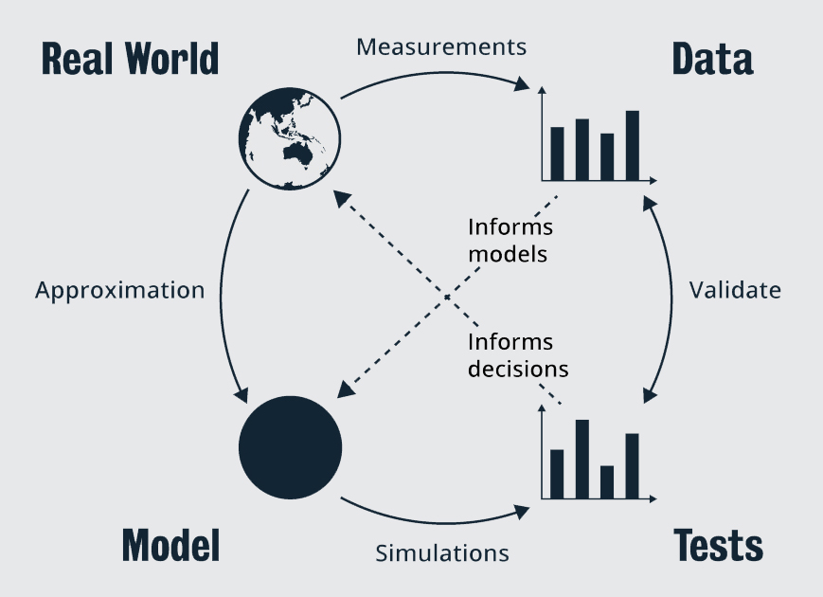
An illustration of the relationship between models and reality, and data and measurements
Four elements are shown in the diagram. In the top left is Real world (represented by a globe), top right is Data (represented by a graph), bottom right is Tests (represented by a graph) and bottom left is Model (represented by a circle). An arrow labelled measurements extends from Real world to Data on the right. An arrow labelled Approximation extends from Real world down to Model. An arrow labelled Simulations extends from Model to Tests. A double ended arrow labelled Validate sits between Data and Tests. A dotted line arrow extends through the centre of the diagram from Tests up to Real world. A dotted line arrow extends through the centre of the diagram from Data down to Model
There are lots of paths in this figure: data from the real world can inform your model, and in a similar way, data coming out of your simulation can inform decisions in the real world. You can also validate simulations by comparing their output to real-world measurements. I’ll be talking about all of these processes as the course proceeds.
The main step, for now, is to take a real-world system and approximate it in a mathematical model.
Mathematical modelling isn’t easy. There are many ways to model any given system; many trade-offs between simplicity and veracity. The level of detail in a model is often an issue: imagine modelling a gas—you could model the location and velocity of every molecule and every collision, but this would require a prohibitive amount of processing. The trick is to realise that, for many questions of interest, you need only keep track of the bulk properties of the gas.
Your choices can have a large effect on the quality of the simulation results. The challenge is to include the phenomena of interest, and exclude extraneous details that obscure the key features of the model.

Making choices
At the start, you may be uncertain about some choices when designing your simulation. That is OK—a model is often improved by refinement.
Some of the key choices (in mathematical modelling) are already prescribed here: you want a discrete model (not a continuous model) and a stochastic or random model (not a deterministic model), so part of your job is already completed.
Also, typically, simulation models are closed in the sense that they have limited inputs (often just a few parameters). Mathematical models may also be open. Open models often take a set of inputs, operate on them, and produce a set of outputs. Simulation models can use data as an input, but this is less common, and they are typically closed.
So, the mathematical model’s high-level properties are already determined. But the details are not. You can approach the question of the details of a DES model in a methodological way as described below.

Simulation model components
When faced with a difficult task, it is best to break it into pieces.
Question: How do you eat an elephant?

Answer: One bite at a time.
You have three pieces to think about:
- The system (what its state represents and how it can change, and what the resources in the system are).
- The entities (the people or objects that will have an important meaning in the simulation, and which might make decisions).
- The events that will cause state changes. Concentrating on these pieces will help.

Simplicity
KISS: Keep It and Simple
Always keep simplicity in mind. One way to do so is to minimise the number of state variables. The size of the state space has a dramatic influence on the quality of simulations you can perform. Also, sticking with a small number of types of entities is helpful (remember, entities can have attributes that change their behaviour, so you might only need one type of entity)
Occam’s razor, named after William of Ockham (who lived 1287–1347), is another way to say KISS. William wrote in Latin, but to quote him loosely, he said:
“All other things being equal, simpler explanations are generally better than more complex ones.”– William of Ockham

Answering questions
The key to building a compact and to-the-point simulation is to keep in mind the questions you want to answer. Simulations can be aimed at many applications:
- Exploring and testing possibilities to find an approach that minimises a problem or increases efficiency.
- Understanding why an observed phenomenon occurs.
- Testing “what if?” questions, e.g., “what if power fails in my factory?”
- Diagnosing problems by finding unexpected interactions or discovering difficult to measure properties.
- Identifying constraints such as production bottlenecks.
- Simulations can even be used to communicate an idea; for instance, to create a convincing argument for a new policy or to train people in the use of a new system.

The type of question that you want to answer can guide your simulation model.
Consider this
Which of the following questions might a simulation answer?

- How many people should I employ in a call centre to reduce the call waiting time in order to meet a given service-level agreement?
- What might happen if I buy cheaper but less reliable, internet servers, but have more on standby ready to replace any that fail?
- What part of my factory needs to be streamlined?
- Who caused the failure of my network last week?
SELECT TO VIEW ANSWER
1, 2 and 3 are questions that can be answered by simulation. The question in choice 4 is not able to be answered by simulation as simulation questions are usually concerned with predictions about statistical behaviour. They can sometimes be used to understand past behaviour, and attributing blame to an individual is a non-statistical task.

Building blocks
There are some good building blocks that will often get you started in building a simulation model.

“A building block is a self-contained, interoperable, reusable and replaceable unit, encapsulating its internal structure and providing useful services or functionality to its environment through precisely defined interfaces.”– Verbraeck, 2004
Many DES is built from a relatively small set of such blocks. The common causes are the following:
- Queues and servers: You will learn a good deal about queues, but the fundamental idea is very similar to the queue you might have experienced at the supermarket or at a drive-through shop. A surprising number of systems can be represented using some variant of a queue.
- Delays: A delay implies exactly that; it is a delay between two events. For instance, the arrival time of a customer at the server in a supermarket, and their subsequent departure.
- Networks: A network connects blocks of the system. Sometimes it could be a real network; for instance, a road or rail network. Sometimes it is an network like the internet. And sometimes it is entirely logical, such as in the case of a social network connecting friends (in real life). Networks can be as complex or simple as needed. A common network is a series of stations in a factory—a component passes through each station as it is constructed.
- Triggers: A simple trigger occurs when the system reaches a particular state. The result of the trigger changes some aspects of behaviour. For instance, if the queues in a supermarket get too , the market might add an extra server. Triggers add extra logic to events. The event itself might just be a new customer arriving, but this triggers the extra state change that a new server is added.
Some commercial simulation tools will let you build these blocks very easily. Some might even offer a visual interface. However, it is crucial that you understand what they are actually doing in order to use them properly. In this course, you will build up models from their foundations.
These building blocks won’t cover every possible type of simulation. You will see some others as the course progresses, but, for the moment, I will start by defining queues and servers more precisely.

Reference
Verbraeck, A 2004, ‘Component-based distributed simulations: the way forward?’, in 18th Workshop on Parallel and Distributed Simulation, 2004. PADS 2004, IEEE, pp. 141–148.

2.1.6 Queues Part 1
A queue is a simple concept that you will be familiar with in day-to-day life. However, there are many, many variations. David George Kendall defined a simple notation to precisely define which variant you are using. This notation is widely accepted and has been extended in a number of ways.

Kendall’s queue notation
A queueing system, as described previously, has two main components:
- the server(s),
- the queue.
However, when you are defining a queue, you need to define the way customers arrive at the system, so Kendall’s notation starts with three pieces, each separated by a. It looks like this:
A/S/n.
where:
- A: defines the arrival process behaviour,
- S: defines how a server works, and
- n: says how many servers there are.
Certain letters are used to indicate types of behaviour:
- : indicates ‘Memoryless’ behaviour. This isn’t a good notation, but it is very common. The key here is that the exponential distribution (when used to create inter-arrival processes) leads to a process where the past is absorbed into the current state and the process is thus memoryless. When you see an ‘M’, think ‘exponentially distributed times’.
- : indicates general times. It could be almost anything. This isn’t really precise enough for us, so we usually use a more precise letter, such as:

and there are many other possibilities, but they won’t be used here.
- n: is the number of servers. The servers operate in parallel and independently. In some cases, you might even make the number of servers n=∞. Clearly, you can’t have an infinite number of servers, but sometimes the server isn’t representing an actual resource, but rather it is just a delay.

Examples
- The most common case is the M/M/1 queue. This has exponential inter-arrival times and exponential service times for its one server. It is often the starting model for a simple queue.
- Another common case is the M/M/∞queue. This is used to model systems such as the car-park problem earlier. The ‘servers’ here are not real servers, they represent the delayed time each customer spends in the shop. In principle, an arbitrary number of customers can shop in parallel, so you might model this as an infinite number of servers (but note that some constraints will be put on this below).
- A M/P/1 queue would be one in which customers arrive with exponential inter-arrival times, but service times are Pareto distributed. If you have ever been stuck behind a really, really slow person in a supermarket queue, then you will appreciate that service times are sometimes heavy-tailed.
- A D/M/4 queue would have arrivals that turn up in a regular stream with a fixed time between arrivals. There are four servers, and each service time is exponentially distributed.

2.1.7 Queues Part 2

Kendall’s extended notation
Kendall’s notation is often expanded. By default, the assumption is that there is infinite space in the queue or waiting room. However, in real life, waiting rooms cannot fit an arbitrary number of customers. Call the number of spaces available in the system (including the queue and the servers) m.
Also, Kendall’s default queue is an open-loop model. It assumes customers come from some large pool outside the system. That is reasonable, for instance, for a supermarket. Essentially the population is infinite. However, some systems have a finite population, and so when a customer is in service, it can’t be in the queue or about to arrive. If there is a finite population, this can be denoted by k.
Kendall’s extended notation would look like this:
A/S/n/m/k.
If m and k are omitted they are assumed to be infinite or unlimited.
Examples
- The M/M/10/10 queue has ten servers, and space in the system for 10 customers, but note that this implies there is no queue at all. Customers either go directly to an open server or are blocked. It assumes the number of potential customers is infinite.
- The M/M/1/∞/10 is a queue where 10 customers cycle in and out of the queue.

Service order
Kendall’s notation does not always specify the server discipline, which determines how customers are selected from the queue for the next service. There have been more recent additions to Kendall’s notation, where some people add extra terms to the end. The most common terms are as follows:

- FIFO, to mean a First In, First Out, which is the queue you are probably most familiar with, for instance at the supermarket. It is also known as First-Come-First-Served (FCFS).
- LIFO, to mean Last In, First Out. These are sometimes called stacks, and they commonly occur when, for instance, only the top of the stack is easily accessible (think of a pile of plates).
- SIRO, means Service in Random Order, which means exactly what it says.
One of the problems I have seen in telephone communications occurred a decade or two ago when a very, very popular musician decided to tour Australia. When the tickets went on sale, there were so many people trying to phone in that the telephone system first became congested, and then it crashed. The problem was made worse because people redialed if they didn’t get through quickly enough.
The FIFO queues were , so no one received service quickly, so everyone redialed, and it kept getting worse. It turns out you could help fix this problem by changing to a LIFO queue. With a LIFO queue, some people receive service quickly, even when the queue is very full, and so some tickets get sold. If fewer people redial, then the system will be less congested and less likely to freeze up completely, and some customers, at least, will get tickets.

Question
Imagine you have two queueing systems, identical in all respects, except that one has a LIFO and the other a FIFO queue. Will the average number of customers be greater, smaller, or equal in the LIFO compared to the FIFO?
Hint: Does changing the order of customers served to affect the overall efficiency of the system?
VIEW ANSWER
Both queueing systems will have the same average number of customers.

Priority
Another common case is that the queue has some type of priority mechanism. In an ED (Emergency Department), you need to treat heart-attack patients immediately. A patient with a nosebleed might have to wait until after the more critical cases are treated, even if they arrived first.
Priority can be based on an attribute of the customer: a priority category or value. However, it can also be based on some aspects of the system. For instance, you could process the job or customer with the est (or the est) expected processing time. In this way, you can clear many jobs quickly rather than getting bogged down on one job.
There are many mechanisms to handle priorities. Some systems create separate queues. Others treat the highest priority first and so on. Yet others use Weighted Round Robin (WRR)—a scheme that trades off priorities against ensuring that even low priority customers don’t have to wait too . When working with priority queues you need to specify the mechanism in some detail.
Yet another alternative is Processor Sharing (PS). This is a common model in computer modelling, and it indicates that a server’s efforts are shared simultaneously amongst all customers in the system.

Additional features
The notation described above is all standard. Kendall’s notation has been adapted in many less standard ways to include other features.

- Reneging and Balking: In a standard queuing system, customers arrive and then depart once they receive service. However, as you might know, sometimes the queue is just too . You wait a while and then give up, leaving the system without service. This is called reneging. On the other hand, balking is when you see the queue and think, “I’ll buy this stuff another day” and leave the system without even bothering to queue.
- Dependencies: In standard queueing systems, processes like the arrivals have independent inter-arrival times. It is quite possible to have some dependence structure. The most common is batch-arrivals, i.e. at each arrival event, a batch of customers arrives. Service times can also exhibit dependencies, but these models are less common. A batch arrival process (with exponential inter-arrival times) is indicated by M^B.
- Preemption: Some priority systems allow a more important customer to preempt others. For instance, in an ED, if a heart-attack patient arrives, the healthcare workers might stop treating their current patient (with a nosebleed) and rush over to help the critically ill patient.
- Vacations: Some models allow servers to have “vacation”, i.e. periods when they are idle (even though customers are waiting for service). Although supermarket checkout workers do need to take breaks, the major reason to include vacations in a simulation is to model downtime when servers (in this case machines) are being maintained or repaired in the context of a factory or machine shop.
- Networks: These have already been mentioned, but it is worth explaining the role of networks in the context of queues. Often, you will need to build a network of queues where the outputs of one (the departing customers) are the inputs to another. Think about a production line in a factory: when a component is finished at one station, it is passed to the next.
- Parameters: Parameters are input variables. They are values that can be set or changed. Simple examples include the number of servers n or the size of the waiting room k. Other parameters concern the random distributions that may be used. For instance, the mean value of the inter-arrival times or the service times. A good simulation model allows you to specify the inputs and change them as needed. Other parameters may concern the service discipline (for instance, the priority mechanism) or additional features such as the probability of reneging.
Reading Check
Match the key terms below with their meanings to check your understanding.

Question
Consider a queue where new customers arrive in an arrival stream with independent Pareto-distributed times. Customers join the queue but renege if they wait for 10 minutes. The customers then wait a random amount of time and rejoin the system, hoping that the queue will have died down. So, the total arrivals to the system are made up of the originals plus the arrivals from returning renegers. The total rate of arrivals to the system is higher than the rate of new customers. What should be the maximum waiting time in the queue?
A. Greater than 10 minutes because of the increase in the arrivals.
B. 10 minutes because customers renege at this point.
C. Less than 10 minutes because the reneging customers make it easier for everyone else.
SELECT TO VIEW ANSWER
The answer is B. 10 minutes because customers renege at this point. The wording of the question is complicated (real-life problems in words are often much more complicated), but the critical piece of —customers renege after 10 minutes—hasn’t changed.

2.1.8 Queues Part 3

Thinking about queues and models
There are many ways to think about queues. I like to think about a supermarket for the following reason. It is tempting to think about ‘service times’ as a property of the server, however, it is much easier to implement simulations where the service time is a property of the customer. Think about a supermarket queue: the customer arrives at the queue with a basket of goods to purchase. To a large degree, the service time depends on the size of this basket. A customer buying one can of beans will be quick; a customer with a full trolley of goods will take a time. It is easier to think about service time as an attribute of the customer when you get around to implementing a queue.
Another important thought process revolves around a concept called stability. If the rate of customers arriving at a queue is faster than the servers can deal with, then the queue will grow. If it has finite limits, it will eventually reach these, but if you have modelled it as having infinite space, the queue can grow without limit. This is called an uns queue. The border between stability and instability is important because s queues can be modelled and analysed using simple simulation techniques, but you need to be more careful with uns systems. You might ask, “Why don’t I just put a finite bound on the system?” This is one alternative approach, but if you don’t have a physical reason for this bound, it can lead to incorrect conclusions. Better to approximate by infinity, rather than apply an arbitrary and un-physical bound.
It’s also important to understand that a queue may not be ‘real’. It might be a conceptual model to keep track of activity and resources. For instance, you might model an ambulance service responding to cases by using a queueing model. However, patients don’t ‘queue up’. The queue represents the patients waiting, wherever they may be.

Quantities of interest
There are several quantities that you commonly want to keep track of in a queueing system. Some quantities are system-centric (they concern the system state) and others are customer-centric:

- System-centric measures: Arrival rate: this is the time-averaged rate of arrivals to the system. Often, this is an input parameter for a queueing system, but sometimes you might need to measure it if the queue is downstream of some other simulated systems. Arrival rates are often denoted with the Greek letter λ. The distribution of the number of customers in the system is often the main value of interest. This is composed of the number in service and the number in the queue. Often, you will need to calculate the expected value (and maybe the variance) of this distribution. Server utilisation is the proportion of time the server is active serving a customer.

- Customer-centric measures: The distribution of the waiting times is also important. As you would know, a customer in such a system is mostly interested in how they will have to wait before receiving service. A related time is a total time in the system including the service time. Often you will need to calculate the expected value (and maybe the variance) of this distribution. The chance of being blocked in a finite system is also important. In a finite-sized system, it is possible that a customer can be refused entry into the system or blocked. You usually want to calculate the blocking probability.

These types of performance measurements are so important that some contracts in the telecommunications world specify an SLA (Service Level Agreement), which would contain legal, contractual obligations to keep one or more of these metrics within some bounds. For instance, if your company outsourced your telephone helpline to a call centre operator, then you would have a rule in the form of 95% of customers must talk to an operator within five minutes (I’m not sure all call centres are this good though).
In other industries, you will hear about KPIs (Key Performance Indicators), and sometimes they take the form of the metrics given above. Often, these are quite complicated, but, at their root, are the same ideas. For instance, have a quick look at the Government of South Australia’s SA Health Key Performance Indicators Master Definition Document (2020). Pages 9–10 list the performance requirements for the different triage categories used in South Australian emergency departments. Response times are also crucial for any emergency service. Ambulance, Fire, and Police all have KPIs that measure how quickly they can act.

Activity
Identify which of the following measurements are system-centric and which are customer-centric by selecting the option in the Type column, and then select 'Check'.

Little’s Law
System-centric and customer-centric measures are often related. For instance, there is an important rule linking time and numbers called Little’s Law. It states that the mean number of customers in the system N̄is related to the arrival rate λ and the average time in the system T̄by
N̄ = λ T̄.
This law is incredibly useful:

- when one property is easier to measure than the other

- for sanity checking of results

- for estimating properties like stability.

One of the reasons it is so useful is that the ‘system’ here can be any component of the total. You could consider the system to be the overall queue+server, or you could consider just the server. In the latter case N̄ = p_U, the utilisation probability of the server. Thus, the utilisation (for a simple single server queue) is
p_U = λ / μ,
where μ is the average service time. This quantity is denoted ρ and called the traffic intensity.

Further reading
You will make use of Little’s law here as stated, but if you want to read more, or see the proof, then take a look at the following resources:

Wikipedia 2021, Littles law, Wikipedia, viewed 30 June 2021.

Little, JDC 1961,‘A Proof for the Queuing Formula: L= λ W’, Operations Research, vol. 9, no. 3, pp. 383–387.

Activity
Use Little’s law to compute the average time in the system (the time waiting in the queue plus the time in service) for an M/G/3 queue with an arrival rate of seven customers per minute, and an average of 14 customers in the system.
SELECT TO VIEW ANSWER
2 minutes Little’s law can be rewritten as T̄ = N̄/λ . so the average time in the system is 14/7 = 2 minutes.

Summary
This section has been about how to build your model of the system to be simulated. I have focused on queues and their notation in great detail here. There are many other types of models in different application areas. For instance, you may have heard of SIR models for epidemics. There are two reasons for our initial focus on queues:

- Queues are a very common and useful building block for simulations.

- Queues provide a useful example of the types of thought processes that surround any DES model.

You will use queues in your assessment in two ways. The first is that you will use them to help build the DES that is the core of your Programming Assignment. The second is that queues are a common mathematical model for resource-limited systems, and so you will often return to them to model systems, and many questions in your assessments will rely on your understanding of how they work. However, remember that DES is not just about queueing systems, so you will see other types of models as well.

2.1.9 Lists
A list is one of the fundamental data structures in computer science. The typical structure that implements a list is called a ‘linked list’, but you don’t need to know too much about this. You just need a way to store a collection of items that have a defined order, and you need to be able to add and remove items from the list. Sometimes the type of implementation could have helpful computational properties though. If your list has a fixed number of entries, then storing it as an array could be very efficient. If the list might grow and shrink a lot, then another approach might work. You will see several different approaches in Julia later in this module. For more , read the content on Lists in the Wikibook A-Level Computing (2019).
These lists follow the model components: i.e. at any one moment in time, there is:

- a list of state variables and their state,
- a list of current entities,
- a list of all of the currently known upcoming events.

1. List of state variables
The list of state variables—call it S(t) at time t—is often quite (remember, you want to minimise the complexity of the system). The list of state variables is often of fixed length. It does not have to be, but it is advantageous to represent it in this way as then it can be held in a simple array in memory.

2. List of current entities
The list of entities can be and is often variable, e.g. the number of customers in a queueing system can vary. You usually include in this list the entity attributes as a component of the entities, i.e. don’t list the attributes separately. There may be more than one entity list. For instance, if a system has more than one queue, you might include each entity in a list corresponding to those queues, but you could also include this as an attribute of the entities while keeping them all in one big list.
Note that the entity list and state might be directly linked. For instance, the state might be a count of the number of customers in a queue, and so it is the length of the current entity list (minus the customer in service). It might be tempting to omit the state list in this case, but I would not recommend it. Including the state explicitly can give you a good method to check results.

3. List of upcoming events
The final, and in some ways most important, the list is a list of upcoming events—call it E(t) at time t. At any given moment, you will know of only a subset of future events, but you keep this list and add to it when and where you find out about new events. You might call this list a timeline or a schedule. The next event in this list will be the next event to happen, to need processing. So, the list needs to keep track of time ordering in some way.
This is the most important list because the whole process of simulation revolves around the event list. Certain very simple simulations could even be reduced purely to such a list without the state or entity lists.
The event list is almost always variable in length. Usually, it starts out very (often with a single seed event), but it can grow quite in some simulations. It needs to be implemented carefully because you want to access the event in time order, i.e. you usually want to access the next event. Often, it is stored in a data structure called a time-ordered queue, which is just a priority queue where time gives the priority ranking.
When an event is processed, each list will likely change: the event will change the state, add or remove entities and/or result in the creation of new events. Thus, processing an event is primarily about managing these lists.
You might have some additional lists. The event list is a list of future events, but you may wish to record past events in another list for validation. Or you may want to keep lists of sample statistics as the simulation continues. These lists could become very , so it may be preferable to write the results in a file.
There are many ways to implement lists in programming. However, most languages have good tools to do so, and hence you hardly need to understand the implementation details for this course. However, I will discuss some aspects of list construction when it is time to build a simulation.
In the next topic, you will examine how the model and list structures inter-relate through a simple set of examples.

Question
Which of the following are the qualities that make a data structure composed of a group of items into a list?

A. A list can hold potentially more than one item.
B. The items in the list are ordered.
C. A term sometimes used synonymously for the list is an array.
D. The only type of item a list can hold is a number.
SELECT TO VIEW ANSWER
A, B and C are correct. D is incorrect as a list can hold almost any data type.

Optional vocabulary exercise (2.1)

2.2 Discrete-Event Models

2.2 Discrete-Event Models
This section demonstrates how the various elements of a discrete-event simulation can be combined to model a variety of real-world problems.
- Read through the following pages in order, taking notes as you go and running any example code (if applicable).

2.2.1 A Simulation on Paper
In this topic, you will look at how to translate your mathematical model into a computer model that can be simulated. In the Programming Assignment, you will build a DES. This is a key step in this whole course, so I need to make sure you understand the process. First, you will be given an example of a simulation step-by-step. Then you will extend your understanding through additional examples. Each one will be a guided extension to broaden your knowledge.
The easiest way to start learning how to create a DES is to jump in and do one. Let’s start with a simple FIFO queueing model. And to make it extremely clear about how this works, you won’t be doing any computer programming yet. You’re going to do it by hand. I know, it sounds crazy, but it isn’t too hard.
You will start with the M/M/1 queue. Remember, in Kendall’s notation, this is a queue with exponential inter-arrival times, and exponential service times at a single server. For the sake of simplicity, I will use the same exponential distribution with mean 1 for both sets of time (though this would rarely be the case in a real setting). This is a starter model for all sorts of systems, for example:

- a simple web server: requests for web pages arrive, and take a variable amount of time to serve,
- a plumber who receives call-outs randomly, and who responds to them in turn, each job taking a random amount of time.

The M/M/1 queue
The M/M/1 queue (and some similar queues) has an advantage in that it is simple enough that the math is trac (easy to deal with) and you can compute its behaviour analytically. In equilibrium, when ρ<1, the probability of i customers being in the system (including the customer in service) at any given time is given by π_i = (1-ρ) ρ^i, where ρ is the traffic intensity (defined in the previous section). This simple formula can then be used to check if your simulation is functioning correctly or do back of envelope calculations. For instance, from it you can calculate the expected number of customers in the system to be N̄ = ρ / (1-ρ).
You need to keep track of two pieces of :
- the event list E(t).
- the system state S(t).
You could also maintain an entity list, but I want to keep this as simple as possible.

Event list processing
The event list is the most important facet of a DES, so I will start with this. The number of customers in the system only changes when there is an arrival or departure, so these are your events. The event list looks something like this:

E(t) = [A(t_n), A(t_n+1), D(t_n+2), … ],

where t_i are the times of the events and A stands for an arrival and D a departure. Note that all events in the list will be in the future, and they have been sorted in order so t < t_n < t_n+1 < t_n+2 < ·s.

The way the simulation works is as follows:

- Pull the first item off this list: in this case, the arrival A(t_n) at time t_n.
- Determine how to update the state of the system. In the case of arrival, the number of customers in the system is increased by 1 (for the sake of argument, assume that there is a customer already in service, so this new customer joins the queue).
- Add any resulting events: when you have to process an arrival, you calculate the time of the next arrival and add this new arrival to the event list.
- Then go back to step 1 and repeat.

In most simulations, you will need more about the events in the event list than just a time. For instance, you should usually allocate each event a unique ID to aid in debugging.

The state of the system will be (i) whether the server is occupied or open, and (ii) the number of customers in the queue. You can lump these two together by counting the number of customers in the system as a whole and call this variable N(t).

You could try to calculate arrivals at the start, but you can’t do the same for departures because they depend on the arrival process. That’s why you have to keep adding additional events to the list.

That’s where the main simulation loop comes in. All of the above ideas can be expressed in one generic piece of pseudo-code (shown below). This code is at the heart of all of our simulation work.
initialise( E(t), N(t) ) # set the simulations going (set seeds, ...) while !isempty( E(t) ) e(t_i) <- dequeue( E(t) ) # remove the next event from the event list t <- t_i process( e(t_i) ) end
A loop is started and, in each iteration, you select the next event, update the current time to the time of the new event, and then process the event. You can see that this is a very simple loop. It’s also very general—variants of it apply to a vast range of DES. However, all of the smart parts are hidden in how an event is processed. You will look at this next.

System state
Each event can cause state changes. So, rather than calling the function that updates the state 'process', I will often refer to it as 'update'. In the M/M/1 there are two types of events and they cause the following changes. Note that changes are modelled as instantaneous, but for the purpose of explaining the changes, I will treat them as if they happen between times t and t + epsilon(where epsilon is small) in order to make the notation clearer.

First, you must consider the state changes, which should be fairly clear from the nature of the terminology 'arrival' and 'departure'.

An arrival at time t will change the state N(t + epsilon) ≤ftarrow N(t) + 1.
A departure at time t will change the state N(t + epsilon) ≤ftarrow N(t) - 1.
The more complicated question is how each event might cause another future event.

- Each arrival creates events:
- The arrivals occur in a steady stream, so when you process an arrival, you need to create another arrival. Assuming you are processing an arrival at time t then the next arrival will occur at time t + X where X is a random variable. The inter-arrival times X for the M/M/1 queue are exponential. The new arrival at time t+ X is inserted into the event stream such that you keep the ordering.
- If the system is empty when the arrival occurs, it will immediately go into service, and hence you create a new event for when it finishes service and departs the system.
- A departure will result in either of the following:
- Leave the system empty, i.e., N(t + epsilon) = 0, in which case you don’t need to do anything more.
- Allow a new customer to go from the queue into service. In this case, you generate a new service time Y for the customer entering service. The service times are also exponentially distributed. The customer entering service will be there for this time, and so will depart at time t + Y, and hence you insert a departure at time t + Y into the event list.

Note that in this simplified version, you only keep track of the number of customers in the queue, so there is no point in considering server discipline because the order of customers in the queue isn’t saved anywhere. FIFO and LIFO queues will return exactly the same results using this approach, which tells you something about what you can learn from particular types of models.

Figure 2.2 is a flow chart that illustrates this process visually. Boxes indicate something happening: for instance, changing the system state (adding or removing a customer) or adding new events to the event list. Diamonds show decision points. The arrows indicate the direction of flow of the logic of the program.
Figure 2.2: A flow chart illustrating the control flow in a simulation of a single server queue. The arrows indicate the direction of flow of the logic of the program. Boxes indicate something happening: for instance, adding or removing a customer. Diamonds show decision points.
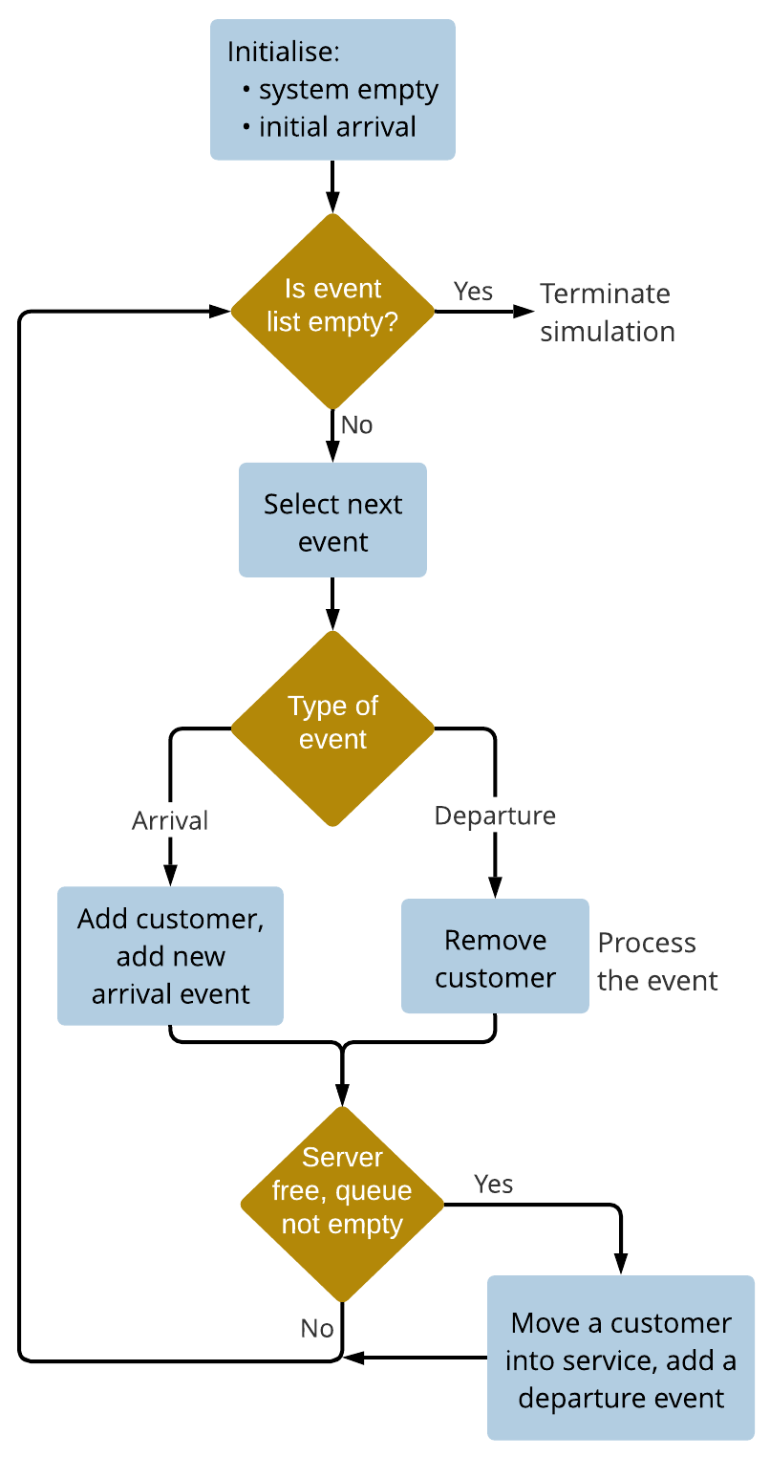
A flow diagram as described in the
A box at the top of the diagram is labelled ‘Initialise’ with the qualities system empty, initial arrival. An arrow from this box points down to a diamond labelled ‘Is event list empty?’. A 'Yes' arrow points to the words ‘terminate simulation. A 'No' arrow points to a box labelled ‘Select next event’. An arrow from this box points down to another diamond labelled ‘Type of event’. An arrow from the left of the diamond is labelled ‘Arrival’ and points to a box labelled ‘Add customer, add new arrival event’. An arrow from the right of the diamond is labelled ‘Departure’ and points to a box labelled ‘Remove customer’. Adjacent to this box are the words ‘Process the event’. Both the boxes point to another diamond labelled ‘Server free, queue not empty’. An arrow labelled ‘No’ points back up to the diamond labelled ‘Is event list empty?’. An arrow labelled ‘Yes’ points to a box labelled ‘Move a customer into service, add a departure event’, this then points to the arrow that leads back up to the diamond ‘Is event list empty?’

A note about inserting an event
You will learn more about implementation later, but, for the moment, notice that I have only briefly looked at how to insert an event into the event list. There are various ways to implement this, but using a priority queue built on a heap is common. Inserting into a heap is an O( log n) operation in the worst case, which means that this approach gets worse as the event list becomes er, but at a slow rate. This is one reason why you don’t create a list of (for instance, arrival) events at the start, even if you can know these times at the start.
That’s it. It isn’t that hard. You will now go through an example by hand.

2.2.2 Example 1

For simplicity, you can start the system empty (no customers in the queue or in-service) and then introduce an event of a single customer arriving at time 0.
In this example, two streams of random numbers will be used:

- the inter-arrival times,
- the workload amounts for each customer.

In this example, I will explicitly list my random numbers. This will not always be done in what follows, but here I want to show you exactly how this works. The first seven random numbers for arrivals and service times (rounded to 3 decimal places) are given in 2.2. They each come from an exponential distribution: the inter-arrivals have a mean of 1.0 and the service times have a mean of 0.8.
2.12: 2.2: A list of inter-arrival and service times
Inter-arrival times | Service times (workload per customer)
0.181 | 0.303
0.126 | 2.550
0.175 | 0.442
2.727 | 1.091
0.390 | 0.324
0.645 | 0.104
0.113 | 1.516

These times were created using a pseudo-random number generator as described in Module 1.
The actual simulation is shown in 2.3, which shows the time at each event, the state of the system before and after each event, the current event list, and the current event being processed. Note that at each step, the current event will always be the first element from the event list because I am showing the event lists sorted in time order, i.e. the first event in the list is the next event to be processed.
2.3: The simulation of a M/M/1 queue
Time | Old State | Event List | Current Event | New State
0.000 | 0 | A_0(0.000), | A_0(0.000) | 1
0.181 | 1 | A_1(0.181), D_1(0.303), | A_1(0.181) | 2
0.303 | 2 | D_1(0.303), A_2(0.307), | D_1(0.303) | 1
0.307 | 1 | A_2(0.307), D_2(2.853), | A_2(0.307) | 2
0.482 | 2 | A_3(0.482), D_2(2.853), | A_3(0.482) | 3
2.853 | 3 | D_2(2.853), A_4(3.209), | D_2(2.853) | 2
3.209 | 2 | A_4(3.209), D_3(3.295), | A_4(3.209) | 3
3.295 | 3 | D_3(3.295), A_5(3.600), | D_3(3.295) | 2
3.600 | 2 | A_5(3.600), D_4(4.386), | A_5(3.600) | 3
4.245 | 3 | A_6(4.245), D_4(4.386), | A_6(4.245) | 4
4.358 | 4 | A_7(4.358), D_4(4.386), | A_7(4.358) | 5
4.386 | 5 | D_4(4.386), A_8(5.578), | D_4(4.386) | 4
4.710 | 4 | D_5(4.710), A_8(5.578), | D_5(4.710) | 3
4.814 | 3 | D_6(4.814), A_8(5.578), | D_6(4.814) | 2
5.000 | 2 | end

Note that the inter-arrival and service times used in this simulation come from 2.2. The columns list (i) the times of each event processed, (ii) the state (the number of customers in the system) before processing the event, (iii) the event list before processing the event, (iv) the event to be processed (note that this event will be the first on the event list, and the time of the event will match up with the time column), and (v) the state after processing the event. Each event has a subscript, which is its unique ID, and also has a time associated with it, e.g. A_3(1.4) means that arrival 3 will occur at time 1.4. In the event list, the events are listed in time order.

Reporting times
Note that all times are reported here to three decimal places to make s more readable, but, in the code, they are stored as 64-bit floating-point numbers (with a much higher level of precision).
Also, 2.3 shows the evolution of the queue for the first 5.0 time units. Let me describe it in some detail here, as this is really important for you to understand.

- The event list starts out empty and the system starts with 0 customers, so the state is 0. I created an initial arrival A_0 at time zero to initialise the system, so the event list starts with one event A_0(0.0).
- Now the main loop starts. Row 1 of the shows the program pulling the first (and, in this case, only) event from the event list and processing it. The event is an arrival, so the state increases to 1. A new arrival A_1 is created at time 0.181 (the current time 0.0 plus the first inter-arrival time from 2.2) and this is inserted into the event list. Also note that, because the system was empty when this customer arrived, the customer goes straight into service, and a departure event D_1 is created at time 0.303 (which is the time of the current event 0.0 plus the service time 0.303).
- The next event to be processed is shown in row 2 of the . It is arrival A_1 at time 0.181. As before, processing this arrival increases the state by 1, and generates another arrival (A_2 at time 0.307=0.181 + 0.126). So, the event list after processing this event will be D_1(0.303), A_2(0.307).
- Row 3 of the shows the processing of event D_1 at time 0.303. A departure reduces the state (the number of customers) by 1. It also results in a new customer moving from the queue into service, so a departure event D_2 is created at time 2.853=0.303 + 2.550(where 2.550 is the second service time) for this new customer and inserted into the event list.
- START SIMPLE For the purpose of this simulation, we don’t actually care which customer moves from the queue into service, as we only keep track of the number of customers, not an explicit entity list. In most simulations, you would need to choose the next customer using the queue discipline (FIFO, LIFO, …).
- END SIMPLE
- Row 4 of the shows arrival A_2 being processed. As with other arrivals, this results in the state increasing by 1, and a new arrival even being inserted into the event list, but, this time, the arrival joins the queue because the server is busy. I won’t generate a departure event for this customer until it gets into service.
The simulation doesn’t stop there, but I won’t try to describe every row in such detail. The tracks eight arrival events and six departures and stops at t=5.0. Note that the event list is not empty at the end. In fact, once the simulation is going there are always some pending events (otherwise it would stop before time 5.0).
You may note that after the start, the event list always has two events: an arrival and a departure. This isn’t guaranteed. If the system empties, the event list will contain only the next arrival. And, in general, event lists ebb and flow. However, in a well-designed simulation, the event list should not grow (on average) faster than events are processed or eventually the event list will consume all of the memory on your computer.
Figure 2.3 tracks the evolution of the number of customers in the system. Arrivals cause an upward step and departures cause a downward step. Note that sometimes they occur quite close to one another.
Figure 2.3: The number of customers in the M/M/1 example tracked over time.
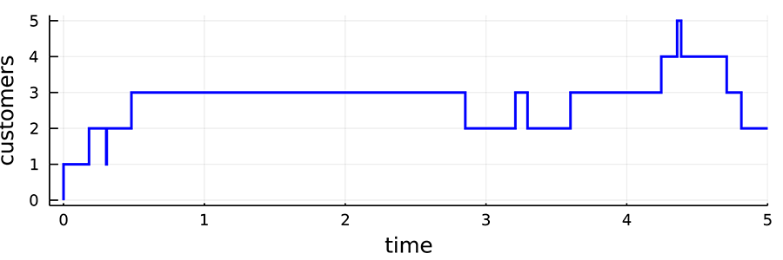
A graph of time against customers as described in 2.3
2.3: Data points for the graph
Time (x-axis) | Customers (y-axis)
0.000 | 1
0.181 | 2
0.303 | 1
0.307 | 2
0.482 | 3
2.853 | 2
3.209 | 3
3.295 | 2
3.600 | 3
4.245 | 4
4.358 | 5
4.386 | 4
4.710 | 3
4.814 | 2
5.000 | 2

: Co-evolution of the queue and the timeline
This animation provides a simulation of the M/M/1 example, showing the queue, the system size plot and the event .

2.2.3 Example 2 - A Car Park
In this example, you will consider a slightly more realistic model and how to approach the problem. You have already looked at one case, but you were given the model without examining the thought process used to construct the model. Here, you will have the opportunity to think about this process.
Consider the following example: the valet parking at Big-Rich Hotel has three valets working on Saturday evenings. Each valet takes 2.5 minutes to park a car and return ready for the next car. When all the valets are busy, arriving cars need to go to the waiting zone. Suppose that you have the following arrival time for cars (in minutes):

0.5, 0.8, 1.5, 1.9, 5, 5.3, 5.6, 7, 8, 8.2, 8.8, 9, 9.1, 9.3, 10.
The hotel would like to know the average time spent by cars in the waiting zone and the productivity of their valets.

Defining the problem
I know what you’re thinking:
“I just read a fully defined problem. Why do I now have to worry about defining the problem?”
On one hand, you are right. You just read a defined example you are about to work through. On the other hand, as it currently stands, this is not precise enough. When it comes to defining the problem, your goal is to take the scenario given to you and break it apart so that you truly know the questions you are trying to answer and then specify them in a precise enough way to implement it in a computer.
When defining the problem, you need to ask yourself:

- What is the scenario?

- What are the questions of interest?

Let’s start with the first question: What is the scenario?

Scenario
As stated in the example, the scenario is that you are working for a hotel company that has three valets. Each valet takes five minutes to park a car and return, and there are cars coming and waiting to be parked. Your first question to yourself should be: “What do I know about this scenario?”
This scenario can be thought of as a queue. You have three servers (the valets), and you have customers that arrive (the cars) and wait to be served. Cars “leave” the system once they are parked (you could have a whole extra model for the car park itself.)
A good way to visualise this is in a picture, as in Figure 2.6:
Figure 2.6: A schematic showing the components of the cark park model, with the flow of customers (cars) arriving, moving towards the waiting area (queue), and then the servers (the valets).
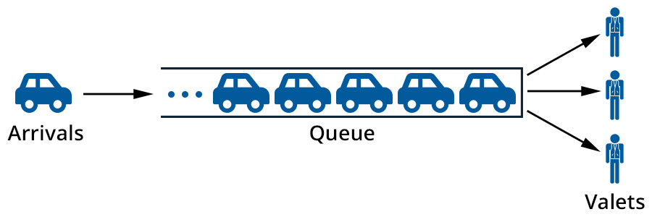
Cars arriving into a queue, which is being served by three valets
To the left of the diagram a car symbolises an arrival. An arrow from the car points to the right to the queue. Five cars are shown in the queue. At the front of the queue on the right are three arrows each pointing to a person labelled valets.
A picture is a great first starting point when trying to construct a simulation. It allows to you take all the words you see and explore them visually. This helps you get away from the specific context (the hotel and cars) and get to the core of the problem being asked. Moving away from cars and hotels, you are being asked to evaluate some questions about a queue.
The next question you need to be asking yourself is: “Do I have to make any assumptions?” Put another way, you are asking whether you have been given all the possible you could need.
For instance:

- How do you model arrivals? (You have an example, but it’s not enough for a decent-sized simulation.)
- Is there a preference for which valet attends which cars?
- Are the valets always available once they have parked a car and returned? Do they have breaks?
- How many cars can wait in the waiting zone? Is it infinite?
- Is the transition from the waiting zone to the valet instantaneous?
- Can you think of any others?
Maybe reading this, you will realise that a lot of these have not been expressly given in the example, so you are going to have to make some assumptions to make your work a bit easier. For instance, let’s make the following assumptions:

- You will model arrivals as having exponential inter-arrivals times with rate λ, which you will set. The value λ is an example of an input parameter.

Arrival rate
The arrival rate is the time-averaged number of arrivals per unit time. It is often denoted with the parameter λ. In common queueing models the arrival rate is given by λ = 1 / E[A], where E[A] is the average inter-arrival time.
- The valets work on a 'first in, best dressed' principle. That is, when a valet is available, they will take the next car waiting in the queue (this is just FIFO under another of its many names).
- The valets are instantly available after 2.5 minutes.
- There is no limit on the waiting zone.
- There is no wait time between a valet becoming available and the next car to be collected and parked.
In the terminology of queueing, this is being modelled as an M/D/3/∞queue. That is, a queue with (i) exponential (Markovian or Memoryless) inter-arrival times, (ii) deterministic service times (2.5 minutes), and (iii) three servers (the valets). You don’t need to write the∞that signifies an infinite waiting space. It is implicit when omitted, but I have included it here to be complete.
You will proceed through the rest of this example with this model and these assumptions, but do they all make sense? Which of these assumptions seem unreasonable in the real world? What would be more reasonable assumptions to make?

2.2.4 Example 2 - A Car Park Continued
Having pondered those questions in the discussion on the previous page, it’s time to start thinking about the problems you are trying to solve for Big-Rich Hotel.

Questions
Once again, you can state the questions simply, or you can dig deeper and really think about what you have to do here. Simply put, you are being asked the two following questions:

- How productively are the valets working?
- On average, how do cars spend in the waiting zone?
The questions affect the way you might construct the model. For instance, waiting times require us to think about cars, so you might want to model these as explicit entities, rather than just counting the number in the system.

Modelling
As always, you start by defining entities, events, and states:

- Entities: The cars. It is possible you would want to model the valets as entities as well, but you don’t need to here, notably because you can keep track of when they are occupied by knowing how full the system is. That is, you don’t need to keep track of them individually.
- Events: As in most queueing problems the main events are arrivals and departures, in this case, cars.
- State: The main part of the state is, as in the previous queueing example, just a count of the number in the system. It is assumed that customers who arrive when a valet is free to get service immediately, so you know how many valets are occupied directly from this count.
Having three servers doesn’t complicate the simulation (much). Keeping track of the entities in the system is a bigger impost.

Simulation example
This example is very similar to the previous case, but now you need to keep track of three pieces of :
- the event list E(t),
- the system state S(t),
- a list of entities A(t)(You can’t really reuse E here).
The entity list will be stored as a queue, and this works perfectly with the model. Each entity will be stored in a data structure, which includes:
- a unique identifier (of just the number of the arrival to the simulation),
- the arrival time,
- the time when it first starts being serviced by a valet,
- the time when it leaves the system.
You could store other in more complex scenarios, but this will do for now.
You need to initialise the system somehow. Usually, you will choose a simple starting point. In this case, assume the system starts empty with the first event (at time 0.0) being the arrival of the first car.
The inter-arrival times are given in 2.7, as are the service times, but these are all 2.5 because I have assumed deterministic, fixed service times of 2.5 minutes.
2.7: The inter-arrival and service times to be used in the car park simulation.
As in 2.2, the inter-arrival times are pseudo-random numbers, but the service times are deterministic
Inter-arrival times | Service times (workload per customer)
0.675 | 2.500
0.187 | 2.500
1.092 | 2.500
1.096 | 2.500
3.225 | 2.500
0.435 | 2.500

2.8 shows the sequence of events similar to the simple queue above. However, now, instead of the state being purely a record of the number in the system, the state has been broken into the number in service and in the queue separately:(N_service, N_queue). The also shows a list of customers in the queue, when the queue is non-empty.
2.12: 2.8: An example of a simulation of the car park model.
Similar to 2.3, but in this , the entities (customers) in the queue are listed when it is non-empty.
Time | Old State | Event List | Current Event | New State | Queue
0.000 | (0, 0) | A_0(0.000) | A_0(0.000) | (1, 0)
0.675 | (1, 0) | A_1(0.675), D_1(2.500) | A_1(0.675) | (2, 0)
0.862 | (2, 0) | A_2(0.862), D_1(2.500), D_2(3.175) | A_2(0.862) | (3, 0)
1.954 | (3, 0) | A_3(1.954), D_1(2.500), D_2(3.175), D_3(3.362) | A_3(1.954) | (3, 1) | C_3
2.500 | (3, 1) | D_1(2.500), A_4(3.050), D_2(3.175), D_3(3.362) | D_1(2.500) | (3, 0)
3.050 | (3, 0) | A_4(3.050), D_2(3.175), D_3(3.362), D_4(5.000) | A_4(3.050) | (3, 1) | C_4
3.175 | (3, 1) | D_2(3.175), D_3(3.362), D_4(5.000), A_5(6.275) | D_2(3.175) | (3, 0)
3.362 | (3, 0) | D_3(3.362), D_4(5.000), D_5(5.675), A_5(6.275) | D_3(3.362) | (2, 0)
5.000 | (2, 0) | D_4(5.000), D_5(5.675), A_5(6.275) | D_4(5.000) | (1, 0)
5.675 | (1, 0) | D_5(5.675), A_5(6.275) | D_5(5.675) | (0, 0)
6.0 | (0, 0) | end

This queue starts with three arrivals beyond the initial one at time 0.0. By the time the last of these three arrives, all the servers (the valets) are occupied and the arrival A_3 at time 1.954 sits in the queue until the departure of the initial customer at time 2.5. At that time C_3 enters service. Figure 2.7 shows the history of the process in detail:
Figure 2.7: The number of customers in the car park queue, separated into the number in the queue and the number in service. 2.7: An example of a simulation of the car park model Time Old State Event List Current Event New State Queue 0.000(0, 0) A_0(0.000) A_0(0.000)(1, 0) 0.675(1, 0) A_1(0.675), D_1(2.500) A_1(0.675)(2, 0) 0.862(2, 0) A_2(0.862), D_1(2.500), D_2(3.175) A_2(0.862)(3, 0) 1.954(3, 0) A_3(1.954), D_1(2.500), D_2(3.175), D_3(3.362) A_3(1.954)(3, 1) C_3 2.500(3, 1) D_1(2.500), A_4(3.050), D_2(3.175), D_3(3.362) D_1(2.500)(3, 0) 3.050(3, 0) A_4(3.050), D_2(3.175), D_3(3.362), D_4(5.000) A_4(3.050)(3, 1) C_4 3.175(3, 1) D_2(3.175), D_3(3.362), D_4(5.000), A_5(6.275) D_2(3.175)(3, 0) 3.362(3, 0) D_3(3.362), D_4(5.000), D_5(5.675), A_5(6.275) D_3(3.362)(2, 0) 5.000(2, 0) D_4(5.000), D_5(5.675), A_5(6.275) D_4(5.000)(1, 0) 5.675(1, 0) D_5(5.675), A_5(6.275) D_5(5.675)(0, 0) 6.0(0, 0) end
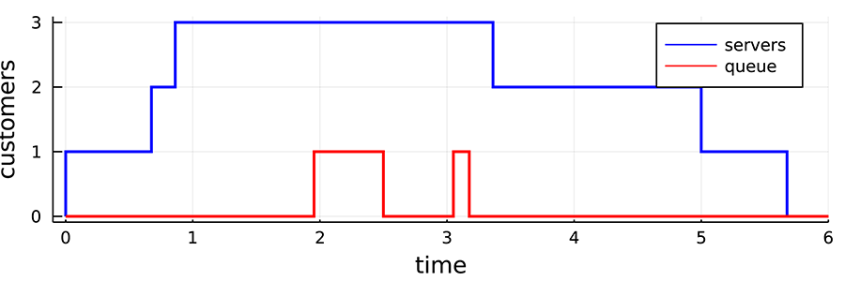
A graph with time on the x-axis and customers on the y-axis
This queueing system ends up empty at time 6.0, but this is just a coincidence. We might have had an alternative realisation that ended in any number of possible states.

Key points from this example
This example was aimed at showing you more of the thought process of modelling and examined how you might think about the problem and build the mathematical model.
The other new trick is the idea of keeping a list of entities that lets you follow their journey through the system. This can be thought of as extra state , but you usually wrap it up into the entity list structure, which, in this case, was stored as a queue.
Finally, I have shown a slightly more detailed state vector here including two numbers. The two are linked (there can’t be customers in the queue unless all of the servers are busy), but they both give useful , so it is helpful, if only for debugging, to keep them separate.
I won’t always go through all the steps of a simulation in the same detail as I have covered in the first two examples. It will be assumed that you have taken on board the ideas here, and you can move forward a little faster.

2.2.5 Example 3 - An Emergency Department

Scenario
The Emergency Department (ED) is a crucial part of modern health care. This is where critically injured or ill patients will first receive care from a doctor (rather than a paramedic or nurse). EDs also cater to a wide range of other healthcare issues, for instance, problems that are serious (such as broken bones), but which are not as urgent to treat as e.g. a heart attack.
People are not, in general, good at self-diagnosis, and so some people may arrive at an ED with fairly trivial (but painful) complaints that they think are very serious, while others may arrive thinking they have a minor complaint (a sore stomach) that turns out to be a burst appendix. The first job in an ED is to work out how urgent it is to see a patient. In Australian hospitals, this is the job of a triage nurse.
Usually, a patient would first see the triage nurse who will take their details and assign a triage category, or, if they arrive in an ambulance, the paramedics may already have performed this task.
Once a patient is triaged, they are asked to wait in a waiting room until they can see a doctor. EDs have a limited number of doctors and indeed a limited amount of space, so it is very important that the doctor's time is used carefully. The doctors will try to see urgent patients very quickly, but it is also important that less urgent patients do not wait indefinitely. Apart from anything else, such patients would fill up the space in the waiting room if they have to wait too . Hence, ED treatment is a balancing act between the different priority classes (triage classes) for patients. This can be modelled with a priority queue.

Questions
I have already mentioned some of the questions a hospital manager might ask about an ED, for instance, “What is the right number of doctors to have in any given shift to ensure patients don’t have to wait too ?”
There are many other questions. Many of them are concerned about how prioritisation between triage classes is implemented, for instance, “Should preemption be allowed?”
Other questions of interest concern how the ED integrates with the rest of the hospital, but these will go beyond the simple simulation presented in this example.

Modelling
As always, start with the simplest possible model. Don’t try to include features such as the triage nurse or paramedics into the model. Rather, focus on the core components of the ED.

- Entities: the entities in this system are the patients. Each patient will have an additional attribute called its triage class. In South Australia, patients are assigned a triage category from 1 to 5, with 1 being the most urgent.
- Events: As with most queueing processes, the main events are the arrival and departure of 'customers' (in this case, patients), but note that you could, in a more complex model, have two types of arrivals—walk-ins and ambulance arrivals. You will start with only one arrivals stream. Note also that some 'departing' patients will actually be admitted to the hospital for further tests or treatment, so a larger system model might include these, but, again, let’s start simple.
- State: The state will be the number of patients in each triage category in the waiting room and seeing an ED doctor. The state will also keep track of priorities in some manner, which are discussed below.
There is one additional aspect to this model. As you might guess from previous comments, this system will be modelled as a priority queue. But what does that actually mean? There are several alternatives, and the following questions should be considered:

- What mechanism is used to decide which patient comes next? Higher-priority patients should get preference, but not at the complete exclusion of lower priority patients.
- Will you allow preemption, i.e. if a high-priority patient arrives while a doctor is seeing another patient, should you allow the high-priority patient to interrupt the doctor from seeing a lower priority patient?
To keep things simple in this example, priority will be modelled by:

- a separate queue for each priority class,
- when a doctor becomes free, they will select their next patient from the highest priority class that has patients in it,
- no pre-emption.
Real EDs are more complicated. They must have some pre-emption (for instance heart attack patients must be seen very quickly for the best outcomes) and always selecting the highest priority patient can lead to lower priority classes having very, very waits when the ED is busy. So, real EDs balance these issues through a complex decision process that involves several steps. If you were solving the problem for a real ED, you would need to understand and model this process more carefully than I am doing here, particularly as one of the most common questions in a situation like this is, “What is the best priority mechanism?”

Simulation example
For the sake of the example, there will only be three triage classes 1,2,3, with 1 being the highest priority. The state will be a vector containing the number of patients of each class in the waiting room, and the number in service (seeing a doctor). I won’t bother to keep track of the priority of the patient seeing the doctor because pre-emption is not allowed, but you would have to add this detail in a queue with pre-emption. Hence the state is a set of four numbers(Doctors, Queue_1, Queue_2, Queue_3).
There are two ways to model arrivals to a priority queue:

- the three priority classes arrive as separate, independent arrival streams, each with its own rate of arrival,
- the arrivals occur as one process, and the priority class is chosen randomly upon arrival according to some probability distribution.

Arrival rates
One of the key tricks with arrival processes that have exponential inter-arrivals is that the arrival rate is enough to characterise the inputs. Even more importantly, they add up, so that if two arrival processes with rates λ_1 and λ_2 merge, you get a total arrival process with rate λ = λ_1 + λ_2.
The second approach will be used, which is slightly simpler to implement. The first approach is more flexible in general but involves implementing a separate type of event for each priority arrival. Each priority has a probability p_i(noting that Σ_i p_i = 1 so that you always chose one of the classes) and the inter-arrival times will be exponential.
In a priority queueing model, it is common that the different priority customers to have different service-time distributions. It is possible that these will be completely different (e.g. Exponential vs. Pareto), but, more commonly, they come from the same family, but with different parameters. In this example, the service times will be exponential with the expected service time for class i given by μ_i.
In Kendall’s notation, you might write this queue simply as M/M/n/m where n is the number of doctors available, and m is the number of customers possible in the system (the waiting room plus the doctors). However, you can see that Kendall’s standard notation is missing many details here.
You will initialise the queue to be empty, with a single arrival with a random priority arrival at time 0.0. EDs are almost never empty in real life; however, in a real simulation model, you would start like this, and use a warm-up period to allow the system to reach a 'steady state'.
Then you would run it as in the examples above, but I will defer presenting it in detail as simulations can very quickly become very laborious to do by hand. You will have the opportunity to program this one up a little later.

Key points from this example
This example is all about priorities. When scarce resources are shared, it is common that some entities to have higher priority access to those resources. An ED was used to illustrate priorities because triage classes define priorities well, but there are many other examples:

- Priority queues are often seen in airports for frequent flyers.
- Network communications often divide traffic into classes depending on the type of application (voice, or data) because some types are more time-sensitive than others.
- When buying stuff online, you can pay extra for priority delivery.
- Supermarkets have priority queues for customers with a small number of items.
- Freeways often have a priority lane for cars with more than one passenger or different types of vehicles (trucks often have to use the slow lane).
You will encounter prioritisation in many forms, and find that the details can be quite complicated, but it is one of the places where simulation can have a large impact. It is often hard to change the number of resources available (for instance the space in an ED waiting room), but comparatively easy to change the prioritisation mechanism.
Prioritisation is also used as a means to encourage certain 'good' behaviours. For instance, consider the example of a freeway that gives an entire lane to drivers with more than one passenger. The highways department is trying to encourage ride-sharing, which will reduce the overall number of cars on the road and hence reduce the use of petrol and diesel, improve the environment, and reduce congestion on the freeway.

2.3 How to Create DES

2.3 How to Create DES
This section introduces the use of a variety of data structures in Julia, and then demonstrates how these can be used to implement a discrete-event simulation.
- Read through the following pages in order, taking notes as you go and running any example code (if applicable).

2.3.1 Control Flow
Control flow refers to the order in which code statements are evaluated. A control flow statement is a statement that determines which piece of code will be evaluated next. The most common control flow statements are for loops and while loops, and if-then-else statements:

- for loops repeatedly evaluate the same lines of code a given number of times.
- while loops repeatedly evaluate the same lines of code until and if the condition is met.
- if-then-else statements make decisions about which code to evaluate next: they make decisions.
There is a lot to say about control flow in Julia, but you will only cover the basics here. For more info, you can read the Julia documentation Control Flow.
As you will see in this section, control flow statements are very important tools for simulation.

for loops
Suppose you are selling your car. Each day, you receive random offers between $2000 and $3000 from potential buyers. You advertise your car for N=5 days. Advertising has a fixed cost of $10, plus an extra cost of $1 per day for every day your car remains unsold. For example, if you sell your car on the 3rd day, you pay $13 for advertising.
Let's simulate the first day. First, set up therng:
using S RNGs # load the RNG package rng = S RNG(1234); # set the RNG and seed
Now, simulate the offer on day 1 and calculate the advertising cost.
offer = rand(rng, 2000:3000) # generate a random offer println("offer: $", offer) cost = 10 + 1 # it is day 1, advertising cost println("cost: $", cost) total = offer - cost println("total: $", total)
OUTPUT:
offer: $2068 cost: $11 total: $2057
To simulate the process of selling your car over 10 days, you would repeat the code above every day, incrementing the advertising costs appropriately. This is exactly what for loops achieve.
rng = S RNG(1234) # set the RNG and seed for day in 1:5 println("day: ", day) offer = rand(rng, 2000:3000) # generate a new random offer println("offer: $", offer) cost = 10 + day # advertising cost println("cost: $", cost) total = offer - cost println("total: $", total) println() end
OUTPUT:
day: 1 offer: $2068 cost: $11 total: $2057 day: 2 offer: $2726 cost: $12 total: $2714 day: 3 offer: $2919 cost: $13 total: $2906 day: 4 offer: $2887 cost: $14 total: $2873 day: 5 offer: $2211 cost: $15 total: $2196
The general syntax for for loops in Julia is
for i in collection statement(i) end
The for loop will iterate sequentially over the values incollection with the variablei taking the respective values and executing thestatement(i) with this value ofi. Notice that the statement may depend on the value ofi, as it does in the car sales example above (the advertising cost depends onday).
In the car sales example, thecollection is formed by the syntax1:5 which denotes that you want to iterate over the integers between 1 and 5. Julia is pretty clever about this and never actually creates the entire set of numbers[1;2;3;4;5] as this would be wasteful. While it is beyond the scope of this course, if you're interested, you can read more on Collections and Data Structures, or the related topic of Iteration utilities on the Julia website.

Loop scope
A variable’s scope is the part of your program where you can access that variable. The scope of variables created within a for loop is that for loop only. This means that variables created within the loop cease to exist after the execution of the loop. Moreover, the iterator (the variableday in the example above) also has the same behaviour. For example, if you try to accessday oroffer Julia will throw an error.
day
OUTPUT
UndefVarError: day not defined Stacktrace: [1] top-level scope [2] include_string(::Function, ::Module, ::String, ::String) at ./loading.jl:1091
offer
OUTPUT
UndefVarError: offer not defined Stacktrace: [1] top-level scope [2] include_string(::Function, ::Module, ::String, ::String) at ./loading.jl:1091
To be able to access variables after the loop, you must declare them before the loop, or make them global variables. To make this concrete, here is a simple example. The following throws an error because in this code the scopex is inside the loop, so we can’t access it outside the loop.
for i in 1:2 x = i^2 end x
OUTPUT:
UndefVarError: x not defined Stacktrace: [1] top-level scope [2] include_string(::Function, ::Module, ::String, ::String) at ./loading.jl:1091
The following does not cause an error becausex is created before starting the loop. So, the scopex will be wider than just the loop.
x = [] for i in 1:2 x = i^2 end x
4
I’ll return to loops later to show you the while loop.

if-then-else statements
if-then-else lets your computer make decisions about which code to evaluate next, based on whether certain conditions are true.
For example, in the car sales example above, you decide you will sell your car to the best of the five offers.
Simulating the example with these decision criteria, you might write:
rng = S RNG(1234) # set the RNG and seed bestOffer = 0 for day in 1:5 println("day: ", day) offer = rand(rng, 2000:3000) # generate a new random offer println("offer: $", offer) cost = 10 + day # advertising cost # println("cost: $", cost) total = offer - cost println("total: $", total) println("condition: ", offer > bestOffer) if offer > bestOffer bestOffer = offer end println("current best offer: $", bestOffer) println() end println("sold price: $", bestOffer)
OUTPUT:
day: 1 offer: $2068 total: $2057 condition: true current best offer: $2068 day: 2 offer: $2726 total: $2714 condition: true current best offer: $2726 day: 3 offer: $2919 total: $2906 condition: true current best offer: $2919 day: 4 offer: $2887 total: $2873 condition: false current best offer: $2919 day: 5 offer: $2211 total: $2196 condition: false current best offer: $2919 sold price: $2919
In the example above, on the first three days, the conditionoffer > bestOffer returnstrue and the code within the if statement is executed. On days 4 and 5,offer > bestOffer is false so the code within the if statement is not executed.
Much more elaborate problems can be tackled by if-then-else statements. The general syntax for these are:
if condition1 statement1 elseif condition2 statement2 elseif condition3 statement3 else statement4 end
And, in general, you can have as manyelseif statements as you like.
To make this more concrete, consider the following examples.

Example 1
x = 1 y = 2 if x < y println("x is less than y") elseif x > y println("x is greater than y") else println("x is equal to y") end
x is less than y

Example 2
x = 2 y = 1 if x < y println("x is less than y") elseif x > y println("x is greater than y") else println("x is equal to y") end
x is greater than y

Example 3
x = 1 y = 1 if x < y println("x is less than y") elseif x > y println("x is greater than y") else println("x is equal to y") end
x is equal to y
Note that, in Julia, the if-else statement is circuiting, which means that Julia runs down the list of if/elseif conditions until it finds the first one which is true, and executes the corresponding code statement, and no further statements are executed.

while loops
while loops are similar to for loops, the evaluation of the code statements is repeated while some condition remains true.
For example, in the car sales example, suppose that you sell your car at the first offer of over $2900, then you could simulate this with:
rng = S RNG(1234) # set the RNG and seed offer = 0 day = 1 while offer <= 2900 println("day: ", day) offer = rand(rng, 2000:3000) # generate a new random offer println("offer: $", offer) println("condition: ", offer <= 2900) println() day = day + 1 end println("sold price: $", offer)
OUTPUT:
day: 1 offer: $2068 condition: true day: 2 offer: $2726 condition: true day: 3 offer: $2919 condition: false sold price: $2919
On occasion, you might want to stop the evaluation of a loop early. This can be done with thebreak keyword.
For example, suppose you want to sell your car if you receive an offer over $2700, or at the best offer over the 5 days. You could simulate this with:
rng = S RNG(1234) # set the RNG and seed bestOffer = 0 for day in 1:5 println("day: ", day) offer = rand(rng, 2000:3000) # generate a new random offer println("offer: $", offer) if offer > 2700 bestOffer = offer break elseif offer > bestOffer bestOffer = offer end println("an expression after the break") println() end println("sold price: $", bestOffer)
day: 1 offer: $2068 an expression after the break day: 2 offer: $2726 sold price: $2726
On the first day, the offer is below $2700, so the first expression in the if statement is not executed. However, the second condition is true, so the corresponding statement is evaluated, and thebestOffer the variable is updated.
On the second day, the offer is above $2700, so the corresponding code within the if statement is evaluated. That is, thebestOffer variable is set tooffer, the current offer, and then thebreak keyword halts any further evaluation of the loop. Julia then continues to evaluate the statements after the loop (in this caseprintln(...)). Notice that, once thebreak statement is reached, nothing after the break is evaluated (e.g., in the code above, the statementprintln("an expression after the break") is skipped onday=2).

: Loops and Variable Scope
In this screencast, Angus Lewis will show you how loops work in Julia. Loops are one of the key ingredients in control flow in programming, and they are very useful in simulations. Julia's loops are pretty standard, so if you've programmed loops in other languages, you will be familiar with most of the ideas. Julia's loops use tighter scoping rules than many other languages and this is a point that catches some programmers out, so it's worth watching this screencast even if you have used loops before. You can follow a using this Jupyter notebook file.

2.3.2 Data Structures
When you implement DES in code, it is likely that you need to keep track of group quantities of data. The most common quantities to track include lists of:

- state variables and their values,
- current entities,
- all of the currently known upcoming events.

The words “data structure” in Computer Science are an umbrella term for all the ways people store data in a computer program. You might be surprised how many of these there are. For instance, have a look at the Wiki page, List of data structures, to see some of the many variations.
The main idea that runs through all of these diverse notions is, however, very simple. Data structures are used to group together related data in a way that makes it convenient to use the data. Grouping data together is exactly what is needed here; for instance, to collect a list of events together.
The topic of Data Structures is a complex and vast topic and not everything will be covered in this course. In this part of the course, you will begin to utilise some tools from the DataStructures.jl package. You will be introduced to the Vector, Array, Queue, Stack, Deque(meaning double-ended-queue, and pronounced deck) and PriorityQueue data structures in Julia. Each data structure has its own advantages and disadvantages and which one you use will depend on how you intend to use it. Additionally, the data structures that you will be introduced to are concepts more than concrete definitions. Their actual implementation may differ, and this can alter their performance. Here, you will stick to the DataStructures.jl.

2.3.3 Arrays
The simplest Arrays are one-dimensional (also known as Vectors); they are lists of elements usually stored in contiguous blocks of memory (meaning the elements in the vector live next to each other). The elements of vectors are indexed by their position within the vector.
In Julia, one way to make a vector with the elements is to use square brackets and separate the elements with a semicolon;, i.e.,
aVector = [1;2;3]
3-element ArrayInt64,1: 1 2 3
In the output above, the line3-element Vector{Int64}: denotes that the variable you have created and calledaVector has three elements, is aVector type variable, and the elements of the vector are all 64-bit integers (Int64). Below that, Julia has printed out the elements of the vector. Vectors are always column vectors.
In general, Arrays can have any number of dimensions. You may be familiar with 2-dimensional arrays, which are often called matrices.
As with vectors, square brackets are used to denote an array. Elements in the same row, but different columns, are separated by spaces, and elements rows are separated by semi-colons;, i.e.,
anArray = [1 2 3; 4 5 6]
2×3 ArrayInt64,2: 1 2 3 4 5 6

Elements
In general, elements of any type can be stored in an array. For example, you can have an array with strings and integers.
stringIntArray = [1 3; 'a' 'b']
2×2 ArrayAny,2: 1 3 'a' 'b'

Values
You can refer to the values in the array using square brackets, and specify the position of the element in the array. For example,
anArray[2,1] # get the (2,1) entry of the variabel anArray, 2nd row, 1st column
4
If you need to get all of the values in a given column or row of an array, in Julia, you can use the colon operator,:. For example,
anArray[:,1] # the colon operator : can be used to get an entire row or column
2-element ArrayInt64,1: 1 4
anArray[2,:] # the colon operator : can be used to get an entire row or column
3-element ArrayInt64,1: 4 5 6
Note that the output is always a column vector.

Row vectors
Row vectors and column vectors are not the same things in Julia i.e., a row vector is actually a matrix with 1 row.
aRowVector = [1 2 3]
1×3 ArrayInt64,2: 1 2 3
aRowVector == aVector
false

Initialisation
Initialisation refers to preparing a system (usually a computer system) to get started. It can involve setting up empty arrays or other data structures or setting the initial values of variables to be used later.
Arrays can be initialised by the commandszeros orones.
anArrayOfZeros = zeros(3) # create an column vector containing 3 zeros anArrayOfOnes = ones(3); # create an column vector containing 3 ones
Alternatively, you can initialise an array with undefined entries with:
anUndefArray = ArrayFloat64,1(undef,3)
3-element ArrayFloat64,1: 2.262025244e-314 2.3135146707e-314 2.2620252597e-314
Here, you must specify the type of the entries of the array and the dimension of the array via the arguments in the curly brackets{Float64,1}. Then, you specify that you want an array with undefined entries, and to have 3 entries via the arguments in the round brackets(undef,3).
I found this notation a bit tricky when I started to learn Julia. The good news is that, for most applications, thezeros andones commands are perfectly sui .

The behaviour of references to arrays
By default, any reference to an array is a View of that array, not a Copy. For example,
A = [1 2; 3 4] # make an array
2×2 ArrayInt64,2: 1 2 3 4
B = A # set B equal to A
2×2 ArrayInt64,2: 1 2 3 4
B[1] = 1000 # change B
1000
A # A HAS CHANGED
2×2 ArrayInt64,2: 1000 2 3 4
Notice that changingB also changesA. This is because, by assigningB = A, all you have done is made another pointer to the arrayA(i.e., another name for the contents ofA). Julia does this because it is more efficient, but it can cause bugs for those unaware of this behaviour. To make an actual copy ofA, you can use thecopy function.
A = [1 2; 3 4] # make an array B = copy(A) # set B equal to a copy of A B[1] = 1000 # change B B
2×2 ArrayInt64,2: 1000 2 3 4
A # now A and B are different objects in the computer’s memory, so A does not change.
2×2 ArrayInt64,2: 1 2 3 4
Review the Julia documentation for further reading on arrays.

2.3.4 Arrays (continued)

Type
It is good practice to include the type of the elements of the array you create e.g. if you know your array will contain floating-point numbers only, then you would specify:
emptyFloatArray = Float64[]
Float64[]
Julia is clever; when your code is compiled to machine code by Julia, the compiler can use the type to optimise your code. That can make it faster and more memory efficient. These are important for simulations.
In addition, specifying types, or typing can help prevent hard-to-fix errors. Without fixed types, an error can be hidden, and cause rare and/or mysterious problems. With fixed types, an error is forced to the surface and made apparent.
A famous example was the Ariane 5 explosion. In 1996, the $7-billion-dollar Ariane 5 rocket exploded about 40 seconds into its maiden flight. The reason was they weren’t careful with types. A 64-bit floating-point number was converted to a 16-bit integer, but the largest possible 16-bit integer is 32,767, so the conversion didn’t work as planned.
Julia wouldn’t let you do that. Try the following code:
x = 33000.5 convert( Int16, x)
It will throw an error, which, if you wrote your code carefully, would let you detect the problem, rather than causing your rocket to explode and destroy its $500 million payload. It seems worth the effort.

: Types, Functions and Errors
In this screencast, Angus Lewis will show you the use of types, functions and errors in Julia. These are important programming concepts that you most likely have seen in other languages. You need to know how to translate these concepts into Julia's syntax. This screencast will be useful if you haven't spent a lot of time on these before. You can follow a using this Jupyter notebook file.
Transcript [TXT]
Audio Only [MP3]

Readings
Read more about the Ariane 5 rocket explosion and the error that caused it.

Gleick, J 1996, A Bug and a crash, viewed 6 July 2021.

Lions, J L n.d., Ariane 5 Flight 501 Failure, Report by the Inquiry Board, viewed 6 July 2021.

2.3.5 Growing Arrays
You can add elements to the end of an array using thepush!() function. For example,
vec = [] # an empty array
Any[]
push!(vec,1) # add the integer 1 to the array
1-element ArrayAny,1: 1
push!(vec,2,3.0,"four") # add the numbers 2,3 and the string "four"
4-element ArrayAny,1: 1 2 3.0 "four"
Notice that the variablevec is a VectorAny. This means thatvec can contain any type of data, e.g., Int64, Float64 and Strings as it does above. You can even append an array as an element! e.g.,
push!(vec,[1.0,π])
5-element ArrayAny,1: 1 2 3.0 "four" [1.0, 3.141592653589793]
As mentioned above, it is good practice to specify the type of elements that you are going to put into an array (if you know this ). For example, if you know the vector will contain only Int types, then you would code something like this:
vecOfInts = Int[]
Int64[]
push!(vecOfInts, 10,12)
2-element ArrayInt64,1: 10 12
If you now try topush!something onto the end ofvecOfInts, which is not of Int type, then an error will be thrown (or occasionally it will be automatically converted to an Int, but only if this conversion is obvious). For example,
push!(vecOfInts, "hello world") # throws an error because we are trying to add a String
MethodError: Cannot `convert` an object of type String to an object of type Int64 Closest candidates are: convert(::TypeT, ::T) where T<:Number at number.jl:6 convert(::TypeT, ::Number) where T<:Number at number.jl:7 convert(::TypeT, ::Ptr) where T<:Integer at pointer.jl:23 ... Stacktrace: [1] push!(::ArrayInt64,1, ::String) at ./array.jl:934 [2] top-level scope at In[24]:1 [3] include_string(::Function, ::Module, ::String, ::String) at ./loading.jl:1091
push!(vecOfInts, 1.0) # 1.0 is a Float, this automatically converts to an Int
3-element ArrayInt64,1: 10 12 1
push!(vecOfInts, 1.5) # error because it is not obvious how to make 1.5 an Int
InexactError: Int64(1.5) Stacktrace: [1] Int64 at ./float.jl:710 [inlined] [2] convert at ./number.jl:7 [inlined] [3] push!(::ArrayInt64,1, ::Float64) at ./array.jl:934 [4] top-level scope at In[26]:1 [5] include_string(::Function, ::Module, ::String, ::String) at ./loading.jl:1091

2.3.6 Shrinking Arrays
You can take the last element off of an array using thepop!() function, e.g.,
vecOfInts # note the last element is 1
3-element ArrayInt64,1: 10 12 1
a = pop!(vecOfInts) # use pop!() to take the last element off of the array
1
vecOfInts # notice that 1 is now no er in the array
2-element ArrayInt64,1: 10 12
Notice that the 1, which was the last element of the array, has now been removed.
You can also usepushfirst!() andpopfirst!() to add and remove elements from the beginning of an array.
Queues provide another solution to this problem.

Implementation note
In some languages (e.g., MATLAB), growing an array like this is exceptionally slow, as the entire array has to be copied to a new location in the computer’s memory. Julia avoids this most of the time by allocating extra space around the array in the computer’s memory. Only when the vector grows in size by a given factor does the array need to be copied. The implementation is something like that described in Dynamic array on Wikipedia.<

2.3.7 Queues
In the DataFrames.jl package, Queues avoid the problem of copying when growing arrays altogether. The DataFrames.jl package implements a Queue as a collection of blocks of memory that are joined together via a linked list. When a Queue grows large enough that a new block is required, DataFrames.jl allocates an additional block of memory for the queue and then links the old section of the queue to the new block.
Actually, in this implementation, Queue is a wrapper for Deque, a double-ended queue. You will learn more about Deque in the following pages of this module.
To download the DataStructures.jl package, run the following in Julia:
# download and import the DataStructures.jl package import Pkg Pkg.add("DataStructures")
Load it into the workspace withusing:
using DataStructures
The documentation for the DataStructures.jl package is reasonably simple to follow and will serve you as a good reference if you need it.
A queue is essentially an array optimised for appending elements to the end of the array and taking elements from the start of the array; that is, an array optimised for FIFO access.
To initialise an empty Queue use:
QueueT()
Here,T denotes the type of elements which you will queue—if you don't know the types that will go into the queue, you can specifyAny, which will let you put any types into the queue. For example,
myFirstQueue = QueueInt() # a queue which will contain Int64 only
QueueInt64(Deque [Int64[]])
mySecondQueue = QueueAny() # a queue which can take any types
QueueAny(Deque [Any[]])
To add elements to the end of the queue, you need to use theenqueue!command (notpush!). For example,
enqueue!(myFirstQueue,1) # add the integer 1 to the queue
QueueInt64(Deque [[1]])
enqueue!(myFirstQueue,2) # add the integer 2 to the queue
QueueInt64(Deque [[1, 2]])
enqueue!(myFirstQueue,3) # add the integer 3 to the queue
QueueInt64(Deque [[1, 2, 3]])
Notice that each element is added to the end.
To take elements out of the queue, usedequeue!(notpop!and not to be confused with Deque). For example,
a = dequeue!(myFirstQueue) # take the first element from the queue
1
myFirstQueue # show the queue
QueueInt64(Deque [[2, 3]])
Notice that dequeue!has taken the element from the front of the queue.
a = dequeue!(myFirstQueue) # take the element 2 from the queue
2
myFirstQueue # show the queue
QueueInt64(Deque [[3]])
If you try to take elements from an empty queue, an error is thrown,
dequeue!(QueueInt())
ArgumentError: Deque must be non-empty Stacktrace: [1] popfirst! at /Users/aXXXXXXX/.julia/packages/DataStructures/ixwFs/src/deque.jl:299 [inlined] [2] dequeue!(::QueueInt64) at /Users/aXXXXXXX/.julia/packages/DataStructures/ixwFs/src/queue.jl:37 [3] top-level scope at In[41]:1 [4] include_string(::Function, ::Module, ::String, ::String) at ./loading.jl:1091
You can look at the first and last elements of the queue withfirst() andlast(), respectively (this does not remove them from the queue). For example,
## Add some elements to the queue enqueue!(mySecondQueue,1) enqueue!(mySecondQueue,"two") enqueue!(mySecondQueue,"three") enqueue!(mySecondQueue,4) mySecondQueue # print out the queue
QueueAny(Deque [Any[1, "two", "three", 4]])
first(mySecondQueue) # view first element
1
last(mySecondQueue) # view last elements
4
mySecondQueue # print out the queue again
QueueAny(Deque [Any[1, "two", "three", 4]])
You can empty the entire queue with theempty!function
empty!(mySecondQueue)
QueueAny(Deque [Any[]])
And check that it is empty withisempty.
isempty(mySecondQueue)
true

2.3.8 Stack
A Stack is like a Queue but is optimised for LIFO access. The usage is similar to Queue, except you usepush!to add items to the top(end) of the Stack andpop!to remove items from the top of the stack.
s = StackInt() # create an empty stack
StackInt64(Deque [Int64[]])
isempty(s) # check whether the stack is empty
true
length(s) # get the number of elements
0
push!(s, 1) # add item to top of stack push!(s, 2) # add item to top of stack push!(s, 3) # add item to top of stack
StackInt64(Deque [[1, 2, 3]])
first(s) # get an item from the top of stack
3
last(s) # get an item from the bottom of stack
1
pop!(s) # get and remove a first item
3
s # print out the stack
StackInt64(Deque [[1, 2]])
empty!(s) # make a stack empty
StackInt64(Deque [Int64[]])

2.3.9 Deque
A Deque is a double-ended queue, optimised for both FIFO and LIFO access. As with Stack, the functionspush!andpop!add and remove, respectively, items from the back of the queue.pushfirst!andpopfirst!add and remove, respectively, items from the front of the queue.
a = DequeInt(1) # initialise and deque with the integer 1 in it isempty(a) # test whether the deque is empty length(a) # get the number of elements push!(a, 10) # add an element to the back push!(a, 30) pop!(a) # remove an element from the back pushfirst!(a, 20) # add an element to the front popfirst!(a) # remove an element from the front first(a) # get the element at the front last(a) # get the element at the back
10
You may have noticed that Stack and Queue are just wrappers for Deque, but limit the functionality of the Deque to either LIFO or FIFO access only—this can be useful to limit the possibility of bugs—if you use a Queue, you cannot accidentally remove elements from the back of the queue. I’m always after ways to make accidents harder because I hate debugging code.

2.3.10 Priority Queue
PriorityQueues allow you to assign a priority to items in a queue—the items with the lowest priority are served first. Items in a priority queue consist of two parts:

- a key that describes the item in the queue,
- a value that gives the priority to the item.
The keys are the elements being stored in the queue. Keys must be distinct. In our context, each key might be an event in the event list. Each event has a unique ID, so these will always be distinct.
The values give the priorities, so, in an event list, the values would be the time of each event (the lowest time is the next event, which has priority). The priorities don’t have to be distinct though: they could be triage classes; for example, where many patients in the waiting room might fall into the same class.
Perhaps this is easiest to understand via an example.
For reference, usage of PriorityQueue is as follows (you may skip this and look at the example below, and refer back if you need to):
pq = PriorityQueueString, Int() # construct a new priority queue with keys of type K and priorities of type V (forward ordering by default) enqueue!(pq, "Angus", 1) # insert the key k into pq with priority v enqueue!(pq, "Matt", 1) # insert the key k into pq with priority v enqueue!(pq, "Lewis"=> 2) # (same, using Pairs) dequeue!(pq) # remove and return the lowest priority key dequeue_pair!(pq) # remove and return the lowest priority key and value peek(pq); # return the lowest priority key and value without removing it

Activity
The experiment in Julia is to find out how a priority queue selects the next item to dequeue if all of the items in the queue have the same priority.
Write your own Julia script to insert multiple items in a priority queue with the same priority and then dequeue them to see what order they come out.

Example: The Emergency Department
When a patient arrives at an emergency department, they are first triaged(briefly assessed by a nurse) and assigned to one of five categories (priorities):

- Resuscitation,
- Emergency,
- Urgent,
- Semi-urgent,
- Non-urgent.

Suppose that when a patient arrives, they are triaged into:

- category 1 with a probability of 0.05,
- category 2 with probability 0.1,
- category 3 with probability 0.2,
- category 4 with probability 0.3,
- category 5 with a probability of 0.35.

Make a function to randomly generate a triage category for a patient. Note that the triage class probabilities are assigned to a parameter vector so that they can be changed easily if needed.
using S RNGs # load s RNG package rng = S RNG(5678) # set seed and RNG P = [0.05, 0.1, 0.2, 0.3, 0.35] # probability of each triage class function generateTriage(P) r = rand(rng) if r < P[1] category = 1 elseif r < P[1] + P[2] category = 2 elseif r < P[1] + P[2] + P[3] category = 3 elseif r < P[1] + P[2] + P[3] + P[4] category = 4 else category = 5 end return category end
generateTriage (generic function with 1 method)
Set up a variable calleded to represent the emergency department.ed will be a priority queue, with the priorities corresponding to the triage categories above, and the keys corresponding to a unique case ID.
using DataStructures ed = PriorityQueueString, Int()
PriorityQueueString,Int64,Base.Order.ForwardOrdering()
Now, generate a few patient arrivals randomly.
for n in 1:5 id = "Patient "*string(n) triageCategory = generateTriage(P) enqueue!(ed, id, triageCategory) end ed
PriorityQueueString,Int64,Base.Order.ForwardOrdering with 5 entries: "Patient 4" => 2 "Patient 3" => 3 "Patient 1" => 4 "Patient 2" => 5 "Patient 5" => 5
Notice that the patients are ordered according to their triage category, which serves as their priority.
English is confusing. It is common to talk about the highest priority as the 1st priority, so the lower the number, the higher the priority. Here, triage class 1 has the highest priority. In the event list, the event with the lowest time is the next event and hence has the highest priority.
When a patient is attended to by a doctor, you can remove them from the queue. There are a few ways to implement this, depending on what you want. To remove the lowest category (highest priority) patient from the queue and return their key (ID), use:
p = dequeue!(ed) # remove highest priority display(p)
"Patient 4"
ed # to print out the queue
PriorityQueueString,Int64,Base.Order.ForwardOrdering with 4 entries: "Patient 3" => 3 "Patient 1" => 4 "Patient 2" => 5 "Patient 5" => 5
Alternatively, you can remove the next highest priority customer and return the ID and the category with:
patient, cat = dequeue_pair!(ed) display(patient) display(cat)
"Patient 3" 3

2.3.11 Composite Types
A useful way to keep track of entities and their attributes in a system is to define a custom composite type, which contains all the about the entity. A composite type is a collection of named fields that can be treated as a single value. For example, in an emergency department, you may want to track the arrival time of the patient, the injury they came in with, and the triage category they are assigned. Composite types are convenient for this.
Similar concepts to composite types exist in other languages and are commonly referred to as records, structs, or objects. However, the exact behaviour of these may differ across languages. In Julia, they use the term struct, and how they work will be explained below.
To implement the emergency department patient example, you can define the struct like this:
struct Patient triageCategory::Int # which triage category they were assigned arrivalTime::Float64 # the number of minutes since midnight until the patient arrived injury::String # the type of injury end
The keywordstruct is hand for the user-defined data structure.
To generate an instance ofPatient, you call it as if it were a function, passing the values for the fields as arguments. For example,
cat = 5 # triage category inj = "broken arm" t = 567 # arrival time, minutes since midnight p = Patient(cat, t, inj )
Patient(5, 567.0, "broken arm")
You use. a notation to retrieve the values of the fields, such that:
p.arrivalTime
567.0
and you can determine the field names of a struct withfieldnames:
fieldnames(Patient) # note: pass the type to this function, not the name of an instance
(:triageCategory, :arrivalTime, :injury)
Structs in Julia are immu by default (which means that their values cannot be changed after they are assigned).
p.arrivalTime = 1
setfield! immu struct of type Patient cannot be changed Stacktrace: [1] setproperty!(::Patient, ::Symbol, ::Int64) at ./Base.jl:34 [2] top-level scope at In[69]:1 [3] include_string(::Function, ::Module, ::String, ::String) at ./loading.jl:1091
It is possible to define mu composite types which can be changed. There are also lots of other things you can do with structs. If you are interested, you can read more about Composite Types in the Julia documentation.
Similar behaviour to composite types can be achieved using named tuples.

: Composite Types in Julia
In this screencast, Angus Lewis will show you the use of composite types or structures in Julia. In particular, he will demonstrate how to create a simple system state structure, and the associated constructor functions to create them in your simulation. He'll also discuss mutability and other related issues associated with structures.
Now that you have all the tools to get started, you will get to have a look at a full example on the next page.

2.3.12 DES Example - An Emergency Department
Here, you are going to learn how to assemble all the programming tools you have learned so far to implement a DES.
Recall that a DES has four main conceptual components:

- A notion of time.
- A system with a precise concept of state.
- Entities that are controlled by the events.
- The events themselves.

Keep these concepts in mind as you continue.
In an emergency department (ED), patients arrive randomly, each with varying conditions and severity of their conditions. Patients may arrive in an ambulance, or not. Upon arrival, all patients immediately see a triage nurse who assigns them one of the following five categories:

- Resuscitation
- Emergency
- Urgent
- Semi-urgent
- Non-urgent

These categories also give their priority, with category 1 being the highest priority and 5 being the lowest.
Once a patient has been triaged, they have to wait until a doctor is available to treat them. Once a doctor becomes available, the patient is then treated by the doctor for some amount of time before either being discharged, assigned to another ward in the hospital, or dying.
Consider the following model for an emergency department.
Suppose that patients arrive randomly and that the time between patient arrivals is independent and exponentially distributed with a mean of 30 minutes. With probability 0.3, a patient arrives in an ambulance, and, with probability 0.7, a patient arrives in some other way.
When a patient arrives, they are immediately seen by the triage nurse and assigned to:

- category 1 with a probability of 0.05,

- category 2 with probability 0.1,

- category 3 with probability 0.2,

- category 4 with probability 0.3,

- category 5 with a probability of 0.35.

If, at any time, there are multiple patients in the queue, patients with a higher priority must be seen before patients with a lower priority. For example, patients in category 2 will be seen before any patients in categories 3, 4, or 5, but patients in category 1 will be seen before anyone else.
This is a small hospital, so suppose that there is only one doctor in the emergency department. The time it takes to treat a patient is independent of the triage category or how the patient arrived and is exponentially distributed with a mean of 20 minutes. If the doctor is treating a patient and a patient with a higher priority arrives, then the doctor will immediately cease to treat the current patient and begin to treat the patient with the higher priority.
The first question you might want to answer is what is the mean total time spent in the emergency department for the patients? The total time is the waiting time plus the treatment time. The waiting time is the elapsed time between arrival at the emergency department and being treated by the doctor.
Not all of the in the example described above is relevant to answer the question which has been posed.

Question
Reflecting on the model just described, what elements of the model do you think are relevant to answer the question outlined?
SELECT TO VIEW ANSWER
The answer is all of it, except how the patient arrives. How the patient arrives does not affect waiting times in this model. To calculate the waiting time of a patient, you need to know the arrival time of the patient and the time until they are treated. The time until a patient is treated is a function of their priority; how many patients are ahead of them in the queue, and how the patients before them take to be served.

DES concepts in this example
The four main concepts of a simulation are time, entities, state and events. Each of these is defined for this model.
A notion of time
Time will be measured in minutes from the start of the simulation. You will track the arrival time of each patient, and the time until they are served.
Entities that are controlled by the events
The entities you need to track are the patients. Each patient will have an associated priority and as you want to track the patient’s times, you will store extra about these.
A system with a precise concept of state
There are many different ways you could choose to represent the state of the system, and this will depend on the situation you are modelling and the question you want to answer. Here, you need to track individual patients through the queue so that you can determine the amount of time that they stay in the system. You also need to serve patients according to their priority. To do this, you will use a PriorityQueue.
The events themselves
There are three events comprised: (i) arrivals; (ii) when a patient goes from waiting to treatment; and (iii) departures from the system, i.e. when patients leave the emergency department.

Cooking the code
The code given below (and on the next page) can be downloaded here:
- emergency.jl(this file contains various structures, functions and so on)
- emergency_run.jl(this file loads emergency.jl and runs the simulation)
Now that you know the recipe, you can start mixing ingredients. Of course, in Decision Sciences, the ingredients are computer code, so now it is time to start working on that. First up is a quick reminder of how to set up a pseudo-random number generator.
using DataStructures, S RNGs # load packages rng = S RNG(1234) # set the RNG and seed
S RNGs.LehmerRNG(state=0x000000000000000000000000000009a5)
Next, define some functions which will let you generate arrival and service times easily. In the case below, I am writing this from scratch using the inverse CDF method, but you could also use the Distributions package.
# a function to generate exp random variables with mean mu function randExp(mu) # mu is the mean of the exponential distribution return -log(rand(rng))*mu end # simulate a random service time rand_service() = randExp(20) # simulate time between arrivals rand_interarrival() = randExp(30) # a function to randomly allocate priority to patients P = [0.05, 0.1, 0.2, 0.3, 0.35] # probability of each triage class function generateTriage(P) r = rand(rng) if r < P[1] category = 1 elseif r < P[1] + P[2] category = 2 elseif r < P[1] + P[2] + P[3] category = 3 elseif r < P[1] + P[2] + P[3] + P[4] category = 4 else category = 5 end return category end
To keep track of patients, make a struct to represent them.
struct Patient triageCategory::Int # a number between 1 and 5 arrivalTime::Float64 # in minutes since the start of the simulation end
Now, create a function to generate a new random patient.
function generate_patient(patient_arrival_time) # Input: patient_arrival_time is the arrival time of the patient # Output: a patient with a random triage category patient = Patient(generateTriage(P), patient_arrival_time) return patient end
You are going to keep track of the meantime in the system for patients in an online fashion. To do this, you need a function to update the running mean.
function update_running_mean(running_mean, n, new_obs) # a function to update a running mean # Inputs: # + current_mean; the current running mean # + n: the total number of observation to date (including the new one) # + new_obs: the new observed value to add to the mean n = n + 1 # running_mean = (running_mean*(n-1) + new_obs)/n return running_mean, n end
There are two types of events that can change the state of the system: a service and a patient's arrival. In the event of arrival, you just need to add the new patient to the queue. In the event of a service, you need to remove the patient from the queue, record their service time and add it to the running mean, and update the status of the doctor (whether they are busy or not).
Here are some functions to do this.
function update_system_on_arrival(q, interarrival_time, t) # this function adds a new patient to the queue on the event of an arrival and updates the time counter, t # inputs: # + q: a queue to add the new patient to # + interarrival_time: the time since the last event # + t: the time counter # outputs: # + q: an updated queue with the new patient # + t: an updated time counter # + doctor_busy: the doctor is always busy after an arrival # update time t = t + interarrival_time # generate a random patient patient = generate_patient(t) # queue the patient enqueue!(q, patient, patient.triageCategory) # on an arrival, the doctor must become busy (or already be busy) doctor_busy = true return q, t, doctor_busy end function update_system_on_service(q, service_time, t, running_mean, n) # adds a new patient to the queue on the event of an arrival and updates the time counter, t # inputs: # + q: a queue to add the new patient to # + interarrival_time: the time since the last event # + t: the time counter # + n: the total number of patients served to date (including the one just served) # outputs: # + q: an updated queue with the new patient # + t: an updated time counter # + doctor_busy: the doctor is always busy after an arrival # + running_mean: the updated running mean # + n: updated number of patients served # update time t = t + service_time # discharge the patient which has been served patient = dequeue!(q) # compute the total time for the patient patient_total_time = t - patient.arrivalTime # update the number treated, running mean running_mean, n = update_running_mean( running_mean, n, patient_total_time ) # update status of doctor if length(q) == 0 doctor_busy = false else # the doctor is busy with the next patient doctor_busy = true end # return q, t, doctor_busy, running_mean, n end

2.3.13 DES Example - An Emergency Department - Writing the Simulation
You are now ready to write the simulation. The following is a set of Julia codes that simulates an ED for 1,000,000 minutes. I chose 1 million minutes to show just how powerful a simulation can be—you couldn’t practically observe an ED in the real world for that . It’s nearly two years and, in that time, the whole hospital may change.
Because this is an M/M/1 queue, you know that it will have an event list with at most 2 events (the next arrival and departure). These are stored explicitly, rather than creating a separate event list priority queue. In later simulations, you will have more variable event lists, so this will be stored in a separate data structure.
function simulate_ED(time_horizon) patient_queue = PriorityQueuePatient, Int() doctor_busy = false t = 0 # t will track the time (minutes) since the start of the simulation running_mean = 0 # to track the mean waiting time n_patients_treated = 0 # to track the total number of patients served while t < time_horizon # main event loop if doctor_busy # generate a random service time service = rand_service() # generate a random interarrival time arrival = rand_interarrival() # NOTE: because the exponential distribution in memoryless, we can generate these # times randomly and independently on each loop. if service < arrival # if the service ends before the next arrival patient_queue, t, doctor_busy, running_mean, n_patients_treated = update_system_on_service(patient_queue, service, t, running_mean, n_patients_treated) else # an arrival occurs before the service is finished patient_queue, t, doctor_busy = update_system_on_arrival(patient_queue, arrival, t) end else # the doctor is not busy (and therefore no one is in the queue) # in this case we can only see an arrival # generate interarrival time arrival = rand_interarrival() patient_queue, t, doctor_busy = update_system_on_arrival(patient_queue, arrival, t) end end return running_mean end
simulate_ED (generic function with 1 method)
simulate_ED(1_000_000)
58.62063361030374
Since all service and inter-arrival, times are independent and exponentially distributed, the total number of customers in the system can be modelled by an M/M/1 queue. As the system was simulated for a very time (so it is approximately stationary), you can use this knowledge to sanity check the estimated waiting time above. The mathematics tells you that the mean number of customers in the system is N̄ = 2. Using Little's law and solving for the meantime in the system gives T̄=60, so the estimate is pretty close.
This type of simple instrumentation + sanity check is something I will explain in much more detail in Module 3.
You may be asking, "what is the point in the simulation if the answer was already known?".
Well, with the simulation, you can answer much more detailed questions about the system. For example, with only a small change to the code above, you could estimate the mean waiting time for each triage category. Moreover, the mathematical analysis relies on the system being stationary (i.e., taking the average over a very time horizon).
If the time horizon is , then, in this case, you cannot use simple maths to get the solution. With no change to the code at all, you can (at least approximately) answer the question, "what is the expected total time a patient stays within the system over one day, given the emergency department is initially empty?". The code to do this is:
sum([simulate_ED(24*60) for n in 1:1000])/1000
48.58471228421384
Note: The average time spent in the system for patients in any one simulation is quite variable. To get a less-noisy estimate of the expected time, the code above averages over 1000 simulations.

2.4 Advanced DES

2.4 Advanced DES
This sections discusses how discrete-event simulations can be applied to some more advanced modelling problems. The applications described here are a little outside the scope of the course, but they demonstrate the usefulness and versatility of this simulation technique.
- Read through the following pages in order, taking notes as you go and running any example code (if applicable).

2.4.1 Advanced DES and Examples
In this topic, you will see some more advanced DES ideas; in particular, the ideas of:

- stationary versus non-stationary simulations,
- a network being used in a simulation.

I grouped them together here because I really want to cover both topics early. I’ll be coming back to them several times over the next few weeks and they will be needed in your assessments. The two ideas aren’t related, except that you can use both in simulating the spread of disease.
That is really what I want to deal with in this last topic for this week. I want to get you to the point where you can see how a DES can be used to simulate situations that aren’t just queued and don’t have arrivals and departures happening in nice sequences, such as the spread of disease.
There’s a lot more detail to come, so let’s get going.

2.4.2 Stationarity
The term stationary is a weird technical term used in modelling random processes. A stationary process is one where you can look at any point in time and expect to see the same statistical behaviour. You won’t see exactly the same state or transitions because those are random, but the underlying process is identical. Casino games are a good example, once again, because they are designed to be stationary. That is, you can turn up at a casino day or night and you would expect the Roulette wheel to have the same chance of red and black.
Another term often used almost synonymously is steady-state, but I find this even more confusing because it seems to take away the randomness. Stationarity doesn’t mean unchanging or deterministic, it means the probabilistic behaviour is steady.

Stationary processes
- many models (e.g., the standard queueing models) are stationary,
- stationary processes are easier to analyse because you can look at them at any given time point and derive statistics for the process.
In reality, there are some difficulties that you should overcome in order to work with stationary processes. Also, non-stationary process simulation is important, so these will be explored here.
First up, you need to gain some intuition about stationarity. Technically, stationarity is a mathematical property. You should prove that your process is stationary using appropriate theorems, but these are very specialised and hard to use for complex models. In fact, you can get a pretty good idea without them. Again, I will resort to queues as an example. Consider a queue in a supermarket. If the queuing process is stationary, then the number of people waiting will fluctuate, but it won’t become excessive. It will tend to bounce around the standard queue lengths. When the queue becomes non-stationary or uns the queue will still fluctuate, but will generally grow, at least until other factors (the size of the room available) create some other limits on the process.
When thinking about stationarity and non-stationarity, it is important to think about this distinction between processes that stay about the same, and those that grow (or die). Sometimes the thing that is growing isn’t obvious—it might be some more subtle statistical property of the process, but that won’t be common in this course and I will indicate it clearly if it is.
Other examples of non-stationarity include processes that undergo periodic cycles. These are not uncommon, but the examples you will see here will be driven by external—exogenous—environmental processes such as the diurnal (day/night) cycle and so they will be fairly obvious.

Testing stationarity
As I said, stationarity is a technical condition that is hard to prove for a complex process. But it is reasonably easy to test for. A process is said to be “second-order” stationary if its expected value and variance are constant. So, that’s what you will test. I will say more about testing in future modules, and I don’t want to jump the gun, but the most obvious check to do here is to make sure the state of the process stays around the same values. For instance, with a queueing process, you don’t mind seeing the queue build up sometimes, but it should decrease sometimes as well. It should bounce around some typical values, and not keep growing. If you see signs of growth, you probably have an uns queue.

Warming up
Earlier in this module, I introduced the term “warm-up” period (see Other Parts of Simulation Terminology). Although your model may be stationary, it will start in some state that you will choose arbitrarily. In order for the model to have time to move from this arbitrary start into its stationary regime, you need to run the simulation for some time.
How does a warm-up need to be?
No one can answer that question for all possible simulations, so you use a variation of the stationarity testing described above. Look at the simulation’s statistics over time, and pick a time where they approach being constant. The exact choice is always a trade-off between time wasted (the warm-up data is thrown out, remember), and the degree to which you want the stationarity approximation to hold. However, the good news is that this choice is usually pretty easy with a few diagnostics that I will explain in the following modules.

Non-stationary models
The example models presented earlier—the queues—are models that can be non-stationary. If the arrival rate of customers is faster than the rate at which customers can be served, the queue will grow. As noted, these uns queues are non-stationary. In fact, one of the questions you might ask about a queueing system is, “What arrival rate can the system tolerate and still be s ?”
However, you typically want to simulate s queues. The key advantage of stationary modelling is that, although time is a core element of the simulation, you only need to keep track of relative times. The exact time at which a queue becomes full or empty doesn’t matter. It is more important to be concerned with how often it becomes full or empty.
On the other hand, there are models that are fundamentally non-stationary. These models usually have a non-arbitrary start and sometimes a distinct endpoint, and you want to track the process. In such simulations, time is now very relevant and you need to keep careful track.
Several models of non-stationary DES will be examined in the following pages.

2.4.3 Example 4 - Beach Volleyball
In this example, you will see a case where the process being simulated is non-stationary. It has a start and an end, and thus can’t be said to be in a steady-state. Processes that have such things (starts and ends) are automatically non-stationary. Here, the start will be the service of a volleyball and the end will be when the ball is mis-hit (out of court, for instance) and the simulation will do everything in between.

Scenario
DES is not limited to queues. In fact, although these are often the main example presented in books on DES, they can be applied to many other processes. Let’s look at a fourth example—a game of beach volleyball.
Key differences in this simulation:

- You will simulate a single point, a single serve-and-response-and… until the point is lost. A whole game can be made up of a series of these, but I won’t get that far today. Note that a point has a beginning and end (unlike the queueing processes, which can go on ad infinitum).

- The state in this process will be the player who “has” the ball. Of course, the ball is always in motion, so the player who has the ball is the player who is about to hit it. State, here, is an approximation of a continuously moving process. However, for many purposes, this is sufficient.

- There are many state changes possible in a game of beach volleyball. Each corresponds to a way of hitting the ball (serve, block, set, dig, etc.) and there are rules that govern these (a team has only three hits before it must return the ball).

If you’re unfamiliar with the game, take a look at this of beach volleyball.
Coop_Beachtour_Basel_2016_NED_v_SUI.webm.720p.webm

Questions
There are a few questions you might like to ask. Simple ones include the probability of a team winning, giving the individual player characteristics, but an even simpler and more generic question is, “How much of an advantage does serving convey?” The server in many games has some advantage (or disadvantage), so the servers swaps sides according to a set of rules. In volleyball, winning a point gives you the right to serve again, so if there is an advantage in serving, it can have a bigger effect.

Modelling
As always, you want to start with the simplest possible model and define the events, entities and state.
- Entities: The entities are the players. You could model a player in great detail here, including their individual strengths and weaknesses, but, for the moment, treat all players as equal. In beach volleyball, a team has two players. Players will be denoted by their team and a letter, e.g., for Team one, player A, will be written as(1,A).
- Events: Volleyball has a lot of different plays: passing, setting, spiking, blocking etc. However, to reduce this to its simplest form, a player can:
- serve the ball,
- pass the ball (to their teammate),
- return the ball (to the other side),
- miss-hit (either miss it altogether or hit it out of bounds).
- State: After each hit or pass, the state will be the next player to get the ball, or the end of the sequence if the ball is mis-hit. When the ball is served or returned, it will transition to a player on the opposite team, chosen at random (with equal probability). When the ball is passed, it goes to the other player on the same team. The state changes can be illustrated as shown in Figure 2.9.
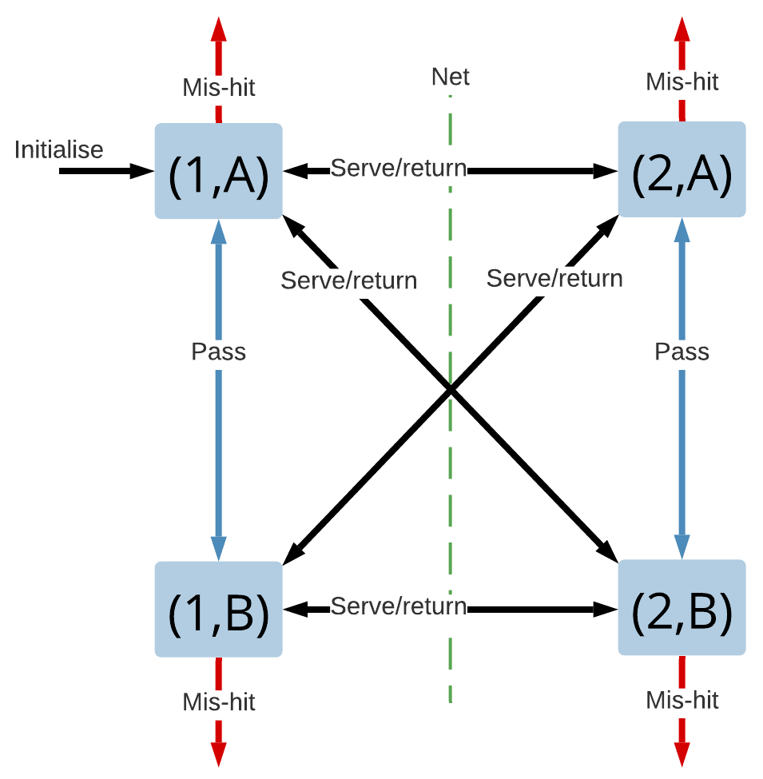
Diagram of volleyball players and arrows indicating directions of play
There are four players designated by team A or B and number 1 or 2. The point begins with a serve (in this case from player (1,A). Then play continues through a series of passes (between teammates) and returns between teams. Play finishes when the ball is mishit (either hit out of the court or into the net or missed altogether).
There is one extra rule in the state changes. The ball can be passed only twice before it must be returned. Thus, the state should have an extra variable included, which is the number of passes. When a ball is received by a team, this counter starts at 0. When it reaches 2, the next player must try to return the ball to the other team.
In a real game, there might be additional rules. For instance, the server can’t pass the ball (they have to serve it), but we will ignore these for the moment.

Simulation example
In this example, the probability of a mis-hit is assigned to be 0.2, and the probability of a return or serve being sent to each player (on the other team) is equal. Finally, the teams will try to pass the ball the maximum number of times before returning it. In reality, teams will often play like this in order to set up their return. Sometimes, they might change in order to throw the other team off, but these details will be omitted in our very simple model.
All random numbers generated here will be U(0,1). Our list of these are:
[ 0.25,0.40, 0.96,0.88,0.32, 0.89, 0.06 ...].
Initialise the system by assigning player(1,A) to serve. At each time, the event list will only have one event, so when you process an event, you then add in the next event. A mis-hit happens with probability 0.2, so when your U(0,1) random number falls below 0.2, there is a mis-hit. The remaining probability is divided equally when returning the ball, so that the ball will go to player A if the random number falls between 0.2 and 0.6 and to player B otherwise. You also have to keep track of the number of passes to ensure this doesn’t exceed 2, so the state is augmented with this . 2.10 shows a simple example.
2.10: Event list for a game of beach volleyball
Current State (team,player,passes) | Event list | Random number | New State
(1,A,0) | serve | 0.25 | (2,A,0)
(2,A,0) | pass | 0.40 | (2,B,1)
(2,B,1) | pass | 0.96 | (2,A,2)
(2,A,2) | return | 0.88 | (1,B,0)
(1,B,0) | pass | 0.32 | (1,A,1)
(1,A,1) | pass | 0.89 | (1,B,2)
(1,B,2) | mis-hit (return) | 0.06 | end
end

2.11 shows a less successful example (for the server):
2.11: Event list for a less successful game of beach volleyball
Current State (team,player,passes) | Event list | Random number | New State
(1,A,0) | serve (mis-hit) | 0.18 | end
end

Key points from this example
The example of volleyball is intended to introduce you to a few concepts:

- Sometimes the event list is almost trivial—here, there is just one event in the list at a time.
- The clock here is almost trivial as well. It is just the number of hits, so this hasn’t even been listed.
- The states are made up of two pieces: a team and a player. Often, a state is combined in this manner, which is called a Cartesian product, between two sets. The state-space would be written as: S = 1,2 otimes A,B, where otimes means the Cartesian product.
- The events can be limited by some extra logic. For instance, in this case, the number of consecutive passes is limited to 2.

2.4.4 Example 5 - A Twitter Cascade or a Simple Epidemic
Info: Content warning
The COVID-19 pandemic can be considered a worldwide catastrophe. It has touched almost every person on the globe. I acknowledge that this topic may be challenging for some students, particularly those who have suffered the loss of a loved one or have otherwise been severely negatively impacted by the pandemic. The inclusion of material related to this has not been included carelessly. It is included because the very nature of the impact of the pandemic—the fact that it has had such a terrible impact on so many people—is what makes it important to study. If you find this material challenging, I encourage you to access and use the University’s Student support services.
In this example, you will see how to simulate the spread of a disease, or the spread of an idea (the two are remarkably similar).

Scenario
A very large class of models concerns a topic broadly called mathematical epidemiology, which studies the spread of diseases. Mathematical models and simulations have been used extensively to understand the spread of COVID-19 and to model the impact of interventions; for instance, wearing masks and social distancing. It would be fair to say that the course of the pandemic has dramatically been affected—at least in Australia—through the use of simulation.
This type of modelling goes back to Daniel Bernoulli who in 1760 built a model to understand the earliest form of vaccination (to protect against smallpox). This letter in Nature describes how Bernoulli was way ahead when it comes to modern epidemiology. Of course, he didn’t have a computer, so he had to do calculations by hand.
The same type of model can be used to understand the spread of a meme. Memes spread, for instance, over Twitter, much like disease spreads through a population. Close contacts pass on a disease just as ideas are passed on to Twitter followers.
Some epidemic models are very simple, but the other idea I want to introduce in this section is that of a network. A network is a model of relationships between a set of entities. It could represent close contacts in real life or online social media friends. Figure 2.10 shows an example. It shows, that Amy, for instance, is friends with Bob and Cam.
Figure 2.10: A social network between five people.
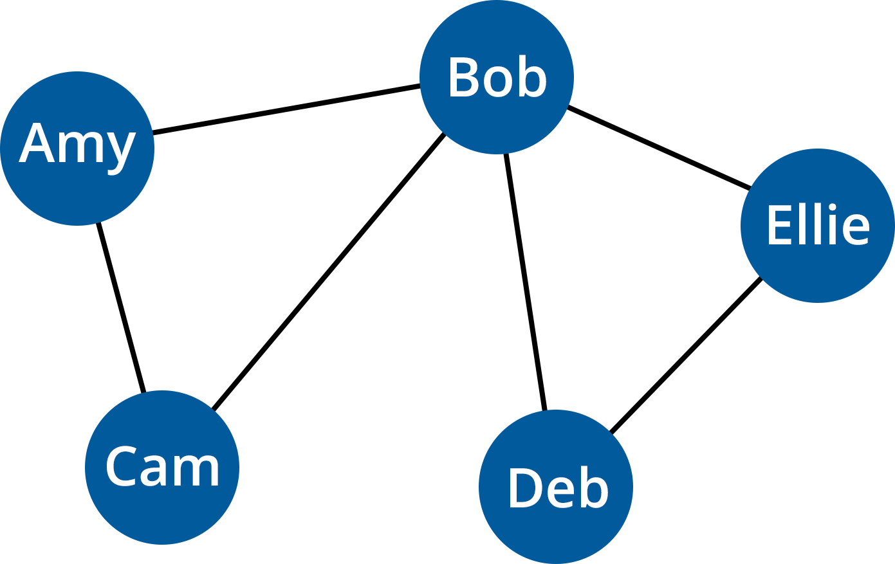
A diagram showing five circles connected by lines
The five circles are spaced out and labelled with the following names: Amy, Bob, Ellie, Deb and Cam. Two lines from Amy’s circle join her to Cam and Bob. Two lines from Cam’s circle join him with Amy and Bob. Bob has four lines connecting him to Amy, Cam, Deb and Ellie. Two lines join Ellie to Bob and Deb. Two lines join Deb to Bob and Ellie.

A network is described mathematically by a graph, which has a list of nodes or actors (corresponding to the entities) and a set of edges or links or arcs or ties that connect them. By abbreviating names to just their first initial, the network in the figure has nodes N and edges E defined by the following equations:
N = A, B, C, D, E , E = (A,B), (A,C), (B,C), (B,D), (B,E), (D,E) .
The edges are described by a pair, so(A,B) means a link between Amy and Bob. In this graph, the edges are undirected, but you could also build directed graphs; for instance, to represent followers.
It is common in modelling an epidemic to assume it spreads most readily between the close contacts described in such a network. The contract tracers you hear so much about these days are using data to construct these networks. This network will be used in the model that follows in a similar way.

Questions
There are several standard questions you might like to ask. The most obvious is, “given early observations of a new disease, will it be a serious epidemic or pandemic, or will it burn itself out?”
Other questions about disease involve the impact (positive or negative) of interventions, for instance, “What if everyone wears masks?”
Viral marketers would like to ensure their campaign “goes viral” and so are interested in understanding the features that would make it a meme “pandemic”.

Modelling
Entities: The entities are the people in the system, whether it be participants in an online social network or a population of potential infectees.
Network: In addition to the entities themselves, you need a model of the network connecting them. In this simple simulation, the network will be static, but in some simulations, the network might evolve as part of the simulation.
Events: The main events in this model are the transmission of the disease, or the meme, from person to person. I will assume that infection can only occur across a network link, i.e., to a close contact or friend. The key difference between such an event and others that have previously been considered is that one person can infect many others, so a single infection event can generate many. The other type of event here is recovery.
State: The state needs to describe the state of each entity. It is common to model a population subject to disease as Susceptible, Infected and Recovered. With many diseases, the body’s immunity kicks in after having the disease, so recovered individuals are no er capable of catching the disease. You might imagine the same is true for memes (you can’t catch a meme twice). In any case, each entity will be given a label: S, I or R. If the disease is more serious, there is a fourth possible state, Deceased (D).

SIR Modelling
SIR modelling has a history and many variants. The earliest models date to the early 20th century and don’t include a network—they assume that the population mixes freely and the disease can transfer to anyone. Many of the early models also approximated a population as a continuum, even though people are quite discrete. These types of models have been used to model everything from disease to viral marketing to computer viruses. They have even been used to model the Zombie apocalypse.

Optional readings
Kermack, W O, and McKendrick, A G, 1927. ‘A contribution to the mathematical theory of epidemics.’Proceedings of the Royal Society of London. Series A, Containing Papers of a Mathematical and Physical Character, vol. 115, no. 772, pp. 700–721.

This paper is the original. It is the paper that started much of the thoughts about event-based epidemic models. This is not required reading, as mathematics is not part of this course, but you may wish to investigate the source of the types of models that are often used to model the spread of diseases.

Rodrigues, H S, 2016. Application of SIR epidemiological model: new trends, International Journal of Applied Mathematics and Informatics, 10: 92–97

A common approach to modelling disease is to treat a population as a continuum, and use differential equations to model the disease. This provides a simple approach, but it is very limited because it can’t understand the unpredic variations that are seen in real disease spreads. However, the same concepts can be adapted to simulate the discrete events that spread disease. It’s a good paper to read to understand why you use the approach I am proposing.

You can also access all the readings for this course from the 'Course Readings' menu item on the left of your screen.

2.4.5 Example 5 - A Twitter Cascade or a Simple Epidemic (continued)
The other facet of epidemic models that differs from the models looked at earlier is the types of questions you want to ask. A couple of questions already mentioned include:

- Will my meme “go viral”?
- Will a disease burn out or become a pandemic?
Let’s now fill in a few more gaps and go through a simple example.

Simulation example
Starting with the network defined on the previous page, initialise the network with the event of Amy becoming infected. A few more details need to be clarified:

- When an individual becomes Infected at time t they will remain infected for an exponential time T(this is somewhat unrealistic for most diseases, but is the closest from our limited selection of distributions). Thus, at time t + T the individual will move from being Infected to being Recovered.
- When an individual becomes infected, their close contacts in the network who are still Susceptible have a probability p of becoming Infected as well, creating new infection events.
- If a contact i is to become infected, the time at which that happens will be uniformly distributed, i.e., it will be at time t_i ~ U(t, t+T).
You will write the states—the status of each entity—as a vector in alphabetical order. For instance, start with Amy Infected and all others Susceptible, so after Amy is infected, the state is (I, S, S, S, S). Events will be written by what happens (Infection or Recovery) and who it happens to (by their initials), so Amy becoming infected is denoted by I-A. You augment the events in the event list with the time at which they will occur. 2.12 shows an example simulation.
2.12: Event list for infection states
Time | Current State | Event list | Event | New State
0.0 | (S,S,S,S,S) | I-A(0.0) | I-A | (I,S,S,S,S)
0.4 | (I,S,S,S,S) | I-B(0.4), R-A (2.1) | I-B | (I,I,S,S,S)
0.8 | (I,I,S,S,S) | I-E(0.8), I-D(0.9), R-B(1.2), R-A (2.1) | I-E | (I,I,S,S,I)
0.9 | (I,I,S,S,I) | I-D(0.9), R-B(1.2), R-E(1.5), R-A (2.1) | I-D | (I,I,S,I,I)
1.1 | (I,I,S,I,I) | R-D(1.1), R-B(1.2), R-E(1.5), R-A (2.1) | R-D | (I,I,S,R,I)
1.2 | (I,I,S,R,I) | R-B(1.2), R-E(1.5), R-A (2.1) | R-B | (I,R,S,R,I)
1.5 | (I,R,S,R,I) | R-E(1.5), R-A (2.1) | R-E | (I,R,S,R,R)
2.1 | (I,R,S,R,R) | R-A (2.1) | R-A | (R,R,S,R,R)

At each step, you process one event, and, in doing so, you sometimes create multiple new events. Each infection event generates (i) a recovery event, and (ii) zero, one or more new infections events. Recovery events, on the other hand, do not lead to new events.
New events occur at times determined by random variables, so the new events (highlighted in bold in the ) aren’t necessarily at the end of the event list.
Notice, at the end of the simulation, that not all entities were infected: Cam avoided being infected. However, all individuals have recovered. One interesting question is, “What is the distribution of the number of individuals infected during the epidemic?” In this case, four out of five, but you need to run many simulations to see the distribution. You might summarise that number using its expected value or mean.
Another question you might ask is, “How did it take until the disease burned itself out?” In this case, 2.1-time units occurred until the final recovery event (and the event list was left empty).
The animation in Figure 2.11 provides a visual demonstration of the infection and recovery in the network described in this example.
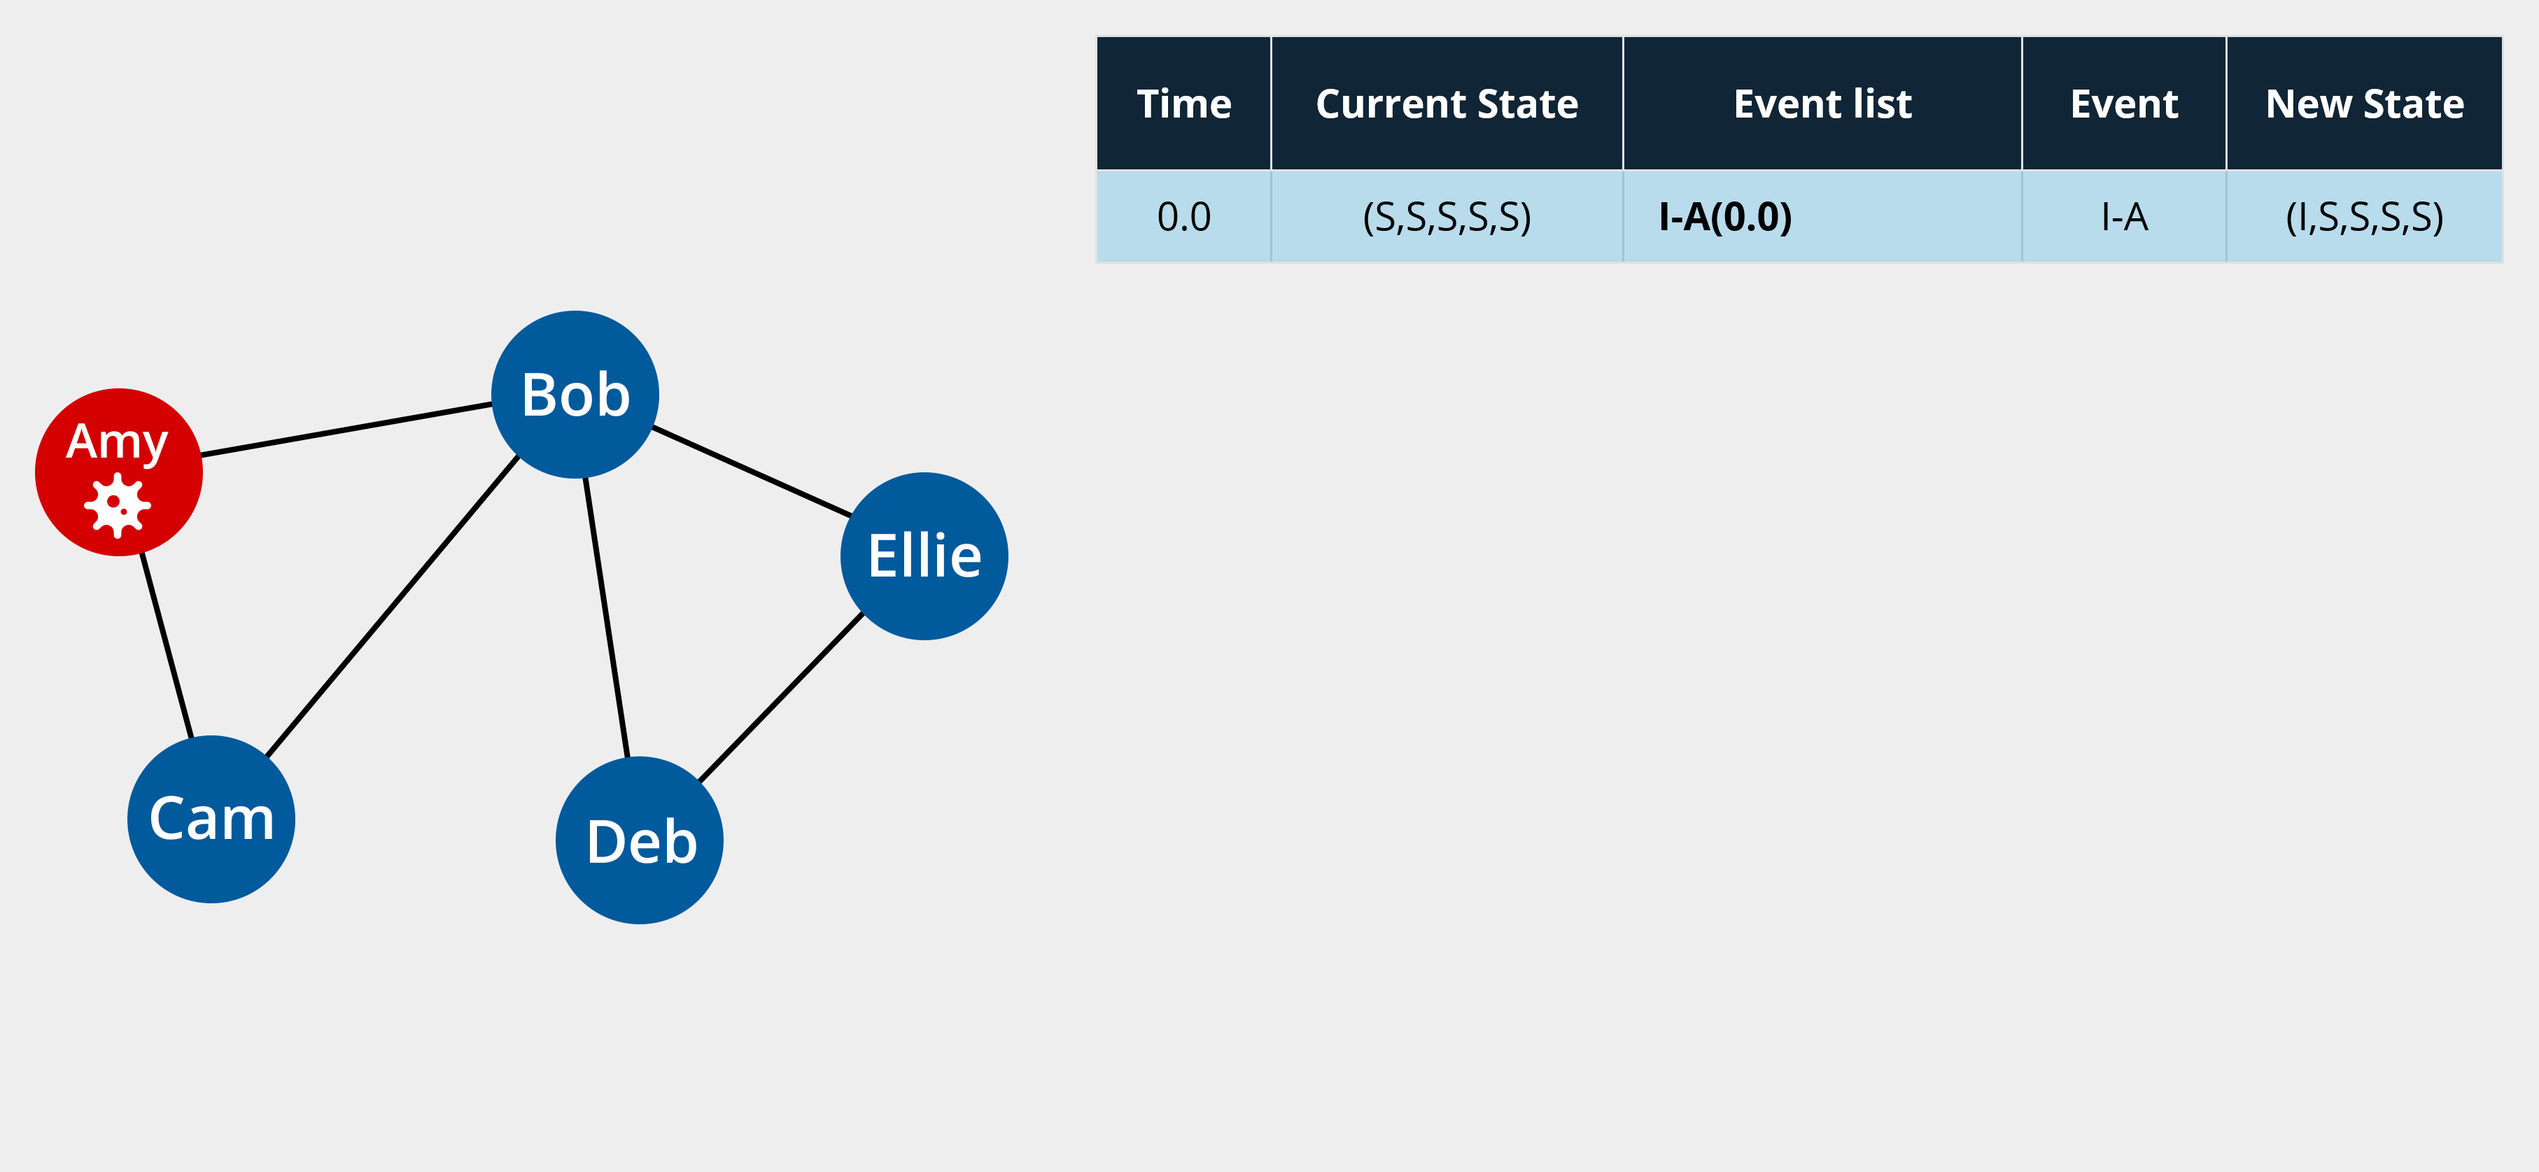
Animation of the spread of the virus as described in 2.12

Key points from this example
- You learnt about networks and how they can represent relationships between entities. In other simulations, a network can also transfer , or represent relationships, between queueing subsystems, so this is a very useful concept.
- In this simulation, you saw events that spawn more than one follow-on event. In extreme cases, this can lead to cascades of events that increase in number exponentially. That is a huge problem for a disease, as it means it spreads very rapidly to a large population. It is, however, the aim of viral marketing where the advertisers want many people to be influenced by an idea.
- You also saw some different types of questions about how an epidemic arises, and how it lasts.

3. Instrumentation, Test & Validation

Module 3 Overview
module banner
In this , Professor Matt Roughan provides an outline of this module and gives an overview of instrumentation of simulations, test and validation. These are the two pieces that were missing from last week in terms of making your simulations useful.

Learning outcomes for Module 3
On successful completion of this module, you will be able to:

- generate and store useful data from DES,
- summarise behaviour from DES,
- validate DES using output data,
- diagnose and correct problems in DES.
The above learning outcomes will also prepare you for your assessment tasks.

Activities
In this Module, you will:

- learn about measuring what is happening in your simulation. The simulation happens in silico, and so is essentially invisible. You need a strategy to instrument it to obtain data. You will also learn about VV&A (Verification, Validation and Accreditation), which are needed to convince people that your results are useful.
- further improve your skills with the programming language Julia.
- perform numerous small quizzes and activities to reinforce the learning objectives for this week.
- participate in workshops, including a discussion of the Car Park Valet queue model in more detail, and debugging some code to see how verification works.

3.1 How to Extract and Work with Data from a Simulation
This section is an introduction to the different ways data can be extracted and recorded from a simulation.
- Read through the following pages in order, taking notes as you go and running any example code (if applicable).

3.1.1 Instrumenting a Simulation
If you were performing an experiment in real life, a crucial part of the experiment is measuring the results. That is no less true when you perform in silico experiments like simulations. In fact, it is even more true because you can’t see what is happening in silico.
Measuring the results of a simulation is easier, in some ways, than measuring a process in real life, but it has challenges. The most obvious is understanding how to get at what you want to measure when you can’t see it directly. You solve that challenge by instrumenting a simulation.
Scientific instruments have been used for centuries to enhance our natural human abilities to sense the world:

- Microscopes let you see tiny objects and telescopes objects that are far away.
- Geiger counters let you measure radiation.
- MRI machines let you see inside objects.
- Vernier callipers let you make precise measurements of lengths.
There are many, many other examples where instruments enhance your senses or allow you to measure things that would otherwise be invisible.
Here, you will learn to construct measurement instrumentation for your simulation. The instrumentation will let you output data about what is happening inside the simulation.
At one level, writing out data is easy. Most programming languages provide simple functions to write data, and Julia is no exception. It has a fleet of output commands, starting with simple commands like print and println, with others like the macros in the Printf package for doing formatted output. So, it might seem like this will be easy, but the output is a relatively slow operation, and doing this carelessly can slow your whole simulation down. And there is a second problem.
Adding data output is a cross-cutting concern, which means that the measurements cut across the otherwise clean structure of your simulation. If they are not implemented carefully, measurements can cause very hard-to-diagnose bugs because they break the clean, crisp modular design of the underlying sim.
So, you need to think about instrumentation carefully. The first starting point is the strategy you will use.

Measurement strategies
There are two major strategies for instrumentation, oriented around the core objects of the simulation:

- event-driven measurements, where you measure the simulation at events,
- entity-driven measurements, where you measure the simulation as seen by the entities.

Each approach has its own merits. The approach required is determined, at least in part, by the questions you wish to answer about the system, but I am going to advocate the careful use of both approaches here. Using both provides you with a double-check that will be incredibly useful when testing your simulation.
There is a further distinction to be made before you progress to understanding how to implement these measurements:

- Continuous output: means that you output data, for instance from events, as those events are processed in your simulation timeline. It is a simple approach to program, but has the issue that input/output operations are often very slow compared to everything else in your simulation.
- Batch output: means that you collect a batch of output together before writing it to a file. The extreme version of this is to wait until the end of the simulation to write out all of the data. This approach has the advantage that you don’t block the simulation as it progresses, but now you need to create data structures to store data as the simulation progresses, and the memory these consume may become a performance bottleneck if you are not careful.

Continuous output has advantages when you are debugging. It allows you to see the simulations 'so far' up until the point when it crashes. Be aware, however, that some software systems will automatically 'batch up' output for you. They will store data in a buffer (yet another queue) to write as a block, and so the data you see written to a file may not be up to date unless the buffer has been flushed. This advantage will lead you to use continuous output here, but you should be aware of the performance problems this might cause when you need to write a very fast simulation.
It would be ideal to write out 'everything' when instrumenting a simulation. That would allow you to answer questions you might not have thought of yet. However, the performance cost of writing data to a file means that you can’t write out data carelessly. You should always think about exactly what data is needed to answer the questions of interest.
For instance:

- Do you want to know about the state of the system and in what level of detail?

- Do you want to know about the entities in the system, and again, at what level of detail?

Reconsider the examples from Module 2:
- The M/M/1 queue: consider answering the question, 'How does the queue get?' In this case, you didn’t record separate entities so you will focus on the state, which tells you the queue length. You would therefore use an event-driven strategy and, at events, you would write out the state.A car park: one question asked here was, 'On average, how do cars spend in the waiting zone?' This is a question about the entities, so it is natural to adopt an entity-driven strategy, and write out the wait time for each entity, which you know, once it receives service.An emergency department: the questions here were more complex, and so to answer them you might want to know about the state of the system at event times, and also the experience of each patient, i.e. each entity. So, you would need a hybrid approach where you write out each item of .
- A car park: one question asked here was, 'On average, how do cars spend in the waiting zone?' This is a question about the entities, so it is natural to adopt an entity-driven strategy, and write out the wait time for each entity, which you know, once it receives service.
- An emergency department: the questions here were more complex, and so to answer them you might want to know about the state of the system at event times, and also the experience of each patient, i.e. each entity. So, you would need a hybrid approach where you write out each item of .

Hybrid measurements
As I said before, even if only one type of measurement strategy is needed, it is often useful to use both approaches—though that is only practical where the model supports both events and entities.
Reading Check
Scroll through questions 1 and 2 to check your understanding.

3.1.2 Event-Driven Instrumentation
The actual implementation of event-based instrumentation is usually fairly easy. You create an output file stream and, when each event occurs, you write out the system state. You’ll need to be able to do this for your assessments. In particular, you will be required to do the in the Programming Assignment.
Some details you need to consider include the following:

- The output file stream is a global object: it needs to be accessible from almost everywhere in your program. Outputs might originate in several different places and at multiple times. However, it is best to avoid global variables, so it is better to pass handles to the output streams into the event-processing functions as input arguments.
- Do you need to write out the whole state (which might be big and complicated) or just some function of it? A simple example is the car-park problem where the state is keeping the number of valets that are occupied and the number of cars waiting as separate variables. Maybe you only need one of these or the sum of them.
- When you are writing out the system state (or some function of that state), you could write the state before or after the event is processed. Either is useful, but you must know which you are doing. It makes a big difference in some cases. Sometimes it is useful to write out both—particularly for debugging code because then you can see the state transitions.
- It can be useful to write out about the event, as well as the state. Simple event like the event ID or type is very useful in debugging.
- Always include a timestamp in the output. Remember that simulation time is not the same as your time, so you need to keep track of system time in order to make sense of the results.
- Writing out data has a performance cost, so consider writing out a sample of results, e.g. write out every 10th event. This can improve performance but can make the results less useful for debugging.
- In a similar vein, you might write out the state only when certain types of events occur.

For instance, consider the M/M/1 queue. I want to know about the queue lengths, and I am most interested in how the queue looks to new arrivals. Therefore, I might write out only after-arrival events, and for the example presented earlier, I would write something like:
timestamp,arrival_number,queue_length(before arrival) 0.000,0,0 0.181,1,1 0.307,2,1 0.482,3,2 3.209,4,2 3.600,5,2 4.245,6,3 4.358,7,4

3.1.3 Entity-Driven Simulation
Implementing entity-based measurements involves many of the same issues described on the previous page, but one additional feature is required. The complete set of important about an entity is not usually available when the entity first arrives in the system. You often learn about that through the simulation. Hence:
- You only write out the about an entity when it is 'finished', for example, when it leaves a queueing system.
- Your data structures used to store about an entity therefore must also store the relevant statistics about it.
You will also be expected to implement entity-based measurements in the Programming Assignment.
For instance, consider the car-park model. Each entity (car) has several attributes you should keep track of:
- the time t_A at which it arrives at the system (its arrival time)
- the service time t_S) which is how it spends being served
- the time t_D when it is finished being served (its departure time).
You can calculate the waiting time t_W using the formula
t_W=t_D-t_A-t_S
That is, the waiting time is the time between arrival and departure, minus the time spent in service.
The output of the car-park simulation might look like:
entity_ID,arrival_time,service_time,departure_time 0,0.000,2.5,2.500 1,0.675,2.5,3.175 2,0.862,2.5,3.362 3,1.954,2.5,5.000 4,3.050,2.5,5.675
Note that, in this system, the service times are deterministic, so they are all exactly 2.5. In a case like this, you don’t need to write out this detail, but for the moment, I will include it to make the process clear.
Each of the rows in this output would have been created (continuously) when the entity was finished, i.e. on the departure event where it left the system.
One final point before I move onto storing the output: you may note that there is some redundancy from event-driven and entity-driven output. Sometimes one could infer one from the other. Typically, you should use the approach that is natural to the question being asked. This just makes your life easier. However, the redundancy is a feature you will later use in testing, so it is not a bad thing.

3.1.4 Storing the Output
The output from a simulation must be stored somehow and there are many variations that are possible. You will learn a particular approach, the value of which lies in its simplicity and portability. You will be expected to use this idea in the Programming Assignment as well.

File formats
There are many ways to store data. Binary formats used to be common because they are faster to write and can save space. However, binary formats are much more complicated to implement properly and are less por than simple text files, and so you will use the latter.
Text files are simpler and more por because:
- they are human-readable, and so much easier to check and debug
- text formats are more uniformly supported over a wide range of computers and operating systems.
Even within text formats, there are many alternatives. You may hear of XML and JSON. These are very common. However, many such formats are complex and inefficient. In this course, I recommend using CSV (Comma Separated Value) files.

CSV
CSV files are a special case of a larger set of value delimited files, e.g. TSV files are tab delimited. Any of these are sui formats, but CSV are the most commonly used.
CSV files have one row per record, and each row is a series of values with a comma delimiting the values. For most cases, this is all you need to know—mostly, you will be reporting 'simple' values such as a number or a string of characters representing the type of an event. You will need to do this in Assessment 2.
However, CSV files also allow for the case that a value contains a comma. In these cases, you must escape the comma. The most common approach being to put the entire string, including the comma, into quotes.
Here is a simple example:
# this file is an example entity_ID,arrival_time,service_time,departure_time,notes 0,0.000,2.5,2.500, 1,0.675,2.5,3.175, 2,0.862,2.5,3.362, 3,1.954,2.5,5.000, 4,3.050,2.5,5.675,"this, is the last entity"
Note that this example is slightly different from the output above, in that it includes a 'notes' column. Most of the entries in this column are empty (which is allowed), but the final note is a string that includes a comma inside quotes.
CSV is not an entirely well-defined file format, and there are some variations. A common variation is including column headings in the first line of the file. This is very useful, and so I will use it here. Most programming languages provide some way to read or write such headings (Julia certainly does).
Another common CSV variant is to allow comments, i.e. in the file that is not strictly part of the data. A common way to include comments is to use a#at the start of the line. Thus, comments can appear anywhere in the file. This is also very useful, and so I will use it here.
Julia has a package to allow simple reading and writing of CSV files. Surprisingly, it is called CSV. It integrates easily with the DataFrames package, and therefore with many others, so it is ideal for our work. A simple example follows.

Example 1 — Writing a CSV from a DataFrame
using CSV, DataFrames DF = DataFrame( "ID" => [1,2,3], "Time" => [1.0, 2.5, 4.5] ) CSV.write("csv_example.csv", DF)
The resulting CSV would look like:
ID,Time 1,1.0 2,2.5 3,4.5

Example 2 — Reading from a CSV into a DataFrame
REMOVE -
using CSV, DataFrames DF = CSV.read( "csv_example.csv", DataFrame; comment="#" )
3 rows × 2 columns
 | ID | Time
 | Int64 | Float64
1 | 1 | 1.0
2 | 2 | 2.5
3 | 3 | 4.5

The optional third input for the functionCSV.read says that comment lines begin with a#and the program should ignore these. We don’t have any comments in this tiny file, but I wanted to show you how it was done.
Try it yourself.

3.1.5 Directory Structure and File Naming
Following on from the previous page, once you have decided on your file format, you must choose the file into which you write the data. The two components of setting this file up are:
- choosing the name of the file,
- choosing the path of the file, i.e. the directory or folder in which it will reside.
These choices should be made carefully in order to:
- avoid overwriting files when the simulation is run multiple times,
- organise the data so that,
- it is easy to process and analyse,
- a particular piece of data is easy to find,
- aid in sharing the data.
The combination of path and filename should always be unique in order to avoid overwriting. Thus, several components should be included in this name:
- an identifier for the particular model being simulated
- any parameters used as inputs
- the random seed used to initialise the pseudo-random number generators in the simulation.
For example, consider the carpark model. You might use the directory/path to specify that you are examining this model and the filename to include the specific parameters (e.g. the number of valets and the service times), as well as the seed, resulting in something a the lines of:
.../Data/car_park_simulation_1/entities_3_2.50_001.csv .../Data/car_park_simulation_1/entities_3_2.50_002.csv .../Data/car_park_simulation_1/entities_3_5.00_001.csv .../Data/car_park_simulation_1/entities_3_5.00_002.csv .../Data/car_park_simulation_1/entities_4_2.50_001.csv .../Data/car_park_simulation_1/entities_4_2.50_002.csv
Here, we have simulated two instances (with seeds 1 and 2) for several combinations of parameters. Each file name clearly shows what is being stored (the entities), the number of valets (3 or 4), the service times (2.5 or 5.0) and the seed values. Often, the meaning of the numbers in the file names could be made even more obvious by including extra words and letters.
There are many alternative approaches that can be used successfully here. For instance, sub-directories can be used instead of putting parameters into each filename and the order in which the parameters appear in the filename is often unimportant.
The key thing to learn is that you should not stint. Put everything you might need here as it will save you time later.

Metadata
The file naming process I have recommended above is a first instance of a more general principle, that of always keeping the metadata.
Metadata is data about data. In this case, it includes:
- the name and version of the program that generated the data,
- the model simulated,
- the date when the data was created,
- the parameters and seeds used in the simulation,
- any input data files,
- anything else that would later help a subsequent researcher understand your output data.
All of this metadata should be included into every output file as comments. I know that some of it may have already been included in the filename itself, but redundancy never hurts. You might also think that it is sufficient to store the metadata in a separate file a side the actual output. But you don’t know what someone else will do to your data later on. They may change filenames or move the files around. Including metadata in the file makes it much harder to get lost.
Some of the metadata is breadcrumbs, i.e. little hints to help you when you come back to the data at a later date (the version number of the code you used can be very helpful to compare results, for instance).

Breadcrumbs
Hansel and Gretel were led off into the forest by murderous parents to be left to die. But Hansel left a trail of breadcrumbs and so they found their way home. OK, so the story is a little er and more complex, but analogies aren’t meant to be perfect. When working with data, breadcrumbs are a simple way to include metadata that helps you find your way back to the source. For example, informative file names (including the data type and perhaps some parameter settings), a little in the file itself (as comments, if possible) to say what the source of the data was and how it has been processed, and README files (see Alice’s Adventures in Wonderland for an explanation or look at the CatB website). Breadcrumbs can save you hours or days of work and make your data much easier to share.
Some of the metadata will be used in test and validation of your data. Some of the metadata is just there in case your results are questioned at a later date (imagine that your data was used to plan a major capital investment and the plan goes wrong—you would want to be able to justify your results very strongly). Including metadata takes a little extra effort at the start, but pays off big time later on.

Optional reading
Most research communities have become more and more concerned about curation of data. The data created, for instance by simulations, is a crucial resource for reproducible research, which is the basis of good science. Many organisations have published on how they want data to be preserved, and the Australian Research Data Commons provides a really good example. Reading this will fill you in on many of the broader concerns that I am trying to address here.
Australian Research Data Commons n.d. Metadata – Enabling and enhancing the discover and reuse of data, ARDC, viewed 21 July 2021.

3.1.6 Ensuring You Measure What You Wanted
There is one more topic I must touch on. In a DES, our instrumentation measures the system at events. That is, you 'see' the system at the times when it is changing. However, this view can be biased.
For example, imagine the following simulation: a D/D/1 queue, i.e. a queue where the inter-arrival times and service times are both deterministic. Take the inter-arrival times to be 1 minute and the service times to be 30 seconds. Start with the system empty. The first arrival will go straight into service, and be finished after 30 seconds, so the second arrival will also find the system empty, and so on, and so forth, as shown in Figure 3.1.
Figure 3.1: The number of customers in a D/D/1 queueing system.
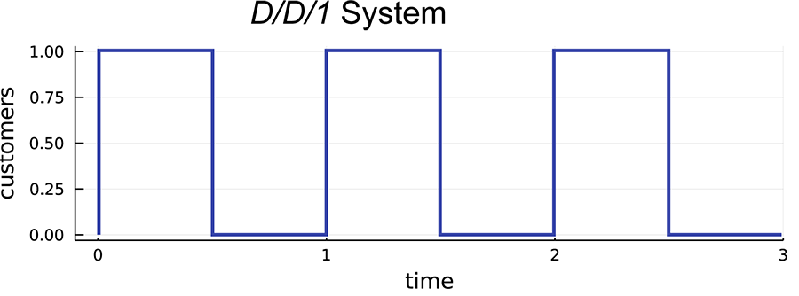
DD1 System

The deterministic arrivals and departures are chosen so that the system is exactly periodic, oscillating between 0 and 1 at ½ second intervals.
3.1: Data points shown on the graph
Time (x-axis) | Customers (y-axis)
0.0 | 1
0.5 | 0
1.0 | 1
1.5 | 0
2.0 | 1
2.5 | 0

If you look at the figure you see that:

- an arriving customer always sees the system as empty,
- after the arrival, the state is always 1,
- before a departure, the system always has 1 customer in it,
- after a departure, the system is again empty.
And yet, the system has one customer in it half the time, so the average occupancy is 0.5.
Thus, depending on what you measure, your average number of customers in the system would appear to be 0, 1 or 1/2.
You can't be vague here. The goal is to provide our business with a precise numerical estimate of something important, so you need to decide which number you want to use. You need to choose which number is useful to you or your business. How do you decide?
The first step is to be very clear about what you want to measure. Sometimes you want the average, and sometimes you want to know what customers see. You need to decide which is important to you.
You might guess the second step is to measure what you want, but unfortunately, that isn't always possible. In the previous example, you can easily measure what an arriving customer sees because it happens at an event that you can monitor. However, you cannot directly monitor the average.
There are two main tricks used here:
- Reconstruction: If you collected all the data on arrivals and departures in the above simulation, you could essentially reconstruct the figure and, from that, calculate the average. This isn't quite what you do. You don't actually draw a picture. You can recalculate the state average by weighting it according to the times you spend in each state. Take the time in the state after the i th transition to be t_i, and the state during this time to be s_i, then you can calculate a weighted average as: s̄ = (Σ_i t_i s_i) / (Σ_i t_i). The numerator incorporates the time-weights into the sum, and the denominator “normalises” the average. To understand normalisation consider s̄if all of the values s_i = 1.
- PASTA: The acronym PASTA stands for Poisson-Arrivals-See-Time-Averages. I haven't talked specifically about the Poisson process in this course, but, simply put, when you have an arrival process with independent, exponential inter-arrival times, it is Poisson. In this case (for instance in the M/D/3 queue), the arrivals see (on average) the same thing as the actual average. Hence, in these cases, you can be a little more laissez fair.

Expectation revisited
Earlier, I talked about the 'expectation' of a random variable. Here, you are starting to calculate 'averages'. The two are linked so strongly that, often, the two terms are interchanged. Here, I use expectation as the 'average' of a theoretical random variable like an exponential, and you use 'sample mean' or 'average' to talk about data.

Optional readings
Testing performance metrics isn't just the domain of simulation. System benchmarking is a common tool used to compare, for instance, two different computers based on their performance. The following readings are optional, but discuss system benchmarking and show the parallels. In particular, there are some common causes for systematic mistakes in both simulation and benchmarking, and these readings are helpful to understand them.

Alcorn, P 2021, CPU Benchmarks and Hierarchy 2021: Intel and AMD Processors Ranked, Tom's Hardware, viewed 21 July 2021

Testing performance metrics isn't just the domain of simulation. System benchmarking is a common tool used to compare, for instance, two different computers based on their performance.

Gunter, N J 2004, Benchmarking Blunders and Things that Go Bump in the Night, Performance Dynamics Company, California, viewed 21 July 2021

Benchmarking is fraught with exactly the same problem of systematic mistakes. Some nice war stories are presented in this reading.

3.1.7 Activity - Measurement
This activity will help you understand what you’ve just learnt on the previous pages by getting you to try it out. The plot in Figure 3.2 shows the state transitions of a queueing system (note all transitions happen at integer-valued times).
Figure 3.2: The number of customers in a queueing system.
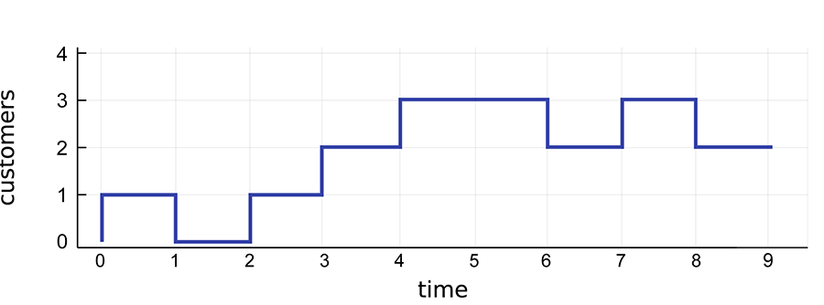
graph
3.2: Data points for the graph
Time (x-axis) | Customers (y-axis)
0 | 1
1 | 0
2 | 1
3 | 2
4 | 3
5 | 3
6 | 2
7 | 3
8 | 2
9 | 2

Calculate the following:

- the average state of the system as seen by arrivals,
- the average state of the system as seen by departures,
- the true time average.
Hint: arrivals result in an upwards step and departures, a downwards step. The value 'seen' by an arrival or departure is the state just before that event.
SELECT TO REVEAL ANSWER
- s̄_arrivals = 1.
- s̄_departures = 7/3.
- s̄ = 17/9.
Calculations
- Arrivals (at times 0, 2, 3, 4, 7) see the following states: 0, 0, 1, 2, 2 s̄_arrivals = (1) / (5) (0 + 0 + 1 + 2 + 2) = 1.
- Departures (at times 1, 6, 8) see the following states 1, 3, 3 s̄_departures = (1) / (3) (1 + 3 + 3) = (7) / (3).
- The time average looks at the times spent in each state shown in 3.3.
3.3: Time averages
State | Start Time | End Time | Total Time
1 | 0 | 1 | 1
0 | 1 | 2 | 1
1 | 2 | 3 | 1
2 | 3 | 4 | 1
3 | 4 | 6 | 2
2 | 6 | 7 | 1
3 | 7 | 8 | 1
2 | 8 | 9 | 1

Hence the calculation is
s̄ &= ( (1×1) + (1×0) + (1×1) + (1×2) + (2×3) + (1×2) + (1×3) + (1×2)) / ( 1 + 1 + 1 + 1 +2 + 1 + 1 + 1) &= (17) / (9).

3.1.8 DES Example in Julia - Part 1
Now, I’ll walk you through an example DES to demonstrate one way of instrumenting a simulation and storing the output. I will start with a new set of code here, so that you see a slightly more advanced setup (our first go was a little primitive because we didn't track everything).

Download packages and set the seed
Start by making sure you have all the packages you will use. Notably, you are going to be writing data out, so you will use the CSV and DelimitedFiles packages.
#### If you do not yet have the DelimiterFiles.jl or CSV.jl packages, you will #### need to download it with import Pkg Pkg.add("CSV") Pkg.add("DelimitedFiles")
Next, make sure that all of the required packages are included, and set the random seed for the simulation.
using DataStructures, S RNGs, CSV, Distributions, DataFrames, DelimitedFiles seed = 17 # set the RNG and seed rng = S RNG(seed)
S RNGs.LehmerRNG(state=0x00000000000000000000000000000023)

Coding the simulation
This example will implement the car-park simulation model described in Module 2: Example 2 — A Car Park. Remember that this is a simple queueing system where the customers are cars that queue to receive valet service and with 3 servers (the valets who park the cars). Later on, the number of servers will be one of the parameters of this system, so you will put it into a variablen_valets.

The scenario
Suppose that customers arrive in the car park randomly with an exponentially distributed inter-arrival time with a mean of 2 minutes. Upon arriving at the car park, the customer is immediately served by a valet if one is available, otherwise, the customer waits until a valet becomes available. The customers in the waiting queue are served in a FIFO discipline. Assume that customers do not baulk and they wait as as is needed.

How you can code this
The way you are going to code this is to keep track of all of the future events that are known in a priority queue, where the priority is the time at which the event is to occur. This is called the event queue.
At every iteration of the main event loop, you take the highest priority event from the event queue (that is, the event with the next time) and update the state of the system based on the event.
The events may spawn new events, and these are added to the event queue. For example, the arrival of a customer when a server is free can spawn a corresponding departure event when the customer will finish being served.
Since the arrival process is specified in terms of interarrival times, you also generate the next arrival event (in the future) when you process the current arrival. This means there can be many service events in the event queue, but only one arrival event.
To keep track of entities, you will create a muCustomer structure with fields:

- id: a unique identifier for each customer,
- arrival_time: the random time at which they arrived into the system,
- start_service: the time they started service,
- end_service: the time at which they end their service.
Note that we are instrumenting the entity here. Fields have been added to the record, which includes important details about the customer. You could add more (for instance, the number of customers in the queue when this customer arrives), but the fields included here are enough to answer the questions of interest.
Note that the code will need to change some of these fields. For instance, when the customer departs, you insert theend_service time. As some fields must change, you need to make this a mu structure. It's easy to construct a mu structure—just include the keywordmutable in the definition, as shown in the code:
# this struct represents customers (cars) in the queue # it is mu so you can add the start_service field after it is initialised mu struct Customer id::Int64 # a unique id to be allocated upon arrival arrival_time::Float64 # the time of arrival (from start of simulation) start_service::Float64 # the time the valet serves them (from start of simulation) end_service::Float64 # the time the valet finished (from start of simulation) end # generate a newly arrived customer (where start_service and end_service are unknown) Customer(id,arrival_time) = Customer(id,arrival_time,Inf,Inf)
Customer
When a customer arrives, it is initialised. If all the servers are occupied, the customer joins the queue, and so you only know the arrival time. Thus, when the customer is initialised, you want to call a constructor function, but the last two entries aren't known. To do that, you create your own constructor calledCustomer that sets the unknowns to∞to indicate you don't know their value yet.

3.1.9 DES Example in Julia - Part 2

Defining the events
Now, to define the events in the problem. Start by constructing an abstract type, calledEvent, that will be the supertype of all events. This is a useful umbrella type that can be used when defining functions or composite types that include events—your event list (or event queue) being the prime suspect.
In this problem, new customers arrive or customers complete their service and depart the system. Therefore, you have the following two events.
abstract type Event end struct Arrival <: Event id::Int64 # a unique event id time::Float64 # the time of the event end struct Departure <: Event id::Int64 # a unique event id time::Float64 # the time of the event end
After defining the abstract typeEvent, the notation<: Event allows you to specify that theArrival andDeparture events are sub-types ofEvent. You are going to store the events in an event queue and, to do so, you need to tell Julia which types you will put into the queue. Here, the event queue needs to hold bothArrival andDeparture events, which are both sub-types ofEvent. So, you can just tell Julia to expectEvent s in the event queue.

State of the system
You also need to keep track of the state of the system. To do this, you can make aSystemState struct. This includes the system state (the queue and the number of customers in service) as well as the event queue and some additional values:
- time: Simulation time.
- event_queue: This is a queue of all future events that are known.
- waiting_room: This is a queue of any waiting customers.
- in_service: The number of customers being served.
- n_entities: This is to keep track of the total and allocate each entity a unique id.
- n_events: This is so each event can be allocated a unique id.
I suggest you also opt to keep track of thein_service queue, which is a list of all of the entities who are currently being served. These are kept in a priority queue as well, as you want to process them in the order that they are served. This is overkill in this situation, as you don't really need to know all the about the customers in service, only the total number currently being served. However, in other situations, this might be necessary.
n_valets = 3 # this struct will represent the state of the system # it is mu because we need to be able to change the state of the system mu struct SystemState time::Float64 # the system time (simulation time) event_queue::PriorityQueueEvent,Float64 # to keep track of future arravals/services waiting_room::QueueCustomer # to keep track of waiting customers in_service::PriorityQueueCustomer,Float64 # to keep track of customers in service n_entities::Int64 # the number of entities to have been served n_events::Int64 # tracks the number of events to have occur + queued end

Functions
You can also define some helper functions to help generate interarrival times, service times, and to check the state of the system. These are small functions, so you can use Julia's abbreviated function definition style.
mean_interarrival = 2 # units here are minutes interarrival_time() = rand(rng,Exponential(mean_interarrival)) # to generate interarrival times service_time() = 5 # to 'generate' deterministic service times servers_full(system) = length(system.in_service)>=n_valets # returns true if no valets avail.
servers_full (generic function with 1 method)
The first 'big' function you will create is an event handling function calledupdate!. Each type of event will need its own way to handle it, so use multiple dispatch to overload theupdate!function so that the right type of update is performed for the right event. But first, you will create a generic wrapper function. This serves two purposes:
- It's a place holder used for documentation.
- It will be called if there is no match to a specific event, but that would mean an invalid event, so it will throw an error.
This type of pattern is fairly standard in many Julia packages, so it's worth learning in its own right.
# update!(system,arrival::Arrival) # # Update the system when in response to an event. # Input: # + system: a System struct to be updated # + e: an event # Output: # + customer: the customer who arrived or departed or .. in response to the event # function update!( system::SystemState, e::Event ) throw( DomainError("invalid event type" ) ) end
update! (generic function with 3 methods)

Arrivals
You can now start defining handlers for events that change the state of the system. The first type of event to deal with is anArrival. On the event of an arrival, we:
- add the customer to the system,
- generate the next arrival time (in the future) and add it to the event queue.
Also, if the arrival finds that there is a free valet, it should go immediately into service, so I am going to write a little extra function to do that (I will use this function later, so it's useful to create it separately).
function move_customer_to_server!( system::SystemState ) # move the customer from the waiting room to being in service and update it customer = dequeue!(system.waiting_room) # remove customer from queue customer.start_service = system.time # start service 'now' customer.end_service = customer.start_service + service_time() enqueue!(system.in_service, customer, customer.end_service) # put the customer in service # create a departure event for this customer system.n_events += 1 departure_event = Departure( system.n_events, customer.end_service) enqueue!(system.event_queue, departure_event, customer.end_service) end function update!( system::SystemState, event::Arrival ) system.time = event.time # advance system time to the new arrival system.n_entities += 1 # new entity will enter the system # create an arriving customer and add it to the queue new_customer = Customer(system.n_entities, event.time ) enqueue!(system.waiting_room, new_customer) # generate next arrival and add it to the event queue system.n_events += 1 future_arrival = Arrival(system.n_events, system.time + interarrival_time()) enqueue!(system.event_queue, future_arrival, future_arrival.time) # if a valet is available, the customer goes to service if !servers_full(system) # valet available move_customer_to_server!( system ) end return new_customer end
update! (generic function with 3 methods)
You might be thinking that you have just overwritten theupdate!function, but Julia is smart. Notice, in the very first line of the function definition, we have defined the function call withupdate!( system::SystemState, event::Arrival ). The::Arrival type for the event here specifies that this function works only for arrival events. The functionupdate!has been overloaded with two meanings. Julia will use the most specific one. This functionality is called multiple dispatch.

Departures
A similar approach will be used to overloadupload!for departure events. When a service is finished, you update the state and event queues as follows:
- Remove the served customer from thein_service queue.
- If there is someone waiting, remove them from thewaiting_room queue, allocate them a service time, and add them to the list of customers being served, resulting in a new departure event.
function update!( system::SystemState, event::Departure) system.time = event.time # advance system time to the new departure time departing_customer = dequeue!(system.in_service) # remove customer if !isempty(system.waiting_room) # if someone is waiting, move them to service move_customer_to_server!( system ) end return departing_customer end
update! (generic function with 3 methods)

3.1.10 DES Example in Julia - Part 3

Testing the code
So far, you have coded to implement the DES itself. We haven't written any instrumentation code, but the hooks are there. The entities (customers) include some of the you might like, as does the system state. The next trick will be to get this data out, but first, let’s do a very quick simulation with this code to test that it works. You can output the event list as a diagnostic to see what is happening.
# initialise the system. In this case, the system starts with 1 arrival t0 = 0.0 init_event_queue = PriorityQueueEvent,Float64() enqueue!(init_event_queue,Arrival(0,t0),t0) # event_queue, init with arrival @ t=0 system = SystemState( 0.0, # time init_event_queue, # event_queue QueueCustomer(), # waiting_room PriorityQueueCustomer,Float64(), # in_service queue 0, # n_entities 0 # n_events ) # main event loop while system.time < 6 # grab the next event from the event queue event = dequeue!( system.event_queue ) # process the event customer = update!( system, event ) # temporary outputs display(system.event_queue) end
OUTPUT:
PriorityQueueEvent, Float64, Base.Order.ForwardOrdering with 2 entries: Arrival(1, 2.60112) => 2.60112 Departure(2, 5.0) => 5.0 PriorityQueueEvent, Float64, Base.Order.ForwardOrdering with 3 entries: Arrival(3, 3.632) => 3.632 Departure(2, 5.0) => 5.0 Departure(4, 7.60112) => 7.60112 PriorityQueueEvent, Float64, Base.Order.ForwardOrdering with 4 entries: Departure(2, 5.0) => 5.0 Arrival(5, 5.11363) => 5.11363 Departure(4, 7.60112) => 7.60112 Departure(6, 8.632) => 8.632 PriorityQueueEvent, Float64, Base.Order.ForwardOrdering with 3 entries: Arrival(5, 5.11363) => 5.11363 Departure(4, 7.60112) => 7.60112 Departure(6, 8.632) => 8.632 PriorityQueueEvent, Float64, Base.Order.ForwardOrdering with 4 entries: Arrival(7, 5.98404) => 5.98404 Departure(4, 7.60112) => 7.60112 Departure(6, 8.632) => 8.632 Departure(8, 10.1136) => 10.1136 PriorityQueueEvent, Float64, Base.Order.ForwardOrdering with 4 entries: Arrival(9, 7.50664) => 7.50664 Departure(4, 7.60112) => 7.60112 Departure(6, 8.632) => 8.632 Departure(8, 10.1136) => 10.1136 PriorityQueueEvent, Float64, Base.Order.ForwardOrdering with 4 entries: Departure(4, 7.60112) => 7.60112 Departure(6, 8.632) => 8.632 Departure(8, 10.1136) => 10.1136 Arrival(10, 12.0674) => 12.0674

Writing the data out
The next part concerns how to actually write the data out. There are two strategies and we will implement both here.
The first strategy is relatively simple: event-driven instrumentation sits inside the main loop and records the details at each event.
The second requires you to write some output for each departing customer, so you will need to check if an event is a departure; and, if it is, then write out details of that entity to the output.
Before starting the simulation, you want to specify the location you want to save the data and the name of the file (via thefid variable below). It is recommended you use a filename where the path (the subdirectories or folders) specifies some of the metadata, some of the simulation parameters—namely the number of valets—the interarrival distribution, and the seed of the RNG. Note that*concatenates strings (joins them together).
A word of caution,open will overwrite the file if it already exists.
# file directory and name; * concatenates strings. dir = pwd()*"/data/"* "/n_valets"*string(n_valets)* "/mean_interarrival"*string(mean_interarrival)* "/seed"*string(seed) # directory name mkpath(dir) # this creates the directory dir file_entities = dir*"/entities.csv" # the name of the data file (informative) file_state = dir*"/state.csv" # the name of the data file (informative) fid_entities = open(file_entities, "w") # open the file for writing fid_state = open(file_state, "w") # open the file for writing
IOStream(<file /home/matt/Dropbox/Classes_and_postgrads/DecisionSciences/Modules/Module_3/data//n_valets3/mean_interarrival2/seed17/state.csv>)
You could write your data to CSV in many ways. Some would use the CSV package, but right now, I want to show you how to do it line by line using direct writing. Note that this also adds a small set of metadata into the files in the form of comments starting with a#. Before the start of the simulation, you want to initialise the CSV files with metadata and column headings as follows.
println(fid_entities, "# seed = $seed") println(fid_entities, "# n_valets = $n_valets") println(fid_entities, "# service_time = $(service_time())") println(fid_entities, "entity_ID,arrival_time,service_time,departure_time") println(fid_state, "# seed = $seed") println(fid_state, "# n_valets = $n_valets") println(fid_state,"# service_time = $(service_time())") println(fid_state,"time,event,n_customers")
Now you will create functions to write out data to the files in question. Note that, once again, we are using overloading and multiple dispatch to define separate functions for each type of event. This is because you want:
- to write out entity only on departures,
- state only on arrivals.
function write_entity( fid::IO, customer::Customer, event::Arrival ) end function write_entity( fid::IO, customer::Customer, event::Departure ) println(fid, "$(customer.id),$(customer.arrival_time),$(customer.start_service),$(customer.end_service)") end function write_state( fid::IO, state::SystemState, event::Arrival ) n_system = length( state.in_service ) + length( state.waiting_room ) println(fid, "$(state.time),$(typeof(event)),$(n_system)") end function write_state( fid::IO, state::SystemState, event::Departure ) end
write_state (generic function with 2 methods)

3.1.11 DES Example in Julia - Part 4

The simulation
Having performed all the preceding steps from the previous pages, you can now begin the simulation.
# initialise the system. In this case, the system starts with 1 arrival t0 = 0.0 init_event_queue = PriorityQueueEvent,Float64() enqueue!(init_event_queue,Arrival(0,t0),t0) # event_queue, init with arrival @ t=0 system = SystemState( 0.0, # time init_event_queue, # event_queue QueueCustomer(), # waiting_room PriorityQueueCustomer,Float64(), # in_service queue 0, # n_entities 0 # n_events ) # main event loop while system.time < 1_000 # grab the next event from the event queue event = dequeue!(system.event_queue) # update the system based on the next event, and spawn new events. # return arrived/departed customer. customer = update!(system, event) # write out data write_entity(fid_entities, customer, event) write_state(fid_state, system, event ) # note that we are writing out the state AFTER each ARRIVAL end # remember to close the files close( fid_entities ) close( fid_state )
Then review the output. First up, have a look at the first ten entries in the entities list.
data_entities = CSV.read(file_entities, DataFrame; comment="#") # ignore the metadata first(data_entities, 10)
OUTPUT:
 | entity_ID | arrival_time | service_time | departure_time
 | Int64 | Float64 | Float64 | Float64  10 rows × 4 columns
1 | 1 | 0.0 | 0.0 | 5.0
2 | 2 | 3.68951 | 3.68951 | 8.68951
3 | 3 | 5.8646 | 5.8646 | 10.8646
4 | 4 | 6.14809 | 6.14809 | 11.1481
5 | 5 | 8.9115 | 8.9115 | 13.9115
6 | 6 | 8.92522 | 10.8646 | 15.8646
7 | 7 | 10.3491 | 11.1481 | 16.1481
8 | 8 | 12.4868 | 13.9115 | 18.9115
9 | 9 | 15.9576 | 15.9576 | 20.9576
10 | 10 | 17.1648 | 17.1648 | 22.1648

Then the states at the events times.
data_state = CSV.read(file_state, DataFrame; comment="#") # ignore the metadata first(data_state, 10)
10 rows by 3 columns
 | time | event | n_customers
 | Float64 | String | Int64  10 rows × 3 columns
1 | 0.0 | Arrival | 1
2 | 3.68951 | Arrival | 2
3 | 5.8646 | Arrival | 2
4 | 6.14809 | Arrival | 3
5 | 8.9115 | Arrival | 3
6 | 8.92522 | Arrival | 4
7 | 10.3491 | Arrival | 5
8 | 12.4868 | Arrival | 4
9 | 15.9576 | Arrival | 3
10 | 17.1648 | Arrival | 3

Analysing the output
Finally, you can do some very simple processing to start analysing the output. Here, you will calculate the average time until a customer starts receiving service, otherwise known as the waiting time.
mean(data_entities[:,:service_time] - data_entities[:,:arrival_time])
2.372664667542844

Conclusion
So, now you can collect data. And you have seen another example of implementing a DES. This version is more sophisticated. It uses Julia's features—in particular, overloading and multiple dispatch—to create an elegant structure that can be generalised to many other types of simulation.
Although we haven't done much with it yet, you will use this to get data out of your simulation in Assessment 2.
There are still many of details of DES to cover. For instance, warm-up times aren’t being used here. You’ll learn more about these extras in the next module—but first, now that you can extract data from a simulation, you can start to check that your simulations are doing what they are supported to do.

Question
In theSystemState structure, how might you change the fieldwaiting_room to implement a LIFO queueing discipline?
HINT: Remember that a 'stack' is essentially a LIFO queue.

Change it towaiting_room::Stack{Customer}.
You could create a new priority queue where the priorities are the times of arrival reversed, but this would require changes elsewhere in the code as well.

3.2 Test and Validation of a Simulation
In this section we look at some ways to formally test and document simulation models and code.
- Read through the following pages in order, taking notes as you go and running any example code (if applicable).

3.2.1 Test and Validation of a Simulation
One of the main dangers of simulation is that it is entirely in the computer, so there is no intrinsic “reality check.” Your simulation could be doing almost anything. One scientist, Rodney Brooks, coined the phrase, ‘The problem with simulations is that they are doomed to succeed.’ (Grim et al. 2013, p. 2378). What this means is that a simulation can look right, even when it isn’t.
Therefore, you need to check and double-check, test and triple-test everything about the simulation.
The process of testing simulation code has three major components:
- Verification: testing that the code for the simulation indeed generates the model specified.
- Validation: testing that the model is sufficient to answer the questions of interest with the fidelity required.
- Accreditation and Acceptance: demonstrating the simulation is sufficient for the task in a convincing and compelling manner.
These three tasks—sometimes abbreviated to VV&A—are each vital if a simulation is going to have a genuine impact. Here, you will examine these activities and you will learn a wide variety of strategies and techniques that will be necessary for you to successfully complete your assessments.
“In , verification addresses the question, ‘Have we built the model right?’ … Validation considers the question, ‘Have we built the right model?’”– Cook, D. A. & Skinner, J. M.‘How to Perform Credible Verification, Validation, and Accreditation for Modeling and Simulation’, CrossTalk: The Journal of Defense Software Engineering, 18(5), 2005, p. 20.
Most big companies don’t advertise their failures. But you know they happened. You know it by looking at the requirements they now have. Some large organisations—the Department of Defense (DoD) in the USA for instance—require that:
“Models, simulations, and associated data used to support DoD processes, products, and decisions shall undergo verification and validation (V&V) throughout their lifecycles.”– Department of Defense Instruction 5000.61, December 9, 2019, p. 2.
The DoD won’t use simulation to inform decisions unless it goes through exhaustive testing. In this, and many other contexts, a simulation will have little to no impact on operations unless it passes accreditation.
Reading check

Optional readings
The following optional readings are examples of the type of documents written about VV&A. They are included to provide emphasis to this topic. It is, perhaps, hard to understand how many problems have been caused by bad simulations, and how important this topic is without seeing at least a small sample of the very many documents written about VV&A.
Cook, D. A. & Skinner, J. M.‘How to Perform Credible Verification, Validation, and Accreditation for Modeling and Simulation’, CrossTalk: The Journal of Defense Software Engineering, 18(5), 2005, p. 20.
Grim, P, Rosenberger, R, Rosenfeld, A, Anderson, B & Eason, RE 2013,‘How simulations fail’, Synthese (Dordrecht), vol. 190, no. 12, pp. 2367–2390.
MITRE Systems Engineering Guide – Verification and Validation of Simulation Models, MITRE, viewed 21 July 2021.

3.2.2 Verification
Verification is the process of providing convincing evidence that your computer code is bug-free and that it implements the specified mathematical model. You can never be 100% convinced of the correctness of the code for a complex simulation, but you can certainly conduct processes that reduce the chance of error.
The starting point for any computer program is to assume it will have errors. Computer code is very complex, and almost every non-trivial program ever written contained errors in its first version. Hence, you start from the presumption of errors without any associated guilt and proceed to find and fix these errors.
Easy testing is closely associated with well-structured code. Good modularisation makes testing much easier. And it is easier to correct bugs in well-designed code. Well-designed code will catch many errors before they can infect other areas of the code. Your first step, therefore, lies in the design of the code before you even start debugging. This was covered extensively in Module 2: Control Flow.
Presuming you have designed the code well, there are many types and levels of testing that one should conduct.
Reading Check
Scroll through questions 1 to 3 below to check your understanding.

Traditional debugging
The traditional processes of debugging software apply to debugging simulation code as well. Bugs that generate errors are often corrected simply by reading error messages and fixing the appropriate code line. You can also trace through code as it runs, and check that it does what you want.
Most of this section, however, is concerned with testing for run-time logic errors in your simulation. Problems in logic are often much harder to see.

Unit testing
Unit testing is the process of testing single components of your code. Ideally, these are written as individual components (functions in Julia) that can be tested in isolation.
For each component, you construct a set of unit tests that show that the component performs its tasks correctly.
Often, such tests focus on little “toy” cases where you can calculate the desired result by hand.
A simple example of a unit test involves random number generation. You would, for instance, check that the outputs of your random number generator for inter-arrival times in an M/M/1 queue are genuinely simulating the exponential distribution.
No test is too small at this stage. Some tests should be as simple as testing that a function throws an error if the input is out of the desired range. A single function might have many such tests.
Designing unit tests for simulations is easier than for many types of software because the inputs and outputs are numbers, not the way a person interacts with the interface. However, designing a truly comprehensive set of tests is often hard. One approach is to test obvious features but ignores less obvious features—unless a bug is found, and, for each bug, create a new test to check that the bug never recurs.

Integration and systems testing
Once you know each component does its job flawlessly, you perform systems or integration testing where the components are tested together. This might be in small groups where possible (integration testing), or as a whole (systems testing). Such tests expose problems in the ways functions work together.
Such tests are even harder to write than those for unit testing. The problem is there is no oracle that knows the answers, otherwise why simulate in the first place?
However, you can often still find good test cases. The obvious cases are as follows:

- Special cases of the model, for which the answers are easy to derive mathematically; for instance, the M/G/1 queue is hard, but its special case the M/M/1 is pretty easy. Other common special cases: set some parameters to 0 or 1 or other extreme values.
- Use the formula you know: you may not know the full distribution of the queue lengths in the M/M/1 queue, but the average number of customers in the system is ρ/(1-ρ).
- Get test data from an alternative implementation: there might be an implementation for a special case already, against which you can test your new (more general) code.
However, throughout testing, keep in mind that your simulations incorporate randomness, so your results won’t be exactly the same as a reference solution. I will talk more about taking statistical variations into account soon but remember that an important aspect to test is the randomness itself. An important test for a random simulation is to test whether random seeds are working. If your random seeds are working, you should be able to obtain:
- exactly the same results from two simulations if they are given the same initial seed,
- completely different results if the seeds are different.

A subset of system testing is sanity testing. Often, you will have upper and lower bounds of what is possible. Most obvious, a queue can’t have a negative number of customers, but there are many other cases. Such tests are called sanity tests because it would be crazy if the simulations gave such results.

Regression testing
At times, the program will need to be updated—either to modify or improve the model or fix bugs. Regression testing is used to ensure that these changes do not introduce new bugs. Any tests created as part of unit or integration testing should be retained, such that you can check that any modifications to the code are at least as good as the old code.
Regression testing works hand-in-glove with unit, integration and systems testing. Often, a systems test will find a bug, and correcting it will require changes to a module. You would then rerun all of your unit tests to ensure that the changed code did not introduce a new defect. Integration and systems testing would then check that the newly corrected module fixed the existing bug without creating a new one.
Reading check

3.2.3 Verification — Performance Testing
Performance testing is not strictly a part of verification. However, simulations are computation-heavy and it is often necessary that you have at least a rough idea of the performance of your code, either to know that it will finish in a reasonable amount of time or to work out to improve it if not.
There are two main issues in the performance of simulations:
- Memory: the maximum amount of RAM used can be a bottleneck in performance. Many computers today have at least 16 GB of RAM, so this problem is less prevalent than it was historically, but it can still cause problems for very large simulations. And, on the other hand, if a simulation is small enough to fit into the CPU cache (typically, a few MB per core), then it may run much faster.
- Compute Time: to be useful, simulations should run much faster than in real-time. You often need to run thousands to millions of separate simulations, so the speed of each is very important.

Measuring time
When measuring computer performance, there are two times you might like to measure. You might like to measure the CPU time, which is how much effort the CPU puts into the program, but this is not always easy. Instead, you often measure clock time which is how the task took, as seen by an external clock. The second is often easier to measure (and that is what@time sees), but you must be aware that your computer is sharing processing time between all of the tasks running at a given time, and so this time reflects the amount of shared time your process received. Hence, it may vary from run to run, and won’t be very accurate as a measure if your computer is heavily loaded with other tasks.
In Julia, there are several strategies to test the performance of a program. The simplest is the@time macro. You use it in the following form:
@time begin #code end
It will output results like:
@time begin for i=1:1000 x = sin(π*i) end end
0.000018 seconds (1000 allocations: 15.625 KiB)
x = rand(10,10); @time x * x;
0.651429 seconds (2.37 M allocations: 127.550 MiB, 4.21% gc time, 96.26% compilation time)
The output is first saying how the problem took, and, in brackets, giving some insight into how much memory was being used. It also shows how much time was spent on gc, which is garbage collection, and how much compiling the code. In this case, most time was spent on the compilation.

Just-In-Time
Julia (and many other languages like Python and R) is a JIT (Just-In-Time) compiled language. That means that the first time you run code, it will be compiled, and this can take a significant amount of time. On subsequent runs, the code will be much faster. So, when testing the performance of code, you should ignore the first run and only test subsequent runs.
There are other similar macros (@timev,@timed and@allocated) as well as benchmarking tools in the BenchmarkTools.jl package, but you should also learn about profilers. Tools such as@time will tell you how much time your code took, but not how to improve it. A profiler will tell you where the program spent the most time.
In Julia, the profiler comes in a module called Profile(surprisingly enough). That defines a macro@profile that you use much as you did@time. For instance:
using Profile function myfunc() A = rand(200, 200, 400) maximum(A) end myfunc() # run once to force compilation @profile myfunc()
This puts the results into a data structure, which can be viewed in various ways. The simple version is:
Profile.print()
Overhead ╎ [+additional indent] Count File:Line; Function ========================================================= ╎51 @Base/client.jl:485; _start() ╎ 51 @Base/client.jl:302; exec_options(opts::Base.JLOptions) ╎ 51 @Base/client.jl:372; run_main_repl(interactive::Bool, quiet::Bool, banner::Bool, history_file:... ╎ 51 @Base/essentials.jl:706; invokelatest ╎ 51 @Base/essentials.jl:708; #invokelatest#2 ╎ 51 @Base/client.jl:387; (::Base.var"#874#876"Bool, Bool, Bool) ...
I won’t go through all of the details here, but, essentially, each line of output represents a single line number in the code, and is a measure of how many times you hit that spot. There are many options for Julia’s profiler and learning to use it well is outside the scope of this course, but you should at least be aware that such facilities exist.
Testing software is often divided into functional testing, which is testing that the program is correct, and non-functional testing, which is testing of other aspects of the code such as its performance.

Additional issues
There are a number of other issues that arise in testing:
- Coverage: it is desirable to test all of the possible ways that a program can execute, but this is usually impossible in a large program. However, you can ensure, at least, that every line of code has been run by at least one test. Coverage is a measure of how much of the code has been assessed by at least one test. It is usually measured as a proportion of the number of lines of code.
- Variety: it is desirable that the program be tested under a wide variety of scenarios. Obtaining such a variety is not always easy, but, for instance, extreme values of parameters may be tested (at least).
- Debug output flags: it is common to write more out to files when debugging code, but when you move to a production state, you need your code to run fast. Hence, you should include in your functions a parameter—a flag—that says whether the code is in debug mode (or not). When you switch on the parameter, your code outputs extra debugging . When you switch it off, the code is ready for a high-performance run.

Summary
Testing takes time—a lot of time. You have limits on how much you can do here, in your assessments, and other work, so I won’t be asking you to submit material on how you tested your code. But you will be marked on whether your code works, so you need to test it. I would advise that your tests use as many of the above ideas as they can. You have quite a few marks riding on the results.

3.2.4 Verification in Julia
Your tutor will test the code you submit in Assessments 2 and 3. This won’t be done by hand, as it would take too . Instead, this will be automated. Julia has a nice tool to automate testing, and you can take advantage of it yourself.
A test harness is a framework of software that automates and enacts the unit and other tests you have constructed. There are many ways to construct these, ranging from DIY harnesses built through Julia itself, all the way to continuous integration tools.
Julia has a module to help called, surprisingly, Test. It is not a fully-fledged test harness. The essence of the strategy Julia uses is to have a testall.jl script that uses the Test package to implement a sequence of tests. The package defines several macros. The simplest is@test that tests whether a statement is true. For instance:
using Test @test true
Test Passed
@test [1, 2] + [2, 1] == [3, 3]
Test Passed
Tests can be designed with a tolerance; for example:
@test π ≈ 3.14 atol=0.01
Test Passed
where hereatol specifies an absolute tolerance of 0.01 for errors in the comparison. You could equally have written the test:
@test π ≈ 3.14 atol=0.0001
Test Failed Expression: ≈(π, 3.14, atol = 0.0001) Evaluated: π ≈ 3.14 (atol=0.0001)
There are macros like@test_throws to test if a function throws a correct error, and@testset to group a set of tests together. For instance, you might group all of the unit tests for a single function into a test set. For example:
@testset "sin function tests" begin θ = 2/3*π @test sin(-θ) ≈ -sin(θ) @test sin(0.0) ≈ 0.0 @test sin(π) ≈ 0.0 atol=0.0000001 @test sin(π/2) ≈ 1.0 @test sin(3π/2) ≈ -1.0 end;
Test Summary: | Pass Total sin function tests | 5 5

Try this
Write Julie code to calculate the Fibonacci numbers. Now, create tests to check that your code works using the@test macro.
Hint: the first six Fibonacci numbers are 0,1, 1, 2, 3, 5 and the 20th is 4181.

3.2.5 Validation
Validation is significantly harder than verification. The latter task is hard, but well defined. But validation often requires knowledge you don’t possess. You are often aiming to model a phenomenon that hasn’t been seen yet, so how can you check that the model is correct?
Any model is a simplification of reality. Models make assumptions, which are rarely perfect. The real world is always more complicated. In addition, arithmetic on computers is not exact.
Thus, even if a computer model is bug-free and does exactly what was specified, it still might not simulate reality with enough accuracy to answer your company’s questions with the required fidelity. Computations can contain numerical errors because they use floating-point numbers. Those errors might add up and cause mischief.
In one famous (and maybe apocryphal) story, a programmer working for a bank realised that, when interest was calculated, it often resulted in numbers like $24.21345432. The programmer understood that if they rounded off the numbers and added the remainder, e.g., 0.00345332 in this case to their account, the sheer number of transactions would eventually make them rich and no-one would guess because they couldn’t see the difference in their individual accounts. Approximations and rounding errors are a problem!

Floating-point numbers
Floating-point numbers are the most common way to represent an approximation of a real number. You convert the number into a form like 123 × 10^231 and then store two integers (123 and 231). Floating point is a very complicated topic, but, these days, many modern languages use a fairly standard representation called IEEE 754. The standard is supported in hardware in most modern computers, and so has come to dominate. The most important thing to understand about floating-point numbers is that they approximate real numbers, and so when working with them, there is always an error.
For more see What Every Computer Scientist Should Know About Floating-Point Arithmetic.

Validation of assumptions
Any model will have a set of assumptions. Roughly, these fall into the classes of the following:
- Logical assumptions about the structure of the process (e.g. what type of queue you should use).
- Data assumptions, which are those derived from observations of the real world (e.g. what distribution of inter-arrival times should you use).
Testing the latter type of assumptions is a statistical task that I shall talk about in detail in future modules, but note that there will always be some element of approximation in this component.

Logical assumptions
The logical assumptions roughly fall into two categories:
- Those that are obviously true (e.g. a customer cannot leave the queue before arriving).
- Those that are simplifications and which you know are not always true (e.g. you assume that a customer, once they join the queue, stays there until they receive service, but you know that a few customers might get bored and leave the queue early).
However, even when assumptions are simplifications, the simulation may still serve its purpose. Therefore, testing the validity of assumptions is a useful concept, but cannot, by itself, prove or disprove the validity of a model for the purpose you intend.

Statistical validity
I will discuss statistical analysis of simulations in future modules, but, for the moment, note that when you deal with any statistical analysis, you must have enough data. In the context of simulations, you can generate as much data as needed, however, generating data requires computer time. You may want to explore quite a large parameter space and so need to conduct many simulations, and so computer time is not free. Thus, you need to trade-off simulation time against the amount of data needed.
There is a large value in generating multiple simulations with different random seeds (see Module 1: 1.3 Generating Random Numbers). Such simulations will be independent realisations, and analysing multiple independent datasets is easier than the correlated output one obtains by observing a single simulation as it evolves over time.
I will further discuss the number of realisations needed in later modules.
Other issues that arise in considering statistical validity include:
- ensuring that warm-up and cool-down periods are sufficient when you aim to measure steady-state behaviour,
- verification that random seeds are performing correctly.

Comparison to historical data
Your simulation is most likely aimed at predicting future behaviour in a changed system. However, if it is well designed, it should also be able to simulate the current setting. Therefore, you can at least compare that it produces satisfactory results for that setting.
You must be careful, however, in any validation efforts to understand that a model is always imperfect. Thus, it should be validated to be within some tolerance of the real data. The allowable tolerance is determined in relation to the problem setting, the value of the outcomes, and the cost associated with errors in the outcomes. There will always be a trade-off between more accurate models that are intrinsically more complex—and, hence, more expensive to build and run—and simpler models, which may be less accurate, but also less difficult to develop.

Comparison to other models
You may also wish to test your model against other models. The value of this lies in the case where the alternative models’ potential scenarios overlap but do not duplicate your own (or else, why bother with the new model?). Much as in verification, using the known cases to test your new simulation can obtain the correct results in at least these cases.

Sensitivity analysis
Models have assumptions that you know are not exactly true. Sensitivity analysis explores the impact of these assumptions. By varying these assumptions, you can see if the changes have a large impact on the results. If a change in an assumption has a negligible impact on the results, then the model is robust to that assumption, and you can feel safe in making it, even if the real world varies somewhat. However, if the output changes dramatically, you must be much more careful to ensure that assumption is valid.
For instance, you might assume in your model that data comes from an exponential distribution, and so you might test the sensitivity of the model using another distribution. In the case of testing the exponential, you could replace it with a completely different distribution, but it is more useful to use a family of distributions that includes the exponential as a special case. One such is the gamma distribution.
The gamma distribution is a two-parameter family of distributions with PDF x^k-1 e^-x/θ θ^-k Gamma(k), where Gamma is a special mathematical function. The important special case is that when k=1 the gamma distribution is just the same as the exponential distribution with parameter θ
You test sensitivity to the assumption that the distribution is exponential by trying the simulation with a gamma distribution for a range of values of k. Ideally, the results will only change by a small amount as k changes.
Likewise, you can assess sensitivity to other inputs such as the parameters of input models.

Prediction experiments
One of the best approaches to validation is to conduct a prediction experiment. This is not always possible in its full form (testing the whole model against a real-world experiment), but sometimes it is possible to conduct an experiment against some part of the model.
For instance, your model might aim to test the impact of a new triage priority system in emergency departments. Experimenting with triage as a whole, however, is dangerous, and needs extensive justification. However, it may be safe to experiment with lower priority classes in order to validate the model works for such a change, and hence build acceptance for a larger, more serious test.
Prediction experiments are arguably the best possible type of validation that is likely to be practical. Prediction falls into the Popperian philosophy of science in the sense that it provides a falsification experiment. In brief, if your experiment fails then it indicates a problem in the model. If it doesn’t fail, that doesn’t prove the model, but this type of evidence says that the model is hard to dispute.

Optional reading
For more on the philosophy of science and simulations, see this reading.
Korb, K B & Mascaro, S n.d. The Philosophy of Computer Simulation, Monash University, Clayton, viewed 21 July 2021.
You can also access all the readings for this course from the 'Course Readings' menu item on the left of your screen.
One additional note. Simulation is sometimes employed for model validation. That is a related, but the different, idea to what I mean by validation. Sometimes a mathematical theory needs to be checked, and some math equations are so hard that a person can’t do the job reliably. Then a simulation could be used to check that analysis of the model is correct. This isn’t a topic that comes up often in industry, but can be quite common in scientific research.

3.2.6 Accreditation and Acceptance
Verification and validation together may convince you that your work can do the job. But that is not enough. You must convince others.
Accreditation(sometimes called acceptance testing or otherwise associated with acceptance) is the process of building support from a community that your simulation provides useful answers to the questions of interest.
Of course, a model cannot be accredited if it is just bad. So, I am talking here about a model that should be accredited, and the process whereby it can be.
Accreditation is about trust. Building trust is hard work. You build trust (in general, and for simulation models) through:
- honesty (for instance, about the model’s assumptions and limitations),
- transparency (for instance, about what has been tested and how),
- consistency (being reliably wrong by the same (small) amount is better than being very inaccurate sometimes).
Good communication supports and creates all of these. Bad communication is a common source of errors. So, fundamentally, accreditation is about communication.
Here, I will break your communications strategy into three parts—the 3 Ds of accreditation:
- Description,
- Documentation,
- Demonstration.
These may sound like they overlap, but it is worth concentrating on each as a separate topic.

3.2.7 3 Ds of Accreditation — Description
The first step in accreditation, and indeed in verification and validation, is to describe your system. I described, in previous modules, various simulation models, so words are the first step.
However, as you have seen, there can be some complicated logic in the construction of a DES. It is helpful to have tools that describe the simulation through as many different pathways as possible. Alignment of these descriptions is a useful process to refine anyone’s understanding of the DES.
To that end, I suggest four graphical tools:
- Schematics,
- Flowcharts,
- State-transition graphs,
- Event graphs.

1. Schematics
Schematics show the overall structure of a process. In the car-park model, you saw the schematic in Figure 3.3.
Cars arriving into a queue, which is being served by three valets
To the left of the diagram a car symbolises an arrival. An arrow from the car points to the right to the queue. Five cars are shown in the queue. At the front of the queue on the right are three arrows each pointing to a person labelled valets.
A schematic is a visual diagram illustrating the components of a system. It will often use abstract symbols or simplified representations of the components, but it should clearly label those components. It may omit some details in order that the important details are clearly displayed, but, in the context of simulations, it is preferable to omit as little as possible. The range of schematics is so broad that it is not easy to describe how to draw one: they include maps, electronic circuits, mechanical drawings, and illustrations of chemical processes. However, the key ideas to illustrate in a simulation are:
- the entities,
- the resources in the system—usually linked to the system state,
- some indication of the way time functions in the simulation.

2. Flowcharts
Flowcharts are a standard concept in computer programming. They describe the control-flow logic of a program. A flow chart of our simple car-park simulation is shown in Figure 3.4 (from Module 2: A Simulation on Paper).
Figure 3.4: A flow chart illustrating the control flow in a simulation of a single server queue. The arrows indicate the direction of flow of the logic of the program. Boxes indicate something happening: for instance, adding or removing a customer. Diamonds show decision points.
A flow diagram as described in the

A box at the top of the diagram is labelled ‘Initialise’ with the qualities system empty, initial arrival. An arrow from this box points down to a diamond labelled ‘Is event list empty?’. A 'Yes' arrow points to the words ‘terminate simulation. A 'No' arrow points to a box labelled ‘Select next event’. An arrow from this box points down to another diamond labelled ‘Type of event’. An arrow from the left of the diamond is labelled ‘Arrival’ and points to a box labelled ‘Add customer, add new arrival event’. An arrow from the right of the diamond is labelled ‘Departure’ and points to a box labelled ‘Remove customer’. Adjacent to this box are the words ‘Process the event’. Both the boxes point to another diamond labelled ‘Server free, queue not empty’. An arrow labelled ‘No’ points back up to the diamond labelled ‘Is event list empty?’. An arrow labelled ‘Yes’ points to a box labelled ‘Move a customer into service, add a departure event’, this then points to the arrow that leads back up to the diamond ‘Is event list empty?’.
The flowchart shows the steps in the actual program. The main blocks are:
- rectangles which show activities,
- diamonds which show decisions.
Other types of blocks are used in more sophisticated diagrams: for instance, oval boxes might be used for terminals, and rhomboids for input output.
Flowcharts can show very detailed steps, or combine some steps (as I have done here) when they are closely linked together. Colours can be used creatively to indicate the type of activity being undertaken. Sometimes an entire block of a flowchart is abstracted into a single box for a higher level chart.

3. State-transition graphs
A state-transition model is used to illustrate the DES state and how and why it changes. I will draw the states as nodes in a graph (see call-out box), and transitions as directed edges. Remember, I said graphs/networks were useful.

Graphs
Remember, in mathematics, a graph is an abstract representation of a network.
The car-park model might look as shown in Figure 3.5.
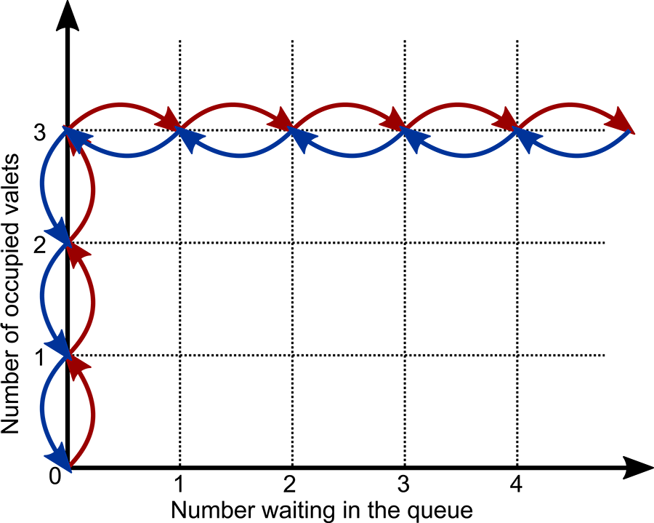
Graph with number waiting in the queue on the x-axis and number of occupied valets on the y-axis
Red arrows are shown a the points as follows:
- (0,0) to (0,1)
- (0,1) to (0,2)
- (0,2) to (0,3)
- (0,3) to (1,3)
- (1,3) to (2,3)
- (2,3) to (3,3)
- (3,3) to (4,3)
- (4,3) to (5,3)
arrows are shown a the points as follows:
- (5,3) to (4,3)
- (4,3) to (3,3)
- (3,3) to (2,3)
- (2,3) to (1,3)
- (1,3) to (0,3)
- (0,3) to (0,2)
- (0,2) to (0,1)
- (0,1) to (0,0)
In this figure, arrivals are represented by red arrows and departures by arrows. The figure shows that, when there are free valets, then customers go immediately into service, and so the queue only grows when all of the valets are occupied. Likewise, departures always reduce the queue first, and then the number in service. This is a very simple state diagram, but it shows crucial aspects of the dynamics you are modelling:
- There is no delay before receiving service from the queue or for a new arrival.
- Valets are always ready for service when they are free.
- You are modelling the system only through the number in service and in the queue—the state does not track individuals.
State diagrams can quickly become much more complicated, so some simplification or abstraction is often necessary. You might, for instance, omit some variables if they are less important or more obvious.

4. Event graphs
In an event graph, the nodes indicate events, and the links indicate that one event causes another to be scheduled. The nodes may also indicate a start transition linked to the event.
For instance, in the car-park model, you might draw a diagram as shown in Figure 3.6.
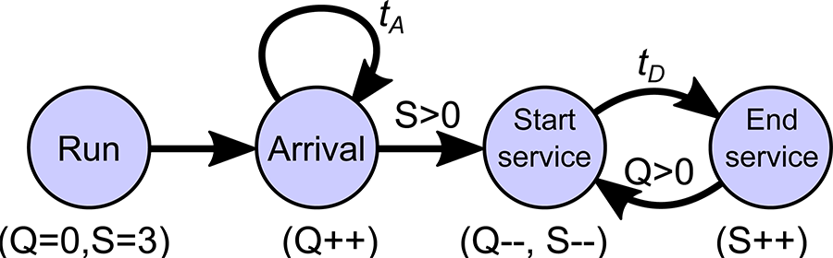
An event diagram as described in the
Event graph for the car-park model. Nodes indicate events such as an arrival. The arrows show the events that are subsequently created. For instance, an arrival results in another arrival at a time t_A afterward. Extra notations indicate how the events change the state, for instance, and arrival, which increases the number of customers in the queue is indicated by Q++. If there is a server free (Sgt0) then the arrival causes an event where a customer starts service (and the queue length and number of servers available decreases, i.e., Q--and S--).
Here, the states are indicated as additional notation: Q indicates the number of customers in the queue, and S indicates the number of servers that are free. So, you see that each arrival creates another arrival event after a time, and if there is a server free (Sgt0), then it generates a “start service” event, which reduces the number of customers in the queue, and the number of free servers. At a time after the start service event, there will be an end service event, and this will cause a new start service event if there is a customer waiting in the queue.
This view is showing the relationships between events, and how new events are scheduled as old events are processed. Thus, it is complementary to the state-transition diagram.
In each of the previous charts, you illustrate a different aspect of the simulation. Together, they can provide a good description (with encompassing words), but one alone will miss some details of the model. There are other views you could make as well, but the list above is sufficient for many purposes.
In addition, tools exist to “model check” against formally specified versions of some charts, but this type of formal verification goes a step beyond what you are learning in this course.

Optional reading
Event graphs for simulation are described in more extensive detail, with more examples below. However, you won’t be assessed on all of the provided in this paper. It is provided to enhance your understanding if needed.
Buss, A. April 2001, Basic Event Graph Modeling, Simulation News Europe, Issue 31, viewed 21 July 2021.

3.2.8 3 Ds of Accreditation — Documentation
The description of your model is one aspect of documenting it. However, when it comes to accreditation, you need to document all of the other aspects that have gone into the simulation. For instance, you need to explain not just what the simulation does, but also why.
The documentation should describe the following in detail:
- How data or assumptions were obtained, e.g. through expert advice or measurements.
- The assumptions of the model and how these have been tested or examined.
- The verification and validation processes that were undertaken.
- The manner in which the simulation should be used in order to obtain valid results (for instance, parameter settings, or length of warm-up periods, etc.).
Another way is to think of documentation as providing an audit trail for the process of construction of the simulation. One way in which this documentation might be used would be to provide enough detail so that an independent assessor could understand the limitations and advantages of your DES. Hence, it needs to provide the steps in construction such that a qualified expert could replicate your work and check the process of construction followed accepted best practices. You will come across this again later in the course, and in the Project report assessment.

Part of the goal of documentation is also archival—it is to inform future simulators about what has gone before so that they can use it correctly or improve it. If a major investment is being made in simulation tools and the resulting system, it is unlikely to be a one-off process. Often, there will be follow-up studies to either consider additional evolution of the system or how the system might work in new contexts such as a new market.

3.2.9 3 Ds of Accreditation — Demonstration
The documentation described on the previous page might take the form of a report, but the goal is communication. It is also necessary to present the critical features of the work in a discussion. A document is vital, but many people—senior managers, in particular—might only read the executive summary. Socialising the work through presentations is therefore vital.
Even better than a Power-Point talk is a demonstration. Nothing sells work better than seeing it work. However, a simulation, as described here, is not visual. The simulations described so far output a set of numbers. It is therefore quite common these days to put a front end on a simulation that allows people to observe it working.
Such demonstrations can be quite useful in verification and validation as well, but it is most useful when it comes to persuading colleagues of the veracity of the work.
Good demonstrations require a great deal of additional work. Software must be created to visualise the dynamics of the simulation. The software should be a genuine visualisation of the simulation in action, not an artificially created “artist’s rendering.” And most simulations are complicated, so one cannot visualise everything at once. Hence, choices must be made about what facets of the system to visualise. Making sense of a global pandemic (2020 - ) through simulations provides a nice example of simulation demonstration.
Despite these difficulties, visualisation is a common addition to many simulation packages because humans are deeply visual creatures and we gain intuition through seeing. Learning how to build such visualisation tools is beyond the scope of this course.

3.2.10 Other Issues in Accreditation
There are other issues that arise in accreditation. Notably, the following:
- In cases where high certainty about results is required—for instance, simulations of critical infrastructure such as power and water distribution— independent testing should be used to provide additional certainty that the simulations answers are valid. Independent testing can take many forms: it could mean another group “in house” or a consultancy firm. Whichever it is, they will use the 3 Ds already outlined to verify and validate the work. They may also institute their own tests.
- The reputation of the people building the simulation and the strength of the term relationship to the “owners” of the problem can have a large influence on the owners’ trust in the simulation. Success follows success. Good communication engenders better communication.
- Accreditation is for a particular setting. It is aimed at testing whether the simulation can answer specific questions. It does not mean that the simulation can answer arbitrary new questions. Each time a simulation is used to consider a new question or variation of a model, validation should be reconsidered. It might be simpler to re-validate a simulation for a new context, but it should never be ignored as even small changes in the setting can result in unexpected errors.
- Although this part of the course follows our part on building the simulation, the activities (VV&A) should commence in parallel to building the simulation. Testing code, checking models and building documentations are all activities that can and must be commenced at the same time (or even before) writing that code. Likewise, communication between the owners of the problem and the people building the system must be ongoing and frequent during the model construction and validation. These processes all work synergistically. For instance, description is an important step in precisely defining the model, and documentation aids in debugging.
- Much of VV&A applies to any mathematical or computational modelling exercise. Using AI to aid in decisions may require a different set of tests, and a mathematical model of a refinery may use numerical computation instead of simulation, but the process of VV&A will be very similar. Software must be verified to perform the specified task correctly, the tool must be validated to show it can do the job required, and the results must be accredited in some fashion in order that they be trusted to help in allocating large amounts of money or building systems where peoples’ health, welfare, or even lives, are at stake. The skills you have learnt in this part of the course are highly transferable.

4. Exploration

Module 4 Overview

Module 4 Overview
module banner
In this , Professor Matthew Roughan provides an outline of Module 4 and gives an overview of how to use simulation to answer real questions efficiently and effectively, incorporating data as you go.
In the last module, I taught you how to
- get data from your simulation
- make sure it was working
- convince others that it is working.
But that isn’t enough to answer questions. You need to be able to explore the system model efficiently using simulations.
Moving forward into this module, I will teach you how to use simulation to effectively and efficiently answer THREE types of questions:
- categorical
- ordinal and
- quantitative questions.
Then I will show you how to build a simulation harness to help you explore a possible space. I’ll also show you how to estimate the performance of your simulations and thus improve them.
The last part of the module will focus on including data in your simulations to make them more realistic.
Keep up the great work! As you progress, the level of your simulation skills will continue to improve by a notch (one step)!

Learning outcomes for Module 4
On successful completion of this module, you will be able to:

- design a possibility space,
- develop a simulation harness,
- choose simulation approaches using complexity analysis,
- incorporate data into a simulation.
These learning outcomes will also prepare you for:

- Test 2
- Programming Assignment.

Activities
In this module, you will:

- learn how to use exploration to understand your system and your simulation,
- build a simulation harness to automate the exploration of a question, including seeing how you can use parallel processing in simulation,
- analyse your algorithms using big-O notation,
- include real data into your simulations,
- participate in a Zoom session where you will meet your tutor and classmates and obtain advice on how to finish your second assessment.

4.1 Exploring Possibility Spaces

4.1 Exploring Possibility Spaces
- Read through the following pages in order, taking notes as you go and running any example code (if applicable).

4.1.1 Possibility Spaces - Hypothesis and Parameters
You already know you’re going to use simulations to
- answer questions, or to
- determine which hypotheses about your future system are correct.
Questions can concern a choice (“should I choose A or B?”) or ask, “what if I change my system in some way either deliberately (as an upgrade) or accidentally?” for instance, due to equipment malfunction.
You can classify these questions into a few cases:
- Categorical questions ask, “Which category should I choose? Should I choose A or B or C?” Categories are discrete and their ordering (if it exists at all) is accidental. Typical examples are:
- Ordinal questions concern categories that have some intrinsic ordering, but where the ‘gaps’ between categories aren’t specified. An example is:
Ordinal questions are less common in this context than categorical questions (as above) or quantitative questions as described below. In decision support, you usually want to make a clear decision, and ordinal decisions are sometimes a little abstract.
- Quantitative questions ask a question about a quantity or value. Usually, the values are numeric. They can still be discrete, e.g.
Or a quantitative question can concern continuous values, e.g.
Statisticians use the same names (Categorical, Ordinal and Quantitative) to describe types of data. For instance, in analysing demography data you might have values like gender (categorical) and age (quantitative) and education (ordinal). The difference here is that statisticians are analysing given data, whereas simulators are asking questions about values they can change.
The quantity of interest is described as a parameter. The job at hand is to determine the effect of the parameter, so as to help a decision-maker chose it, or otherwise improve the system under study.
Remember, I used the term parameter when you were working with families of probability distributions, e.g. the θ parameter of the exponential distribution. Here, I am using the same word in a more general way. It includes the sense that was applied to probability distributions but can refer to any numerical value as a parameter.

Activity
Classify the following questions by selecting whether they are ‘Categorical’, ‘Ordinal’ or ‘Quantitative’, and then select 'Check'.

4.1.2 Possibility Space
The questions that you will aim to answer can be complicated, and they rarely come one at a time. Usually, you have to decide between a complex set of choices, and each choice can interact with the others. So, you can’t isolate the questions one at a time.
The set of possible choices is called a possibility space. The possibility space is (often, but not universally) a Cartesian product of the sets of decision variables.

Cartesian Space
A Cartesian Space is a mathematical concept created by René Descartes(hence, the name). The story I heard was that he was an invalid, and that as he was lying in bed, he observed a fly. He imagined how you would describe the position of the fly in space. From this he created his eponymous coordinate system. It is at the core of much of modern mathematics and data science. How often, in data science, have you used a vector? If you have, you are using a coordinate system, most likely Cartesian.
For instance, if you were asking two questions:
- Is a red balloon better than a balloon? and
- How high should the balloons fly?
You might represent the space of choices visually, as in Figure 4.1.
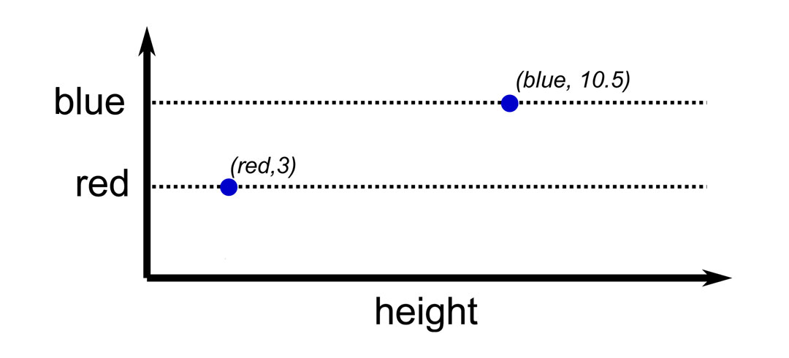
graph
A dotted line labelled ‘red’ extends horizontally from the y-axis. A point (red, 3) is marked. A dotted line labelled ‘ ’ extends horizontally from the y-axis above the line labelled ‘red’. A point ( , 10.5) is marked.
A Cartesian (or rectangular) space defines a coordinate system where each point is defined uniquely by a vector. For instance, in the case above, you might say for a red balloon, 3m in the air or for a balloon 10.5m in the air. You usually draw the axes as perpendicular.
The important fact to understand about such spaces is that as the number of variables increase; hence the dimension of the space, the volume of the space increases exponentially.
For example, imagine you have a number of Yes or No questions. Each question has two possibilities, so you might think the range of choices is small. But the total number of points in the possibility space will be. This grows very fast: when there are roughly one thousand possibilities, and when there are more than one million possibilities.
If you considered continuous parameters, each with a range from 0.0 to 10.0. Then, when there are two variables, they sketch out a rectangle with area 100. When there are three, they sketch a box with volume 1000, and when there are, they create a ‘hyper’-rectangle with volume. This grows even faster!
The crucial result that you must understand is that possibility spaces can be very large. You might not be able to search them completely.

Activity
You are given the following three questions about the valet car park system:
- Should you allow people driving expensive cars to have priority over others?
- How many valets should you have (cost limits us to a maximum of 10)?
- There are three choices for the parking spaces you will use. The distance of these car parks determines how it takes a valet to park the car and return. One possibility is two minutes away, one is five minutes, and another is 10 minutes away. What effect would the choice have?
Determine the size of the possibility space.
60 possibilities.
The three questions have two, 10 (at least one valet is needed) and three possibilities. The total space will therefore be 2 × 10 × 3 = 60.

4.1.3 Exploration and Parameter Sweeping

Parameter sweeping
Here, you will get to see how to ‘sweep’ (skim) through a set of parameters.
Categorical questions are relatively straightforward (quite clear): Yes or No; Go or Stop; Red, Green or . But quantitative questions involve an extra degree of difficulty.
When you start a simulation to determine a quantitative parameter, you might not have any idea about its effect. You may not even know what bounds are reasonable for the value. It could, in principle, range from-∞to∞.
Some quantitative parameters come with units(metres, kg, $, or number of valets) and this gives them an intrinsic scale. Arrival rate, for instance, is measured in arrivals per second. However, other parameters don’t even have scale. For instance, some parameters have only abstract meaning such as the shape parameter s of the Pareto distribution.
Hence, the first step of any simulation study with such parameters is to gain some intuition about reasonable values. Your main goal here is to select a smaller part of the possibility space to examine in detail. Any part that you can exclude from future analysis will reduce your computational workload in the future.

Exploration
Exploration is also a crucial component of the previously discussed topics of verification and validation.
Exploratory analysis with simulations isn’t too far from exploratory analysis in statistics. You try out values, and visualise the results.
Key ideas for exploration are as follows:
- Isolate each variable or parameter. In general, individual parameters can interact, so our final analysis will have to consider them all together. At this stage, you are just trying to get a clue, so fix all but one parameter, and see how that one behaves—that is sweep through one parameter at a time. Of course, there is the question of what value you should use to fix the others. Play around with the values.
- Try things out.
- Draw pictures of the results, e.g. measure a key performance indicator y as a function of parameter x and draw the(x,y) graph.
- Experiment with simulation parameters such as the length of time you run the simulations.
- Look for unusual behaviour: values that go off to∞(or very large numbers), or discontinuities where some value changes very rapidly. These are areas that will require extra care.
- Always think about VV&A: your explorations may throw up, for instance, a negative number where none should be or some other pathology. Always check these out, as they are often the signature of a deeper problem.
There are no hard-and-fast (strict) rules for this part of the analysis. Do these steps until you are comfor that you understand
- the range of interest for each parameter and
- how responsive the system is to each.
If the system is relatively sensitive to a parameter, you will have to be extra careful with this parameter.

4.1.4 Exploration and Parameter Sweeping — Example
Consider a simple M/M/1 queue as an example. This is a good one to use here because it is pretty quick to set up, and its behaviour is known mathematically in advance.
Starting with a plot of 10 realisations (sample paths) for the queue in Figure 4.2, these show the state as seen by each arrival, with each realisation generated by a different seed, for μ = 1.0 and λ = 0.8.

Figure 4.2: Ten M/M/1 queue realisations.

Ten M/M/1 queue realisations or sample paths showing the variations in evolution for a simple queue. The sample paths are denoted by different coloured lines and feature varying degrees of steps up and down a each line
Looking at these sample paths can give you an idea of the type of variations you might see in these queues. Variations of a single sample path over time, and the variations between sample paths. Mostly, the sample paths sit below five, but there are a few larger excursions up to nearly 20. It’s always good to look at some sets of these to get an idea of the range of behaviours you should expect when you run a larger set of simulations.

Parameter sweep
Next, you will sweep through a parameter. This queue has two parameters: the arrival rate λ and the average service time μ. Here, I will fix μ = 1.0 and then sweep through possible values of λ, and measure the average number of customers in the system (as seen by arrivals). Each data point here is the average of 100 simulation realisations and each simulation ran for a simulated 100 time units (see Figure 4.3).
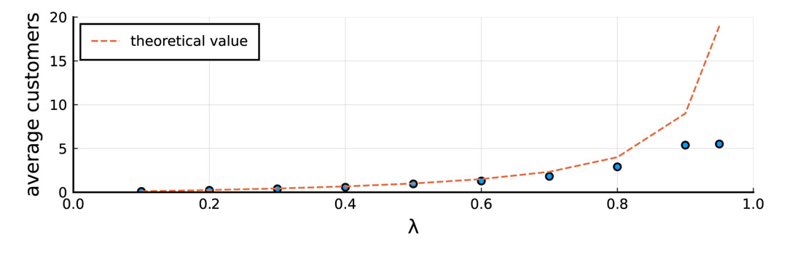
Figure 4.3: The average number of customers in the M/M/1 as a function of the arrival rate λ.

Theoretical values (the dashed line) starts at (0.1, 0) and extend gradually upwards to point (0.8, 4) then increases sharply upwards. The results obtained from a very simulation of 100 time units (dots) follow this line without the sharp rise at the end, plateauing at (0.9, 5).
The plot shows the simulation averages and the theoretical value λ/(1-λ), which mathematicians have calculated. It’s one of the advantages of this simple model—you know what to expect and can compare it to what you get.

Problems
Figure 4.3 shows the simulation has two problems:

- For small values of λ there are small differences between the theory and the measured values. They are OK. Any simulation has random variations so you expect some ‘errors’ of this sort. You will need to quantify them, but I will leave that step until Module 5.
- For large values of λ, the simulation diverges badly from the theory. The theoretical curve goes up sharply as λ → 1.
The second of these problems is our primary concern because it is a systematic error.
I’ll start by explaining why theory curve looks the way it does. It can be understood by thinking about the number of arrivals per service. When the arrival rate is 1, there is 1 arrival for (on average) every service time (the mean service times are 1/μ=1.0) and so the queue will be balanced. But as soon as λ > 1 even slightly, there will be more than one arrival per service time, and so the queue will grow indefinitely (remember that the M/M/1 queue has an infinite waiting room). So, the theoretical curve grows asymptotically towards infinity as λ → 1.
What went wrong with the simulation then? Well, there is an issue of burn-in that I have talked about, and you will learn about further in Module 5. However, the key issue is how I ran the simulation. As the queue becomes more heavily loaded, the length of the queue varies more widely, and over er time periods. Just think about a queue in real life. When it is lightly loaded, it varies between zero, one and maybe two customers pretty quickly. But when queues are loaded heavily, the queue can grow to be quite , and then drop back again, and that takes er to happen.

Exploration
To explore that possibility, I will run the simulation for 1,000 time units, and then 10,000 time units. The corresponding plots are shown in Figure 4.4 and Figure 4.5.
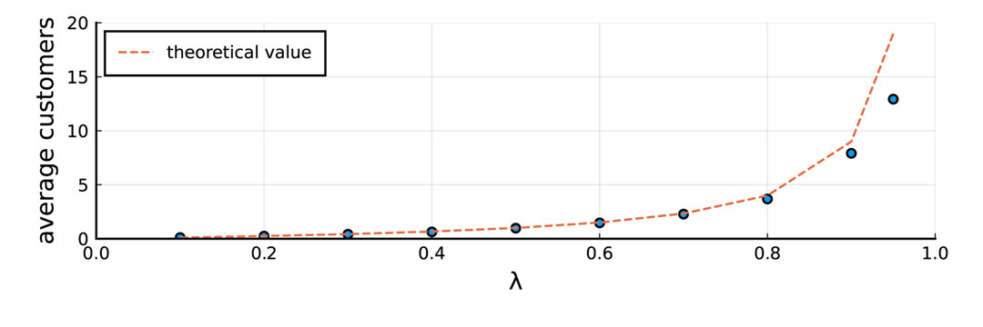
Figure 4.4: The average number of customers in the M/M/1 as a function of the arrival rate λ, simulated over 1,000 time units.

Theoretical values (the dashed line) start at (0.1, 0) and extend gradually upwards to point (0.8, 4) then increases sharply upwards. The results obtained from a very simulation of 1000 time units (dots) follow this except for the final two points which are lower than the theoretical values.
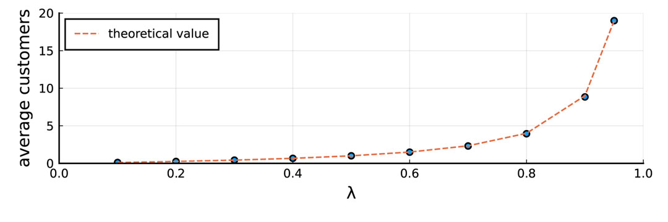
Figure 4.5: The average number of customers in the M/M/1 as a function of the arrival rate λ, simulated over 10,000 time units.

Theoretical values (the dashed line) start at (0.1, 0) and extend gradually upwards to point (0.8, 4) then increases sharply upwards. The results obtained from a very simulation of 10,000 time units (dots) follow this line exactly.
You can see how the simulation results improve for a simulation over a er time. Here, you can see that er simulations are needed as λ gets closer to 1.0. However, there is an advantage here. The theoretical value is known and you can compare against it. Usually, you won’t know the theoretical value (or why would you need to do the simulations?).
A reasonable approach is to increase the time of the simulations, and compare them to each other. In Figure 4.6, I have plotted the simulation’s results for four simulation times: T=100, 1000, 10000 and 25000 time units.
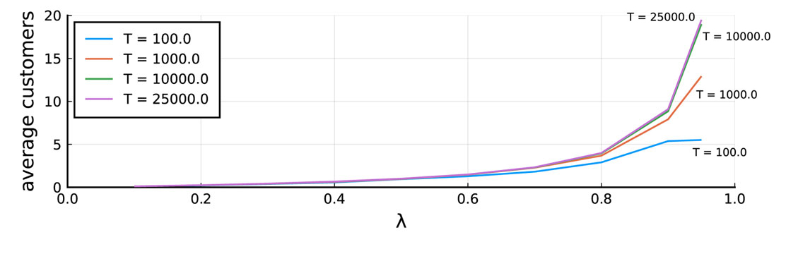
Figure 4.6: The average number of customers in the M/M/1 as a function of the arrival rate λ for four simulation times.

The average number of customers in the M/M/1 as a function of the arrival rate λ for four simulation times, T=100, 1000, 10000, and 25000 The y axis is represents the average number of customers, and the x axis represents (the arrival rate). The two curves corresponding to T=10000 and 25000 are almost exactly the same indicating that there is only a marginal improvement in accuracy and that a simulation of length 10,000 should be enough.
The thing you can see is that the T=10000 and the T=25000 lines are almost the same (they practically sit on top of one another). What you are seeing is that, by simulation time T=10000, the results have converged sufficiently that running the simulation for additional time doesn’t help much.
The M/M/1 simulation presented above used 100 realisations of each parameter setting, and considered 10 values of λ and four choices of T, so altogether, even the simple pictures above required me to run 4,000 simulations. The largest simulations had (on average) near 25,000 arrivals (almost one per time interval). In total, I simulated 19,693,232 arrivals. And this is about the simplest simulation you will ever run. This is why simulations have to be fast.

Summary
So, what can you take away from our simple exploration and the thought process it inspires?

- The meaningful range of λ parameters ranges from[0,μ]. There isn’t much point in considering cases with λ > μ as the queue will be uns.
- There is a tricky point near λ = 1.0, with a vertical asymptote. Such points require extra care as you have seen.
- The total simulation time has to be fairly large for λ near 1.0. You could run for different amounts of time for each parameter setting, but it is a little easier (to start with at least) to fix it to be around T=10000. You might need to explore further if you wanted to consider additional parameter ranges.
There are other lessons to learn in other systems and models. You will see more examples as you progress through this module. There are also more advanced methods to analyse the outputs and I will show you more of these in Module 5. Exploring a simulation will be important for the Programming Assignment because you will need to understand the question space that you are working in.

4.1.5 Iterative Approaches
The previous topic was about building up a rough heuristic (general) understanding of your possibility space. You can only really start formally answering questions when you have a good intuitive grasp (understanding) of the problem that you are working on. It can also be a really helpful part of VV&A. When you have some idea of the part of a possibility space that you want to investigate, the next step is to examine it systematically. Usually this involves some iteration. The type of iteration is determined by the nature of the questions you need to answer.
If you want to understand the possibility space, you might want to simulate every point of the space. For instance, to see the trade-offs in the behaviour of a set of Key Performance Indicators (KPIs) you might want to simulate every combination. However, that could be infeasible. You can instead use a refinement strategy to obtain the best view possible with the computer time available.
If you want to find the very best set of parameter settings, you are solving an optimisation problem. I will, very briefly, introduce you to optimisation through some simple search algorithms.
Optimisation is a large area of mathematical and computational techniques with many sub-topics and hundreds, if not thousands, of algorithms. I won’t be able to cover anything but the simplest approaches here.

Refinement
You can perhaps see from the simple M/M/1 queue example that it is hard to know in advance exactly what issues you will face in a simulation. It may be that there are difficult regions that require more exactitude. It may be that large areas are relatively uninteresting.
Therefore, you will almost certainly need to ‘refine’ your investigation in the sense of adapting and improving it in small steps. An obvious facet that you might need to improve is the resolution with which you analyse parts of the possibility space.
Also, you start your investigation with exploration, but, at some stage, you must become more systematic. Systematic could mean that you try every value, but that could be wasteful: you could end up spending a great deal of time investigating uninteresting regions. Instead, a strategy of successive refinement is ideal.
There are many approaches one could use, but I will suggest the use of a multi-resolution dyadic grid. Resolution is the smallest interval over which you can ‘resolve’ two data points. That means the smallest interval in your parameter sweep. In the M/M/1 queue example, if you used the points λ = 0.25, 0.5, 0.75, then your resolution would be 0.25.
Multi-resolution approaches use some means of adapting the resolution to the problem.
A dyadic grid is a binary hierarchy of grids. It breaks up a range by powers of two. But it’s much easier to show than to describe. The figure below shows: (i) a square broken up into four segments horizontally and two vertically; and (ii) a cube broken into two segments in two directions, and one in the third.
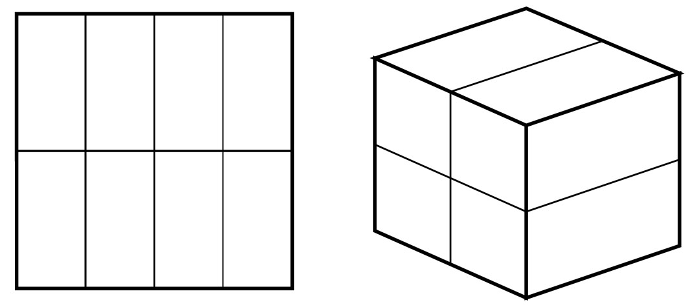
A square and a cube broken up into segments as described under the heading ‘Refinement'.
Figure 4.7: Dyadic segmentation examples for 2D and 3D spaces.
Dyadic grids are based on the dyadic rational numbers; that is, numbers of the form a /2^b where a and b are integers. These numbers are important in computer science because they have exact binary representations (all others must be represented as floating point approximations).
Figure 4.7 illustrates one way in which a dyadic grid can be adaptive: if you are considering more than one parameter, each can be investigated with its own resolution.
The second way a dyadic grid can be adaptive or multi-scale or multi-resolution is to refine it on certain regions. For instance, consider Figure 4.8 that shows simulation results on the M/M/1 queue on a grid that is refined to be more accurate near the λ = 1.0 end of the grid.
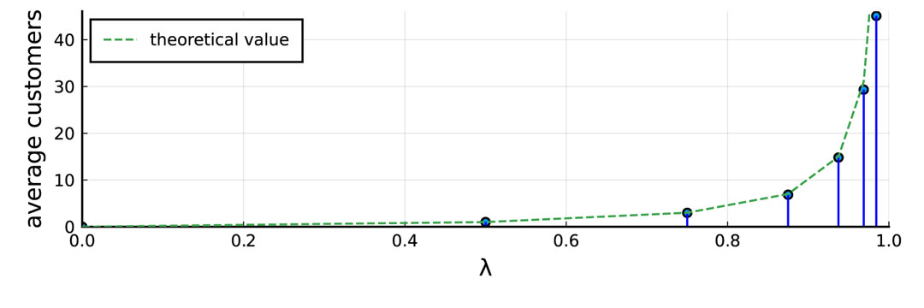
Figure 4.8: The M/M/1 queue with an adapted resolution in the λ axis.
The average number of customers in the M/M/1 as a function of the arrival rate λ showing the that the theoretical values (the dashed line), and those obtained from a er simulation of 1000 time units (dots) have converged together. Note that in this version we have a finer resolution near the λ=1 end to show the curves shape in more detail where it is more important.
The points in the plot are λ = epsilon, 0.5, 0.75, 0.875, 0.9375, 0.96875 and 0.984375. They are closer together (higher resolution) near λ = 1.0.
In mathematics, epsilon usually represents a very small number. The intention here is to see how the simulation behaves when λ = 0. But in that case, the arrival rate is zero, so nothing ever happens. You can use epsilon to explore the behaviour near λ = 0, or other cases where you need to explore a difficult point in a parameter space.

Question
Why have I avoided simulating the M/M/1 queue for λ=0.0?
Because when the arrival rate is zero, nothing happens, so the simulation produces no results.

Advantages of dyadic grids
Dyadic grids have three main advantages:

- They can be used adaptively.
- They are simple (at least compared to the alternatives).
- They allow for reuse of old values.
Reuse is important. Simulations are cheap to run individually, but en masse they can use up a lot of computer time. Reuse allows you to start with a coarse grid, and then iteratively refine it, only computing the new points as needed.
Figure 4.9 illustrates an example of successive refinement on a 1-dimensional dyadic grid.
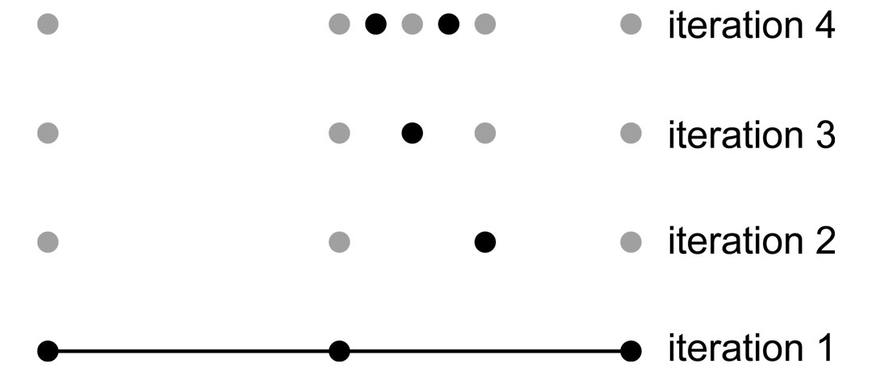
1-dimensional dyadic grip with four iterations
Figure 4.9: Example of successive refinement on a 1-dimensional dyadic grid.
Example of successive refinement on a 1-dimensional dyadic grid with three uniform points in the first iteration and successively finer resolution at certain parts as we progress. Points from earlier iterations are reused at future steps.
The process starts in iteration 1 by calculating three uniformly spaced points. The dark points show newly calculated values. After these first values are calculated, you can make a determination about which regions need higher resolution (I chose the right-hand half).
In iteration 2, the grid is refined by calculating intermediate point (in this case, between the right-hand pair from iteration 1), and I kept the values already calculated (shown in grey). As needed, the intervals are further refined in each iteration.
After the final iteration, the grid is subdivided into regions of relatively coarse resolution, and others with higher resolution. However, the simulation only needs to be run once for each data point.
If you had started exploring naively, then you might have guessed incorrectly about which region needed higher resolution. And if you had used a more arbitrary refinement scheme, you might have had to rerun the simulation many more times.
One of the keys to refinement is having a good simulation harness, which is something I will introduce in the next topic, but there is one more idea to cover before I get to that.

4.1.6 Search Algorithms and Optimisation
Optimisation means finding the best (or worst) case of something. It’s actually at the heart of many machine learning algorithms: for instance, you might want to find the best neural network for classifying cats.
Optimisation is often used hand-in-hand with simulation for decision support. Often, you would call such an algorithm a search algorithm because it is searching for that optimum. However, you have to be especially careful when combining optimisation with simulation because of the randomness that is intrinsic to simulations.
I will take you through a minimisation problem. (You can always flip maximisation problems around and solve them the same way.) And I will take you through a 1-dimensional problem. Real problems usually concern finding a choice in a multidimensional space, but I want to keep it simple here. That will be enough to understand the problems.
I will also assume that a unique minimum exists. There are many problems where there are many local minima that can ‘trap’ a search algorithm and more complicated approaches are needed. In this case, I will assume that the function to be optimised, usually a KPI for our system, is unimodal, which means what it says. It means it has one mode, or one minimum. The problem (the M/M/1 queue minimisation) described above is unimodal.
Finally, I will assume the problem is bounded, i.e. that I know the values over which a parameter can range. I could extend out to other cases—but again, this will be sufficient here.

Dichotomous search
The search algorithm you will learn about here is called the dichotomous search. It is related to a binary search in computer science, but has some differences, so don’t get the two confused. The dichotomous search has two advantages:
- It only requires you to evaluate the function to be optimised. You don’t need to know its derivative or slope. Many optimisation techniques (e.g. most descent methods) require some knowledge of the slope. The dichotomous search doesn’t need to know this.
- The dichotomous search reduces the number of evaluations (simulations) you need. It isn’t the fastest, but it is very simple. It does this essentially by extending the ideas of the dyadic multiscale grid.
The function that you want to minimise, f(x), is called the objective function. It is a function of variables x, which are the parameters of your search space. The dichotomous search requires these to be in a bounded space, so you start with a_0 < x < b_0. Then the dichotomous search has the following algorithm, where L is the desire accuracy (the size of the final interval on which you are uncertain about the value).
k = 1 while b[k] − a[k] > L c[k] = (a[k] + b[k])/2 d[k] = (a[k] + c[k])/2 e[k] = (b[k] + c[k])/2 f_c = f(c[k]) f_d = f(d[k]) f_e = f(e[k]) if f_d < f_c a[k+1] = a[k] b[k+1] = c[k] f_c = f_d else if f_c > f_e a[k+1] = c[k] b[k+1] = b[k] f_c = f_e else a[k+1] = d[k] b[k+1] = e[k] f_c = f_c end end k = k + 1 end
The calculation of f(·), the function you want to minimise, is performed by the simulation.
At each iteration, the search interval becomes half the length it was in the previous iteration. Then you can reuse some of the old estimated function values.
At the end, you have an interval[a_k, b_k] in which the optimal value lies. You specify in advance a maximum size L for this interval, so you can, in principle, guarantee the size of the potential error here.
Note that the code above isn’t the best way to implement this—it is intended to make the algorithm clear. For instance, I have used vectors for the values of a at each iteration, but you only need to keep the current values. Also, the code above isn’t strictly Julia code—you need a few extra pieces, like pre-defining the arrays.

Try this
Implement a dichotomous search in a function, and use it to find the minimum of cos(x) in the interval[0, 2π].

4.1.7 Search Algorithms and Optimisation — Example
Imagine you want to optimise the M/M/1 queue. You can improve the server so that
- the average service time is reduced and thus
- the average number of customers waiting in the system is reduced.
However, a faster server will cost more. Combining the two gives the ‘objective’ function to optimise
cost = a μ + q̄,
where a is a constant, 1/μ is the average service time, and q̄is the average number of customers in the system. The constant a expresses the trade-off between queue length and the cost of the server.
Figure 4.10 plots that function for a = 1.0 and shows the minimum at μ = 2.0.
Figure 4.10: The cost function for the M/M/1 queue=μ + q̄.
The cost function for the M/M/1 queue=μ + q̄, where μ is the reciprocal of the service times. The optimal value is shown at μ = 2.0.
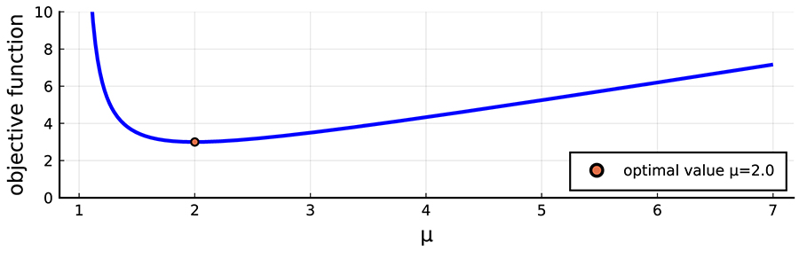
Graph with mu on the x-axis and objective function on the y-axis
The dichotomous search works as shown in Figure 4.11. Start with bounds a_0 = 1.0 and b_0 = 7.0 which were found by exploration. Then divide this interval into three (dyadic) pieces: c bisects[a,b] and d and e bisect[a,c] and[c,b] respectively.

Line with a, d, c, e and b marked at regular intervals
Figure 4.11: Dichotomous search intervals.
The function is evaluated at each of d, c and e(or values from the previous iteration are used) and the relationship between these function evaluations determines the next interval to be[a,c] or[d,e] or[c,b], all of which are half the size of[a,b].
The first three steps are illustrated in Figure 4.12, with the shading getting darker with each iteration.
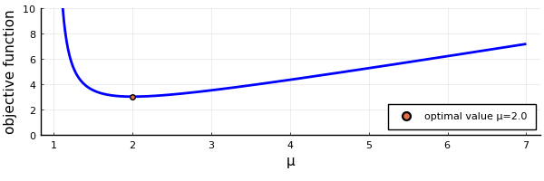
Animation shows the successive refinement of the search.
Figure 4.12: Dichotomous search applied to the M/M/1 queue cost function.
The cost function as shown in Figure 4.10 with shaded regions shown for each iteration. In the first iteration, the area between μ=1 and μ=4 is shaded. In the second iteration, the area between μ=1 and μ=2.5 is shaded. In the third iteration, the area between μ=1.75 and μ=2.5 is shaded.
I have shown you the first three steps. Easy, right? Let’s see what happens when the algorithm progresses a little further. I will run the discotomous search until it has found an estimate within the quite reasonable seeming bound of± 0.01, and using one simulation to estimate f(x) for each evaluation. I will then repeat the whole process 10 times (each with a different seed value). The results are shown in 4.1.
4.1: Ten trials of the dichotomous search applied using simulation to estimate the cost
Trial | Estimate (to three decimal places)
1 | 2.136
2 | 1.794
3 | 2.058
4 | 1.873
5 | 2.027
6 | 1.941
7 | 1.924
8 | 1.542
9 | 2.105
10 | 1.880

You can see that, far from finding the optimal value (2.0), each trial is wrong, and each finds a slightly different value. They are all close to the optimal value, but definitely outside the bound I set.
What is going wrong here? The problem is that the dichotomous search assumes that a function is strictly unimodal. However, when you evaluate using a simulation, which introduces randomness, that breaks the assumptions. The objective function—the thing being optimised—now has random fluctuations. The fluctuations are small, but they break the assumption, and so the search doesn’t work.
You will find that, if you look carefully, many optimisation routines have the same problem, or are worse. Optimisation algorithms often make assumptions—for instance, about the derivatives of the function to be optimised—and these can be greatly affected by random fluctuations from your simulations. For example, Newton’s method, which is used in many applications, requires calculation of derivatives.
Optimisation when randomness is included is a whole topic of research. It’s quite possible, but the techniques go beyond what I am trying to teach you here. The important points to take away are as follows:
- Simulation results contain random fluctuations that can break the assumptions of many optimisation algorithms.
- When using simulation in optimisation, you don’t automatically know the derivative of a function, so many techniques, such as Newton’s method, are harder to use.
Calculating derivatives when there are random fluctuations is much harder again. It requires deep numerical computation skill to use simulations in such a method.
There are a vast number of ways to improve the dichotomous search. As this isn’t a course on optimisation, you don’t need to know them. What you need to understand is how and why simulation can be combined with optimisation to help make decisions, and what the potential limitations are. Ultimately, the simplest way to deal with this is to thoroughly explore the possibility space.

4.2 Simulation Harnesses

4.2 Simulation Harnesses
This section demonstrates how to practically develop code for exploring a possibility space. This is done with so-called simulation harness, essentially a loop to perform a parameter sweep and run multiple realisations of a simulation.
- Read through the following pages in order, taking notes as you go and running any example code (if applicable).

4.2.1 Tools to Automate Simulation
A simulation harness is the name I will use for the computer code you use to automate your analysis of the possibility space. In real problems, the space you are examining will most likely be too big to manually investigate. You need automation. Assessment 2 will require you to build such a harness.
A ‘harness’, in colloquial language, is the set of straps that fasten a horse to a cart, allowing the driver to control the horse and cart. That’s what you will be doing, but, instead of a horse and cart, you will be applying this to a simulation.
Building a simulation harness used to be hard. The harness may need to interact with the operating system of your computer, and some old-school languages did that in a pretty clunky manner. Often, the language of choice for the simulation wasn’t the same as that for the harness.
These days, most programming languages make it very easy to construct a harness around your simulation’s code. Essentially, it is just a series of loops, for example,
M = 100 rerun = false PARAMETER_SET = read(parameter_file) for seed = 1:M for parameter in PARAMETER_SET if rerun || !exists(output_file(seed, parameter)) run_sim( seed, parameter ) end end end
This code isn’t really Julia code by itself. You would need to write extra functions likerun_sim and a function to read the parameter file. It is just an illustration of how you might put this code together.
Things to keep in mind:
Keep it flexible: you will want to change your harness as you explore and learn about the system you are simulating, so don’t try to make it too complicated if that makes it hard to modify. I’ve always found nested for loops(as above) to be a pretty easy approach.
- Separate code and data (Line 3): The code above obtains the list of parameters to explore from a file. It isn’t hard-coded into the harness. That increases your flexibility, and also adds to the ‘single source of truth’ property of your code (the source becomes the data file).
- Check outputs and reuse when possible (Line 6): You will often want to change the parameters you are exploring, but, when you do, you will want to reuse any existing simulations so that you don’t waste time redoing them.
- Flags are useful: Lines two and six set a flag (a Boolean variable) to say when you want to rerun all of your scenarios—if you find a bug in your code, your old simulations won’t be useful, so you would want to rerun even the ones you already have data for. Other Boolean flags can be useful as well.
You can see that building a harness isn’t hard these days, but it does require some thought. It can also enable you to use parallel processing in your simulations to take advantage of modern high-performance computers—but that requires a little more knowledge, which I will provide in on the next page.

Try this
Using what you have learnt here, create a simulation harness to run the car park simulation code. It should explore the effect of the number of servers available.

4.2.2 Parallel Processing
The modern approach to speeding up computation is to use multiple processors. Computer clock speeds reached their limits of scalability some time ago, so, although chip architectures continue to improve, there is a limit to how much one can do with a single processor. On the other hand, even the average laptop today has multiple CPU cores (all on a single silicon chip) and the number seems to keep increasing.
Parallel processing can be daunting. Running multiple pieces of code that communicate with each other can be one of the hardest programming tasks to get right. However, simulations fall into a category that is sometimes called embarrassingly parallel. That means little effort is required to utilise as many processors as you have available.
Simulations are so easy to parallelise because many realisations are often run, either:
- with different seeds to obtain multiple independent realisations; or
- with different parameters to explore possibility space.
Your simulation harness should be built to take advantage of parallelisation easily.
Julia has parallel processing built-in from the start, so it’s a great programming language for this as well.
There are two cases to consider:
- Using multiple cores on the same computer.
- Using multiple computers.
I will talk mainly about the first case, but note that it isn’t too much harder to deal with the second case. It’s a little system dependent, so it is hard for me to give general advice. You would still use the same essential elements in your program, but you also need to make sure the separate computers can communicate, and that requires some skills that you have probably learnt elsewhere in this degree, which go beyond the scope of this course.
The following is one way to set up parallel simulations in Julia. It isn’t the only approach, but it will get you going. First, you will install an extra package called CpuId, which provides some help. Then you can find out some about your computer using the following code.
import CpuId info = CpuId.cpuinfo() cores = CpuId.cpucores()
Note that the code is usingimport here, instead ofusing, so that you can see exactly what module each function comes from.
The first command will tell you some technical about your CPU, and the second will just return how many cores you have available. This is an upper limit on the useful number of parallel processes you should run. For instance, if it were four, then you might run four simulations in parallel, but there is little point in running five. However, some processors allow more ‘hyper-threads’ to run, so you could also useCpuId.cputhreads() to estimate this number.
The second new package you will use is called Distributed. You should also install this as it provides some helpful functionality to tell Julia how many processors it should use. By default, Julia will only use one processor core. You could tell it to use four, for example, using the following code.
import Distributed Distributed.addprocs(4-1) Distributed.nprocs()
You add4-1 processors because one is already being used, and you want four in total. The command on Line 3 lets you know how many cores are allocated. The Distributed package also gives you functions to remove processors, get their IDs and so on.
Now you can run a really simple simulation across these four processors. The simulation just tosses coins, and counts the number of Heads and Tails. It uses two pieces:
- A ‘worker’ function (that does the actual work of tossing coins). I created this with the following code in a file called cointoss_worker.jl.import Random
function cointoss_worker(instance, tosses)
heads = 0
tails = 0
Random.seed!(instance)
for toss in 1:tosses
if Random.rand() < 0.5
heads += 1
else
tails += 1
end
end
return (heads, tails)
end Note that the function takes two inputs. The argumentinstance sets the seed, and the argumenttosses is the number of coin tosses to throw. You could call this function in a standard (non-parallel) Julia program by writing:include("cointoss_worker.jl")
(H,T) = cointoss_worker(1, 1000) and it would return the result of 1000 coin tosses.
- You need a ‘runner’ function that will create parallel jobs and run them over the multiple available processors. I use the following function, which I have placed in a file called cointoss_runner.jl.
import Distributed
function run_cointoss(tosses_per_instance, instances)
heads = 0
tails = 0
# A is an "instances" element array of whatever
# cointoss_worker() returns for each instance
A = Distributed.pmap(instance ->
cointoss_worker(instance, tosses_per_instance),
1:instances)
​
# Now that the parallel processing is finished, sum the numbers in A.
for instance in 1:instances
heads += A[instance][1]
tails += A[instance][2]
end
return (heads, tails)
end This code is a little more complicated, and it revolves around the functionpmap, which stands for ‘parallel mapping’. The waypmap works is that it takes the second argument (which should be a vector) and pushes it through the mapping defined by the first argument. It does this by distributing the individual ‘instances’ across the available processors. So, in the case above, the mapping isinstance -> cointoss_worker(instance, tosses_per_instance), which maps an ‘instance’ number to the output ofcointoss_worker. The instance number is used as the seed in each worker function. Each worker will start with a seed defined by the second argument, which is just a range 1:instances. If instances = 4, then this code would run the coin toss worker with four input seed values, 1, 2, 3 and 4. The input argumenttosses_per_instance is just a constant here that determines how many coins each worker will toss.
Once these functions are in place, you can run a parallel simulation of many coins being tossed as follows:
import Distributed # for addprocs() and nprocs() import CpuId Distributed.addprocs(4-Distributed.nprocs()) include("cointoss_runner.jl") Distributed.@everywhere include("cointoss_worker.jl") instances = 4 tosses_per_instance = 1000 (H,T) = run_cointoss(tosses_per_instance, instances)
I am hoping that, at this stage, you should understand most of this, except Line 5. That line uses the macro@everywhere, which is a special command that says to run the specified code on every Julia process. In this case, we make sure that all of our Julia processes have included the worker function. This is important because if you just used a standard include line, only the master process would know about the function.
To create a parallel harness, you just need to do the same for your simulations.

4.2.3 Data
OK, more data! Surely not?
Well, this is part of a degree on real world maths and statistics so you will keep coming back to data. For now, I have one little piece to add, though I am reiterating material from Module 3’s topic on storing output.
When you create a simulation harness, one of the most important problems to avoid is collisions between file write operations. You must never try to write to the same file from multiple processes at once. That means you must avoid ever using duplicate file names.
The most obvious reason to be careful with file names is so that you don’t overwrite existing files with later files. That is just wasteful.
A more subtle reason is that when you have parallel processes all running simultaneously, they don’t know about each other. If they were writing to the same file, they would interfere with each other. Thus, it is critical that you avoid overwriting.
If you followed earlier advice about filenames (see Module 3: Storing the Output), this bit is easy. Just as a reminder that when you choose a filename, choose something meaningful. It should contain:

- parameter values used in the simulation (both parameters of the simulation such as the simulation length, and parameters of the model such as the arrival rate)
- the seed values.
If you follow this advice, your output files won’t clash and you can safely simulate in series or in parallel without overwriting your output. In your assessment, this will be evident by choosing good file names, so that each simulation run will write to completely separate files.

4.3 Complexity Analysis for Simulations

4.3 Complexity Analysis for Simulations
This section describes how to use ideas from complexity analysis to understand the performance of simulations code. The aim is to understand the various factors that contribute to the "real-world" time it takes to run a simulation.
- Read through the following pages in order, taking notes as you go and running any example code (if applicable).

4.3.1 Complexity Analysis for Simulations
Complexity analysis or algorithm analysis is the study of ‘how ’ or ‘how much memory’ an algorithm or computer program will use. It is a big area and it still has open research problems—one is so difficult and important that its solution is one of the Clay Mathematics Institute's seven ‘Millennium Prize’ problems, and the winner gets one million dollars
You only need a tiny piece of complexity analysis here. It is important, however, because often simulations will consume a large amount of computer time, and being able to anticipate this will help you plan, and use this time more efficiently.
First, I must emphasise that the ‘complexity’ I am talking about here is not the common meaning of complexity. Here, it refers to the amount of time and storage needed to run your program.
Second, the simplest version of this is about counting. You need to count how much ‘stuff’ your program does and how many resources it uses.
For instance, if you are concerned with computational time, you count the number of things that take up time, and there you have it! Of course, it is a little more difficult because computers do lots of different things and they each take up different amounts of time. These are broken into primitive operations, which include things like:
- arithmetic operations: e.g.×, +, -, ….
- relational operations: e.g. comparisons x gt 0, or y == 2.
- logic operations: e.g. if true statements, or && and ||.
- set operations: e.g. union, intersection, …
- memory accesses: e.g. creating a variable (memory allocation), setting a variable, reading from an array.
These are the smallest operations, but there are many others. For instance, calculating a simple function like sin(x) takes quite a few arithmetic operations. Likewise, if you create a queue, each time you enqueue or dequeue items from this structure, you are performing memory accesses to change some parts of that memory.
This is all very difficult, so you simplify and approximate. The main approximation used is called the uniform cost model where you assume all primitive operations take the same amount of time. This is not true; even multiplying two integers is different from multiplying two floating point numbers, but it is a standard approximation. And the alternative would need to include many details of your computer CPU, operating system and programming language that would make the calculations incredibly complex.
The next step is to break your code into blocks and count:
- how much is done inside the block
- how often the block is used.
For instance, in the following code
for i=1:n for j=1:m x = x + (i*j) # inner block end end
the inner block (Line 3) does two primitive operations (a multiplication and an addition). The inner block is run through two nested loops, so it is run n × m times. In total, the loop performs 2 n m primitive operations.
Strictly, the loop performs other operations. For instance, it keeps track of the two indices i and j, but we often skip operations that are very low cost by incrementing a loop variable.
This approach has a great deal of power, but does not deal with one common case: indeterminacy. For instance, the following code is indeterminant (at compile time).
if (x > 0) y = x + 1 else y = x + z + w end
At compile time, the value ofx is not known, so you can’t tell if that code will execute one addition or two. In these cases, worst case analysis is often used. That is, we assume the worst case. In this code it is two additions in Line 4.
But be careful. If the code was:
x = 2 if (x > 0) y = x + 1 else y = x + z + w end
Then you know that part of the conditional will be the one chosen, and the problem is no er indeterminate.

Questions
- Calculate the total number of additions and multiplications in the following code for n≥ 2.for i=2:n
for j=1:i-1
x = x + 1
end
end Which of these is correct?n × m n × (n-1)/2 n^2 n^2/2 VIEW ANSWER The correct answer is 2. Option 1 is incorrect as there is no m in the formulation. Option 3 is incorrect as the outer loop runs n times, but the inner loop runs a number of times depending on the outer loop. Option 4 is incorrect—be careful counting the number of times in the inner loop.
- Calculate the worst-case number of addition or subtraction operations for the following code in terms of the input n.total = 1 + 3
while n > 0
if iseven(n)
total = total + 3
n = n-2
else
total = total - 3
n = n-1
end
end Hint: The notation lceil x rceil is called the ceiling of x, and means the smallest integer at least as large as x. So lceil 3.2 rceil = 4 and lceil 5 rceil = 5. Which of the following is correct?2 lceil n/2 rceil lceil n/2 rceil + 1 n + 1 2 lceil n/2 rceil + 1 VIEW ANSWER The correct answer is 4: 2 lceil n/2 rceil + 1 Option 1 is incorrect—remember the operation on line 1. Option 2 is incorrect as the inner loop does two additions or subtractions. Option 3 is incorrect—be careful of the difference between odd and even inputs. Note: The code has two parts: the initial sum on line 1 (1 operation) the loop, which has two addition/subtraction in each iteration. Now, if the input n is even, it is decremented by two each time, and so the loop runs n/2 times. If n is odd, then the first iteration subtracts 1, and the loop runs(n-1)/2 times. You can express the two alternatives using the ceiling notation.
Well done! You have just learnt the first step towards calculating computational complexity. You will be expected to be able to do simple calculations like this in your assessment. However, you can probably see that this can become complicated. On the next page, you will see a very powerful method to make your life much easier.

4.3.2 Big-O Notation
You may be able to see how algorithm analysis could be very difficult for a large computer program. Determining the total complexity for a complex simulation is beyond my skills. There are several tools to help with this, but perhaps the most useful, once you learn it, is called Big-O Analysis. The formal definition of Big-O notation follows, but first note that it is used in a setting where you have a function (call it f here) that depends on some variable, say x. For complexity analysis, the function might be the time your program takes to finish, and x would be some parameter of the simulation, such as the number of customers. You are concerned with how the time f(x) grows as a function of that parameter.

Definition: Big-O notation
We write
f(x) = Obig( g(x) big),
to mean that there exists positive constants c and x_0 such that for all x ≥ x_0
big| f(x) big| ≤ cbig| g(x) big|.
That’s a pretty mathsy definition, so I will break it into pieces to help you to understand it.
First, there is a constant x_0, and the whole thing only applies for x ≥ x_0. What that means is that this is an asymptotic formulae. That is, it only works for big x. That’s what makes Big-O notation useful—but it also limits it.
Why would you care about big x? Well, larger values are where the problems lie. When you are worrying about how your simulations will take, you don’t care if they take one millisecond or two milliseconds. You won’t notice the difference. You care if it’s one hour or two hours though. You care about the big values of x.
Second, there is that constant c. All you care about is that the constant is just that, i.e. constant. It could be any positive number. That’s weird right? Surely you care? Actually, the c factor here is one of the things that makes the Big-O notation so easy to use. Between that and the first constant, you can choose a very simple g(x) function.
The use of ‘=’ in Big-O notation is weird. It is used commonly, but if you look at the definition carefully, it isn’t like any equals sign you are used to. For instance, it isn’t symmetric, so if f(x) = x and g(x) = x^2 then f(x) = O(g(x)) but g(x) ≠ O(f(x)).
For instance, consider the three cases below:
- f(x) = 5 x, then f(x) = O(x), because we can choose c=5
- f(x) = x + 3, then f(x) = O(x), because we can choose x_0 = 3, c=2, and even
- f(x) = 2 x + log(x) - 12.1 + sin(x), then f(x) = O(x), by choosing the right x_0 and c.
In each increasingly complex case of f(x), you get f(x) = O(x). Thus, the Big-O notation has simplified it dramatically and you get to ignore all the nitty-gritty details, and focus on the big picture.

Questions
- Which of the following are correct? Choose all that apply. 2 x + 2log(x) - 2.1 + sin(x) = O(x) x^2 - 4 x^3 + 12 = O(x^3) sin(x)+ 1 + x = Obig(sin(x)big) 1.2 e^x + 2 + x^12 = O(e^x) VIEW ANSWER The correct answers are 1, 2 and 4. The sin function oscillates, but does not grow, so it is dominated by even a linear term like x.
- Choose x_0 and c such that 2 x + 2log(x) - 2.1 + sin(x) ≤ c x for all x ≥ x_0. x_0 = 5.0, c = 2.0 x_0 = 5.0, c = 1.0 x_0 = 12.0, c = 1.5 x_0 = 2.5, c = 2.5
The correct answer is 1, as shown in Figure 4.13.
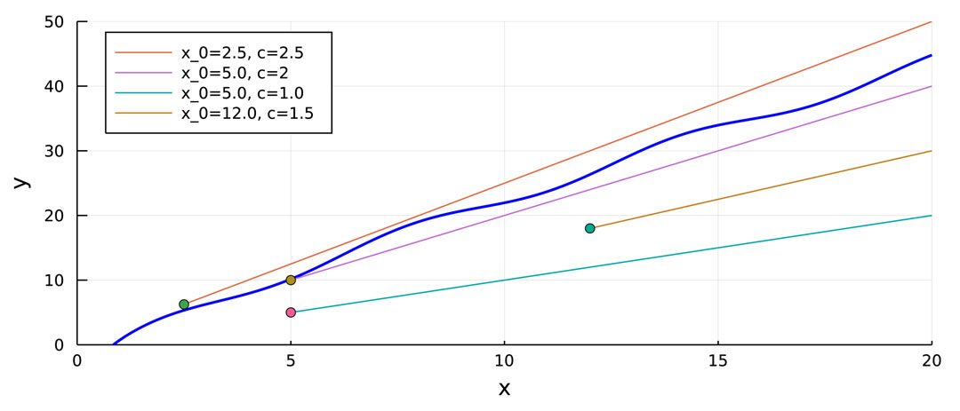
Graph of x versus y
Figure 4.13: The curve y = 2 x + 2log(x) - 2.1 + sin(x), with four potential bounding curves, only one of which sits above y for all x > x_0

Four lines are shown on the graph, a with the curve y = 2 x + 2log(x) - 2.1 + sin(x).
x_0 = 5.0, c = 2.0 sits above the curve, whilst x_0 = 5.0, c = 1.0, x_0 = 12.0, c = 1.5 and x_0 = 2.5, c = 2.5 sit below.

4.3.3 Manipulating Big-O Notation
Big-O notation can also be manipulated. This allows you to start small, analysing small chunks of code, and then combine the analysis as the code is combined into larger segments. For instance, imagine you have two chunks of code, and you know that their performance is O(g_1) and O(g_2), then you can combine them by multiplication if one chunk calls the other, or summation if the two act in series. The math is then pretty easy:

- Multiplication: If f_1 = O(g_1) and f_2 = O(g_2) then
f_1 × f_2 = O(g_1 × g_2).
- Summation: If f_1 = O(g_1) and f_2 = O(g_2) then pick whichever of g_1 or g_2 grows fastest (say for the sake of argument it is g_1 here) and
f_1 + f_2 = O(g_1).
You use these and the definition to find ways to simplify Big-O notation; for instance

- if f(x) is a sum drop everything except the term with the largest growth rate, and
- if f(x) is a product, then drop any constants.
For example:

- x^7 - 200 x^4 + 10 = O(x^7) because the polynomial is dominated by the x^7 term and so we drop the other terms.
- n^2 + log n = O(n^2) because we can drop the log term, which grows more slowly.
- 3 n^2 = O(n^2) because we can drop any constant factors.
Therefore, very complex formulae can be dramatically simplified.
You should always write Big-O notation in the simplest form possible, ideally with the tightest bound you can find. Although it is technically correct that x + 1 = O(x^2 +10), according to the definition, you should use the rules above to put this into the simple form x + 1 = O(x).
Classic examples of the use of Big-O notation to describe algorithm performance occur in matrix algebra. For instance, see the following (in the , A and B are n × n square matrices).
4.2: The computational complexity of common matrix algebra operations
Problem | Notes | Complexity
A × B | Simple approach | O(n^3)
Clever algorithm | O(n^2.373)
A^-1 | Simple approach | O(n^3)
Clever algorithm | O(n^2.373)
det(A) | Simple approach | O(n!)
Clever algorithm | O(n^3)

The simple approach is the approach you were most likely taught in a first course of linear algebra, but you can see that these are not the best approaches.
Finally, note that Big-O notation is often used with more than one variable parameter. Hence, it is common to see formulations like
F(n,m) = O(n log m).
The meaning of such expressions can be broken down into the parts.
So Big-O notation is a way to simplify expressions of computational complexity. Remember its limits though:

- Big-O notation concerns asymptotic behaviour—it doesn’t say what happens for small x.
- Big-O notation is an upper bound. Performance might be considerably better than its predictions.
There are alternatives (Big-Omega and Big-Theta notation are the most common) that can provide additional insights, but you won’t need those in this course.

Optional reading
These readings will provide you with more about Big-Omega and Big-Theta notation.

freeCodeCamp 2020, What is Big Omega Notation?freeCodeCamp, viewed 22 July 2021.

freeCodeCamp 2020, Big Theta and Asymptotic Notation Explained, freeCodeCamp, viewed 22 July 2021.

Questions
1. Given f_1(x) = O(x) and f_2(x) = O(x^2), what is the simplest possible form of the Big-O notation for f_1(x) × f_2(x)?
- f_1(x) × f_2(x) = O(x^2)
- f_1(x) × f_2(x) = O(x)
- f_1(x) × f_2(x) = O(x^3)
- f_1(x) × f_2(x) = O(x + x^2)
The correct answer is 3. (Use the multiplication rule.)
2. Given f_1(x) = x^2 + 3 and f_2(x) = x - log(x), what is the simplest possible form of the Big-O notation for f_1(x) × f_2(x)?
- f_1(x) × f_2(x) = O(x^3)
- f_1(x) × f_2(x) = O(x^3 + 3x - x^2 log(x) + 3log(x))
- f_1(x) × f_2(x) = O(x)
- f_1(x) × f_2(x) = O(log(x))
The correct answer is 1. (Convert the functions into Big-O notation, and then use the multiplication rule.)

4.3.4 Back of the Envelope Analysis
So, now for the actual calculations. The idea here is to make these as simple as possible to get a rough estimate of how your simulations will take.
As with examples provided on the previous pages, there are two parts:
- Calculate how an individual simulation will take.
- Calculate how many simulations you will run.
The second part is the easy part. You just need to count how many loops there are in your harness. For instance, you might run through 10 values of a parameter p and two binary (Yes/No) questions, for a total number of elements in your possibility space of 10 × 2 × 2 = 40. Then multiply by the number of realisations for each case; that is, the number of different seeds used. For instance, say this is 100, then you would need to run the simulation 4,000 times.
Calculating the work in each simulation is harder. You could start from scratch, and count each elementary operations, and, in some cases, that approach might be needed. However, I would encourage you to think at a higher level, at least to start with. What are the ‘big’ chunks of work. Remember, the big things are the ones that will stand out using Big-O notation.
So, you can (usually) ignore:
- initialisation—this only happens once at the start, so even if it involves a lot of work, it is amortised over the life of the whole simulation
- any small jobs done a the way.
Output is usually slow, so keep track of that. And creating new events, or new entities will often require some work—particularly if you also output data about each entity, or at each event.
Let me assume, for the moment, that you are going to output data about each arrival to a queue. Then the amount of time to simulate will be (very roughly) determined by the number of arrivals. The number will be
N = λ T,
where λ is the arrival rate, and T is the total (simulation) time.
So, you might expect your simulation times to be O(N) = O(λ T).
One more note. So far, I have focused on computational time, but another common aspect of complexity analysis is to consider memory or storage requirements. On today’s computers, this is less important, but it is still worth considering because if you can run your simulation in the space provided by a CPU’s cache memory, then it will be much faster. Memory or space is dominated by the data structures you store. You can do a similar back-of-the-envelope calculation by thinking about, for instance, how many entities your system might have to keep track of. For instance, a queue will need as many entities as there are customers in the queue.
Back-of-the-envelope calculations are a great way to get started. In reality, your simulation may be worse or better. Sometimes there are aspects of the code that cause unanticipated problems. For instance, you may not realise that your event list priority queue takes a certain amount of computer time to maintain, and that this does not scale linearly. So, this analysis is only used to get a first guess. This guess can be coupled with measurements, as described next section.

Optional Activity
Read Heaps and Priority Queues(HackerEarth 2019) and determine the computation complexity of a heap-based implementation of a priority queue (you don’t need to understand everything about the approach, just how much work is needed). Think about the implications for the computational complexity of your simulations.

You use a priority queue for the event list (and potentially other queues as well). A heap-based priority queue has several computation times of interest. Each time you want to add an event to your priority queue, it needs to be inserted into the right part of the heap. Inserting into a heap takes O(log N) work, so if your priority queue grows er, you have to do more work for each event. Extracting the next event takes a similar amount of work. Thus, you don’t want this list to be over . However logarithmic growth isn’t too bad, so a fairly event list can be accommodated. You just don’t want to be careless and do something like generating all of your arrivals at the start so you have to add one million arrival events to this list.

4.3.5 Testing Performance
Performance estimation has some limitations. You might consider the worst case, but care more about the average case, for instance. The most obvious way around this is to use actual tests of performance.
You’ve already considered performance testing in Module 3: Verification - Performance Testing. In this module, however, you are most interested in measuring performance (you could also consider memory use as well).
The standard approach I showed you for measuring computation times in Julia is to use the@time macro as follows.
@time begin for i=1:1000 x = sin(π*i) end end
0.000015 seconds
This is great for interactive use, but now you need to systematically test your program and store the results as some parameters are varied. You do that using the@timed or@elapsed macros. The@timed macro returns the:
- value of the expression being executed
- the elapsed time
- the total bytes allocated
- the garbage collection time, and
- and object pertaining to memory allocation.
You only need the second term. The macro@elapsed is focused on that. The code below shows how you can use it to collect a timing measurement.
t = @elapsed begin for i=1:1000 x = sin(π*i) end end t
1.4517e-5
In this code, the variablet has been set to have the value of the elapsed time.
There are a lot of other clever timing mechanisms in Julia—see, for instance, Timing in Julia for more alternatives—but you won’t need them for this course as@elapsed should be enough. The macro is also clever enough to ignore some of the compilation time (which you shouldn’t include in your performance results). Even so, it is good practice to ignore the first measurement.

Activity
Look up Julia’s internal help for the@elapsed macro. Try out the example that is included on the help page. Why doesn’t it return exactly 0.3 seconds?

When you run the example, you should get a different value (I got 0.302840009). The command ‘sleep’ should pause the program for 0.3 seconds. There are two possible reasons as to why it doesn’t return exactly 0.3 seconds:
- The measurements are not accurate below about 100th of second.
- The sleep command does its best to sleep for 0.3 seconds, but is a little off.

Timing measurements
Once you can measure times, this needs to be included into the simulation harness. In the code below, I have included timing measurements in a simplified simulation harness to collect data about our simulation.
M = 100 T = [100.0, 1_000.0, 10_000.0, 100_000] N = length( T ) times = zeros( M, N ) for seed = 0:M for j = 1:N if seed == 0 # ignore the time of the first run run_sim( seed, T[j] ) else times[seed,j] = @elapsed run_sim( seed, T[j] ) end end end
The functionrun_sim only takes one parameter (apart from the seed), which isT the length of simulation time for the simulation. So, this harness tests how (in real time) the simulations take as a function of the simulation times.
Once you have obtained a matrixtimes of the run times for each simulation, you can then analyse it. The most common first steps are either to calculate the minimum, mean or maximum over the seeds. There will be some variation in run times because modern computers are always doing some other work in the background. You might use the minimum to get at the ‘best’ time, or you might prefer maximum to get at the worst case. Here, I will use the minimum, for example:
t = vec(minimum(times; dims=1))
The second input tominimum specifies that you take the minimum over the first dimension, i.e. that you do it over the columns. Thevec function is there to convert the result (which is a matrix) into a simple vector.
Here’s an example output for the M/M/1 queue simulation.

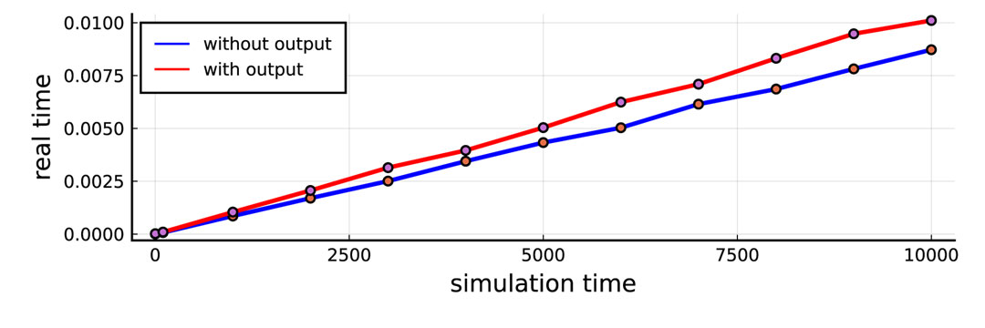
Figure 4.14: Run times for the M/M/1 simulation as a function of the simulation end time.

Run times for the M/M/1 simulation as a function of the simulation end time. The and red curves show the times with and without outputting functions turned on ( for without output, and red for with output). There is a near linear relationship between the two as the two lines extend up to the right, but that real times (measured in seconds) are much smaller than the simulation times.
Note the following:
- The real times are much smaller than the simulations times. Guess why?
- The performance is pretty close to linear, i.e. the run time is O(T), where T is the simulation time.
- There are some random variations still, but that is to be expected. We could reduce these by running more examples.
When computing simulation times, you may wish to turn off your output functions. Input/output is one of the slowest activities of a computer program, so if you just want to test the underlying simulation, you probably shouldn’t be outputting results. The curve shows the performance of the simulation including output. The second curve (in red) in Figure 4.14 shows the M/M/1 queue’s performance when writing out results. It isn’t actually too bad, but, in some simulations, it can be worse and it certainly isn’t negligible.
It’s is often useful to plot time results on log axes. Do this when there is a large disparity in values so you can compare very small to very large values.
One final note about performance testing. When you report results, you must always document the system that you are using in detail. For instance, the computer I was using here was:
System: Kernel: 5.4.0 x86_64 bits Distro: Linux Mint 20.1 Ulyssa CPU: 10-Core model: Intel Core i9-10900K bits: 64 type MT MCP L2 cache: 20.0 MiB Julia: version 1.6.0

There are more details you could find, but this is a satisfactory level of detail.

Try this
Set up your code harness for the car park model to measure computation times using the@elapsed macro and plot the results.

4.4 Including Data into Simulations

4.4 Including Data into Simulations
This section introduces the important idea that the value of simulation parameters can be informed by real-world data. Some basic statistics is revised with a view to fitting distribution parameters.
- Read through the following pages in order, taking notes as you go and running any example code (if applicable).

4.4.1 Including Data into Simulations
Up until this point, you have been told what distributions to use. For example, you have been told your arrival times are exponential, or your service times are deterministic. But what are you going to do when a customer has pre-existing data you can use? Are you going to ignore it? Of course not! Data is valuable and makes your simulations more informed!
In this topic, you will learn how to approach the selection of your distributions as guided by data. You will learn some reliable methods to help you identify what family of distributions to consider for your data through the use of histograms and QQ-plots. You will also learn how to select a specific distribution to best match the data you are given using the Method of Matching Moments. These skills will be vital for your final assessment piece, where you will apply these methods to a given dataset.
Throughout this topic, there will be some Julia popping up, so make sure you have the following packages to help you work a side the module.
# For this module, you will need the following packages so don't forget to install them. using DataStructures, S RNGs, Distributions, Plots, StatsPlots # load packages rng = S RNG(1234) # set the RNG and seed

Looking at data
Let’s take a simple example to help you through this, although the techniques will be much more generalisable. Consider ‘old faithful’, the valet car park example from Module 2: Example 2 - A Car Park. In the example, Big-Rich Hotel has three valets working on Saturday evening, and each valet takes five minutes to park a car and return to be ready for the next car. Now, you modelled this queue with an M/D/3 queue because you were told you had exponential arrival times and this deterministic service time.
Now, suppose that Big-Rich Hotel has re-evaluated its valet service times. Over a period of five weeks, it timed how it actually takes its valets to park a car and return to be ready every Saturday night, and it looks like its estimate of five minutes was way off. In the five weeks, the valets parked 150 cars, and Big-Rich has supplied you with the recorded service times in minutes, the first ten of which are displayed below.
3.053, 10.564, 7.763, 5.100, 7.840, 4.349, 0.939, 1.908, 4.442, 9.270
You see here that the service times are definitely not deterministic, so you need to consider a M/G/3 model now, for a general service distribution. What do you do? How do you think you are going to model these service times? Are you going to just chuck any old distribution at it and be happy? Or is there a more methodical way to approach this?
You may have guessed, there is a more methodical way, which is what you will go through now. This all begins with looking at your data.

The histogram
Now you can cheer for joy, because you finally have data to play with! As a budding data scientist, this should truly be the moment you have been waiting for. A client has come and given you data, so your very first instinct should be to look at it and understand it.
There are many ways to look at data that I am sure you have come across, and they change depending on the data you are looking at. Here, you have been given recordings of service times for a valet to park cars and return, which means you have some continuous quantitative data. Generally, for continuous quantitative data, you want to do two things: look at some summary statistics, and look at the shape of the distribution. Summary statistics are coming later on in Module 5, so shelve that for now. Here, you will be concerned with looking at the shape of the distribution of the data.
One of the best ways to look at the distribution of the data is through a nice simple plot called a histogram. Here is a histogram of the Big-Rich Hotel data to take a look.
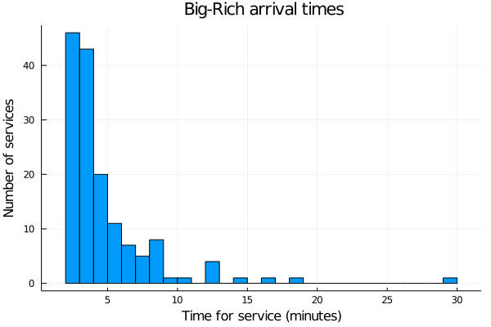
Histogram with time for service in minutes on the x-axis and number of services on the y-axis
Figure 4.15: A histogram of the Big-Rich Hotel data.
A histogram of service times for the Big-Rich Hotel data showing the number of services that fall within each bin. The time-bins range from 0–25 minutes, and roughly there are fewer in the bins corresponding to er times, but there is some random variation as well.
What do you see here? You can describe this distribution as unimodal (it has one tall peak) and right-skewed (the tail of the data shoots off to the right). Does this look like any distributions you know?
Straight off the bat, there are two distributions that jump to mind as being right-skewed and unimodal: the exponential distribution and Pareto distribution. If you can’t remember what these look like, let’s look at a histogram of each of them.

Exponential distribution
First up, generate 150 observations from an exponential distribution with parameter λ = 1 to get a feel for its shape. You can use the following code to do this:
# generate an Exponential sample exp_sample = rand(rng, Exponential(1), 150); # Make a histogram exponential_histogram = histogram(exp_sample); plot(exponential_histogram, = "Exponential distribution", legend = false, xlabel = "x", ylabel = "Frequency")
Figure 4.16: A histogram of samples from the exponential distribution. A histogram of service times for simulated exponential data showing the number of events that fall within each bin. The bins range from 0–5 minutes, and roughly there are fewer events in the bins corresponding to er times, but there is some random variation as well.
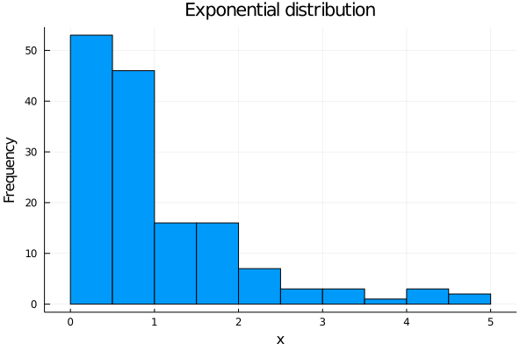
Histogram with x labelled on the x-axis and frequency on the y-axis
Do not be worried if your plot looks different to the one shown here. This code will generate a random sample from an exponential distribution and plot a histogram of it. This will be slightly different every time you run it purely because it is a random sample.
Now you can see why an exponential distribution jumped to mind. It has one mighty peak (so it is unimodal) and the data trails off to the right (so it is right-skewed).

Pareto distribution
Now for the Pareto distribution. To get a feel for how it looks, use α = β = 2. You can use the following code to generate a histogram of this (still generating 150 data points).
# Generate a Pareto sample par_sample = rand(rng, Pareto(2,2), 150); # Pareto histogram par_histogram = histogram(par_sample); plot(par_histogram, = "Pareto distribution", legend = false, xlabel = "x", ylabel = "Frequency")
Figure 4.17: A histogram of samples from the Pareto distribution. A histogram of 150 simulated Pareto random variables (α = β = 2), showing the number of events that fall within each bin. The bins range from 0–50 minutes, and roughly there are fewer events in the bins corresponding to er times, but there is some random variation as well. The drop-off is faster than for the exponential distribution,i.e. there are more small events and a few large outliers.
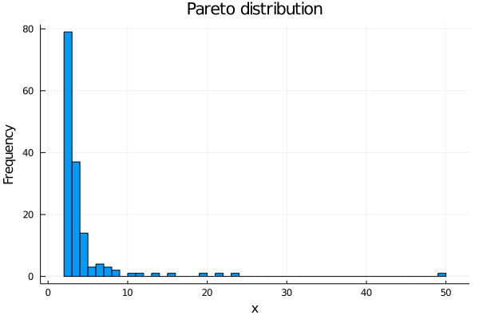
Histogram with x labelled on the x-axis and frequency on the y-axis
Once again, you see this is unimodal and right skewed. However, you may notice that you see some very large values appear in this histogram compared to that in the exponential distribution. This is the beauty of the Pareto distribution. It allows you to capture the idea that very large values can occur, although they will be less frequent than the smaller value.
So, out of these two distributions which do you think is going to be a better model for the service times at Big-Rich Hotel?
Just from an eye-ball, the data is looking more exponential because it doesn’t have those big values popping up, but can you do better than an eye-ball?
Of course you can! On the next page, I will explain how—through the use of a QQ-plot.

Questions
- When generating the exponential and Pareto distributions above, why were only 150 observations generated from the distributions?VIEW ANSWER The original data only has 150 observations in it, so you really should compare like with like.
- The Pareto distribution has a shape parameter α. Obviously, this is going to affect the way the distribution looks. Take the code above and play around with the shape parameter. How does the distribution change?VIEW ANSWER It squishes the distribution up making the extreme values much smaller.

4.4.2 The QQ-plot
So, you have some data from a customer (Big-Rich Hotel), and you want to test different distributions to see which distribution (if any) is the best fit for the data. You have looked at the data with a histogram, and you have identified some candidate distributions—in this case, you want to try either an exponential distribution or a Pareto distribution. You will now learn about QQ-plots which are a nice visual tool to help you decide whether your data matches a given distribution.

The theory of QQ-plots
In this , Matt Ryan explains what a QQ-plot is and takes you through the theory.

4.4.3 The Use of QQ-plots
Now that you have an idea of what QQ-plots are doing, it’s time to use them. Previously, you looked at the distribution of the service times at Big-Rich Hotel and noted that it looks more like an exponential distribution than a Pareto, but let’s use the QQ-plots to justify this choice a little more.
First up, a QQ-plot of your data compared to an exponential distribution with parameter 1. You can produce a QQ-plot with the following code:
# Exponential QQ-plot # To do this, you use the qqplot function from StatsPlots qqplot(Exponential(1), # This is the distribution you want to compare to big_rich_service_times, # This is your dataset/sample = "QQ-plot of Big-Rich vs an Exponential", # Make it look pretty with labels xlabel = "Theoretical Quantile", ylabel = "Sample Quantile", qqline = NaN)
Figure 4.18: A QQ-plot against the exponential distribution.
A QQ-plot comparing the Big-Rich data to the exponential distribution. Although the points are almost linear, they do not sit on the 1:1 line indicating the correct family of distributions, but the wrong parameter.
Now, this is looking good! You see a nice, relatively straight line in your QQ-plot, which means that an exponential distribution is looking like a good choice to model the service times. How does the Pareto distribution hold up though? Let’s compare the Big-Rich Hotel data to a Pareto distribution with α = β = 2.
# Pareto QQ-plot qqplot(Pareto(2,2), # This is the distribution you want to compare to big_rich_service_times, # This is your dataset/sample = "QQ-plot of Big-Rich vs a Pareto", # Make it look pretty with labels xlabel = "Theoretical Quantile", ylabel = "Sample Quantile", qqline = NaN)
Figure 4.19: QQ-plot against the Pareto distribution.
A QQ-plot comparing the Big-Rich data to the Pareto distribution. The curve has steep incline at the start and then plateaus before the final points which are spaced out and rise higher.
Figure 4.20: QQ-plot with 1:1 line.
A QQ-plot comparing the Big-Rich data to the exponential distribution. The curve is approximately linear for a large part of the curve, rising from the bottom left upwards. The last few points are more spaced out and rise higher.
You see how that line does not lie on your data? That means you have the correct family of distribution (an exponential), but you don’t have a perfect match for the data. Don’t worry, not all is lost! I will show you how to make an informed choice for your parameter from your chosen distribution on the following pages.

4.4.4 Choosing Your Parameters
Now, let’s recap where you’re at. You have been given data (service times at Big-Rich Hotel), and you want to use this data to make your simulation more realistic.
You have looked at it with a histogram, and you have identified a candidate family of distributions using QQ-plots (it looks exponentially distributed). Now you are faced with the problem: which exponential distribution should you choose? That is, what value of θ should you choose? Getting that choice right will make your simulation more realistic.
This comes down to making smart choices for the parameters of your distributions, and by smart, I mean choose the parameters that best match your data. There are many ways you might want to do this. Here I will introduce you to the Method of Matching Moments(MMM), which will give you informed parameter estimates based on your data. Another popular choice is the Maximum Likelihood Estimates, but this will not be covered here.

The theory of MMM
The way the Method of Matching Moments works is that you take your theoretical moments of your distribution and equate them to the sample moments you see in your data. Now, the obvious question is, “What is a moment?”
A theoretical moment, or just moment for , of a random variable X is a generalisation of the expected value. Formally, the k^th moment M_k of X is defined to be
E[X^k] .
In this sense, the moments generalise the expected value since M_1 = E[X].
Now, why would you care about a moment?
Well, they help you capture about your random variable. For example, the second moment M_2 can be used to find your variance of X, and the third moment M_3 can be used to find the skewness of X. Another benefit is that moments are easily calculated for common distributions.
Now, don’t you fear, you will not be expected to calculate theoretical moments. For all examples needed in the course, these will be provided to you.
So, that is the theory of moments. What about a sample moment?
Well, suppose you have data x_1, x_2, …, x_n. Then you define the k^th sample moment m_k as
m_k = (1) / (n) Σ_i = 1^n (x_i)^k ,
that is, you take each data point, raise it to the k^th power, add them all up, and then divide by how many there are. You can see this is the right definition since m_1 = x̄, the sample mean.
Now, the Method of Matching Moments is done by equating
M_k = m_k
for each k. Then M_k will be in terms of your parameters (i.e. θ) and the m_k will be in terms of your data. In this way, you can find values of your parameters based on your data. So how many values of k do you need to consider? Well, that depends on your distribution.
For instance, an exponential distribution has one parameter θ, so you only need to consider the first moment M_1 to get an estimate of θ. However, if you consider the Pareto distribution, it has two parameters α and β, so you will need to consider the first two moments M_1 and M_2 to get estimates for both α and β. The rule is: consider as many moments as you have parameters in your distribution.

4.4.5 Some Examples of Moments
Here, you will be presented with the useful moments for two of your common distributions: the exponential distribution and the Pareto distribution. It will be useful to cast your mind back to Module 1: Continuous Distributions to remind yourself about these distributions.
First, the exponential distribution. Let X be exponentially distributed with parameter θ. As mentioned above, you only need to consider the first moment for an exponential distribution in the MMM. Now, since M_1 = E[X] you get that:
M_1 = θ
for an exponential distribution. Now, let x_1, x_2, …, x_n be a random sample of X with sample moment m_1. Then the Moment of Method Matching estimate of θ is found by equating:
θ̂= m_1 .
Now, the tough one. Let X have a Pareto distribution with parameters α and β. For the MMM to work here, you need to assume that α > 2. Now, you need the first two moments. Since the first moment is the expected value, you get that:
M_1 = (α β) / (α - 1) .
Now, the second moment is defined as:
M_2 = E[X^2] ,
but currently you don’t know what this is. What you do know is that the variance of X is:
Var(X) = (β^2α) / ((α - 1)^2(α - 2)).
To get the second moment, you can use the following really useful statistical formula:
Var(X) = E[X^2] - (E[X])^2 .
Using this and doing some cancellation, you get that:
M_2 = E[X^2] = (β^2 α) / ((α - 2)) .
Now, let x_1, x_2, …, x_n be a random sample of X with sample moments m_1 and m_2. Equating:
m_1 & = (hatα hatβ) / (hatα - 1) , m_2 &= (hatβ^2 hatα) / ((hatα - 2)) ,
and rearranging gives the Method of Matching Moments estimates:
α̂ & = 1 + sqrt((m_2) / (m_2 - m_1^2)) , β̂ & = (m_2) / (m_1)≤ft( 1 - sqrt((m_2 - m_1^2) / (m_2)) ) .
How about you go put these moments into action?

Reading
A really nice source on the Method of Matching Moments, with lots more examples, can be found in ‘Chapter 7.2 The Method of Moments’ in the online text Probability, Mathematical Statistics, and Stochastic Processes(Siegrist 2020).
Siegrist, K 2020, Probability, Mathematical Statistics, and Stochastic Processes, LibreTexts, viewed 23 July 2021.

4.4.6 MMM in Action
Finally, you are ready to find the distribution that best suits the data provided. In the service time data from the Big-Rich Hotel, you identified that it is likely to come from an exponential distribution. Let’s use the Method of Matching Moments to find out which one.
So, you can calculate the first sample moment of the data using themean function. This gives that the first sample moment is approximately:
m_1 ≈ 5.134
Then the MMM estimate of θ is:
θ̂ ≈ 5.134 ≈ 5
See? In the end, it is just that easy. Finally, you need to double-check that this matches your data using a QQ-plot. You can add a the 1:1 line y = x to make sure it matches up nicely:
# Exponential QQ-plot # To do this, you use the qqplot function from StatsPlots qqplot(Exponential(5), # This is the distribution you want to compare to. big_rich_service_times, # This is your dataset/sample = "QQ-plot of Big-Rich vs an Exponential", # Make it look pretty with labels xlabel = "Theoretical Quantile", ylabel = "Sample Quantile")
Figure 4.21: QQ-plot comparing fitted distribution to data.
A QQ-plot showing the Big-Rich data against an exponential distribution with the correctly fitted parameter λ = (1) / (5). The data sits close to the 1:1 line.
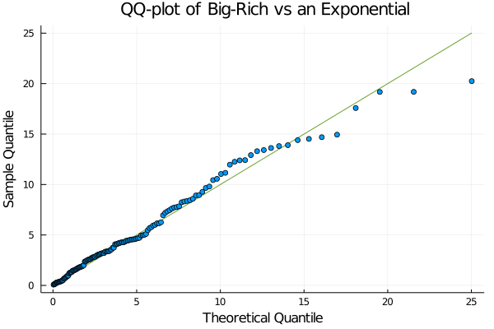
Graph with theoretical quantile on x-axis and sample quantile on y-axis
There you have it. You can now confidently model the service times at Big-Rich Hotel as an exponential distribution with parameter θ=5.

Recap
Time to recap this section. When you are lucky enough to be given data, you can make your simulation best match this data by:
- looking at the data with a histogram,
- identifying candidate distributions that look similar (like an exponential),
- checking which is the best distribution using QQ-plots,
- finding the right parameters using the MMM,
- confidently modelling the data.
And that’s it for now. It’s time to put these new found skills to the test in the following exercise.

4.4.7 MMM Exercise
While looking at their valet service time, Big-Rich Hotel also decided to time the inter-arrival times of their customers. The data is available in big_rich_arrival_times.jld2. Note that this is saved as a.jld2 file. This can be loaded using the JLD2 package (so make sure it is installed) and code like:
using JLD2 @load "path_to_file/big_rich_arrival_times.jld2"
For this dataset, do the following:
- Produce a histogram of the data.
- Compare this data to an exponential with λ = 1 and a Pareto with α = β = 2 distribution using QQ-plots.
- Pick the best matching distribution.
- Use the Method of Matching Moments to find the parameters for your distribution.
- This data was drawn from a Pareto with α = 2 and β = 5/2. How different are your parameter estimates from the true values?
Solutions to this exercise can be found on the following page.

4.4.8 MMM Exercise — Solutions
- Produce a histogram of the data.
- Compare this data to an exponential with λ = 1 and a Pareto with α = β = 2 distribution using QQ-plots.
- Pick the best matching distribution.
- Use the Method of Matching Moments to find the parameters for your distribution.
- This data was drawn from a Pareto with α = 2 and β = 5/2. How different are your parameter estimates from the true values?

5. Statistical Analysis of Simulation Data

Module 5 Overview

Module 5 Overview
module banner

In this , Professor Matt Roughan provides an outline of Module 5 and where you will be going this week. He emphasises the fundamental need to appreciate that all simulation measurements will contain statistical errors, which are quite different from bugs in code. Statistical errors are deliberate, and you need to understand the variability of a potential system.
The previous modules have shown you how to build a simulation and how to extract data from it. But data alone is not enough; you need to distill your data into useful . This week you will be guided through data analysis and the use of statistical methods that you are familiar with, but the focus will be different. When you run a simulation you can create your own data, and that is a little different from most data science settings.
For instance, you don’t normally need to worry about burn-in in data science, but you do here. This topic will finish with some of the simplest methods to reduce the variance in your simulations.

Learning outcomes for Module 5
On successful completion of this module, you will be able to:

- determine appropriate statistical frameworks to analyse DES data
- systematically derive quantitative using statistical methods adapted to DES data
- estimate error bounds for DES-derived
- develop approaches to improve accuracy when needed.

Activities
In this Module, you will:

- learn about analysis of the data you obtain from simulations and how that analysis can help you do better simulations, for instance, by avoiding the transient ‘burn-in’ data at the start of a simulation
- learn about estimation and errors from the point of view of a simulation
- explore how to improve the accuracy of your simulations

5.1 Summary Statistics

5.1 Summary Statistics
This section revises some ideas from elementary statistics and demonstrates how they apply in the context of analysing simulation output.
- Read through the following pages in order, taking notes as you go and running any example code (if applicable).

5.1.1 Summary Statistics
The aim of this module is for you to learn how to draw meaningful conclusions from your simulations. But what is meant by a meaningful conclusion?
Suppose you have been asked to improve service times at a supermarket which has a mean service time of 10 minutes. You go away, do some thinking, build the simulation of your new and improved system, and find that the mean service time of your new system is 9.5 minutes. There you go. You are all happy and can confidently say that your new system will decrease service times by 0.5 minutes. But, being a good data scientist, you really want to be sure, so you change the seed of your simulation and rerun it. Having done this, you find a mean service time of 11.2 minutes, and now you are not so confident that your simulation has actually improved the original system.
What is going on here? Why do you see different mean service times when you change the seed? Why can’t you confidently claim an improvement of a system after just one simulation? Throughout this module, you will learn the answers to these questions, as well as a nice way to approach and handle them.
You will use these skills in the Project report assessment to analyse the results of your simulation code.

5.1.2 What Is Being Measured - Time or State?
The 'What is being measured' is a broad statement. Here you will cover two key ideas about what you measure. The first is the more abstract idea of what you measure and why you see different numbers on each simulation. The second tackles the more down-to-earth concept of what aspect(e.g. time or state) of the simulation you measure.
Let’s tackle the first big question: ‘Why should you expect to see different numbers every time?’ One of the fundamental ideas of a random simulation is that it is random, as you might have guessed. You run the simulation, and generally you will draw values randomly from a distribution to simulate, for instance, an arrival time.
This means that the simulation is inherently random; so any outputs you record from your simulation will also be random. More formally, because the inputs of your simulations are random variables, your outputs are also random variables. This means that you need to be very careful when drawing conclusions from your simulations. Think of it like forecasting the weather. Just because today was 25 degrees, it does not mean you can confidently say that tomorrow will also be 25 degrees.
So if the outputs you get from a simulation are going to be random, does that mean all is lost? If so, then all your work up until now would have been a colossal waste of time. Luckily, this is not the case. You can use statistical tools to analyse your results, but you need to understand what you are seeing first.

Stochastic processes
Any outputs you are measuring from your simulations, such as the time each customer waits in a queue, is known as a stochastic process. A stochastic process is just a sequence of time-ordered random variables that you want to draw some conclusion about. For instance, if you measure the number of people in a system at time t, you might denote this as N(t). This means that, given some time t, which is any positive real number, you are measuring the number of people in the system.
Before jumping into the stats, a quick note about what you are looking at. There are two main categories of stochastic process, discrete and continuous, and two ways each can occur. One is in the underlying ‘time’ index of the process you observe, and the other is in the values.
For instance, N(t) is a discrete-valued random variable (it counts the number of people, which is discrete) with a continuous time index t so you can ask a question about this process at any time, e.g. at 5.32 minutes. For instance, see Figure 5.1(a), which shows the number of customers in a queue, which is discrete, as a function of measurement time, which is continuous. Even though the events are discrete, time itself is continuous, so we see the characteristic stair-step plot.
Figure 5.1: An illustration of the difference between monitoring discrete states of a system (a), as compared to continuous valued variables such as times between arrivals (b).
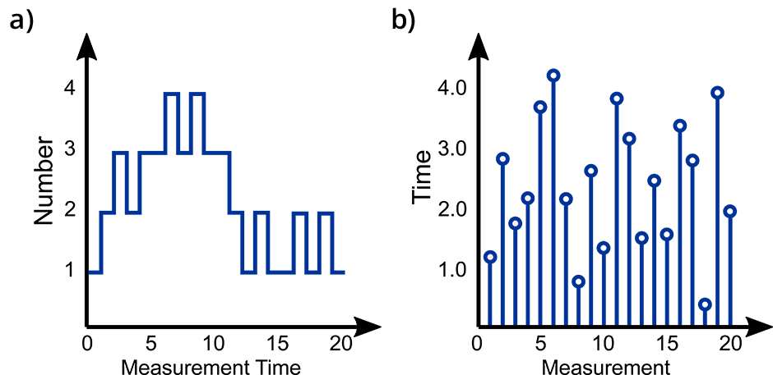
Two graphs side by side as described in the
- Measurement time on the x-axis and number on the y-axis. The line appears in steps initially going up, then down and then up again as measurement time increases before dropping back down.
- Measurement on the x-axis and time on the y-axis. A series of separate vertical lines ascend from the x-axis representing time measurements. Each line ends at a point with a circle corresponding to a time on the y-axis. Each line is a different length with no direct pattern.
Another example of a stochastic process you might observe is the inter-arrival times of customers in a queue. You may write T_1 to denote the inter-arrival time of the first customer, T_2 to denote the inter-arrival of the second, and so on. The T_i together form another stochastic process. This process has continuous values. The times could take any non-negative value, and rarely will you see the same value twice. However, now ‘time’ in the stochastic process refers to the measurement index, e.g. the index of measurement T_2 is 2. Now these indexes are discrete. So, you see a situation, such as Figure 5.1(b), where the y-axis is continuous (the measured times can take any value) but the x-axis is discrete. It’s sometimes useful to plot these as stem plots.
Note that the discrete number in a system takes a limited group of set values (usually integers) whereas times can take any (non-negative) value and you may only rarely ever see the same time value twice. Note also that when monitoring state, the measurement time is a continuous variable—you can monitor the system at any measurement time—whereas in the case of monitoring continuous objects like inter-arrival times, the x-axis is now discrete.
When it comes to drawing conclusions from a simulation, it really boils down to drawing conclusions about these unknown stochastic processes that you are simulating, i.e. the outputs of your simulation. Since these are random variables, you need to do this using a statistical approach. In the rest of this module, you will learn a few ways you can analyse these stochastic processes so you can confidently make statements about any simulated process you might design. You’ll use these ideas in your Project Report assessment.

5.1.3 Sample, Mean and Variance
Statistics really has two sides to it. The first is the theoretical side, where you construct all the nitty gritty (small) details and theory that allow you to
- test hypotheses
- construct confidence intervals
- discuss random variables, and so forth.
The other side is actually doing these things on real data. This is what you will be mainly focusing on in this topic.
The goal here is to draw meaningful conclusions from a stochastic process. To do this you really need two key concepts:
- the sample mean and
- the sample variance.
The sample mean is the ‘real data’ side of the ‘theoretical’ expected value of a random variable that you learnt about way back in Module 1. To be clearer, the previous definition relied on a theoretical definition based on sums or integrals, but now you want to calculate these for actual samples of real data.
Similarly, the sample variance is the ‘real data’ side of the variance of a random variable. You have been introduced to these concepts using things like the mean function in Julia, but now let’s go through what they actually are. The rest of this topic is going to break away from the idea of simulations for a while. It will look at the basis of the sample mean and variance. This will all link back to simulations later in this module.
To get started, let x_1, x_2, …, x_n denote a sample of a random variable X, that is, there is some random variable X and you have observed n values of it that you denote x_1, x_2, …, x_n. How can you use this sample to gain about what you can expect from your random variable? A good thing you can do is to summarise these n numbers into what is called sample statistics. These are usually single values that describe what you can expect to see in new observations given the data you have already seen.

Sample mean
Probably the most famous sample statistics is the sample mean. The sample mean, denoted by x̄(and read as x-bar), captures what you like to think of as the average value of a set of numbers. You can calculate the sample mean by simply adding up all your numbers and dividing by how many there are. In maths, this is written as:
x̄ &= (x_1 + x_2 + ·s + x_n) / (n) & = (1) / (n)Σ_i = 1^n x_i .
Don’t get scared by that big Σ symbol; it is just a hand way of writing that you want to add up all the numbers x_1, x_2, …, x_n.

Example
Suppose you have 5 observations of a random variable X, say x_1 = 1, x_2 = 1, x_3 = 2, x_4 = 4, and x_5 = 5. What would your sample mean be? Well, you would add them up, and then divide by 5. So you get:
x̄ &= (1 + 1 + 2 + 4 + 5) / (5) & = (13) / (5) & = 2.6 .
You can interpret this sample mean as the average number you would expect to see for your random variable given the data that you actually saw, that is, on average you expect the random variable X to take the value 2.6.
Notice how the sample mean is not an actual value you see in your sample. This is COMPLETELY fine, so don’t freak out about that. There is no need for your mean to be an actual number from your sample, ever.
So that is how you can measure what you think your average number is going to be, but can you capture how much you expect this to change? You may have noticed that none or our numbers x_1, x_2, …, x_5 actually had the value 2.6, so can you measure how far away you can expect your observations to be from that mean value? This is captured in the twin notions of sample variance and sample standard deviation.

Sample variance
The variance of a sample x_1, x_2, …, x_n measures how much your data varies from the sample mean (see, it’s right there in the name!). It does this in a way that seems confusing, but it is mathematically sound. What you do is take each data point, subtract the mean value from it, square the resulting value, add them all up, and then divide by n-1. See. Simple.
Put mathematically, the sample variance s^2 is given by:
s^2 &= ((x_1 - x̄)^2 + (x_2 - x̄)^2 + ·s + (x_n - x̄)^2) / (n-1) & = (1) / (n-1)Σ_i = 1^n (x_i - x̄)^2 .
Once again, don’t be put off by the Σ. A key thing to note about the sample variance is that it is always going to be a positive number, so if you are ever doing calculations and get a negative answer, you have our permission to panic.

The weird ‘-1’ in sample variance.
You may have noticed that you divide by n when calculating the sample mean, and by n-1 when calculating the sample variance. This is a technical point to make our sample variance unbiased when you have an independent sample of points. You can think of it this way: when you calculate the sample variance, you need to first calculate the sample mean. This means that you have already used a lot of from your data. To account for this, you remove 1 in your denominator because you have already estimated one thing (the mean). For those who are interested, this is related to the concept of degrees of freedom.
Now sadly, the sample variance can be a little difficult to interpret. This is all because of the fact that you are squaring everything, so the sample variance is in units^2, e.g. if you were measuring people’s heights in centimetres, the variance would be in units centimetres^2. This gives all sorts of headaches when trying to explain what this is doing. A much simpler explanation comes in the sample standard deviation s, which is given by:
s = sqrt(s^2) .
This is now much simpler to interpret as you have taken the square root, i.e. if you are measuring height in centimetres, the units of the standard deviation is in centimetres also.
Let’s see if this can be cleared up for you with our example. So from above, you had that x_1 = 1, x_2 = 1, x_3 = 2, x_4 = 4, x_5 = 5, and x̄ = 2.6. Let’s calculate the variance and standard deviation now. The variance is given by:
s^2 &= ((1 - 2.6)^2 + (1 - 2.6)^2 + (2 - 2.6)^2 + (4 - 2.6)^2 + (5 - 2.6)^2) / (4) & = 3.3 .
Now to get the standard deviation, all you do is take the square root:
s & = sqrt(3.3) & ≈ 1.817
If you have never seen the≈symbol before, it stands for ‘approximately equal to’. You tend to use this symbol when you have rounded off a decimal place somewhere (here, you rounded to 3 decimal places), or when you are estimating a quantity. It tells people that you know what you’re writing down isn’t 100 per cent correct, but it’s close.

Central Limit Theorem (CLT)
The sample mean and variance are really important when trying to understand the nature of a random variable. These quantities can be used to make inferences about the random variable you are interested in, but how do you do this? One way to do this is through one of the most powerful results you will ever come across in statistics: the Central Limit Theorem (CLT).

Inference
This is just a technical term meaning drawing a conclusion on the basis of evidence. Don’t let it worry you. I’ll show you the actual techniques below.
I won’t get into the details of the CLT, because its technical statement is almost incomprehensible. However, you will learn how to use it. A simplified statement of the CLT is the following:
Let X_1, X_2, …, X_n be a sample of a independent observations of a random variable X such that E[X] = μ and Var(X) = σ^2. Let X̄ = (1) / (n)Σ_i = 1^n X_i denote the sample mean. Then for sufficiently large n, the distribution of X̄is normal with mean μ and varaince σ^2/n, that is,
X̄ ~ N≤ft(μ, (σ^2) / (n)) .
That’s it for the CLT for now, but you will come across this amazing theorem again later in the module and learn how to use it in the context of drawing inferences from your simulation models for the Project report a ssessment. For now, work through the example below to make sure you have your head around sample means and variances.

Questions
Consider the following sample:
x_1 = 37 , & x_2 = 50 , x_3 = 36 , & x_4 = 30 , x_5 = 92 , & x_6 = 28 , x_7 = 71 , & x_8 = 58 , x_9 = 54 , & x_10 = 93 .
Using what you have learnt, answer these questions:
- What is the sample mean?
- What is the sample variance?
- What is the sample standard deviation?
- x̄ = 54.9
- s^2 = 571.4333
- x̄ = 23.90467

5.1.4 Time Averages versus Ensemble Averages
We have now covered how to take averages and calculate the variance. You can now go further and explore the kinds of averages you might want to look at. Remember that the output of your simulation is a stochastic process. This is a just a time-ordered sequence of random variables. Also, remember that multiple realisations of a given model can be generated.
Thus, for any simulation, you can generate two views of the system. For instance, say N(t) is the number of people in a system over time t, you could look at:

- time-based: The system measured over time t. Over time N(t) varies, and this is one source of statistical variation.
- ensemble-based: Multiple simulation realisations form an ensemble. You can form this by taking multiple runs indexed by i starting with different seeds. At a fixed time t you can measure N_i(t), each of which will vary randomly as well.
You can use both measures for statistical estimates. For instance, you could take the mean of a set of observations over time N(t_i) or you could have multiple simulations and take values N_i(t) at some given time. These two cases are both useful as you shall see below.
Let X(t) denote the stochastic process where X represents the variable you are measuring and t represents the time it is measured. Let the observed process be denoted by x(t_0), x(t_1), x(t_2), …, x(t_n).
Given an observed stochastic process x(t_i), i = 0, 1, 2, …, n you want to get some sort of understanding of the underlying true process X(t), and generally, you are interested in its average behaviour. Going off this line of thought, you probably want to take some sort of average or mean. However, there are two ways you might want to do this: the time average or the ensemble average.

Time average
Time averages are used to understand the expected value of your stochastic process. Suppose you have run one simulation, then you have one realisation of the stochastic process X(t), which you can denote x(t_0), x(t_1), x(t_2), …, x(t_n). You can then use this realisation to gain insight into the true underlying process X(t).
When talking about a process, you often write X(t) to mean the state of the process X at time t.
For instance, you might want to know what the average of this process is, so you could look at the mean of your observed points:
x̄ = (1) / (n)Σ_i = 1^n x(t_i) .
This is what you call the time average of your stochastic process, and gives you an estimate of the expected value of your process. One issue with the time average, however, is that it is often the reason the observed values of your stochastic process are dependent on each other. Suppose for example that X(t) is measuring the total number of customers in the waiting room of the emergency department. Then, if you take a measurement x(t_i) at time t_i, then this will obviously depend on how many customers are in the waiting room at time t_i - 1. This dependence is an issue when it comes to calculating the variability of the process and drawing any statistical conclusions from it (more on this later).
There are two ways you would commonly deal with the issue of dependence:

- Run the simulation for an extended period of time and take snapshots of your process at far apart intervals. This will normally ensure that the values of your stochastic process are far apart enough that they do not influence the value of each other. But you don’t know how far apart intervals should be in advance, so this isn’t always easy to do well.
- Run the simulation many times with different seeds, calculate the mean of each of those simulations, and use this collection of means as your sample of data points. This approach has the advantage that you choose the seeds yourself, thus making sure each individual simulation is independent.

Ensemble average
What happens when you are interested more in the evolution and shape of your stochastic process rather than just its average value? That is where the ensemble average comes in. Suppose you have an underlying stochastic process X(t), e.g. you have written the code for a simulation and you want to study your output. Further suppose you have N separate and independent observations of this stochastic process X_1(t), X_2(t), …, X_N(t), e.g. you have run your simulation with N independent seeds, and recorded the output each time. The ensemble average is then defined by:
X̄(t) = (1) / (N)Σ_j = 1^N X_j(t) ,
that is, you observe each stochastic process X_j at time t, and average over those observations. This will give a good idea of how the stochastic process is evolving over time and will allow you to study the process in this way.
Now, this was just defined in the realm of random variables, so how do you do it with data?
To make our lives easier for the moment, suppose you have observed each stochastic process at exactly the same time (this assumption will be relaxed later on). That is, suppose for each of your simulations you measure the value of X_i(t) at the same time points t_0, t_1, …, t_n so you have data x_1(t_0), x_1(t_1), …, x_1(t_n) for X_1(t), data x_2(t_0), x_2(t_1), …, x_2(t_n) for X_2(t), all the way up to x_N(t_0), x_N(t_1), …, x_N(t_n) for X_N(t). You would then define your ensemble average at time t_i as:
x̄(t_i) = (1) / (N)Σ_j = 1^N x_j(t_i) .
You can then use this observed data to make inferential conclusions about your underlying process.

Summary
So those are two of the types of means you may want to look at for a stochastic process. Which one you look at is heavily dependent on the question you are trying to answer. If you are trying to answer a question of the form
‘How will my customers wait on average?’
then you will want to look at the time average of your process. If you want to answer a question of the form
‘What percentage of the time does the waiting room hit capacity, on average?’
then you will want to look at an ensemble average.
Drawing conclusions from both types of means will be largely the same, but it is vital that you are measuring what you think you are measuring, so the choice of which one is very important as they will answer different questions.
Next, you will learn how to handle ensemble averages where your time points are not so nicely aligned.

5.1.5 Converting from Irregular Samples to Uniform Samples
We need one more detail to be able to take advantage of ensemble averages. You need to be able to measure each realisation of the ensemble at the same time points. That is much easier if you convert the irregular samples (based often on event times) into samples spaced uniformly in time. That will be needed for you to take full advantage of this in Assessment 3.
Recall that you have multiple independent realisations of the stochastic process X(t) denoted by X_1(t), X_2(t), …, X_N(t) and you want to use these realisations to draw conclusions about the evolution of the process over time. To do this, you might look at the ensemble average already defined. A problem you might face here is that when you observe these processes from your simulations, they may not be sampled at the same time point. Samples from the simulation using the event-driven model come at the times of events, which are not times that you choose. This makes the individual realisations difficult to compare.

Example
For example, suppose you have two realisations you have observed. The first realisation is denoted by x_1(t^(1)_0), x_1(t_1^(1)), x_1(t_2^(1)), …, x_1(t_n_1^(1)) and is observed at times t_0^(1), t_1^(1), t_2^(1), …, t_n_1^(1). The second realisation is denoted by x_2(t^(2)_0), x_2(t_1^(2)), x_2(t_2^(2)), …, x_2(t_n_2^(2)) and is observed at times t_0^(2), t_1^(2), t_2^(2), …, t_n_2^(2). A problem you face here is that there is no reason to expect that t_i^(1) = t_i^(2) for any value of i, or even that n_1 = n_2. That is, the stochastic processes can be observed at different times AND for different amounts of time. This makes comparison a massive headache.

Converting irregular time intervals into uniform time intervals
What to do in this situation is convert your irregular time intervals into uniform time intervals so that your stochastic processes are comparable with each other. There are two main cases:
- Your desired uniform time intervals are much er than the average time between events you have observed in your process.
- Your desired uniform time intervals are er (or on par) with the average time between events in your process.
Here you will mainly consider situation 1, as this is the more common case.
Suppose you have N independent realisations of a stochastic process X(t) which you denote by x_j(t^(j)_0), x_j(t^(j)_1), …, x_j(t^(j)_n_j), with t^(j)_0 < t^(j)_1 < … < t^(j)_n_j for every j = 1, 2, …, N. Note that you do not require n_j = n_k for any j, k = 1, 2, …, N or t_i^(j) = t_i^(k) for any j ≠ k. What you aim to do now is resample your time points t^(j)_i into a set of points t_0, t_1, t_2, …, t_n such that the amount of time between t_i and t_i + 1 is larger than the time between t^(j)_i and t^(j)_i + 1 on average.

Windowed average of data
One common approach would be to consider a windowed average of your data. What this means is that you would take your realisation, and the value at time t_i would be given as the average of the values observed between times t_i and t_i + 1(remember that t_i is your new, resampled time).
Put mathematically, let I_i^(j) = k : t_i ≤ t^(j)_k < t_i + 1
x_j(t_i) = (1) / (|I_i^(j)|) Σ_k∈ I_i^(j) x_j(t^(j)_k) ,
where|I_i^(j)|denotes the number of indices k in the set I_i^(j). The main trick here is to choose your new resampled time interval t_0, t_1, …, t_n such that I_i^(j) has at least one value in it for every i = 0, 1, 2, …, n and j = 1, 2, …, N.
The math of this approach looks complicated, but it is actually pretty easy to implement. However, one trick that is needed is to make sure that at least one event occurs in each window, or the above formula will result in 0/0.
Figure 5.2 is a simple example of an
M/M/1 queue. You have seen this before (for instance in Module 4). I used it to illustrate the idea of exploration of a system. Let’s explore further, but this time using the windowed averages described above.
Figure 5.2: A windowed average applied to the M/M/1 queue with μ=1.0 and λ=0.98, simulated for 5000.0 time units.
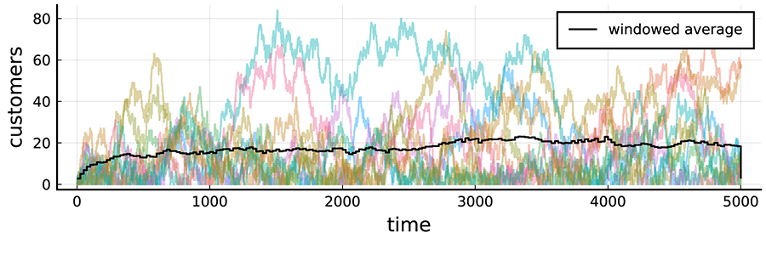
Graph of time on x-axis and customers on y-axis
A graph shows a windowed average applied to the M/M/1 queue. 'Time' is on the x-axis, ranging from 0 to 5000, and 'customers' is on the y-axis, ranging from 0-80. Pale coloured lines show the sample paths of 10 realisations of the simulation. A dark line across the middle shows an average over time windows of 25, also averaged over 100 independent realisations.
The figure shows (in pale colours) 10 independent realisations of the simulation. Each starts at the same point (an empty queue), but uses a different seed and so evolves differently. The solid black line shows a windowed average with a window size of 25.0 (time units), also averaging over 100 independent realisations.
The noteworthy features you can see are that:
- the large variations in the individual simulations have been smoothed out
- you can still see something of the time evolution of the process, which will be useful, for instance when calculating burn-in times.

Try this

Consider the car park simulation. Set it up to output the system state at arrival times (or rather just before arrivals, so that you ‘see’ what arrivals see. For instance, say arrival I occurs at time t_i, and sees the number of customers in the system to be N(t_i) then you know that the system takes a step up at that time, i.e. goes from N(t_i) → N(t_i) +1.
Assume that the average inter-arrival time is 1 / λ , then choose an interval ten times as wide, i.e. 10 / λ , and for each interval calculate the average. That is, for the k th interval [10k/λ, 11k/λ ) calculate the sample average of the N(t_i) such that t_i is in the interval.
Make a plot showing the original states at arrival times N(t_i) and the new windowed averages.

5.1.6 Burn-In and Cool-Down
Now that you can calculate the statistics of a process, you can finally consider the problem of burn-in. Remember that you want to understand the steady state of the process, but the initial state (zero customers) was chosen arbitrarily and isn’t representative of the steady-state. Therefore, you need to remove some of the early ‘burn-in’ data to avoid pollution by the transient starting state.
I have mentioned burn-in before (see Module 2: Other Parts of Simulation Terminology). The problem is that you want to observe the ‘steady state’ of a process, but you start it in an arbitrary state. For instance, you often start a queue empty, but in its term operation, it will rarely be empty. The starting state, if included in your statistics, would artificially bias the results, so you need to discount this state, and some of the initial evolution of the process that is closely dependent on that state.
Unfortunately, you don’t know a priori how much of the initial start of the process to discount. But you can easily work it out through some simple experiments with your simulation.
Figure 5.2 on the previous page showed a simple example of a M/M/1 queue. The windowed average tracks the average behaviour of the queue over time. This shows that it starts empty (near zero) and increases over time until reaching an approximately steady value at about time t=1000.0 here. This is your burn-in time, and the data from before that time is ignored.
Let me show you very quickly why this is important. Calculate the average number of customers in the system using: (i) the theoretical result n̄ = ρ/(1-ρ),(ii) the whole set of data, and (iii) the data excluding the burn-in period. 5.1 shows the results.

5.1: Estimates of the mean number of customers in the M/M/1 queue using different data
Estimation approach | Value
Theoretical value ρ | 19.0
Estimate using all data | 17.6
Estimate excluding burn-in up to t=1000.0 | 18.8

Note that, by excluding the burn-in data, a more accurate estimate is obtained.
Also, note that it still isn’t perfect. There are still statistical variations (noise) in the results even after all of this averaging. That’s a topic that will be considered next.
I didn’t come by the values I used here as easily as it might seem. It took a little exploration to get it right (see Module 4: Exploration and Parameter Sweeping).

Cool-down
Cool-down is similar. In some simulations, there is behaviour that happens near the end and if you stop the simulation before it reaches this, you can cause your statistics to be biased in the same manner. The trick is to plot the statistics you are interested in as a function of time and check them for odd behaviour. I was looking for steady-state behaviour, so the initial upwards curve in the M/M/1 results were odd and I needed to exclude this burn-in data. In other systems, the odd behaviour might be near the end of the simulation, so check for it if you are concerned about the possibility.
In the M/M/1 simulation, I wasn’t too careful about how I ended it. I just stopped at a particular time. When you look at Figure 5.2, you’ll notice that the last time point of the windowed average drops suddenly. I should also exclude that data point from my estimates. One data point (out of thousands) doesn’t have too much influence, but you need to keep an eye out for more serious cool-down anomalies.

Length of burn-in
There is another issue to be aware of—the length of burn-in required may depend on the system parameters. In the M/M/1 queue, I chose λ = 0.98 because the closer λ is to μ(which is 1.0 here), the more heavily used the queue will be, and the er burn-in will be required. I wanted to show you a case with a er burn-in time. Many other systems will be much faster, but some will be even slower to reach a steady state. Choosing burn-in times should be considered over the range of parameters you will explore.
One final note: the method described here is termed a graphical method because you look at a graph (plot) of the behaviour and choose the burn-in by eye. This approach is sometimes called Welch’s Method but there are many other more quantitative approaches. See Mahajan and Ingalls (2004) in the optional readings for details.

Try this
Return to the car park simulation. Using your earlier efforts, plot the queue’s behaviour and determine a sui burn-in period.
Be ready to share your insights about a sui burn-in period in this week’s Zoom session where this will be discussed further.

Optional readings
There are research efforts to automate the determination of burn-in times. These two papers contain a comparison.

Hoad, K, Robinson, S & Davies, R 2010,‘Automating warm-up length estimation’, The Journal of the Operational Research Society, vol. 61, no. 9, pp. 1389–1403.

Mahajan, P & Ingalls, R 2004,‘Evaluation of methods used to detect warm-up period in steady state simulation’, in Proceedings of the 36th conference on winter simulation, vol. 1, Winter Simulation Conference, Piscataway NJ, pp. 663–671.

5.2 Estimation and Errors

5.2 Estimation and Errors
- Read through the following pages in order, taking notes as you go and running any example code (if applicable).

5.2.1 Estimation
One of the key goals of a simulation (and statistics in general) is that you are trying to answer questions about an unknown quantity. For instance, you might be redesigning a supermarket with the goal of improving the service times at the checkout. Here you are trying to answer a question about the true service time even though you don’t know what that is.
A key thing in this case is to estimate the unknown quantity. We have already seen how to take a sample mean and how this approximates the true mean. We will now look at the correct ideas behind this approach, and how to estimate quantities a bit more formally.
Imagine you run a simulation that gives you output X_1, X_2, …, X_n about a quantity of interest, for example the service time in a supermarket. Notice how I am using capital letters to denote the output to remind us that the outputs are random (Think back to What is being Measured – Time or State?if this sounds difficult). With this output sample, you need to estimate the true value of interest. For instance, if you are interested in the true mean service time in the supermarket (let’s call it μ), then you want to use the data X_1, X_2, …, X_n to tell you something about μ.
In practice, you should combine the data in some way to get a value as close to μ as possible. The way you combine your data needs to give a value that makes sense for the parameter you are trying to estimate. For instance, if μ is the true service time, then you know that μ has to be positive, so make sure you don't combine your data in a way that produces a negative number.
In mathematical terms, we say an estimator T of μ is a function of the data T(X_1, X_2, …, X_n) that takes values in the sample space of μ.
In fact, you can combine your data any way you want, but there are some logical choices you might want to consider. Suppose you are trying to estimate your mean parameter μ. One thing you might do is simply take your first observation X_1. A better thing you might do is consider the sample mean:
X̄ = (1) / (n)Σ_i = 1^n X_i ,
which makes much more sense given what you know. You call X̄an estimator for the population mean μ, and, in fact, it is the best estimator you can get. Similarly, suppose you now want to estimate the population variance σ^2. Then the best you can get is the sample variance given by:
S^2 = (1) / (n-1)Σ_i = 1^n (X_i - X̄)^2 .
There are two things to emphasize here:

- You may have noticed that I have used capital letters throughout this whole section while talking about estimators. This shows you should consider the estimators as random variables, and recognise that they come with error and uncertainty that you need to be aware of. You’ll learn more about this on the next page.
- When saying that S^2 is the best estimator for σ^2, you do need to be a bit careful. This relies on the assumption that X_1, X_2, …, X_n are independent from each other. The reasons will be discussed briefly on the next page, and methods to achieve this will be further discussed in a later part of this module.
Now you have some data, you’ve calculated your estimate, and you’re done, right? Sadly not. These estimators are called point estimators. This mans they give just a single value. However, you will notice that if you run your simulation again with a different seed, your estimate will change. This is because the estimators are random variables, so they have an inherent uncertainty. The next part of this module will explain this error. We will look at how you can use it to improve your estimates and evaluate the performance of your model.

5.2.2 Errors – Bias and Variance of Estimators
Estimation gives you an estimate. It might sound obvious.
But remember that the estimates are dependent on the random data, and so they are random themselves. They are never exactly right and you always need to remember that there will be some error.
You have an estimator that gives you a single value to describe your parameter, but you know that this estimator can vary from simulation to simulation. How can you go about describing this variation you know you will see? How can you capture and account for this? You will learn all about doing exactly that here, describing the error of estimators.
When discussing an estimator (let’s call it T) of a parameter (let’s call it θ) there are two things you normally want to ask:
- How far away do you expect T to be from θ?
- How uncertain are you about the value of T?
These two questions are addressed in the twin concepts of bias and variance. It is likely that you have heard these terms before, but I will recap them here to make sure you know what’s what.

Bias
The bias of an estimator T is a measure of how far you expect T to be for your true parameters θ and is defined by:
b_T(θ) = E[T] - θ .
Remember that T is a random variable, so taking the expected value makes good sense. Three terms you will commonly hear with bias are:

- if b_T(θ) < 0 then T is negatively biased for θ, i.e. you expect T to be less than θ(on average)
- if b_T(θ) > 0 then T is positively biased for θ, i.e. you expect T to be greater than θ(on average)
- if b_T(θ) = 0 then T is unbiased for θ, i.e. you expect T to be equal to θ(on average).
An unbiased estimator is ideal, since this will mean you expect your estimator will have the same value you are interested in on average. Let X_1, X_2, …, X_n be some independently and identically distributed random variables with mean μ and variance σ^2. Then the bias of your favourite estimators are:
- When T = X̄(the sample mean) and θ = μ(the population mean), then b_X̄(μ) = 0, that is, E[X̄] = μ.
- When T = S^2(the sample variance) and θ = σ^2(the population variance), then b_S^2(σ^2) = 0, that is, E[S^2] = σ^2.
Note that S^2 is only unbiased for σ^2 when the X_i are independent, which means that the value of any X_i doesn’t effect the value any X_j for i, j = 1, 2, …, n, i ≠ j.

Variance
The variance of an estimator T is the same concept of variance as for a random variable, and captures how uncertain you are about the value of your estimator. For good measure, I will repeat the definition of the variance of T, which is:
Var(T) = E≤ft[ (T - E[T])^2 ] ,
and you can think of the variance as describing how much you expect your estimator to change about the true mean value (the expected value). To look at your favourite estimates:

- When T = X̄, then Var(T) = (σ^2) / (n). Please note that this relies on the assumption of independence of the X_i variables.
- When T = S^2, it gets tricky and ugly. In generally you are not expected to know this. However, if you further assume that your data X_1, X_2, …, X_n come from a normal distribution, then you get that Var(S^2) = (2 σ^4) / (n-1).

Bias-variance trade-off
I stated above that bias and variance are twin concepts to one another. That is because they combine to give you what is known as the mean squared error (MSE) of an estimator. The MSE of an estimator T of θ is defined as:
MSE_T(θ) & = E≤ft[ (T - θ)^2 ] & = Var(T) + b_T(θ)^2 .
The above formula gives the famous bias-variance trade-off. You come across this quite frequently when learning about data science and machine learning. The idea is that you are always trying to minimise the MSE of your estimator. To do this, you need to decrease your variance and your bias. Sadly, in the real world, in general as the variance decreases, the bias increases, and vice-versa. This doesn’t apply to the estimators that I have discussed here, but this is a very important fact to know. Once you start looking deeper into more complicated methods and models, the MSE becomes very important and your understanding of the trade-off is vital.
That concludes how you can capture the variability of your estimators. On the next page, you will take this variability and use it to construct confidence intervals for your true parameters. This is a fundamental statistical step to help you draw meaningful conclusions from your simulation models. You’ll use this in reporting your results in the Project report. There you will need to show you understand the difference between variance and MSE.

5.2.3 Error Bounds and Confidence Intervals
Here you will learn about confidence intervals and how you can use them to draw conclusions about your simulations. You will find that the theory of confidence intervals is truly awesome. You will be inspired by how practical they are to implement and use. and inspired with the practicality of how to implement and use them. You will also discover how to use the wondrous Central Limit Theorem (CLT) that was introduced earlier in this module (see Module 5: Sample Mean and Variance) to make your life much easier.
Throughout this section, let X_1, X_2, …, X_n be a set of independently and identically distributed normal random variables with mean μ and variance σ^2. The two key assumptions you are making here are that the data are independent and they come from a normal distribution. These are some pretty strict assumptions to make, but you will see throughout that you can really get away with them when using simulations.

Assumptions
Even when you can’t assume your data is independent and normally distributed, you can still use confidence intervals, but you have to calculate them differently. The calculations can get quite complicated, though, and you won’t need them in this course.

What is a confidence interval?
First up, let’s get a bit meta and discuss what a confidence interval is in general. A confidence interval is a range of plausible values for your true parameter. For instance, suppose you have done the hard yards and calculated a confidence interval of(9.23, 11.34) for the average service time at a supermarket. This means that you are confident that the true average service time lies somewhere between 9.23 and 11.34 minutes.
A few things are left unanswered here. Namely:

- What is meant by confidence?
- What does a confidence interval mean precisely?
- How do you construct a confidence interval?

Let’s tackle these from the top down.
What is meant when you say confidence? This all depends on how confident you want to be. The very first thing you do when you want to construct your confidence interval is choose your confidence level α. This is a value between 0 < α <1 that will describe just how confident you are in your claim by stating you are(1-α) × 100%confident in your interval. Some common values of α are 0.1, 0.05, and 0.01 corresponding to being 90%confident, 95%confident, and 99%confident, respectively. Suppose your confidence interval above is a 95%confidence interval. Then you could state that you are 95%confident that the true average service time lies between 9.23 and 11.34 minutes.

Use standard α values!
Now you may be tempted to just pick α to be super, super small and claim you are basically 100%confident. Trust me, this is a very bad idea. There is some deeper mathematical reasoning going on, but basically the smaller you choose α then the larger your interval will be, blowing out to infinity. One of the subtleties of confidence intervals is weighing up a narrow interval with large confidence. Through many years of hard research and potluck, statisticians have found the above levels of α tend to do them well in practice.
Next up, what does a confidence interval actually mean? This is a bit of a trickier one to get your head around. Let’s fix α = 0.05 for the convenience of this discussion, which means you are working at a confidence level of 95%. You have a 95%confidence interval at your disposal, say(9.23, 11.34). Sadly, this does not mean that your true parameter value (in the case, true average service time) lies within this interval. What it means is that, if you were to do this experiment over and over again many times, and for each of those experiments you calculate a confidence interval, then you would expect the true mean to lie in about 95%of these intervals on average. If you did the experiment 100 times and obtained a confidence interval every time, you would expect 95 of these intervals to contain the true mean value. I know this is a bit confusing to get your head around, but I want to make sure you have an idea of what you are claiming when you construct these intervals.
Figure 5.3: One hundred 95 per cent confidence intervals (for the same parameter).
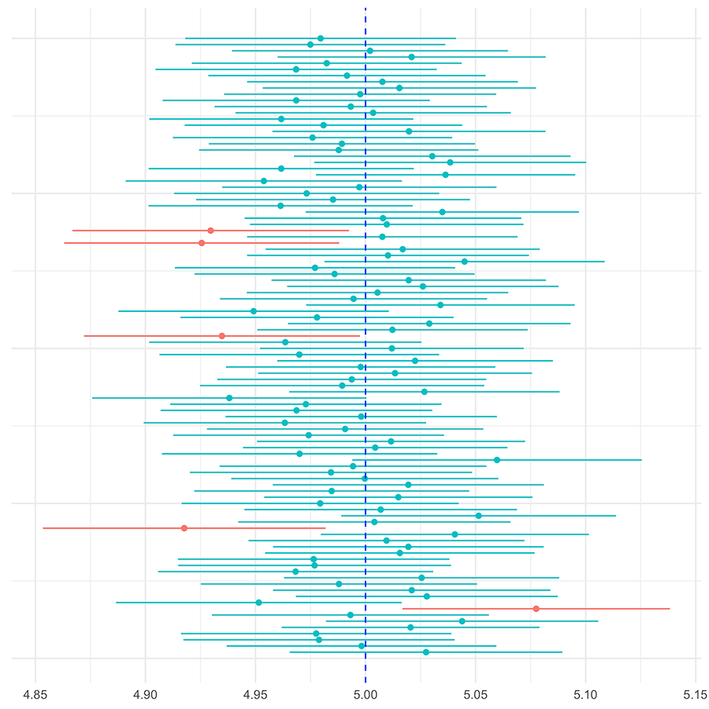
Graph of confidence intervals
A series of horizontal bars. Each bar has a dot in the centre. Lines are stacked and sit some distance to the right or left of a central dotted line at 5.00. The majority of lines appear whilst five are red. The red lines to not cross the central line. Four sit to the left of the central line and one sits to the right.
Figure 5.3 shows one hundred 95 per cent confidence intervals for a parameter whose true value is 5.0. The dot shows an estimate, and the horizontal bars show the confidence intervals for the estimate. Note that approximately 95 out of 100 of the intervals contain the true value, because these are 95 per cent confidence intervals. However, also note that it doesn’t need to be exactly 95 of 100. These are random, so it easily could have been 94 or 96.

5.2.4 Constructing a Confidence Interval
Finally, let’s talk about how to construct a confidence interval. The assumptions that we made at the beginning (that the data are independent and normally distributed) will be useful here. In general, a confidence interval will always have the following form:
Best Guess ± Crit.Val × SE ,
that is, the lower bound will be your best guess minus a critical value times the data’s standard error (SE), and the upper bound will be your best guess plus your critical value times the data’s standard error (SE). This is a very loose formulation, but works for a general confidence interval. In your setting, you have:
- The ‘Best Guess’ will be your estimator evaluated on your observed data, i.e. x̄.
- The ‘Crit.Val’ will be a value from a reference distribution that depends on your confidence level. In most simulations this will come from a normal distribution with mean 0 and variance 1, and will be calculated in advance (see below).
- The ‘SE’ will be the square root of the MSE of your estimate, i.e.(σ) / (sqrt(n)).
You already know something about the estimates—the best guesses—you will use.
Next, you will learn about the critical value, and then you will learn the formula you need to know for a confidence interval. The critical value of a normal distribution will be denoted by z≤ft(α/2 ) and is defined by:
PBig(Z > z≤ft( α/2 )Big) = (α) / (2) , Z ~ N(0, 1) .
That is z≤ft( α/2 ) is the value (also called a quantile) such that the probability of being greater than z≤ft( (α) / (2) ) is(α) / (2). Here, α is your confidence level as defined above. You can see this is the right choice of value since:
P≤ft(-z≤ft( (α) / (2) ) < Z < z≤ft( (α) / (2) ))=1 - α
which corresponds to your confidence probability, i.e. being 95%confident. To get a visual understanding of this, consider the following plot.
Figure 5.4: The standard normal distribution.
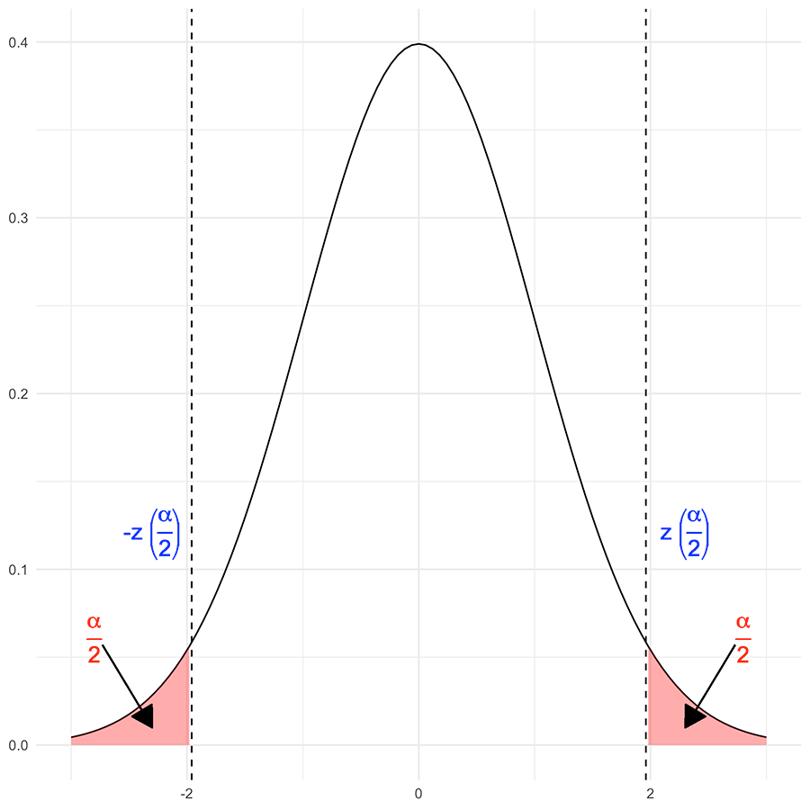
A steep bell curve graph showing the distribution
The standard normal or Gaussian distribution (with mean 0 and standard deviation 1) showing (as shaded regions) the two α/2 critical regions (shaded). The α/2 regions under the curve summed up each have probability α/2 by definition, and so combined they have probability α . The place where they start is called ± z(α/2).
Here, you see a plot of the standard normal density function (a normal distribution with mean 0 and variance 1). This plot is showing you that when you consider the critical value z≤ft( (α) / (2) ), you will have exactly a probability of α of being in the tails of the distribution. This means that by considering a confidence level of α for α small, you want extreme values to be unlikely, where extreme is classified as being in the tails of this distribution.
Critical values for your common choices of confidence level are shown in 5.2.
5.2: Critical values for standard confidence levels α
Confidence level: α | Critical values: z≤ft( (α) / (2) )
0.01 | 2.58
0.05 | 1.96
0.1 | 1.64

In general, given a value for α you can calculate a critical value or quantile from the standard normal distribution using Julia with code like the following. Try it out!
using Distributions alpha = 0.05 quantile(Normal(), 1-alpha/2)
1.9599639845400576
This is the only new thing you need for a confidence interval. So, what does a confidence interval actually look like? You assumed at the start that your data X_1, X_2, …, X_n are identically and independently normally distributed with a mean μ and standard deviation σ^2. Using this, at a confidence level α your confidence interval will be:
X̄ ± z≤ft( (α) / (2) ) × (σ) / (sqrt(n)) .
Now supposing that you have actually run your experiment and observed x_1, x_2, …, x_n, you would calculate a confidence interval as:
x̄ ± z≤ft( (α) / (2) ) × (s) / (sqrt(n)) ,
where s is your sample standard deviation.
For anyone familiar with statistics, you will see this isn’t precisely correct. In the ‘assumptions’ section you will see that this approximation is good enough in practice. To do better would devolve into more statistical theory than you have time to cover in this course.
In Figure 5.5, note the use of confidence intervals to examine windowed averages from the M/M/1 queue.
Figure 5.5: The M/M/1 queue with μ=1.0 and λ=0.98, between simulated times 5000.0 and 5500 time units.
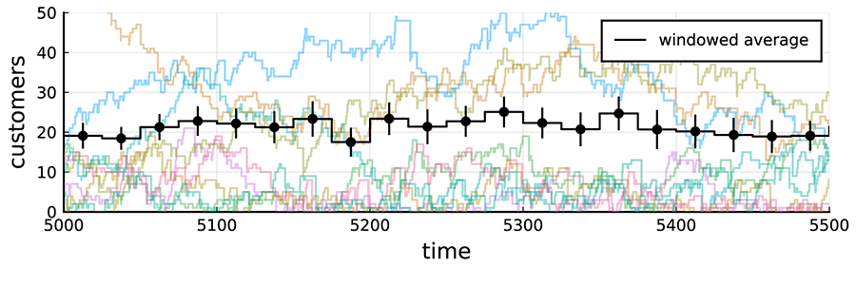
The M/M/1 queue with mu=1.0 and lambda=0.98, between simulated times 5000 and 5500 time units
The M/M/1 queue with μ=1.0 and λ=0.98, between simulated times 5000.0 and 5500 time units. The windowed averages are shown in black, with the vertical lines showing 99 per cent confidence intervals.
The plot shows (as in Figure 5.2) a set of sample paths, and it also shows a windowed moving average. The simulation is the same as before, but the plot is different:
- The plot zooms in on a region 5000 ≤ t ≤ 5500 so that you can see what is happening more easily.
- The windowed averages use only 10 independent simulations, otherwise the confidence intervals are small and hard to see.
- The plot also shows 95 per cent confidence intervals for the estimates in each window.
I chose to look at the behaviour between times 5000.0 and 5500.0 because the queue is in a steady state after time 5000.0, so you would expect that the average should be constant. You will notice that the windowed average is not constant. Is that wrong?
Well, no. The way you can understand what is going on is to view the confidence intervals. These show that the estimates include some natural statistical variation. The confidence intervals overlap, so there is no evidence here that the underlying values you are attempting to estimate are changing. You are just seeing noise.
So now you know how to get a confidence interval and what they mean.
On the next page you will see an example of how to construct a confidence interval and how to use it to answer a question about whether a new approach is better than the old one.

5.2.5 Confidence Intervals — An Example
Continuing on with the supermarket example, suppose the local supermarket ‘Konsumption Kingdom’ has approached you to redesign their checkout service. They know that it will take about 10.2 minutes to serve customers on average with their current system.
In this , Matt Ryan shows an illustrative example on the use of confidence intervals to address this scenario.
APP_MTH_7201OL_Confidence-Intervals.mp4

Activity
Now it’s your turn to try calculating confidence intervals. You’ll start with some z values, and then the full calculations of confidence intervals.

1. Using Julia, calculate the value z(0.2).
Hint: What is α?
using Distributions alpha = 0.4 quantile(Normal(), 1-alpha/2)
0.8416212335729143
2. Using Julia, calculate the value z(0.00005).
using Distributions alpha = 0.0001 quantile(Normal(), 1-alpha/2)
3.8905918864131266
3. Suppose from a sample of n = 163 you have x̄ = 2 and s^2 = 4. Calculate the confidence interval with α = 0.05.
using Distributions alpha = 0.05 z = quantile(Normal(), 1-alpha/2) bar_x = 2.0 s = sqrt(4) n = 163 ci = [ bar_x - z*s/sqrt(n); bar_x + z*s/sqrt(n) ]
[1.6929675, 2.3070325]

4. Suppose from a sample of n = 297 you have x̄ = 10.45 and s^2 = 7.14. Calculate the confidence interval with α = 0.01.
using Distributions alpha = 0.01 z = quantile(Normal(), 1-alpha/2) bar_x = 10.45 s = sqrt(7.14) n = 297 ci = [ bar_x - z*s/sqrt(n); bar_x + z*s/sqrt(n) ]
[10.0506185, 10.8493815]

5.2.6 Confidence Intervals — The Assumptions
There are two key assumptions in this discussion of confidence intervals:

- The data X_1, X_2, …, X_n are independent.
- The data X_1, X_2, …, X_n came from a normal distribution.
The independence assumption is really so that you have an unbiased estimate of your population variance. Recall in the discussion of bias earlier in this module that you were told that S^2 is unbiased for σ^2 precisely when the X_i are independent. This is actually very vital to the calculation of the confidence interval, and there are two ways you can ensure independence in your simulations:

- You can run your simulation for a large time horizon (millions of time points) and sample your simulation at spread out periods (every 1000 time steps for instance). This will ensure that your data are spread out enough that they shouldn’t have much influence on one another.
- You can run multiple simulations in parallel with different seed values, and use the resulting means of each simulation as your data that you analyse.
The second assumption is the normality assumption. Sadly, this is rarely going to hold when you actually simulate data but don’t fret! The Central Limit Theorem (CLT) is here to save the day! Recall from Sample Mean and Variance that the CLT states that if your sample size is large enough, then the sample mean follows a normal distribution. There are two ways you can make sure the CLT will kick in and you can use the assumption of normality, and they are very similar to how you can get independence.

- You can run your simulation for a large time horizon to make sure you have a lot of data (large sample size n).
- You can run multiple simulations in parallel with different seed values, and use the resulting means of each simulation as your data that you analyse.

5.2.7 An Extension — Comparing Two Samples
Taking the supermarket example a little further, suppose you are trying to improve service time at ‘Konsumption Kingdom’ and you have two methods you can implement: method A and method B. You go and implement both methods, run your simulation models for the same time, and get a sample mean x̄_A and sample variance s_A^2 for method A, and a sample mean x̄_B and sample variance s_B^2 for method B. How can you decide which method is better or whether they are the same? Well, one way you can do this is to construct a confidence interval.
This type of interval will look slightly different to the last one, but follows the same general formula of:
Best Guess ± Crit.Val × SE .
In this situation, you have:
- Best Guess: This is the difference of your sample means: x̄_A - x̄_B.
- Crit.Val: This doesn’t change, it is still z≤ft( (α) / (2) ).
- SE: This is the tricky one. The SE is given by sqrt((s_A^2 + s_B^2) / (n)). Think of it as an average of your two variances from each method.
Using this, your α-level confidence interval looks like:
(x̄_A - x̄_B) ± z≤ft( (α) / (2) ) × sqrt((s_A^2 + s_B^2) / (n)) .
You can then use this interval as follows:
- If the lower bound (x̄_A - x̄_B) - z≤ft( (α) / (2) ) × sqrt((s_A^2 + s_B^2) / (n)) is great than 0, this means that you are(1-α)× 100%confidence that method A has a larger mean than method B.
- If the upper bound (x̄_A - x̄_B) + z≤ft( (α) / (2) ) × sqrt((s_A^2 + s_B^2) / (n)) is less than 0, this means that you are(1-α)× 100%confidence that method B has a larger mean than method A.
- If 0 lies between the lower and upper bound, you are(1-α)× 100%confident that there is no detec difference between methods A and B.
That is how you can use your simulations to draw meaningful, statistical conclusions to help you answer questions.
For those of you more familiar with statistics, you may have noted that there is a much more formal and careful approach to take when you want to answer questions like this. That is an area of statistics known as ‘hypothesis testing’. I will not delve into that area because it is very easy to go down the rabbit hole, and it is beyond the scope of this course.

Activity
Consider the car park example. ‘Big Rich’ Hotel has suggested that on average their customers are in service for about 10 minutes. Do the following to test whether you agree with this:
- For an α = 0.01 level of confidence, run your simulation for a time horizon of t = 10000. Construct your confidence interval and test whether you think the average time customers are in service is 10 minutes.
- For an α = 0.05 level of confidence, run your simulation for a time horizon of t = 10000. Construct your confidence interval and test whether you think the average time customers are in service is 10 minutes.
- For an α = 0.1 level of confidence, run your simulation for a time horizon of t = 10000. Construct your confidence interval and test whether you think the average time customers are in service is 10 minutes.
- For an α = 0.05 level of confidence, run 100 simulations each of a time horizon of t = 1000. For each of these simulations, calculate the mean time customers are in service: these 100 means are now your data. Using your data, calculate a confidence interval for the mean, and test whether you think the average time customers are in service is 10 minutes.

5.3 Improving Accuracy

5.3 Improving Accuracy
- Read through the following pages in order, taking notes as you go and running any example code (if applicable).

5.3.1 Improving accuracy
There are many ways of improving the accuracy of simulation results. You have been introduced to a few already. Ideas like excluding burn-in data are important to reduce bias(see the bias equation in Errors – Bias and Variance of Estimators). Reducing bias is very important for accuracy, because bias is a systematic error, and such errors are more painful to deal with than random variations around the correct measurement.
Think of it like this: the random errors are like mistakes you make using a ruler to measure a piece of wood. Measure it a few times and you can improve the accuracy of your estimates. But if your ruler is badly made, or if it is the wrong length, then no amount of double checking will help. So, removing bias is important.
However, you do also want to reduce the variance of estimates. That will tighten your confidence intervals and lead to more accurate estimates.
The obvious way to improve accuracy is to run your simulations for er. That generates more data, and with more data—a bigger n—the variance of estimates will be reduced (see the variance equation in Errors—Bias and Variance of Estimators).
But that isn’t always the most efficient method to reduce variance. In this topic, you will explore some better approaches, starting with repetition (again), and using independent realisations to get multiple views of the same process. What I am steering towards are smarter variance reduction techniques that can reduce variance without doing extra calculations.

5.3.2 Independent Realisations
The most significant, and easiest, approach to reducing variance is to increase the amount of data. You could simulate your system for er. That will create more data. However, most interesting systems have dependencies over time, and remember that the nice results for variance and so on follow from independent samples. Thus, all your work would be easier if the samples were independent.
There is one easy approach to obtaining more independent data, and you already know what it is. The approach is to use multiple seeds to create independent realisations of the process.
Too many people rely on a small number of simulations, or even just one. On the other hand, if you follow the ideas that have already been presented, you can easily create 100 or 1000 independent realisations of your system.
The other reason to bring this up, however, is to mention one limitation. Remember burn-in times? Well, remember that the data from burn-in is discarded. That means, if you run your simulation for time T, and burn-in stops at time S you only get O(T-S) data from your simulation for O(T) effort. If T is too small, you get almost no data from each simulation.
Thus, you need to balance the run time T of each independent simulation with the number of independent realisations N to get the most bang for your buck. Usually, the balance isn’t hard to get close enough, but only if you are aware of the problem.
As a rough rule of thumb, run each simulation for around T = 10S, that is, ten times the length of the burn-in. That isn’t a hard and fast rule—it depends on the effort to set up a new realisation as compared to that per data point generated—but it isn’t a bad starting point.
However, what if you could improve accuracy without doing extra simulations? That’s what I will talk about next.

5.3.3 Variance Reduction
Generating more data is an obvious, but computationally expensive, approach to reducing variance and consequently errors. That can be unfeasible if you have to explore a large possibility space.
There are many alternatives. They include special approaches when you need to consider rare but important events (rare events are harder to simulate because of their rareness). They also include approaches that use very sophisticated probabilistic algorithms including control variables or stratified sampling. These are beyond the scope of this course, because although they work very well, they are usually analysed in a framework where the probability structure of the simulation is described by simple formula. In this course the simulations could be of very complex processes, and it isn’t always easy to see how to adapt the more sophisticated probabilistic approaches to a complex simulation.

Common Random Numbers
One very easy approach is to use Common Random Numbers (CRN). Sometimes this is called matched streams sampling. The setting is the case where you want to compare two or more strategies. It is explained using a simple example.
Consider a simple M/M/N queueing scenario (remember the N is the number of servers). What advantage would you get by increasing N from 2 to 3, that is, from adding a server?
One approach to determining the answer would be to run independent simulations of both scenarios and compare them. But that isn’t the best idea.
You want to estimate the improvement, and you might measure this by the reduction in the average queue length. Imagine that q̄_N is the average queue length for the queue with N servers, then you want to estimate:
μ = q̄_2 - q̄_3.
You would estimate μ by taking some samples, and obtaining estimates Q_N, e.g.:
μ̂ = Q_2 - Q_3.
Now, the variance of μ̂is:
Var(μ̂) = Var(Q_2) + Var(Q_3) - 2 Cov(Q_2, Q_3).
So, if the variables Q_2 and Q_3 are dependent, i.e. their covariance is non-zero, the combined variance of the estimate can be reduced. Covariances can be negative, so this could also backfire, so you have to ensure that the two are positively correlated.
One way to do that is to reuse the same random numbers. Imagine that, for this queue, you generated one arrival stream of customers, with given inter-arrival times, and workloads for each customer. Then you could feed the same workload into the two queues. The net effect would be that the outputs are correlated. Not exactly, because they aren’t the same queue. However, when a customer arrives at one, with a heavy workload, they would also arrive at the other with the same workload. So, the two processes would have some positive correlations.
Another way to think about the CRNs approach is that you are comparing ‘apples with apples’. You are comparing two processes that are as alike as possible, and differ only in the critical aspect—in the queueing case, the number of servers.
Other variance reduction techniques exploit the more generate form of the variance of two combined random variables, such that:
Var(a X + bY) = a^2 Var(X) + b^2 Var(Y) + 2 ab Cov(X,Y),
in other variations.
The effectiveness of variance reduction techniques depends on the covariance of the random variables being compared. That isn’t always easy to anticipate. Just because you use the same input stream of pseudo-random numbers doesn’t guarantee it. Interesting simulations are very complex.
So sometimes a pilot run is needed to determine what approaches work best. This is all part of your exploratory analysis process.
There are also some tricks to get right. Note that the arrival streams here include the workload of each customer up front. In some of the simulations, I only generated this time when the customer reached the server. But if you do this, with varying numbers of servers, the customers might get mixed up, reducing the correlations. So, some thought is needed to synchronise random variables used in the two simulations. The easiest way to do that is to dedicate separate pseudo-random number streams for each purpose in your simulations, e.g. one for inter-arrival times, and another for service times in the queueing example.

6. Applications

Module 6 Overview

Module 6 Overview
module banner

In this , Professor Matt Roughan provides an outline of Module 6. This module will bring everything together by showing you how the pieces of a simulation project can fit together, both through a discussion of the workflow of a project and through case studies. It will also touch on some of the other software tools that can be used to help build an effective simulation.

Learning outcomes for Module 6
- identify practical situations where simulation modelling can be helpful,
- collect relevant to the simulation model,
- design a process to iteratively create and refine the simulation model,
- communicate the results to aid in decision making.
- Project Report.

Activities
- learn about the workflow of a simulation project—where to get started, and how to incorporate all of the ideas I have talked about in past modules.

6.1 How to Build a Simulation with Confidence

6.1 How to Build a Simulation with Confidence
- Read through the following pages in order, taking notes as you go and running any example code (if applicable).

Simulation Workflow — The Waterfall Model

6.1.1 Simulation Workflow — The Waterfall Model
The traditional style of software engineering project is called a waterfall model and it proceeds through a series of phases:
- Requirements gathering and analysis: Determine what is needed in the simulation. What is the System Under Study (SUS) and what are its key properties? What questions will you answer? Usually this would be conducted in communications with experts on the SUS. It should also determine what data is available or could be collected to inform the model.
- System Design: This is the conceptual design phase. It could involve building schematics or other graphical descriptions of the system, as well as mathematical and statistical models of any data available. In a classical waterfall model such designs are quite detailed. This uses tools from Modules 1–3 such as the specification of the random number generators you will use (see Module 1: Generating Random Numbers); decisions about whether queues should include priorities (see Module 2: Queues – Part 2); and what data will be extracted (see Module 3: Test and Validation of a Simulation).
- Implementation: This is the phase where the computer code implementing the system is developed. You learnt about this in Modules 2 and 3.
- Integration and Testing: In this context, this is VV&A. You know all about this from Module 3 (see Module 3: Test and Validation of a Simulation).
- Deployment: In classical software engineering, you are building a software tool that would be deployed to users. Here, this means using the simulation to actually find answers, which would be done in conjunction with the analysis techniques of Module 5. Data scientists might call this experimentation.
- Maintenance: Once again, the terminology used in software engineering isn’t quite applicable here. We are not (usually) deploying a tool to users, and it does not need to be maintained in a traditional software sense. However, it is rare that a simulation study is a one off. Often the simulation will continue to be extended and applied to new problems and so there is a need for ongoing support.
- It is simple and easy to understand.
- It is easy to manage. It has clear milestones, and anyone with a Gantt chart can see where the project is at any given time.
- The output, when the process works, can be quite successful.
- It relies on each stage being successful.
- It relies on the requirements being easy to define, i.e. the SUS must be well understood at the start.
- It can’t accommodate changes.
- VV&A takes place relatively late in the cycle, and any problems discovered late are hard to fix.

Try this
Think about a simple problem and follow the waterfall model. The problem is to calculate Fibonacci numbers. Your requirement is that you have a function that can take an input integer n up to 300, and calculate floating point approximations of F_n, the n th Fibonacci number.
Your code must do the calculation in around one microsecond. Follow each of the steps (you need not do maintenance) and see where you get to. Hint: The natural approach here is use the defining form of the Fibonacci sequence to create a recursive function to calculate it. The waterfall model encourages this, because you specify your method early. However, you will, if you follow this process find that the code is far too slow for large n.
You will consider the spiral model on the next page.

Simulation Workflow — The Spiral Model

6.1.2 Simulation Workflow — The Spiral Model
The second model to consider for simulation workflow is the Spiral Model.
Iterative modelling, as suggested by Law (2008), would allow some backwards steps to get each stage right. It’s a better approach, but a still better strategy is the spiral model. In the spiral model, you attack the same tasks as described in the waterfall model, but in smaller chunks. This is illustrated in Figure 6.1.
Unlike the waterfall model, the spiral model starts small in which you begin by trying out ideas and concepts for small components of the SUS or starting out with simple models, knowing full well that they will later be made more complex and realistic. In this way, you learn as you go.
In Figure 6.1, I have used terminology that is similar to the terms used in the waterfall model described above, but I have customised them to the context of the simulation. I have partitioned, for example, the requirements analysis phase of the waterfall model into conceptualisation and design. Here, I will go through each in slightly more detail.
- Conceptualisation: Conceptualisation is where you determine what is needed in the simulation. Law (2008) calls this ‘Formulating the problem’. Consider: what is the System Under Study (SUS) and what are its key properties. What questions will you answer? The types of questions can range widely depending on the application. A rough categorisation o f these is into:
The output of a conceptualisation phase should be a clear, but perhaps somewhat abstract, description of what is to be simulated.

- Design: Design is the other side of the initial modelling process. It is about specifying what will be built. Law (2008) calls this the ‘Collect and construct assumptions document’. Many of the techniques for documenting a simulation would be used here, e.g. schematics, flow charts, state diagrams, and event graphs. However, words are very important too. Diagrams without words can be easily misinterpreted. The output of a design phase should be a specification that is concrete enough for a coder to implement and verify their code against. The specification can include system parameters (e.g. the type of random variables being used and their means and variances) and simulation parameters such as the length of burn-in to use. Law (2008) includes some aspects of validation in a sister step called ‘Is the assumptions document valid’.

- Implementation: Implementation includes writing computer code or using other computer tools to create a working simulation that can be verified against the design. Law (2008) calls this ‘Program the Model’.

- VV&A: I have called this phase VV&A, but it is focused on validation. Verification is included, at least in part, in the previous phase and accreditation is an ongoing part of all of the phases. The ideas of validation need to be applied in a more focused manner here.

- Experimentation: Once you have a working simulation that you trust, you can start to experiment with it. The outputs would seek to answer the questions you started with. As noted in Module 4: Iterative Approaches, experimentation is often an iterative process in itself.

- Analysis: Analysis of the results, largely statistical, is needed to understand the complicated and random data that is produced. An important component of your final analysis phase is documenting the results. The final documentation should be a clear, concise and precise report presenting the final model and analysis of its outputs.

Note that the point of the spiral is that once you have gone through this sequence, your validation, experimentation and analysis may reveal more about the system and simulation that leads you to rethinking it. You may question assumptions, or realise that additional data is needed. Hence the need for the spiral. You might like to adopt this method when approaching Assessment 3. You already have an implementation, so you don’t have to start from scratch. But do you know if it works? Try it, and improve it, and so on.
Therefore, the motto of the spiral model should be taken from the Paul Kelly and Kev Carmody Song“From Little Things, Big Things Grow”.

Activity
Match the task to the phase of the spiral model.

Optional reading
These readings are provided as source material and further . They are not required reading, but may be of assistance when completing Assessment 3.

Simulation & Modeling Team 2000, Basic Steps and Decisions for Simulation, University of Houston, viewed 29 July 2021.

This article (part of a larger work on simulation modelling) describes another breakdown of the tasks of a simulation project, and an alternative flowchart for a waterfall-like process to implement a simulation project. One difference (from what is described here) is that it places more emphasis on the decision to continue a simulation project based on cost-benefit analysis.

Law, A 2008. How to Build Valid and Credible Simulation Models, In Proceedings of the 2008 Winter Simulation Conference. Tucson, viewed 29 July 2021.

Many of the ideas about modern simulation project structure come from various works written by Averill Law. He presents a slightly different breakdown of tasks from those here, but provides many examples and organises the tasks in a way that is iterative similar to the spiral model. However, the many examples here are perhaps the most useful part of this paper. Law made important contributions that improved the standard of simulations, and hence helped increased the number of industries and applications that trust simulation outputs.

Karnon, J, Stahl, J, Brennan, A, Caro, JJ, Mar, J & Möller, J 2012,‘Modeling using Discrete Event Simulation: A Report of the ISPOR-SMDM Modeling Good Research Practices Task Force-4’, Value in Health, vol. 15, no. 6, pp. 821–827.

Simulation modelling was ‘invented’ almost independently in different fields. Telecommunications, defence, and medicine all use different terminology, so it is interesting to see how in recent times the different strands have all grown together. This paper (part 2) discusses the tasks of simulation as performed in the context of health and medicine.

Roberts, M, Russell, LB, Paltiel, AD, Chambers, M, McEwan, P & Krahn, M 2012,‘Conceptualizing a Model: A Report of the ISPOR-SMDM Modeling Good Research Practices Task Force–2’, Medical Decision Making, vol. 32, no. 5, pp. 678–689.
Simulation modelling was ‘invented’ almost independently in different fields. Telecommunications, defence, and medicine all use different terminology, so it is interesting to see how in recent times the different strands have all grown together. This paper (part 4) discusses the conceptualisation of a simulation model as performed in the context of health and medicine.

Additional Concepts and Notes

6.1.3 Additional Concepts and Notes
This course has covered almost all of the phases described in the spiral model in some detail. There are still some more advanced elements that you should be aware of as they will feature in Assessment 3. I will cover these below.

Subject Matter Experts (SMEs)
Any important system will have its experts. These are people who understand the details of a system. An SME’s wisdom is needed to build a credible simulation model.
However:

- An SME may be too close to the trees to see the forest. They may be focused on details that could be irrelevant, and not see the important factors in play.

- An SME may not know much about simulation, for instance, about random variables, and hence may be unable to advise about such details.

- SMEs are not invariably correct. They are likely to be a very good source of knowledge, but they may rely on outdated or received wisdom that is no er valid.

Hence, SMEs should be treated with respect, but all , from any source, should be processed critically. In Assessment 3, you will be encouraged to treat your tutor as the SME for the task you have to complete.

Sub-models
It is implicit in the spiral model that you will build up from simpler models. One particularly useful approach is to build up from smaller building blocks. These can be more easily validated and, once you are confident of them, they can be reused, sometimes many times.
For instance, in simulating communications networks, one might build models of:

- the ‘nodes’, e.g. packet routers,

- the communications links (which include queues),

- the protocols that determine where and when packets are sent,

- the software that controls the overall network,

- failure models for the links and router,

- the traffic generation process (say, the traffic from people's web browsing).

If each of these is built in a modular manner, so that they can be used as bricks to build a system, then VV&A can be greatly enhanced.
More about modular simulation can be found in ‘A Framework for Standard Modular Simulation’ (McLean and Leong, 2002).
One final warning, however, complex systems are sometimes more than the sum of their parts. That is part of the reason simulations are conducted. You might be able to mathematically model a simple queue, but you don’t know how it will function in a large network of queues.
In Assessment 3, you will see sub-models used. Assessment 3 considers a system that is built from two queues in sequence. Items from the first travel to the second and then out of the system. If you understand one queue, you are a way toward understanding the system in Assessment 3.

Optional reading
Sub-module design is a big and important topic in its own right. I cannot hope to talk about all of the issues, but if you want to know more, the following optional reading will get you started.
McLean, C & Leong, S 2002,‘A framework for standard modular simulation’, in Proceedings of the Winter Simulation Conference, vol. 2, IEEE, pp. 1613–1620.

Reporting and Communicating

6.1.4 Reporting and Communicating
Results are not useful if no one ever sees or hears them, and so the ultimate results of your simulation must be communicated to your target audience, often your boss or a client. Communication can be verbal, but when reporting technical , a written report is less likely to be misinterpreted. So, I will focus on that style of communication for reporting the results of a simulation.
Remember that communication is a two-way process, and it is an important means to gather the that informs your simulations. Less formal communication strategies will also be explored in this topic.

Final reports
I talked about description and documentation in Module 3: Accreditation and Acceptance, but I didn’t lay out the final report. Reporting the results is a crucial part of a study. It will also be the deliverable for Assessment 3.
There are many variations on such a report, but here, I want to very quickly spell out what such a report should include. Here is a template of what to include:

- page: The page should list the date, authors and a meaningful (concrete, specific) as well as any other important (e.g. the organisation preparing the report).
- Executive summary: This is no more than a one-page summary that describes, in brief, the problem, the approach used to solve the problem, and the key results. Results should be quantitative and useful to your executive(s).
Hint: Assume your boss will only read the executive summary, so you’d better make it count.
- Introduction: This ‘introduces’ the work. At its core, it explains the question(s) you are answering. It should introduce the core ideas, motivate the work, describe, very briefly, what you have done, and provide a summary of the results. This summary can be very close to that of the executive summary but should have more details or more scope.
- Background: This should contain references to past studies and other contextual materials such as common assumptions (those that apply in the whole application domain) or terminology and jargon. The IEEE Reference Guide is a helpful resource to use when adding references to your report.
- Methods: This should describe the simulation and the methods used in VV&A. It should be written in a manner such that a smart person can reconstruct your approach (given some time). It should therefore be quite detailed.

The Methods Section might often have subsections that align with the activities in the spiral model (apart from analysis, which should go in the next section).
It should not include computer code unless the code is particularly revealing for some reason.

- Results: This section contains the analysis of the results. It should answer the questions you asked in the introduction. It can use a combination of figures, s and text to explain the results. Good analysis is closely linked to good explanations.

- Conclusion: All reports should have a conclusion. It should be a bookend to the introduction. It should briefly summarise what you have done. No new should be presented here, but you may sometimes want to suggest further work.

- Additional sections: It is common to have references or appendices after the conclusion. Use these as needed.

The ‘headings’ I have provided are generic and boring. Customising them to the context is helpful. Likewise, this is a very crude ‘starter’ template. Often, there might be more than one results section, for instance, focused on different questions.
Other notes about such reports:
- The report is about where you got to, not about the journey.
- Don’t waste people’s time. You don’t need to explain things that are common knowledge to your audience. And you should work hard to keep the report concise.
- Write easy, edit hard!
- Use sentences and strong verbs.

Communication
The theme here, and elsewhere in the course, is that good communication is a very important part of a simulation modeller's toolkit. In fact, it is absolutely necessary. This is not a course on communications skills, but it should at least emphasise the need for such skills. Not all communication is about writing. Sometimes you will need to do an oral presentation as well. But often, there is a need for formal meetings and informal conversations as well. Advice about such meetings: Informal meetings can be great because they let people be more creative and expressive. Keep it small. Two to three people is great. Four is possible, but, after that, an informal meeting can become too chaotic. Despite informality, keep notes—even informal meetings can convey important , but you must be careful that you remember what was really talked about. Actively listen. Learning how to hear what people are really saying is an important skill. This article—Active listening—explains this further. More formal meetings should have an agenda with a clear set of goals. They should result in decision or action items to follow up. More about meetings can be found in many sources and it is worth improving your skills. In the next part of this module, you will see some case studies that provide examples of how simulations have been used in real applications. The goal of these is to show you some of the thoughts and attitudes that can lift your simulations from being toys up to being real tools that governments or industries can trust to inform important decisions. The case studies are not there for you to memorise. They are to contextualise the large amount of that you have received in this course and, in so doing, they will help you fit the pieces together. They are not ‘complete’ case studies in the sense that I am not providing you with answers to questions. However, they each show you: (i) the naive starting points that many people have adopted to solve a particular problem, and then (ii) what was needed so that the simulations provided accurate enough answers to be useful in making big decisions.

6.2 Case Studies

6.2 Case Studies
This section demonstrates how discrete-event simulation can be applied to telecommunications networks. In particular, there is a focus on "risk analysis" here to understand how the robust the network being studied is to various problems.
- Read through the following pages in order, taking notes as you go and running any example code (if applicable).

Telecommunication Network Models

6.2.1 Telecommunication Network Models
Whenever considering quantitative risk analysis, you need to consider three questions:

- What is the system and how will it be modelled?
- What are the risks?
- How could risks be managed?

These are not separate questions. The risk-management strategies will, to some extent, determine the features of the model. I’ll discuss a detailed case below.

The System
Consider here, a telecommunications network designed to provide internet service backbone. That is, a network that provides the backhaul capacity that connects individual Internet Service Providers (ISPs) to the rest of the world. This is the type of network that the Georgian woman ‘hacked’.
An ISP connects a set of customers (home or business internet users) to its network via optical fibre, copper digital subscriber lines (DSL), or wireless technology. The ISP’s network might be local or nationwide. However, traffic from its customers must be able to reach: (i) other customers using a different ISP in the same region, and (ii) other regions of the world. A backbone network provider allows smaller ISPs to connect and provides such connectivity. Backbone providers usually construct the links between countries like Georgia and Armenia.

The world of telecommunications is actually much more complicated than this. Individual ISPs range in size from tiny local organisations with a few dozen customers to globe-spanning giants. ISPs can connect directly to each other, and backbone providers have their own hierarchy of connections. And content providers, such as Amazon and Google, often run their own networks as well. The goal of this model is to capture some essential parts of this complex web.

Fundamentally, a telecommunications system consists of a network. That is, a set of nodes connected by links(see Module 2: Example 5 — A Twitter Cascade or a Simple Epidemic).
Three example networks from the Internet Topology Zoo are shown here. Select each tab to view the different networks.

AARNet
Figure 6.3: The AARNet.
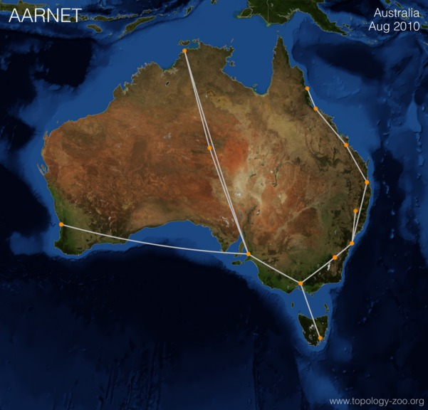
Map of Australia with major cities shown and lines connecting them

China Telecom
Figure 6.4: China Telecom.
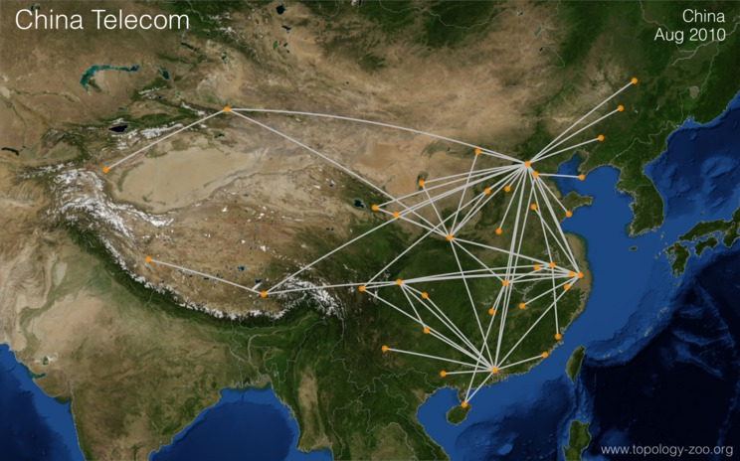
Chinanet

Geant2012
Figure 6.5: GEANT2012 backbone.
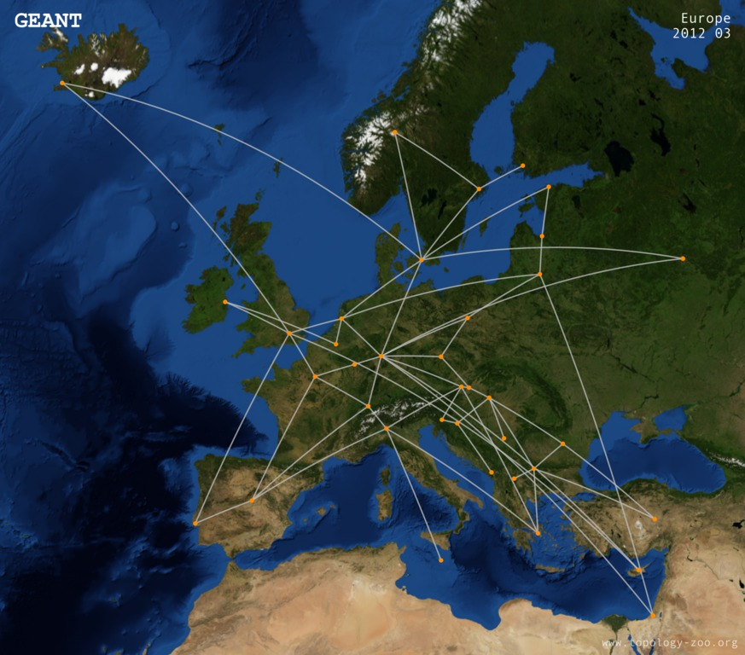
Map of Europe with major cities shown and lines connecting them

The Model
Telecommunications systems are very, very complicated. You can do an entire degree in telecommunications engineering and still not know everything that goes into the web of technology that allows us all to, for instance, jump onto a Zoom call.
Hence, the first question to ask is, “what are you going to model, and at what level?”
Firstly, note that the networks depicted above are inter-PoP networks, and a Point of Presence(PoP) roughly translates to be a metropolitan area that is connected to the backbone. The network pictures show PoPs as nodes, and the links between them as singular and atomic (indivisible). In reality, a PoP is a complex system in itself, and the links between PoPs often consist of multiple fibre-optic cables. So, the link between Adelaide and Perth in AARNet’s network isn’t a singular link—there are actually two in this case. However, for the point of illustration, I will focus on the inter-PoP network.
Secondly, note that a network has multiple ‘layers’ determined by the OSI Framework. Each layer has its own software and hardware reliability issues. Each provides different mechanisms for recovery. I will concentrate here only on the network layer.

OSI Framework
The OSI Framework determines seven layers in telecommunications systems. The lowest three layers: the physical, the link, and the network layers are of most interest from the point of view of this study.
In a real telecommunications system model, much effort needs to be devoted to determining exactly what aspects of the network are needed for the particular reliability or risk analysis. Technology experts and network managers need to be involved in developing any model to be used successfully in this domain. However, always keep in mind that you should aim for the simplest possible model that can answer the questions of interest.
Some of what is discussed here can be applied directly to other applications. For instance, there are many similarities between risk analysis on telecommunications networks and electricity grids, however, there are also many subtle differences. Great care is needed.

So, the system to be modelled here will be a network that connects PoPs with telecommunications cables. Some additional details will be needed to make the model complete, primarily the capacity of the links. Capacity of a telecommunications link is described in terms of the data rate it can achieve in Mbps (Mega-bits per second).

Mega
Note that in computer science the prefix ‘mega’ often refers to 2^20 = 1,048,576, however, in telecommunications, the prefix refers to 1,000,000 exactly. That is, 1 Mbps means one million bits per second, precisely.

You should also know the length of a link. Most links are not laid in straight lines (as the crow flies). They have to follow a path constrained by geography (mountains, etc.) and human activity (roads, buildings, etc.). It is important to know how a link is because this will have an impact on its failure probability.

Activity
I n the AARNet network, label each PoP by the name of its city (you may wish to consult a labelled map of Australia). Then write the undirected graph in set notation.
Hint: The locations on the map aren’t precise, but AARNet supports universities in Australia, so the cities are all those with an academic presence. You can also find a version of this map at The Internet Topology Zoo and the city names will come up when you hover your mouse over them.
N = &Perth, Darwin, AliceSprings, Adelaide, Melbourne, Hobart, ; &Canberra, Sydney, Armidale, Brisbane, Rockhampton, Cairns, ; &Townsville E = &(Perth,Adelaide), (Adelaide,AliceSprings), (AliceSprings,Darwin), ; &(Darwin, Adelaide), (Adelaide,Melbourne), (Melbourne, Hobart), ; &(Melbourne,Canberra), (Canberra,Sydney), (Sydney,Armidale), ; &(Sydney, Brisbane), (Brisbane, Rockhampton), (Rockhampton, ; &Townsville), (Townsville,Cairns)

Risks to Communication Networks

6.2.2 Risks to Communication Networks
Telecommunications systems, like all systems, have many risks. Common types of risk events include:

- disasters: natural and man-made, e.g. storms, floods or fire,

- technological: software or hardware failures, either internal (e.g. equipment failure) or external (e.g. a power failure),

- human error: a person running a backhoe through a network cable,

- security: hackers interfering with operations.

In a general setting, you might need to consider the problems of personnel availability (for illness or other reasons), disruptions to supply chains, political and legislation changes and budget overruns. However, the focus here is on system risks.
In telecommunications networks, the most common risks can be summarised by considering that they cause either:

- node (PoP) failures; or

- link failures.

For instance, a fire in a data centre might disrupt a PoP’s ability to provide service. Or a backhoe driver might dig through a fibre-optic cable conduit, breaking the links that use those fibres.
The typical risk model for risk in telecommunications involves independent failures. That is, the assumption that each link or node fails with some probability in a given time interval.

In many failure-modelling simulations, you model the time between failures (for instance, using an exponential distribution). You could also do that here, but it is simpler to model them just using a single probability and, in this situation, it is sufficient because there is no concern with ‘when’ a failure occurs, only that it does occur, and you always use the simplest sufficient model.

Expert advice and past data should be used to estimate the probabilities of such failures.
Link failures, if caused by a backhoe or similar problem, might be assumed to be proportional to the length of the link, or based on a binomial model, treating subsections of the link as independent.

Shared-Risk Link Groups (SRLGs)
In July 2001, a train derailed and caught fire in a tunnel under Baltimore. The train was carrying hazardous materials and the extreme heat (nearly 1000 degrees Celsius) of the fire made it difficult to put out. In the meantime, a large part of the USA’s East Coast internet went out. It turns out that many ISPs run cables a train lines (because it is easier to get the rights-of-way there) and this tunnel, in particular, hosted cables from at least three of the biggest ISPs: WorldCom, PSINet, and AboveNet. All of these cables were destroyed simultaneously (The New York Times, 2001).
Telecommunications equipment is relatively robust, so failure rates are often quite low. A large network may have thousands of links, so there is a chance that more than one link will fail simultaneously. However, under the independent failure model, the chance of multiple failures is usually assumed to be very small indeed. Therefore, often a reliability analysis will consider only ‘single link failure scenarios’.
In reality, failures can be coupled. For instance:

- Many optical fibres run through the same conduits, so if one fails, often this can cause seemingly unconnected links to fail. That’s what happened in Baltimore, but there are many other ‘choke’ points.

- A disaster, such as an earthquake or a major storm, can cause multiple links or nodes to fail.

- Or large carrier ‘hotels’ providing housing for network equipment from multiple providers. A fire in such a building would impact many networks.

Companies that analyse their networks carefully will create Share-Risk Link Groups (SRLGs) that express groups of links that are coupled together, and which, therefore, can fail together. Figure 6.6 illustrates the idea. Links sharing the same conduit are shown grouped in red cylinders.
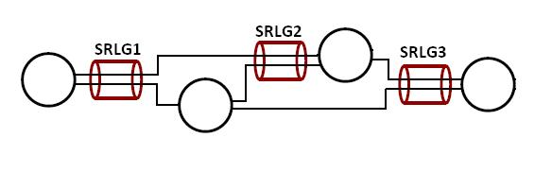
Diagram of shared risk link groups
Four circles are spaced out horizontally, from left to right. Two lines extend to the right from circle 1. One line goes to circle 2 and the other to circle 3. A cylinder labelled SRLG1 sits over these two lines before they branch off. Two lines extend to the right from circle 2. One to circle 3 and the other to circle 4. A cylinder labelled SRLG2 sits over the two lines leading to circle 3. One line extends from circle 3 to circle 4. A cylinder labelled SRLG3 sits over the two lines that lead to circle 4.
One may similarly define Shared-Risk Node Groups (SRNG) and other similar concepts.

Risk impact
Many network risk assessments consider likelihood using a sophisticated probability model (such as those described on the previous page) but consider impact as a simple two-category outcome. Either:
- The network remains connected (all nodes can reach all other active nodes); or
- The network is disconnected (the network is partitioned into at least two pieces that can no er talk to each other). See Figure 6.7.
Four circles joined by a line form a square on the left. Three green circles connected by two green lines form an incomplete triangle on the right. A dotted red line connects the bottom right corner of the square with the bottom left circle of the incomplete triangle.
This oversimplifies the problem of reliability. Real networks carry traffic. When a link failure occurs, the network may still remain connected, but without enough capacity to carry the required traffic. In this case, congestion occurs, and this can damage a company’s revenue or reputation. Advanced network risk analysis will consider the traffic-carrying capacity as well as simple connectivity, but I will not consider this here as it requires considerably more knowledge of telecommunications protocols than you are likely to possess or require.

Question
Imagine you run a billion-dollar telecommunications company. What would be the impact of a major outage on your business? Select all that are appropriate.
- Loss of reputation making it harder to bring in new customers.
- Loss of revenue because customers switch their traffic from your network to another.
- Government sanctions because telecommunications providers must meet standards.
- Law suits due to failure to meet contractual obligations.
All of these are possible impacts on a large telecommunications company.

Optional reading
-The New York Times 2001,‘Fire in Baltimore snarls Internet traffic, too’, Late Edition (East Coast), p. A15.

Managing Risks in Telecommunications

6.2.3 Managing Risks in Telecommunications
The internet’s strategy to deal with reliability comes from Paul Baran’s paper (1960) Reliable Digital Communications Systems Using Unreliable Network Repeater Nodes. Baran wasn’t the first to propose redundancy in telecommunications but was the first to think about this for what would become our modern internet, and his ideas were part of the reason that the US defence agency DARPA originally funded the ARPANET. His idea can be summarised in one picture, shown in Figure 6.8.
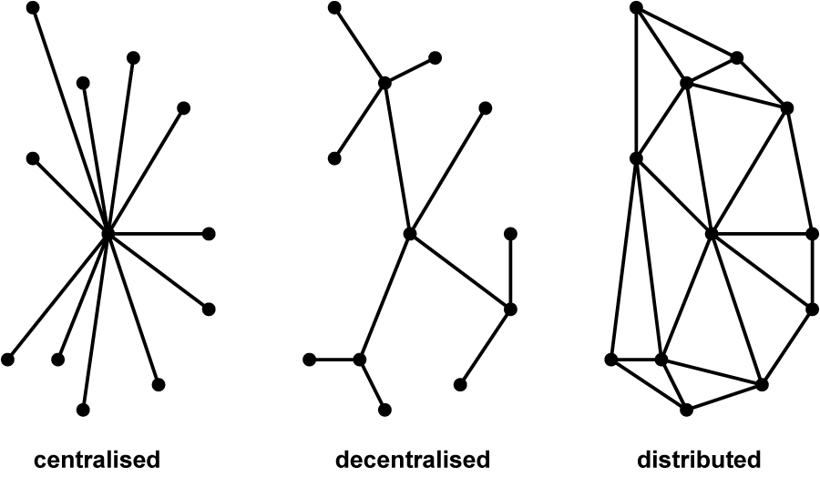
Connected node in three systems: centralised, decentralised and distributed
Centralised—lines spread out from a central point. Decentralised—four lines spread out from a central point. Three of the four lines end with more two or three more lines spreading out from that point. The fourth line has no further links. Distributed—lines extend from a central point. Additional lines spread from the ends of these lines to points. All points are connected to lines creating a web.
The crucial idea is that in the distributed network, you can damage any one node or any link, and the rest of the network will continue to function.
It is a little more sophisticated than that, however. You could achieve much of this result just by doubling every link, so there is a spare for any failure. However, that would double the cost of the network. Baran’s idea balances cost with reliability.

Optional reading
These optional readings provide some insight into the development of the early internet. Specifically, they discuss Paul Baran’s ideas about using distributed networks to provide resilience against failures.

Baran, P 1960, Reliable Digital Communications Systems Using Unreliable Network Repeater Nodes. California: The RAND Corporation, viewed 30 July 2021.

Navarria, G 2016, How the Internet was born: from the ARPANET to the Internet. The Conversation, viewed 30 July 2021.

Question
Which of the following networks remains connected when any single link fails? Consider the worst case. Choose all that remain connected.
- Figure 6.9: Option A.
- Figure 6.10: Option B.
Six dots are connected by a continuous line. One of these has offshoots connecting to another two dots in a triangular shape.
- Figure 6.11: Option C.
Four dots, three of which are connected to make a triangle. A diagonal line connects the top left dot diagonally to the bottom right dot which is outside of the triangle.
- Figure 6.12: Option D.
Five dots on the left, four dots on the right. The dots on the left are connected to make a network. The dots on the right are connected to make a network. A line connects the network on the left to the network on the right.
A—remains connected under single edge failures. B—remains connected under single edge failures. C—If the diagonal link in C from NW-SE breaks, the SE node is disconnected. D—There is a single link that connects the two sides of the network. If that breaks, then the network is partitioned into two halves.

The Final Model

6.2.4 The Final Model
So far, I have shown you much about risk analysis in general and the particular application of it to network reliability. Here, I summarise what a simulation model for such an application would look like.
Where have we gotten to? Real models in the telecommunications domain can involve thousands of nodes and links and many technical details. However, the essential core of the model used here would be:

- A network is expressed as a (mathematical) graph, but with annotations indicating things such as link capacities and distances. One of the most difficult parts of applying these techniques to a real network is obtaining the large amount of data needed to build this graph.

- A set of SRLGs, i.e., a set of links that have failure modes that are coupled together.

- A set of failure scenarios with probabilities, e.g., a “line cut” probability, might depend on the length of a link.

- A set of criteria that describes when the network is in a satisfactory state, or not. This could be as simple as the network has become unconnected, or as complicated as you need for the particular application.

The simulation model itself is very simple at one level. Events are failures and recoveries. They are often modelled as independent with exponential times between them. The difficult part of risk analysis in this domain is assembling the data that goes into it.
However, there is one big choice you can make in how you implement it. In this course, I have presented stochastic simulation as the approach of preference. In this problem, there is an alternative.
You could simulate the network, randomly creating failures, and analyse the network at each point in time to obtain probabilities of certain behaviours.
However, it may be that the number of failure scenarios is small enough that you can directly explore all of them. That is, you could enumerate all possible failures and evaluate every one of them. That has the advantage that you know you won’t miss anything!
However exhaustively, exploring all possible failures is practical only for relatively small networks and where only single link failures are considered.
If:

- the network is large; or

- the number of failure models (SRLGs) is large; or

- you need to consider the various multiple failure scenarios that are possible,

then you will need to perform a stochastic simulation.
Stochastic simulation, as you remember, will not produce such precise results, but you can quantitatively assess the errors in outputs to provide an answer with some bounds on its confidence.

Activity
The network in Figure 6.13 shows the locations of links, as well as how they connect up the nodes. Links that are close together are vulnerable to the same failure modes. Draw your own version of this network, explicitly labelling the SRLGs. Once you have constructed this picture, determine if a single SRLG failure can disconnect the network.
Figure 6.13: Network diagram
Seven dots in a circuit are connected by a continuous line—the first dot is positioned at the top and the direction moves clockwise. The second and fifth dot are connected via an eighth dot positioned inside the circuit. There is an additional connection between the first and fifth dot, and the sixth and seventh dots have two connections between them.
Figure 6.14: Network diagram with SRLGs labelled.
No single SRLG failure can cause the network to become disconnected.

Summary
Risk is a complex topic with many facets. Simulation is a key tool to help evaluate and mitigate risk. This case study shows some of the thinking that must take place as part of a risk analysis and mitigation exercise in a particular problem domain. This case study does not try to go into all of the details of telecommunications network modelling, but rather aims to show that careful thought is needed to avoid false results. Network engineers, scientists and data scientists need to work together to build something useful.

6.3 Simulation Packages

6.3 Simulation Packages
- Read through the following pages in order, taking notes as you go and running any example code (if applicable).

General Purpose Simulation Packages and Simulation Programming Languages

6.3.1 General Purpose Simulation Packages and Simulation Programming Languages
Since as early as the ‘60s, simulation has been used to enhance decision-making. In that time, there have been many simulation specific tools created. Some are almost general-purpose programming languages in themselves. Important examples that have influenced the field of simulation include:
- Simula, developed in the ‘60s, is also sometimes cited as the first object-oriented (OO) programming language. It was originally implemented as a pre-processor on the ALGOL language, so you might think of it like a simulation package within another language, but it was a little more than that.
- General Purpose Simulation System (GPSS) was also created in the ‘60s and has been re-implemented in various languages over the years. It also has strong OO characteristics.
- SimCAD is a much more modern tool that is intended to allow you to draw your system from pre-built blocks through a Graphical User Interface (GUI).

Optional reading
For more on the history of simulation packages, see this reading:
Krogdahl S 2003, ‘The Birth of Simula’ in J Bubenko, J Impagliazzo & A Sølvberg (eds), History of Nordic Computing from the IFIP Conference on the History of Nordic Computing (HiNC1), Springer, Boston, PA, pp 261-275.

00 in simulations
You might have noted that there is an OO commonality in simulation software simply because simulations are about the things (the objects) being simulated. Events, Entities, and Resources can all be thought of as objects.
Historically, simulation software and packages tended to be commercial. Many of the general packages haven’t changed that trend. However, there are also good open-source tools available. Commercial tools can be very expensive, but very powerful. Open-source tools can also be amazing, but often have quirks.

Packages that are Part of a Larger Programming Language

6.3.2 Packages that are Part of a Larger Programming Language
There are many simulation packages built on top of other programming languages. In some sense, Simula and some of the others that are billed as full tools, actually fall into this category. However, the standard package or library additions to a language usually:

- share characteristics with the underlying language in terms of syntax and concepts

- rely more heavily on the underlying language for many features such as visualisation of results.

Tools built on another language are often almost independent of that language. For instance, you might not have to write a single line of code in the underlying language.
Classic examples of such packages that add to a larger programming language include:

- Simulink in Matlab: which is a graphic programming environment. It is not specifically oriented to DES, but there are some application specific components.

- SymPy in Python: which is a process-based DES package.

This course is in Julia, and so I shall present more detail on simulation packages within Julia. I don’t expect you to use these packages in your assessment, but it would be wrong for me not to tell you of such tools’ existence.

Simulation packages in Julia
You have so far programmed your simulations almost from scratch. You have used a few standard packages, e.g. Distributions to help, but no simulation specific packages.
Julia has, however, no less than four simulations packages:
- Discrete Events
- SimJulia
- Simulate
- EventSimulation
It isn’t obvious which is best. They each have strengths and weaknesses and a complete assessment of all four isn’t needed here. What I want to do is show you how such packages look and function, and hence give a little insight into their utility.
Some simulation packages really just give you some extra tools to do what you have already done. They might have some helpers to implement the underlying clock of the simulation, or around the event list. I will use DiscreteEvents to illustrate these.

Installation of DiscreteEvents is a little finicky. The current version didn’t work with Julia 1.6.0, but did with 1.5.0 (and some other versions).

The package introduces several ideas you should have learnt about, but with convenient mechanisms. It also introduces some novel ideas worth knowing.

- Clock() creates a simulation clock. This is actually much more than a clock. It includes a schedule of future events (the event list); event counters, a dictionary of processes and many other details of the simulation. It introduces a time-sample based measurement strategy—think of this as introducing purely measurement events every Δ t time units. The clock can be queried, or reset, and so on.

- run!(clock, duration) sets the clock going for a given duration. There is an equivalent macro@run.

- @event is a macro corresponding to the functionevent!() to create a new type of event. It specifies a function to be called when that event occurs, the timing of the event (every seems to be the only option at the moment), a random distribution, and an optional number of repetitions.

- Channel creates a queue (or buffer). Items are added to it withput!and removed withtake!. In our simple problems, it is an almost trivial concept, but remember that it could also model an intermediate queue between two systems.

- @delay does what it says, it delays a process until a given time (which could be determined by a random distribution). This is a standard mechanism to implement a customer being served or some similar mechanism.

- @process is the main new concept here. A process is like an activity. It is a thing to be done. For instance, the server of a queue is a process. The process takes a customer from its input queue, spends some time ‘processing’ the customer, and then releases the customer into its output queue. All of the other ideas above are efficient means to implement the same ideas you have been learning about throughout this course. The@process is a new and powerful addition, though it isn’t always easy to use.

For example, a complete set of code to implement an M/M/3 queue looks like:
using DiscreteEvents, Printf, Distributions, Random ​ # describe a server process function serve(c::Clock,id::Int,input::Channel,output::Channel,X::Distribution) job = take!(input) print(c, @sprintf("%6.3f: s%d serving cust. %dn", tau(c), id, job)) @delay c X print(c, @sprintf("%6.3f: s%d finished %dn", tau(c), id, job)) put!(output, job) end # model the arrivals function arrive(c::Clock, input::Channel, cust::VectorInt) # Line 13 cust[1] += 1 @printf("%6.3f: cust. %d arrivedn", tau(c), cust[1]) put!(input, cust[1]) end Random.seed!(123) # set random number seed const mu = 1/3 # service rate const lambda = 0.9 # arrival rate count = [0] # a job counter clock = Clock() # create a clock input = ChannelInt(Inf) # Line 24 output = ChannelInt(Inf) for i in 1:3 # start three server processes @process serve(clock, i, input, output, Exponential(1/mu)) end # create a repeating event for 10 arrivals @event arrive(clock, input, count) every Exponential(1/lambda) 10 # Line 31 @run! clock 20 # run the clock for 20 time units
This code works by scheduling a set of 10 arrival events (Line 31) in advance. They are separated by exponential random variables. That’s different from the approach presented earlier, which was to reschedule events when we needed them. It is a little less flexible, but works here.
Each arrival event puts a customer into the input channel using the functionarrive(Line 13). The input channel is a queue with infinite capacity (defined on Line 24).

One criticism I have of this code is that it uses a global variable count to keep track of arrivals.

When the@run macro is called, the scheduled events are processed one-by-one (in temporal order). The@process macro has set theserve functions going (three times). That means that when one of these becomes ‘idle’, it looks for another customer to process, and then grabs that one from the input queue, delays its processing, and then passes it to the output queue.

Try this
Input the code above and examine the output carefully. Now, change the number of servers and try again.
The use of some of these commands isn’t completely obvious. Sometimes, this type of simulation package seems more complicated to me than writing my own simulation, but it does have advantages. The most obvious here, is that this code keeps track of which customer is served by each ‘process’ or server. We didn’t bother with such niceties before, but it could be useful.
A really good simulation package would also provide the simulation harness, but none of the simulation packages I am aware of do this in Julia. Perhaps that is because a harness is so easy to write on your own.
For more about DiscreteEvents look at:
- DiscreteEvents.jl on GitHub
- documentation for DiscreteEvents.jl
- documentation for DiscreteEventsCompanion.jl.

Application Specific Software Packages

6.3.3 Application Specific Software Packages
There are so many application-specific simulation packages that they are hard to list. Almost every area that uses simulation seriously has its own specialised tool.
A specialised tool may have many characteristics in common with the more general tools. However, it will include blocks that are purpose-built for the common sub-components of that application domain’s systems.
Specialisation has advantages:

- The blocks for sub-components are often more detailed and realistic.

- The tools can directly use terminology and jargon specific to the area, rather than generic terms.

- Much testing (VV&A) of blocks has already been conducted.

Specialisation also has disadvantages:

- It can be hard to extend these to add new models or sub-systems.

- It can be harder to combine the particulars of the application domain with those from other domains where they overlap.

- Specialised tools sometimes build in common assumptions from that domain, and non-experts might not realise the importance or limitations created by those assumptions.

To illustrate the issues, I will consider a simulation package specific to telecommunications networking, and specifically internet-like networks that break data into packets—a packet network.
The internet is one of the most important infrastructures of the modern world. It enables much of our modern technology. Underlying it is a packet network that breaks all data into discrete packets of and sends this across a network of switches and routers. These devices receive packets, queue them, and then forward them a towards their destination when they have available capacity on the connecting link. They are so complicated that simulation has been the only viable tool to understand some aspects of their operation.
The terminology ‘switches’ and ‘routers’ is a good example of the use of jargon in telecommunications. These two terms have very specific meanings to network engineers, and these meanings come with a wealth of assumptions and concepts. An insider would welcome the use of such terminology to make the simulation more precise, but, to the outside, it is hiding many potential problems.

ns-2
As an example of application-specific simulation tools, I will present ns-2, The Network Simulator (version 2). This was created in the ‘80s, and was used heavily until the mid-2000s when it was replaced by ns-3. I concentrate, here, on version 2 because it illustrates the advantages and disadvantages well (and I used this tool a lot).
The simulator was built in C++, but users largely interacted with it through the language called Tcl(or ‘tickle’ to its friends). New components are added by writing C++ code, but it comes with a large suite of components that can be created through very simple Tcl commands.
The ns-2 simulator had many great features for network simulation:
- It allowed you to create switches and links with very simple commands, e.g.set n0 [$ns node]
set n1 [$ns node]
ns duplex-link \$n0 \$n1 2Mb 10ms DropTail These few lines hide a wealth of detail. They are creating complex devices, including multiple routers and a link between them, and these are themselves composed of multiple elements including more than one queue.
- It included realistic implementations of communications protocols, which are the mechanisms by which the internet regulates itself. Each one of these is a large software component, and creating so many is not something that a single user or group could hope to do themselves.
- The tool was validated by many experiments and people.
- It came with a visualisation toolkit that could illustrate your network and animate the flow of packets across it.
- Many additional tools were built to interact with ns-2; either to input complex networks or to work with its output.
And by including all these things, it meant that even an undergraduate student could build a simulation of a very complicated, very sophisticated communications network and test its behaviour.
So, you might think it was a no-brainer to use ns-2 instead of building your own simulation. However, ns-2 incorporated some limitations that were not at all obvious to a naive user. It simplified the real systems (just like all simulations). That is necessary and part of modelling (as I have often noted), but, if you are not aware of those simplifications, you can produce erroneous results. Example simplifications include:

- real networks are built from a stack of protocols, and ns-2 focused almost entirely on layers 3 and 4 of that stack

- real internet-like networks allow packets to have variable sizes, but ns-2 did not (at least within a single connection)

- many other small details were omitted from protocols such as dynamic window advertisement in TCP.

I don’t expect you to understand all of that jargon—that is exactly the point. The simulator allowed novice network engineers to create a simulation, but novice users might not understand the limitations of the tool. In many cases, those limitations were irrelevant or minor. That’s why those approximations were made. However, sometimes the limitations are important.
Another point that is reinforced by ns-2 is that if you are a typical user who wants to build a system using the existing components it is relatively easy—you just write a simple Tcl script. However, if you want to extend the simulator, you need to write C++ code, and that code has to integrate into a much larger existing codebase in precisely defined ways. It is much harder to extend the system than to use the existing system.

Optional reading
For more about ns, see this reading:
Altman, E & Jimenez, T 2003, NS Simulator for Beginners. Viewed 9 August 2021.

Application-specific simulation packages
Application-specific packages are such a useful tool that some companies will create such a package for their products. That is, the company will create a simulation package that includes modules and tools of their own products so that you can test out how those products would work in your production system.
In the data networking domain, for instance, one of the largest equipment manufacturers, Cisco, have a tool called the Cisco Modeling Labs that supports creating advanced and detailed simulations of networks composed of Cisco devices. The Lab has a much more detailed and exact model of network devices than ns-2, but only those models sold by Cisco. The tool also uses some technologies in advance of what we have learnt about here including providing cloud-based execution, and some abilities to ‘digitally twin’ an existing network to help troubleshoot that network or to train new staff in its operations in a safe environment.
Such tools provide both a value-add to the product line as well as a strong marketing tool. But their utility outside of a particular vendor space is limited.

Try this
Choose an application domain. Find a domain-specific simulation package for that application. Research the advantages and disadvantages of that package.

Alternatives to DES

6.3.4 Alternatives to DES
Topic: Simulation Packages

In this course, you have focused on discrete-event simulation. However, simulation is used much more widely to model deterministic or continuous processes such as those in:

- chemical, civil, environmental or mechanical engineering

- physics (e.g. electromagnetism, fluid dynamics and spacecraft operations)

- plant operations (e.g. boiler modelling and robot operations).

There are also many alternative styles of simulation (other than discrete-event or agent-based), such as Petri nets, system dynamics, gamification, and so on. Software is available for much of this. For instance, Gazebo is a robot simulator. To do that, you need a ‘physics engine’ to model the continuous dynamics of the mechanical systems from which robots are constructed. You also need to be able to simulate how real sensors and actuators function, including random noise in both. It’s used to help design new robots and robotic systems.

Many of the ideas you have learnt here are specific to DES, but much of the surrounding material on analysis of results, incorporating data and VV&A are applicable to almost any domain and approach.

