**Assignment 3**

**5140379043 盛思远**

**Part 1 source code**

#include <opencv2/core/core.hpp>

#include <opencv2/highgui/highgui.hpp>

#include <opencv2/imgproc/imgproc.hpp>

#include <iostream>

using namespace cv;

using namespace std;

const int MAX_GRAY_VALUE = 256;

const int MIN_GRAY = 90;//remove the effect of background

int main(int argc, char** argv)

{

IplImage* image = cvLoadImage("cherry.png", 0);//load image with gray model

//draw histogram and show it

int bins = 256;

int hist_size[] = { bins };

float range[] = { 0, 256 };

const float* ranges[] = { range };

MatND hist;//hist data

int channels[] = { 0 };

Mat gray(image, 0);

//calculate hist and store the data into dist

calcHist(&gray, 1, channels, Mat(), // do not use mask

hist, 1, hist_size, ranges,

true, // the histogram is uniform

false);

double max_val = 0;

//minMaxLoc(hist, 0, &max_val, 0, 0);//calculate the max of histogram(max num of occurences)

for (int i = MIN_GRAY; i < MAX_GRAY_VALUE; i++)

{

if (hist.at<float>(i) > max_val)

{

max_val = hist.at<float>(i);

}

}

int scale = 2;//width of hist

int hist_height = 256;//height of hist

Mat hist_img = Mat::zeros(hist_height, bins*scale, CV_8UC3);//image of histogram

//load the data from hist to image

for (int i = MIN_GRAY; i<bins; i++)

{

float bin_val = hist.at<float>(i);

int intensity = cvRound(bin_val*hist_height / max_val); //要绘制的高度

rectangle(hist_img, Point(i*scale, hist_height - 1),

Point((i + 1)*scale - 1, hist_height - intensity),

CV_RGB(255, 255, 255));

}

double histogram[MAX_GRAY_VALUE];//histogram for probability of gray value

for (int i = 0; i < MAX_GRAY_VALUE; i++)//initialize the histogram

{

histogram[i] = 0;

}

//update the histogram

for (int row = 0; row < image->height; row++)

{

uchar* ptr = (uchar*)image->imageData + row*image->widthStep;

for (int col = 0; col < image->width; col++)

{

int temp_gray_value = ptr[col];

histogram[temp_gray_value]++;

}

}

//normalization

int totalpoints = 0;

for (int i = MIN_GRAY; i < MAX_GRAY_VALUE; i++)

{

totalpoints += histogram[i];

}

for (int i = MIN_GRAY; i < MAX_GRAY_VALUE; i++)

{

histogram[i] = histogram[i] / totalpoints;

}

//w0:percentage of foreground

//w1:percentage of background

//u0:average gray value of foreground

//u1:average gray value of background

//u:global average gray value

//tips:w0 + w1 = 1 and u0 + u1 = u = sum(histogram[i]*i)

double w0 = 0, w1 = 0, u0 = 0, u1 = 0, u = 0;;

for (int i = MIN_GRAY; i < MAX_GRAY_VALUE; i++)//initialize u

{

u = u + i*histogram[i];

}

//search optimal threshold values

int threshold = -1;

double max_variance = -1;

for (int index = MIN_GRAY; index < MAX_GRAY_VALUE; index++)

{

w0 = w0 + histogram[index];//update percentage of foreground

w1 = 1 - w0;//update percentage of background

u0 = u0 + histogram[index] * index;//update average gray value of foreground

u1 = u - u0;//update average gray value of background

double temp_variance = w0*(u0 - u)*(u0 - u) + w1*(u1 - u)*(u1 - u);

if (temp_variance > max_variance)

{

max_variance = temp_variance;

threshold = index;

}

}

//create foreground and background pictures

IplImage* foreground_image = cvCloneImage(image);

IplImage* background_image = cvCloneImage(image);

for (int row = 0; row < foreground_image->height; row++)

{

uchar* foreground_ptr = (uchar*)foreground_image->imageData + row*foreground_image->widthStep;

uchar* background_ptr = (uchar*)background_image->imageData + row*background_image->widthStep;

for (int col = 0; col < foreground_image->width; col++)

{

int temp_gray_value = foreground_ptr[col];

if (temp_gray_value > MIN_GRAY)

{

if (temp_gray_value > threshold)

{

foreground_ptr[col] = 255;

background_ptr[col] = 0;

}

else

{

foreground_ptr[col] = 0;

background_ptr[col] = 255;

}

}

}

}

//output the threshold

cout << "Threshold: " << threshold << endl;

cvSaveImage("foreground.png", foreground_image);

cvSaveImage("background.png", background_image);

cvSaveImage("histogram.png", &IplImage(hist_img));

cvReleaseImage(&image);

cvReleaseImage(&foreground_image);

cvReleaseImage(&background_image);

system("pause");

}

**Part 2 output**

1. Threshold

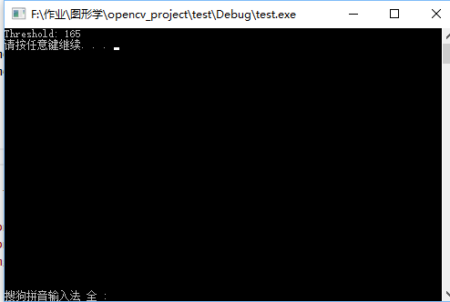

1. Foreground

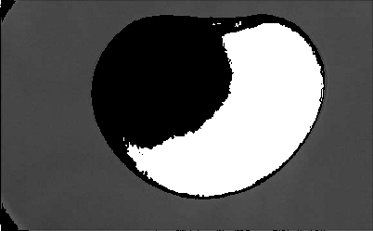

1. Background

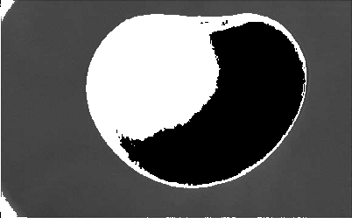

1. Histogram

