**Assignment 6**

**Part 1 source code**

Get more details about codes and comments at HistogramEqualization.cpp.

**Part 2 explaination**

(1)



This function aims to dram a histogram and save it into a file named histName.

for example:





(2)

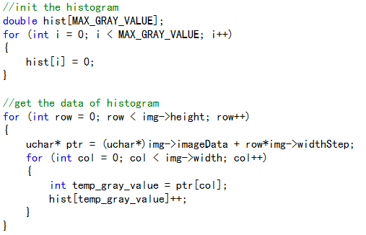

This part initializes the hist array with 0 which stores the histogram data.

And it looks up the point of image one by one to count the number of each gray value from 0 to 255.

(3)

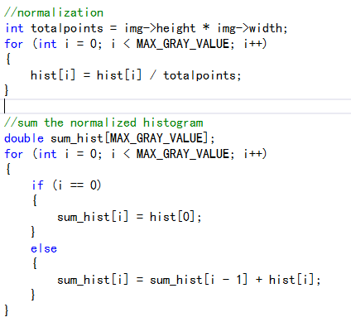

It calculates the totalpoint to invert the hist array from occurences of gray value to probability of gray value. This operation is also called normalization.

Then it sum the normalization hist array for the next operation.

(4)

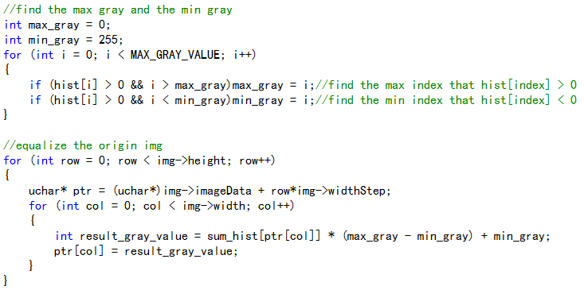

First of all, it find the max&min gray value of the origin image. Then it equalizes the origin image with several variables.

I think equalization just like to reset the gray value with the weight of the point multiplies the gap between max and min gray value.

**Part 3 output**

1. origin histogram



1. result histogram

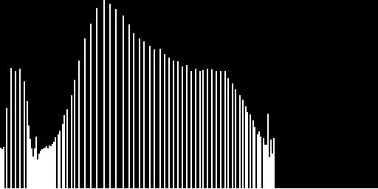

1. result image

