* Try to solve UCL e address to Github account

Link GitHub to Moodle

<https://classroom.github.com/classrooms/72557623-ucl-cs-comp0138-lw/roster/new>

* + Choose the Classroom
  + Choose Students
  + Upload the a csv file

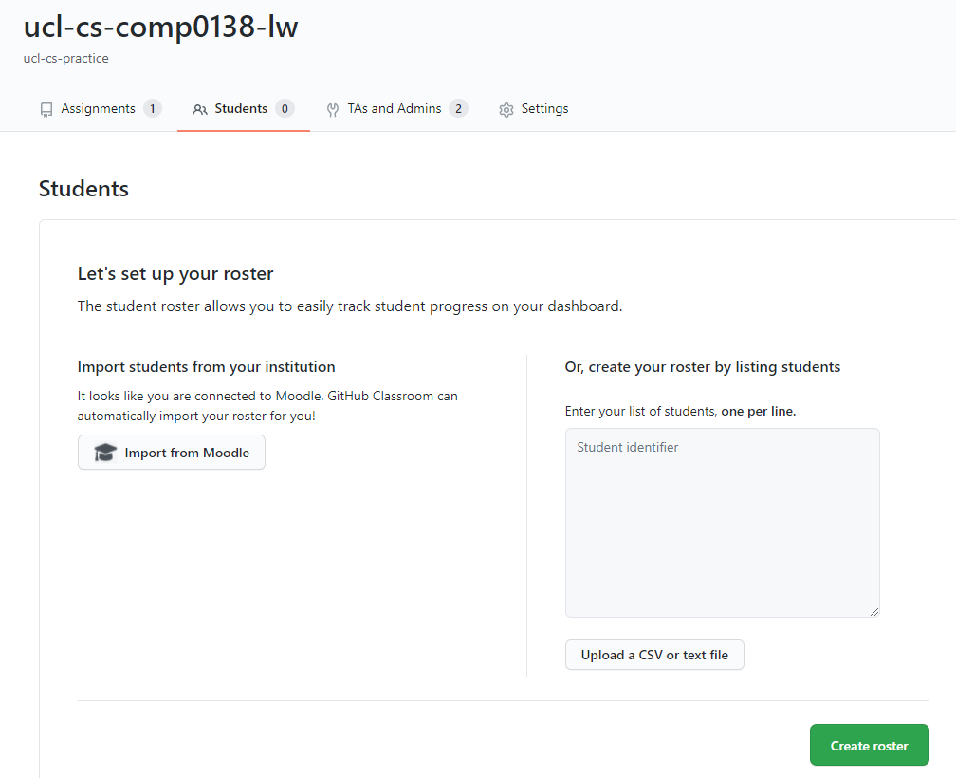

* + Try Import from Moodle, get:



* + Try to upload a txt file(roster) contains student’s UCL email address and his/her GitHub account, get:

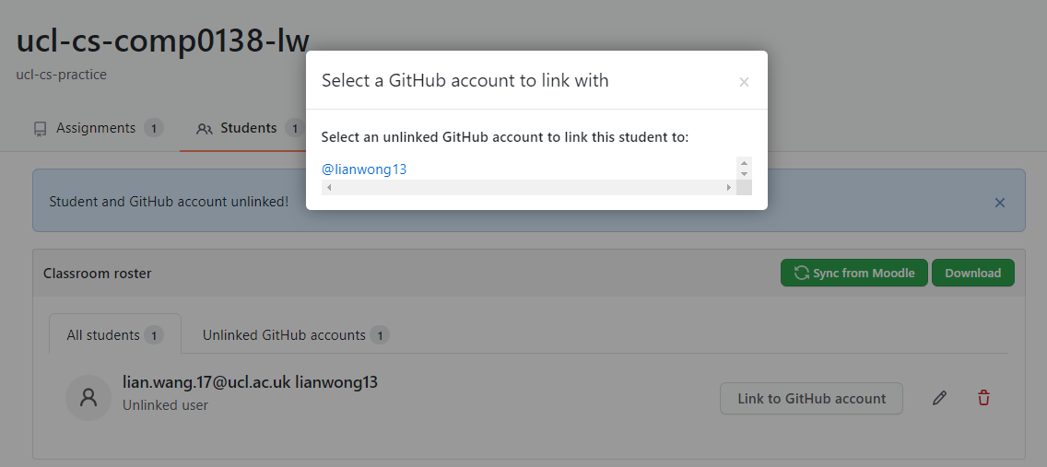

The pre-requirement of this process could work is the student is already added in the assignment.

* + Link them

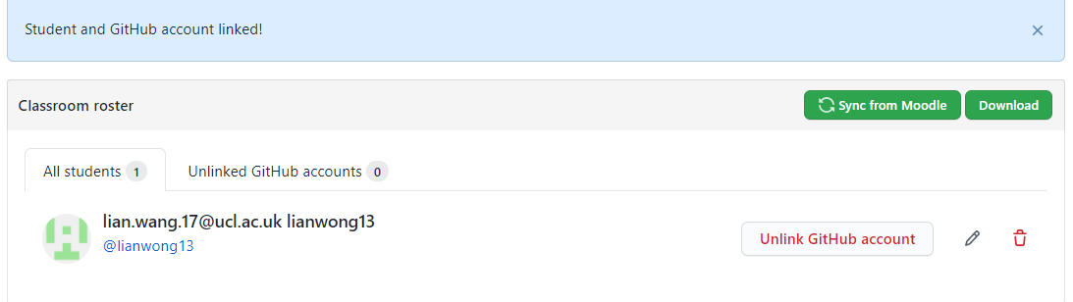

* Try to solve matching Moodle group to GH classroom group
  + Currently, the function for classroom owner to create groups is not available. A feasible way is to invite one students in each team and let that student create the team. Each team only need one student to create a team. Once the team is created, the classroom owner can allocate students to the corresponding groups. With the GitHub accounts already linked with their UCL email address, the students in Moodle groups can be added in the GH classroom groups accordingly.

