  - Your final report must include:
  - Cover page (including the names of team members) , which is Ho Man_Cheng and Yatao_Peng
  - Brief description of data mining tool(s) you used.
  - Brief description of all classification algorithms you used.
  - Detailed description of data mining procedure (the procedure you actually followed) including all data preprocessing you performed. This must be a step-by-step description which I may have to rely on to reproduce your results.

  - Data mining result and evaluation:
    - Performance measures of all models you built.
        - For each model, you must include the following performance measures:
            - Confusion matrix
Performance measure table: Show, for each class, TP rate, FP rate, precision, recall, F-measure, ROC area, MCC, and kappa statistic. You must also show the weighted average of each measure (see an example format below).
Any other additional measures as needed.

Do not include the screenshots of confusion matrices and performance measures from your program output in your report. Instead, you must create confusion matrices and performance measure tables in your report yourself.
Example format of performance measure table:
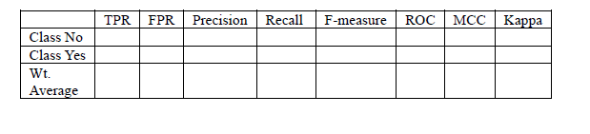

You must present your result using tables, graphs, charts, or in other visual format so that readers of your report can easily and effectively understand your result.
  - All parameters of your final best model (the best among 36 models).
  - Discussion and conclusion.
  - Division of work between team members.
for this part please leave it blank and I will fill it out later

