Zane Alderfer

Professor. Lando

IST 718

January 30, 2023

Lab 1

**Background**

There is no secret that NCAA football coaches get paid a considerable amount. So, when negotiating a salary for someone in this position, the ability to manifest a number that both makes the coach happy and not be too fiscally demanding would be a luxury.

Syracuse University needs a new football coach but would love to use existing data and parameters that are readily available to determine an ideal salary. There are many ways in which this goal can be made. Using other salaries across the league or just salaries in the ACC or using other variables such as stadium size, annual donations or even points per game to determine a fair salary can be leveraged.

**Data**

I used the Coaches9.csv file in our class github and merged this dataset with the case study from class 2 that used the same variables that were needed to answer the questions of the case study. After merging the data, the columns that were merged together in the dataset can be seen below.

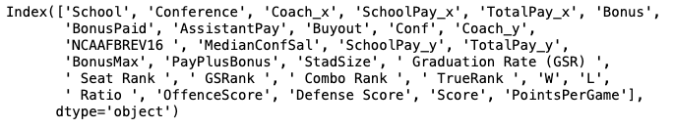

I first deleted any columns that were duplicates such as coach, school pay, and other pay. After this I determined what conferences I should remove from the data that I decided wouldn’t be of use to the ultimate goal or that were just deemed too small or irrelevant to the case study. I removed the Sun Belt conference as well as the independent schools. I removed Sun Belt as I decided they were too small of a conference and removed independent schools as I deemed them “one-offs” and thought they may skew the data.

The last thing I did to clean up the data was remove special characters from the total pay column in order to convert this column to a numeric format in order to do proper testing on it. A sample of the data description can be seen below.

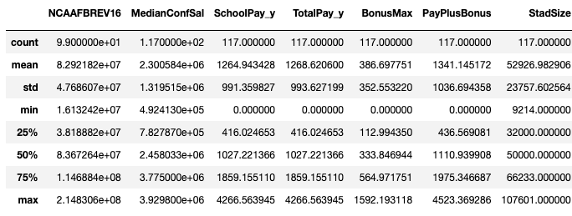

**Results**

To get a look at how salary is across the league for head coaches, a histogram frequency chart was made to represent salaries across the league. As can be seen the majority of coaches make anywhere between 500,000 and 5 million with a few outliers of highly paid coaches.

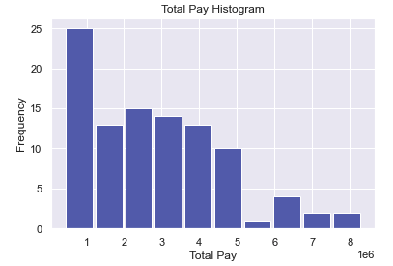

**Syracuse Salary**

The first question that needed to be answered was: “What should a Syracuse football coach get paid?” When looking at the box plot of all the coaches in the ACC as well as the description of just ACC schools, the average salary looks to be around $3.4 million. These graphics can be seen below.

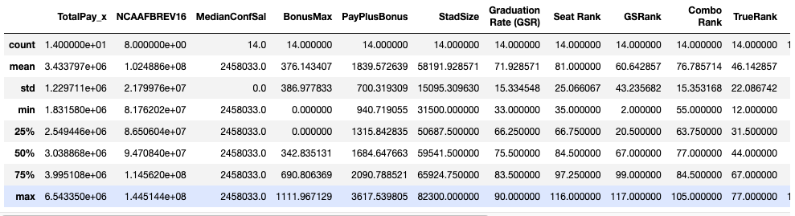

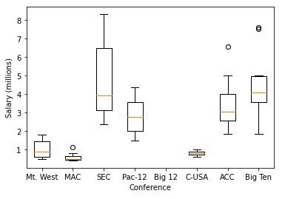

However, when considering Syracuse specifically, it would be ideal to consider all of Syracuse’s variables and cross match with the other ACC schools such as stadium size. Syracuse is on the lower side of stadium size and schools in this quadrant have an average salary of $2.5 million but Syracuse is also close to the top 25 percentile in graduation rate and on average these coaches make almost $4 million. So, based on this data, the Syracuse head coach should probably make on the low end of $3 million.

**Big Ten Salary**

In a similar way, we can determine how much the head coach would make in the Big Ten. The description of just Big Ten data can be seen below.

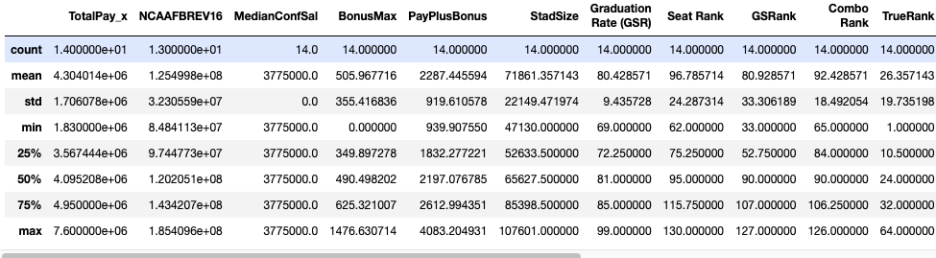

Using the box plot from above, we can see the Big Ten on average makes more than coaches in the ACC. With that being said, when looking at factors such as graduation rate, stadium size, etc., Syracuse is on the low end of all of them which would suggest the Syracuse head coach would ultimately make the same thing in the Big Ten if not a little more.

**Schools Dropped**

As mentioned earlier, I dropped the Sun Belt conference because I deemed them too small in comparison and believed they were irrelevant in determining the Syracuse head coach salary. I also removed the Independent schools as I believed they didn’t have any connection to one another in terms of size or other variables and figured they’d develop outliers that would skew the data.

**Graduation Impact**

Graduation Rate is an interesting factor as there seems to be a slight positive correlation but evidently not a big enough factor to confidently say it drives head coach salary.

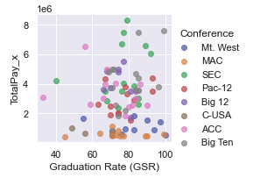

As shown in the table above, there doesn’t seem to be any huge indicator that graduation rate hugely impacts salary. What can be noticed here, however, is that the conferences with the big schools tend to be on the high salary side of the spectrum which is probably more telling than the graduation rate.

To further strengthen that point, another scatter plot was made drawing a correlation between stadium size and salary as seen below.

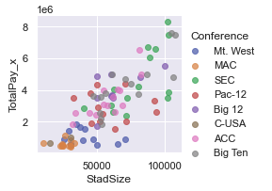

The bigger the stadium size, the more the coach gets paid which could also mean the bigger the school and more money the school has may be the biggest indicator for how much the head coach will make.

**Regression Models and Conclusion**

I developed two regression models and predictions using the smf.ols functions with training and testing datasets I created. The first model shows the impact that conference and stadium size has on the total pay. The results can be seen below.

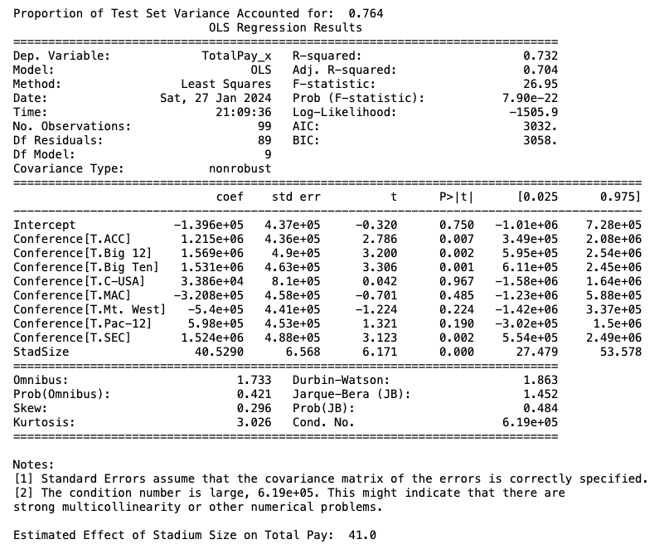

In terms of impact in comparison to what conference they are in, the stadium size has very little significant impact on salary as far as coefficient goes. The same can be seen in the second regression model for the impact conference and points per game has on total pay. This can be seen below.

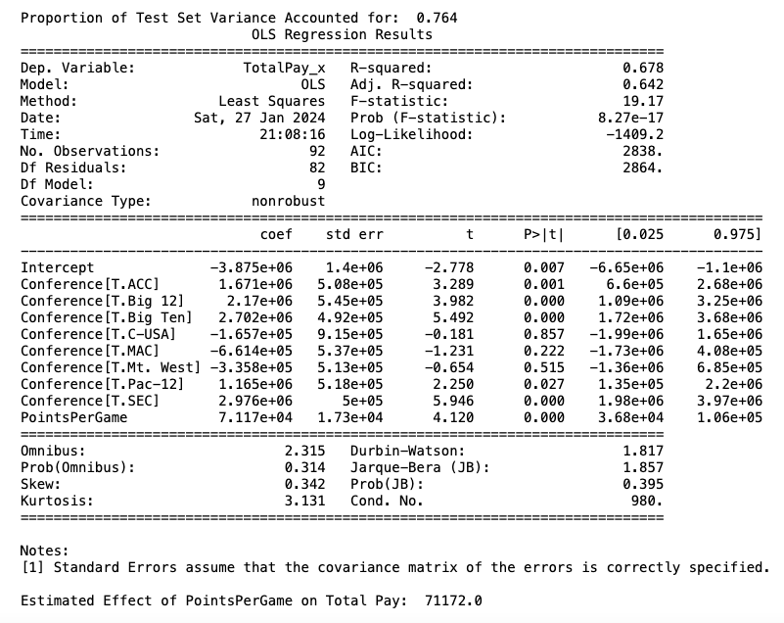

While points per game seems to impact salary more than stadium size, this variable still seems insignificant to how much a coach’s salary is. After seeing how much conference impacts salary, I believe it is safe to say that conference is the biggest driver in how much a coach should be getting paid. More specifically, the conferences with the huge schools such as the SEC or the Big Ten will just by virtue have higher paid coaches. So, while graduation rate or your win/loss ratio seem like logical drivers for coach salary, this is just not the reality.