Zane Alderfer

Professor Rieks

IST 615

2/13/23

Azure Lab Part 1

**Describe Cloud Computing**

Cloud computing is the delivery of computing services over the internet. This includes common IT infrastructure which encapsulates virtual machines, databases and networking. The perks of cloud computing include not being constrained by physical infrastructure which is ideal for proper scaling and a rapid expansion of an IT footprint.

The shared responsibility of cloud computing can be evenly dispersed across the four types of cloud services: SaaS, Paas, IaaS, and On-prem. A breakdown of the shared responsibilities can be seen in the graphic below.

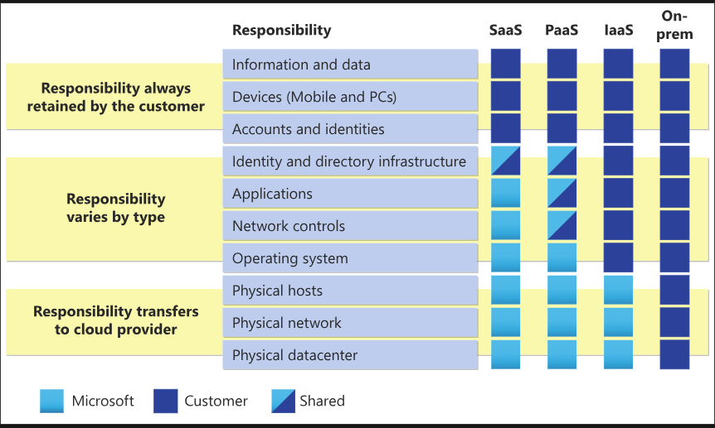

The company, however, will always be responsible for the information stored on the cloud, the devices with permission to connect, and the accounts of the people and services within the organization.

There are 3 kinds of clouds: private, public and hybrid. The differences and benefits of each type of cloud can be seen below.

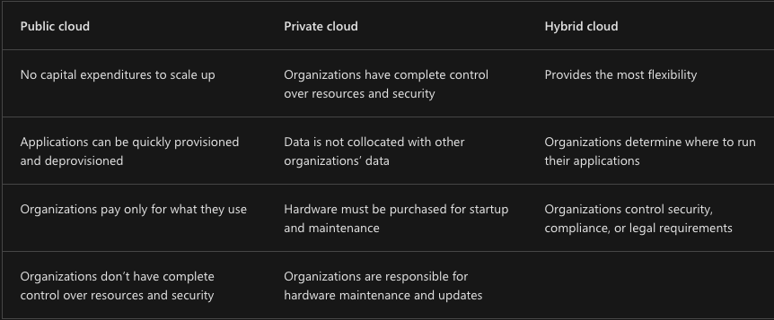

**Describe the benefits of using cloud services**

High availability and scalability are two of the biggest benefits for cloud computing. High availability is paramount to ensure maximum availability and scalability allows organizations to adjust to demand as needed. There’s vertical and horizontal scaling. Vertical scaling allows apps to adjust to process power needs while horizontal scaling allows resources to be scaled to a steep jump in demand.

Predictability, Reliability, Performance, and Cost are also vital benefits of cloud computing. Reliability is the ability of a system to recover from failures and continue to function. Predictability allows you to move forward with confidence with accurate performance and cost predictability. Performance predictability focuses on predicting resources needed to deliver a positive experience and Cost predictability is focused on predicting the cost of the cloud spend.

Finally, security and governance in cloud computing is a vital benefit. Set templates ensure that all your deployed resources meet corporate standards and government regulatory requirements. The security side allows some flexibility with how much a company wants control of security. This could include managing operating systems or installed software.

**Describe Cloud Computing types**

The graphic above represents the shared responsibility of the service models. Infrastructure as a service is the most flexible of cloud services. This maintains the hardware, network connectivity, and physical security.

Platform as a service is the middle ground between renting space in a datacenter and paying for a complete and deployed solution. In this environment, the cloud provider maintains physical infrastructure, physical security, and connection to the internet.

Software as a service is the most complete cloud service model from a product perspective. This is a company essentially renting and using a fully developed app.

**Describe Cost Management in Azure**

The OpEx cost can be impacted by a myriad of factors. These factors can include resource type, consumption, maintenance, geography, subscription type, and azure marketplace. An example of how resources can impact cost can be seen in the form of this blob storage example.

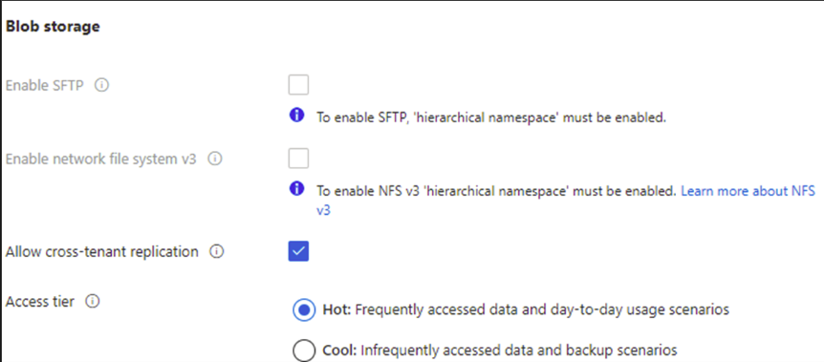

The amount of consumption can also impact cost as a pay-as-you-go model is created to optimize the amount of resources used and paid for. However, Azure also offers the ability to commit to using a set amount of cloud resources. Maintenance allows the user to adjust resources based on demand. Picking a specific region for data centers allows the company to reduce costs of resource dispersion. Network traffic, subscription type, and Azure marketplace are other factors important in determining the cost of cloud computing.

Cost management provides the ability to quickly check Azure resource costs, create alerts based on resource spending, and create budgets. A depiction of what a cost management dashboard looks like for a user can be seen below.

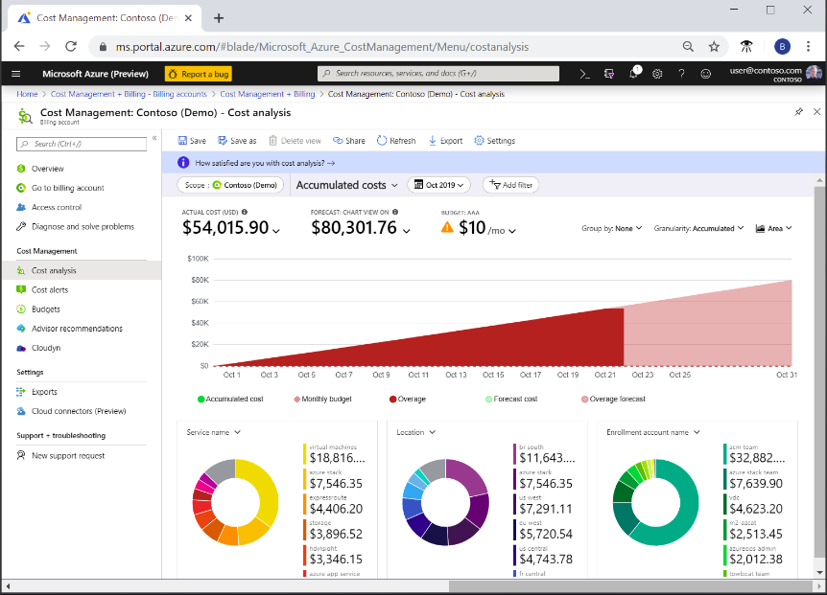

**Describe features and tools in Azure for governance and compliance**

Microsoft purview allows the user to stay up-to-date on your data landscape with automated data discovery, sensitive data classification, and end-to-end data lineage. The two ends of the spectrum for microsoft purview are risk and compliance and unified data governance.

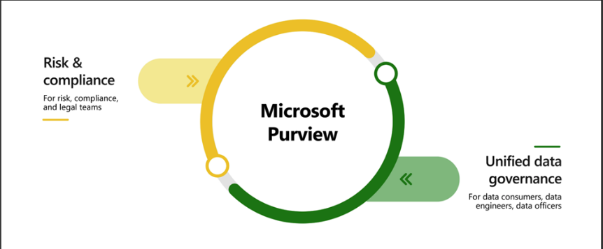

Azure policy enables you to define both individual policies and groups of related policies, known as initiatives. Azure Policy evaluates your resources and highlights resources that aren’t compliant with the policies you’ve created. An Azure Policy initiative is a way of grouping related policies together. The policy definitions under this initiative can be seen below.

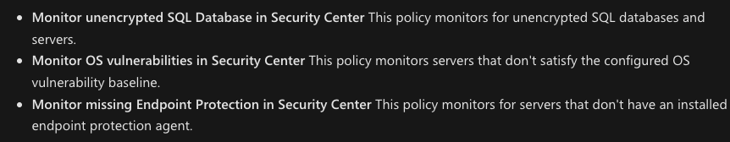

Resource locks prevent resources from being accidentally deleted or changed. There are two types of resource locks, one that prevents users from deleting and one that prevents users from changing or deleting a resource.

The Service Trust Portal is a portal that provides access to various content, tools, and other resources about Microsoft security, privacy, and compliance practices. This contains details about the implementation of controls and processes that protect our cloud services. A dashboard can be seen below.

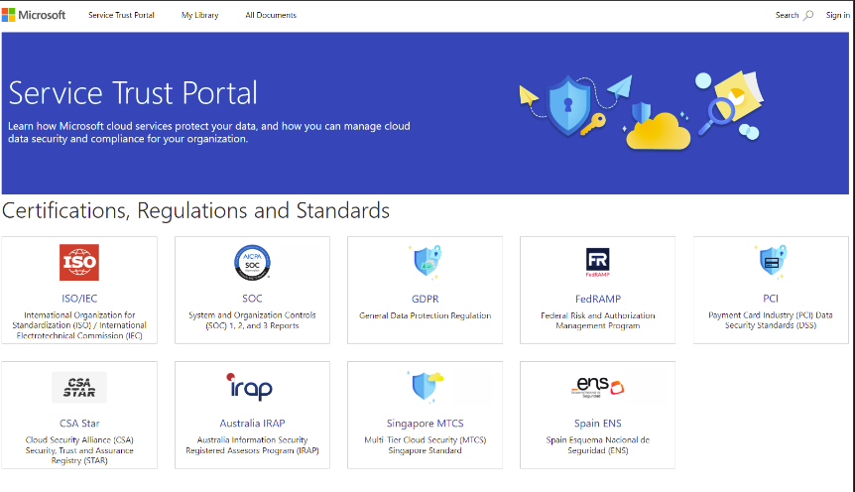

**Describe features and tools for managing and deploying Azure resources**

Using the Azure portal, powershell and CLI, Azure allows the user to interact with their environment in an effective way. The portal is a web-based, unified console that provides an alternative to command-line tools. The portal is designed for resiliency and continuous availability. The powershell allows developers to run commands called command-lets. The command-lets are run independently to handle one-off changes. The Azure CLI is functionally equivalent to the powershell.

Arc lets you extend your Azure compliance and monitoring to your hybrid and multi-cloud configurations. Arc’s abilities to deliver an effective platform can be seen below.

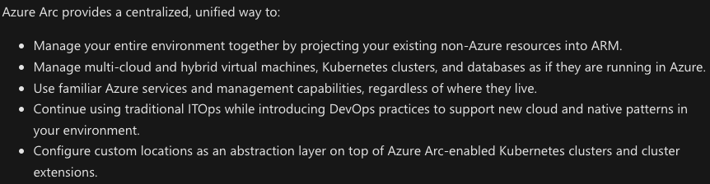

Azure Resource Manager is the deployment and management service for Azure. This allows you to update the resources on your Azure account. Infrastructure as code is a concept where you manage your infrastructure as lines of code. ARM templates allow you to describe the resources you want to use in a declarative JSON format. The deployment code is verified and this ensures the resources will be created and connected properly. Finally, Bicep is a language that uses declarative syntax to deploy Azure resources. These files define the infrastructure and configuration.

**Describe Monitoring Tools in Azure**

Azure advisor evaluates your Azure resources and makes recommendations to help improve reliability, security, performance, achieve operational excellence and reduce costs. It’s designed to help you save time on cloud optimization. A sample dashboard can be seen below.

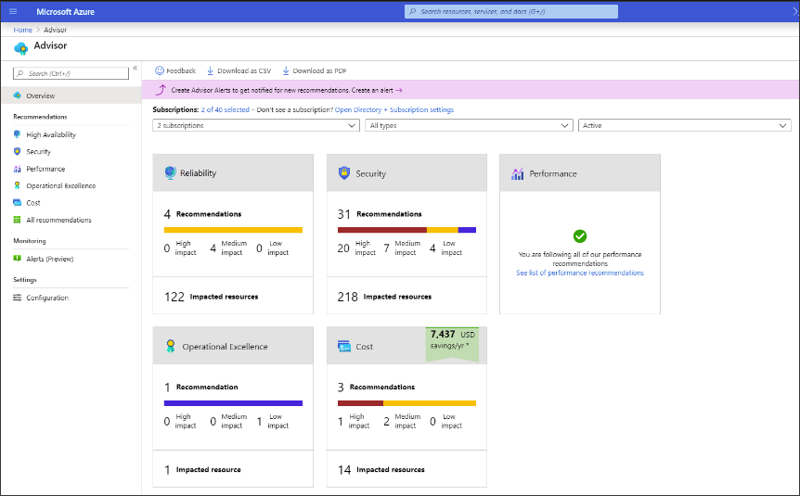

Azure Service Health helps you keep track of Azure resources. This involves Azure Status which is a broad picture of the status of Azure globally. This informs you of service outages in Azure. Service Health provides a narrower view of Azure services and regions. This focuses on regions you’re using and inquires about planned maintenance activities. Resource Health is a tailored view of your actual Azure resources. This is a depiction of the health of your cloud resources.

Finally, Azure Monitor is a platform for collecting data on your resources, analyzing the data, visualizing the information and even acting on the results. The following diagram is a representation of what Azure monitoring covers.

