Министерство образования и науки Российской Федерации

Федеральное государственное бюджетное образовательное   
учреждение высшего образования  
«Новосибирский государственный технический университет»



Кафедра прикладной математики и информатики

Лабораторная работа №1  
по дисциплине «Нейросети»

|  |  |  |
| --- | --- | --- |
|  | Факультет: | ПМИ |
| Группа: | ПМ-51 |
| Студент: | Тябин Е. А. |
| Преподаватель: | Ступаков И.М. |

Новосибирск

2019

# **Цель работы**

* Изучить ML.NET framework
* Понять, как работает нейросеть
* Обучить нейросеть и провести анализ

# **Постановка задачи**

1. Обучить нейросеть распознавать новые наборы вещей, изображенных на картинках.
2. Проверить работоспособность на новых картинках.
3. Сделать выводы
4. Исходные данные

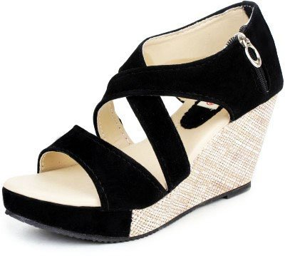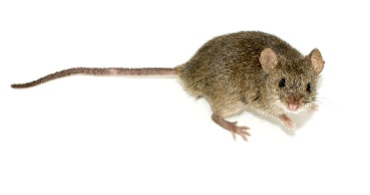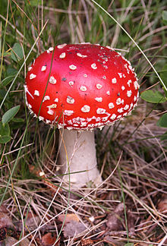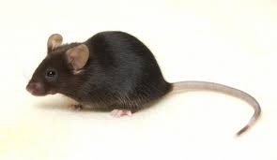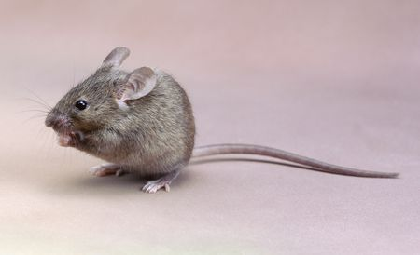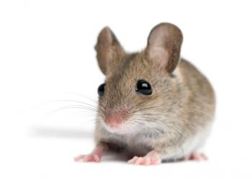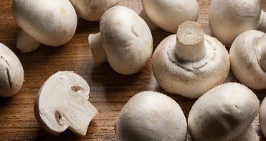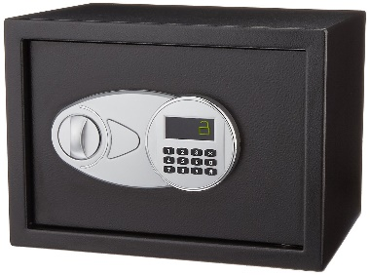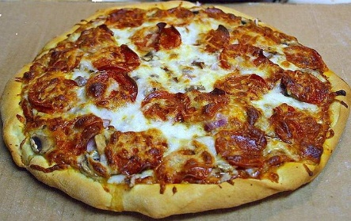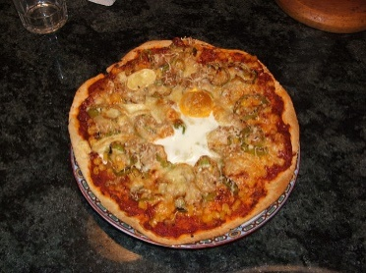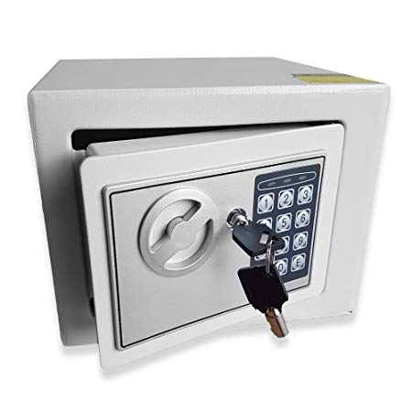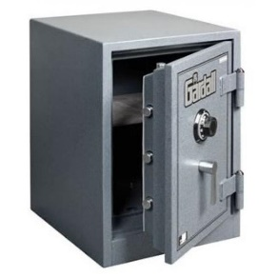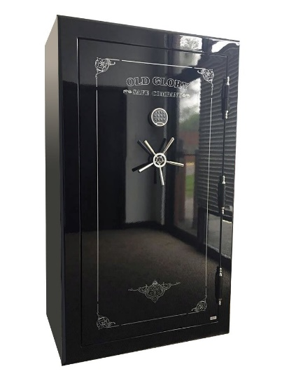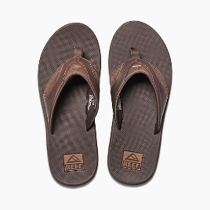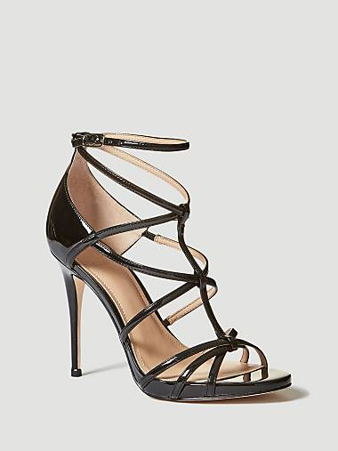Изображения для обучения:

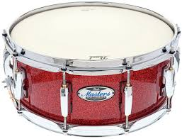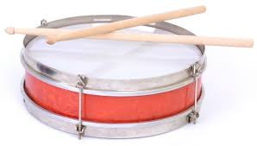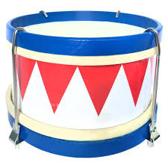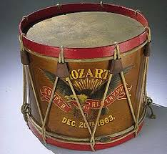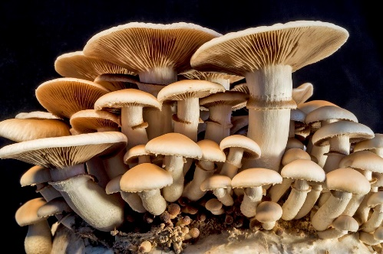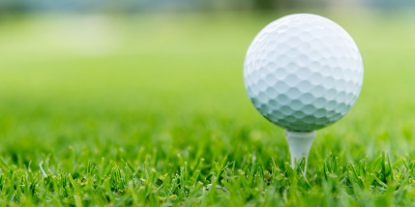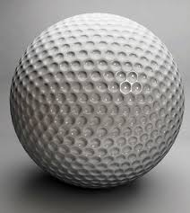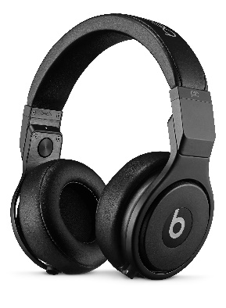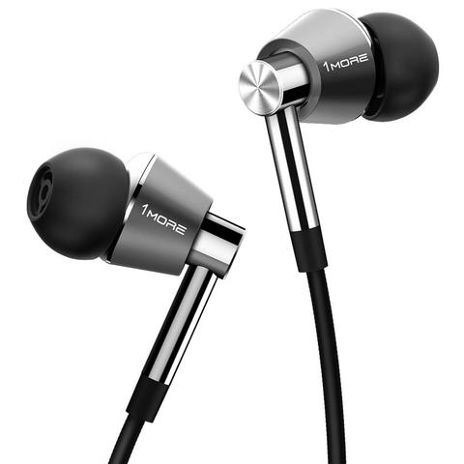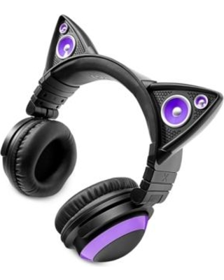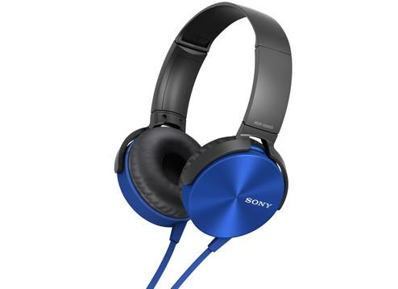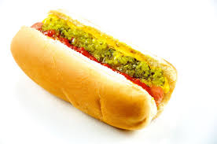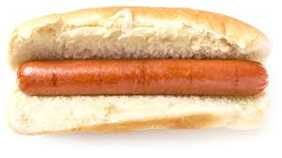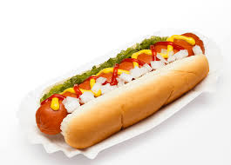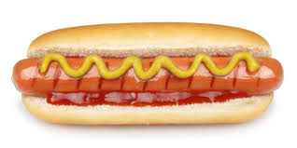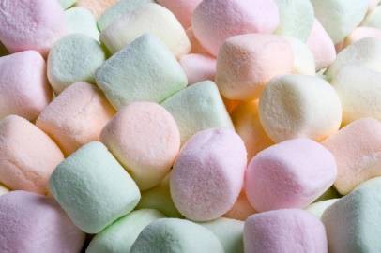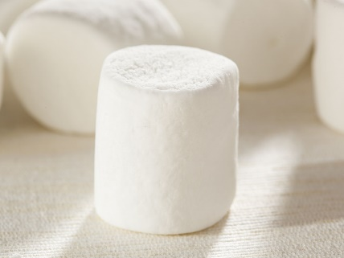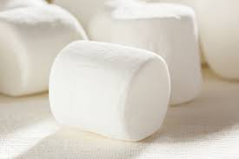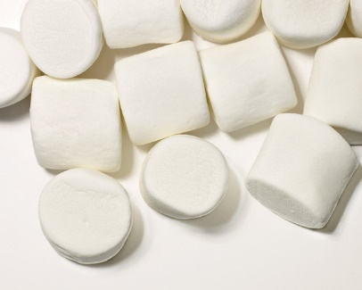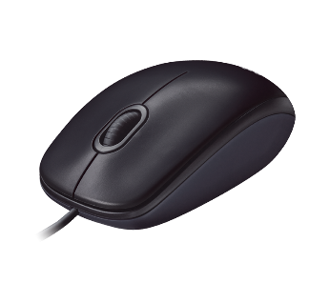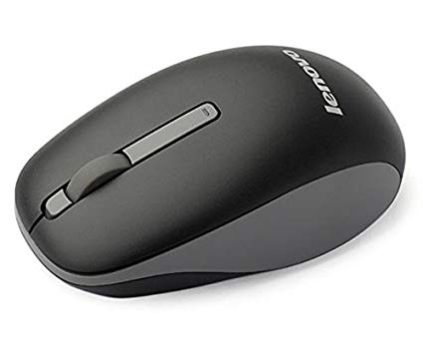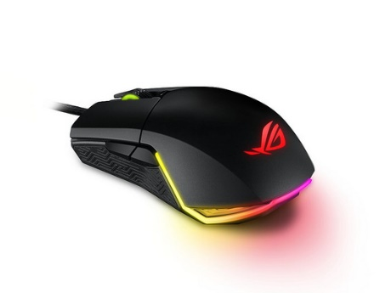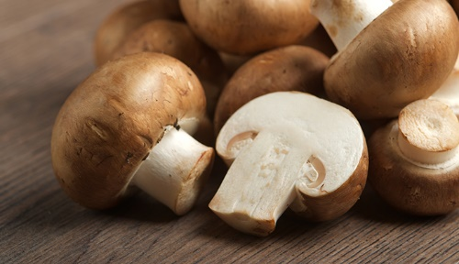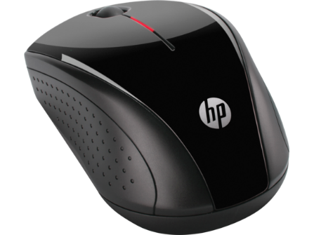

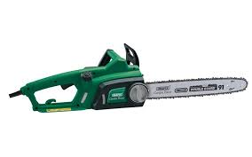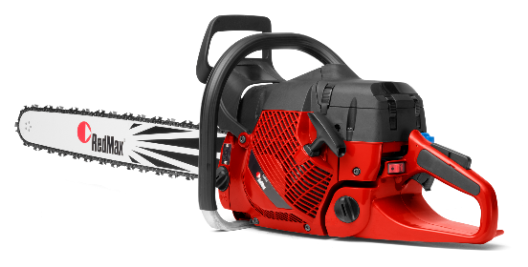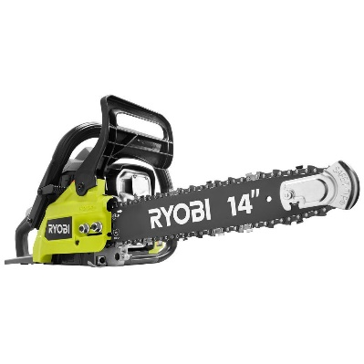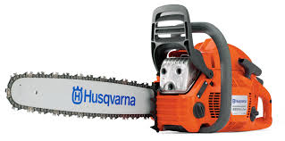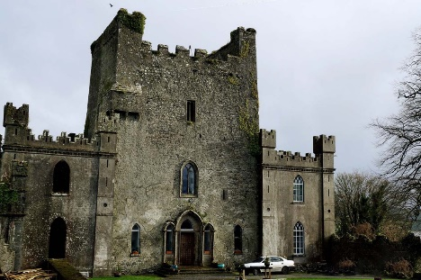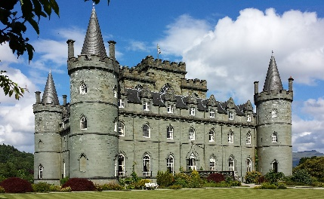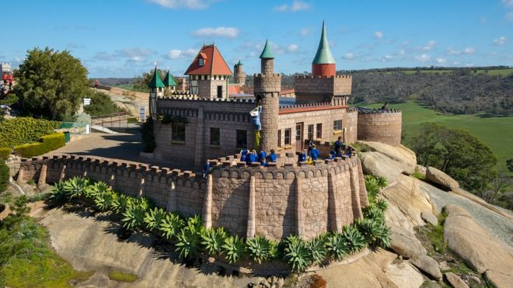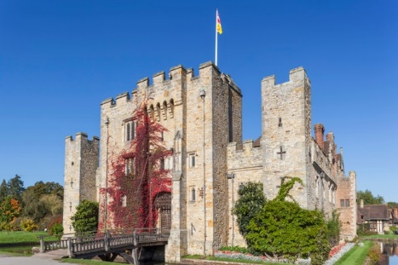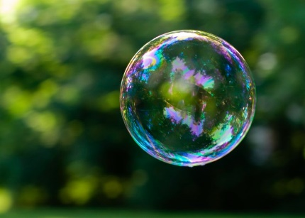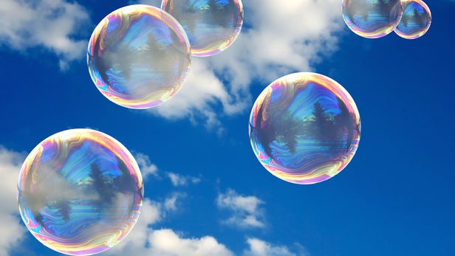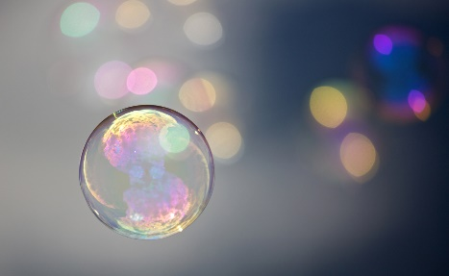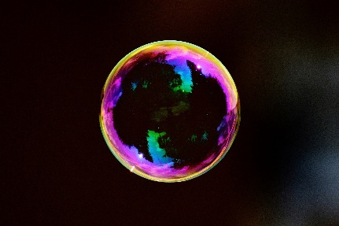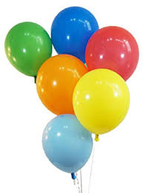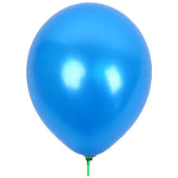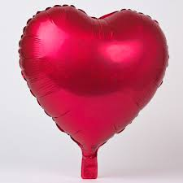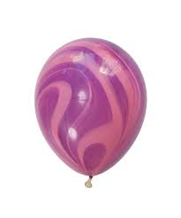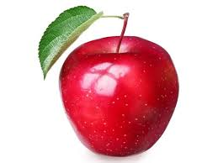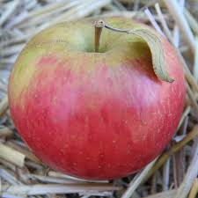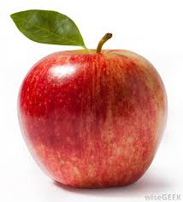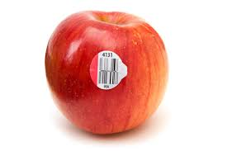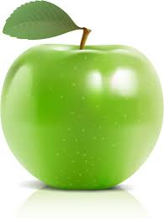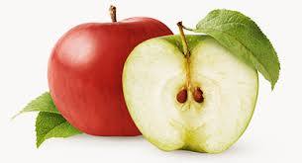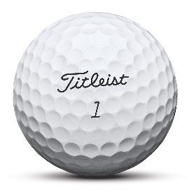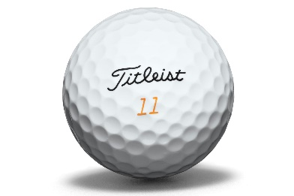

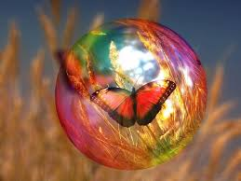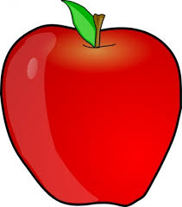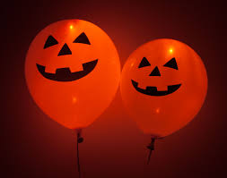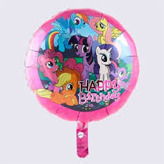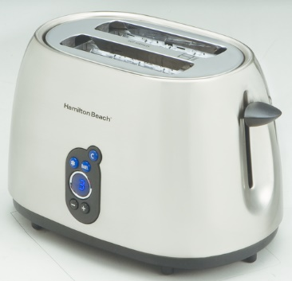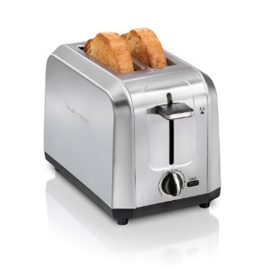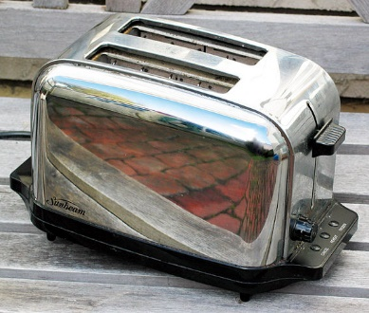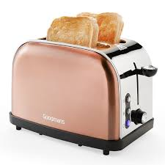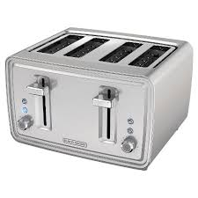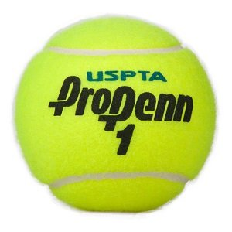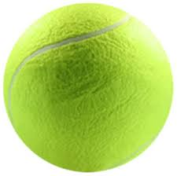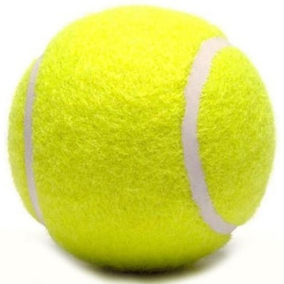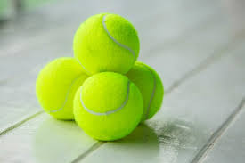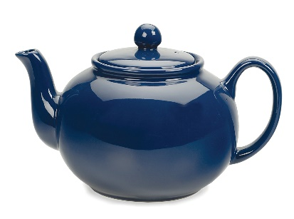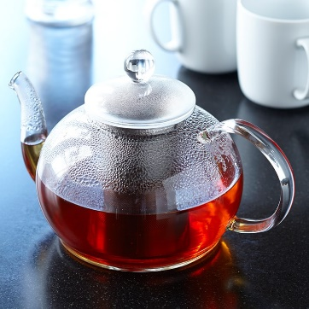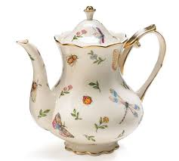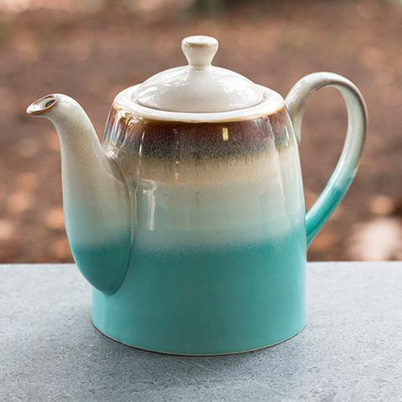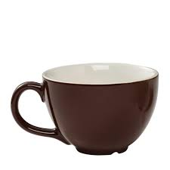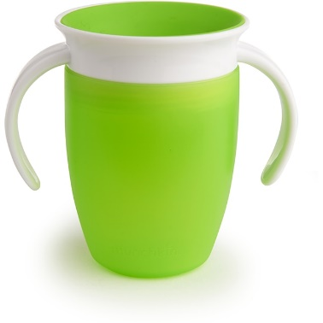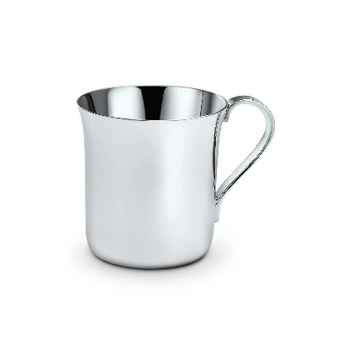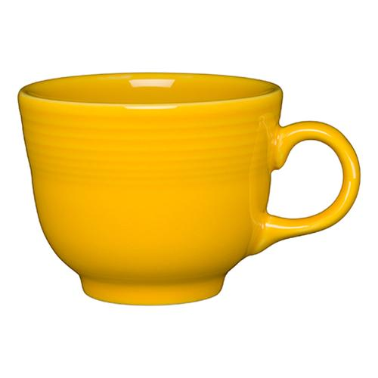Изображения для предсказания:

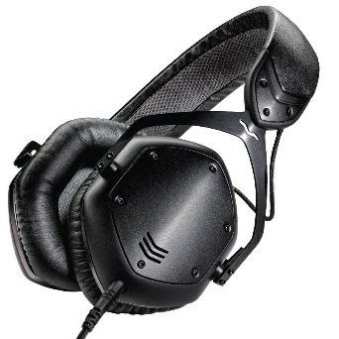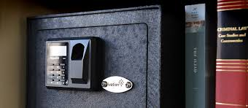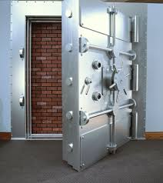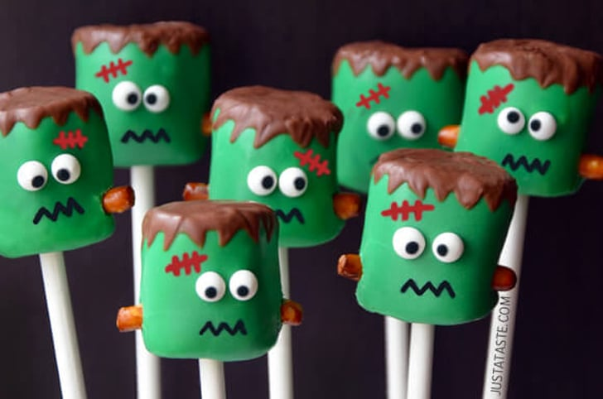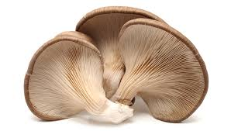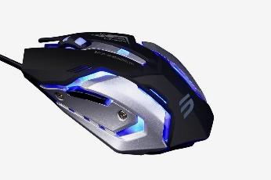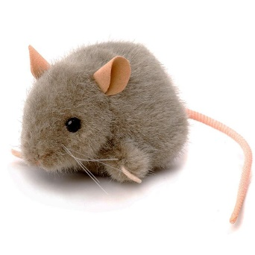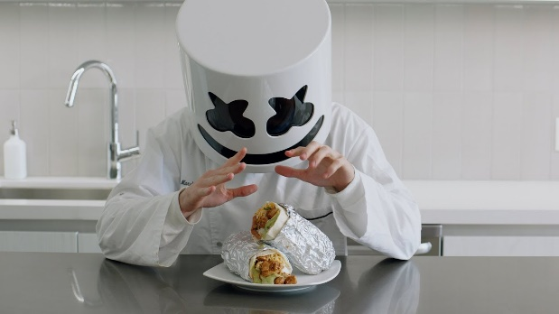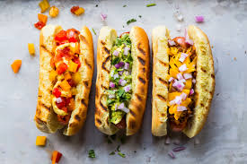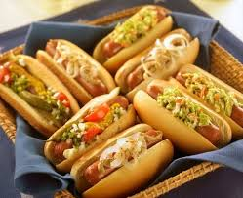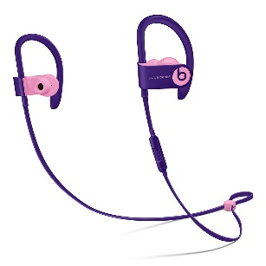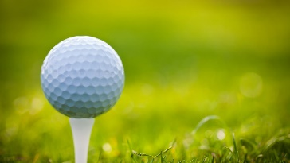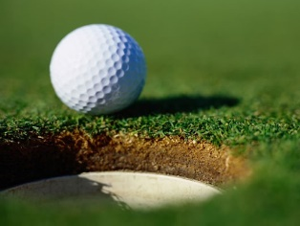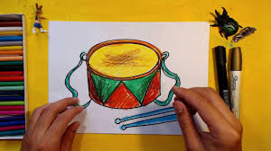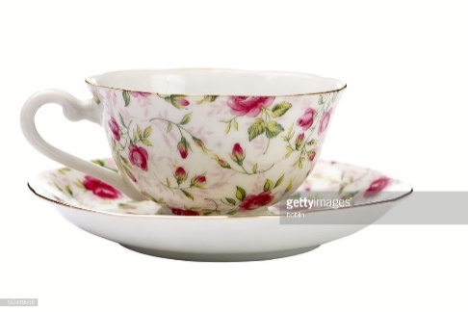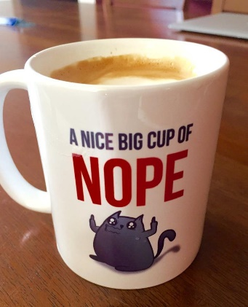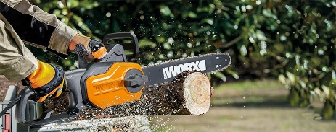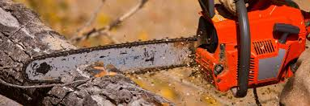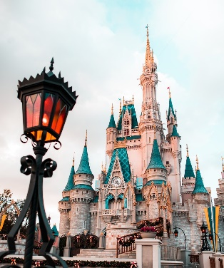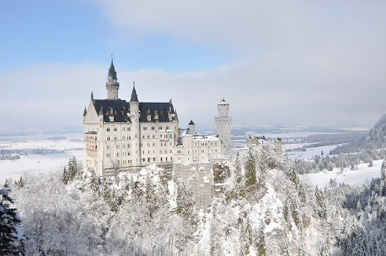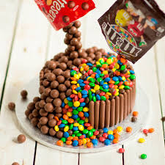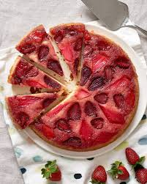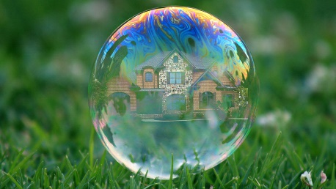

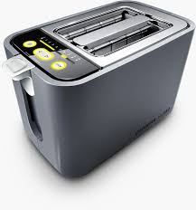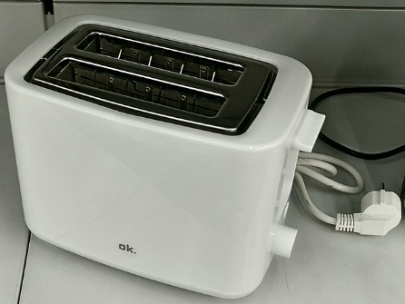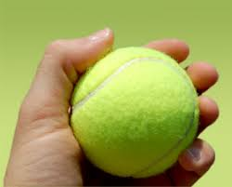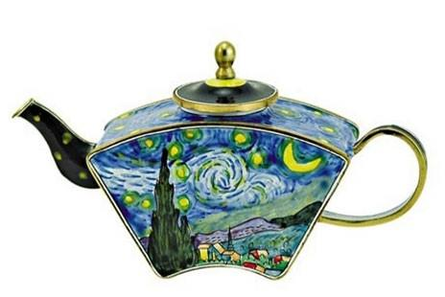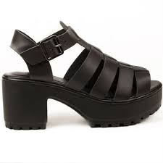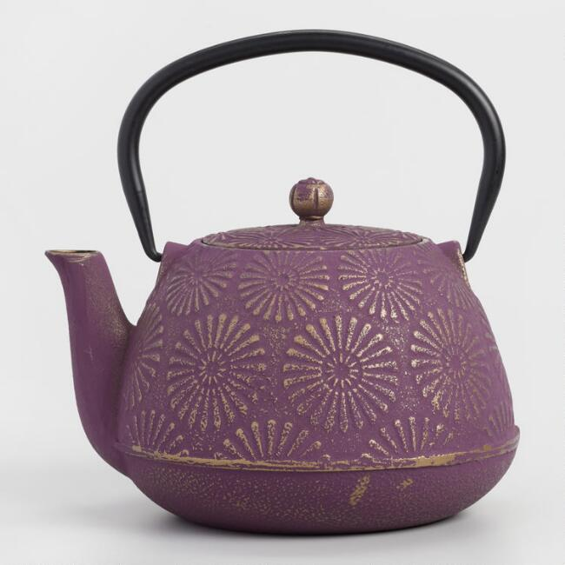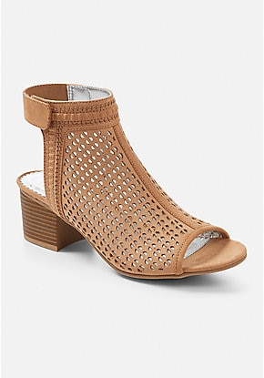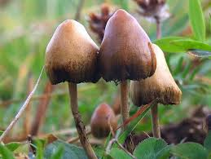

1. **Ход работы**

Сначала посмотрим, что происходит, когда мы просим распознать обученную нейросеть майкрософт на наших начальных данных:

ImagePath: apple4.jpg labeled as apple predicted as toilet seat with probability 0,2225501

ImagePath: ballon5.jpg labeled as ballon predicted as jack-o'-lantern with probability 0,9787819

ImagePath: ballon6.jpg labeled as ballon predicted as maraca with probability 0,9399862

ImagePath: broccoli.jpg labeled as broccoli predicted as broccoli with probability 0,9999077

ImagePath: broccoli.png labeled as broccoli predicted as broccoli with probability 0,998471

ImagePath: bubble4.jpg labeled as bubble predicted as maraca with probability 0,3177012

ImagePath: bubble5.jpg labeled as bubble predicted as bubble with probability 0,9999963

ImagePath: cake4.jpg labeled as cake predicted as strawberry with probability 0,3735127

ImagePath: cake5.jpg labeled as cake predicted as confectionery with probability 0,6755481

ImagePath: canoe2.jpg labeled as canoe predicted as canoe with probability 0,7031567

ImagePath: canoe3.jpg labeled as canoe predicted as canoe with probability 0,7545109

ImagePath: canoe4.jpg labeled as canoe predicted as canoe with probability 0,9950532

ImagePath: castle4.jpg labeled as castle predicted as castle with probability 0,9787174

ImagePath: castle5.png labeled as castle predicted as castle with probability 0,9960126

ImagePath: chainsaw4.jpg labeled as chainsaw predicted as chain saw with probability 0,9999907

ImagePath: chainsaw5.jpg labeled as chainsaw predicted as chain saw with probability 0,994714

ImagePath: coffeepot.jpg labeled as coffeepot predicted as coffeepot with probability 0,6209241

ImagePath: coffeepot2.jpg labeled as coffeepot predicted as coffeepot with probability 0,8302079

ImagePath: coffeepot3.jpg labeled as coffeepot predicted as coffeepot with probability 0,9499788

ImagePath: coffeepot4.jpg labeled as coffeepot predicted as pitcher with probability 0,5957755

ImagePath: cup4.jpg labeled as cup predicted as coffee mug with probability 0,9667796

ImagePath: cup5.jpg labeled as cup predicted as cup with probability 0,7580832

ImagePath: drum4.jpg labeled as drum predicted as bucket with probability 0,6355268

ImagePath: drum5.jpg labeled as drum predicted as can opener with probability 0,2919788

ImagePath: golf_ball4.jpg labeled as golf ball predicted as golf ball with probability 1

ImagePath: golf_ball5.jpg labeled as golf ball predicted as golf ball with probability 1

ImagePath: headphones4.jpg labeled as headphones predicted as microphone with probability 0,8173534

ImagePath: headphones5.jpg labeled as headphones predicted as stethoscope with probability 0,8073857

ImagePath: hotdog4.jpg labeled as hotdog predicted as French loaf with probability 0,9073345

ImagePath: hotdog5.jpg labeled as hotdog predicted as hotdog with probability 0,8780857

ImagePath: marshmallow4.jpg labeled as marshmallow predicted as cup with probability 0,150669

ImagePath: marshmallow5.jpg labeled as marshmallow predicted as rubber eraser with probability

ImagePath: mouse4.jpeg labeled as mouse predicted as hamster with probability 0,6769982

ImagePath: mouse5.jpg labeled as mouse predicted as mouse with probability 0,3079152

ImagePath: mushroom4.jpg labeled as mushroom predicted as earthstar with probability 0,6750084

ImagePath: mushroom5.jpg labeled as mushroom predicted as hen-of-the-woods with probability 0,9214669

ImagePath: pizza.jpg labeled as pizza predicted as pizza with probability 0,9998779

ImagePath: pizza2.jpg labeled as pizza predicted as pizza with probability 0,6319026

ImagePath: pizza3.jpg labeled as pizza predicted as pizza with probability 0,9991034

ImagePath: safe4.jpg labeled as safe predicted as safe with probability 0,9555703

ImagePath: safe5.jpg labeled as safe predicted as safe with probability 0,2966986

ImagePath: sandal4.jpg labeled as sandal predicted as sandal with probability 0,7263685

ImagePath: sandal5.jpg labeled as sandal predicted as clog with probability 0,9042963

ImagePath: teapot4.jpg labeled as teapot predicted as teapot with probability 0,9959524

ImagePath: teapot5.jpeg labeled as teapot predicted as perfume with probability 0,4869211

ImagePath: teddy1.jpg labeled as teddy bear predicted as teddy bear with probability 0,9996483

ImagePath: teddy2.jpg labeled as teddy bear predicted as teddy bear with probability 0,9956694

ImagePath: teddy3.jpg labeled as teddy bear predicted as teddy bear with probability 0,9998852

ImagePath: teddy4.jpg labeled as teddy bear predicted as teddy bear with probability 0,9990584

ImagePath: teddy6.jpg labeled as teddy bear predicted as teddy bear with probability 0,999044

ImagePath: tennis_ball4.jpg labeled as tennis ball predicted as tennis ball with probability 0,9999593

ImagePath: tennis_ball5.jpg labeled as tennis ball predicted as tennis ball with probability 0,9991037

ImagePath: toaster.jpg labeled as toaster predicted as toaster with probability 0,9999989

ImagePath: toaster2.png labeled as toaster predicted as toaster with probability 0,9999999

ImagePath: toaster3.jpg labeled as toaster predicted as toaster with probability 0,9999996

Видим, что нейросеть не распознает вещи, которым не обучена, и присваивает им неправильный классификатор.  
Обучим нейросеть распознавать эти вещи.

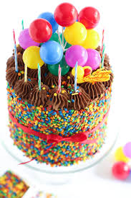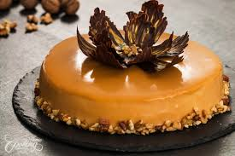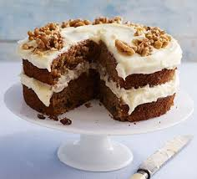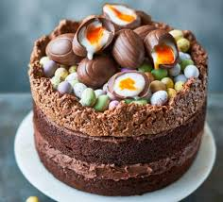В программу обучения были заложены следующие картины:

Картины для которых требовалось определить, что на них изображено:

Результат:

ImagePath: cake4.jpg predicted as pizza with score 0,4963307

ImagePath: cake5.jpg predicted as cake with score 0,8430523

Действительно первое изображение чем-то напоминает пиццу, поэтому были загружены еще изображения пирогов.   
Добавленные изображения:

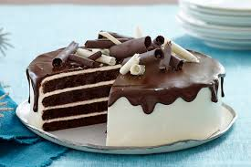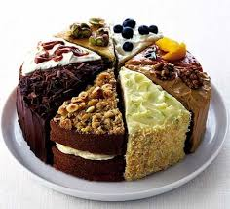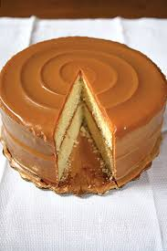Новый результат:

ImagePath: cake4.jpg predicted as cake with score 0,6251109

ImagePath: cake5.jpg predicted as cake with score 0,695118

Теперь обе картины были определены правильно, однако во второй картине уменьшилась «уверенность» нейросети в том, что это пирог.

Результаты всего обучения:

ImagePath: apple4.jpg predicted as ballon with score 0,5104501

ImagePath: ballon5.jpg predicted as ballon with score 0,9019156

ImagePath: ballon6.jpg predicted as ballon with score 0,9666744

ImagePath: broccoli.png predicted as broccoli with score 0,9100303

ImagePath: bubble4.jpg predicted as ballon with score 0,3671426

ImagePath: bubble5.jpg predicted as bubble with score 0,9654702

ImagePath: cake4.jpg predicted as cake with score 0,529085

ImagePath: cake5.jpg predicted as cake with score 0,8344853

ImagePath: castle4.jpg predicted as castle with score 0,8176214

ImagePath: castle5.png predicted as castle with score 0,9826238

ImagePath: chainsaw4.jpg predicted as chain saw with score 0,9967846

ImagePath: chainsaw5.jpg predicted as chain saw with score 0,9463968

ImagePath: cup4.jpg predicted as cup with score 0,843064

ImagePath: cup5.jpg predicted as cup with score 0,7100878

ImagePath: drum4.jpg predicted as drum with score 0,9493483

ImagePath: drum5.jpg predicted as cup with score 0,4013387

ImagePath: golf_ball4.jpg predicted as golf ball with score 0,9969881

ImagePath: golf_ball5.jpg predicted as golf ball with score 0,997183

ImagePath: headphones4.jpg predicted as headphones with score 0,911846

ImagePath: headphones5.jpg predicted as headphones with score 0,4397984

ImagePath: hotdog4.jpg predicted as hotdog with score 0,9770651

ImagePath: hotdog5.jpg predicted as hotdog with score 0,7522396

ImagePath: marshmallow4.jpg predicted as cake with score 0,3464385

ImagePath: marshmallow5.jpg predicted as marshmallow with score 0,677221

ImagePath: mouse4.jpeg predicted as mouse with score 0,9524502

ImagePath: mouse5.jpg predicted as gaming mouse with score 0,8945709

ImagePath: mushroom4.jpg predicted as mushroom with score 0,9771402

ImagePath: mushroom5.jpg predicted as mushroom with score 0,6700234

ImagePath: pizza3.jpg predicted as pizza with score 0,9876345

ImagePath: safe4.jpg predicted as safe with score 0,9802814

ImagePath: safe5.jpg predicted as safe with score 0,7747102

ImagePath: sandal4.jpg predicted as sandal with score 0,9986743

ImagePath: sandal5.jpg predicted as sandal with score 0,9549367

ImagePath: teapot4.jpg predicted as teapot with score 0,9894323

ImagePath: teapot5.jpeg predicted as teapot with score 0,7443625

ImagePath: teddy6.jpg predicted as teddy with score 0,9573295

ImagePath: tennis_ball4.jpg predicted as tennis ball with score 0,9520887

ImagePath: tennis_ball5.jpg predicted as tennis ball with score 0,8578299

ImagePath: toaster3.jpg predicted as toaster with score 0,9469264

# **Выводы**

Изначально нейросеть естественно не была способна распознать те предметы, которым она не была обучена, поэтому нейросеть присваивала не точные, но все же достаточно близкие по виду классификаторы. Нейросеть была обучена распознавать новый набор вещей. При работе были получены интересные результаты, например если показать абсолютно новую вещь нейросети, она ассоциирует её к наиболее подходящему предмету, например плюшевую мышь, определит как плюшевого медведя «teddy». Так же было выяснено, что недостаточный объем данных для обучения сулит за собой ошибки в определении особенно похожих предметов, например мыльный пузырь может определить как воздушный шарик, поэтому для более высокого процента уверенности следует тратить больше ресурсов на обучение.