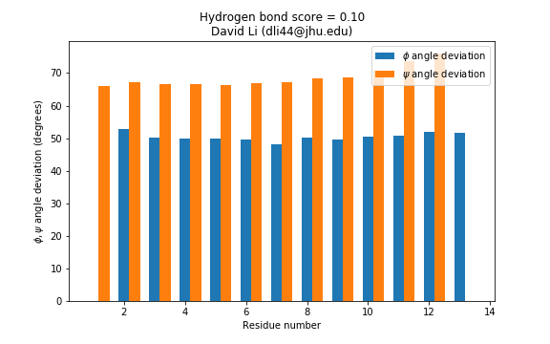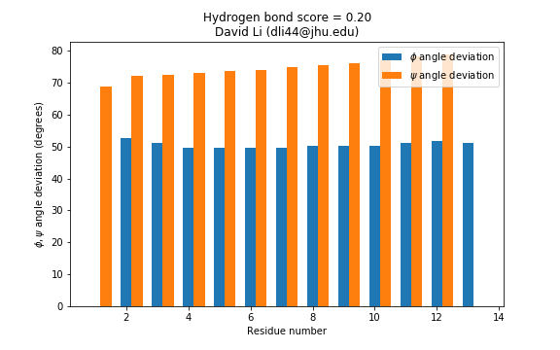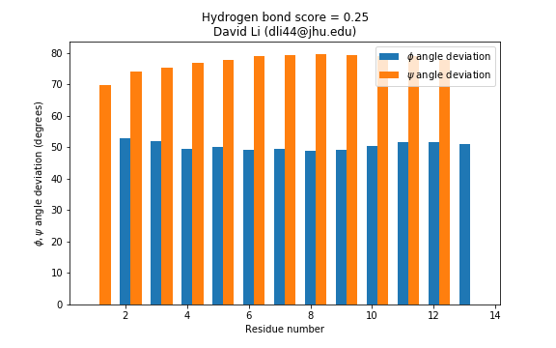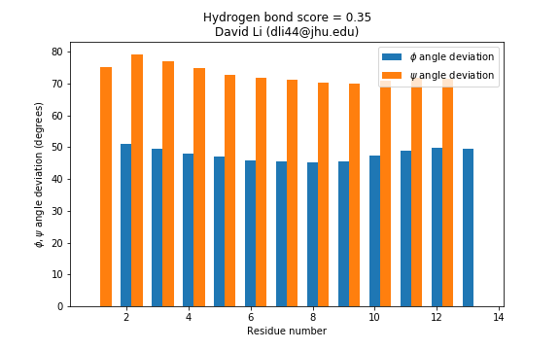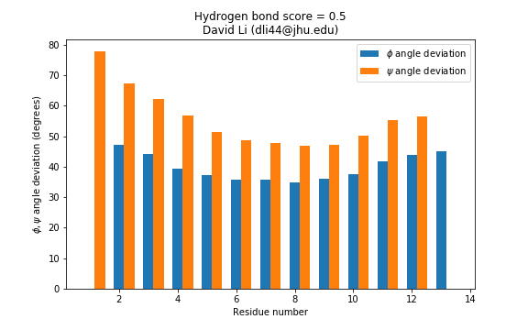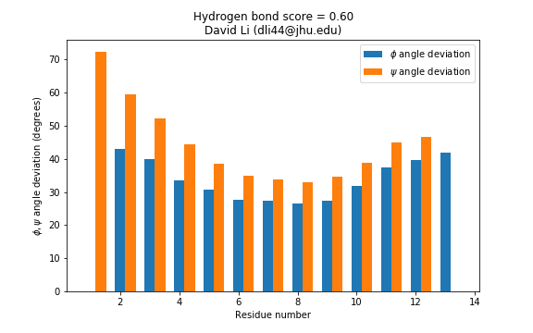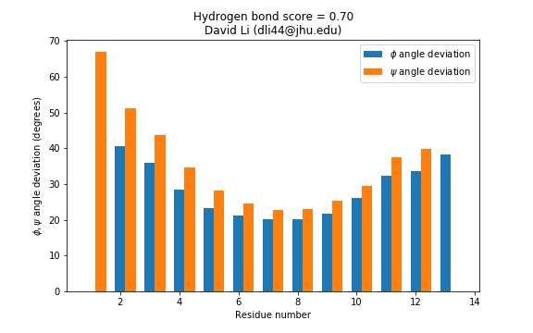

The optimal value of the hydrogen bond is probably something close to 0.7, since it’s the only score that I tested where the maximum stability is in the center and tapers off near the ends.

Discussion: (Q7)

Our initial values from the simulation with hbond=0.35 don’t agree with the chart given. This is because the lowest delta G in the given chart seems to be around 11 or 12, so there is a high proportion of unfolded proteins. However, since the middle has a high delta G, we expect more folded proteins, and less deviation. In summary, the chart given suggests that we have high deviation at the ends, and low deviation in the center, which isn’t the case in the 0.35 plot.