# Clinic appointment system – MVC ASP.Net

# By Chris / Dongfan Zhang

**Purpose:**

1. allow patients to take appointment through this application.
2. Allow doctors to visulize the appointments taken and manage their availability.

Program will have three different user group. (Admin, Doctor, Patient)

Home, Contact is accessible to all without authentification.

Doctor, Admin, Page can be displayed, but as soon as user click functionality link on those page, they have to be authentificated.

Patient can register through the website.

Any new Doctor’s profile will be entered by Admin. Existing Doctors, patients and edit their own profile.

**Process:**

Each Doctore will enter his daily availability for the next 2-4 weeks. This is done periodically.

Doctor will choose the date, then enter the available from - available to hours. They can enter the hours skipping the break hours. Admin can do it for doctor if wished.

When doctor enters the availability, database trigger will automatically create default time slots for that date with that doctor Id.

time slots will have a status taken or available(in dabase it is bit (value 0 for taken, value 1 for available, default is available. Existing time slots, can be modified by admin (some condition?)

When patient choose a doctor to book appointment, he will see only the available time slots.

Patient can also cancel an appointment if 24 hours before the appointment.

Admin can have full access to all the functionality: add doctore, register a patient, take an appointment, modify the schedule, add/ modify time slots etc.

**Tools:**

Visual studio, MVC, C#, sql server azure, entity framework, using code first based on existing database approche.

**Database diagram**

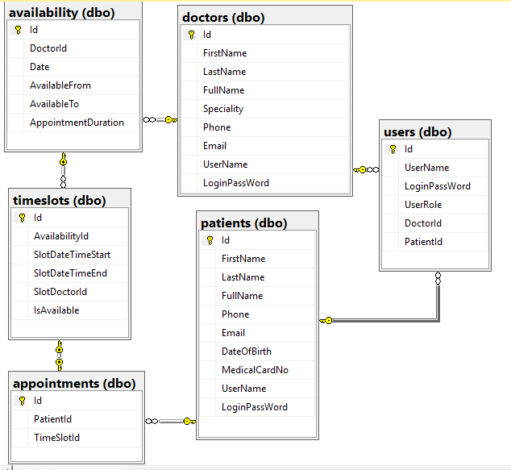

Implemented trigger to enter the timeslots automatically according to availability.

Doctor with id 3 entered an availability as below:

Id DoctorId Date AvailableFrom AvailableTo Appointment Duration

4 3 2018-04-03 2018-04-03 08:00:00.000 2018-04-03 12:00:00.000 60

Then these below records are inserted into timeslots by trigger

Id AvailabilityId SlotStart SlotEnd Slot DoctorId IsAvailable

1 4 2018-04-03 08:00:00.000 2018-04-03 09:00:00.000 3 1

2 4 2018-04-03 09:00:00.000 2018-04-03 10:00:00.000 3 1

3 4 2018-04-03 10:00:00.000 2018-04-03 11:00:00.000 3 1

4 4 2018-04-03 11:00:00.000 2018-04-03 12:00:00.000 3 1

Implemented trigger to enter the user table automatically when a doctor or patient is added.

Important validation to be implemented:

1. Each Availability entering by doctor will be checked to see if overlaping with existing ones. Overlaping is not allowed. But availibilty can be entered without date/time sequence.
2. Doctor can delete availability if there is no appointment is taken on the time slot with this availability
3. Patient can cancel appointment if 48 hours in advance.
4. Patient (User) registration check to see if the entered user name is unique.

UI interface can change, this is draft.

Patient

Doctor

Admin

