**Project Name: JQDF Clinic Management System**

**Author: Jianqiu Chen, Dongfan Zhang**

**Intro:**

In this project we aim to build a Scheduling and Deployment System for a typical clinic in Canada. By the end we expect the system to properly handle registration of doctor, workers and patients. More importantly, the system facilitates scheduling System and allow users to access scheduling at any time to avoid missing appointment or coming to the wrong appointment. By doing such, the clinic will significantly improve efficiency and be able to serve more patients.

**List of Technologies:**

* WPF, C#, Database (Microsoft SQL server)
* WPF extended toolkit and many others as we dive deeper

**Screen Shots:**

First of all we need a log in window that allows the user to choose his profile, (whether he is a doctor, a patient, a receptionist or an administrator)

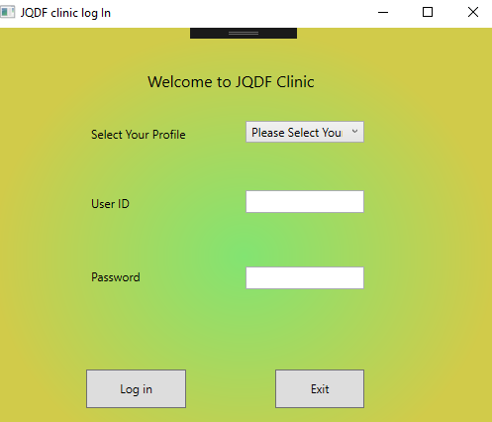

The user has 4 choices: doctor, patient, admin and receptionist. Each choice will lead to a different Custom Dialog window.

When the user opens the Custom dialog for a doctor, we will give a default view of list of patients (retrieved from database) to the doctor, and doctor can do different things by choose different options in menu items (File, Option, Exit)

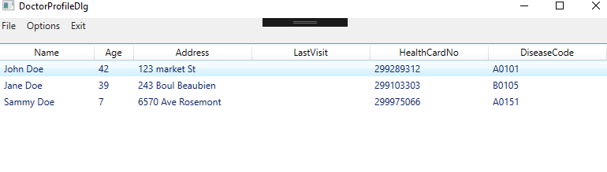

For example, for Doctor’s dialog, we embed functionalities for the doctor to add patient, add prescriptions, modify calendar and record important notes for a patient in the system, as well as changing her own profile and passwords, of course.

For instance, this is one of the custom dialog that would pop up from one of the menu item in File:

