# Project - Invoicing from sales orders

Team member Zhao Jian / Zhang Dongfan

## Content and purpose

To create a desktop application to allow billing clerk review sales orders and issue invoices as well as exact desired information as statements for customer, etc.

Assumption: Sales orders are existing with status complete and not complete stored in database. Clerk can choose any not complete S/O to issue invoice, one S/O can have one invoice. But one invoice can have multiple S/O for the same customer. Once invoice is issued, it will be saved into database, system also need to automatically set the sales order status to complete once invoice issued.

What user can do:

1. Review sales orders (different search criteria)
2. Review invoices (different search criteria)
3. Issue invoices
4. Export invoice as pdf file
5. Export selected invoices as per user criteria into csv for analyze purpose
6. Email statement to customers

Below are the three windows that user can interact with to fulfil the tasks.

Main window: default show 10 most recent invoices. Then user can search the invoice by customer name

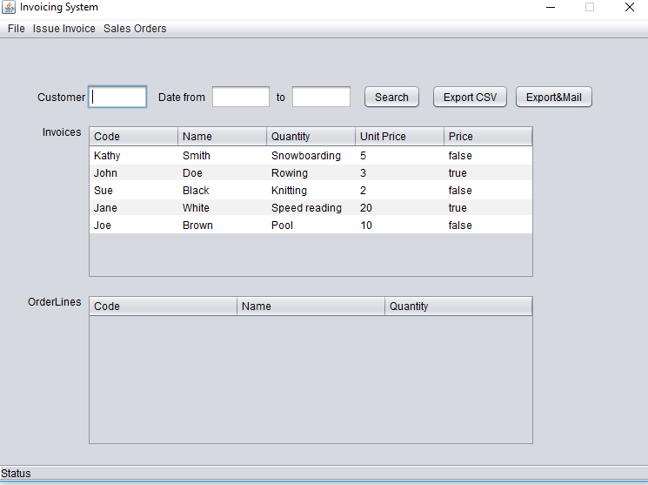

Second window issue invoice, will show when use click menu issue invoice

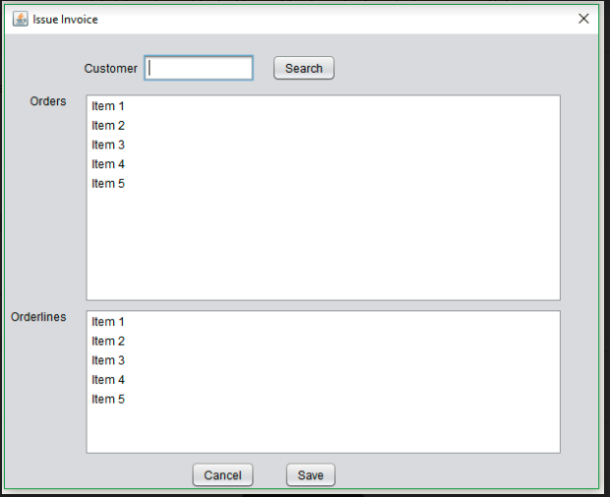

3rd window, use can query sales orders

