Deployment Kafka [kafka_2.13-3.5.1](https://archive.apache.org/dist/kafka/3.5.1/kafka_2.13-3.5.1.tgz)

1.Install Kafka

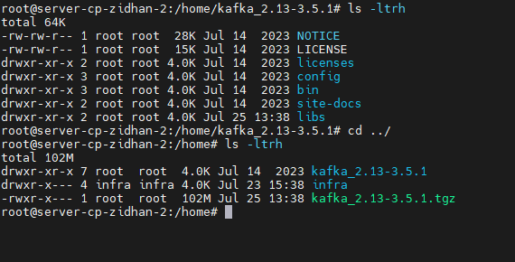

2. mv Kafka to /usr/local/kafka

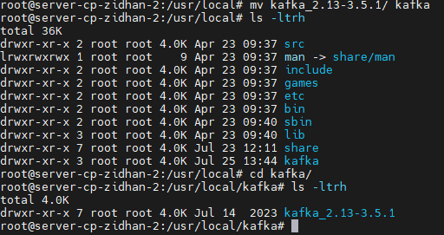

3. Isi zookeeper.service

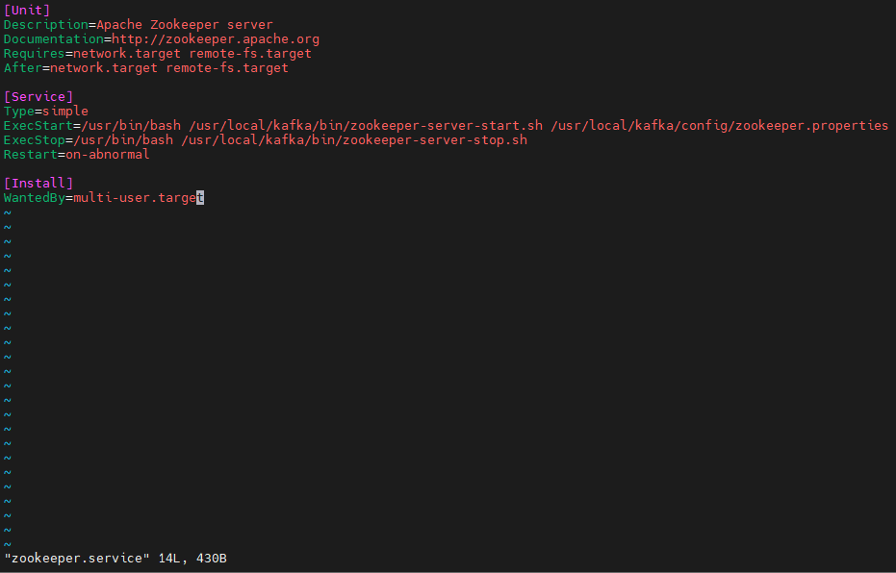

4. Isi kafka.service [ada perubahan di param Environment terkait JDK yang terinstall]

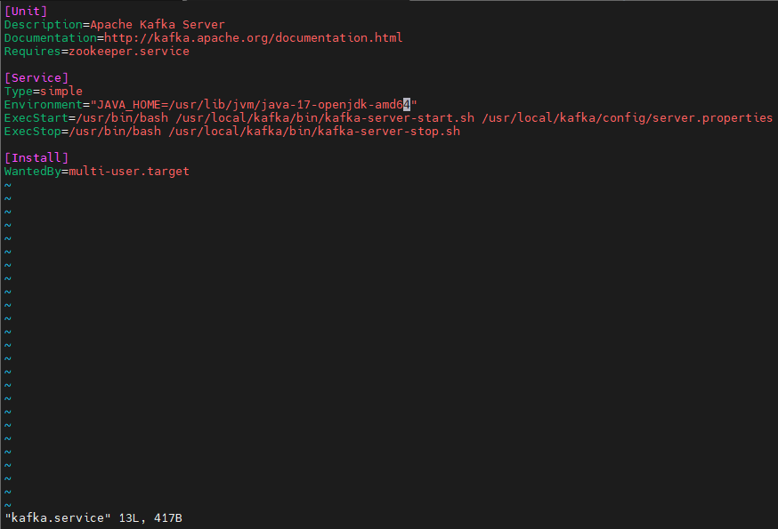

5. Status Zookeeper-kafka & Kafa setelah reload daemon, enable service, start service dengan default Configuration system.

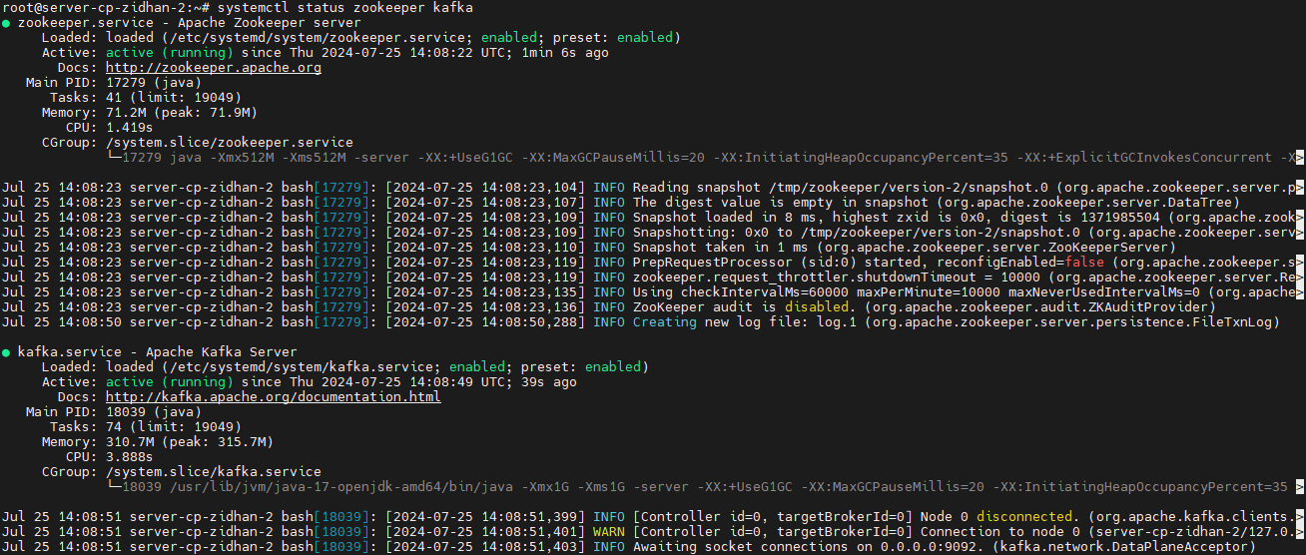

6. Modify configuration server.properties  
Isinya : [Saya ubah zk-connectnya ke IP server yang digunakan dan Logdirs nya ke /data/kafka-logs]  
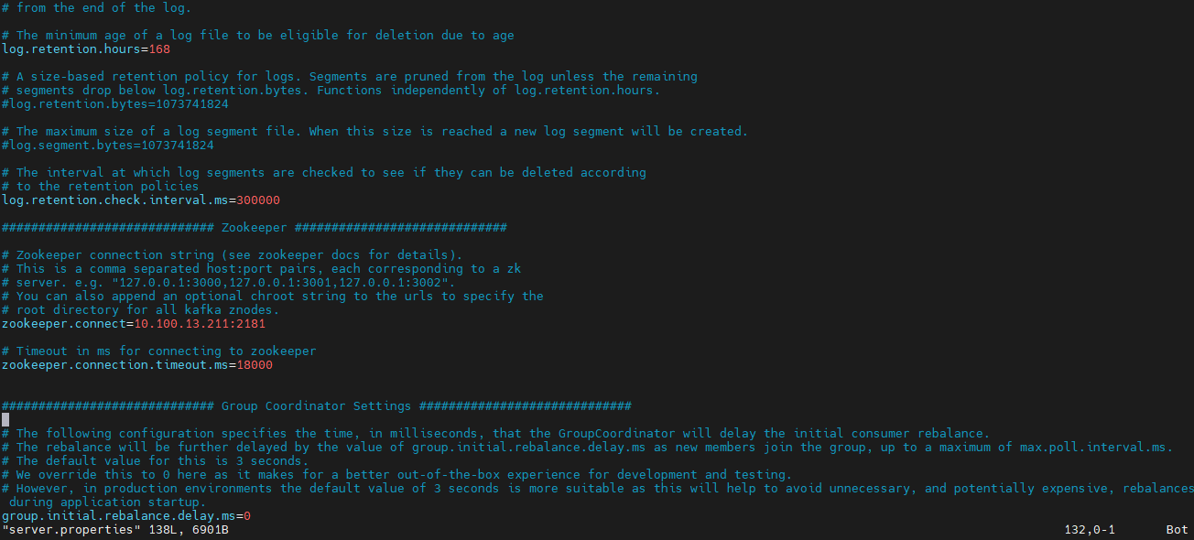

7. Modify configuration zookeeper.properties   
[Saya ubah dataDirnya ke /data/zookeeper]

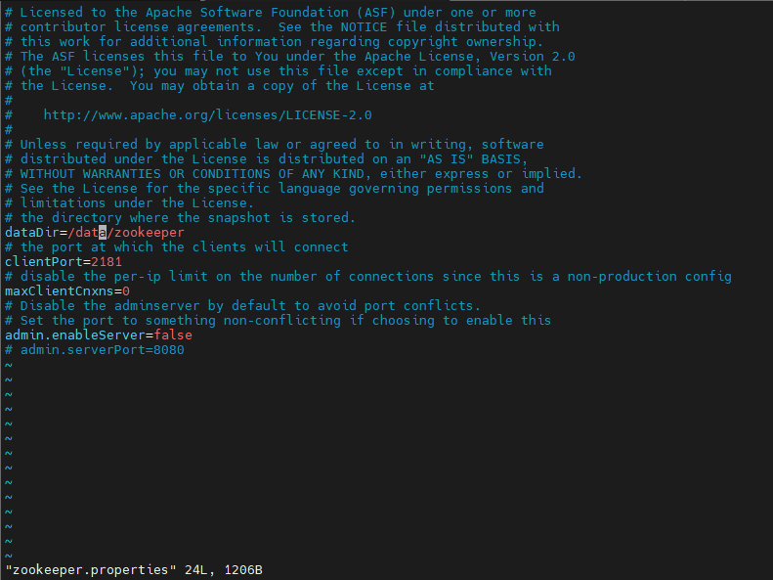

8. After modify configuration systemctl restart zookeeper & kafka

