CS691 – Computer Science, Fall 2022

Pace University



SYSTEM TEST PLAN

REVOLUTION ART

Authors: Zo DiSanto, Jianan Jiang, Kishore Kanchan, Shanshan Li, Rufan Mirganiyev, Louise Ngo, Melika Zandikarimi

Project Manager: Zo DiSanto

Date: 11/30/2022

**Table of Contents**

INTRODUCTION (Zo) **3**

TESTING SCOPE (Melika) **3**

TESTING OBJECTIVES (Melika) **3**

Features to be Tested 3

Features not to be Tested 4

TEST PROCESS DEFINITION (Rufan) **4**

Test Process Phases and Tasks 4

Deliverables 5

APPROACH TO SYSTEM TESTING (Jianan) **5**

Approach to Functional Testing 5

ENTRY/EXIT CRITERIA (Shanshan) **5**

Entry Criteria 5

Exit Criteria 5

ENVIRONMENTAL NEEDS (Rufan) **6**

ROLES AND RESPONSIBILITIES (Kishore) **6**

TEST CYCLES AND SCHEDULE (Zo) **7**

RISKS AND CONTINGENCIES (Rufan) **8**

# INTRODUCTION (Zo)

This document describes the System Test Plan for the “Revolution Art” project. It provides a common understanding on the project's scope, objectives, and approach to performing the system testing. The document also explains the features to be tested, testing entry/exit criteria, resource and responsibilities, and testing schedule.

# TESTING SCOPE (Melika)

The testing scope includes two perspectives - the functional scope and technical scope.

The functional scope: For each testing cycle, the test plan must includes:

* Testing for all the features that have been implemented
* Testing for integration between all the features that have been implemented

The technical scope includes the following architectural components:

* Web browser
* Application server
* Database server

# TESTING OBJECTIVES (Melika)

The primary focus of this System Test Plan is functional testing with the objective to evaluate the system implementation stability. The non-functional testing requires some special tooling to monitor performance characteristics, which is not available on this project.

The basis for developing functional tests and evaluating the system functionality includes the following sources:

* Business Requirements Document (BRD)
* User Stories (functional requirements)
* Data Flow Diagrams
* Requirements Composition Table (supplementary requirements)

## Features to be Tested

This section lists all core features that will be tested grouped by the application modules below:

**Customer and Gallerie Account:**

* Create an account
* Sign into account
* Delete an Account
* Modify General User's Information
* Update Password
* Review and Choose Subscription Plan
* Contact Customer Support
* Cancel Subscription Plan
* Agree to Privacy Conditions

**Only for Customer Account:**

* + Select Recurring Payment
  + See History of Purchase
  + Rate Artwork, Artist, Services

**Only for Gallery Account:**

* + Add artworks
  + Remove Artworks
  + Modify Artworks Information

**Searching:**

* Select Artwork by filters

**Shopping Cart:**

* Make Payment
* Modify Shopping Cart
* Add Items to Shopping Cart
* Remove items from shopping Cart

**Subscription Plan:**

* Make Payment
* Receive Sales Program Weekly
* Receive Artwork Report
* Receive Discount

## Features not to be Tested

System performance and security will not be tested for the lack of required tools.

# TEST PROCESS DEFINITION (Rufan)

## Test Process Phases and Tasks

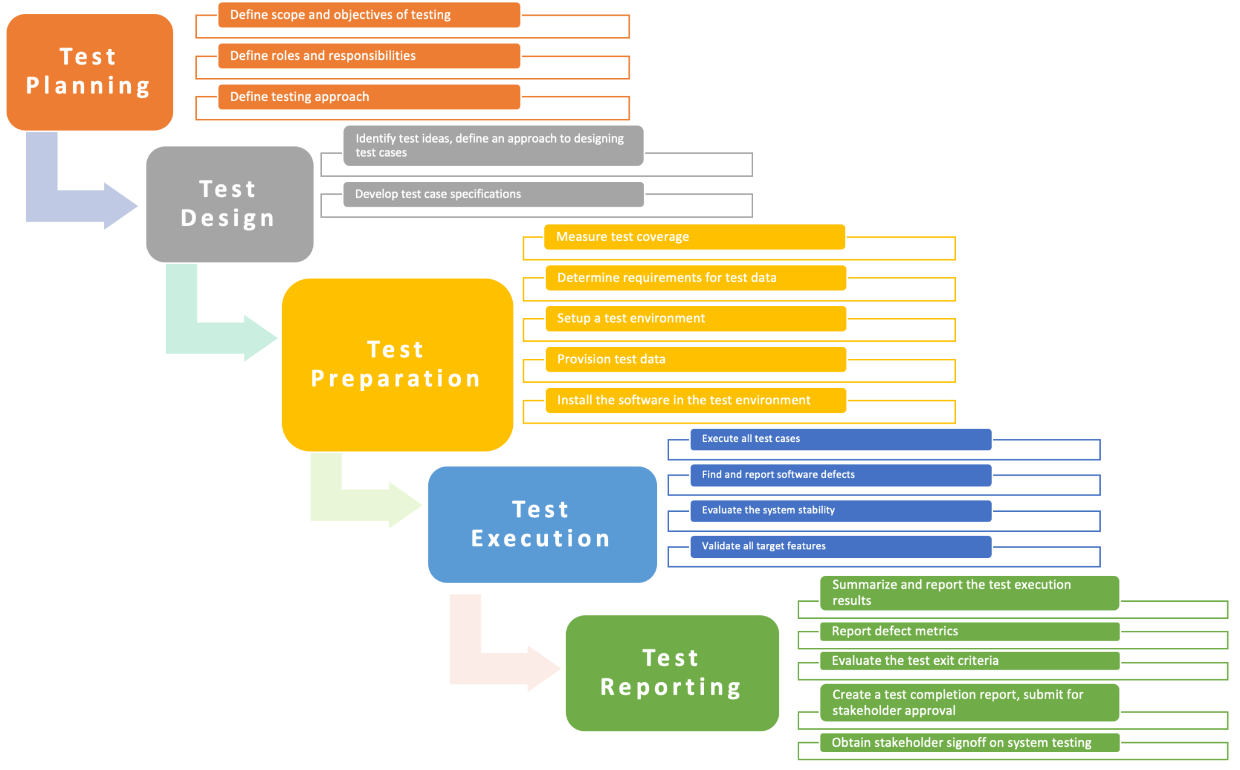

## Deliverables

On this project, the test process deliverables include:

* Test Plan document
* Test Design specifications
* Test Case specifications
* Software Defects Report
* Test Execution Logs
* Test Completion Report

# APPROACH TO SYSTEM TESTING (Jianan)

## Approach to Functional Testing

* Use Black-box Test strategy and techniques (Boundary-value analysis, decision table testing, state-transition testing, cause-effect graphing)
* Tests will be conducted partially automated, with the manual portion limited to GUI tests.

# ENTRY/EXIT CRITERIA (Shanshan)

This section defines both Entry and Exit Criteria for test execution and is intended to establish a common understanding about the conditions when the test execution can start and when it can stop.

## Entry Criteria

The test Entry Criteria include the following items:

* The application build is produced and deployed to the test environment
* The system test plan is produced and approved
* The test environment is ready for testing
* Test Designs and test case specifications are completed

## Exit Criteria

The test Exit Criteria include the following items:

* All requirements, in scope of testing, are covered by test cases
* All test cases have been executed
* Zero defects of Critical and High-severity remain open
* Open defects of Medium and Low severity have known work-arounds
* Test Summary report is produced and published

# ENVIRONMENTAL NEEDS (Rufan)

The test environment must be available to start test execution. It includes a laptop with a virtual machine running the web server and database, and internet browsers (Chrome, Firefox, Internet Explorer and Safari) to access the application. The architecture of the test environment is shown below.

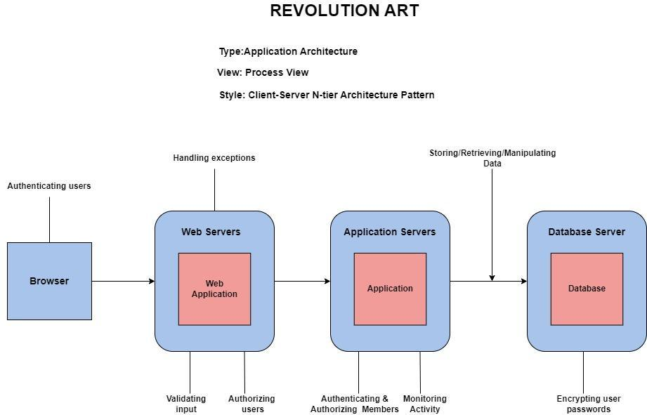

# ROLES AND RESPONSIBILITIES (Kishore)

The project team has seven members that are assigned various project roles including Project Manager, Product Owner, Lead Business Analyst, Lead Developer, DBA, Lead QA Analyst. Their responsibilities in the testing process are defined in the table below:

| **Project Role** | **Role Responsibilities** |
| --- | --- |
| Project Manager | Keep the team on the right track for the timelines;  Review and approve the System Test Plan. |
| QA Analyst & Tester | Make test plans and design test cases,  Establish and maintain the test environment, Execute tests and report tests results. |
| Product Owner | Contributing to the test plan;  Execute UAT and make report tests results. |
| Business Analyst | Contribute to the test plan and test case specifications.  Review tests results; |
| Lead Developer & Developers | Assisting the QA Analyst & Tester throughout the testing process. |
| DBA | Contribute to the test plan;  Review tests results; |

# TEST CYCLES AND SCHEDULE (Zo)

The system test execution will be conducted as three test cycles that are listed below:

**Cycle 1.** Unit Tests Execution

**Cycle 2.** Integration and System Test Execution

**Cycle 3.** User Acceptance Test Execution

# RISKS AND CONTINGENCIES (Rufan)

This section highlights a few potential risks and contingencies that may have happened during the system testing.

* A delay could be caused by insufficient testing resources.
* A delay or more work may result from any changes to the scope objectives.
* Longer testing times are needed when there are more flaws to be fixed.
* The progress of the testing can be negatively impacted by the team members' lack of cooperation.