**CS691 - Computer Science, Fall 2022**

**Project Initiation Document**

Project: Revolution Art

Project Manager: Zo DiSanto

Start Date: ${20}^{th}$ September 2022

Completion Date:

Table of Contents

Document Purpose (assigned to Zo) 4

Background to the Proposed Work (assigned to Zo) 4

Vision (assigned to Melika) 4

Project Objectives (assigned to Melika) 5

Project Scope (assigned to Shanshan) 5

Business Case (assigned to Jianan) 6

Assumptions (assigned to Jianan) 8

Constraints (assigned to Shanshan) 8

Risk Management Strategy (assigned to Louise) 9

Deliverables (assigned to Zo) 10

Stakeholders (assigned to Rufan) 10

Project Team (assigned to Rufan) 11

Project Plan (assigned to Kishore) 12

Project Controls (assigned to Louise) 13

Communication Plan (assigned to Kishore) 13

Document Details

| Version | Modifications | Author | Date |
| --- | --- | --- | --- |
| 1 | Initial PID Document | Zo | 09/20/2022 |
|  |  |  |  |
|  |  |  |  |
|  |  |  |  |

Approvals

This document requires the following approvals:

| Name | Role | Signature | Date | Version |
| --- | --- | --- | --- | --- |
| Yuri Chernak | Lead Stakeholder |  |  | V1 |
| Zo DiSanto | Project Manager |  |  | V1 |
| Melika Zandikarimi | Product Owner |  |  | V1 |
| Jianan Jiang | Business Analyst |  |  | V1 |
| Shanshan Li | Lead Dev |  |  | V1 |
| Kishore Kanchan | Dev |  |  | V1 |
| Rufan Mirganiyev | DBA |  |  | V1 |
| Louise Ngo | QA/Tester |  |  | V1 |

Distribution

This document has been distributed to:

| Name | Role | Date of Issue | Version |
| --- | --- | --- | --- |
| Zo DiSanto | Project Manager |  | V1 |
| Melika Zandikarimi | Product Owner |  | V1 |
| Jianan Jiang | Business Analyst |  | V1 |
| Shanshan Li | Lead Dev |  | V1 |
| Kishore Kanchan | Dev |  | V1 |
| Rufan Mirganiyev | Lead DBA |  | V1 |
| Lousie Ngo | QA Analyst & Tester |  | V1 |

# Document Purpose (assigned to Zo)

This Project Initiation Document (PID) will be used to keep record of the basic information needed for product management. All vital information related to the Revolution Art website will be described in this document, i.e., the scope, objectives, task, roles and responsibilities, cost and deliverables.

This document records important aspects such as detailed information regarding the steps that are needed to be taken for the Revolution Art website’s execution, an in-depth documentation of the roles and responsibilities, activities and a description of their functions, a detailed communication plan between team members and stakeholders, along with important records, risks, project controls and exceptions.

The following segments of this document will potentially change over the lifetime of the production of the Revolution Art website. All changes will be noted in the PID. The PID will be a reference every time a major decision is taken about the project, and will require approval from the team members and the lead stakeholder. Submitting the PID will be at the end of the project to properly measure the project's overall success.

# Background to the Proposed Work (assigned to Zo)

Due to a recent global pandemic, it has become clear that there is a need for everything to be accessible remotely. When buying, selling, or even viewing artwork, it shouldn’t matter whether the person is sick, or in a different country.

This project’s purpose is to provide easier access to artwork, auctions and artists' work. The aim is to create an easy to use website for our users, i.e., collectors, art enthusiasts, interior designers, or even everyday people who want something nice to showcase on their wall.

With Revolution Art, we have come up with a solution to not being able to attend an art gallery. This website is designed so attending an auction, buying or selling art will come with ease for the user. With an intuitive visual interface, users can purchase and return artwork in a timely fashion for them and the administrators. Buying art couldn’t be easier than from the comfort of your own home.

# Vision (assigned to Melika)

This section describes the vision of the project; it should be short, concise and achievable.

In today’s everyday life style, art is becoming a more valuable asset. There is no question in the vast variety of artworks all over the world. However, Finding the right march might be quite challenging. We believe we can make this a more easy and a more pleasant process for both, new and experienced collectors by offering an accessible and categorized selection of works.

# Project Objectives (assigned to Melika)

* Create a user friendly interface
* to create an online art marketplace
* There are 2 type of users, galleries that are presenting artworks and people who are looking to acquire artworks
* Register user with login id and password
* To provide details about the artworks like the name of the artist, dimension , title , description , medium of the work , price and …
* To connect with a shipping and a delivery service
* To be able to receive feedbacks
* Payment gateway

# Project Scope (assigned to Shanshan)

Our scope is to create an online art gallery website which deals with following scope categories:

**Features include:**

* Login in by user’s Google email directly or Phone number
* Allow users to create artwork posts with a picture, a title, artist name, a description, and key words
* Allow users to like a artwork
* Allow person who post the artwork to edit the posts
* Allow login users to make comments on any art work
* Search features allowing users to search dream artwork by artist name and key words
* Recommendation features, like you may also like: …
* If click an artwork in homepage, will redirect to detail page about this artwork

**Technical, we will:**

* To analyze similar products to improve the features
* To apply UI practices such as Material UI
* To decide what database to use based on needs
* To decide helperful APIs helping our development
* To discuss roles, skills and responsibilities in our team
* To install the required software
* To arrange skills learning material for team to learn and improve
* To set up development, staging and production environment

# Business Case (assigned to Jianan)

| **Application Name** | Revolution Art |
| --- | --- |
| **Type of business model** | **Brokerage**: We will connect buyers and sellers and help facilitate a transaction. We will charge a fee for each transaction to either the buyer or the seller and sometimes both.  **Subscription**: We will create subscription models that will require the customer to sign up for automatic payment plans, and we may charge a cancellation fee for a contract that ends prior to the preset time frame. |
| **Target audience of external users**  **(Customer Segments)** | **For whom are we creating value?**  Art Collectors / People interested in acquiring artworks  **Who are our most important customers?**  Art Enthusiasts/Collectors, Interior Designers, Previous Purchasers… |
| **Groups of internal stakeholders, business users** | ***Indicate who will be using the system in your organization, i.e., internal users.***  Galleries, Users, Development Team (login as Admins)  **Do we need a product development group?**  Yes, to build and develop the front and back end to our web application.  **Do we need a sales group?**  Not now, but in a future scope, yes.  **Do we need a finance group (accounts payable, receivable)?**  Yes, to handle commissions, yearly subscriptions and % shares from the galleries.  **Do we need a customer support team?**  Yes, our end users are all very different and need to have access to support through FAQs, Contact Us form and through email.  **Do we need an advertising management group?**  Yes, advertising will be needed to get art influencers and enthusiasts/collectors to get our name out there to help us get trusted by the public. |
| **Value propositions** | **What value do we deliver to the customer?**  Revolution Art’s main goal is to give our users easy access to artwork, making the shopping process much easier and safer. We plan to create a bridge between the gallery/galleries and their clients.  **Which one of our customer’s problems are we helping to solve?**  Due to a recent global pandemic, people have become aware that there is a need for everything to be accessible remotely. This provides easier access to artwork and authorizes an easy way to show a client's artwork. We also are planning on implementing a delivery system with a shipping company.  **What bundles of products and services are we offering to each Customer Segment?**   * Online shopping, payment, delivery, simple artwork acquisition. * Event Management (advertise art shows (like ArtExpo)):   + Art auctions (sell tickets to these events) * Marketplace (where artists offering their services)   **Which customer needs are we satisfying?**  We are creating remote access to more variety of artworks from the convenience of the user's own home . |
| **Key resources** | **What Key Resources do our Value Propositions require?**  Team of developers, Artworks consigned to the gallery, computer softwares.  **Our Distribution Channels?**  Our website is also accessible via tablet and mobile.  **Customer Relationships?**  Our customer relationship is self-service. Artists list their artwork and users buy or bid on an item.  **Revenue Streams?**  Sales commission, subscription. |
| **How the system is used** | **What are the main system use scenarios for the External Customers?**  Revolution Art will have a web application for collectors and art enthusiasts to find artworks and purchase them.  A user will sign up for an account through our website with their email or phone number (user will be presented with the two options for their preference), we will send to their email/phone a verification link/code and that will send it back to us, thus verifying the users account.  The artwork will be delivered to the customers via the shipping company directly after purchase.  We will also have email/text notifications for the customers confirming the users purchases.  **What are the main system use scenarios for the Internal Users?**  Our internal users will manage, maintain and scale the website, along with receiving feedback from customers. |
| **Revenue generation, Revenue streams** | **Such as Subscription fees, renting, leasing, licensing, brokerage fees, advertising sales, etc.**  Subscription fees (to the gallery subscribe to be able to use the platform)  Commission |
| **Key Partners/Suppliers**  **(Stakeholders)** | **Stakeholder – the party who is involved in or affected by your project**  Development Team, Advertising Team (people to get our name out; influencers…), Payment Gateways (3rd party), Delivery Partner (3rd party) |
| **Expected Benefits to the Customer** | Provides an easy/remote access to a variety of artworks with different prices for people interested in purchasing artworks. Revolution Art creates an easy process of purchasing artwork. If the client cannot buy artworks in person, using our website can make their experience less frustrating and more memorable. |
| **Known Prototypes** | **Reference some known portals on the Internet that are similar to your business case. You will use these prototypes for developing business, user requirements.**  [*www.artsy.net*](http://www.artsy.net) */* [*www.theartpledge.org*](http://www.theartpledge.org) */* [*https://www.bonhams.com*](https://www.bonhams.com) |
| **Front-end Technology** | **Indicate what technology will be used to develop the front-end of your application.**  HTML/CSS,Bootstrap, JavaScript, React |
| **Back-end, Database Technology** | **Indicate what technology will be used to develop the back-end database of your application. The database should be relational.**  MySQL, MongoDB, Python |

# Assumptions (assigned to Jianan)

This section will include assumptions made before the requirements specifications have been documented. It may look something like this:

| Assumption | Validated by | Status | Comments |
| --- | --- | --- | --- |
| Meeting | Product Manager | In Process | Product manager will  schedule one – two  meetings every week |
| Team Work | Product Manager | In Process | Product manager will  assign works to all team  members |
| Skill Requirement | All Members | In Process | All members should  cooperate on the  programing works |
| Museums’ support | Product Owner | In Process | Owner needs to make  sure the support from  museums for the  artwork supply and service |

# Constraints (assigned to Shanshan)

The things that need to be taken into consideration during the delivery of this project are:

* Deadlines: As this is a team project, there are multiple people with different schedules and different levels of time available. Each person has to plan within their own schedule to arrange time to do their individual work for this project and additionally, as a team, we have to work around everyone’s schedule to find time to meet. Despite limited time as stated, the deadlines team set for each deliverable must be met.
* Requirements: We have to make sure that the application fulfills the requirements that have been set for this project.
* Limitations: Some teammates may not be familiar with some skills that fit in their position, so we will arrange enough time before deliverables to let them learn and practice.

# Risk Management Strategy (assigned to Louise)

This section will include the risk mitigation and management techniques and strategies that will be applied to the project. This may be presented in the following format:

Alongside this, there should be a summary of the most significant risks threatening the project.

| Risk | Probability | Impact | Mitigation Method |
| --- | --- | --- | --- |
| Ambiguous requirements | High | High (Build up products that do not meet customer’s demands) | * Have on-site customer * Frequently clarify requirements for products via meetings. |
| Personnel changes | Medium | High | * Maintain at least 2 people who are available for a task at every point in time. * Encourage everybody to extend their skills set; |
| No more demand for the product | High | High | * Make simple designs and reusable technology that will easily meet customer’s demand; or can be easily changed to fit new demand. |
| Project takes more time than estimation | Medium | High | * Make estimation with care, add in time for unexpected events that can interrupt the product development process. * Having people in the right positions will make their work more efficient. * Have mid-way deadlines so that problems can be addressed as early as possible. |

# 

# 

# Deliverables (assigned to Zo)

| No | Artifact Name | Responsible Party |
| --- | --- | --- |
| 1 | Project Plan | Project Manager (PM) |
| 2 | PID Document | PM |
| 3 | BRM Diagram; User Roles | Product Owner (PO) |
| 4 | Context Diagram; System Interface Table | Business Analyst (BA) |
| 5 | Architecture Diagrams | Lead Dev/DBA |
| 6 | Business Requirements | PO |
| 7 | RCT | BA |
| 8 | Use-Case Diagrams | BA |
| 9 | Activity Diagram | BA |
| 10 | Data-Flow Diagrams | BA |
| 11 | Functional Requirements | BA |
| 12 | Class Diagrams | Lead Dev |
| 13 | Sequence Diagrams | Lead Dev |
| 14 | ER Diagrams | DBA |
| 15 | Table Specifications | DBA |
| 16 | Source Code sample + GitHub repository slides | Lead Dev |
| 17 | Test Plan document | QA |
| 18 | App Demo, Presentation PowerPoint | All |

# Stakeholders (assigned to Rufan)

| Stakeholder | Interest |
| --- | --- |
| Banking/CC Companies | Providing payment options, user subscriptions |
| Delivery Partner | Loading, transporting, and delivering artworks to clients in a safe, timely manner |
| Advertising management group | Getting art influencers and enthusiasts/collectors to advertise our platform to help us get trusted by the public |
| Finance group | Handling commissions, yearly subscriptions and % shares from the galleries |
| Customer support team | Supporting users through FAQs, CONTACT US form and through email |

# 

# 

# Project Team (assigned to Rufan)

| Name | Role |
| --- | --- |
| Zo DiSanto | Project Manager |
| Melika Zandikarimi | Product Owner |
| Jianan Jiang | Business Analyst |
| Shanshan Li | Lead Dev |
| Kishore Kanchan | Dev |
| Rufan Mirganiyev | Lead DBA |
| Lousie Ngo | QA Analyst & Tester |

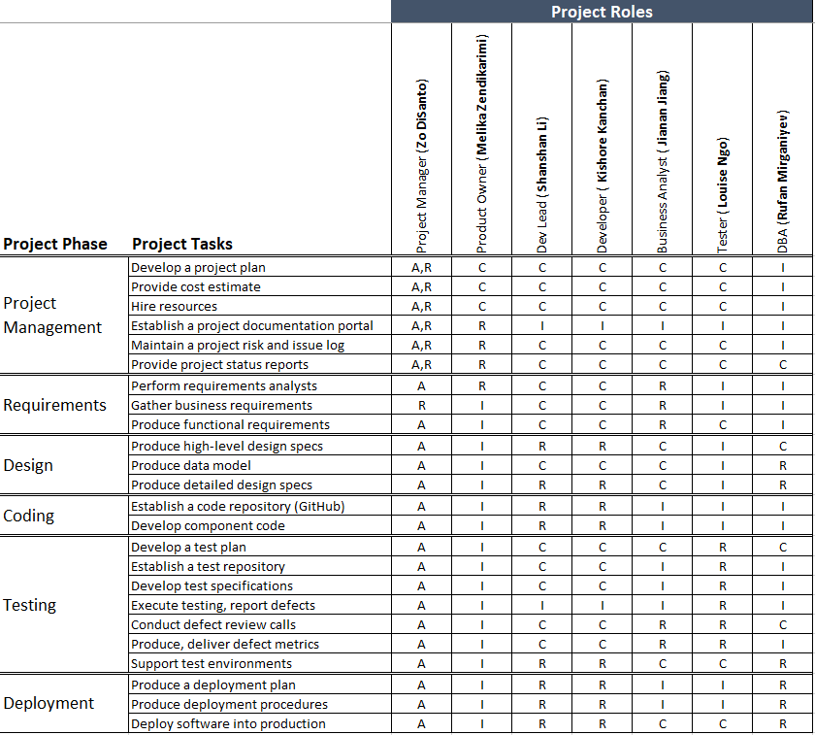

# Project Plan (assigned to Kishore)

This section will include a summary of the project plan, including a schedule of activities and resource requirements. Indicate, the team will follow the Waterfall Development methodology.

This semester (Project I), the project will follow the Waterfall Development model comprising the phases shown below. The implementation phase is scheduled for 2 weeks where the project team will implement the Home page and login features, laying grounds for the next semester.

The project plan includes 5 milestones defined below.

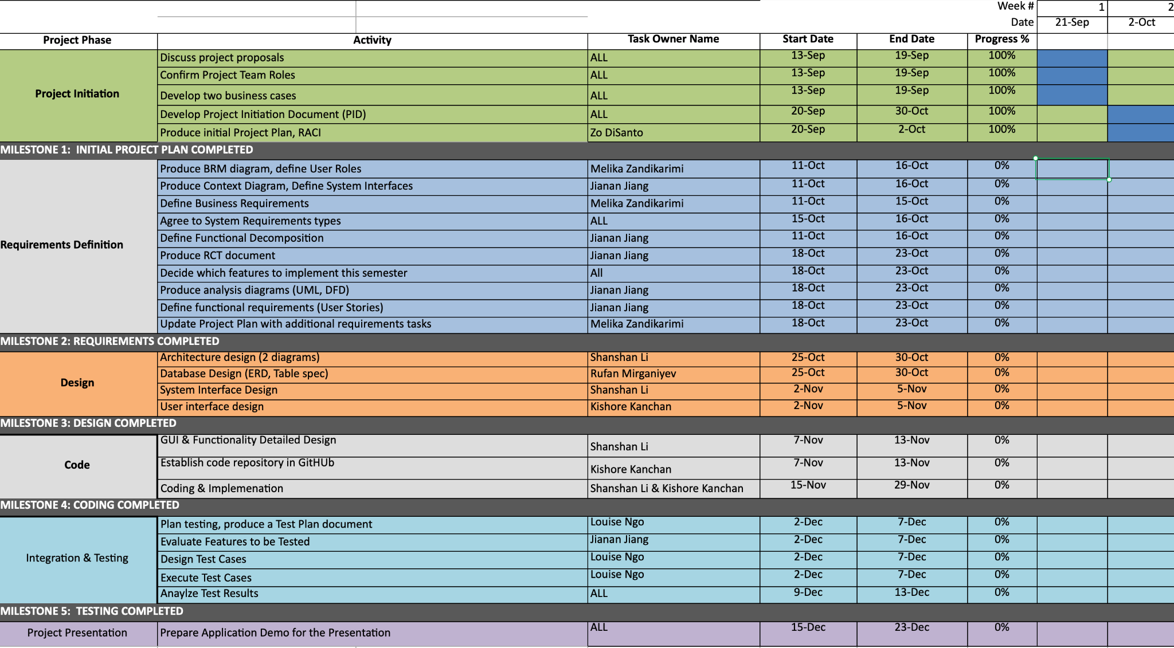

# 

# Project Controls (assigned to Louise)

* All project aspects will be maintained in English, including, but not limited to, communications, documents, and source code.
* Methods of communication include Zoom for video conferencing, text by Whatsapp among team members, and Slack for team and professor communication.
* Project documents will be kept and shared using Google Drive for remote access and ease of editing.
* Official meetings will be held at least twice a week, either in person or through remote video conferencing, in order to discuss progress, delegate tasks, and actively collaborate on project assets.
* All potential changes will be discussed in weekly meetings. Changes will only be made after considering everyone's opinions.
* Source codes are shared and controlled via [Github repository](https://github.com/zdisanto/CS691-Project1).

# Communication Plan (assigned to Kishore)

| Stakeholder | Frequency | Type | Purpose |
| --- | --- | --- | --- |
| Banking/CC Companies | At key stages | Meetings, Email and Phone calls | Integration and Management of payments, refunds and disputes |
| Delivery Partner | On every order | Meetings, Email and Phone calls | Integration and Management of product delivery and handling |
| Advertising  management group | Every week | Meetings and Email | Managing product advertisement and conversions |
| Finance group | At key stages | Meetings, Email and Phone calls | Managing funds and revenue |
| Customer support team | Daily | Meetings and Email | Resolving customer issues and requests regarding the product |