**Supplementary Requirement Release 2**

**Iteration 3**

1. CN - Connectivity

**Scope:**

* UC02.05 Add Artworks.
* UC02.06 Remove Artworks.
* UC02.07 Modify Artwork Information.

**Requirements:**

* When modifying artwork information, the system should retain caches to populate values, if the front-end is disconnected due to Network issue, or some error.
* System should also show a popup window with an error message,

“Connection failed, please try again later”.

**Conditions to Apply:** After the respective join points.

1. DF-In - Data Flow Out

**Scope:**

* UC02.05 Add Artworks.
* UC02.06 Remove Artworks.
* UC02.07 Modify Artwork Information.

**Requirements:**

* 02.05 Add artworks generates artworks data that is displayed in 02.06 Remove Artworks and 02.07 Modify Artwork Information.
* Artworks’ basic information and product type flows out.

**Conditions to Apply:** After the respective join points.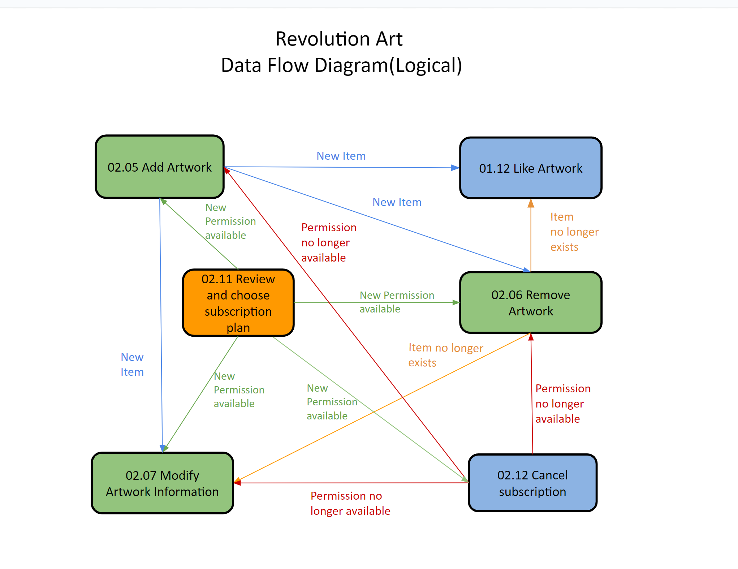

1. DF-In - Data Flow In

**Scope:**

* UC02.05 Add Artworks.
* UC02.06 Remove Artworks.
* UC02.07 Modify Artwork Information.

**Requirements:**

* When removing artworks, artworks’ information flows from 02.05 Add Artworks. When Modifying artwork information, artworks’ information flows from 02.05 Add Artworks and artwork no longer exists information flows from 02.06 Remove Artworks.
* Artworks’ basic information and product type flows in.

**Conditions to Apply:** After the respective join points

