**Supplementary Requirement Release 2: Iteration 4**

1. CN – Connectivity.

**Scope:**

* UC01.08 Cancel Subscription Plan.
* UC01.12 Like Artwork.
* UC02.12 Cancel Subscription Plan.

**Requirements:**

* If the front-end is disconnected due to Network issue, or some error. System should show a popup window with an error message: “Connection failed, please try again later”.

**Conditions to Apply:** After the respective join points.

1. DF-Out -Data Flow Out

**Scope:**

* UC01.08 Cancel Subscription Plan.
* UC02.12 Cancel Subscription Plan.

**Requirements:**

* 01.08 Cancel Subscription Plan generates data “permission is no longer available” and passes it to 01.12 Like Artwork. 02.12 Cancel Subscription Plan generates data “permission is no longer available ” to 02.05 Add Artwork, 02.06 Remove Artwork and 02.07 Modify Artwork Information.
* “Permission is no longer available ” flows out.
* **Conditions to Apply:** After the respective join points

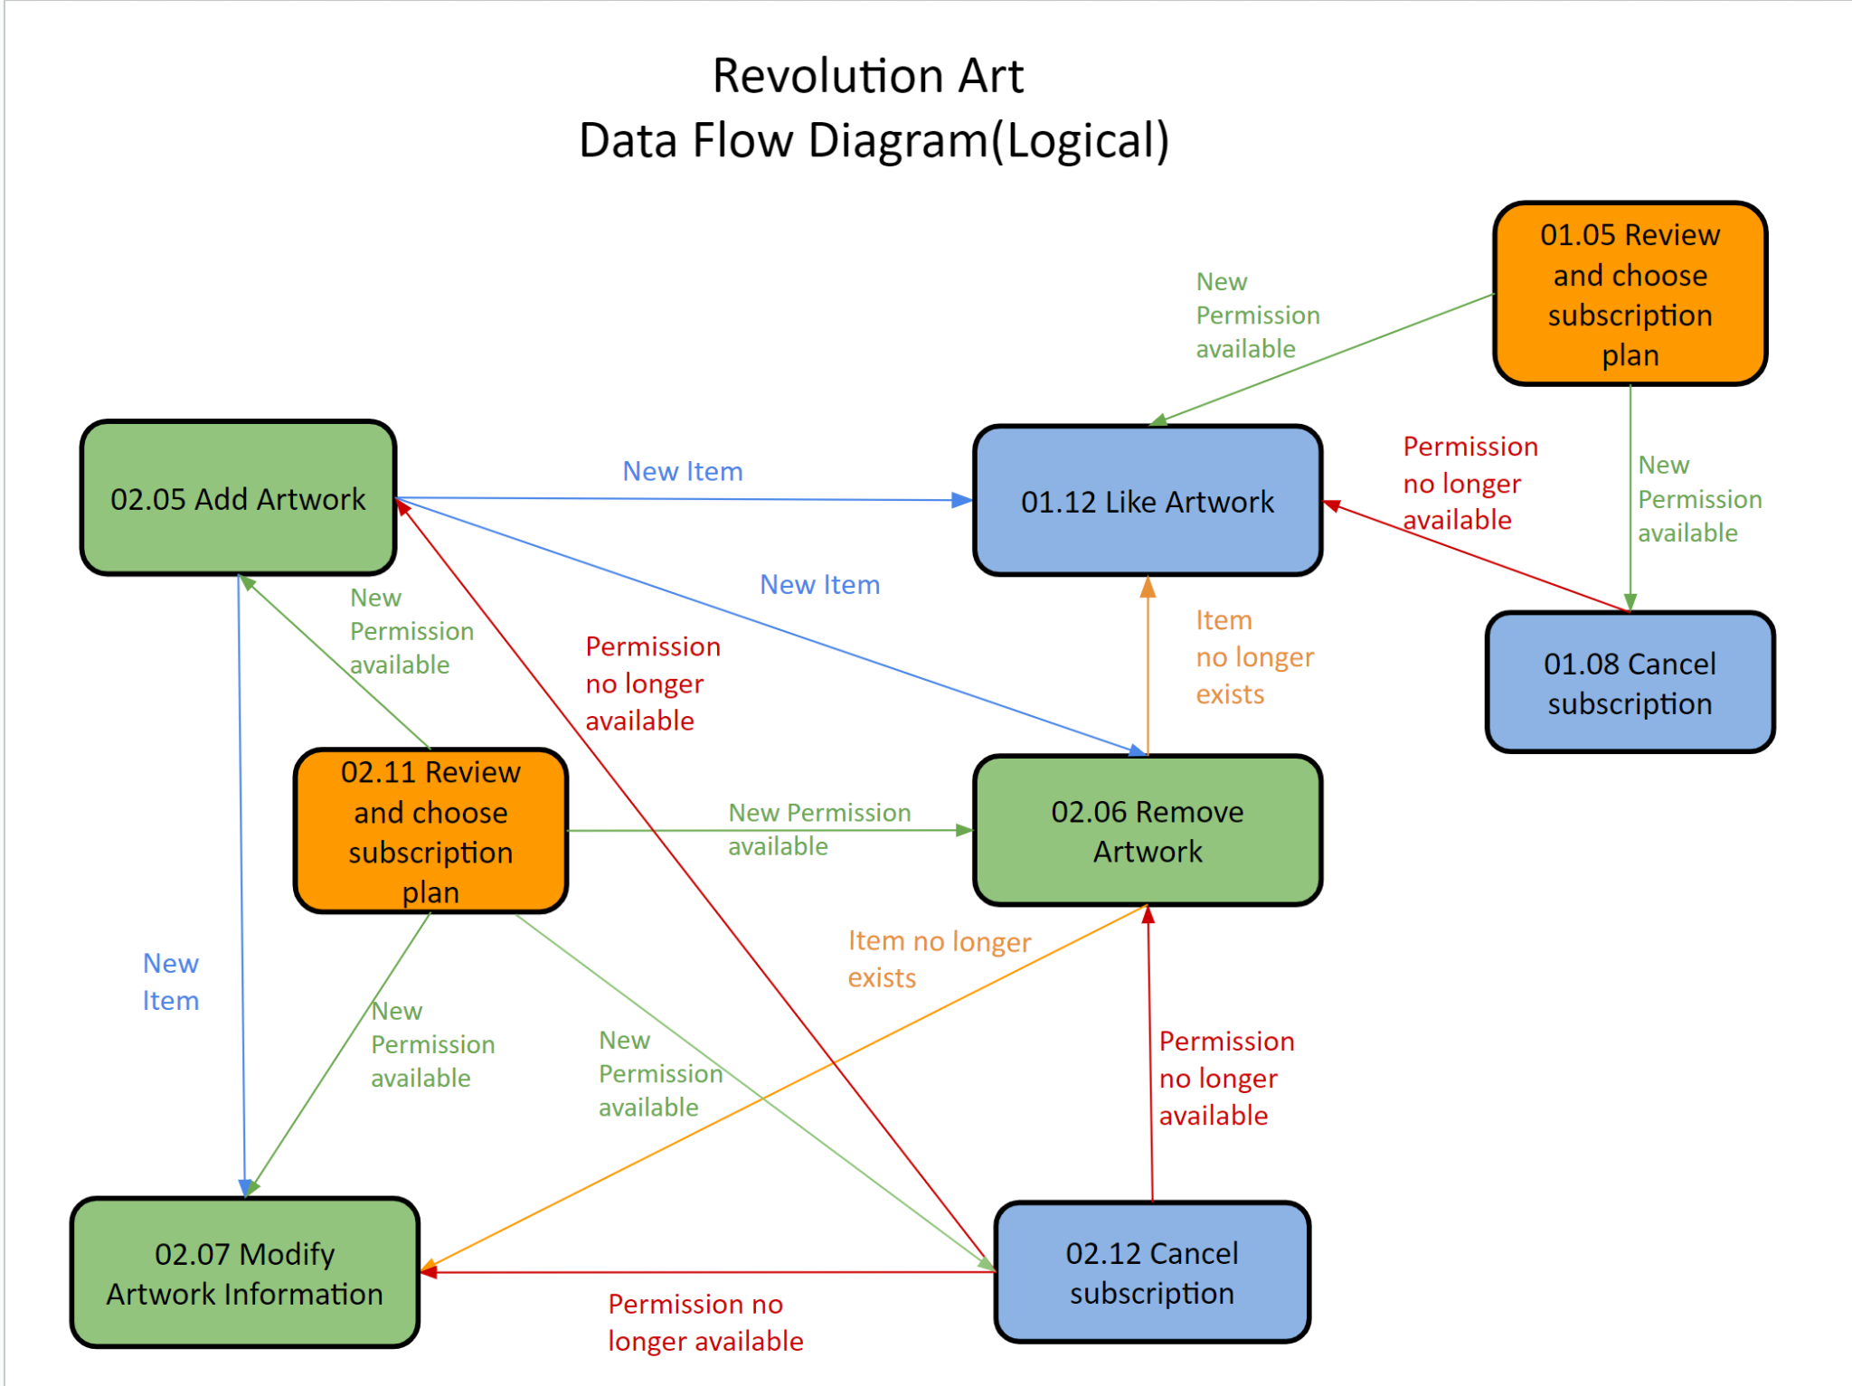

1. DF-In -Data Flow In

**Scope:**

* UC01.08 Cancel Subscription Plan.
* UC01.12 Like Artwork.
* UC02.12 Cancel Subscription Plan.

**Requirements:**

* 01.05 Review and Choose Subscription Plan generates data “New permission available” and passes it to 01.08 Cancel Subscription Plan. 01.08 Cancel Subscription Plan generates data “permission no longer available” and 02.06 Remove Artwork generates data “item no longer exists”, both these two pieces of data are passed to 01.12 Like Artwork.
* “Permission is no longer available ”, “New permission available ”and “item no longer exists” flows in.

**Conditions to Apply:** After the respective join points.

