常见错误

# 一．Maven报错总结

## 1.1解决Tomcat启动报Failed to start component [StandardEngine[Catalina].StandardHost[localhost]]

**问题描述：**

用Tomcat启动一个Maven项目时，启动不起来，报错如下：

03-Dec-2019 20:32:21.358 严重 [localhost-startStop-1] org.apache.catalina.core.ContainerBase.addChildInternal ContainerBase.addChild: start: org.apache.catalina.LifecycleException: Failed to start component [StandardEngine[Catalina].StandardHost[localhost].StandardContext[/fendo-SSM]] at org.apache.catalina.util.LifecycleBase.start(LifecycleBase.java:162) at org.apache.catalina.core.ContainerBase.addChildInternal(ContainerBase.java:753) at org.apache.catalina.core.ContainerBase.addChild(ContainerBase.java:729) at org.apache.catalina.core.StandardHost.addChild(StandardHost.java:717) at org.apache.catalina.startup.HostConfig.deployDirectory(HostConfig.java:1129) at org.apache.catalina.startup.HostConfig$DeployDirectory.run(HostConfig.java:1871) at java.util.concurrent.Executors$RunnableAdapter.call(Executors.java:511) at java.util.concurrent.FutureTask.run(FutureTask.java:266) at java.util.concurrent.ThreadPoolExecutor.runWorker(ThreadPoolExecutor.java:1142) at java.util.concurrent.ThreadPoolExecutor$Worker.run(ThreadPoolExecutor.java:617) at java.lang.Thread.run(Thread.java:748)Caused by: org.apache.catalina.LifecycleException: Failed to start component [org.apache.catalina.webresources.StandardRoot@7822458a] at org.apache.catalina.util.LifecycleBase.start(LifecycleBase.java:162) at org.apache.catalina.core.StandardContext.resourcesStart(StandardContext.java:4969) at org.apache.catalina.core.StandardContext.startInternal(StandardContext.java:5099) at org.apache.catalina.util.LifecycleBase.start(LifecycleBase.java:145) ... 10 more

开始一直关注 “Failed to start component ”这个错误，网上找了很多方法，都不行，后来看到还有一个错误是“java.util.zip.ZipException: invalid LOC header (bad signature)”，然后从这里入手，发现是mvn下载的jar包邮问题导致的，下面给出解决办法

2.解决方法

右键项目->Run as-> Maven test， 这里一定要注意：不要看到控制台打印出BUILD SUCCESS就认为是没问题的，要仔细看控制台的信息，如果出现

[WARNING] 读取C:\Users\PC\.m2\repository\org\springframework\spring-jdbc\4.3.12.RELEASE\spring-jdbc-4.3.12.RELEASE.jar时出错; invalid LOC header (bad signature)[WARNING] 读取C:\Users\PC\.m2\repository\org\springframework\spring-aspects\4.3.12.RELEASE\spring-aspects-4.3.12.RELEASE.jar时出错; invalid LOC header (bad signature)[WARNING] 读取C:\Users\PC\.m2\repository\javax\servlet\jstl\1.2\jstl-1.2.jar时出错; invalid LOC header (bad signature)

类似于如上的信息，就找到本地maven仓库的地址把出错的jar包删除掉，然后重新maven update一下，重新下载jar包，再启动就没问题了

注意：如果运行maven test没出现的话，先maven clean一下再执行maven test

1.2 Maven Install报错：Perhaps you are running on a JRE rather than a JDK?

**所遇问题：**

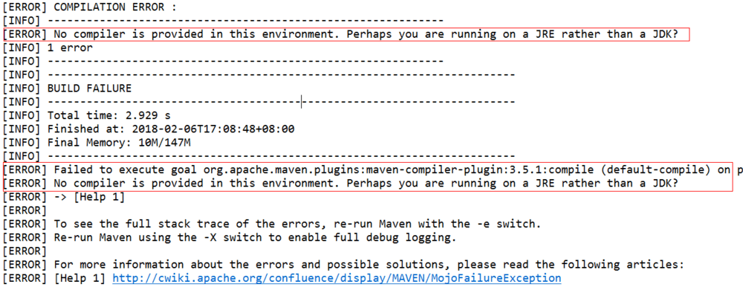

**英文描述：**

[ERROR] Failed to execute goal org.apache.maven.plugins:maven-compiler-plugin:3.5.1:compile (default-compile) on project busiservice: Compilation failure  
[ERROR] No compiler is provided in this environment. Perhaps you are running on a JRE rather than a JDK?

**中文描述：**此环境中未提供编译器，你可能使用jre运行而不是jdk。  
**引发原因：**Eclipse默认在jre上运行，maven install 编译需要jdk中的编译器，而jre中并没有  
**问题解决：**

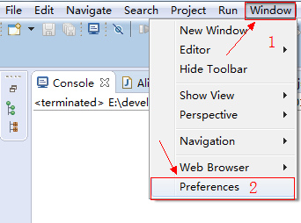

Window->Preferences

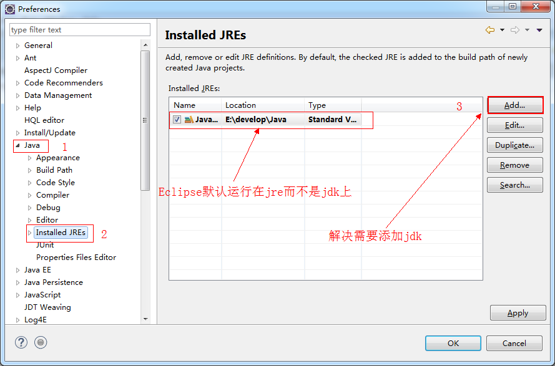

Java->Installed Rres->Add

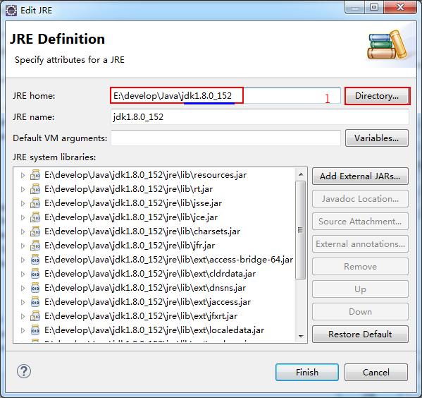

Directory...

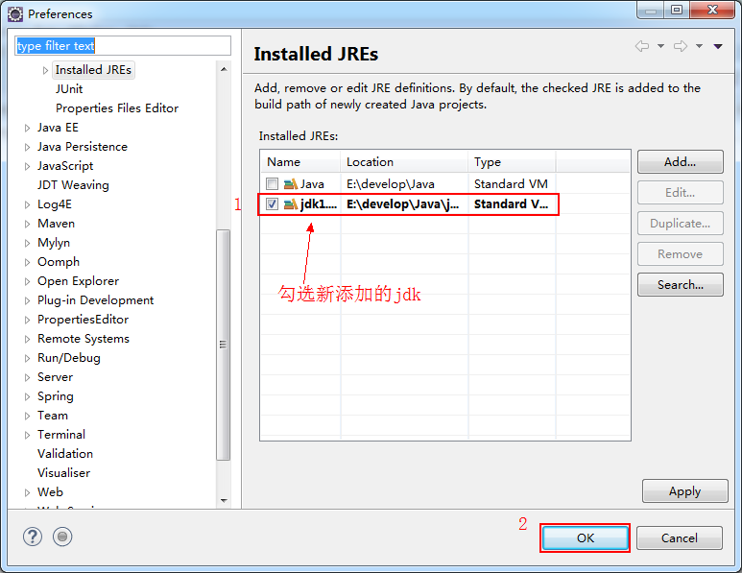

jdk->ok

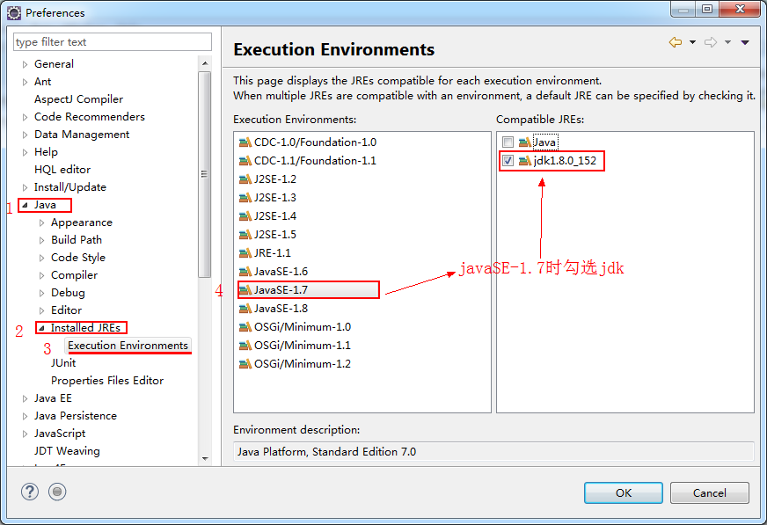

Java->Installed JREs->Execution Environments->JavaSE-1.7->jdk1.x

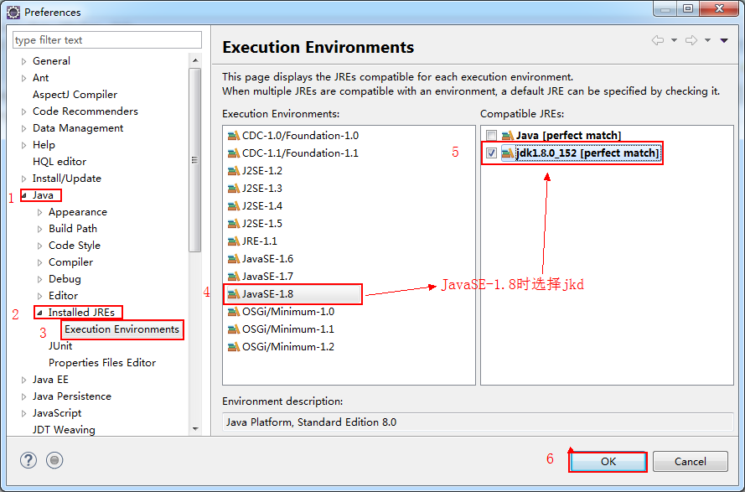

Java->Installed JREs->Execution Environments->JavaSE-1.8->jdk1.x

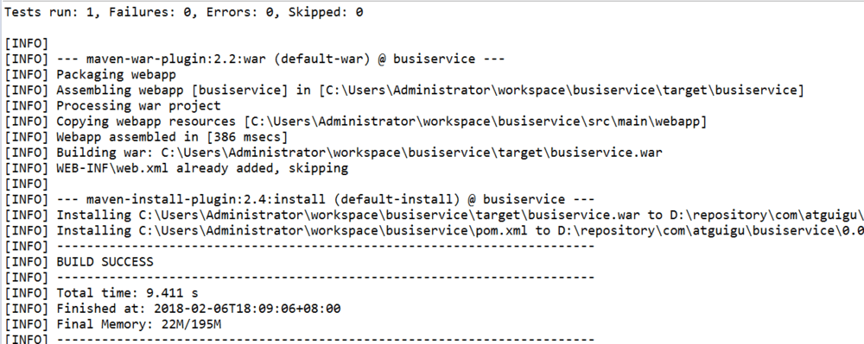

maven->install(编译成功)

1.3 **he server time zone value '?й???????' is unrecognized or represents more than one time zone.**  
问题描述： mysql连接数据库时提示系统时区出现错误the server time zone value '?й???????' is unrecognized or represents more than one time zone. You mus

解决方案：

在数据库驱动的url后加上serverTimezone=UTC参数。写代码的时候要注意，如果该参数是‘？’后的第一个，即

<property name="url" value="jdbc:mysql://localhost:3306/mybatis?serverTimezone=UTC" />

但如果不是第一个，即

<property name="jdbcUrl"> jdbc:mysql://localhost:3306/mybatis?characterEncoding=utf8&serverTimezone=UTC />1

这种写法是会报错的，会提示The reference to entity “serverTimezone” must end with the ‘;’ delimiter.

运行后控制台也会出现 对实体 “serverTimezone” 的引用必须以 ‘;’ 分隔符结尾。

修改为

<property name="jdbcUrl"> jdbc:mysql://localhost:3306/mybatis?characterEncoding=utf8&amp;serverTimezone=UTC />