实例60：打印和打印预览功能

实例说明
在本实例中，我们将制作一个能实现打印和打印预览功能的应用程序。程序运行结果如图60-1所示。
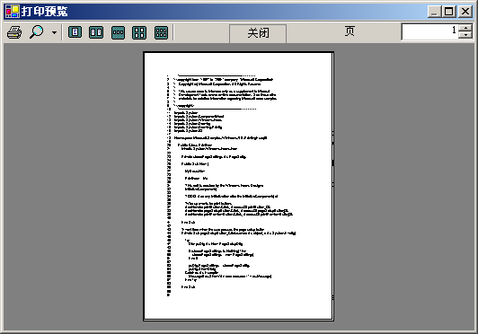
图60-1 运行结果

技术要点
- 打印预览功能的实现
- 打印功能的实现

实现过程
- 新建项目
打开Visual Studio.NET，选择“新建项目”，在项目类型窗口中选择“Visual Basic项目”，在模板窗口中选择“Windows应用程序”，在名称域中输入“PrintExample”，然后选择保存路径。单击“确认”。
- 添加控件和设置属性
向当前窗体上添加三个Button控件，将他们的Text属性改为和界面一致。
- 添加组件类和要打印的文件
通过菜单“项目|添加组件”为当前项目添加一个组件类，并添加一个需要打印的文件。
- 添加代码
'组件类中的代码
Imports System
Imports System.ComponentModel
Imports System.Windows.Forms
Imports System.Drawing
Imports System.Drawing.Printing
Imports System.IO
Namespace Microsoft.Samples.WinForms.VB.PrintingExample5
Public Class TextFilePrintDocument
Inherits PrintDocument
Private printFont As Font
Private streamToPrint As StreamReader
Public Sub New(streamToPrint As StreamReader)
MyBase.New
Me.streamToPrint = streamToPrint
End Sub
'Override OnBeginPrint to set up the font we are going to use
Overrides Protected Sub OnBeginPrint(ev As PrintEventArgs)
MyBase.OnBeginPrint(ev)
printFont = new Font("Arial", 10)
End Sub
'Override the OnPrintPage to provide the printing logic for the document
Overrides Protected Sub OnPrintPage(ev As PrintPageEventArgs)
MyBase.OnPrintPage(ev)
Dim lpp As Single = 0
Dim yPos As Single = 0
Dim count As Integer = 0
Dim leftMargin As Single = ev.MarginBounds.Left
Dim topMargin As Single = ev.MarginBounds.Top
Dim line as String
'Work out the number of lines per page
'Use the MarginBounds on the event to do this
lpp = ev.MarginBounds.Height / printFont.GetHeight(ev.Graphics)
'Check count first so that we don't read line that we won't print
line=streamToPrint.ReadLine()
While ((count < lpp) And Not(line Is Nothing))
yPos = topMargin + (count * printFont.GetHeight(ev.Graphics))
ev.Graphics.DrawString (line, printFont, Brushes.Black, leftMargin, yPos, new StringFormat())
count = count + 1
if (count < lpp) then
line=streamToPrint.ReadLine()
end if
End While
If (line <> Nothing) Then
ev.HasMorePages = True
Else
ev.HasMorePages = False
End If
End Sub
End Class
End Namespace
'主窗体中的代码
Imports System
Imports System.ComponentModel
Imports System.Windows.Forms
Imports System.Drawing
Imports System.Drawing.Printing
Imports System.IO
Namespace Microsoft.Samples.WinForms.VB.PrintingExample5
Public Class PrintForm
Inherits System.Windows.Forms.Form
Private storedPageSettings As PageSettings
Public Sub New ()
MyBase.New
PrintForm = Me
InitializeComponent()
AddHandler printButton.Click, AddressOf printButton_Click
AddHandler pageSetupButton.Click, AddressOf pageSetupButton_Click
AddHandler printPreviewButton.Click, AddressOf printPreviewButton_Click
End Sub
'页面设置
Private Sub pageSetupButton_Click(sender As object, e As System.EventArgs)
Try
Dim psDlg As New PageSetupDialog
If (storedPageSettings Is Nothing) Then
storedPageSettings = new PageSettings()
End If
psDlg.PageSettings = storedPageSettings
psDlg.ShowDialog
Catch ex As Exception
MessageBox.Show("An error occurred - " + ex.Message)
End Try
End Sub
'开始打印
Private Sub printButton_Click(sender As object, e As System.EventArgs)
Try
Dim streamToPrint As StreamReader = new StreamReader ("PrintMe.Txt")
Try
'使用缺省打印机
Dim pd As TextFilePrintDocument = new TextFilePrintDocument(streamToPrint)
If Not (storedPageSettings Is Nothing) Then
pd.DefaultPageSettings = storedPageSettings
End If
Dim dlg As New PrintDialog()
dlg.Document = pd
Dim result As DialogResult = dlg.ShowDialog()
If (result = System.Windows.Forms.DialogResult.OK) Then
pd.Print()
End If
Finally
streamToPrint.Close()
End Try
Catch ex As Exception
MessageBox.Show("An error occurred printing the file - " + ex.Message)
End Try
End Sub
'打印预览
Private Sub printPreviewButton_Click(sender As object, e As System.EventArgs)
Try
Dim streamToPrint As StreamReader = new StreamReader ("PrintMe.Txt")
Try
Dim pd As TextFilePrintDocument = new TextFilePrintDocument(streamToPrint)
If Not (storedPageSettings Is Nothing) Then
pd.DefaultPageSettings = storedPageSettings
End If
Dim dlg As New PrintPreviewDialog()
dlg.Document = pd
dlg.ShowDialog()
Finally
streamToPrint.Close()
End Try
Catch ex As Exception
MessageBox.Show("An error occurred - " + ex.Message)
End Try
End Sub
Public Overloads Overrides Sub Dispose()
MyBase.Dispose()
components.Dispose()
End Sub
<STAThread()> Shared Sub Main()
System.Windows.Forms.Application.Run(New PrintForm())
End Sub
End Class
End Namespace
- 运行程序
单击菜单“调试|启动”或单击 图标运行程序。

小结
在打印和打印预览时，我们可以使用PrintPreviewDialog，PrintPreviewControl控件和PrintDocument控件来实现。

