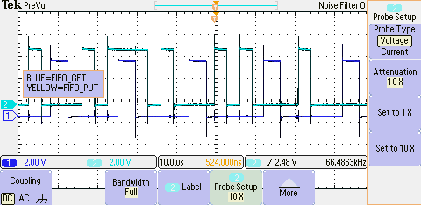Part B) The lab 2 starter project had two threads, a foreground and a background. The foreground would set PT1 when it called Fifo_Get() and clear it when it returned. The interrupt would set PT0 when it started and clear it when it returned. The interrupt would fire at an incrementing amount of cycles (23) so that it was not fundamentally periodic. Because of this, the Fifo_Get() would sometimes get interrupted, and sometimes not. The screenshot below shows the reactions of PT0 and PT1. Since the oscilloscope inverted the colors, the green waveform is Fifo_Get and the blue waveform is Fifo_Put (the interrupt).

Part C) The first version takes 48 cycles to execute. The second one takes 10336 cycles. The third one takes 85 cycles.

Part D) Using the scope, we get 2.13 us. The first Fifo_Get function is 48 cycles/24000000 cycles per second = 2 us. The measurement error for setting and clearing PT0 is 160 ns = .16 us. So the advantages of using the TCNT method are that we can store it in memory and it is very accurate, but storing TCNT takes some execution time. The advantage of the scope is that it introduces no unnecessary execution time. The disadvantage of the scope method is that it introduces error in the total measurement. However if the error is compensated then the scope method gives 1.97 us which is only a 1.5% difference between methods.

Part E) Txt file needing to be changed to excel. And pdf the source code for arrows. And data-flowgraph with labeled arrows.

Part F) Four Pins are changed during different stages of the code execution. PTT is changed to 0x01 when entering and leaving the interrupt routine. PT1 is toggled before calling Fifo_Get() and after calling it. PT2 is toggled inside of Fifo_Get() and PT3 is toggled inside of Fifo_Put(). So when PTT = 0x01, the interrupt is occurring, and when PTT = 0x09 the interrupt has called Fifo_Put(). When PTT = 0x02, the program is in the foreground, but is not calling Fifo_Put(). When PTT = 0x06, the foreground is calling Fifo_Put().

Part G)