A) Objectives

This lab is designed to teach us how to optimize an existing hardware/software interface between a LCD display and a microcomputer, design a hardware/software interface for three switches using key wakeup, to design a hardware/software driver for generating single tones on a speaker, to measure supply current necessary to run the embedded system, and to implement a digital alarm clock.

B) Hardware Design

The LCD interface and speaker interface are on the schematic on the last page.

C) Software Design

We organized the system the same as Figure 3.4 and 3.5, so the data flow and call graphs are the same.

D) Measurement Data

LCD Supply voltage vs. Time as the system powers up

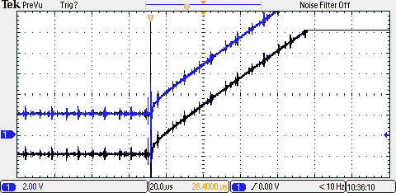

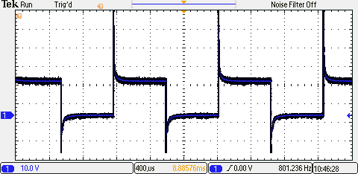Speaker Voltage vs. Time during an alarm

The current required to run the alarm clock with the alarm is 120 mA and without the alarm is 5 mA.

E) Analysis and Discussion

1) Give two ways to remove a critical section.

Make the shared global more local in scope or make the offending section atomic.

2) How long does it take to update the LCD with a new time?

A full update to the LCD takes about 530 us.

3) What would be the disadvantage of updating the LCD in the background ISR?

If the ISR updates the LCD then when the interrupt fires to add a second, the clock start to be off. Also the majority of the program will be in an interrupt leaving little processing power for any foreground code.

4) Did you use the LCD clear function? If so, how could you have redesigned the LCD update to run much faster?

Yes, but we could have just overwritten all of the character slots since we were already over writing 8 out of 16 of the slots if the alarm was off.

5) Assuming the system were battery powered, list three ways you could have saved power.  
 1) Only update the LCD character slot that changes instead of rewriting every slot.  
 2) Synchronize the interrupts so that updating the LCD can run in an interrupt between each update to the seconds.  
 3) Find a way to make the microcontroller sleep when interrupts are not firing.