1. Jerk is the change in acceleration of an object. Jerk can be minimized by smoothing out the changes in acceleration.
2. 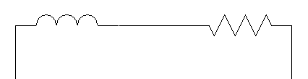

Resistor

Inductor

1. The interface must be able to output enough current to activate the coils of the motor. The base resistor was chosen to create a high enough current from the 5 volt power, while using the transistor protected the output pins because they can only output a continuous 10 mA out of the required 120 mA.
2. Because there are always two motor coils drawing current since each possible output has two 1s.
3. The motor drew 310 mA while running at 5V so the electrical power is 1.550 W. The mechanical power is the force required to push the worm gear times the distance moved. They are proportional because the higher the electrical power, the more power will be transferred to the mechanical work.