Objectives) The goals of this lab were to interface a stepper motor, to implement background processing with periodic interrupts, and to develop a dynamic linked command structure.

Hardware Design) See last page of the report for the schematic.

Software Design) The LRC scanner was not working, but we can provide the paper state graph if asked. The system is the same as Figure 4.3 and 4.4 so we did not have to draw the data flow or call graph.

Measurement Data) The resistance of one coil of wire is 37.7 ohms. At 5 volts, the current through one coil of wire is 130 mA. The fastest rate that our motor can vibrate back and forth is 24 Mhz / 128((6(DELAY1) + 4(DELAY2) + 4(DELAY3))) = 9.69 Hz. During operation, the totally current required was 360 mA idle and 310 mA while moving.

Analysis and Discussion)

1. Jerk is the change in acceleration of an object. Jerk can be minimized by smoothing out the changes in acceleration.
2. 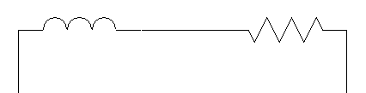Components of a motor coil.

Resistor

Inductor

1. The interface must be able to output enough current to activate the coils of the motor. The base resistor was chosen to create a high enough current from the 5 volt power, while using the transistor protected the output pins because they can only output a continuous 10 mA out of the required 120 mA.
2. Because there are always two motor coils drawing current since each possible output has two 1s.
3. The motor drew 310 mA while running at 5V so the electrical power is 1.550 W. The mechanical power is the force required to push the worm gear times the distance moved. They are proportional because the higher the electrical power, the more power will be transferred to the mechanical work.