1. The tested scene is OldBrickHouse. In rendering process, image was generated with the help of one of the following techniques : TAA/ DLSS/XeSS/TUS. Videos are encoded via ffmpeg or MSDK. As for MSDK, in this round, videos are all encoded in SG1 server, and bitrate are set to 6/10/15/20 Mbps. PSNR values are noted to evaluate video qualities in different configurations.
2. The encoded video quality is overall quite sensitive to Bitrate configs: the higher the bitrate is set, the better the quality will be.

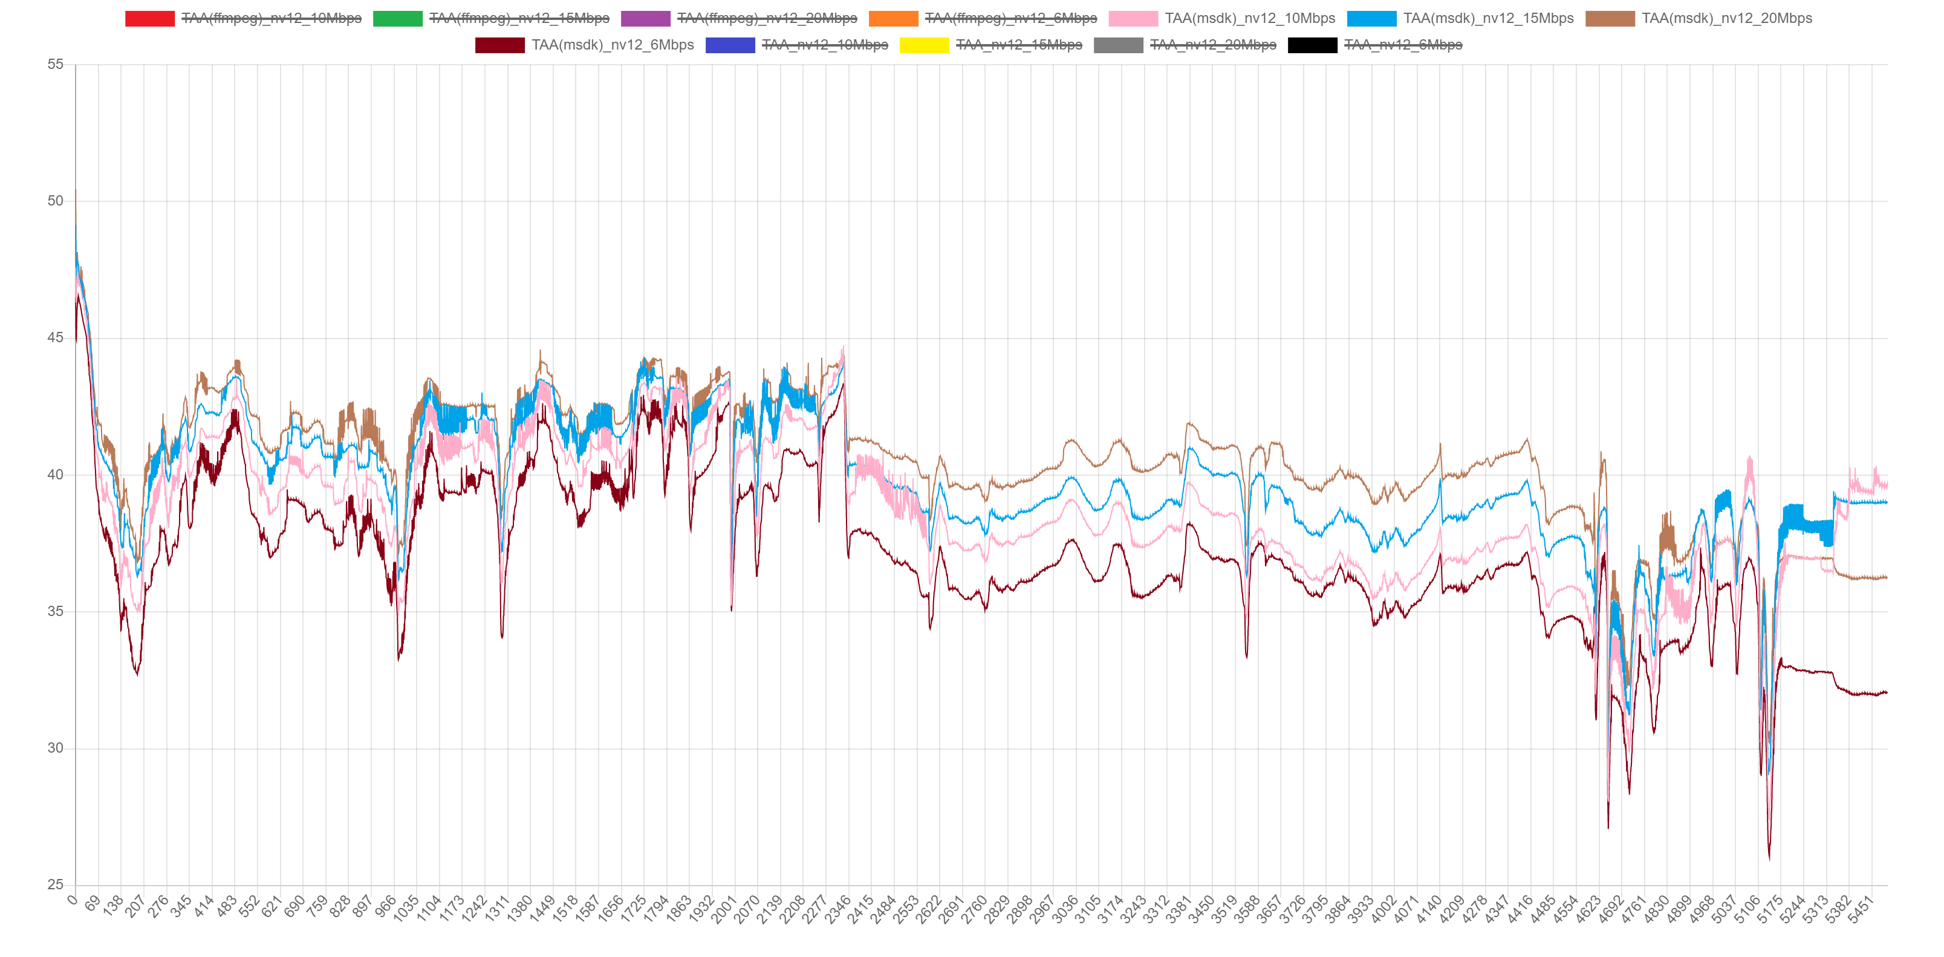

Case of MSDK encoding for TAA images at different bit rates.

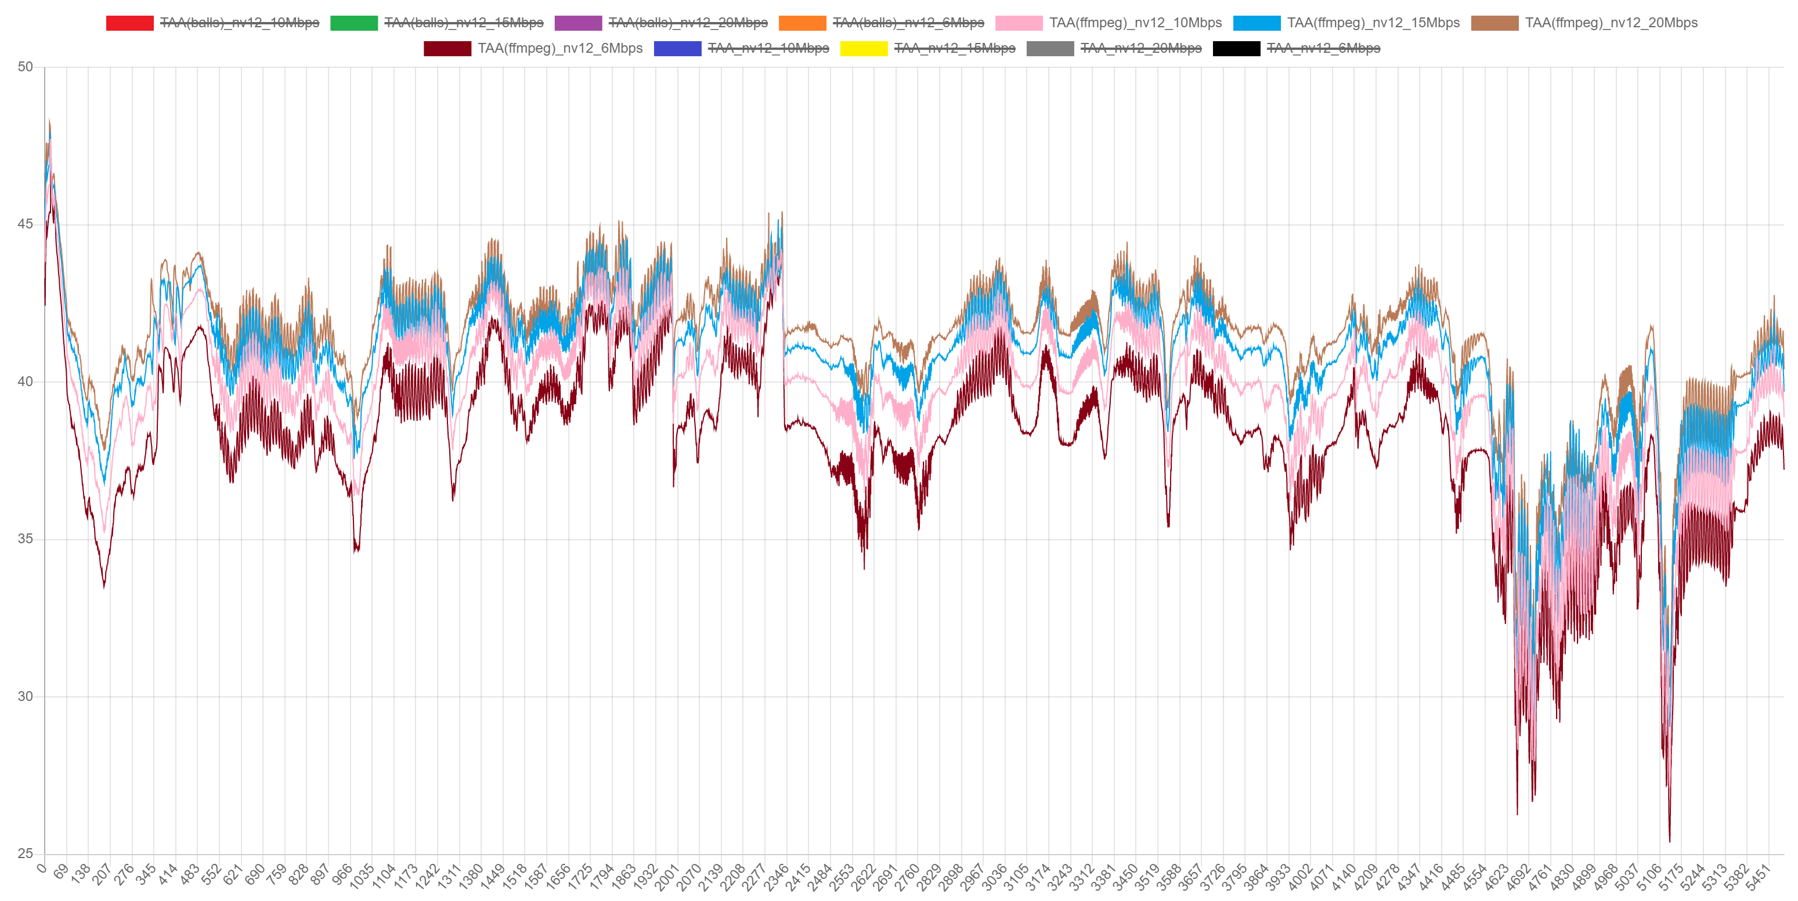

Case of ffmpeg encoding for TAA images at different bit rates.

It could be seen that in different region, sensitivity of Bitrate is different for video qualities, as the image above refers, in region from frame 2300~ frame 5000, video quality varies more when bitrate changes. Meanwhile, in region from frame 0~ frame 2300, change of bitrate does not cause that much incline/decline on video quality.

1. As for MSDK encoding, params [-TransformSkip], [-PicTimingSEI] and [-NalHrdConformance] will affect video quality. Specifically in OldBrickHouse scene, turning HRD on will increase the video quality, while turning TransformSkip on will decrease it. Initially, average quality of video encoded by MSDK is lower than that encoded by ffmpeg. Changing parameters will change the situation.

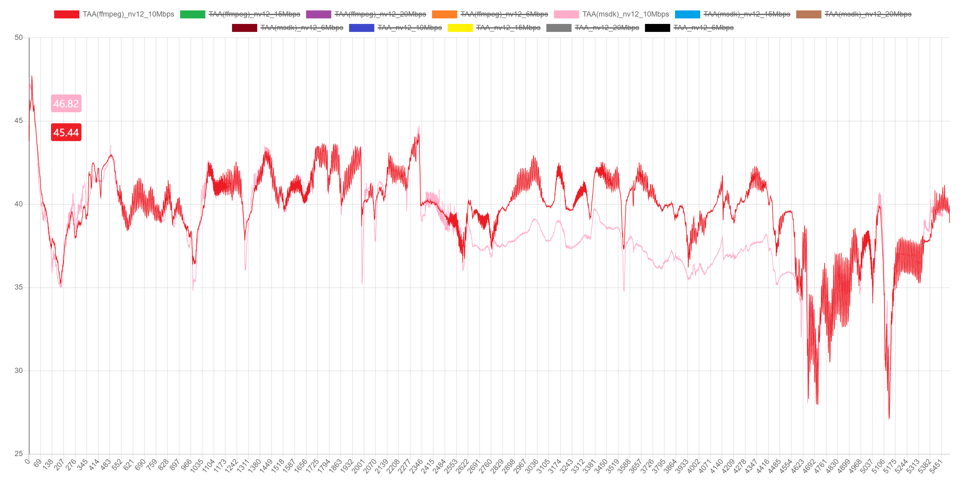

Case of rendering @ 10Mbps by MSDK(pink) and ffmpeg(red). Could see that ffmpeg could produce higher quality in that “bitrate sensitive” region.

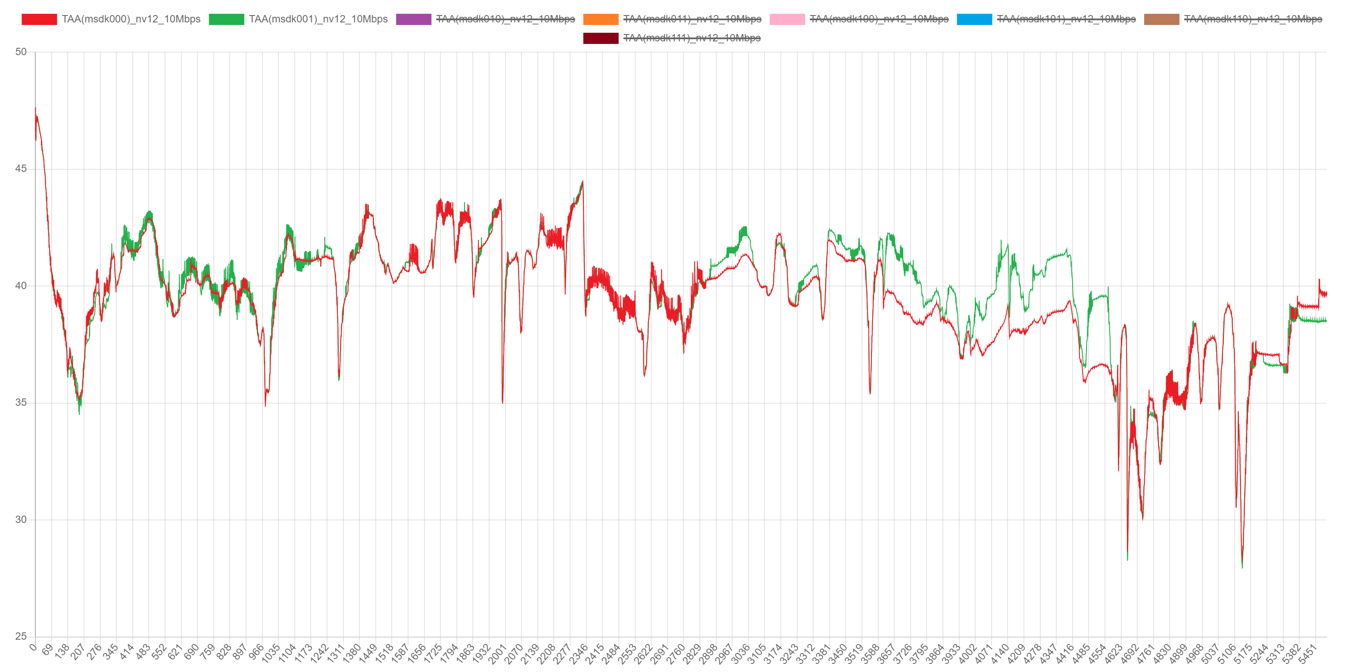

Case of rendering @10Mbps by MSDK with HRD on(green) and HRD off(red). Could see that HRD could increate video quality.

In this case, if we turn HRD on, the curve of video quality will be quite similar to that of video encoded by ffmpeg.

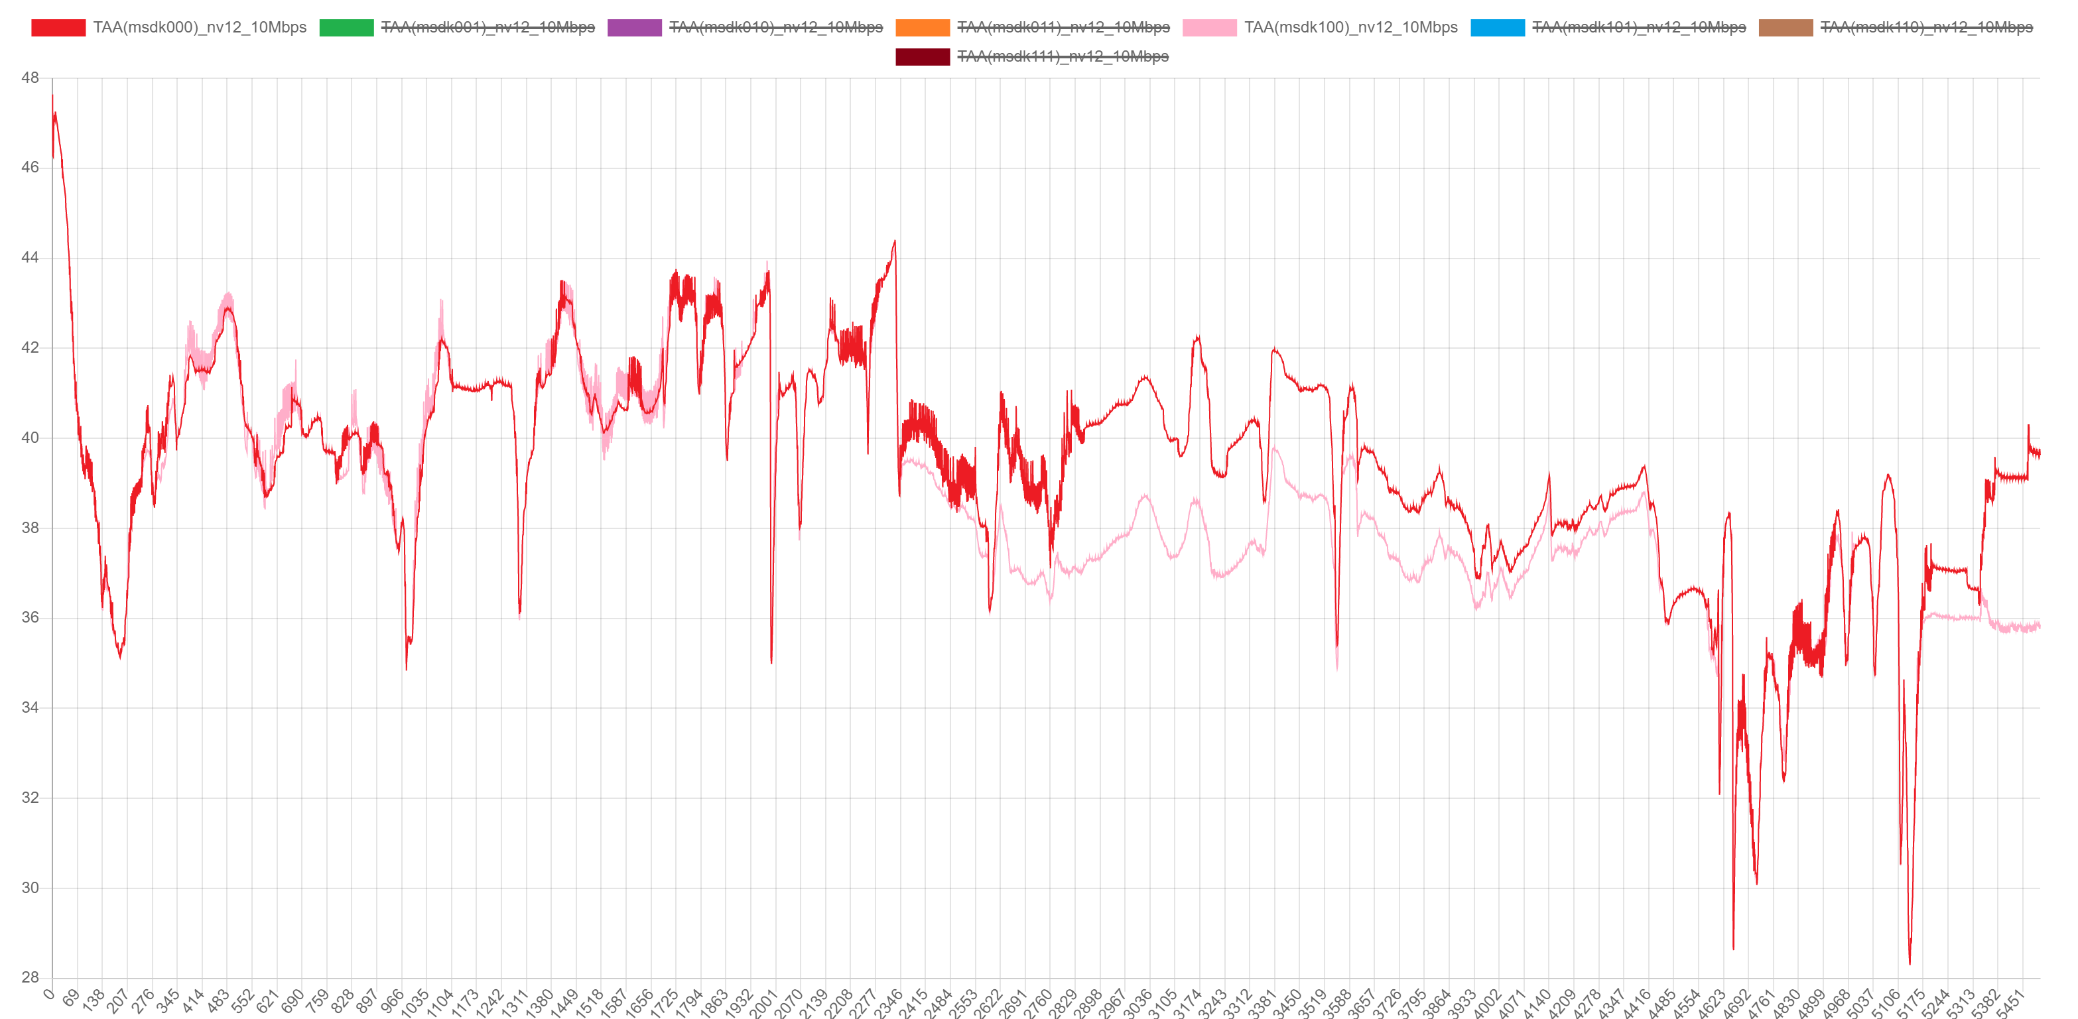

Case of rendering @10Mbps by MSDK with TransformSkip on(pink) and off(red). Could see that turning TransformSkip on make the quality decline.

1. We’ve compared quality loss of MSDK-encoded videos rendered with different techniques including DLSS/TAA/XeSS/TAAU. It turns out that encoding will cause different level of quality loss on different render techniques.

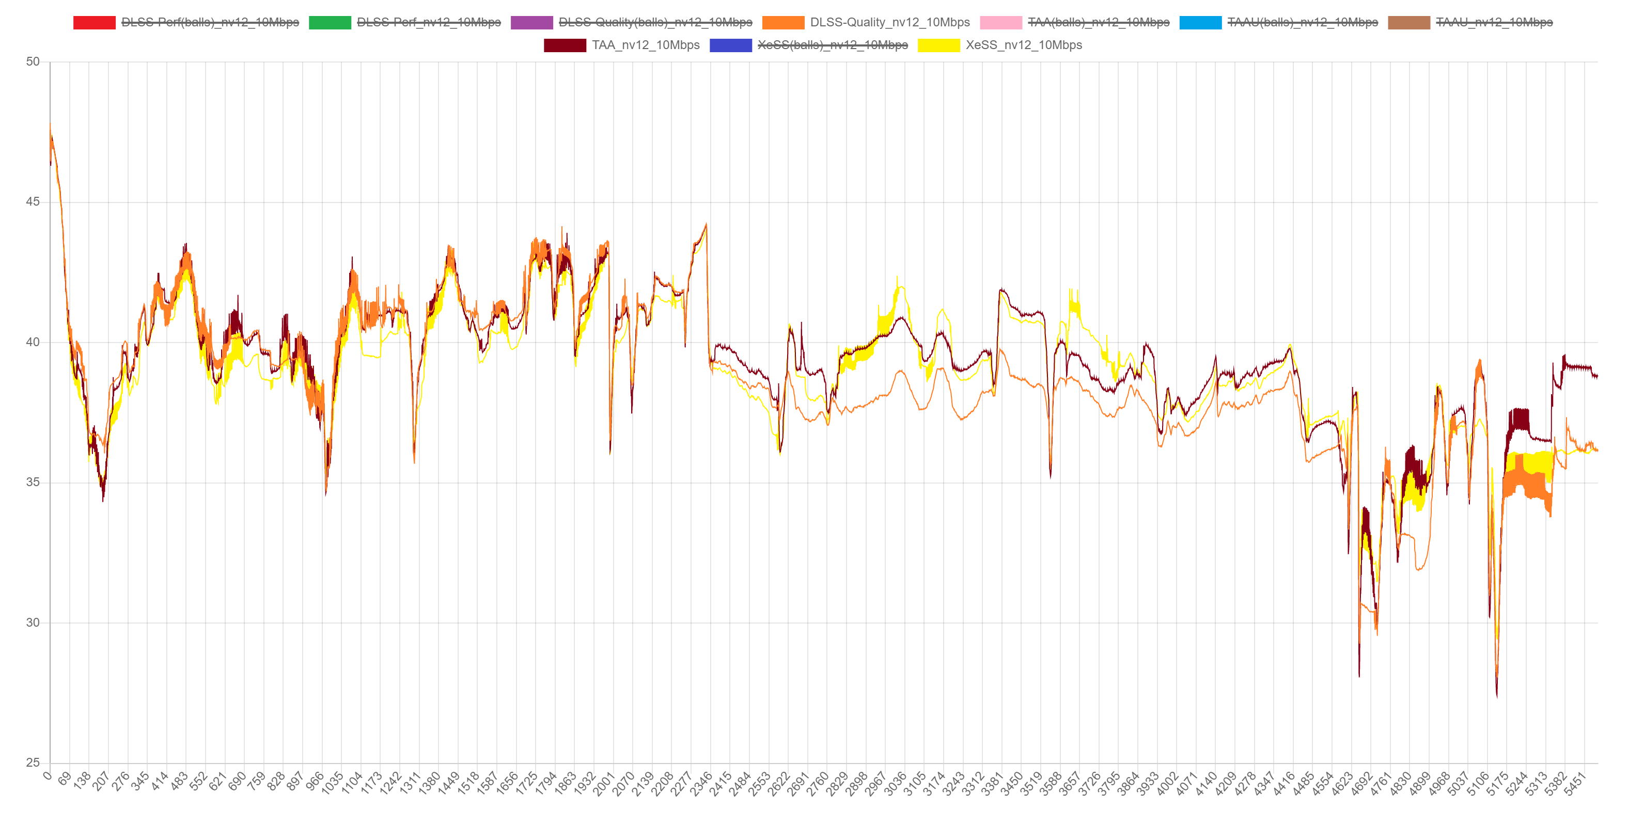

PSNR values of encoded videos rendered with TAA(brown), DLSS_Quality(orange) and XeSS(yellow), in the “bitrate sensitive” area, it seems that DLSS images have more quality loss than that of TAA images/XeSS images.

1. We’ve added three moving balls (red, blue & green) into the OldBrickHouse scene to make the whole scene more complex. We evaluated the PSNR value with/without the balls to see if the presence of moving balls could change the level of quality loss.

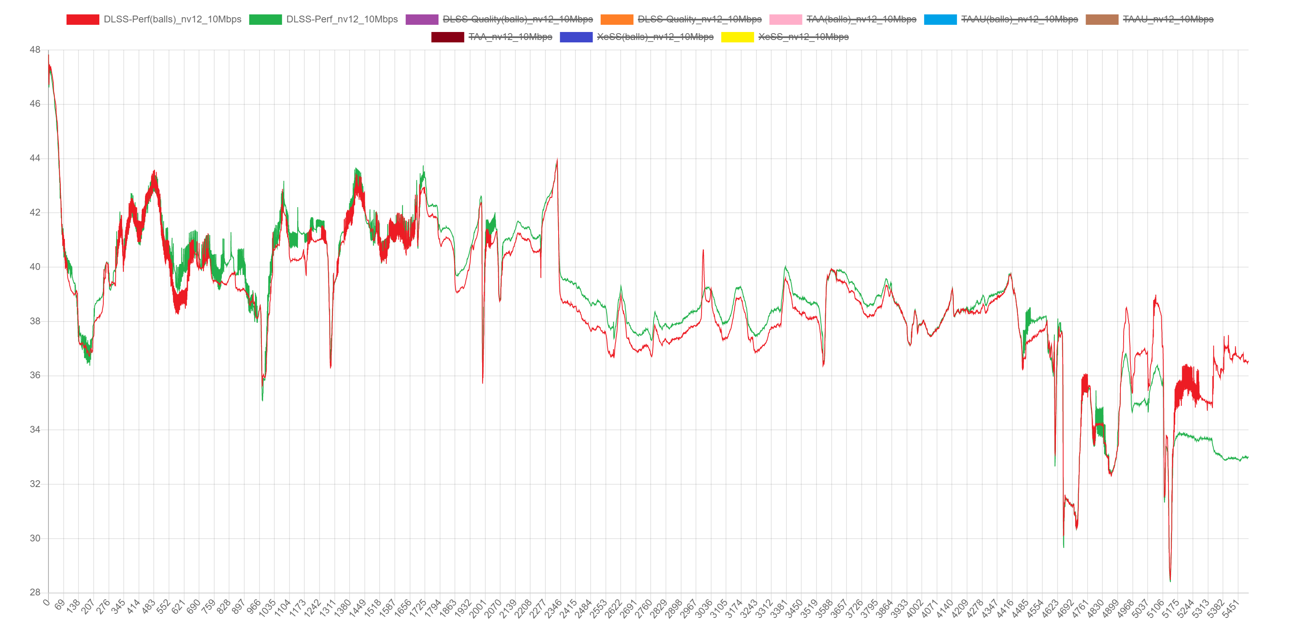

For DLSS_performance, video quality has a slight decline with the balls present.

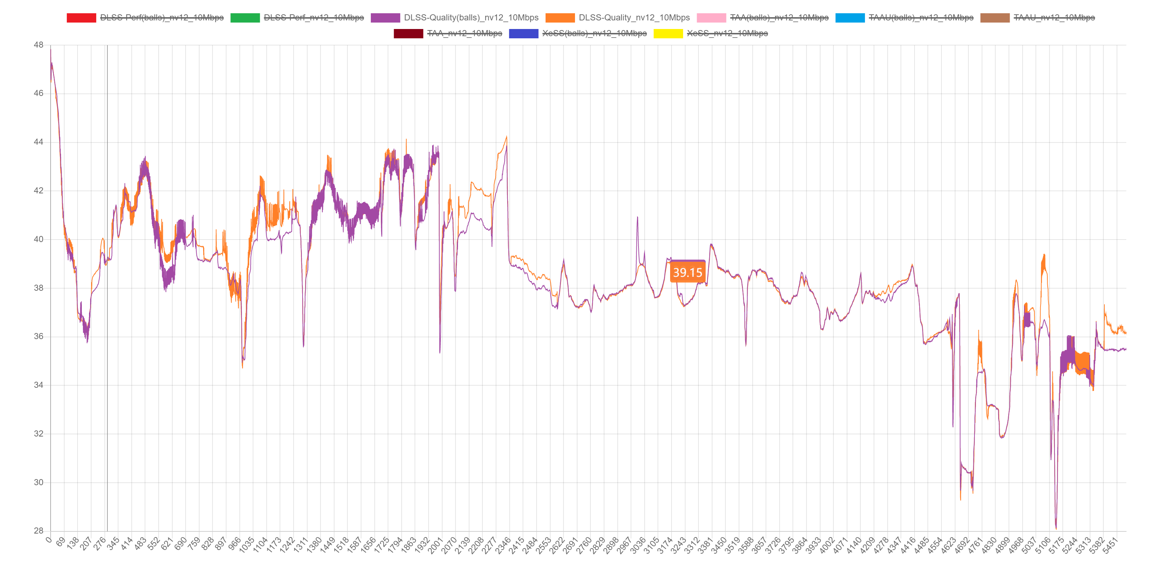

For DLSS_performance, presence of balls does not have obvious impacts.

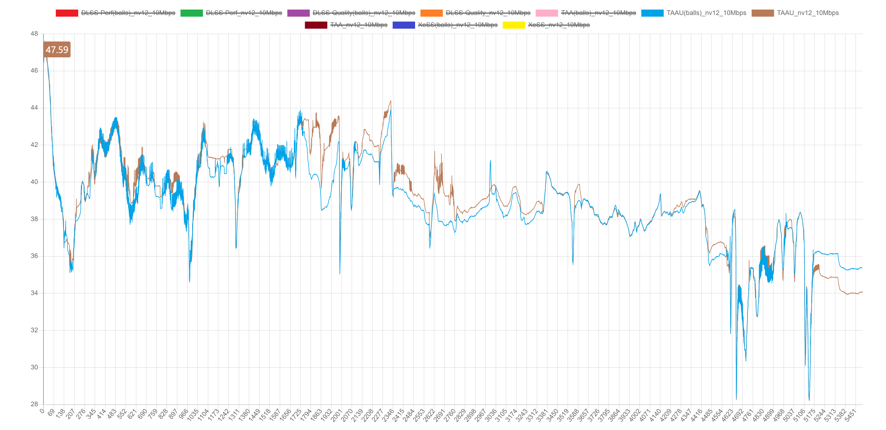

In case of TAAU, still the presence of balls will cause the video quality to drop a little bit.

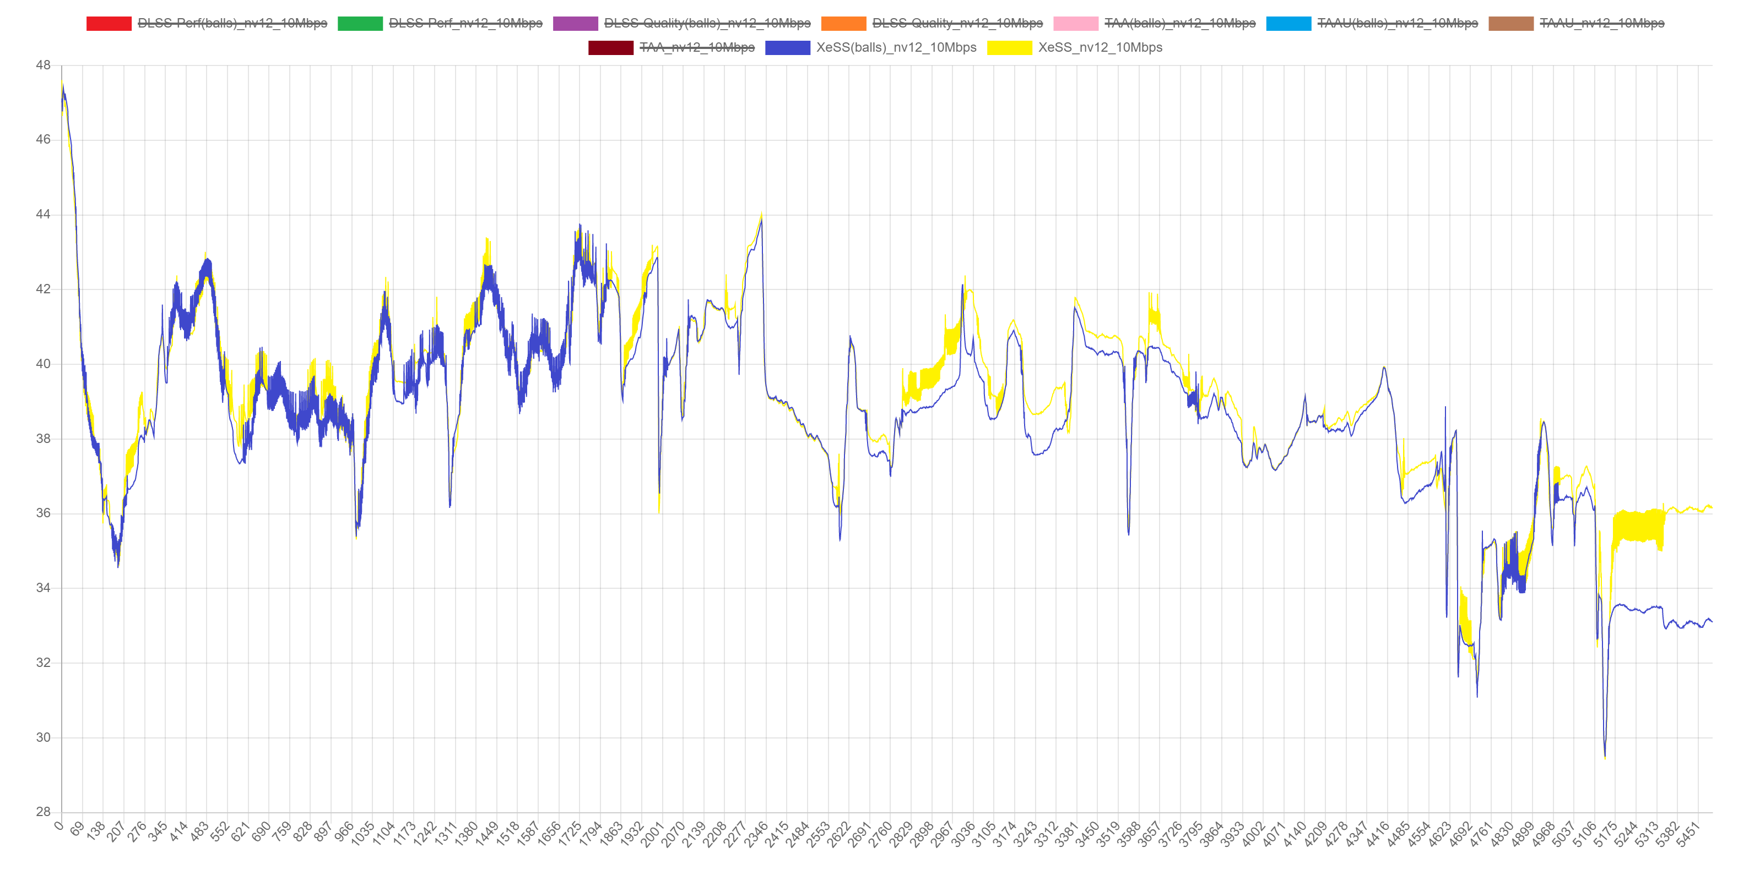

In XeSS, could also see some observable decline of quality with the balls moving in the scene.

There is a strange issue present in these cases: in the last few frames (after frame 5000) of the scene, balls are not inside (balls are set to disappear at frame 5208), and the images are supposed to be the same with/without the balls. However, the quality loss turns out to be different in this part. It is required to figure out the main causes of that.