DSAA2011 Covertype Project Report
2026 Spring

Introduction
This project analyzes the UCI Covertype dataset, which contains 581,012 forest observations, 54 cartographic features, and a seven-class forest cover target. The largest class is 2 (Lodgepole Pine, 48.8%), while the smallest class is 4 (Cottonwood/Willow, 0.5%), so macro-averaged metrics are more informative than accuracy alone.
The main result is that natural clusters do not align strongly with the seven cover types, but supervised tree ensembles perform well. On a stratified 120,000-row modeling sample, the best test model is Random Forest, with accuracy=0.902, macro-F1=0.845, and macro one-vs-rest AUC=0.991.
Cover_Type | Cover_Type_Name | count | proportion
1 | Spruce/Fir | 211,840 | 36.5%
2 | Lodgepole Pine | 283,301 | 48.8%
3 | Ponderosa Pine | 35,754 | 6.2%
4 | Cottonwood/Willow | 2,747 | 0.5%
5 | Aspen | 9,493 | 1.6%
6 | Douglas-fir | 17,367 | 3.0%
7 | Krummholz | 20,510 | 3.5%

1. Data Preprocessing
The raw UCI file is a numeric, comma-separated table without headers. The preparation script preserves the original data/covtype.data.gz, assigns the official feature names, and writes data/covertype.csv.gz. There are no missing values in the prepared data (maximum missing ratio=0.000). The first 10 variables are continuous terrain measurements, followed by 4 wilderness-area indicators and 40 soil-type indicators. For linear models and distance-based methods, the continuous variables are median-imputed and standardized, while binary indicators are imputed by their mode and kept as indicators. Tree-based models use the same feature set without scaling.
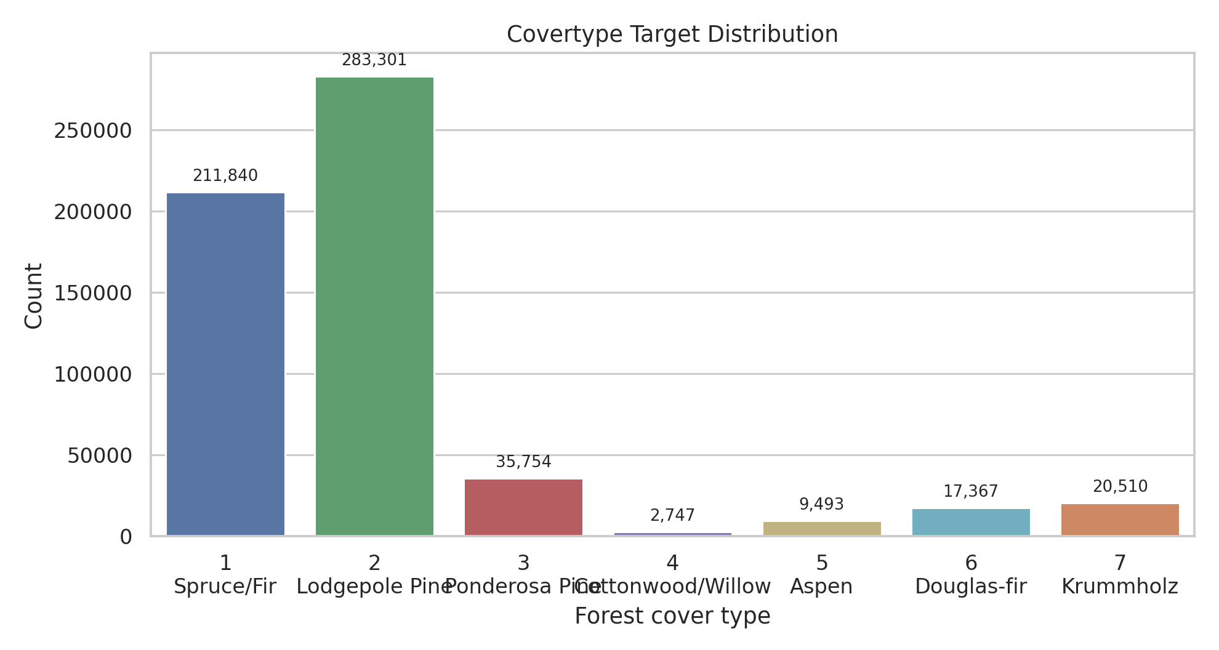
Target distribution

2. Data Visualization
t-SNE is applied to a stratified 6,000-row sample after standardization and PCA compression to 30 dimensions. The embedding shows partially separated regions for high-elevation classes such as Spruce/Fir and Krummholz, while Spruce/Fir and Lodgepole Pine overlap heavily. Rare classes are visible in local pockets but do not form clean global islands, which suggests that cover type is shaped by interacting terrain features rather than a single low-dimensional boundary.
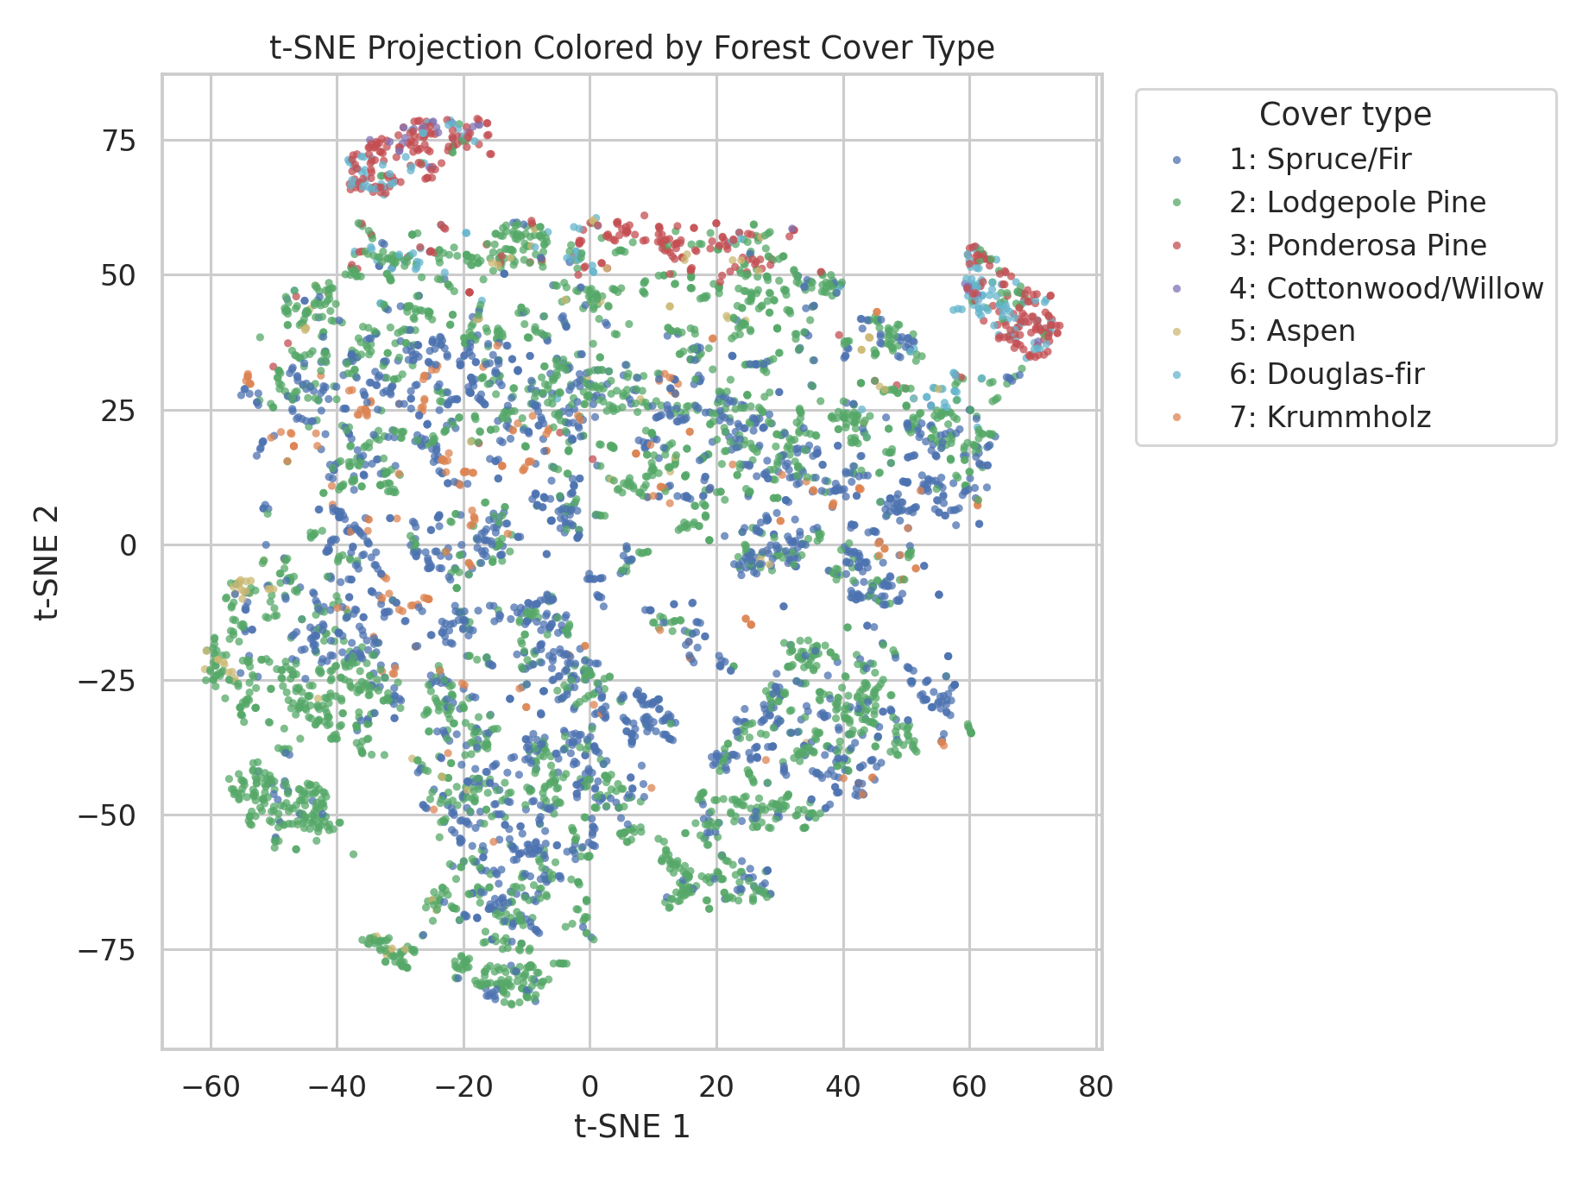
t-SNE projection

3. Clustering Analysis
MiniBatchKMeans and Ward hierarchical clustering are evaluated on stratified samples using silhouette, Calinski-Harabasz, and adjusted Rand index against the true cover labels. Both algorithms select k=2 by silhouette, but their ARI values are close to zero. This means the strongest unsupervised split is not the same as the seven ecological labels. MiniBatchKMeans is used instead of ordinary K-Means because it has the same interpretation but scales better to larger samples; Ward is kept as a small-sample dendrogram-based structural check.
algorithm | k | silhouette | calinski_harabasz | ARI_vs_Target
MiniBatchKMeans | 2 | 0.191 | 1340.066 | 0.003
Agglomerative Ward | 2 | 0.153 | 406.143 | 0.004
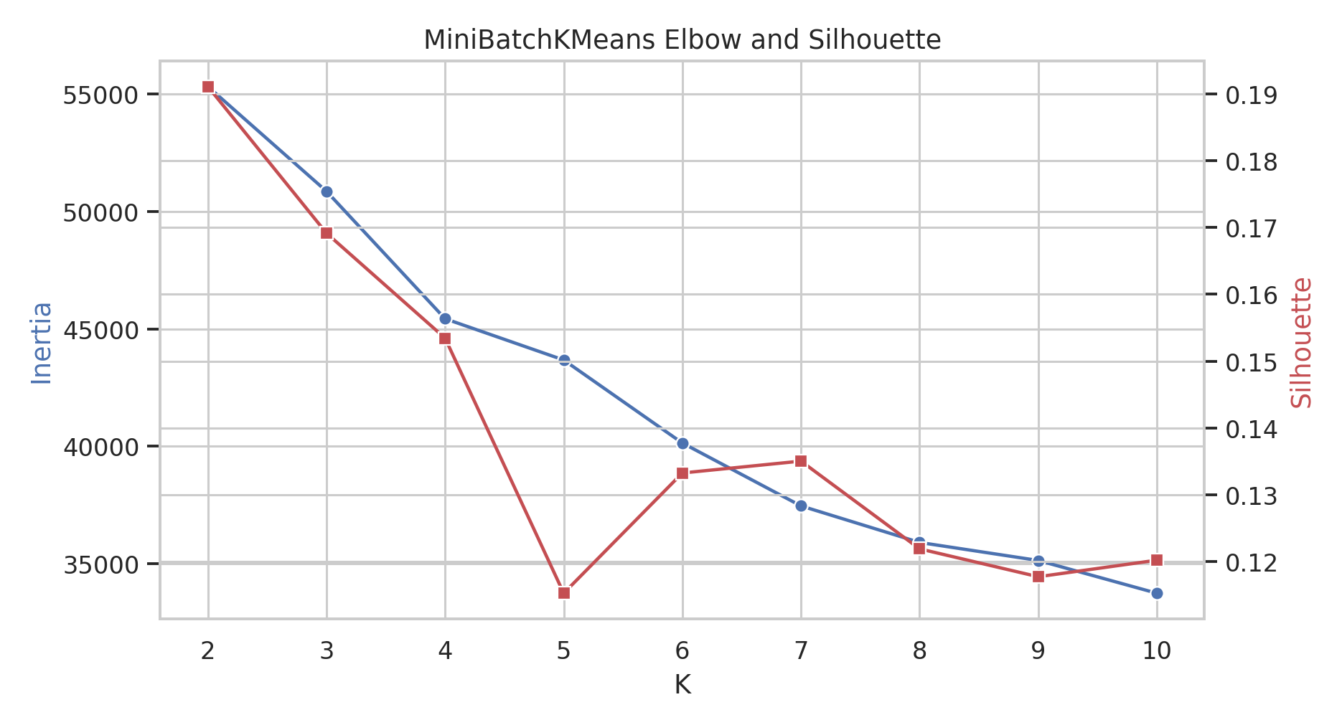
MiniBatchKMeans selection
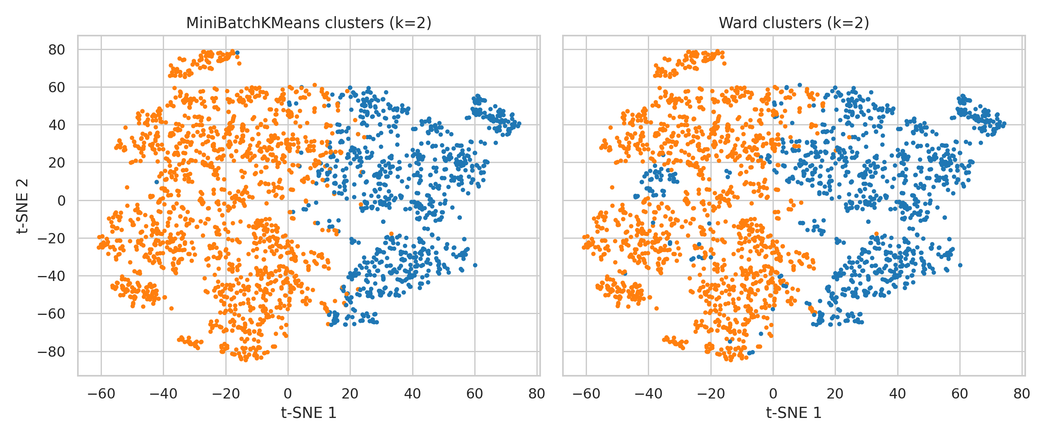
Cluster comparison

4. Prediction: Training and Testing
The supervised target is the seven-class Cover_Type. The project uses a stratified 120,000-row modeling sample to keep validation reproducible and computationally reasonable while preserving class proportions. A 70%/30% train-test split gives 84,000 training rows and 36,000 test rows. Logistic regression is a simple linear baseline with class weighting, and a depth-limited decision tree is a nonlinear baseline. Both are also evaluated on the full 581,012-row dataset after training.
model | split | accuracy | f1_macro | AUC_ovr_macro
Logistic Regression | train | 0.594 | 0.473 | 0.923
Logistic Regression | test | 0.593 | 0.471 | 0.923
Logistic Regression | full | 0.593 | 0.472 | 0.923
Decision Tree | train | 0.826 | 0.727 | 0.985
Decision Tree | test | 0.775 | 0.663 | 0.942
Decision Tree | full | 0.782 | 0.671 | 0.949
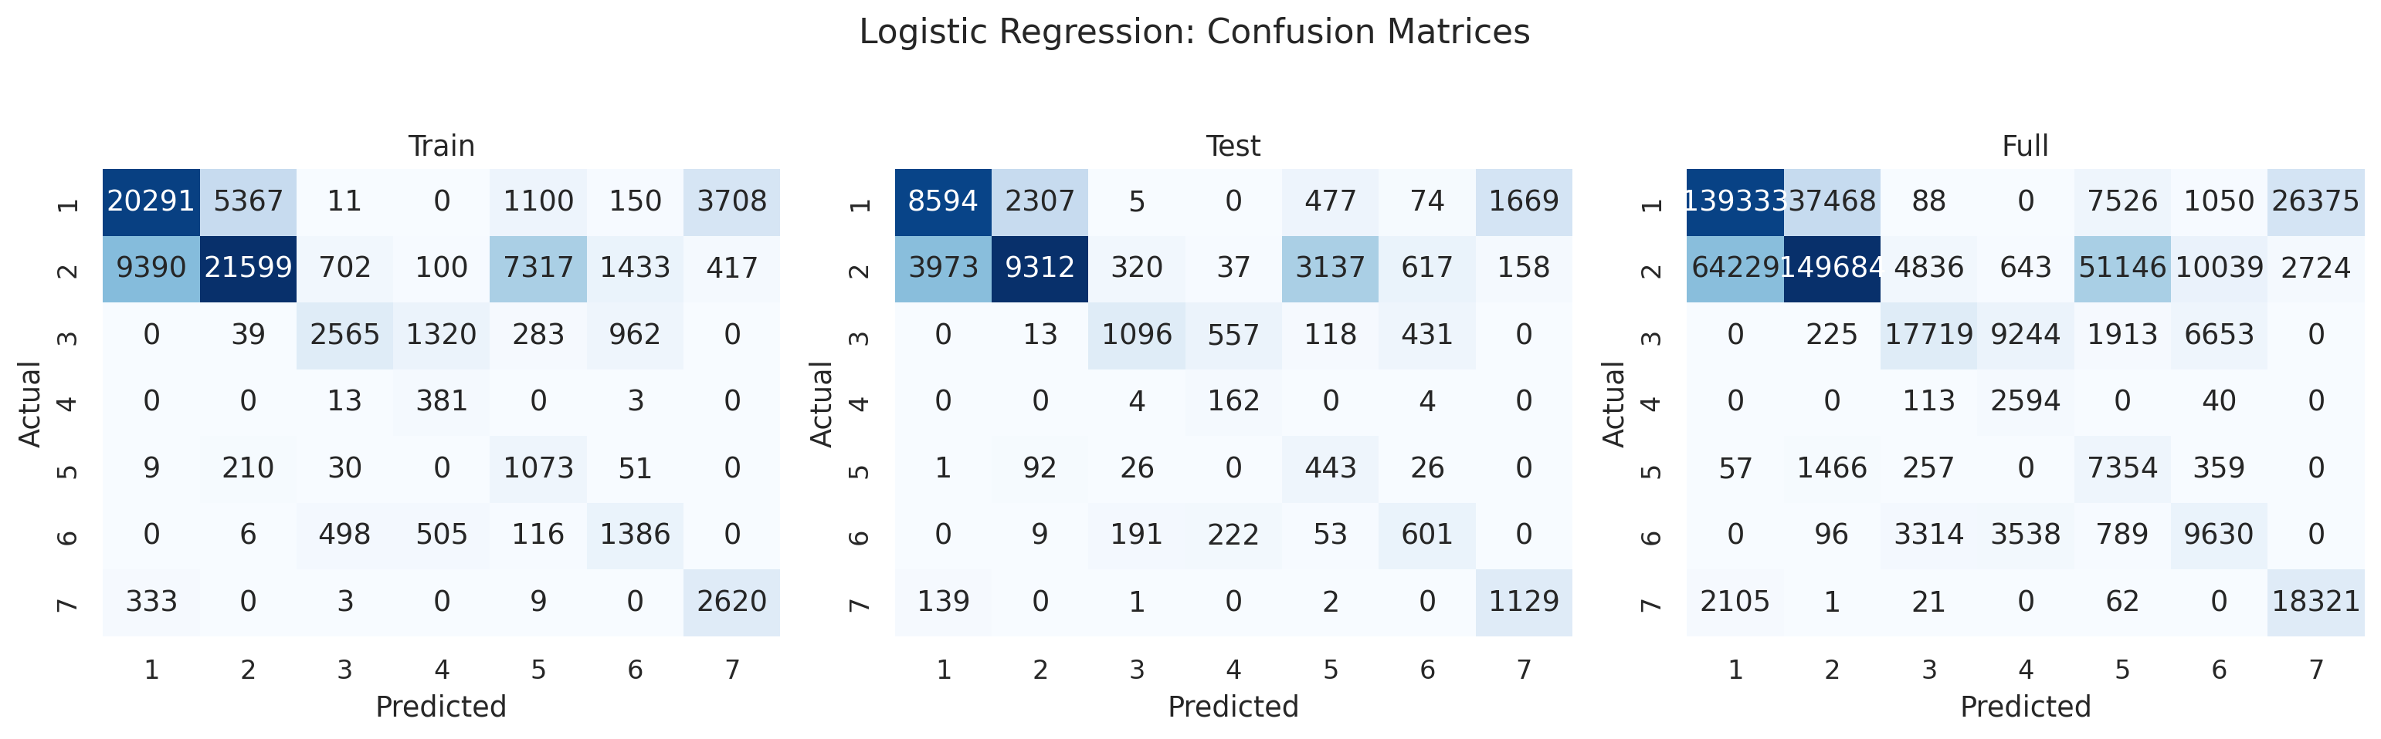
Logistic regression confusion matrices
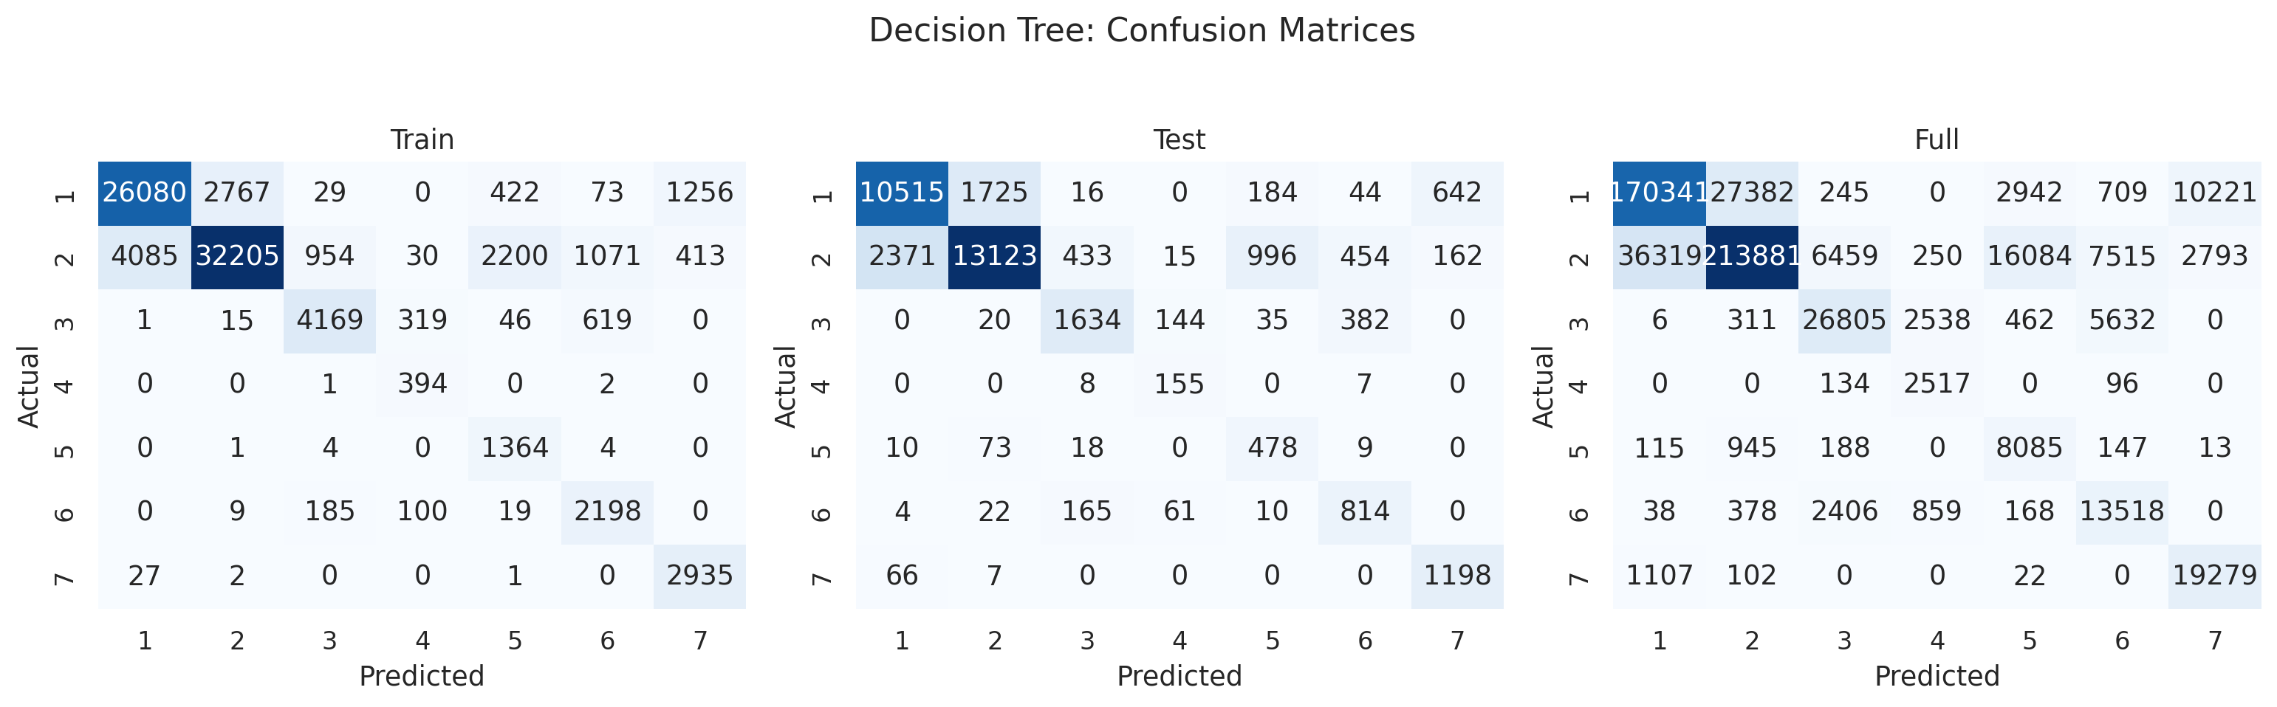
Decision tree confusion matrices

5. Evaluation and Model Choice
The simple logistic model has high macro AUC but weak macro-F1 because its linear boundary struggles with minority classes. The decision tree improves recall and F1 but overfits relative to the test set. The open-ended comparison adds Random Forest and HistGradientBoosting. Random Forest is the best test model, with accuracy=0.902, macro-F1=0.845, and macro AUC=0.991.
model | accuracy | precision_macro | recall_macro | f1_macro | AUC_ovr_macro
Logistic Regression | 0.593 | 0.447 | 0.690 | 0.471 | 0.923
Decision Tree | 0.775 | 0.596 | 0.816 | 0.663 | 0.942
Random Forest | 0.902 | 0.853 | 0.840 | 0.845 | 0.991
HistGradientBoosting | 0.869 | 0.866 | 0.806 | 0.831 | 0.985
Cross-validation on a separate 36,000-row stratified sample confirms the same ranking.
model | accuracy_mean | f1_macro_mean | AUC_ovr_macro_mean
Random Forest | 0.844 | 0.755 | 0.978
HistGradientBoosting | 0.826 | 0.739 | 0.973
Decision Tree | 0.693 | 0.569 | 0.907
Logistic Regression | 0.598 | 0.496 | 0.925
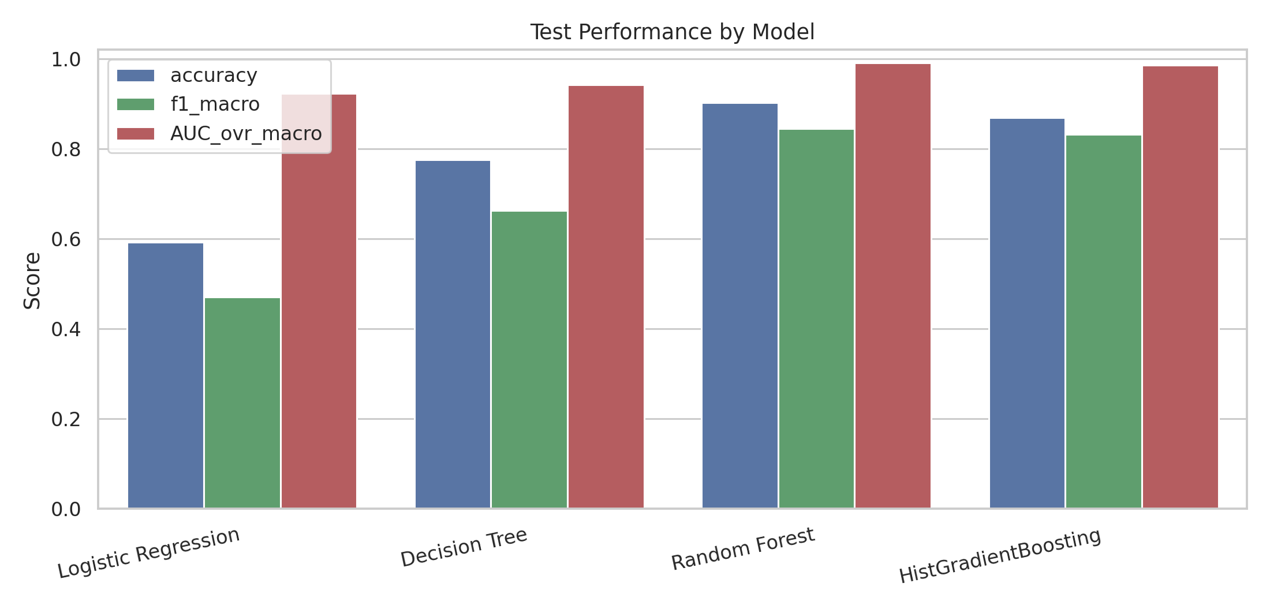
Model comparison
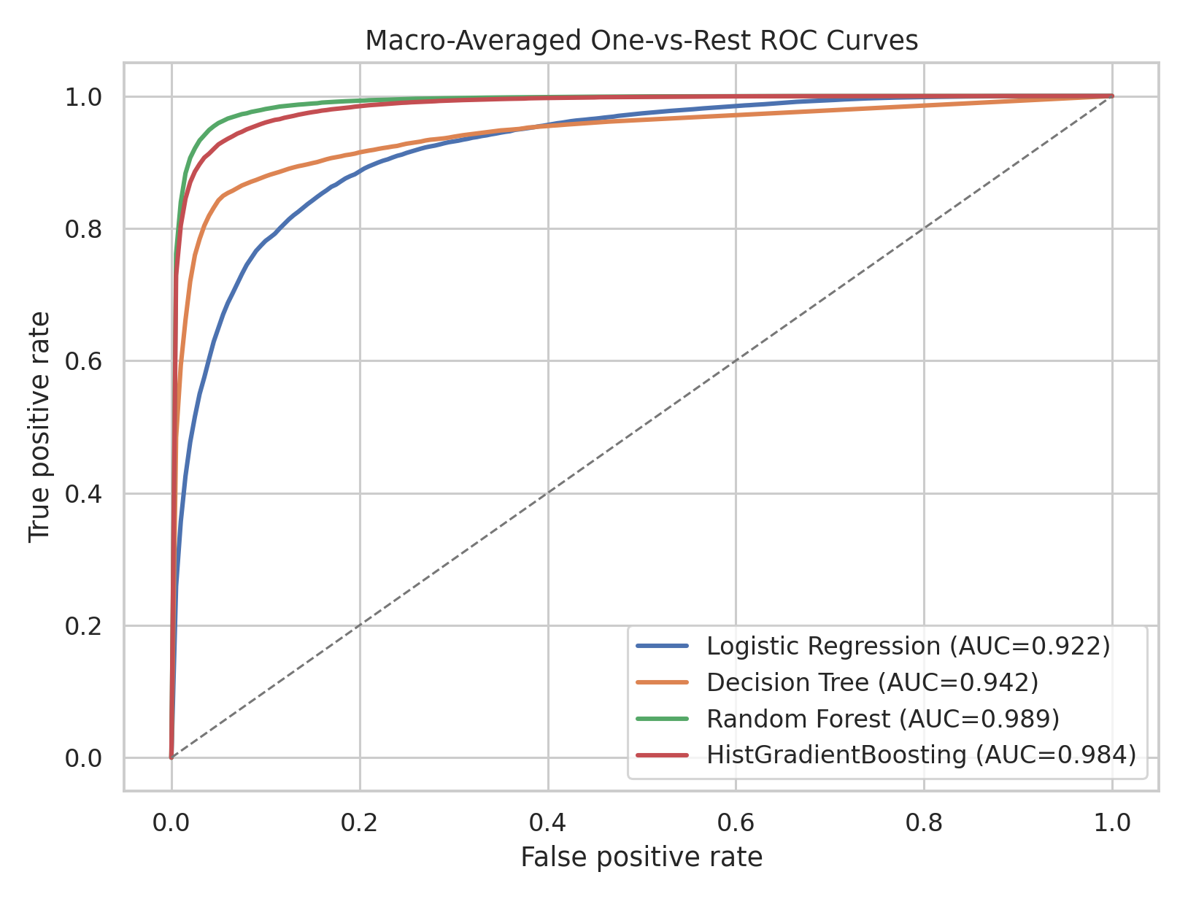
ROC curves

6. Open-Ended Exploration

6.1 Feature Importance
Random Forest impurity importance ranks Elevation as the dominant feature, followed by road/fire/hydrology distance variables and hillshade. Permutation importance for the best model agrees that the model relies most on terrain and distance variables rather than only on one-hot soil or wilderness indicators.
feature | importance
Elevation | 0.235
Horizontal_Distance_To_Roadways | 0.099
Horizontal_Distance_To_Fire_Points | 0.077
Horizontal_Distance_To_Hydrology | 0.062
Vertical_Distance_To_Hydrology | 0.050
Hillshade_9am | 0.049
Aspect | 0.044
Hillshade_3pm | 0.042
Wilderness_Area_4 | 0.042
Hillshade_Noon | 0.040
feature | importance_mean_f1_drop | importance_std
Elevation | 0.396 | 0.008
Horizontal_Distance_To_Roadways | 0.181 | 0.008
Horizontal_Distance_To_Fire_Points | 0.132 | 0.005
Horizontal_Distance_To_Hydrology | 0.066 | 0.007
Wilderness_Area_1 | 0.049 | 0.005
Vertical_Distance_To_Hydrology | 0.044 | 0.004
Hillshade_9am | 0.033 | 0.007
Hillshade_3pm | 0.030 | 0.006
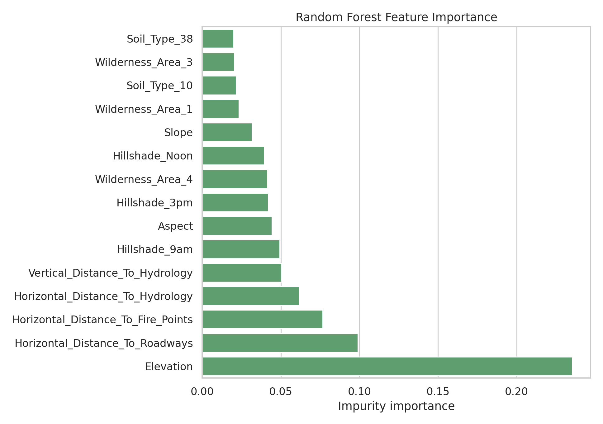
Feature importance

6.2 Feature Group Ablation
Ablation with HistGradientBoosting shows that topographic variables alone are already strong, but adding soil indicators nearly recovers the all-feature model. Wilderness indicators alone are weak. This supports the interpretation that cover type is primarily driven by elevation, terrain geometry, hydrology/road/fire distances, and finer soil context.
experiment | n_features | accuracy | f1_macro | AUC_ovr_macro | f1_macro_drop_vs_all
All features | 54 | 0.857 | 0.815 | 0.983 | 0.000
Topographic + soil | 50 | 0.850 | 0.807 | 0.981 | 0.008
Topographic + wilderness | 14 | 0.837 | 0.784 | 0.973 | 0.031
Topographic only | 10 | 0.820 | 0.764 | 0.973 | 0.051
Soil only | 40 | 0.618 | 0.279 | 0.873 | 0.536
Wilderness only | 4 | 0.535 | 0.203 | 0.741 | 0.612
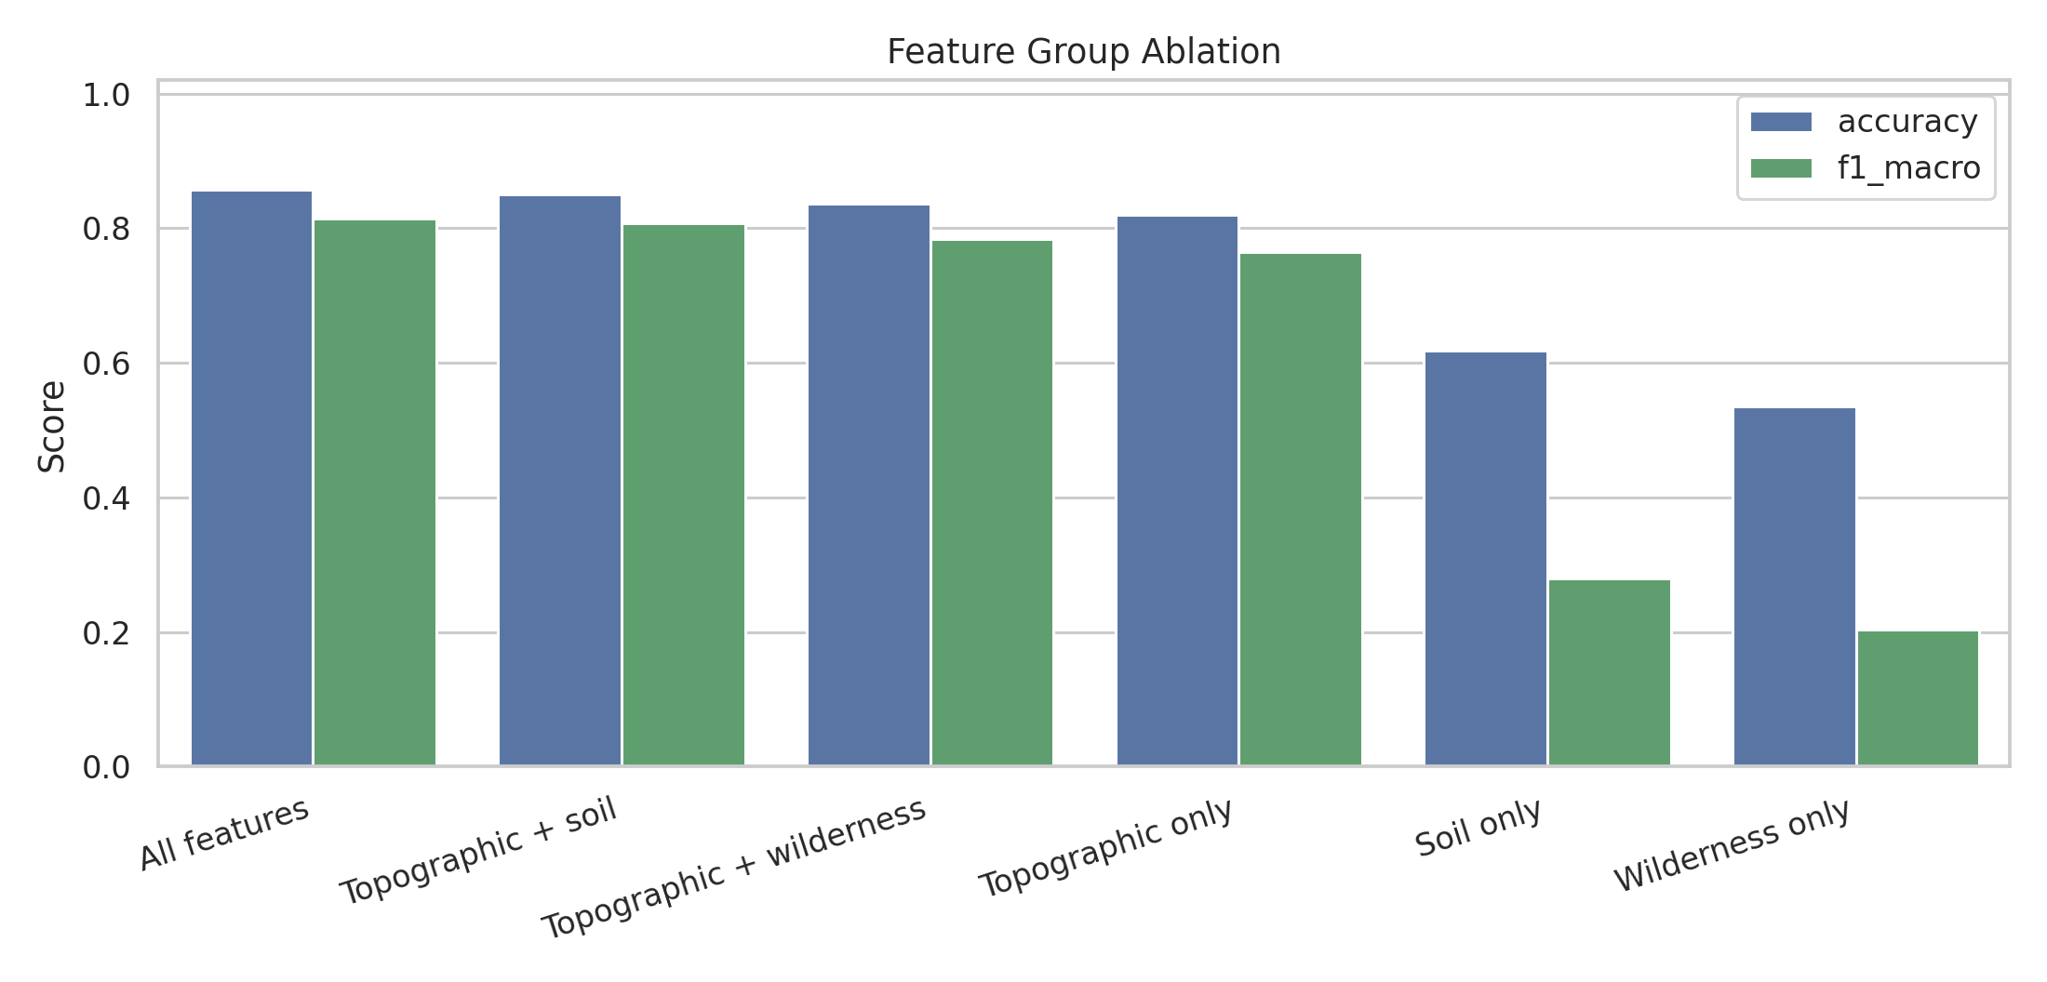
Feature group ablation

6.3 Calibration, Terrain Robustness, and Error Cases
Calibration is measured with top-label confidence bins. HistGradientBoosting has the lowest expected calibration error, while Random Forest has the best accuracy and F1 but is under-confident on average: its mean confidence is below observed accuracy. This is acceptable for ranking and classification, but probability interpretation should use calibration checks.
model | multiclass_brier | expected_calibration_error | mean_confidence | observed_accuracy
HistGradientBoosting | 0.194 | 0.047 | 0.822 | 0.869
Logistic Regression | 0.546 | 0.066 | 0.655 | 0.593
Decision Tree | 0.324 | 0.104 | 0.880 | 0.775
Random Forest | 0.178 | 0.128 | 0.775 | 0.902
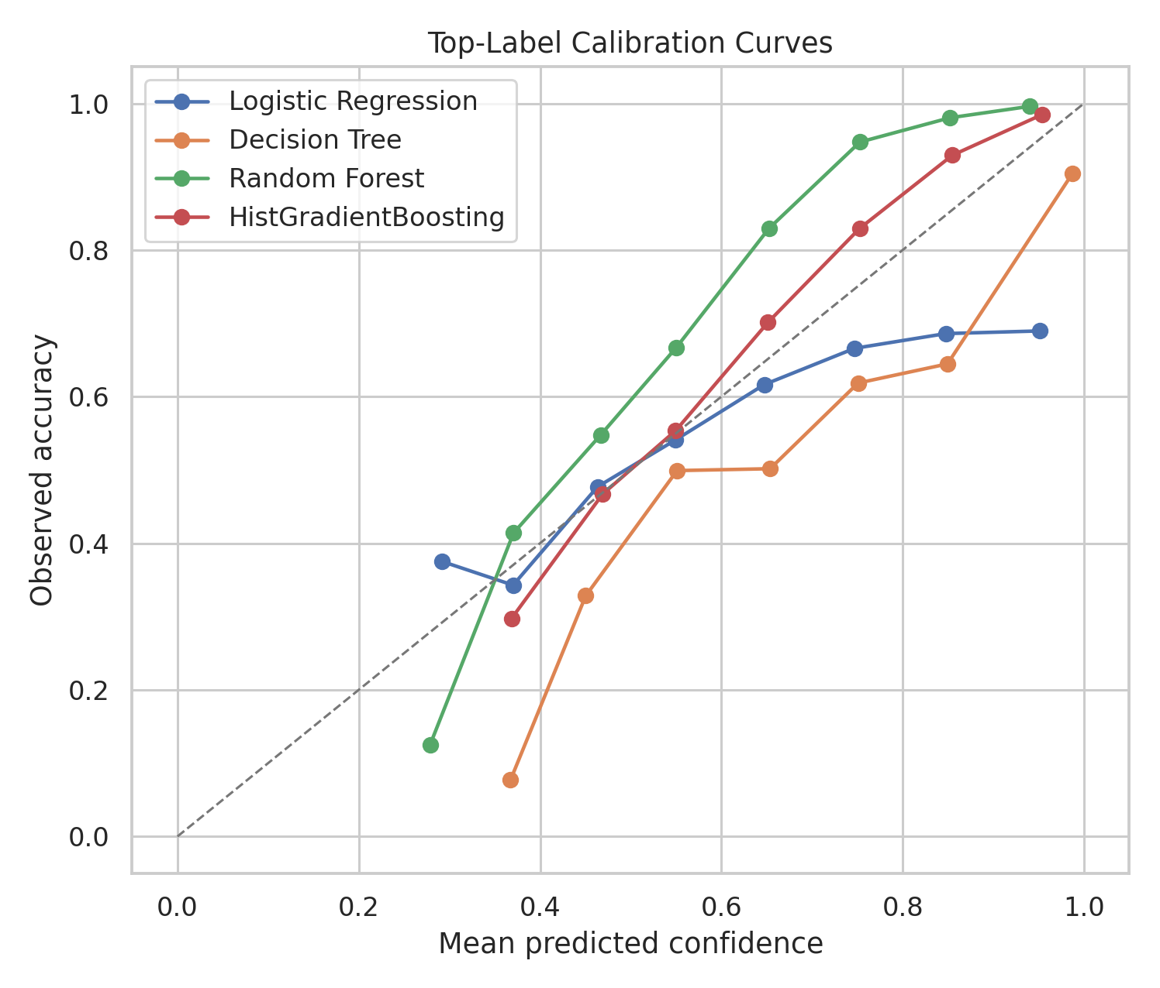
Calibration curves
The best model performs better in the highest elevation band than in lower bands, indicating that high-elevation classes are easier to separate. Error analysis also shows that incorrect predictions have much lower average top-class confidence than correct predictions, so confidence is useful for triaging uncertain cases.
elevation_band | n | accuracy | f1_macro | dominant_true_class_name
(1886.999, 2753.0] | 7217 | 0.874 | 0.783 | Lodgepole Pine
(2753.0, 2939.0] | 7238 | 0.894 | 0.773 | Lodgepole Pine
(2939.0, 3058.0] | 7164 | 0.893 | 0.822 | Lodgepole Pine
(3058.0, 3198.0] | 7194 | 0.914 | 0.823 | Spruce/Fir
(3198.0, 3856.0] | 7187 | 0.938 | 0.922 | Spruce/Fir
correct | count | mean | median | min | max
False | 3515 | 0.595 | 0.576 | 0.254 | 0.965
True | 32485 | 0.794 | 0.821 | 0.290 | 0.999
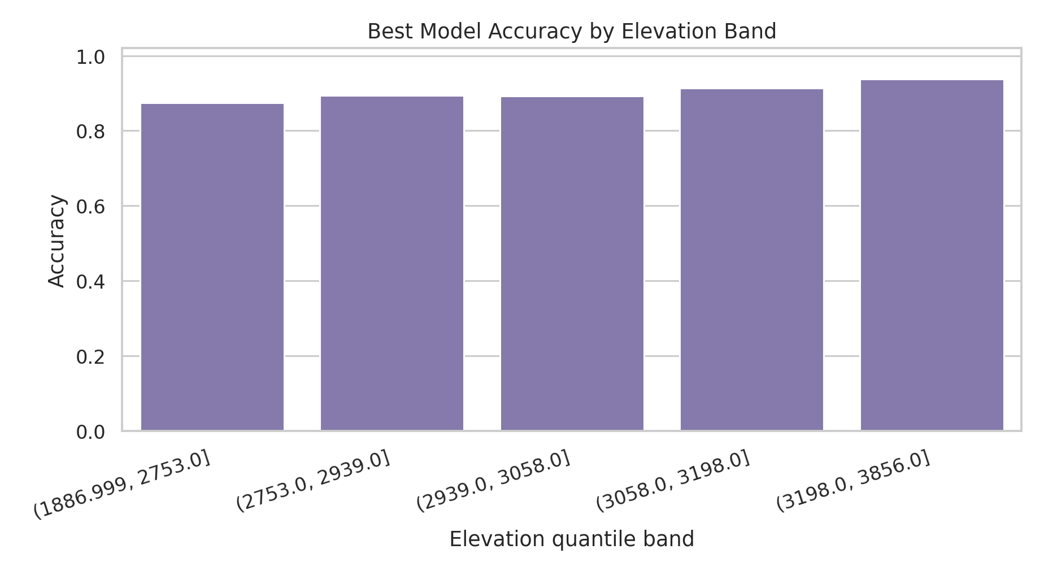
Elevation band accuracy
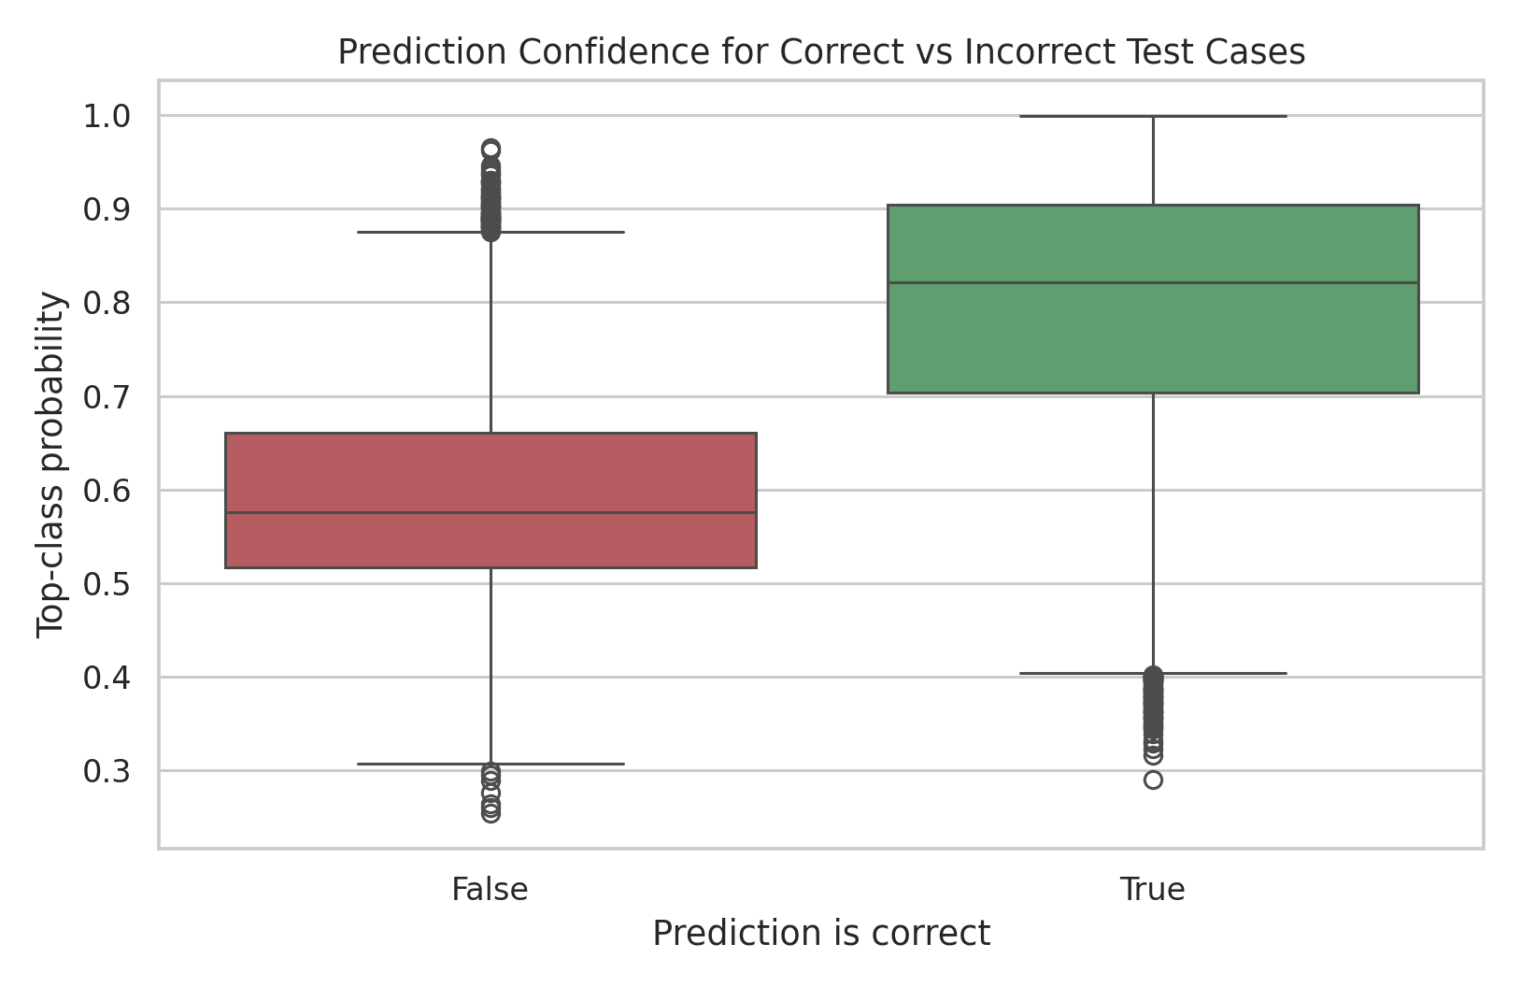
Confidence by correctness
Class-level recall confirms that minority and ecologically adjacent classes are harder than the two dominant classes.
Cover_Type | Cover_Type_Name | support | precision | recall | f1
1 | Spruce/Fir | 13126 | 0.919 | 0.885 | 0.901
2 | Lodgepole Pine | 17554 | 0.907 | 0.930 | 0.918
3 | Ponderosa Pine | 2215 | 0.852 | 0.924 | 0.887
4 | Cottonwood/Willow | 170 | 0.782 | 0.824 | 0.802
5 | Aspen | 588 | 0.792 | 0.639 | 0.707
6 | Douglas-fir | 1076 | 0.796 | 0.778 | 0.787
7 | Krummholz | 1271 | 0.920 | 0.901 | 0.911
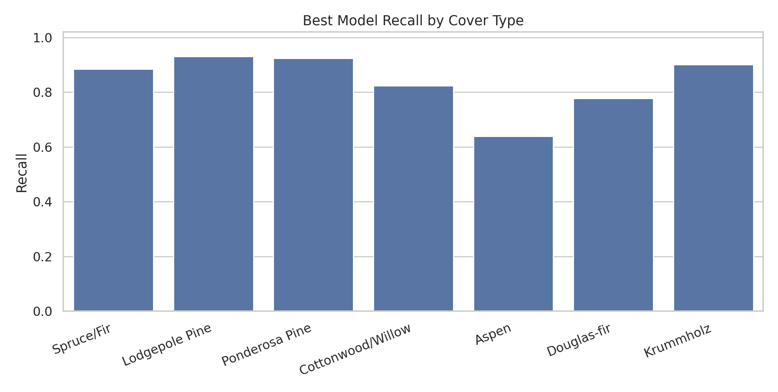
Class recall

6.4 Computational Cost and Scalable Optimization
Covertype is large enough that model training is feasible, but several standard analysis steps become expensive if applied naively to all 581,012 rows. Full-data t-SNE, full-data Ward clustering, exhaustive grid search, and full permutation importance are the main computational risks. The optimized workflow now implements dtype downcasting, manifest-based caches for heavy stages, stratified samples for expensive visualization/validation, PCA before distance-based analysis, MiniBatchKMeans for scalable clustering, and parallel tree ensembles for prediction. The naive all-int64 memory estimate is 243.8 MB; the optimized dataframe uses about 47.1 MB, a 80.7% reduction.
module | scope | cost_score | optimization
Data read and preprocessing | full 581,012 rows x 54 features | 1 | implemented dtype downcast from naive 243.8 MB to 47.1 MB
Standardization and PCA | 6,000-120,000 stratified rows | 2 | apply PCA before t-SNE and clustering
t-SNE visualization | 6,000 stratified rows after PCA | 9 | use stratified sample plus PCA; UMAP is a possible faster substitute
MiniBatchKMeans clustering | 6,000 stratified rows after PCA | 3 | implemented MiniBatchKMeans with fixed batch size for scalable clustering
Ward hierarchical clustering | 2,500 stratified rows | 10 | restrict to small sample or replace with BIRCH/MiniBatchKMeans
Supervised model training | 120,000 stratified rows, 70/30 split | 6 | use n_jobs=-1, bounded tree complexity, and efficient boosting
Cross-validation | 36,000 stratified rows x 3 folds | 7 | use 3-fold sample CV; tune on sample, then train final model
Permutation importance | 8,000 test rows x 54 features x 5 repeats | 8 | combine cheap impurity importance with sampled permutation checks
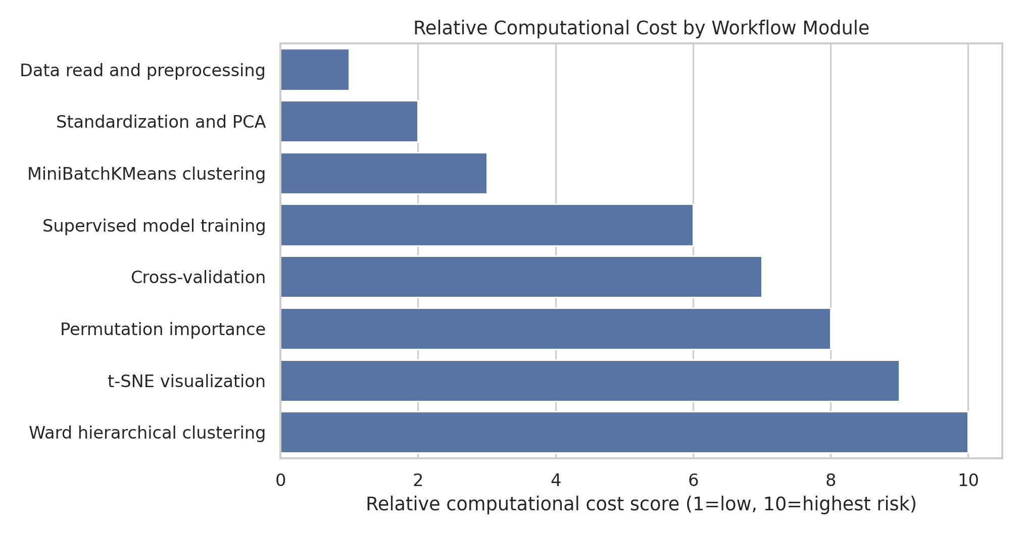
Computational cost tiers
The run profile records whether each stage was computed or recovered from cache.
stage | seconds | cache_status
data_read_downcast | 0.89 | computed
descriptive_outputs | 0.69 | computed
computational_cost_outputs | 0.20 | computed
t-SNE | 0.00 | cache_hit
clustering | 0.00 | cache_hit
modeling | 0.01 | cache_hit
The optimization directions can be grouped as follows.
category | action | benefit
Data types and I/O | Implemented uint8 indicators/target, float32 continuous variables, and cached prepared files | Lower memory pressure and faster repeated runs
Sampling strategy | Use stratified samples for t-SNE, Ward clustering, CV, and permutation importance | Stable estimates without quadratic or repeated full-data costs
Dimensionality reduction | Run PCA to 20-30 components before t-SNE and clustering | Faster visualizations and more stable distance-based structure
Scalable clustering | Implemented MiniBatchKMeans for scalable clustering; kept Ward for small structural samples | Maintains clustering analysis without infeasible memory growth
Model training | Use parallel Random Forest, HistGradientBoosting, class weights, and bounded tree complexity | High accuracy and macro-F1 with controlled runtime
Validation and tuning | Use 3-fold CV, RandomizedSearchCV or halving search on samples, then train final parameters once | Comparable model ranking at a fraction of full-grid cost
Interpretability | Use tree impurity importance first; run permutation importance on a small held-out sample | Good feature diagnostics with bounded prediction calls
Caching and reproducibility | Implemented manifest-based caches for t-SNE, clustering, and modeling outputs | Fast report/PPT rebuilds and auditable intermediate artifacts

Conclusion
The Covertype dataset has strong class imbalance and substantial overlap between ecological classes. Unsupervised clustering reveals broad terrain structure but does not recover the true seven labels. Supervised tree ensembles are much more effective: Random Forest gives the best overall classification performance, while HistGradientBoosting offers better calibration. Elevation is the most important single feature, but soil indicators and distance-to-road/fire/hydrology variables add meaningful predictive value. Computationally, the safest strategy is to combine full-data descriptive analysis, stratified samples for expensive diagnostics, PCA for distance-based methods, and parallel ensemble models. For practical use, the model should report macro metrics, class-level recall, calibration, terrain-band performance, and the sampling assumptions behind expensive steps.

References
- UCI Machine Learning Repository. Covertype dataset. https://archive.ics.uci.edu/ml/datasets/covertype
- Blackard, Jock A. and Dean, Denis J. Comparative Accuracies of Artificial Neural Networks and Discriminant Analysis in Predicting Forest Cover Types from Cartographic Variables. Computers and Electronics in Agriculture, 1999.
- Pedregosa et al. Scikit-learn: Machine Learning in Python. Journal of Machine Learning Research, 2011.
- van der Maaten and Hinton. Visualizing Data using t-SNE. Journal of Machine Learning Research, 2008.

Credit
Code, figures, and report text were generated reproducibly in this repository. Group-member contribution details should be filled in by the project team before submission. OpenAI Codex was used to draft and validate the analysis workflow and report.

