TScratch Documentation

This document contains the documentation for the TScratch program, available from www.cse-lab.ethz.ch/software.html. TScratch is a software tool for automated analysis of wound healing assays, with extensive possibilities to review and modify analysis results in a user-friendly graphical user interface. The TScratch program also performs statistical analysis of the results, presenting them in bar diagrams and text files, which can easily be imported into a spreadsheet program.

TScratch has been developed in MATLAB 2008 on an Intel Mac running Mac OS X 10.5 Leopard, but should also run on version 10.4. Unfortunately it does not run on PowerPC machines.
TScratch has also been tested on Windows XP SP3. It should also run on Windows Vista.

Copyright 2008, Tobias Gebäck and Martin Schulz, ETH Zürich
www.cse-lab.ethz.ch
Table of contents
1 Legal information 5
2 Installation 7
2.1 Mac (Intel) 7
2.2 Windows 8
3 Quick start 9
4 Basic concepts 13
4.1 File formats 13
4.2 Open area measurements 13
4.3 Directory structure and directory modes 13
4.4 Program modes 14
4.4.1 Initial analysis mode 14
4.4.2 Group editing mode 14
4.4.3 Single image mode 15
4.5 Analysis Types 17
4.6 Grouping of images and filename matching 17
5 Output files 18
5.1 Single directory mode 18
5.1.1 Output text file layout 18
5.2 Multiple directory (time-course) mode 18
5.2.1 Output text file layout 18
5.3 File structure: global_data.mat 19
5.4 File structure: all_data.mat 19
5.5 File structure: <<filename>>_data.mat 20
6 Parameters and options 21
6.1 Program settings 21
6.2 Basic analysis settings 22
6.3 Advanced parameters 23
7 The toolbar 25
7.1 The Tools menu 25
7.2 The View menu 25
7.3 The zoom and pan tools 26
7.4 The paint tool 26
7.5 The polygon tool 26
7.6 The undo/redo tools 27
8 Keyboard shortcuts 28
9 Computational details 29
9.1 The open area measurements 29
9.2 Statistical analysis 30
10 Tips for experimental setup 31
10.1 Tips for the wound healing experiment 31
10.2 Tips for image acquisition 31
11 Troubleshooting 33
12 References 34
13 Citation information 35
14 Index 36

Legal information
By downloading and/or installing the TScratch software (referred to below as SOFTWARE), you agree to the following license agreement.
- The Koumoutsakos group at ETH Zurich (from here on referred to as the CSELab), agrees that the LICENSEE uses the SOFTWARE for scientific, non-profit and non-commercial purposes only. SOFTWARE shall mean all SOFTWARE provided by CSELab, including any derivatives thereof. The software is intellectual property of CSELab and all rights, title and interest, including copyright, remain with CSELab.
- The LICENSEE will not copy, distribute, reproduce, manufacture, alter, sell or sub-license the SOFTWARE. The SOFTWARE will be used in accordance with all applicable laws and regulations. Any other use or exploitation (including distribution or sale) of the SOFTWARE requires the prior written permission of CSELab, which may demand compensation from the LICENSEE.
- Nothing in this agreement shall be construed as granting any license under any intellectual property right vested into CSELab or any right to use the SOFTWARE or any CSELab information other than herein expressly specified.
- The LICENSEE including any of its workers, co-workers, students or other persons who may have access to the SOFTWARE or related information agree not to transfer, transmit, distribute or in any other way disclose the SOFTWARE or information about its algorithms and/or implementations to third parties without prior written consent of CSELab.
- In any publications resulting from research done under the use of the SOFTWARE, the LICENSEE will properly cite either party's contribution. Any report or publication of results obtained with the SOFTWARE will acknowledge its use by stating that SOFTWARE « was developed by the Koumoutsakos group (CSE Lab), at ETH Zürich ». Any published work that utilizes the SOFTWARE shall include the following reference:
  - Gebäck, T., Schulz, M.M.P., Koumoutsakos, P. & Detmar, M. A novel and simple software tool for automated analysis of monolayer wound healing assays. BioTechniques (2008).
- Electronic documents will include a direct link to the official CSELab web page at http://www.cse-lab.ethz.ch.
- Proper citation is essential to continued ETH Zurich funding for software development, as it is the primary way in which we demonstrate the value of our software to the scientific community. Thank you for your attention to these details.
- The CSELab does not assume any responsibility for the SOFTWARE and the use of it. CSELab will not assume any liability for damages or loss of data occurring through the use of the SOFTWARE. CSELab does not guarantee the suitability of the SOFTWARE for any application. The LICENSEE will hold CSELab harmless for any claims on damages or loss of data which occur during the LICENSEE's use of the SOFTWARE.
- CSELab does not guarantee that the SOFTWARE does not infringe any third party's intellectual property rights (including copyrights, patents, patent applications, publications or any other type of intellectual property right). The LICENSEE has to acquire on his/her own all necessary licenses and permissions for the use of the SOFTWARE if not otherwise agreed in writing.
- In case the SOFTWARE is or will be under the physical control of the LICENSEE before this agreement is signed, CSELab gives consent to the use of the SOFTWARE under the condition of the LICENSEE's prior consent to this agreement.
- This agreement is subject to Swiss law and ETH Zurich regulations. Place of jurisdiction is the Kanton of Zürich.
- The TScratch program makes use of the CurveLab software (www.curvelet.org) and is subject to the license agreement provided in the file curvelab_license.txt included in this distribution.
- The use and distribution of the MATLAB Compiler Runtime (MCR) libraries is subject to the MATLAB license agreement (see MCR_license.txt). In particular, the MCR may not be redistributed in any way separate from the SOFTWARE.

Installation

Mac (Intel)
TScratch only runs on Intel Macs, and has been tested with Mac OS X 10.5, but should also run with version 10.4.
To install, follow the step-by-step instructions below:
- Unpack the TScratch_pkg file using “Archive Utility” or “StuffIt Expander”. The package contains the following files:
- TScratch – the program file
- run_TScratch.sh – script to run the program from a terminal window
- TScratch_manual.pdf – this manual
- MCRInstaller.dmg – installer for Matlab Compiler Runtime (MCR) 7.8
- TScratchStandalone.scpt – Apple script to run the TScratch program
- TScratch_icon.icns – icon file for TScratch
- scratchicon_sm.png – icon image
- point.png – image file required by the program
- MCR_license.txt – license file for the use of MCR
- curvelab_license.txt – license file for the use of CurveLab
- readme.txt – information about MCR, including troubleshooting
After unpacking, the file TScratch_pkg may be deleted.
- If you have not installed Matlab Compiler Runtime (MCR) version 7.8 on your computer before, do this by opening MCRInstaller.dmg and running MCRInstaller.pkg from the disk that becomes mounted. Remember the path where you install MCR. After installation, the file MCRInstaller.dmg may be deleted.
- Choose one of two ways to run the program:
  - TScratch may be run from a Terminal window using
./run_TScratch.sh $MCRPATH$
when in the TScratch directory. $MCRPATH$ should be replaced by the path to MCR (such as /Applications/MATLAB/MATLAB_Compiler_Runtime/v78). The first time the program is started, it may take some time before the window appears – just be patient and wait, the next time it will be faster.
  - To make things easier you can instead edit the script file TScratchStandalone.scpt using the “Script Editor” (just double-click on the file to open it) and replace the existing paths with your paths to run_TScratch.sh and to the MCR. Then choose “Save As…” and select “Application” and save the script in a suitable location. The TScratch program may now be run by double-clicking on this Application file, and may also be added to the dock.
- A program icon is included in the distribution in the files scratchicon.icns and scratchicon_sm.png. If you would like to change the icon of the application, you need to use a program such as Pic2Icon (available from for example www.download.com). The perform the following steps:
- Drag the file scratchicon.icns to the Pic2Icon conversion window.
- Select scratchicon.icns in Finder and press ⌘I to show the “Get Info“ window. Check that the icon shown on the top left is showing the scratch assay image. Select this icon and press ⌘C to copy it. Open the “Get Info” window for the application file that was created in step B above. Select the icon at the top left and press ⌘V to paste the TScratch icon. Close the “Get Info” windows and the TScratch application should now have a beautiful icon.

Windows
TScratch has been tested on Windows XP, but should also run on Windows Vista.
To install on Windows machines, follow the instructions below:
- Unzip the file TScratch_win.zip to extract TScratch_win.exe.
- Double-click on TScratch_win.exe to unpack the program files. The package contains the following files:
- TScratch.exe – the program
- TScratch_manual.pdf – this manual
- MCRInstaller.exe – the Matlab Component Runtime 7.8 installer
- scratchicon.ico – an icon file for the program
- scratchicon_sm.png – icon image
- point.png – image file required by the program
- MCR_license.txt – license file for the use of MCR
- curvelab_license.txt – license file for the use of CurveLab
- readme.txt – information about MCR, including troubleshooting
After unpacking, the file MCRInstaller.exe will be automatically executed to start the installation of Matlab Component Runtime (MCR) version 7.8. If MCR v7.8 is already installed on the computer, you may cancel the installation. Otherwise follow the on-screen instructions to install MCR. After installation, the files TScratch_win.exe and MCRInstaller.exe may be deleted.
Once MCR has been installed, double-click on TScratch.exe to start TScratch. Add StartMenu, Desktop and Quickstart menu shortcuts manually if desired. The icon file scratchicon.ico may be used as an icon for these shortcuts.

Quick start
The basic workflow of the TScratch program follows the outline in Figure 3.1.
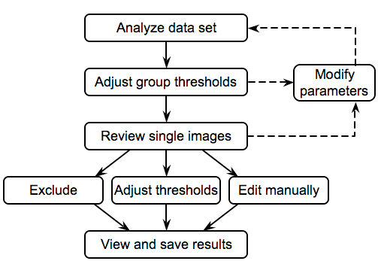
Figure 3.1. The basic workflow of the TScratch program.
A stepwise instruction for the simplest possible use of the TScratch program is as follows:
- Acquire images, saving them as JPEG or TIFF images (with extension .jpg or .tif respectively). If multiple time-points are acquired, save them in different subdirectories directly under one top directory, using the same file name for images taken from the same well. Additionally, use filenames of the form label_nr.jpg to group samples with the same label in the final analysis. The identifier nr can be anything, not necessarily a number, and space can be used instead of underscore. See Figure 3.2 for an example of the directory structure. See also sections 4.3, 4.6 and 10.2 for more information.
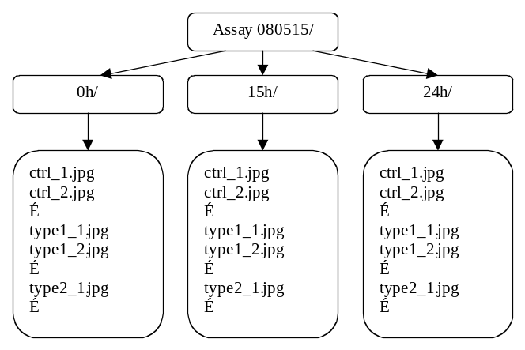
Figure 3.2. Example of the directory and filename structure.

- Start the TScratch program as described in sections 2.1 and 2.2. The program window looks like in Figure 3.3, though no images will be shown until a data set has been loaded. For each step in this instruction, the red numbers in Figure 3.3 indicate the location of the controls referred to.
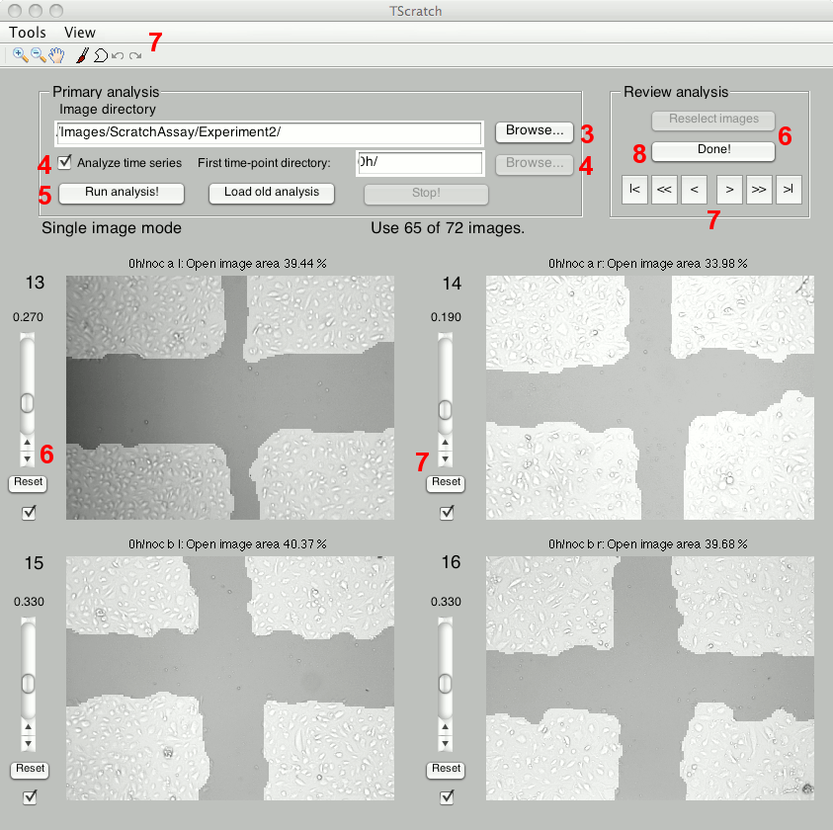
Figure 3.3. The TScratch GUI (in single image mode). The numbers correspond to the numbers in the step-by-step instruction.
- Click the “Browse…” button next to the “Image directory” box and select the top directory containing your images (“Assay 080515/” in the example above).
- If analyzing a time series, check the “Analyze time series” check box. Then click the “Browse…” button next to the “First time-point directory” box and select the subdirectory containing the images for the first time-point (“0h/” in the example above).
- Click the “Run analysis” button to start the analysis. The program will now analyze all the images in the subdirectories at the first level below the top directory (in time-course mode, which is described here; see section 4.3 for more information). The results, together with the analyzed images, are written to data files in the top directory and in a subdirectory called “Analyzed/” in each of the subdirectories containing the segmented images (see section 5). The estimated remaining time for the analysis is shown.
- When all the images have been analyzed, the program enters “group editing mode”, where the thresholds determining the open area measurement may be adjusted for each of the analysis types (see section 4.5), except for type 1 (since the algorithm found a threshold automatically for all images in group 1). A few sample images of each type are shown (the total number of images with that type is shown in parentheses next to the type number above the slider). Adjust thresholds using the sliders. Click “Reselect images” to select new sample images from each group. Click “Reset” under the slider to undo the changes. Click “Done” when satisfied.
- The program now enters “single image mode” (see also section 4.4), giving the possibility to browse through all the images and (a) exclude images where the analysis failed, (b) adjust thresholds for single images and (c) manually edit the marked area using the paint and polygon tools (see sections 7.4 and 7.5), if required. Images are excluded from the analysis by un-checking the check box next to the image, with the number of remaining images shown in a text box. Thresholds may be changed using the sliders, and individual images may be enlarged using the “View” menu (see section 7.2). Selecting the tools in the toolbar gives the possibility to manually draw in the images, as well as zoom in into the images. Click “Reset” to revert to the original threshold, undoing any manual modifications. Click the “<” and “>” buttons to browse through the analyzed images (the numbers next to the images show the image number in the order they were analyzed), or “>>” and “<<” to move faster (16 images at a time) through the data set. “|<” and “>|” moves to the first and last images, respectively. Many keyboard shortcuts are available to speed up the process (see section 8 for a listing).
- When done, push the “Done” button and specify an output file for the data computed using the modified thresholds and excluded images. In addition, a bar diagram is shown for each time-point after the initial one, showing the percentage of open area compared to the initial time-point for each of the groups (determined by the file names). Error bars show the standard error of the mean, and the numbers next to the group names show the number of images used for the analysis in each group. The diagrams may be exported to pdf-files (and many other formats) by selecting File->Save in the menu and selecting PDF as output format. An example of the graph is shown in Figure 3.4.
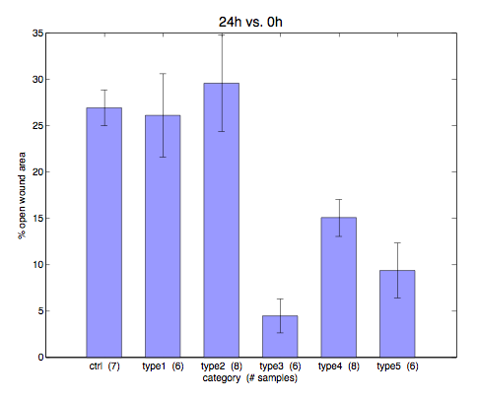
Figure 3.4. Example of the graphical output of results from TScratch, showing means and standard errors for the different groups.
- The output text file may be opened in a spreadsheet program such as Excel, where the data may be further analyzed and presented (see section 5.2.1 for more information on the output file).

Basic concepts

File formats
TScratch supports the following file formats:

File format | Extension
JPEG | .jpg
TIFF | .tif
Bitmap | .bmp
GIF | .gif
PNG | .png
The file format is determined by the extension, and the program will look only for the extensions listed above. The images may be saved as either color or grayscale images.

Open area measurements
Throughout this document and the TScratch program, we discern between two open area concepts: open image area and open wound area.
The open image area is given as the percentage of an image that is not considered as occupied by cells by the algorithm. This value is computed for each analyzed image and is written to the output text files in both single directory mode and time-course mode (see section 4.3).
In time-course mode, the TScratch program also computes the open wound area, which is the fraction of open image area at a later time-point compared to the initial time-point, again given as a percentage. That is, the open wound area after 24 hours is computed as
[open wound area 24h] = 100 x [open image area 24h] / [open image area 0h].
This value is also written to the output file in time-course mode, and this is the value that all the statistical analysis is based on.

Directory structure and directory modes
The TScratch program has two different modes for finding and analyzing images, the single directory mode and the time-course/multiple directory mode.
In single directory mode, the program searches the specified directory for image files and analyzes them, measuring the open image area in each of them and giving this as output (as percentage of the total image area), together with some data on the analysis.
In time-course mode, the program searches the specified directory for subdirectories and analyzes the images in each of these directories separately, assuming that they are data collected at different time- points for the same wells. Images with the same filename in different directories will be treated as different time- points for the same well (see also section 4.6). The directory specified as first time- point directory in the program will be treated as holding images for the first time- point. The output in time-course mode is, first, the open image area for each image, and, second, the open wound area, i.e. the open image area at later time- points divided by the open image area at the first time- point.

Program modes
The TScratch program has three steps, or program modes. They are: initial analysis mode, group editing mode, and single image mode.

Initial analysis mode
In initial analysis mode (see Figure 4.5), the user selects the directory that contains the images to be analyzed, sets parameters affecting the analysis, and starts the analysis by pressing the “Run analysis” button, or, alternatively, loads a previously analyzed data set by pressing the “Load old analysis” button. After the data has been analyzed, or loaded, the program goes into group editing mode (unless this mode has been disabled, see section 6.1).
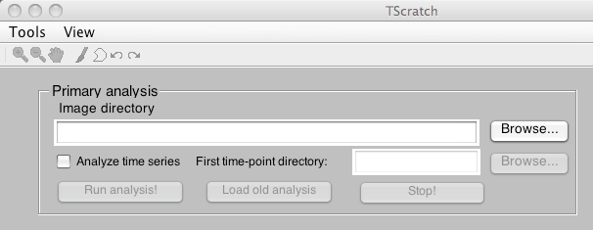
Figure 4.5. The directory selection boxes and buttons in initial analysis mode. In the “Tools” menu, the analysis settings may be changed. Using the “Browse” buttons, the directories containing the images are selected. If the “Analyze time series” check box is checked, a subdirectory containing images for the first time-point must be selected, and the program analyses data in time-course mode, otherwise a single directory is analyzed and no time point comparisons are made.

Group editing mode
In group editing mode (see Figure 4.6), thresholds for the analysis types 2 to 4 (see section 4.5) may be adjusted using the sliders, affecting the measured open image area for all images of the type in question. Thresholds for images of type 1 may not be adjusted in group editing mode, since for this group the program already found a suitable threshold (this threshold may be adjusted for each image in single image mode). The type is shown to the top left of the image, and the number of images of that type is shown within the parentheses. The program displays at most four images at a time, and the lines between images indicate which images belong to the same type. By clicking “Reselect images”, new images from each group are randomly chosen for display. When clicking “Reset thresholds”, all threshold offset are reset to zero, undoing all the adjustments. When “Done” is clicked, the modified thresholds are applied to all images of types 2 to 4, and the program then enters single image mode.
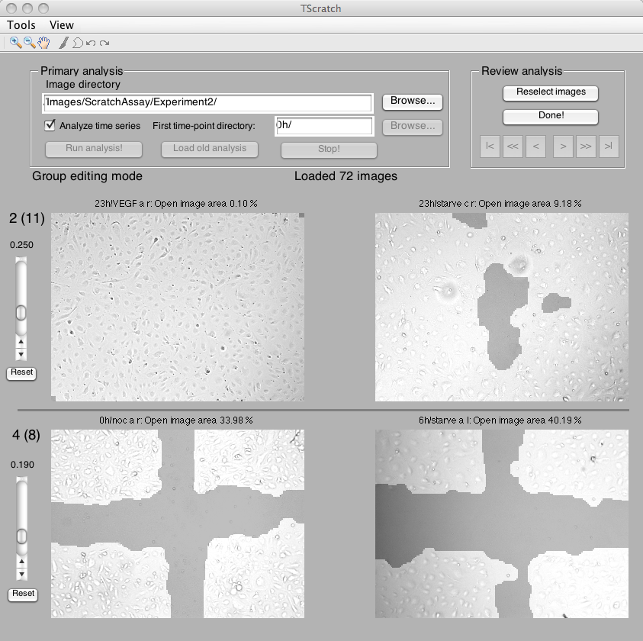
Figure 4.6. The TScratch program in group editing mode. Thresholds may be adjusted using the sliders. Numbers to the left indicate the analysis type of the images and, in parentheses, the number of images of that type. Using the buttons on the top right, the user may reset changed thresholds, randomly select new images of the shown types, and move on to single image mode by clicking “Done!”.

Single image mode
In single image mode, (see Figure 4.7) all the analyzed images are shown four at a time. The number of the image is displayed on the top left. If necessary the user may choose to adjust images by (a) threshold adjustment, (b) image exclusion and (c) manual adjustments, depending on the number of available replicates, image quality and available time.
(a) Thresholds can be adjusted using the sliders to increase or decrease the open image area marked by the algorithm.
(b) Images can be excluded, if a small number of images gave unsatisfying segmentation results due to artifacts in the image or poor image quality.
(c) Images may be rescued by selecting the manual modification tools, paint tool and polygon tool, from the toolbar and use them to mark closed areas in the images. See section 7 for details on these tools.
To move through the data set, use the arrow buttons at the top right, single arrow to move one page at a time, double arrow to move four pages, and the outermost pair of arrows to move to the first and last images.
Changes are saved to the internal data files when the arrow buttons are clicked, when “Done” is clicked to finish the analysis, or when the user answers “Yes” to an explicit question from the program if it should save the changes (as happens when the user exits the program or exports data).
Note also the possibility to enlarge one image at a time to make it occupy the whole lower part of the program window. See section 7.2 for more information.
Also note the available keyboard shortcuts in section 8.
When “Done!” is clicked, the program asks for a filename to write the final results to, and depending on if the directory mode is single directory or time-course, different data is computed and written (see sections 5.1.1 and 5.2.1). The output file can be easily imported into MS Excel or another spreadsheet program for further analysis. In time-course mode, a diagram (as in Figure 3.4) is also shown for each later time-point, showing means, standard errors and number of images for all groups of images (see section 4.6 for image grouping). The diagram may be saved as a PDF by choosing “Save As…” in the File menu and selecting PDF as output format.
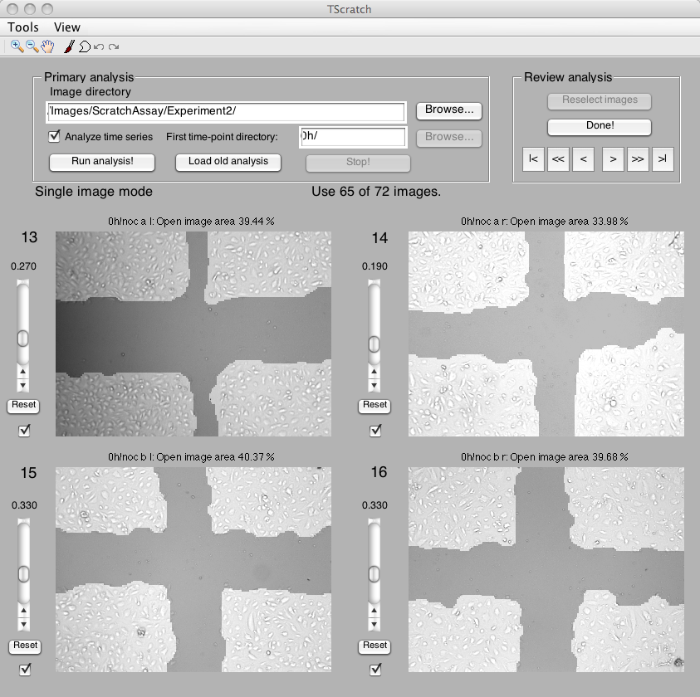
Figure 4.7. The TScratch program in single image mode. Thresholds for individual images are modified using the sliders. Images may be excluded by un-checking the checkboxes or manually rescued using the tool bar and sliders. The numbers next to the images indicate their number in the order all images were analyzed. Using the “Prev” and “Next” buttons, the user moves between images, and with the “Done!” button, the analysis is ended and an output file is written. Using the toolbar, the open area may be manually modified (see section 7).

Analysis Types
When an image is analyzed, it is assigned a type based on the ability of the automated threshold finder to find a threshold. The following table lists the different types:
1 | the threshold finder found a suitable threshold (see section 9.1)
2 | the threshold finder failed, the curve did not have the expected characteristics (i.e. not enough open area to determine threshold)
3 | the threshold finder failed, found a threshold outside the allowed range
4 | the threshold finder succeeded, but the image was very dark or very bright
5 | the image was manually edited using paint or polygon tools in single image mode (not assigned by the threshold finder)
6 | the threshold for the image was manually changed (in single image mode; not assigned by the threshold finder)
For types 2 and 3, the default threshold (see section 6.2) is used instead. In the “group editing mode” of the TScratch program, the user may adjust the thresholds for all images with types 2, 3 and 4 in one go. This is useful if the default threshold was not set to a good value.

Grouping of images and filename matching
In time-course mode, the open wound area is computed for each imaged region comparing later time-points to initial time-points, and means and standard errors are computed for groups of images. The identification of which images to compare is based on the filenames of the images. For an example of a good setup of filenames and directories, see Figure 3.2. More detailed information on how filenames are matched and grouped is given below.
To match later time-points to the initial time-point, the whole filenames are compared. For example, a file called ctrl_1.jpg in the “24h” directory will be matched to the file ctrl_1.jpg in the “0h” directory, and the open wound area will be computed using the open image areas computed for these two images. The comparison of filenames is not case-sensitive, but all characters up to the file extension have to match (though different file extensions, and thus file formats, could be used for the two images).
To group images into the groups used for statistical analysis, only the part of the filename up to the first underscore ‘_’ or space character ‘ ’ (or the ‘.’ separating the extension) is considered. Therefore, images called “ctrl_1.jpg”, “ctrl_2.jpg” and “ctrl 3.jpg” will be put in the same group (called “ctrl”), while “treated_1.jpg” and “ctrl1.jpg” will not. Again, the comparison is not case-sensitive, but all other characters have to match up to the first underscore or space; all subsequent characters are ignored and may consist of any number of spaces and underscores. No attempt is made to correct misspelled filenames, so be careful that all the images are named correctly!
Alternatively the extracted open image areas in the output file can be used directly (without the statistical and graphical analysis) and processed by the user.

Output files

Single directory mode
In single directory mode, the following output files are written:
- TAB-separated text file with open area measures
- <<filename>>_analyzed.<<ext>> for each image, in the “Analyzed/” subdirectory. <<ext>> is the same extension and file format as for the original image
- all_data.mat in the “Analyzed/” subdirectory (for internal use by the program, see section 5.4)
- <<filename>>_data.mat for each image, in the “Analyzed/” subdirectory (for internal use by the program, see section 5.5)
Here, <<filename>> stands for the filename (without extension) of each analyzed image file.

Output text file layout
The output text file in single directory mode is a TAB-separated text file containing the columns “File name”, “Open image area”, “Threshold value” and “Image type”. All analyzed images are listed with their corresponding values in the order they were analyzed. See sections 4.1 and 4.5 for more details on the meaning of these numbers.
At the bottom of the file, some information about the analysis is given, including date, directory and values of the most important parameters (see section 6.2).

Multiple directory (time-course) mode
In multiple directory mode, the following output files are written:
- TAB-separated text file with open area measures, open area ratios and statistical analysis of image groups.
- <<filename>>_analyzed.<<ext>> for each image, in the “Analyzed/” subdirectory. <<ext>> is the same extension and file format as for the original image
- global_data.mat in the base directory (for internal use by the program, see section 5.3)
- <<filename>>_data.mat for each image, in the “Analyzed/” subdirectory (for internal use by the program, see section 5.5)
Here, <<filename>> stands for the filename (without extension) of each analyzed image file.

Output text file layout
The TAB-separated output file in time-course mode has the following structure:
For each matching pair of images, the open image area for all time-points is given, as well as the open wound area comparing later time-points to the initial time point. The columns are given headers like “0h” and “24h” (the names of the subdirectories) for the open image areas, and “24h vs. 0h” for the open wound areas (comparing the “24h” measurement to the “0h” measurement).
In the next section of the output file, means, standard deviations, number of images and standard errors of the mean (SEM) are presented for all the groups of images, including the group names. Separate tables are created for each later time-point.
Next, P-values for two-sided t-tests with unequal variance are given in a table comparing every possible pair of groups. A P-value of less than 0.05, say, indicates that the difference between the two groups is statistically significant at the 5% level. Again, a separate table is given for each later time-point. If a group of images contains only one image, the t-test involving this group is invalid and the value NaN (Not a Number) is shown.
Finally, information about the analysis, including date, directory name and basic parameter values (see section 6.2) are given in the last section of the output file.

File structure: global_data.mat
This file is used internally by the program to save the details of the analysis in time-course mode. The file is saved in MATLAB mat-file format, and could be opened using the MATLAB load command (if the full version of MATLAB is installed). The user is not supposed to modify this file, and will normally not need to look at it. For the interested, however, it includes the variables
version | real number giving the version of the program producing the file
t0diridx | index into the diridx array of the time 0 directory
diridx | indices into fnames cell array of the first file of each directory
fnames | cell array with the filenames of all analyzed files, preceded by the subdirectory, e.g. “0h/image.jpg”
areas | column vector with computed open areas (in [0,1]) for each file
ths | column vector with the threshold used for analyzing each file
types | column vector with the type for each analyzed file
opts | an options structure with all the parameters used for the analysis
Table 5.1. The variables contained in global_data.mat.

File structure: all_data.mat
This file is used internally by the program to save the details of the analysis in single directory mode. The file is saved in MATLAB mat-file format, and could be opened using the MATLAB load command (if the full version of MATLAB is installed). The user is not supposed to modify this file, and will normally not need to look at it. For the interested, however, it includes the variables
version | real number giving the version of the program producing the file
fnames | cell array with the filenames of all analyzed files, e.g. “image.jpg”
areas | column vector with computed open areas (in [0,1]) for each file
ths | column vector with the threshold used for analyzing each file
types | column vector with the type for each analyzed file
opts | an options structure with all the parameters used for the analysis
Table 5.2. The variables contained in all_data.mat.

File structure: <<filename>>_data.mat
These files are saved for each analyzed image, in the “Analyzed/” subdirectory. They are used internally by the program to save analysis data for individual images, and are save in MATLAB mat-file format. The user should not manually modify or delete these files. They include the variables
version | a real number giving the version of the program saving the file
opentotmag | the opened curvelet magnitude image
thresh | the threshold used for the image
itype | the analysis type of the image
Table 5.3. The variables contained in <<filename>>_data.mat.

Parameters and options
All program options and analysis parameters may be set in the Settings window (see Figure 6.8), which is opened by selecting “Settings…” in the Tools menu, or pressing Ctrl-S (⌘S on Mac). The options are divided into three groups: Program settings (see section 6.1) that affect the behavior of the program, Basic analysis settings (section 6.2) with major effect on the image analysis, and Advanced parameters (section 6.3) that affect the threshold finding and image analysis and should not normally be changed.
In the Settings window, checking the box “Display advanced options” shows the advanced options, which are hidden by default. “Reset” restores the default values. With “OK” the chosen parameters are saved to a file and are used for the current analysis, as well as loaded the next time the program is started.
If the Settings window is opened while in “group editing mode” or “single image mode”, some choices are disabled since they affect only the initial analysis. If the parameters are changed while in these modes, the new parameters are directly applied to all images in the analyzed set. This may take a while, and the remaining time is shown in the status box.

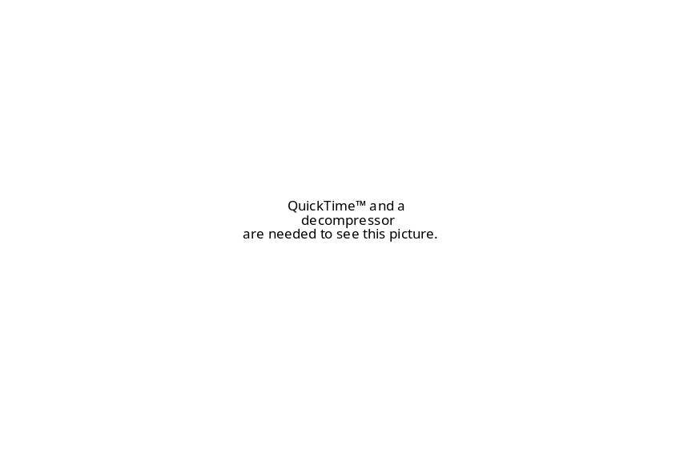
Figure 6.8. The settings window.

Program settings
The following program settings are available:
Write analyzed images | Disabling this option prevents the program from writing the analyzed images with an overlay showing the closed area to files in the “Analyzed” directory. This may be useful to save disk space.
Skip group editing mode | Enabling this option makes the program skip the “group editing mode” and go directly to the “single image mode”.
Display analysis curve | Enabling this option makes the program display a histogram curve for each analyzed image, indicating the chosen threshold. This is useful to see why the program fails on certain images and to evaluate the advanced parameters.

Basic analysis settings
The basic analysis parameters are the ones that affect the analysis most. Therefore, they are also the ones that the user most likely needs to change. Below follows a description of their meaning, and some instructions on when to change them.
The basic analysis parameters have the following meaning:
Default threshold | This is the threshold used if the automatic threshold finder fails, i.e. for analysis types 2 and 3. A lower threshold gives less open area. The ideal default threshold may depend on the cell line morphology. Since the thresholds for images of type 2 and 3 may be modified in group editing mode (see section 4.4), it makes most sense to change this value if several experiments are made with one cell line, using the same image acquisition settings, and it is noted that one particular default threshold works better for these settings.
Disk radius | The radius of the disk used for the morphological opening of the curvelet magnitude image. A smaller disk size makes the analysis more sensitive to small gaps between cells, and to isolated impurities, but may on the other hand give tighter contours for the marked area.  This value could be increased if the cells are sparsely packed, to avoid getting holes inside the closed area. Decrease the value if tighter edges are desired (with less margins on the closed area), but be aware that a too small value may influence the threshold finder, making it harder to automatically find a threshold.
Minimum hole area | The smallest fraction of the largest open area in the analyzed image that is allowed to be open. Smaller isolated open areas are filled.  Increase this value if the program leaves holes in the closed area that should be marked as closed, decrease it if the program erroneously marks small open areas as closed.
Minimum island area | The smallest fraction of the largest closed area that is allowed to be closed. Smaller isolated closed areas are removed.  Increase this value if the program leaves “islands” of closed area due to artifacts or debris. Decrease it if the program erroneously marks entire areas occupied by cells as open.
Erosion size | The amount of erosion applied to the marked closed area after the thresholding. A zero value means nothing is done, and a large value means more closed area is removed at the boundaries. The exact number of pixels removed for a specific erosion size depends on the curvelet analysis, and therefore on the image resolution.  Increase this value if an analysis with edges tighter to the cell boundaries is desired. Decrease it if the edges are too tight, so that the marked open area overlaps with the area actually occupied by cells.
Background compensation | When this box is checked, the program tries to compensate for large variations in background intensity that may otherwise affect the results. If the images to be analyzed have even lighting, this option may as well be disabled, making analysis slightly faster..

Advanced parameters
The advanced parameters mainly affect the automatic threshold finding and have the meaning described in the table below. The threshold finder uses the histogram of the curvelet magnitude image and looks for a local minimum between two large peaks (local maxima), referred to as the first and second max. The average user should not need to bother about these parameters.
Difference to global min | The smallest difference allowed between the value in the histogram for the chosen threshold and the global minimum value (within the allowed range).
Bump size | The smallest difference in histogram value between a local minimum and a subsequent local maximum that makes the algorithm choose the local minimum as threshold.
Lower threshold limit | The lower bound for the threshold (if a smaller value is found, the image is assigned type 3).
Upper threshold limit | The upper bound for the threshold (if a larger value is found, the image is assigned type 3).
Upper first max limit | The upper limit for the location of the first maximum. (Failure assigns type 2 to image)
Lower second max limit | The lower limit for the location of the second maximum. (Failure assigns type 2 to image)
First max minimum height | The minimum height needed to consider a local max as first maximum. (Failure assigns type 2 to image)
Max to min difference | The minimum allowed difference between the maximum found and the global minimum between the two maxima. (Failure assigns type 2 to image)
Dark image threshold | Threshold used to assign images type 4 (=large intensity variation image). Larger value makes it harder to be assigned type 4.
Threshold offset | An offset added to all automatically determined thresholds.

The toolbar
At the top of the TScratch window is the toolbar and the menu bar (Figure 7.9). The menu bar contains the “Tools” and “View” menus, while the toolbar contains several different tools. The drawing tools are only made available in single image mode. There are also keyboard shortcuts for all the tools, as tabulated in section 8. Below we describe the tools one by one.

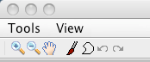
Figure 7.9. The TScratch toolbar containing the “Tools” and “View” menus, zoom and pan tools, the paint and polygon tools and the undo/redo buttons (from left to right).

The Tools menu
The Tools menu contains five items: “Export analysis data”, “Statistics…”, “Settings…”, “About…” and “Exit”.
Selecting “Export analysis data” opens a window that allows the user to select a filename for writing a text file containing names, measured open image area, threshold (unless manually analysed) and analysis type for all the analyzed images, as well as information about the parameters used for the analysis. The output file structure is similar to the one generated in single directory mode (see section 5.1.1).
The “Statistics…” item displays a window with some statistics on the analyzed data set, containing the number of images of each type. The “Settings…” item opens the settings window for changing parameters (see section 6), the “About…” item shows information about the authors and the program version, and the “Exit” item, obviously, quits the program. Keyboard shortcuts are shown next to the menu items.

The View menu
The View menu contains the item “Goto image number…” and five items related to enlarging one of the images in single image mode. “Goto image number…” is active only in single image mode, and opens a dialog box where the user can enter the number of an image to display (along with the next three images, if possible). Entering a number out of range generates an error.
The items “Enlarge image #” make image 1 to 4 be displayed on the whole bottom part of the program window, enabling a closer investigation of the analysis and more accurate manual editing. To go back to viewing four images, select the same menu item again (it has now changed to “Reduce image #”) or select “Reset to 4-image view”. There are also keyboard shortcuts for these menu items: ‘1’–‘4’ for enlarging/reducing images and ‘0’ to go back to 4-image view.

The zoom and pan tools
The zoom tools (the +/- magnifying glasses) enable the user to zoom in into the images and back out. Left-clicking in an image with a zoom tool enabled zooms in/out depending on the tool selected. Double-clicking resets to the original size. Right-clicking brings up a context menu where a few options may be selected, and left-clicking and dragging draws a rectangular area which is what is shown when the mouse button is released.
The pan tool (the hand) can be used to move the zoomed in area by left-clicking and dragging to move the image.
See also the keyboard shortcut section (section 8) for shortcuts for these tools, as well as information on how to zoom and pan without switching tools (using the ‘+’, ‘-‘, ‘*’ and arrow keys).

The paint tool
When the paint tool (the brush) is selected and the mouse pointer is moved over one of the images, the pointer turns into a circle. Left-clicking in the image now draws a covered area (indicated by brightening the image), while right-clicking removes covered area (or draws open area). Clicking and dragging draws continuous lines with the width of the circle. The response may sometimes be a bit slow depending on the computer, so do not drag the mouse too quickly.
When an image is modified using the paint tool, its type is changed to 5, indicating that it was manually edited, and the open image area displayed above the image (and printed in the output file) is updated every time the mouse button is released. If the user then tries to change the threshold for the manually edited image, a warning is shown that this action will remove the manual modifications, and if the user proceeds, the image type is changed to 2 and the image is again automatically analyzed with the previous threshold and the modified offset.
If the image is zoomed in, the painting tool becomes more detailed, with the painted area always corresponding to the size of the circular mouse pointer. Here, it is especially useful to take a look at the keyboard shortcuts for zooming in section 8.
All changes using the paint tool may be undone with the undo tool.

The polygon tool
Using the polygon tool (the polygonal shape in the toolbar), the user may manually analyze images by drawing polygons enclosing regions of open area. To do this, select the polygon tool, then click in the desired image – the mouse pointer now changes to a cross-hair symbol – then left-click repeatedly in the image to add nodes to the polygon. Double-clicking places one last node and closes the polygon by connecting it to the first node placed, while right-clicking does not add a new node, but connects the previously placed node to the first one to close the polygon.
After the last node has been placed, the area enclosed by the polygon is marked as open and the area outside as closed, and the percentage of open image area is updated accordingly. Several polygons may be drawn after one another, each of them enclosing an open area but not overwriting each other, but as soon as the “<” or “>” buttons are clicked to move between image views, or the paint tool is used, the previous polygons are lost (only the resulting open area is kept) and drawing a new polygon will start the procedure from the beginning.
Polygons drawn using the polygon tool can be undone using the undo tool.

The undo/redo tools
The undo and redo tools (curved arrows backward and forward) can be used to undo (and redo) manual modifications using the paint and polygon tools. They work for all four displayed images at the same time, meaning that if image 1 is changed and then image 2 and image 1 again, repeatedly clicking the undo tool will undo changes in exactly this order, though backwards, (and not all changes to image 1 first, then image 2, etc.). Changes that are undone using the undo tool may then be re-done with the redo tool.

Keyboard shortcuts
The following keyboard shortcuts are available (if the corresponding tools/menu items are activated):

Menu item shortcuts
Ctrl-D (⌘D on Mac) | Export analysis data for all analyzed images (section 7.1).
Ctrl-T (⌘T on Mac) | Show the statistics window.
Ctrl-S (⌘S on Mac) | Open the Settings dialog (section 6).
Ctrl-A (⌘A on Mac) | Open the About box.
Ctrl-E (⌘E on Mac) | Exit the program.
Ctrl-G (⌘G on Mac) | Go to image number in single image mode.
0 | Return to 4-image view (single image mode only).
1–4 | Enlarge/reduce image 1–4 (single image mode only).
Tool shortcuts
Z | Select/deselect the zoom in tool.
X | Select/deselect the zoom out tool.
C | Select/deselect the pan tool.
O | Select/deselect the paint tool.
P | Select/deselect the polygon tool.
U | Undo.
R | Redo.
Button shortcuts
N | Next (equivalent to “>” button)
Alt-N | Jump 4 pages forward (equivalent to “>>” button)
M | Last page (equivalent to “>|” button)
B | Previous/Back (equivalent to “<” button)
Alt-B | Jump 4 pages forward (equivalent to “<<” button)
V | First page (equivalent to “|<” button)
Zoom/pan shortcuts
+ | Zoom in into the current image by a factor of 1.7.
- | Zoom out of the current image by a factor of 1.7.
* | Reset current image to original view.
Arrow keys (←,↑,→,↓) | Move around in the current, zoomed in, image.
Table 8.4. The keyboard shortcuts for the TScratch program.
The “current image” referred to in Table 8.4 is the image that was latest clicked in using any of the tools, or no tool at all.
Additionally, the TAB key may be used to move focus between buttons, edit boxes and check-boxes in the GUI, and the SPACE bar and RETURN key may be used to check/uncheck check-boxes and press buttons. If an edit box has focus, the keyboard can be used to write text in it, and the shortcuts in Table 8.4 will not work until another component has the focus.

Computational details

The open area measurements
In this section, the algorithm for measuring the open image area is described in more detail, giving an idea of how the image analysis works. The basic idea is to use the multi-resolution curvelet transform to extract information on the detail levels corresponding to cells in the image, and then separating the regions with much detail (covered area) from regions with little detail (open area) by choosing an appropriate threshold. The implementation was done in MATLAB, using some of the built-in MATLAB functions.
The computation of open image area consists of the following steps:
- Compute the mirror-extended curvelet transform
- Extract two levels from the curvelet transform, and sum coefficient magnitudes over directions and levels
- Optionally scale for large intensity variations
- Compute the morphological opening of the image using a specified disk size
- Automatically find a good threshold for the image
- Apply the found threshold, or a default threshold if none found
- Apply an erosion transformation to remove spill-out covered area
- Fill isolated open areas (“holes”), and isolated covered areas (“islands”)
- Compute the fraction of open area compared to the total image area
The mirror-extended curvelet transform [1, 2] is computed using CurveLab (www.curvelet.org). The use of the mirror-extended version of the curvelet transform ensures that no artifacts are introduced by the image boundaries. The result is curvelet coefficients 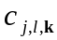 on levels , directions and positions 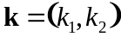.
The algorithm then extracts two detail levels from the levels given by the curvelet transform. If the number of levels computed is , the levels 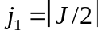 and 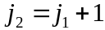 are extracted. Here, 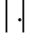 means rounding upwards to nearest integer. The number is determined by the image resolution, namely if the image has pixels, we have 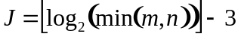, where  means rounding downwards.
The magnitudes of the curvelet coefficients on the two selected levels are then summed over levels and directions to produce the curvelet magnitude image 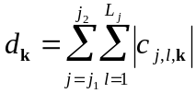, 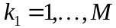, 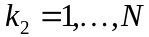, where and are given by the curvelet transform.
The compensation for large intensity variations is performed by using the coarsest scale of the curvelets, and multiplying the curvelet magnitude image by 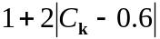, where 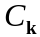 is the intensity value at position computed from the coarsest scale of curvelets, and normalized to be between 0.0 and 1.0.
The morphological opening is computed using the MATLAB command imopen(cmim, strel(‘disk’, radius)), where cmim is the curvelet magnitude image and radius is the parameter disk radius that may be set by the user (see section 6.2).
The threshold used to separate open and covered area is automatically determined by investigating the histogram of the curvelet magnitude image, smoothing it slightly and looking for a threshold between two peaks in the histogram. Parameters affecting the threshold finder are discussed in section 6.3, but should hardly need to be changed by the user. This works well when the open and covered areas both have a significant size (thereby producing large peaks in the histogram), but when either of them is very small or the image is of bad quality, the automated threshold finder may fail, and instead the default threshold (see section 6.2) is applied. The threshold is applied by marking areas with curvelet magnitude larger than the threshold as covered, and areas with smaller curvelet magnitude as open.
An erosion transformation is then applied to the thresholded image by the MATLAB command bwmorph(thim, 'erode', erodesize), where thim is the thresholded image and erodesize is the parameter erosion size (see section 6.2).
Since a connected open area is desired, the algorithm also fills “holes” and removes “islands” if they are smaller than [minimum hole area] * [largest connected open area] and [minimum island area] * [largest connected covered area], respectively. The parameters minimum hole area and minimum island area can be set by the user (see section 6.2).
Finally, the open image area percentage is computed as
100*(1 – [# covered pixels]/[total # pixels]).

Statistical analysis
The statistical analysis of the groups of images in time-course mode consists of the following entities:
- Mean value, μ
- Standard deviation (unbiased), σ
- The number of images, N, belonging to the group
- Standard error of the mean (SEM), σ/√N
- Student’s T-tests
The bars in the diagram shown by the program (see Figure 3.4) represent the means of open wound areas for the groups, with error bars indicating SEM. The number of images is shown in parentheses after the group names.
The t-tests are computed for all pairs of image groups, and are two-sided tests with unequal variance. The numbers given in the output file are P-values giving the probability that the images in the two groups stem from the same distribution. Thus, a P-value of less than 0.05, say, means that the difference between the groups is statistically significant at the 5%-level. The P-values are computed using the MATLAB function ttest2.

Tips for experimental setup
Below are some suggestions on how to set up the wound healing experiment and image acquisition to make the TScratch program perform well on the images. The automated analysis is more dependent on a good image quality than a manual analysis is, but spending some time on making high quality images easily saves a lot of time on the analysis.

Tips for the wound healing experiment

The wound healing assay is a cheap and widely-used image-based migration assay that assesses coverage of a cell-free, open area by migrating cells from a confluent area. Even though there are many protocols available [4], especially online, these suggestions can maximize the observed effect:
- Seed the cells at full confluence and let them attach, depending on the cell line for 2 h to 24 h.
- Starve the cells overnight in serum-free or serum reduced medium (1 % serum), depending on the sensitivity of the cell line.
- Scratch confluent cell layer once horizontally and twice vertically for each well, producing two crosses with a good distance from each other and the well’s rim. Using a 200 µl pipette tip and the lid of the culture plate as a ruler for straight lines worked very well for us. Homogenous cross sizes are the key for replicates with low variance.
- Thoroughly wash the cells with PBS and carefully swirl the plate before applying the treatment to remove cells detached by scratching.
- Acquire “0 h images” and apply treatments directly after scratching.

Tips for image acquisition
Any conventional light microscope with attached camera can be used. To achieve good results and make the analysis process run as smoothly as possible, it is recommended to consider the following sample preparation and image acquisition tips.
- Whenever possible images should be acquired in minimal, Phenol Red-free medium or best PBS to minimize floating debris or serum residues that can add artifacts to images.
- Acquire images with 5X magnification and perfectly centered crosses.
- Consistently name the images, like “condition_replicate#_cross#”, and make sure to have identical names for each sample at each time point saved in separate folders, e.g. 0h and 24h (see Fig. 2.1).
- Maximizing the contrast is the key.
  - For us, using phase-contrast or bright-field with nearly closed aperture gave the best results.
  - Keep the image slightly unfocussed to acquire an image plain on top of the focus plain (see Figure 11.1).
  - If the used image acquisition software supports this, chose an “automatic min/max” contrast option.
- Adjust the brightness of your lamp so that an exposure time of 15 ms to 100 ms gives you satisfying brightness for the acquired image.
- The algorithm deals better with slightly overexposed, brighter images than too dark images.
- Try to have an homogenous light distribution throughout the whole image, preventing brightness gradients. This can be achieved by recalibrating the light path to Kohler illumination (see your microscope’s instruction or this interactive java tutorial http://www.microscopyu.com/tutorials/java/kohler/ ).
- Try to reduce image acquisition time outside the incubator to 30 min at a maximum for preventing effects on cells.

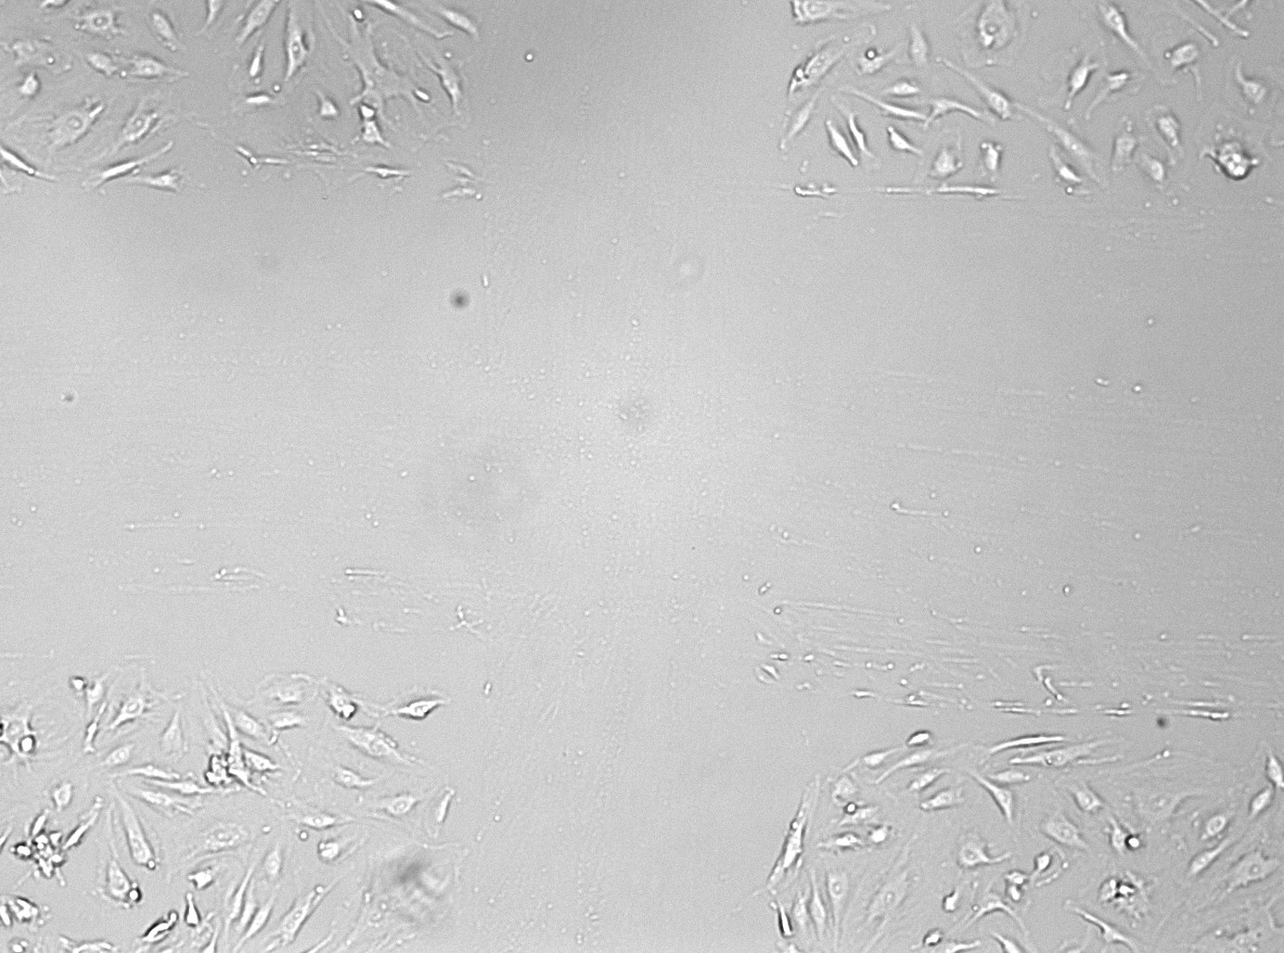
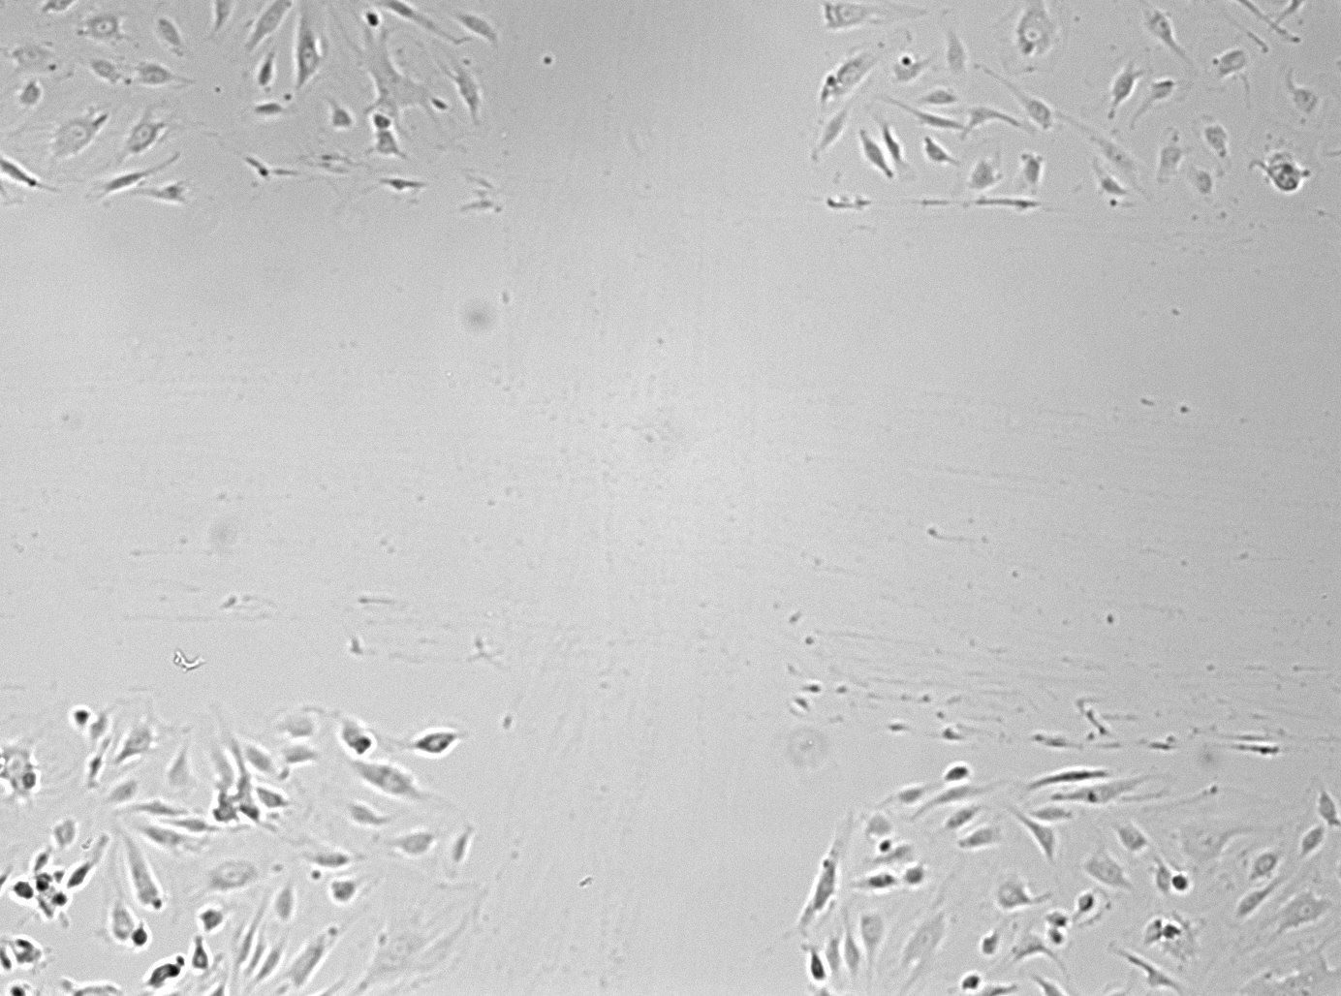
A
B

Figure 11.1. Contrast maximization in image acquisition. For ideal image acquisition the area of interest should be slightly unfocussed. While the contrast can be enhanced by imaging below the focus plain (A), TScratch performs best with imaging on top of the focus plain (B).

Troubleshooting
Below are some common problems that can be encountered and suggestions for their solution.

Question | Answer
The program does not start. | Mac: The first time the program is run, it may take a while before the program window shows up. Just be patient and wait – the next time it will be faster.  If the program still does not run, make sure that:  - MCR v7.8 was properly installed  - If you use the startup script, make sure that you entered the correct paths to MCR and the run_TScratch.sh file, inside quotation marks. Run the script from the Script Editor to see any error messages. If you have trouble with the script, or saving it as an application, you may always run it from a Terminal window by entering  cd $TSCRATCH_PATH$  ./run_TScratch.sh $MCR_PATH$  where $TSCRATCH_PATH$ and $MCR_PATH$ should be substituted to the paths to the TScratch program and the MCR, respectively (within quotation marks if they contain spaces).  Windows: If the program does not start, the most likely cause is that there was some problem with installing MCR. Try reinstalling MCR and pay attention to any error messages.
The program fails to analyze my images. | Although much effort has been put into creating a robust and flexible algorithm, the algorithm still depends on a good image quality to be able to analyze the images. Be sure to read section 10 to get some suggestions on how to acquire images.  Depending on the morphology of cells in the images, it may also be necessary to change some program parameters (see section 6). Start with changing the disk radius and disabling/enabling background compensation, and see if the results get better.

References

[1] E. Candes, L. Demanet, D. Donoho and L. X. Ying, Fast discrete curvelet transforms, Multiscale Model. Sim., 5 (2006), pp. 861--899.
[2] L. Demanet and L. Ying, Curvelets and wave atoms for mirror-extended images, Department of Mathemathics, Stanford University, 2007.
[3] T. Gebäck, M. M. P. Schulz, P. Koumoutsakos and M. Detmar, A novel and simple software tool for automated analysis of monolayer wound healing assays, BioTechniques (2008).
[4] J.-L. Guan, Cell migration developmental methods and protocols, Humana Press, Totowa, N.J., 2005.

Citation information

When using TScratch for your analyses please include the following citation in all related publications:

Gebäck, T., Schulz, M.M.P., Koumoutsakos, P. & Detmar, M. A novel and simple software tool for automated analysis of monolayer wound healing assays. BioTechniques (2008).

Index

analysis type, 12, 15
background compensation, 21
curvelet transform, 27
default threshold, 20, 28
directory structure, 7, 11
disk radius, 20, 27
Done, 9, 12, 13, 14
enlarge image, 14, 23
erosion size, 21, 28
error bars, 9, 28
exclude image, 9
experimental setup, 29
export analysis data, 23
filename structure, 7, 15, 29
group editing mode, 8, 12, 13, 15, 19, 20
image acquisition, 29
initial analysis mode, 12
installation, 5
Mac, 5
Windows, 6
keyboard shortcuts, 9, 14, 23, 24, 26
menu
Tools, 23
View, 23
minimum hole area, 20, 28
minimum island area, 20, 28
open image area, 11, 27
open wound area, 11
options, 17, 18, 19, 24
output file, 9, 10, 11, 14, 15, 16, 17, 24, 28
paint tool, 13, 24, 26
pan, 24, 26
parameters, 12, 16, 17, 18, 19, 20, 21, 23, 28, 31
advanced, 21
basic, 20
polygon tool, 13, 24, 25, 26
program mode, 12
redo, 25, 26
Reselect images, 8, 12
Reset, 9, 12, 19, 26
settings, 19, 23, 26
single directory mode, 11, 16, 17
single image mode, 8, 9, 12, 13, 14, 19, 23, 26
statistics, 28
menu item, 23
threshold, 28
default. See default threshold
threshold adjustment, 12, 13
time-course mode, 8, 11, 12, 14, 15, 16, 17, 28
toolbar, 9, 13, 14, 23
troubleshooting, 31
t-test, 28
undo, 9, 24, 25, 26
zoom, 24, 26

