**CS 4460 HOMEWORK 4**

Name: CHANG Yingshan

Student ID: 903457645

GT Account: ychang363

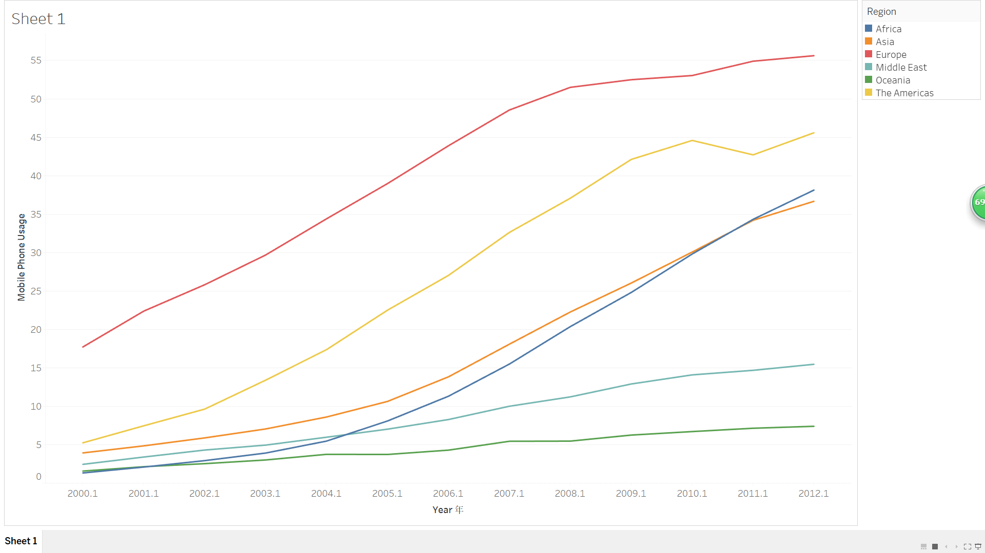

**Chart description:** this chart illustrates the dynamic change in mobile phone usage in each region from 2000 to 2012.

**Question:** Describe and compare the trend of mobile phone usage along the time axis for each region.

**Answer:** With a global view of this chart, the mobile phone usage in all regions have increased during this period, albeit to widely varying degrees. It is obvious that Europe stood out as the country with the largest mobile phone usage, whose mobile phone usage has continuously increased over the period, though the growth slowed down after 2007. The rising rate in mobile phone usage in the Americans was similar to that in Europe. However, the Americans experienced a downward trend from 2010 to 2011 before going back to the upward trend. Asia and Africa can be analyzed together, since both countries witnessed a rise in mobile phone usage between 2000 and 2012, which is particularly noticeable in the latter half of the period. Middle East and Oceania, in contrast, witnessed a much slower increase in mobile phone usage.

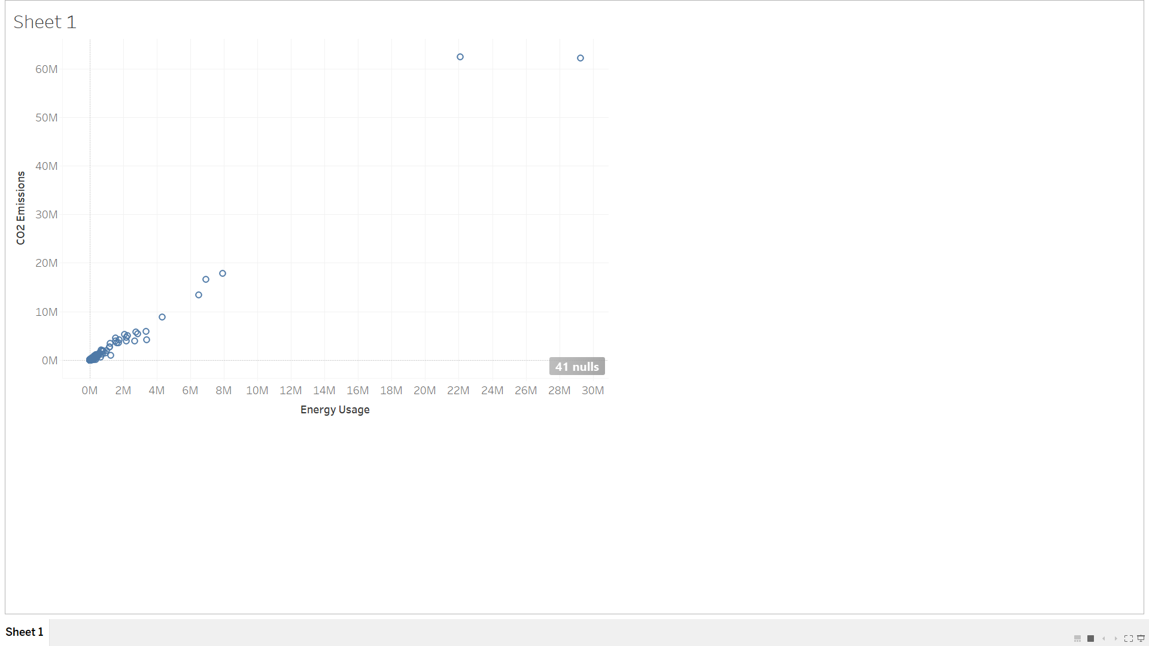

**Chart description:** this scatterplot demonstrates the CO2 Emissions versus energy usage for each country.

**Question:** There are two extreme points on the top right corner of the chart, are they anomalies? Why or why not?

**Answer:** Those two extreme data points on the top right corner of the chart represent: [United States, CO2 Emissions = 62,232,787, Energy Usage = 29,262,272] and [China, CO2 Emissions = 62,411,163, Energy Usage = 22,080,026] respectively. They should not be considered as anomalies for the following reasons.

1. Anomalies are identified with respect to a given relationship or expectation. In this question, no relationship or expectation is given and we should not call those two data points on the top right corner “anomalies” simply by the fact that their positions are far away from other points.
2. There are plenty of reasons to explain why the US and China have extreme values. First of all, both countries are “giant” in terms of population, land area as well as industrial level. This accounts for their large scale of energy consumption. Secondly, CO2 emissions are closely related to industrialization and energy consumption. This positive relationship, as shown in the scatterplot, would well explain why those two enormous energy-consuming countries also have enormous CO2 emissions.

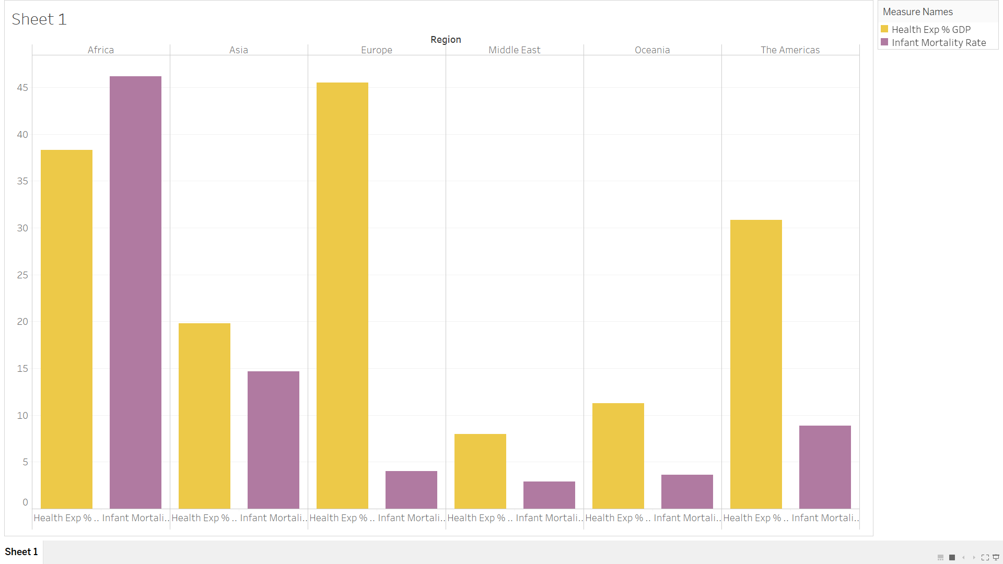

**Chart description:** This bar chart plots health expenditure as a proportion of GDP and infant mortality rate for each region.

**Question:** Are countries with low infant mortality rate necessary to have greater health expenditure as a proportion of GDP?

**Answer:** The argument that countries with low infant mortality have greater health expenditure cannot be applied to all regions. The situation in Europe is consistent with the above viewpoint. Standing out as the country with the largest health expenditure as a proportion of GDP, Europe also enjoys an extremely low infant mortality rate. However, Middle East and Oceania are two counterexamples, with infant mortality rate being even lower than that of Europe and health expenditure being also low, instead of being high as expected by the above viewpoint. In stark contrast, Africa, on the second place in terms of health care expenditure as a proportion of GDP, suffers from a staggeringly high infant mortality rate which has exceeded 45%.

It can be concluded that there is no direct relationship between infant mortality rate and health care expenditure as a proportion of GDP. Perhaps one of the most obvious problem in this question is the fact that large health care expenditure as a proportion of GDP cannot be equated with large health care expenditure. It is highly possible that the total GDP of a region is very low, thus, its health care expenditure is also low even though the it makes up a high proportion of the region’s total GDP. And that’s probably the case in Africa. Apart from total GDP, I believe other underlying factors that affect infant mortality rate should be considered such as hygienic standard and birth policy.

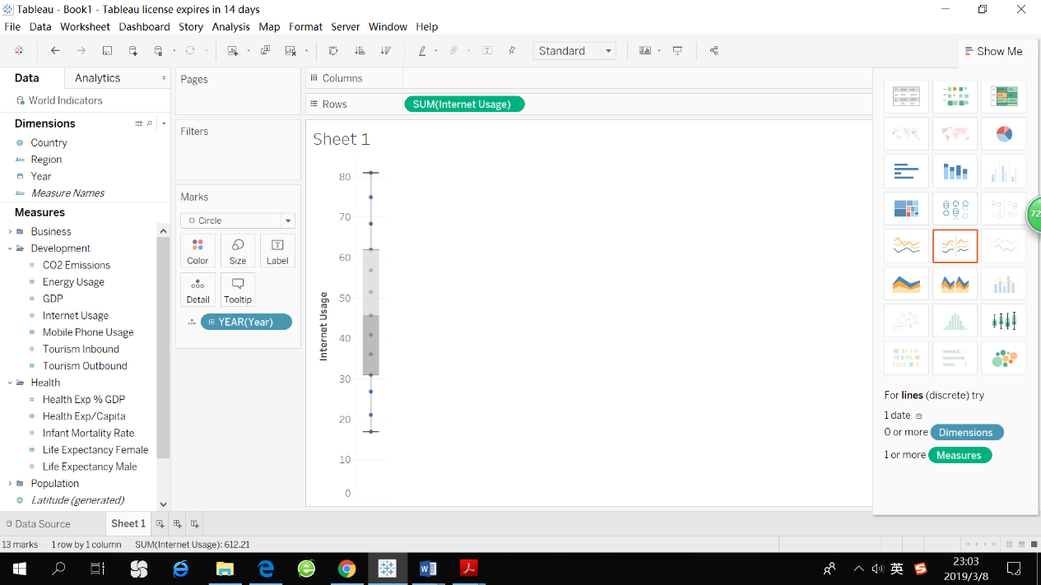**Tableau Strengths:**

1. Allow the user to get familiar with the tools by exploration.
2. Gives the user recommendations about what kind of data needs to be selected in order to plot a certain chart. This is particularly helpful when the user has no idea about a how a certain visualization is established.
3. 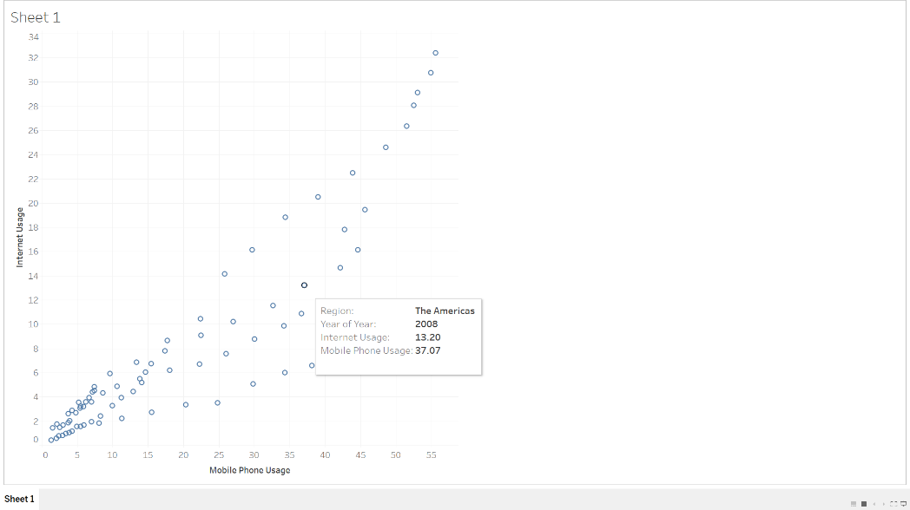Provides sample data sources for the convenience of early-phase exploration of how to use Tableau.

**Tableau Weaknesses:**

1. The default color is the same for different dimensions if the two or more dimensions are included in one chart, making it hard to distinguish different dimensions. For example, the chart on the right illustrates the internet usage against mobile phone usage for different regions and in different years. It is hard to see which circle belongs to which region or year because all circles are blue by default.
2. 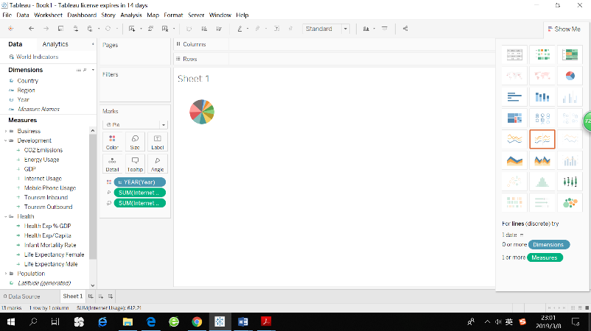Some visualizations are so small and are located only on the corner of the page
3. For the pie chart, there is no additional annotation of what each slice represents.

**Tableau User Tasks:**

1. Select: mark something as interesting

Click on a data point, this data point is highlighted while other points are faded, and the attributes of this data point is shown in a nearby box.

1. Explore & Reconfigure: show something different

Tableau allows the user to explore the dataset by choosing different measures, dimensions as well as chart formats. The user can also rearrange the attributes with respect to different axis.

1. Encode: The color size, shape, etc. of the visual marks can be changed.
2. Abstract & elaboration: adjust the level of overview and detail.

Map is a good illustration of this task.

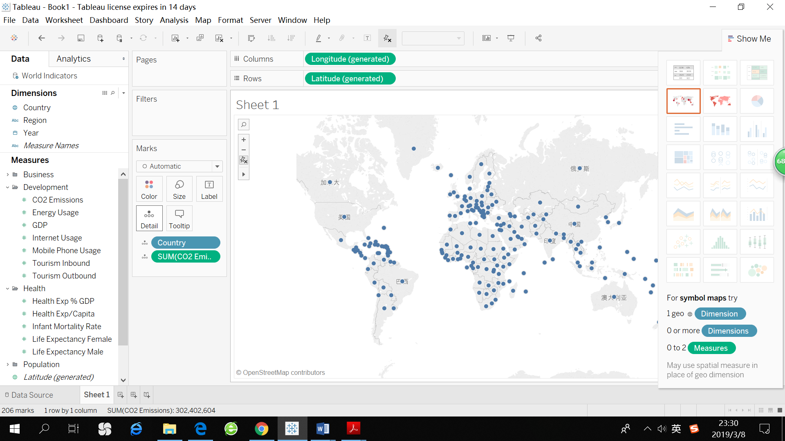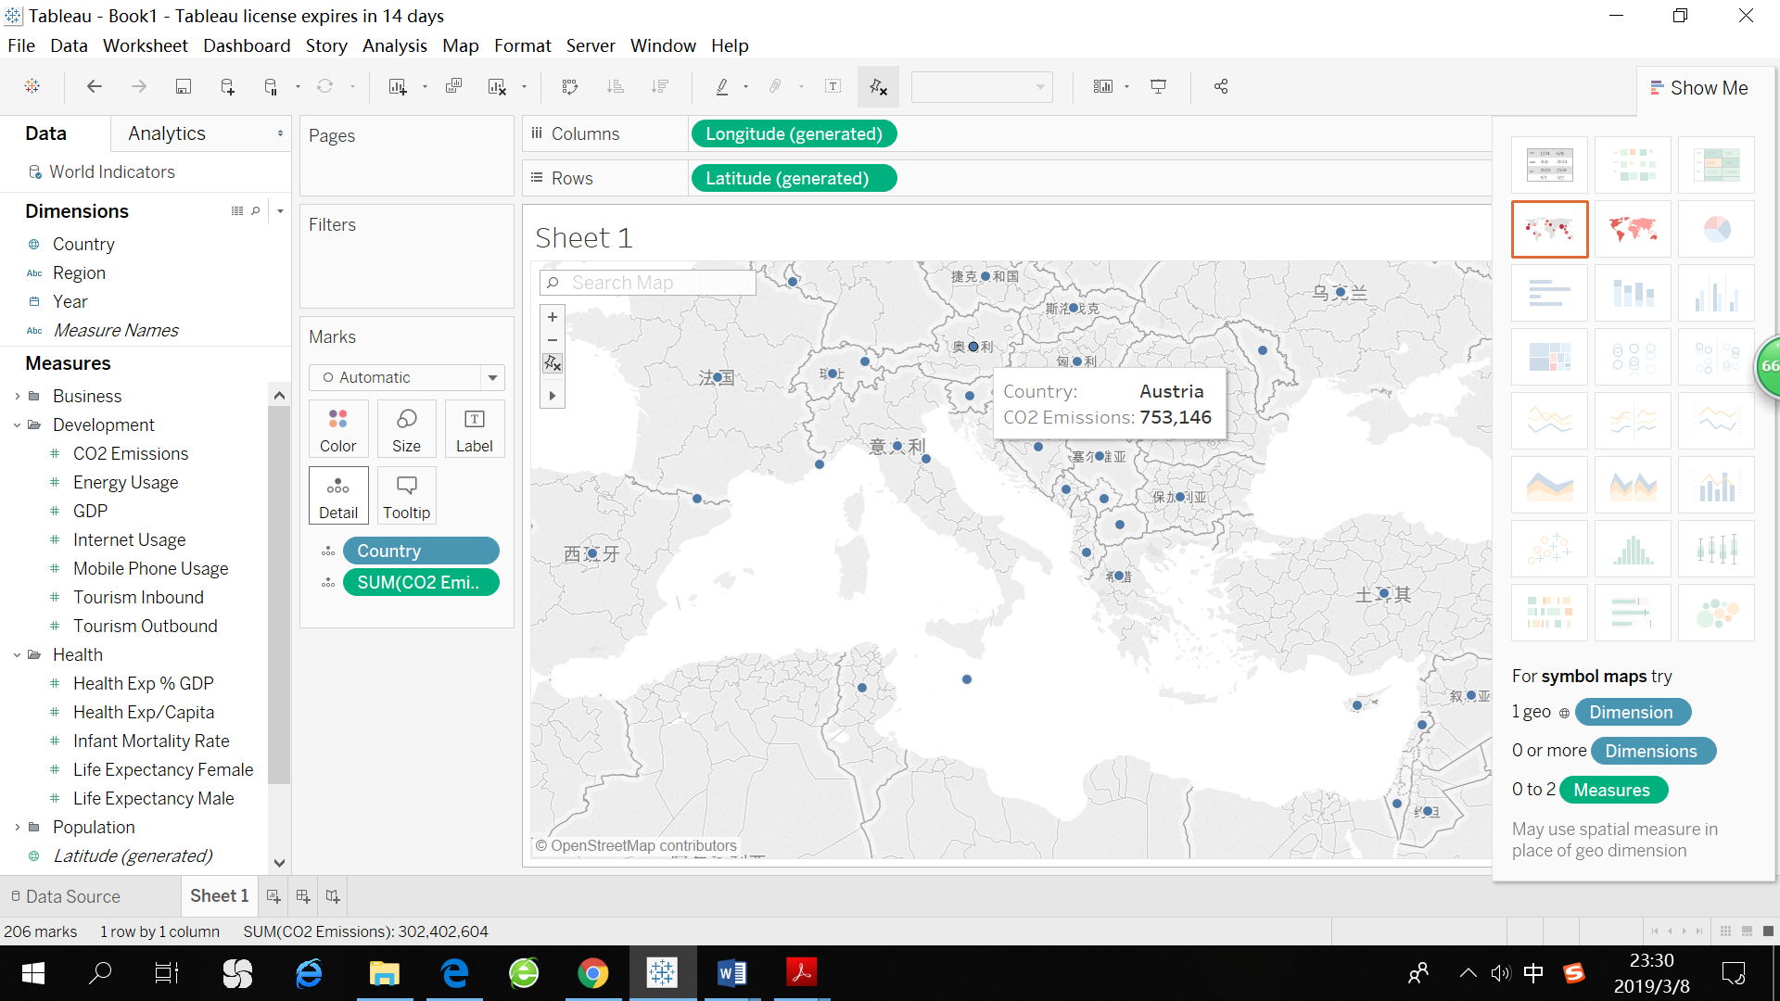

1. Filtering: change the set of data items being presented based on some specific conditions.

Tableau allows the users to edit filters by clicking the arrow beside each attribute.

**Characteristics of Tableau interaction:**

1. The transitions between different states are fluid and not harsh on Tableau. It allows the user to keep on specifying data, conditions and visual formats while providing immediate visual feedbacks on interaction.
2. To a certain extent, Tableau has integrated user interface components in the visual representation. For example, we can select a group of data points on a map. After that, only the selected items are highlighted and others are hidden. The data for the selected items is shown in a box near the actual visual mark on the visualization.
3. For transitions, Tableau is well-designed to preserve the context. For example, after a filtering operation, only the number of original visual marks is changed, while the color, size, shape, etc. of the visual marks are consistent before and after filtering.
4. Tableau ensures that interaction never ‘ends’. It provides all kinds of method to explore a dataset including selecting ‘measures’ and ‘dimensions’, editing filters, exchanging rows and columns, modifying labels and axes, etc. In case the user is unfamiliar with those operations, Tableau also suggest what the user should do in order to plot a certain type of chart. This reinforces a clear conceptual model in which new exploration is followed by new question, which is followed by new exploration again, so on and so forth.