**CS 4460 HOMEWORK 5**

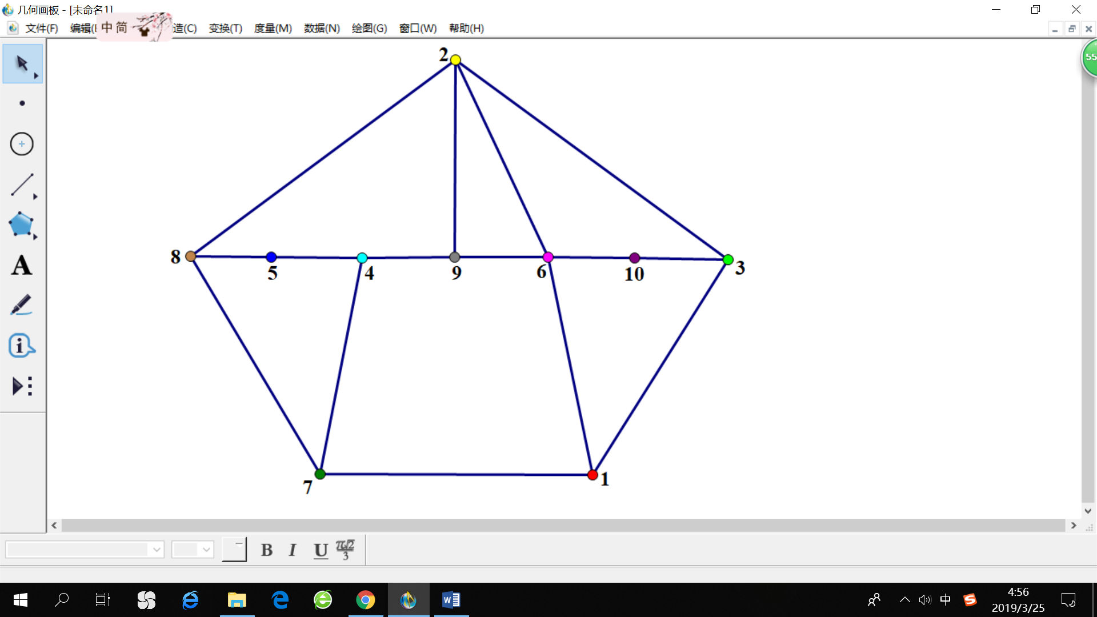

**Name: CHANG Yingshan**

**GT Account: ychang363**

**Design process**

our goal was to come up with a positioning for all the vertices, which would result in an aesthetically pleasing graph. In my own opinion, “an aesthetically pleasing graph” can be understood as “a graph with visual brevity”, which means the graph should not look messy and the lines should have as few crosses as possible.

Based on this rule, I got started with placing the ten vertices on a circle in clockwise order. Then, I drew all the edges according to the matrix. The resulting graph was shown below.

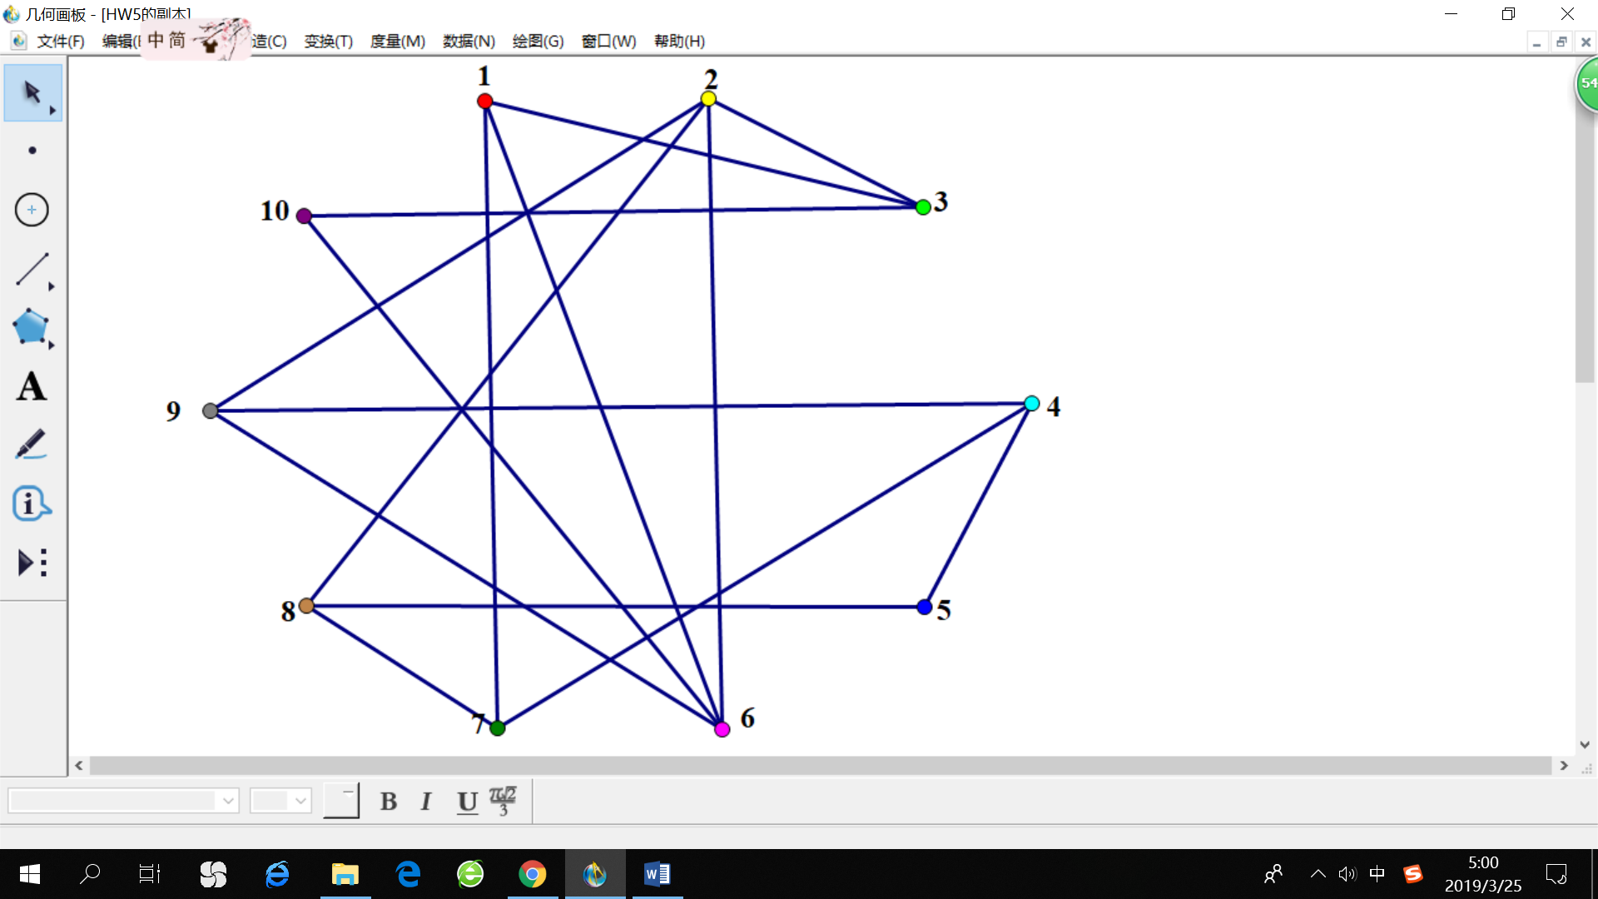

After that, I tried to reduce the number of crosses of edges by moving the vertices around. I used “The Geometer's Sketchpad”, which is an interactive geometry software for exploring geometric constructions. I found this software extremely helpful because when I move a point, all the lines connecting to that point will move accordingly, significantly reducing the time for reconstructing the graph after moving one vertex. Finally, I got a graph with no crossing edges, where vertices 2,3,1,7,8 were on the periphery and the other five vertices were in the middle. Additionally, I fine tuned the positioning such that the five vertices on the periphery form a regular pentagon and the five vertices in the middle are aligned on a straight line.