# speck

Beaulieu, Ray, et al. "The SIMON and SPECK Families of Lightweight Block Ciphers." *IACR Cryptology ePrint Archive* 2013 (2013): 404.

维基百科：<https://en.wikipedia.org/wiki/Speck_(cipher)>

NSA新发布的轻量级分组密码，被用在嵌入式，物联网等安全中

|  |  |
| --- | --- |
| 设计者 | Ray Beaulieu, Douglas Shors, Jason Smith, Stefan Treatman-Clark, Bryan Weeks, Louis Wingers[NSA](https://en.wikipedia.org/wiki/National_Security_Agency) |
| 发布时间 | 2013 |
| 相似算法 | [Simon](https://en.wikipedia.org/wiki/Simon_(cipher)), [Threefish](https://en.wikipedia.org/wiki/Threefish" \o "Threefish) |
| 算法基本信息 | |
| [秘钥长度](https://en.wikipedia.org/wiki/Key_size) | 64, 72, 96, 128, 144, 192 or 256 bits |
| [分组大小](https://en.wikipedia.org/wiki/Block_size_(cryptography)) | 32, 48, 64, 96 or 128 bits |
| 算法结构类型 | ARX |
| 算法轮数 | 22–34 (depending on block and key size) |
| Speed | 2.6 [cpb](https://en.wikipedia.org/wiki/Cycles_per_byte" \o "Cycles per byte) (5.7 without [SSE](https://en.wikipedia.org/wiki/Streaming_SIMD_Extensions)) on Intel Xeon 5640 (Speck128/128) |

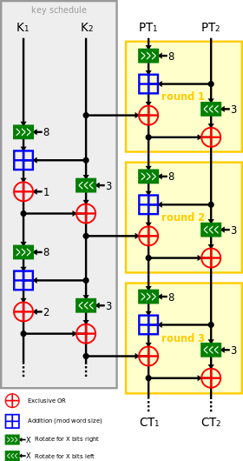

# Simon

Beaulieu, Ray, et al. "The SIMON and SPECK Families of Lightweight Block Ciphers." *IACR Cryptology ePrint Archive* 2013 (2013): 404.

维基百科：<https://en.wikipedia.org/wiki/Simon_(cipher)>

与speck一起提出

|  |  |
| --- | --- |
| General | |
| 设计者 | Ray Beaulieu, Douglas Shors, Jason Smith, Stefan Treatman-Clark, Bryan Weeks, Louis Wingers[NSA](https://en.wikipedia.org/wiki/National_Security_Agency) |
| 发布时间 | 2013 |
| 相似算法 | [Speck](https://en.wikipedia.org/wiki/Speck_(cipher)) |
| 算法基本信息 | |
| [秘钥长度](https://en.wikipedia.org/wiki/Key_size) | 64, 72, 96, 128, 144, 192 or 256 bits |
| [分组大小](https://en.wikipedia.org/wiki/Block_size_(cryptography)) | 32, 48, 64, 96 or 128 bits |
| 算法结构类型 | Balanced [Feistel network](https://en.wikipedia.org/wiki/Feistel_network" \o "Feistel network) |
| 算法轮数 | 32, 36, 42, 44, 52, 54, 68, 69 or 72 (depending on block and key size) |

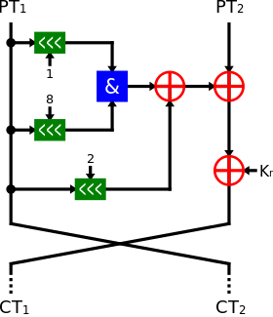

# Lucifer

Sorkin, Arthur. "Lucifer, a cryptographic algorithm." Cryptologia 8.1 (1984): 22-42.

维基：<https://en.wikipedia.org/wiki/Lucifer_(cipher)>

 a candidate for the [Data Encryption Standard](https://en.wikipedia.org/wiki/Data_Encryption_Standard)

|  |  |
| --- | --- |
| 设计者 | [Horst Feistel](https://en.wikipedia.org/wiki/Horst_Feistel) et al. |
| 发布时间 | 1971 |
| 后续继承算法 | [DES](https://en.wikipedia.org/wiki/Data_Encryption_Standard) |
| 算法基本信息 | |
| [秘钥长度](https://en.wikipedia.org/wiki/Key_size) | 48, 64 or 128 bits |
| [分组大小](https://en.wikipedia.org/wiki/Block_size_(cryptography)) | 48, 64 or 128 bits |
| 算法结构类型 | [Substitution-permutation network](https://en.wikipedia.org/wiki/Substitution-permutation_network), [Feistel network](https://en.wikipedia.org/wiki/Feistel_network" \o "Feistel network) |
| 算法轮数 | 16 |



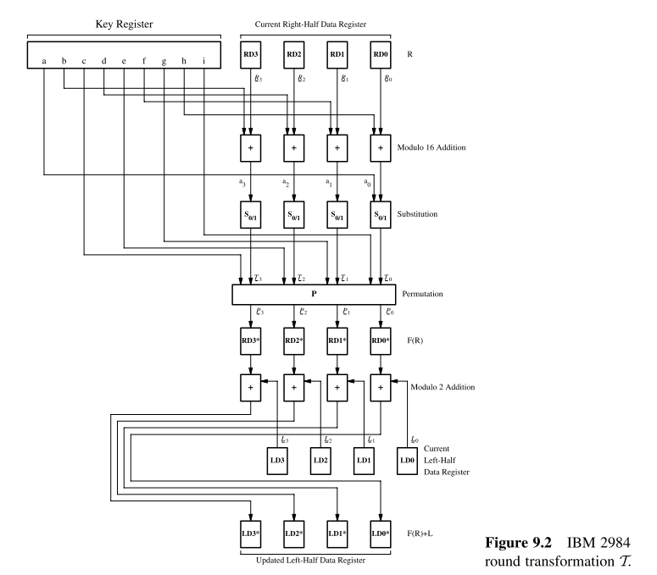

# CLEFIA

Tezcan, Cihangir. "The improbable differential attack: Cryptanalysis of reduced round CLEFIA." *Progress in Cryptology-INDOCRYPT 2010*. Springer Berlin Heidelberg, 2010. 197-209.

Shirai, Taizo, et al. "The 128-bit blockcipher CLEFIA." *Fast software encryption*. Springer Berlin Heidelberg, 2007.

维基：<https://en.wikipedia.org/wiki/CLEFIA>

索尼提出，网站：http://www.sony.net/Products/cryptography/clefia/?j-short=clefia

|  |  |
| --- | --- |
| 设计者 | Sony |
| 发布时间 | 2007 |
| Certification | [CRYPTREC](https://en.wikipedia.org/wiki/CRYPTREC) (Candidate) |
| 算法基本信息 | |
| [秘钥长度](https://en.wikipedia.org/wiki/Key_size) | 128, 192, or 256 bits |
| [分组大小](https://en.wikipedia.org/wiki/Block_size_(cryptography)) | 128 bits |
| 算法结构类型 | [Feistel network](https://en.wikipedia.org/wiki/Feistel_network) |
| 算法轮数 | 18, 22, or 26 |

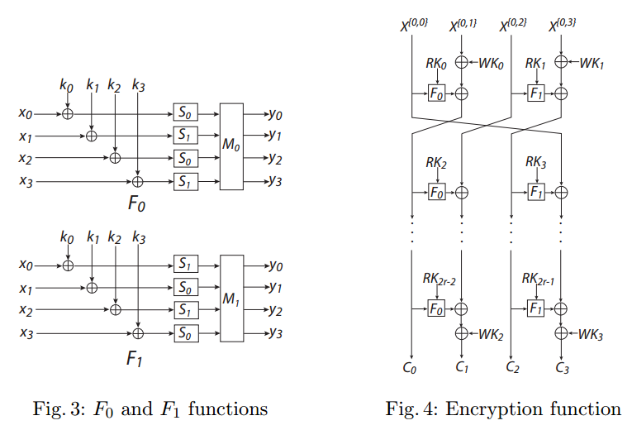

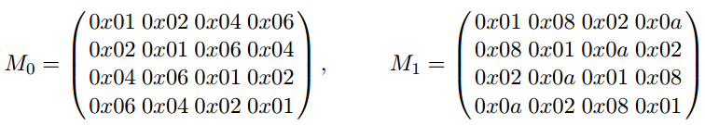

# ARIA

Kwon, Daesung, et al. "New block cipher: ARIA." *Information Security and Cryptology-ICISC 2003*. Springer Berlin Heidelberg, 2004. 432-445.

韩国提出

维基：https://en.wikipedia.org/wiki/ARIA_(cipher)

|  |  |
| --- | --- |
| 发布时间 | 2003 |
| Derived from | [AES](https://en.wikipedia.org/wiki/Advanced_Encryption_Standard) |
| Certification | [South Korean](https://en.wikipedia.org/wiki/South_Korea) standard |
| 算法基本信息 | |
| [秘钥长度](https://en.wikipedia.org/wiki/Key_size) | 128, 192, or 256 bits |
| [分组大小](https://en.wikipedia.org/wiki/Block_size_(cryptography)) | 128 bits |
| 算法结构类型 | [Substitution-permutation network](https://en.wikipedia.org/wiki/Substitution-permutation_network) |
| 算法轮数 | 12, 14, or 16 |

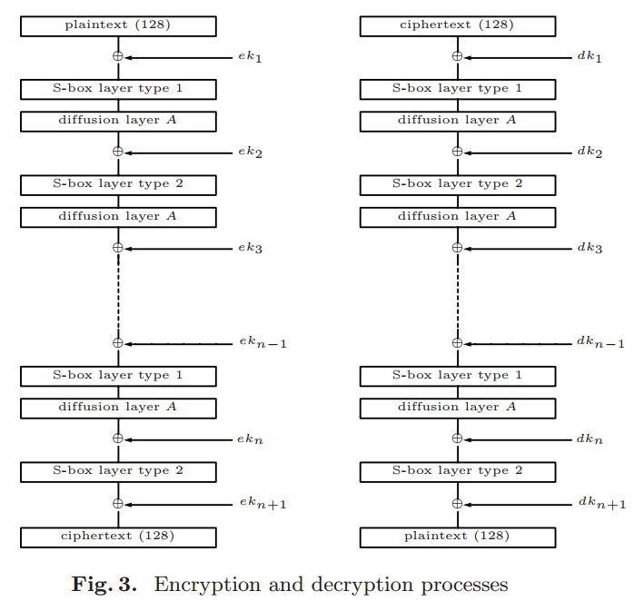

# Cryptomeria/C2

Knudsen, Lars R., and Gregor Leander. "C2–Block Cipher." *Encyclopedia of Cryptography and Security*. Springer US, 2011. 179-180.

维基:https://en.wikipedia.org/wiki/Cryptomeria_cipher

|  |  |
| --- | --- |
| 设计者 | [4C Entity](https://en.wikipedia.org/wiki/4C_Entity) |
| 发布时间 | 2003 |
| Derived from | [DES](https://en.wikipedia.org/wiki/Data_Encryption_Standard) |
| 相似算法 | [CSS](https://en.wikipedia.org/wiki/Content_Scramble_System) |
| 算法基本信息 | |
| [秘钥长度](https://en.wikipedia.org/wiki/Key_size) | 56 bits |
| [分组大小](https://en.wikipedia.org/wiki/Block_size_(cryptography)) | 64 bits |
| 算法结构类型 | [Feistel network](https://en.wikipedia.org/wiki/Feistel_network) |
| 算法轮数 | 10 |

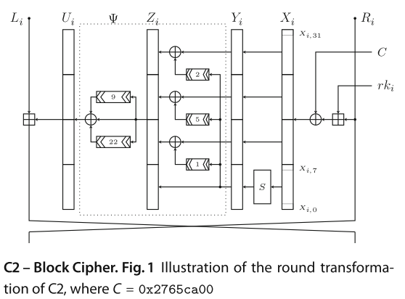

# PRESENT

Bogdanov, Andrey, et al. *PRESENT: An ultra-lightweight block cipher*. Springer Berlin Heidelberg, 2007.

维基：<https://en.wikipedia.org/wiki/PRESENT_(cipher)>

|  |  |
| --- | --- |
| 设计者 | [Orange Labs](https://en.wikipedia.org/wiki/Orange_Labs), [Ruhr University Bochum](https://en.wikipedia.org/wiki/Ruhr_University_Bochum) and the [Technical University of Denmark](https://en.wikipedia.org/wiki/Technical_University_of_Denmark) |
| 发布时间 | 2007-08-23 |
| 算法基本信息 | |
| [秘钥长度](https://en.wikipedia.org/wiki/Key_size) | 80 or 128 bits |
| [分组大小](https://en.wikipedia.org/wiki/Block_size_(cryptography)) | 64 bits |
| 算法结构类型 | [SPN](https://en.wikipedia.org/wiki/Substitution-permutation_network) |
| 算法轮数 | 31 |

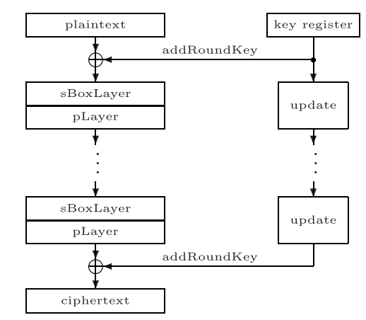

其中sbox是4-4的

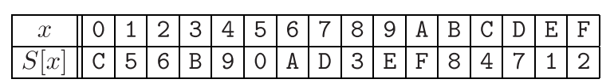

pLayer是64bit置换：

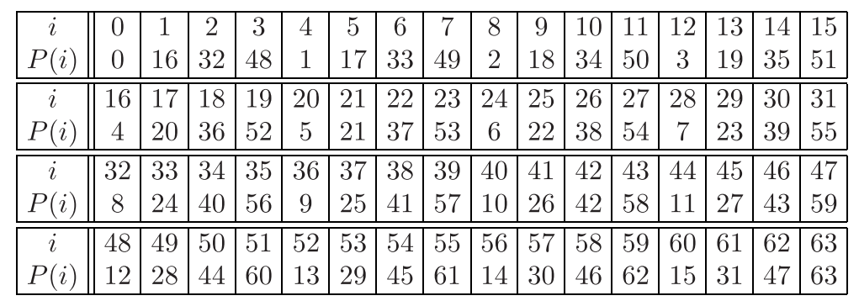

# MacGuffin

Blaze, Matt, and Bruce Schneier. "The MacGuffin block cipher algorithm." *Fast Software Encryption*. Springer Berlin Heidelberg, 1995.

|  |  |
| --- | --- |
| 设计者 | [Bruce Schneier](https://en.wikipedia.org/wiki/Bruce_Schneier), [Matt Blaze](https://en.wikipedia.org/wiki/Matt_Blaze) |
| 发布时间 | 1994-12-14 |
| Derived from | [DES](https://en.wikipedia.org/wiki/Data_Encryption_Standard) |
| 算法基本信息 | |
| [秘钥长度](https://en.wikipedia.org/wiki/Key_size) | 128 bits |
| [分组大小](https://en.wikipedia.org/wiki/Block_size_(cryptography)) | 64 bits |
| 算法结构类型 | Unbalanced [Feistel network](https://en.wikipedia.org/wiki/Feistel_network" \o "Feistel network) |
| 算法轮数 | 32 |

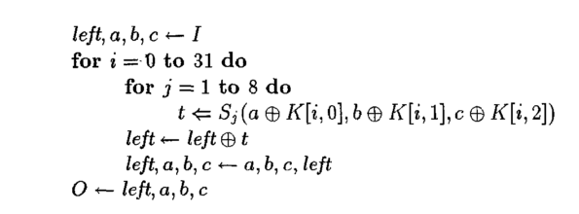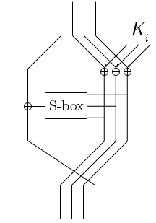

# Square

Daemen, Joan, Lars Knudsen, and Vincent Rijmen. "The block cipher Square."*Fast Software Encryption*. Springer Berlin Heidelberg, 1997.

Knudsen, Joan Daemen, Lars, and Vincent Rijmen. "The block cipher SQUARE." *Fast Software Encryption: 4th International Workshop, FSE'97, Haifa, Israel, January 1997. Proceedings*. Springer Berlin/Heidelberg, 1997.

维基：<https://en.wikipedia.org/wiki/Square_(cipher)>

|  |  |
| --- | --- |
| 设计者 | [Joan Daemen](https://en.wikipedia.org/wiki/Joan_Daemen), [Vincent Rijmen](https://en.wikipedia.org/wiki/Vincent_Rijmen) |
| 发布时间 | 1997 |
| 后续继承算法 | [AES](https://en.wikipedia.org/wiki/Advanced_Encryption_Standard), [CRYPTON](https://en.wikipedia.org/wiki/CRYPTON), [Twofish](https://en.wikipedia.org/wiki/Twofish" \o "Twofish),[Serpent](https://en.wikipedia.org/wiki/Serpent_(cipher)) |
| 算法基本信息 | |
| [秘钥长度](https://en.wikipedia.org/wiki/Key_size) | 128 bits |
| [分组大小](https://en.wikipedia.org/wiki/Block_size_(cryptography)) | 128 bits |
| 算法结构类型 | [substitution-permutation network](https://en.wikipedia.org/wiki/Substitution-permutation_network) |
| 算法轮数 | 8 |

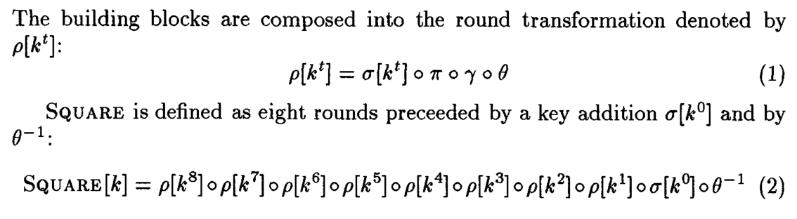

其中：

 秘钥加

字节置换

sbox

有限域乘法

# ~~CRYPTON~~

Lim, Chae Hoon. "CRYPTON: A new 128-bit block cipher." *NIsT AEs Proposal*(1998).

维基：https://en.wikipedia.org/wiki/CRYPTON

|  |  |
| --- | --- |
| 设计者 | [Chae Hoon Lim](https://en.wikipedia.org/w/index.php?title=Chae_Hoon_Lim&action=edit&redlink=1) |
| 发布时间 | 1998 |
| Derived from | [Square](https://en.wikipedia.org/wiki/Square_(cipher)) |
| 算法基本信息 | |
| [秘钥长度](https://en.wikipedia.org/wiki/Key_size) | 128, 192, or 256 bits |
| [分组大小](https://en.wikipedia.org/wiki/Block_size_(cryptography)) | 128 bits |
| 算法结构类型 | [Substitution-permutation network](https://en.wikipedia.org/wiki/Substitution-permutation_network) |
| 算法轮数 | 12 |

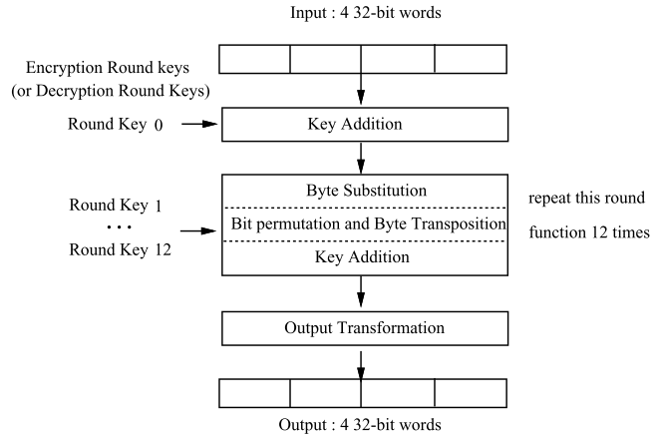

# ~~3-Way~~

Daemen, Joan, René Govaerts, and Joos Vandewalle. "A new approach to block cipher design." *Fast Software Encryption*. Springer Berlin Heidelberg, 1994.

维基：https://en.wikipedia.org/wiki/3-Way

|  |  |
| --- | --- |
| 设计者 | [Joan Daemen](https://en.wikipedia.org/wiki/Joan_Daemen) |
| 发布时间 | 1994 |
| 后续继承算法 | [NOEKEON](https://en.wikipedia.org/wiki/NOEKEON) |
| 相似算法 | [BaseKing](https://en.wikipedia.org/wiki/BaseKing) |
| 算法基本信息 | |
| [秘钥长度](https://en.wikipedia.org/wiki/Key_size) | 96 bits |
| [分组大小](https://en.wikipedia.org/wiki/Block_size_(cryptography)) | 96 bits |
| 算法结构类型 | [Substitution-permutation network](https://en.wikipedia.org/wiki/Substitution-permutation_network) |
| 算法轮数 | 11 |

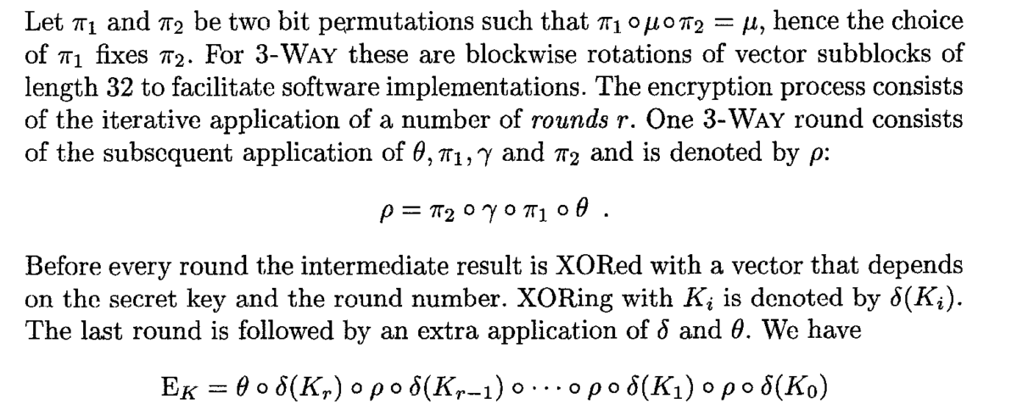

其中：

# NOEKEON

Daemen, Joan, et al. "Nessie proposal: NOEKEON." *First Open NESSIE Workshop*. 2000.

Knudsen, Lars R., and Håvard Raddum. "On noekeon." (2001).

维基：https://en.wikipedia.org/wiki/NOEKEON

|  |  |
| --- | --- |
| 设计者 | [Joan Daemen](https://en.wikipedia.org/wiki/Joan_Daemen),[Michaël Peeters](https://en.wikipedia.org/w/index.php?title=Micha%C3%ABl_Peeters&action=edit&redlink=1),[Gilles Van Assche](https://en.wikipedia.org/wiki/Gilles_Van_Assche),[Vincent Rijmen](https://en.wikipedia.org/wiki/Vincent_Rijmen) |
| 发布时间 | 2000-09 |
| Derived from | [3-Way](https://en.wikipedia.org/wiki/3-Way), [BaseKing](https://en.wikipedia.org/wiki/BaseKing" \o "BaseKing) |
| 算法基本信息 | |
| [秘钥长度](https://en.wikipedia.org/wiki/Key_size) | 128 bits |
| [分组大小](https://en.wikipedia.org/wiki/Block_size_(cryptography)) | 128 bits |
| 算法轮数 | 16 |

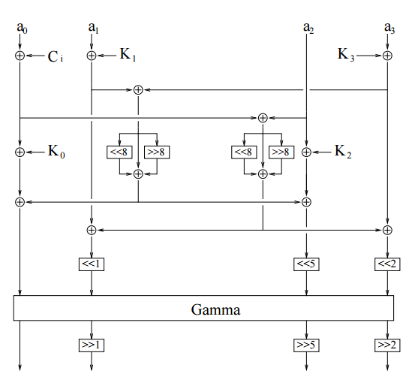

其中：

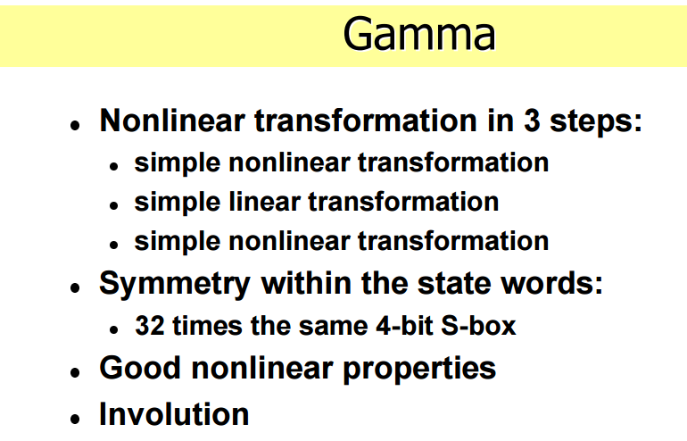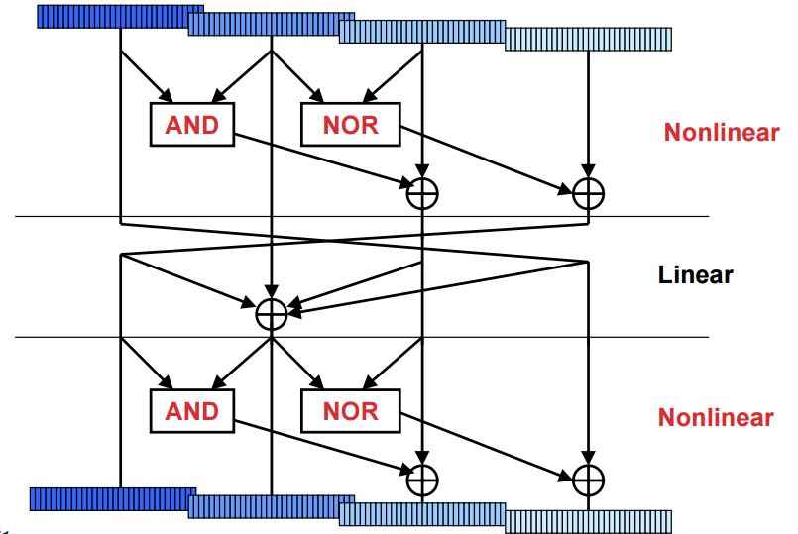

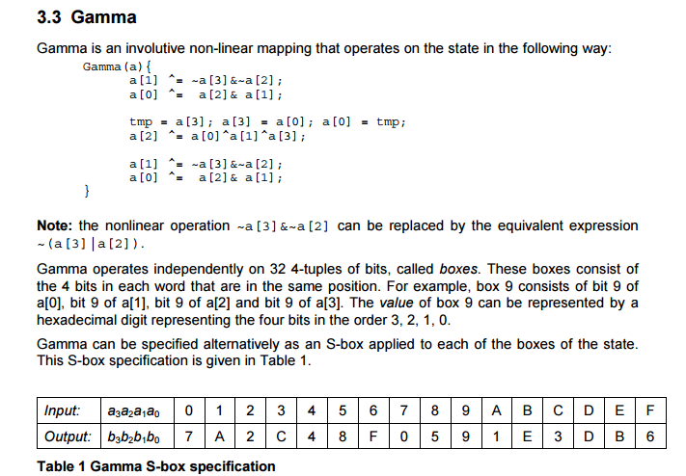

# M6

Kelsey, John, Bruce Schneier, and David Wagner. "Mod n cryptanalysis, with applications against RC5P and M6." *Fast Software Encryption*. Springer Berlin Heidelberg, 1999.

维基：<https://en.wikipedia.org/wiki/M6_(cipher)>

|  |  |
| --- | --- |
| 设计者 | [Hitachi](https://en.wikipedia.org/wiki/Hitachi,_Ltd.) |
| 发布时间 | 1997 |
| 后续继承算法 | [M8](https://en.wikipedia.org/wiki/M8_(cipher)) |
| 算法基本信息 | |
| [秘钥长度](https://en.wikipedia.org/wiki/Key_size) | 40-64 bits |
| [分组大小](https://en.wikipedia.org/wiki/Block_size_(cryptography)) | 64 bits |
| 算法结构类型 | [Feistel network](https://en.wikipedia.org/wiki/Feistel_cipher) |
| 算法轮数 | 10 |

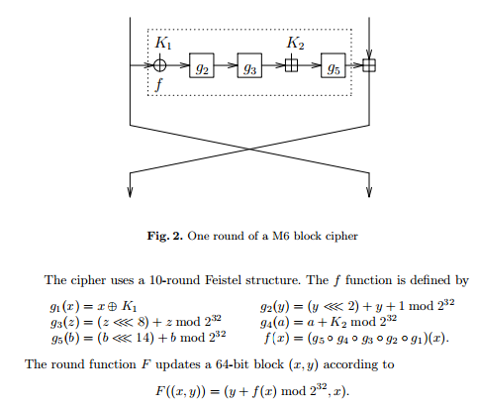

# ICE

Kwan, Matthew. "The design of the ICE encryption algorithm." *Fast Software Encryption*. Springer Berlin Heidelberg, 1997.

维基：<https://en.wikipedia.org/wiki/ICE_(cipher)>

|  |  |
| --- | --- |
| 设计者 | Matthew Kwan |
| 发布时间 | 1997 |
| Derived from | [DES](https://en.wikipedia.org/wiki/Data_Encryption_Standard) |
| 算法基本信息 | |
| [秘钥长度](https://en.wikipedia.org/wiki/Key_size) | 64 bits (ICE), 64×n bits (ICE-n) |
| [分组大小](https://en.wikipedia.org/wiki/Block_size_(cryptography)) | 64 bits |
| 算法结构类型 | [Feistel network](https://en.wikipedia.org/wiki/Feistel_network) |
| 算法轮数 | 16 (ICE), 8 (Thin-ICE), 16×n(ICE-n) |

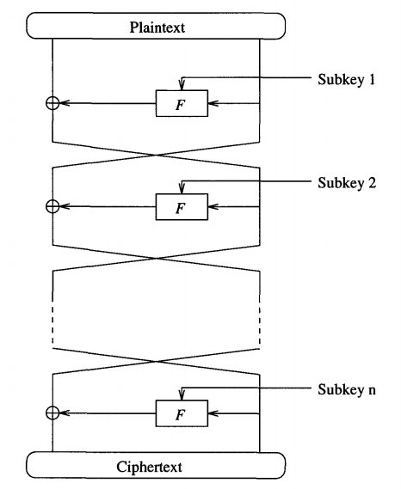

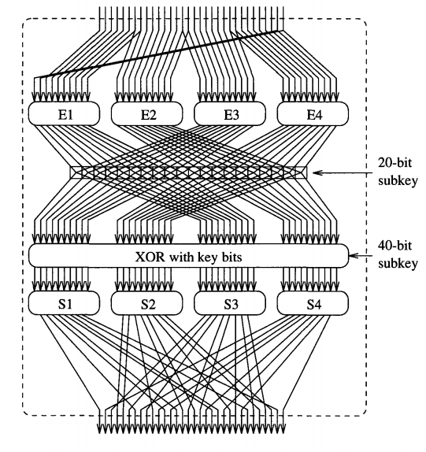

其中E是扩展，和DES的一样

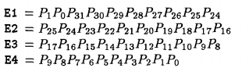

交换（秘钥）

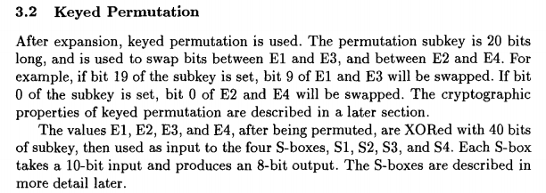

最后的置换

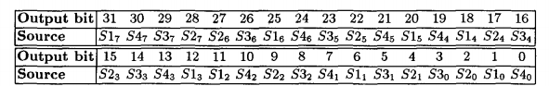

# SHARK

Rijmen, Vincent, et al. "The cipher SHARK." *Fast Software Encryption*. Springer Berlin Heidelberg, 1996.

维基：<https://en.wikipedia.org/wiki/SHARK>

|  |  |
| --- | --- |
| 设计者 | [Vincent Rijmen](https://en.wikipedia.org/wiki/Vincent_Rijmen), [Joan Daemen](https://en.wikipedia.org/wiki/Joan_Daemen),[Bart Preneel](https://en.wikipedia.org/wiki/Bart_Preneel), [Antoon Bosselaers](https://en.wikipedia.org/w/index.php?title=Antoon_Bosselaers&action=edit&redlink=1), [Erik De Win](https://en.wikipedia.org/w/index.php?title=Erik_De_Win&action=edit&redlink=1) |
| 发布时间 | 1996 |
| 后续继承算法 | [KHAZAD](https://en.wikipedia.org/wiki/KHAZAD), [Rijndael](https://en.wikipedia.org/wiki/Rijndael) |
| 算法基本信息 | |
| [秘钥长度](https://en.wikipedia.org/wiki/Key_size) | 128 bits |
| [分组大小](https://en.wikipedia.org/wiki/Block_size_(cryptography)) | 64 bits |
| 算法结构类型 | [Substitution-permutation network](https://en.wikipedia.org/wiki/Substitution-permutation_network) |
| 算法轮数 | 6 |

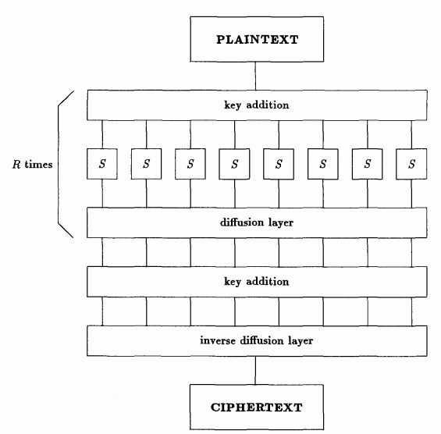

其中diffusion layer是有限域乘2^m(m为sbox的输出)

# CS-Cipher

Stern, Jacques, and Serge Vaudenay. "Cs-cipher." *Fast Software Encryption*. Springer Berlin Heidelberg, 1998.

维基：<https://en.wikipedia.org/wiki/CS-Cipher>

|  |  |
| --- | --- |
| 设计者 | [Jacques Stern](https://en.wikipedia.org/wiki/Jacques_Stern) and [Serge Vaudenay](https://en.wikipedia.org/wiki/Serge_Vaudenay) |
| 发布时间 | 1998 |
| 算法基本信息 | |
| [秘钥长度](https://en.wikipedia.org/wiki/Key_size) | 128 bits |
| [分组大小](https://en.wikipedia.org/wiki/Block_size_(cryptography)) | 64 bits |
| 算法结构类型 | [Feistel network](https://en.wikipedia.org/wiki/Feistel_cipher) |
| 算法轮数 | 8 |

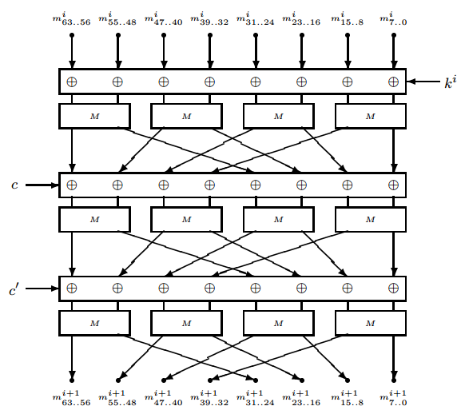

其中：M

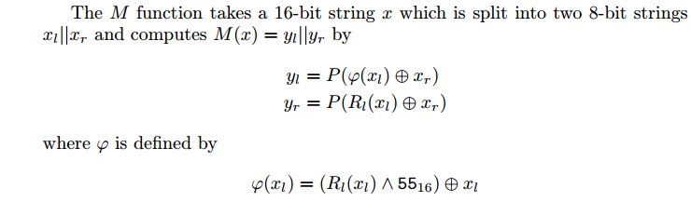

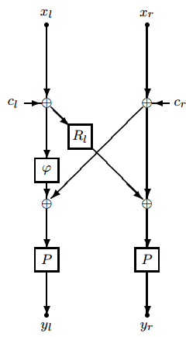 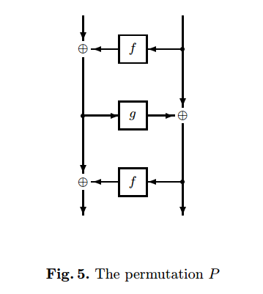

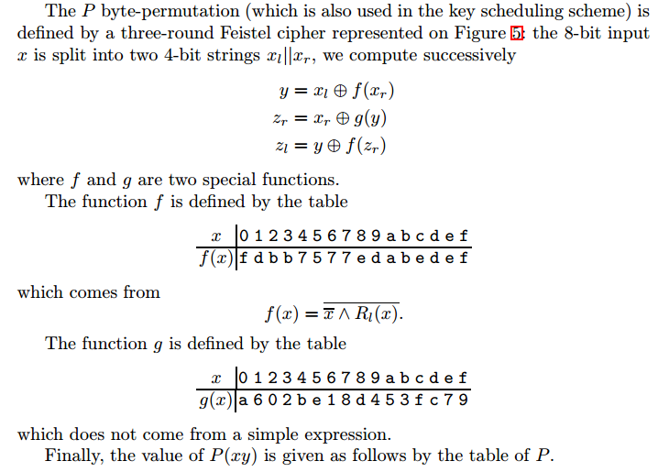

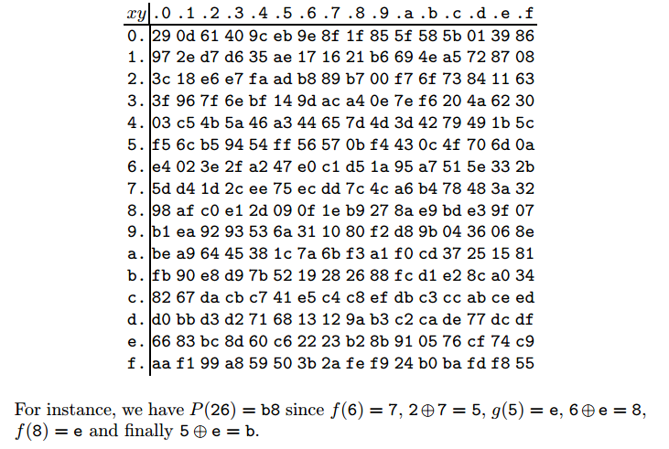

# NUSH

Knudsen L R, Raddum H. A first report on Whirlpool, NUSH, SC2000, Noekeon, Two-Track-Mac and RC6, 2001[J].

维基：<https://en.wikipedia.org/wiki/NUSH>

|  |  |
| --- | --- |
| 设计者 | [Anatoly Lebedev](https://en.wikipedia.org/w/index.php?title=Anatoly_Lebedev&action=edit&redlink=1), [Alexey Volchkov](https://en.wikipedia.org/w/index.php?title=Alexey_Volchkov&action=edit&redlink=1) |
| 发布时间 | 2000 |
| 算法基本信息 | |
| [秘钥长度](https://en.wikipedia.org/wiki/Key_size) | 128, 192, or 256 bits |
| [分组大小](https://en.wikipedia.org/wiki/Block_size_(cryptography)) | 64, 128, or 256 bits |
| 算法轮数 | 9, 17, or 33 |
| Best public [cryptanalysis](https://en.wikipedia.org/wiki/Cryptanalysis) | |
| A [linear attack](https://en.wikipedia.org/wiki/Linear_cryptanalysis) faster than exhaustive search has been found. | |

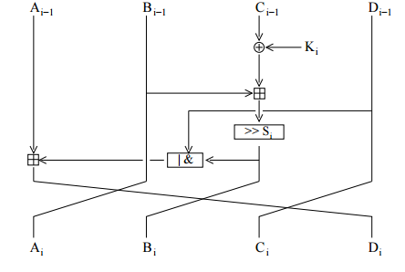

NUSH is a block cipher that accepts 128-, 192- or 256-bit keys, and with block lengths that can be 64, 128 or 256 bits. Each block consists of four registers, which are mixed with key material and transformed through a number of 算法轮数. For the 64-, 128- and 256-bit block versions, the number of 算法轮数 are 9, 17 and 33 respectively. Whitening keys are added to the block before the first round, and after the last round. Each round consists of four iterations where the registers are mixed with each other and with key material. In each iteration two of the registers are changed in a non-linear way, and the registers are rotated as in a type-3 Feistel network. The details of one round are given in the following figure.The number of bit rotations, Si , follows a schedule, and is different in each round. The box with ’—&’ in it denotes the logical OR or AND operations, a schedule defines which one is used in the different 算法轮数.

# Grand Cru

Khan A A, Murtaza G. Efficient Implementation of Grand Cru with TI C6x+ Processor[J]. IACR Cryptology ePrint Archive, 2011, 2011: 385.

维基：https://en.wikipedia.org/wiki/Grand_Cru_(cipher)

|  |  |
| --- | --- |
| 设计者 | [Johan Borst](https://en.wikipedia.org/w/index.php?title=Johan_Borst&action=edit&redlink=1) |
| 发布时间 | 2000 |
| Derived from | [Rijndael](https://en.wikipedia.org/wiki/Rijndael) |
| 算法基本信息 | |
| [秘钥长度](https://en.wikipedia.org/wiki/Key_size) | 128 bits |
| [分组大小](https://en.wikipedia.org/wiki/Block_size_(cryptography)) | 128 bits |
| 算法结构类型 | [Substitution-permutation network](https://en.wikipedia.org/wiki/Substitution-permutation_network) |
| 算法轮数 | 10 |

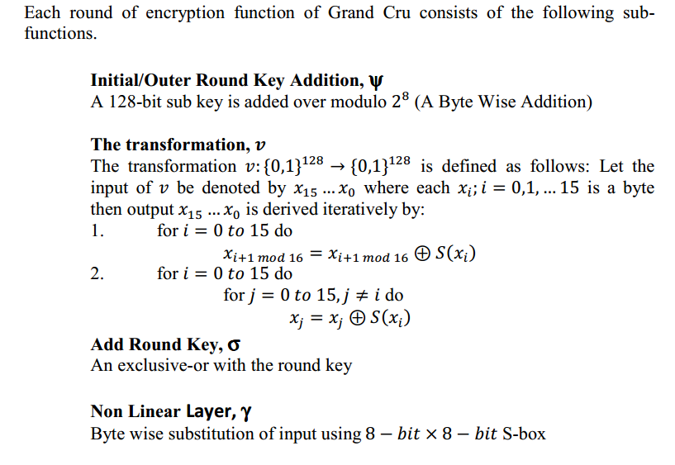

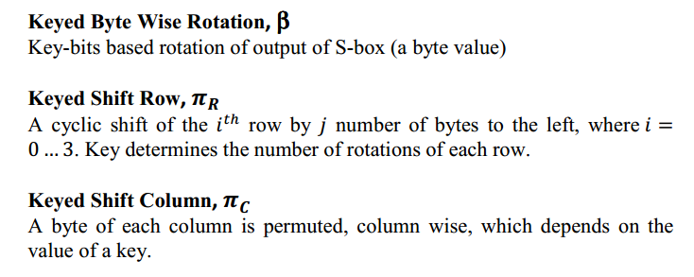

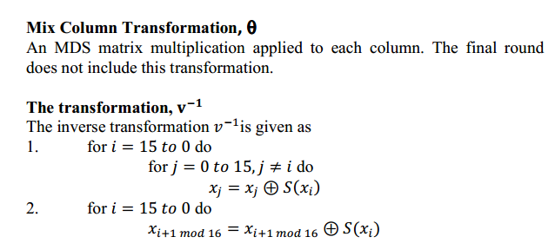

# Q

Keliher L, Meijer H, Tavares S. High probability linear hulls in Q[C]//Proceedings of Second Open NESSIE Workshop, Royal Holloway College, University of London, Egham, UK. 2001.

维基：<https://en.wikipedia.org/wiki/Q_(cipher)>

|  |  |
| --- | --- |
| 设计者 | [Leslie McBride](https://en.wikipedia.org/w/index.php?title=Leslie_McBride&action=edit&redlink=1) |
| 发布时间 | November 2000 |
| Derived from | [AES](https://en.wikipedia.org/wiki/Advanced_Encryption_Standard), [Serpent](https://en.wikipedia.org/wiki/Serpent_(cipher)) |
| 算法基本信息 | |
| [秘钥长度](https://en.wikipedia.org/wiki/Key_size) | 128, 192, or 256 bits |
| [分组大小](https://en.wikipedia.org/wiki/Block_size_(cryptography)) | 128 bits |
| 算法结构类型 | [Substitution-permutation network](https://en.wikipedia.org/wiki/Substitution-permutation_network) |
| 算法轮数 | 8 or 9 |

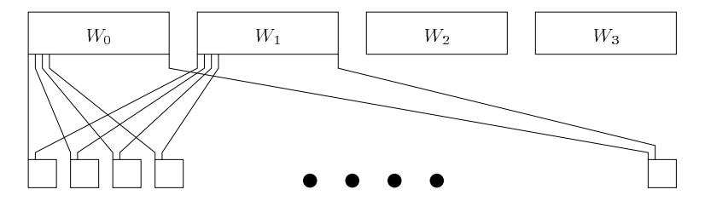

PreSerpent( ) bit wise permutation PostSerpent( )则相反

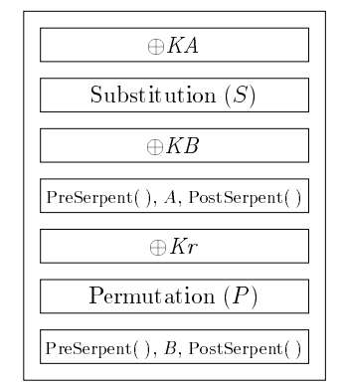

# E2

Matsui M, Tokita T. Cryptanalysis of a reduced version of the block cipher E2[C]//Fast Software Encryption. Springer Berlin Heidelberg, 1999: 71-80.

维基：<https://en.wikipedia.org/wiki/E2_(cipher)>

|  |  |
| --- | --- |
| 设计者 | [NTT](https://en.wikipedia.org/wiki/Nippon_Telegraph_and_Telephone) |
| 发布时间 | 1998 |
| 后续继承算法 | [Camellia](https://en.wikipedia.org/wiki/Camellia_(cipher)) |
| 算法基本信息 | |
| [秘钥长度](https://en.wikipedia.org/wiki/Key_size) | 128, 192, or 256 bits |
| [分组大小](https://en.wikipedia.org/wiki/Block_size_(cryptography)) | 128 bits |
| 算法结构类型 | [Feistel network](https://en.wikipedia.org/wiki/Feistel_cipher) |
| 算法轮数 | 12 |

