W1884798 Report
[Company name] | [Company address]
Business analytics
Zarar Ehsan
2025
Part A (Forecasting)

Question 1
- These are the time series plots for all the three different levels of critical care;
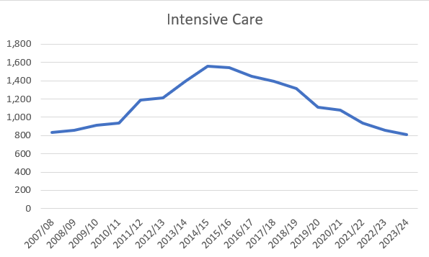
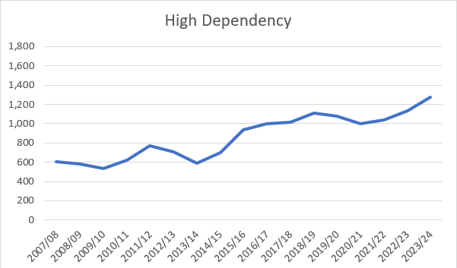
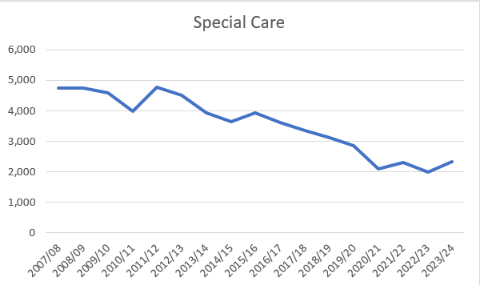
- These graphs show that, Intensive Care has come back down to the same levels as 2007 after a spike around 2014. High dependency seems to have an upwards trend almost doubling in the same amount of time, and Special care has decreased from nearly 5,000 to around half of that number.
Question 2
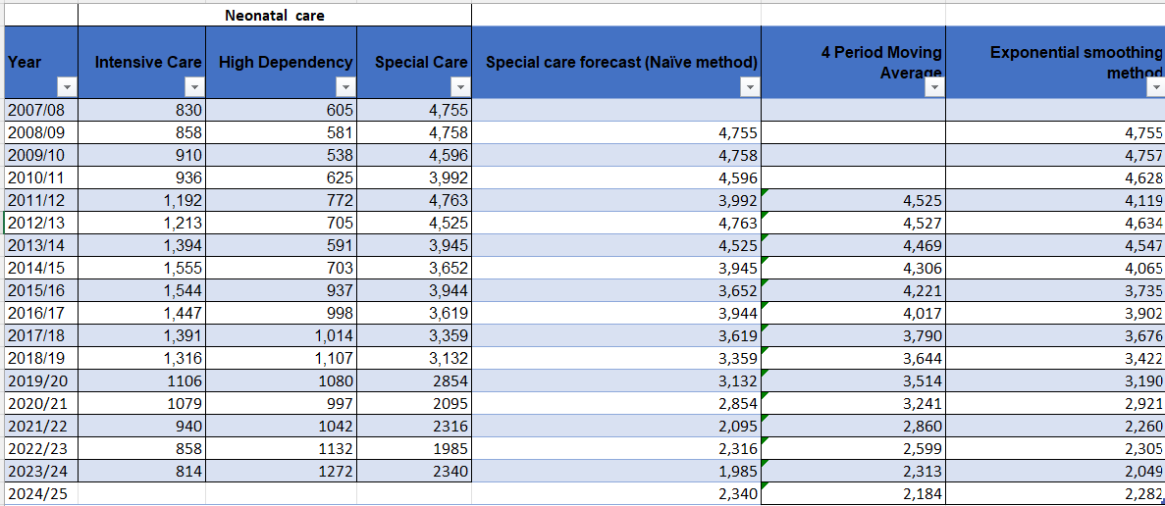
- This is my forecasting using Naïve method, 4 period moving average and exponential smoothing curve, using the formulae provided in the lectures;
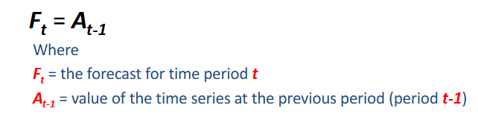 Naïve method
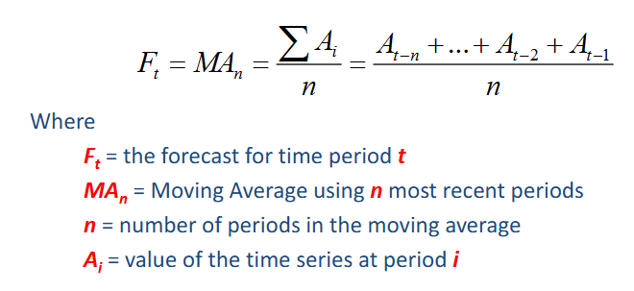 4 period moving average
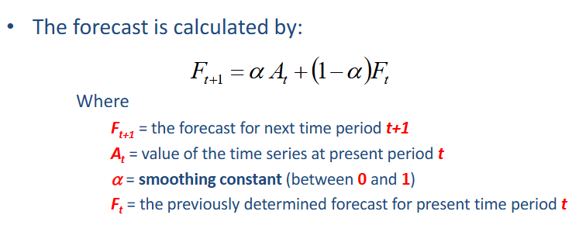 Exponential smoothing method (tried values between 0.1 and 1 in intervals of 0.1 for the smoothing constant, nest constant was 0.8)

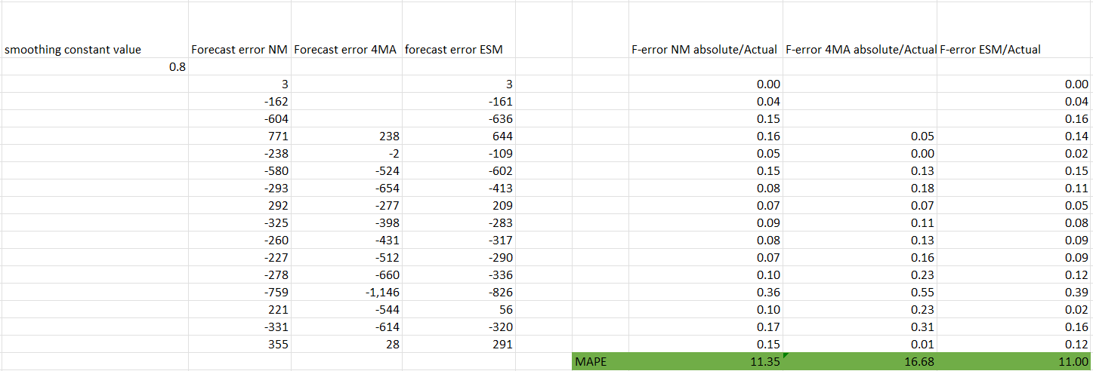
- As you can see the calculated forecast errors which is (Actual – forecast), and then the absolute value of the error divided by the actual and then multiplied by 100 for MAPE.
- For being such a simple method of forecasting, the Naïve method surprisingly is second best out of the three and isn’t far off the best, however using a smoothing constant of 0.8, the best method is the exponential smoothing method, with it having the lowest MAPE. To conclude out of the requested forecasting models, the best model is exponential smoothing with a smoothing constant of 0.8, which gives a MAPE of 11

Question 3
- The forecasting method that I would suggest is the holt’s linear exponential smoothing, it is used to forecast a time series data that has a trend but is not seasonal, this is a type of exponential smoothing, which from the data is already the best, using MAPE as a metric.
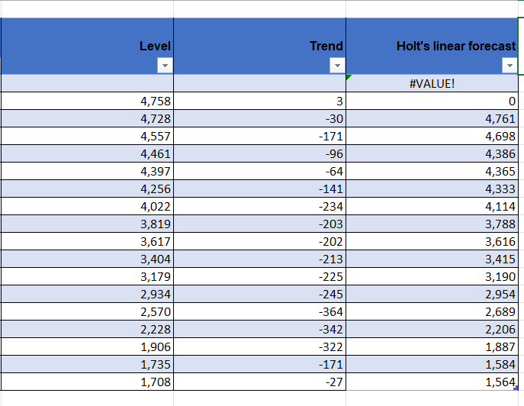
- These were my values using holts’ linear exponential model and looking at the MAPE;
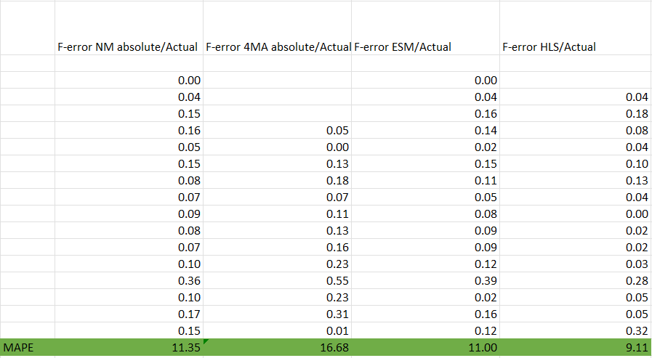
- It has proven to be the best model with an MAPE of only 9.11.
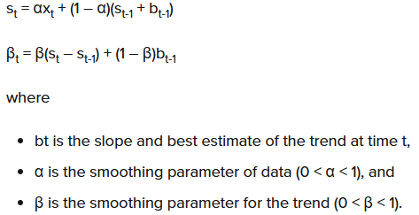 Holt’s linear exponential
- The method requires level to be worked out, which is then used to work out the trend, which is then used to make forecasts. This is the best recommendation out of all the forecasting techniques as it is best suited to the data it is being applied to as well as having the best MAPE.

Influx Data (2023). Exponential Smoothing: A Beginner’s Guide to Getting Started. [online] InfluxData. Available at: https://www.influxdata.com/blog/exponential-smoothing-beginners-guide/#:~:text=Exponential%20smoothing%20is%20a%20time,changing%20trends%20in%20the%20data.

Question 4
- The method of least squares is a method used to determine a trend line which minimizes the mean square error, it is useful as it determines the best fit line in a linear relationship.
Calculation
- My excel formula to calculate b1
- My excel formula to calculate b0
Both of which follow the methods provided; 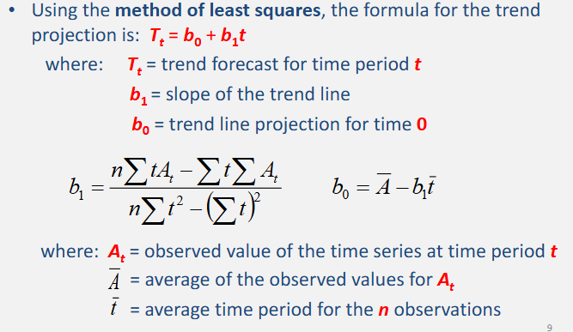
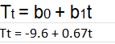
- Using the above equation for forecasting I got a MAPE of 35%; which is quite a high Absolute percentage error.
‌

Part B (Simulation)

Question 1
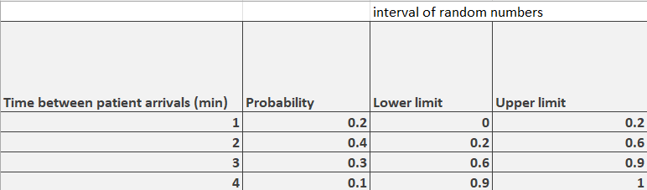
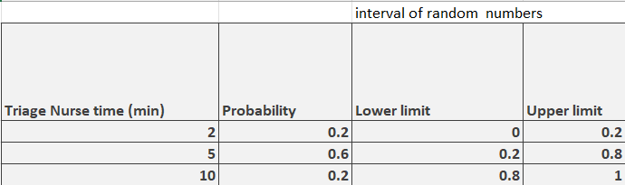
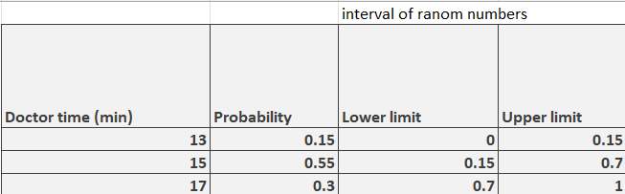
- These are my interval values for the three resources.

Question 2

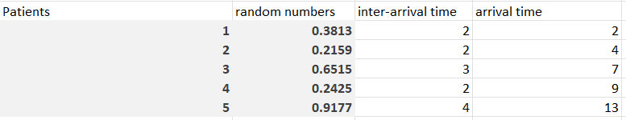
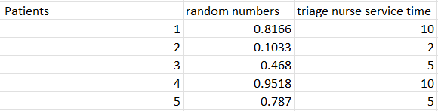
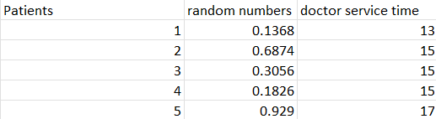
- My generated values for inter-arrival time, triage nurse service time and doctor service time.
- Using the provided random numbers and Vlookup function in excel.

Question 3
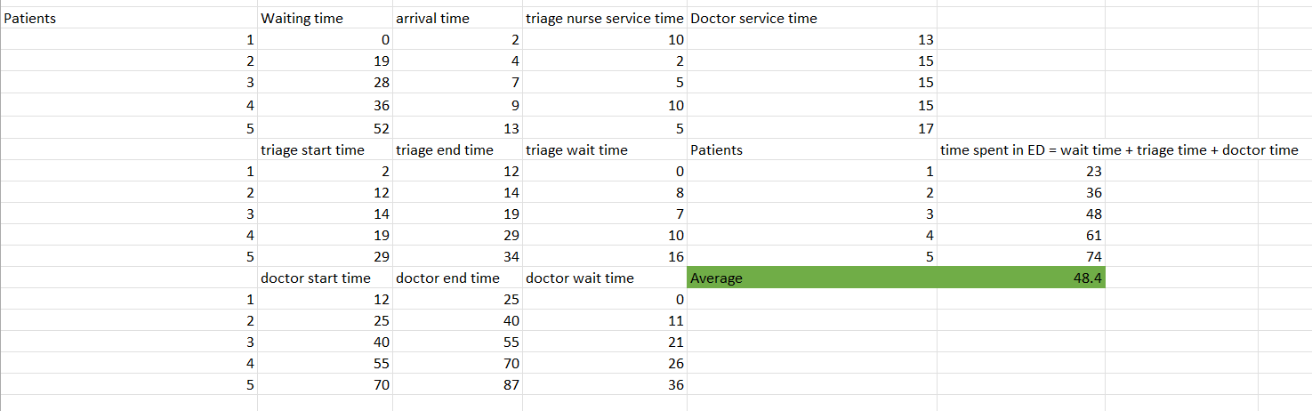
- This is a layout of my calculations; The first patient arrives and is instantly submitted to triage due to no previous patient. With a triage service time of 10, the triage ends at time 12, after which the second patient gets admitted etc.
- Using all these calculations, I got Arrival times of; 2,4,7,9 and 13. Waiting times of; 0,19,28,36 and 52. An average time spent in the system of 48.4 minutes.

Question 4
Scenario 2
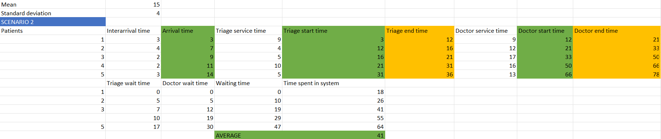

- I worked under the assumption that, the generated inter-arrival times and triage service time from the previous scenario cannot be used.
- I used the excel function RANDBETWEEN using the ranges provided in the brief for the corresponding resource, to generate new inter-arrival times and triage service times and used NORMINV to generate doctor service time as it follows a normal distribution and used an IF statement to make sure triage start time doesn’t conflict with patient arrival time.
- The waiting times for each patient was; 0,10,19,29 and 47 with average time in the system = 41 minutes.
- My use of excel functions;
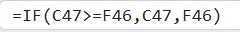

Scenario 3

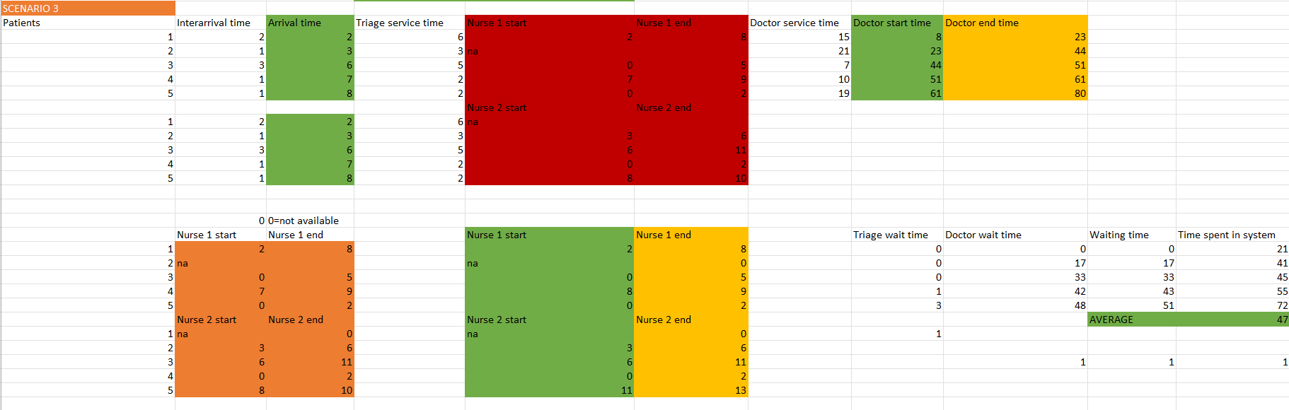
- Using the same assumption from scenario 2, this assumption creates more flexibility in my system and isn’t just adapted to the scenario given.
- This scenario is basically the same as scenario 2; however, the different type of scenarios to handle was exponentially harder.
- I had to make sure the nurse bookings don’t clash, ie one patient isn’t booked for both nurses, and this patient can only book one nurse.
- I had to make sure the patient arrival times don’t clash with the nurse triage start time, ie if a nurse is available, the start time for that patient for that nurse, doesn’t start before his arrival time.
- I had to handle the end and start time for each nurse, ie a nurse doesn’t get booked with another patient before the nurse is done with the previous patient.
- To attain these three conditions, I used many nested if statements, as shown by the three-nurse start/end times; Red, Amber and (Green and Yellow). These functions can be found in provided excel file.
- The waiting times I got for this scenario;0,10,19,30 and 47 with an average time in system of 41 minutes.
- Final note, due to the complexity of the model I made, sometimes the output for the nurse start times generates “0” for both nurses for the rest of the patients, this value means nurses are not available, however this is a rare case, and the model fixes itself if refreshed.
Question 5
- The metrics for S2; waiting times; 0,10,19,29 and 47 and an average time in the system of 41 minutes.
- The metrics for S3; waiting times; 0,10,19,30 and 47 and average time in the system of 41 minutes.
- Between the two scenarios, using multiple randomly generated values from my model, I can see that across all these runs of my model of the same scenarios, the two models are not different given the metrics, due to doctor service time being the lengthiest resource which creates a bottleneck.
- However, using real life context the best scenario is dependent on your criteria, whether it is to reduce money (use scenario 2 with 1 nurse) or whether it is to reduce nurse waiting times (use scenario 3 with 2 nurses).
- Recommendations;
- The best staffing plan would be to use 2 doctors along with 2 nurses as doctor service time is by far the lengthiest resource and process, this recommended staffing plan reduces the bottleneck when waiting for a doctor.

Challenges and final comments
The most challenging parts of this coursework was question from Part A and question 4 for part B; reason being that with Q4 part A, you had to correctly differentiate between which was your dependent variable and which was your independent variable, initially I got the variables mixed up, however eventually I found the correct layout.
For Q4 part B, the reason why it was so difficult, is because you really had to make sure all of the above conditions were being met, which meant nested if statements and also due to my own aim for making the model flexible to any configuration run of patient arrivals, I had to also account for the flexibility of the model.

