Zarar Ehsan

Data pipeline documentation

Process
I first set up a folder called data engineering with sub folders inside labelled datasets, Output and Scripts, I went on Kaggle to find dataset, all three datasets were from different sources and dataset types, 2 different sales data and one dataset on inventory in a store. I started y code by loading in libraries to be able to process my data, I then loaded in my datasets called; “amazon.csv”,” superstore_dataset.csv” and “Sales_dataset2.csv”.
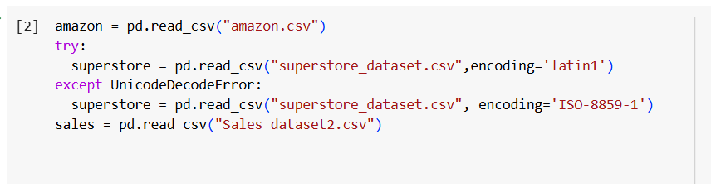
I then run code to describe the shape of the datasets, so I can see the number of columns and rows there are, as I want to judge later whether I have merged the datasets correctly.
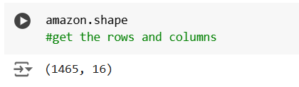
I then ran code to show me the column names and to show me the column types and the number of missing values on each dataset.
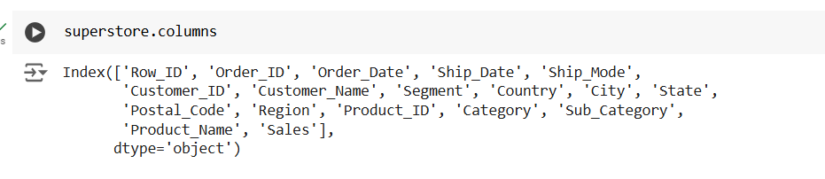
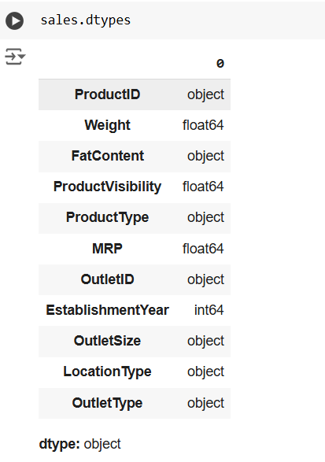
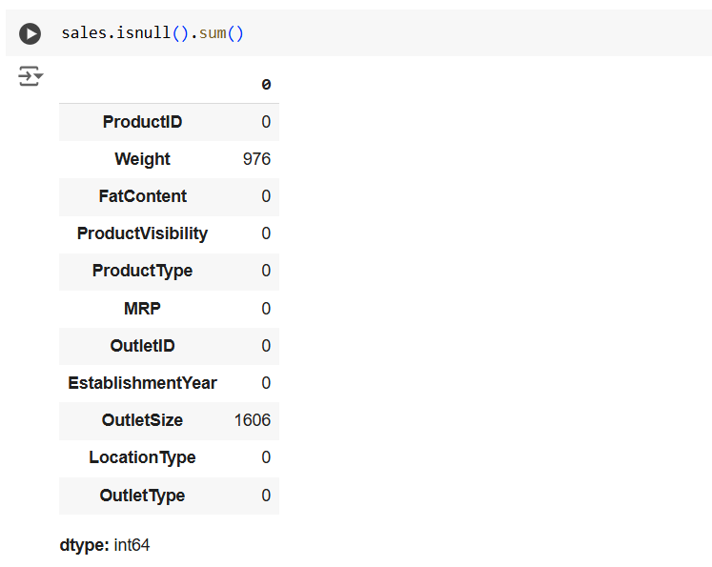
I then ran code “amazon.describe()” to get statistics of each dataset to see unique values.
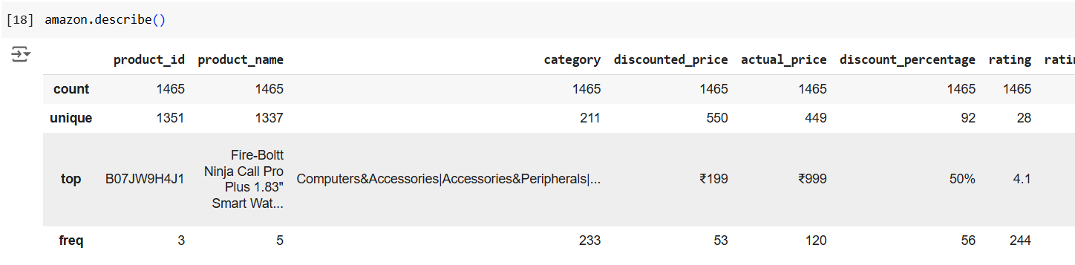
I then collected the sum of duplicated values, after which I created heatmaps to visualise the data and the missing values.

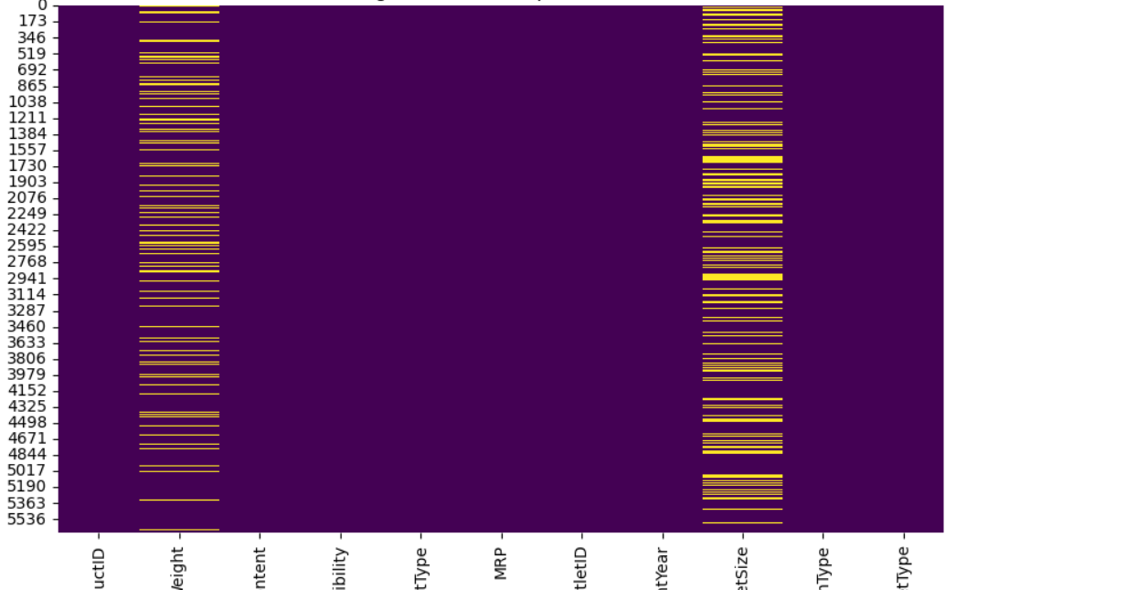
I then created two boxplots for the columns “Ratings” and “Weight” from the dataset’s amazon and Sales respectively.
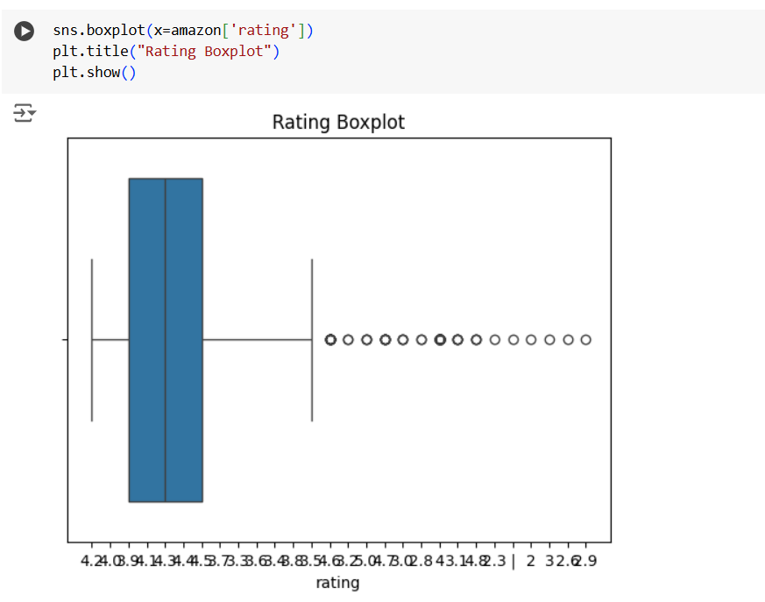
I then renamed the common columns in each dataset to make sure they all had the same name, so that it may be used to merge the data, before merging the data I checked for unique values in this specific column “product_id”, so in the end I can check, whether the amount of product IDs are correct.
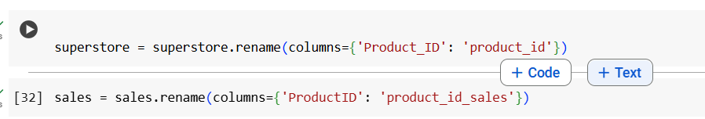
I then chose to concatenate the common column first then merge the data, instead of merging based on this column first step, as this would cause a problem based on my datasets, which I will elaborate more on in the self-reflection. After concatenating this column, I then merged each dataset based on the corresponding “product_id”, throughout this process I was executing data cleaning processes and checking the shape of the merged datasets.
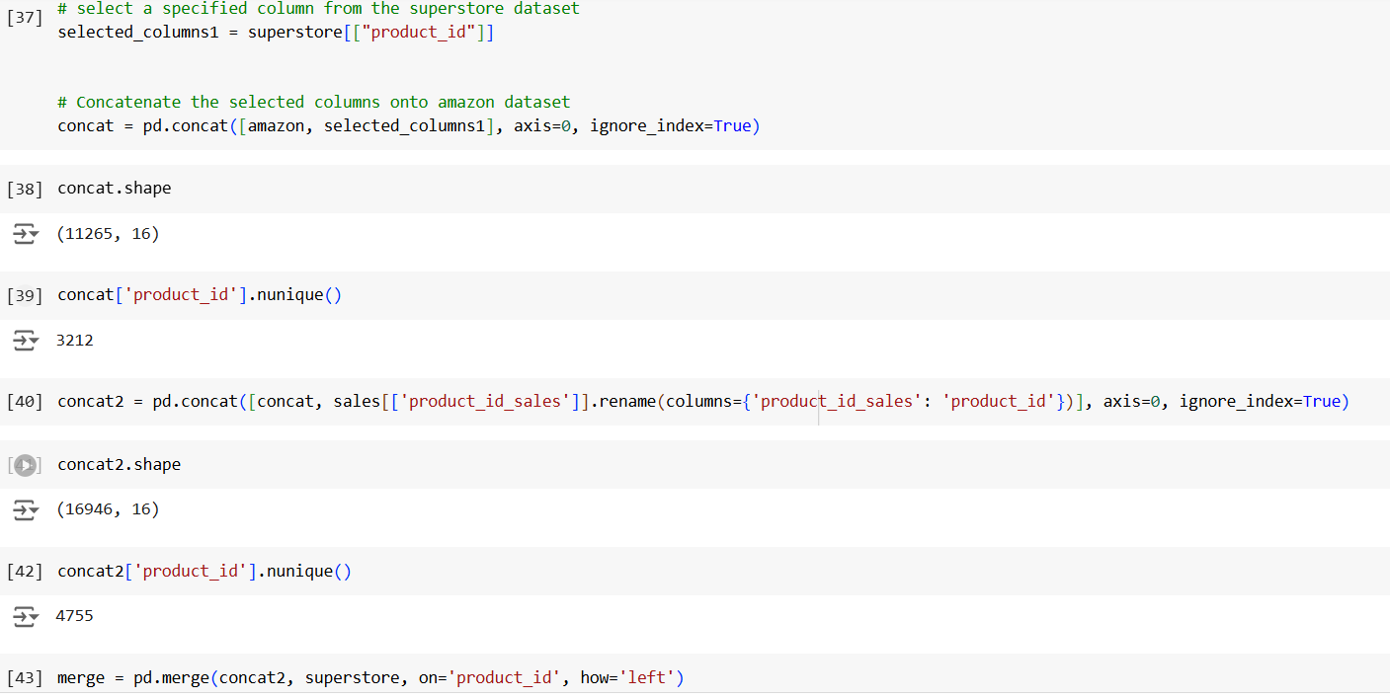
I then did imputation on the columns which had a big percentage of the column as missing values and imputed it with mean values as dropping the missing values would’ve caused too much data loss.
I also dropped values from columns that had a small percentage of the data missing, after which I started dropping columns, which I didn’t want in my dataset.
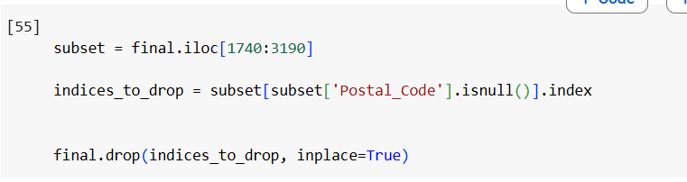
I then encoded the column “category”, after which I created the metadata file.
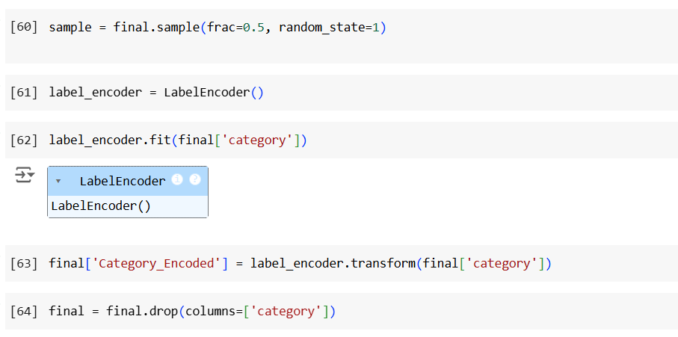
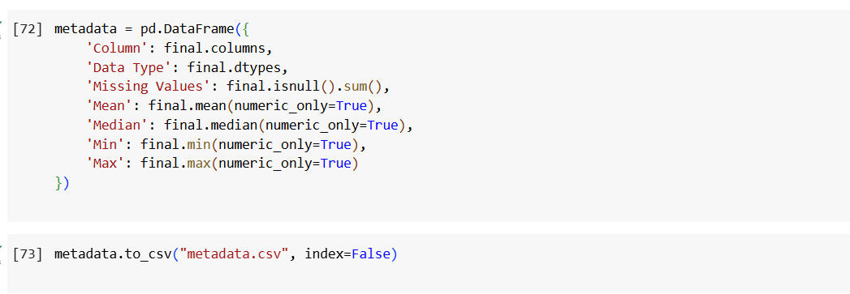
Then connected to a database, I then proceeded to create a table into which I can inject the final dataset.
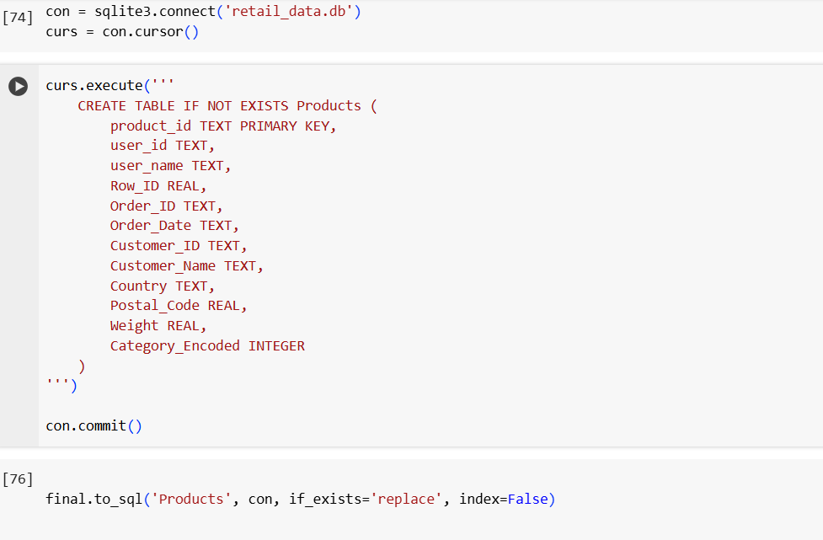

Self-reflection
There are many problems I encountered during the coding process, which I had to work around, the first of which was finding the right data sets, it was hard finding three matching datasets from different time periods, therefore I had to work with three totally different datasets two of which were sales data and one which was inventory data, however they all had a common column. I encountered a problem when reading the “superstore_dataset” due to encoding issues, after which I used a try and except UnicodeDecodeError.

The next problem I encountered was when I was trying to merge data, what I noticed was when using “pd.merge” and merging all the data straight, what it does is it looks for a common value under a common column and combines the datapoint, whilst this may be useful under certain circumstances, when combining different datasets, this would only corrupt the data, therefore what I done was I concatenated the column which was common in all datasets and stacked the values under each other after which I used the “pd.merge” method to combine the rest of the dataset. There was another problem which I encountered whilst doing this, for reasons unknown this causes duplicates to be created, to fix this I checked for the number of unique “product_id” values in each dataset, which in total is 4755 unique values.
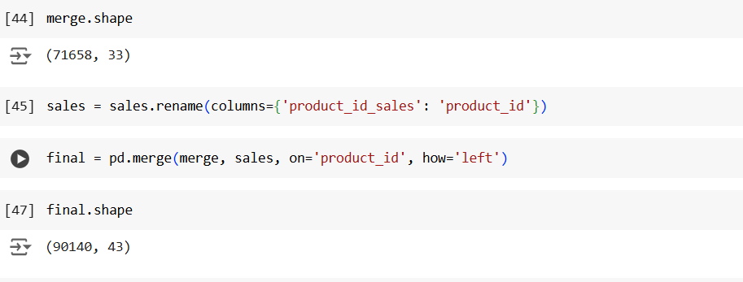
Whilst dealing with this using “.drop_duplicates” function, I came across another issue, which was when concatenating the third data set, the number of unique values wouldn’t increase in the column, which was due to the fact that the programme was overwriting the third data set on top of the current merged dataset, how I worked around this was I renamed the “product_id” column in the third dataset to “product_id_sales” which I then added below the merged dataset using the common column which gave me the correct number of data values of 4755.

RDMS Schema
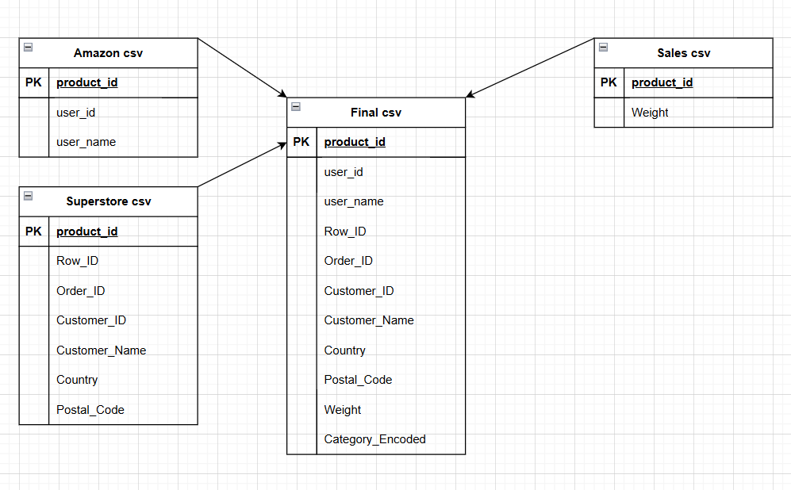

Links to my Source
https://www.kaggle.com/datasets/karkavelrajaj/amazon-sales-dataset
https://www.kaggle.com/datasets/akashdeepkuila/big-mart-sales
https://www.kaggle.com/datasets/rohitsahoo/sales-forecasting

