**CHAPTER I**

**PROJECT AND ITS BACKGROUND**

**PROJECT CONTEXT**

Sales monitoring and management system consolidates all sales processes and performance parameters into simple reports. These can be made available to certain other departments of an organization inside the business to help them understand how their activity is converted into sales data.

One of the most common types of businesses run by Filipinos is the pig farming industry. Backyard operations up to large-scale commercial production are included in this business. One factor is responsible for the success of this company: the Filipino population has a strong preference for eating pork (Statista, 2021).

According to Yash Chawlani (2021), data is the important resource in this day and age and they hold tremendous value to what they enable to accomplish in business. Handlin, managing, analyzing and storing for use in the future is important. It all help to see the sales performance parameters, forecast sales, understand the market and achieve objective quickly as possible.

The monitoring system will allow the respondents to view and track the process as it is filtered, qualified, and prioritized. It will allow a manager/owner to delegate responsibility for execution. Furthermore, the sale analytics is required in the system so that the owner could identify the growth and establish goals for Zarate Piggery Farm because it turns its data into insight and performance metrics shown on our system as a linear graph. Also, used to improve performance and make decisions that will benefit the business in the long run.

As the Zarate Piggery Farm expands tremendously, it will eventually handle, manage, monitor, and record data manually. Thus, that the proponents propose a study that will help the said client to track their sales and manage the availability of livestock in their classification, in the delivery method, and drives the insight record, reserved, and sales. The system development may be an excellent opportunity for them to handle their business easily.

**STATEMENT OF THE PROBLEM**

The Zarate Piggery Farm has difficulty managing and tracking sales due to the time-intensive recording method that needs a person to hand complete data in each book. It is also challenging in determine the price of each classification and check the availability of livestock (pigs) at the farm, which is updated and done by looking through books page by page. Furthermore, because the system is paper-based, there are no means for changes to be made to all volumes simultaneously, as well as calculating mistakes caused by human error, data security is jeopardized if book/s will be stolen or certain pages inside a book appears to be missing.

**OBJECTIVES OF THE STUDY**

**General Objective**

Zarate Piggery Farm's sales monitoring and management system include SMS notification to oversee reports on sales monitoring, cut down on time needed to find and retrieve data, offer a backup copy of each transaction's data, and certain for each transaction.

**Specific Objective**

* To design a module that will handle file, record and important data;
* To develop a sales module that will handle the sales transaction;
* To notify the customer if the livestock is already delivered;
* To monitor the availability of livestock; and
* To generate reports such as:
* Sales monitoring report,
* Number of available livestock, and
* Number of deliveries

**SCOPE AND LIMITATION**

**SCOPE**

The study focuses on developing Sales Monitoring and Management System with SMS Notification for Zarate Piggery Farm. The proposed system is integrated with SMS notification prior to the delivery transaction. The system will monitor the sales per hour and the transactions available given by the farm. Then, the system will provide a login form to add security and boundaries between the admin and the establishment user. In addition, the system shall provide a detailed list and reports of stocked-out livestock (pig) and the stock. Moreover, the system will automatically cancel after three days of confirmation.

The admin page can manage the user account for management and security purposes. The system displays consolidated data or the summary of sales reports and other insights to monitor all the data and transactions in the system encounters. It records data for archiving and for future needs.

Thus, Zarate’s piggery farm sales will be computed and updated automatically and dynamically every transaction. Regarding livestock (pig), classification will be accurate, fast, and reliable due to the system’s reduced human error accuracy. It will create precise system records and give the system security to secure database data. It presents aggregated data or insight summary from all data and transactions seen. It will feature a system that displays a linear graph for its report.

**LIMITATION**

The proposed system will only be available for the Zarate piggery farm; this system will not doesn’t require the internet. The system's development will be based on an offline or window-based system that does not require an internet connection. Thus, it only monitors and manages the transaction and generates reports.

**SIGNIFICANCE OF THE STUDY**

This project Sales Monitoring and Management System with SMS Notification of Zarate Piggery Farm.” may be implemented for the benefit of the following:

**To the staff of Zarate Piggery Farm,** the propose web based system may help them to be directly informed about the reservation request of the client and to easily monitor the sales conveniently.

**To the Pork Traders**, the proposed web-based system and SMS notification may help them secure a reservation slot to Zarate Piggery Farm for the supply and it will provide an efficient transaction though online.

**To the Proponents**, it will improve and enhance their skills to build a system with the use of modernize technology that will help the community to make their everyday lives transaction easier.

**To the Future Proponents**, the proposed web-based system and application may serve as a guide or basis for the future proponents on creating a more advance and high technology integrated system that is valuable to the users.

**DEFINITION OF TERMS**

**Reservation** – is an arrangement to have something kept for a person or for a special purpose.

**Sales** - is a transaction between two or more parties in which the buyer receives tangible or intangible goods, services, or assets in exchange for money.

**Piggery Farm –** is a farm where pigs are raised or kept.

**SMS** - is a native service that allows you to receive Short Message Service

**Supplier** - provides products or services to another entity.

**Monitoring** - maintain regular surveillance over.

**Transaction** – is an exchange or interaction between people.

**Hardware requirements** - are the requirements of a hardware device. Most hardware only has operating system requirements or compatibility.

**Software requirements** – is a condition or capability needed by a user to solve a problem or achieve an objective.

**Peopleware requirements** - refers to the human role in an IT system. In many cases, peopleware forms a kind of conceptual triangle with hardware and software.

**Livestock** - are farm animals, with the exception of poultry.

**Management** – is the act or manner of managing, handling, direction, or control. It also refers to a skill in managing; executive ability: great management, and tact.

**Insight** - is the process of creating and winning sales opportunities and driving change with ideas that matter.

**Database** - is an organized collection of structured information, or data, typically stored electronically in a computer system.

**Automated** – is operated automatically an automated process automated equipment/machinery a fully/highly automated factory.

**Sale monitoring and management system with SMS notification of Zarate Piggery Farm** – are systems that both monitor and manage the operation at Zarate farm. The said system also generates report and handle transactions.

**CHAPTER 2**

**REVIEW OF RELATED LITERATURE AND STUDIES**

**Foreign Literature**

According to Indeed Editorial Team (2022), sales monitoring system is a software program or a networked set of applications that tracks and controls a company's sales data. It may collect and assemble information from many sources and keep sales data about consumers and items.  Many sales monitoring solutions provide analytics or data visualization features to better understand sales patterns. There are some advantages to a sales monitoring system: An effective organization can help maintain track of sales information. Data may be organized by a sales tracking system based on several criteria, such as customers, items, or date periods. Many sales tracking systems may also pull data from other applications, allowing one to access and arrange information from different sources. Analyzing client transaction history and other data might assist in making decisions that may increase the customer base or boost sales. A sales monitoring system enables the collection and analysis of various data to understand customer demands. Many sales tracking systems include visualization tools that may help users better comprehend and show data. A sales monitoring system enables effortless sharing of sales information with other team members, supervisors, and colleagues in other departments. Keeping information readily available will assist in coordinating with other teams or individuals working in separate offices. This can help work well in groups and develop shared sales solutions. Using a sales monitoring system can assist in keeping track of your duties and clients, thereby improving the consistency and dependability of sales. Manage sales methods and track outcomes with a regular sales monitoring system. This may help to replicate previously successful sales procedures. A sales monitoring system is an easy way to keep track of a company's sales history. With data collection and analysis tools, a team may have additional time or energy to devote to other responsibilities. Using a sales tracking system may also help to simplify some activities by giving information from numerous sources.

According to Duijvenvoorde (2019), a sales tracking system is essential for any company. It will assist a manager in keeping track of the business's accomplishments and growth. These indicators are tracked in real-time via the SalesScreen dashboard. It allows

for the building of comprehensive reports. A sales monitoring system does more than track sales goals. It also motivates sales staff and make employees look forward to coming to work every day. That is what does. Managers use the software to increase sales and motivation through activities.

According to Woodruff (2018), an information system for management aids a company's competitive advantage. It reports and detects what is and is not working. These reports provide owners with the information they need to make choices and improve strategy and business performance. A business owner needs a management information system that provides data about the current activities of the company and provides the reports that allow you to keep the business on the road.

**Local Literature**

According to Bianca (2016), a sales and inventory tracking system gathers information to help with production scheduling. Some systems, for example, utilize current sales data to anticipate how many of a particular product is required to fulfill customer’s demand shortly. This involves keeping track of a product's levels in all places. A worldwide firm with clients all over the world is an excellent example. The client may reside in another region, yet the system can determine if a product is available for delivery to the said location. The system evaluates a level, and the number slated for livestock (pig) to the number required and determines if the number of production needs is adjusted.

According to Llanto (2016), literature suggests the establishment of an efficient and effective regulatory management system (RMS). An efficient and effective RMS will be a critical mechanism for reducing the costs of doing business, facilitating international trade and investment, and improving regulatory outcomes in areas such as health, safety, and environmental protection. The paper examines the case for a regulatory management system for the Philippines and recommends specific measures for its establishment in Philippine policy space. It describes the overall experience of the country in regulatory reform, highlights the challenges in its journey toward regulatory quality and coherence, and identifies steps in constructing a responsive regulatory management system.

The said study is also comparable to the planned study in that it includes supervising the flow of products into and monitoring the condition of those items. Inventory management may be pretty valuable if done correctly. A well-functioning system is a method of controlling the movement of things in and out. Having enough commodities in the warehouse is a delicate balancing act. Effective management controls stock costs, allowing it to run a profitable firm (Hiemma, 2016).

**Foreign Studies**

**Sales Monitoring System**

According to Brown (2021), Sales monitoring may aid to organize sales operations and increasing profits: Sales automation can alleviate the stress on sales reps and facilitate their supervision by handling reports and duties. Using a software such as SalesQ, the sales staff may report from the field using their mobile devices. This promotes sales team mobility and allows managers to evaluate sales force success in real-time for improved management. Data visualization is a key aspect of sales monitoring since it displays useful data and underlying patterns that may aid in making critical selling choices and projections. Top customers and sales target achievement are two of the factors that a strong sales management software need to track for enhanced sales force monitoring. SalesQ gives more information about field sales activity through live reports filed by sales professionals from their mobile devices. Geo-fencing also helps you to validate sales rep check-ins, ensuring that salespeople are checking in from the specified region. This improves sales team efficiency by allowing you to keep an eye on the field for remote monitoring.

**Monitoring Sales System**

Kahn (2021), most significant advantages of the monitoring sales system is that it gives you with real-time information on the sales process. Sales are the lifeblood of every organization, thus it is critical to always grasp the sales potential throughout the sales channel. Organization's efficiency can be increased by implementing a systematic sales approach. Sales personnel may spend less time thinking about the next meeting and more time creating a smooth experience for each potential customer by focusing on revenue-generating tasks. Before the sales staff can engage in the process, sales monitoring tools must be in place. Sales professionals may save time by automating activities like lead qualifying and job assignment, giving them more time to advise potential clients. Monitoring the performance of remote field employees is essential for effective sales monitoring. Observation and communication with corporate officials should be possible at all times.

**Monitoring System**

According to Balmes (2016), Monitoring is the systematic collection and analysis of data for a particular activity. It is commonly used in organizations such as schools to keep track of day-to-day activities. There are times, however, when the forms are in unavailable. As a result, most teacher need help submitting their daily monitoring. In this work, the researcher creates an online day-to-day monitoring system to aid professors in submitting day-to-day monitoring quickly and on time. It will also assist the college dean in promptly checking and monitoring the submitted conventional monitoring forms because it is available at any time and from any location.

**Local Studies**

**Monitoring and Managing System**

According to ELID (2018),Monitoring and managing attendance manually may be a time-consuming and arduous endeavor. As a result, it also ends up being highly pricey. Processing your employee's attendance takes longer. This operation involves receiving and processing time cards, making schedules, and reviewing leave and overtime requests. Getting from receiving a request to authorizing it requires multiple processes. However, with the correct HR software solution, time can be saved by setting up an automated system that handles everything for you. Most software can simply keep track of staff hours, establish timetables, and handle PTOs and sick vacations. TimeCheK by ELID is one such software solution. This adaptable tool can handle and gather data from many sites, and then utilize that information to successfully monitor staff attendance. The pertinent data (such as time in and time out) may be quickly turned into a snapshot of hours worked, absences, overtime, and tardiness.

According to Bass (2016), Logistics management attempts to account for every imaginable eventuality that might affect the ultimate customer's delivery. Originally, logistics was a military word for acquiring goods and transporting them to their destinations. These same techniques have been applied by private firms to improve the efficiency of merchandise moving. Warehousing, inventory management, order fulfillment, scheduling, and coordination with other logistics providers are among these responsibilities. Customer service, coordination with manufacturers, sourcing, and procurement are all other aspects of logistics management. One of the most significant aspects of logistics management is information technology. Businesses may now locate a product at any time of day or night, in any place throughout the world, thanks to advances in technology.

**Management System**

According to Bass (2016), Logistics management attempts to account for every imaginable eventuality that might affect the ultimate customer’s delivery. Originally, logistics was a military word acquiring goods and transporting them to their destinations. These same techniques have been applied by private firms to improve the efficiency of merchandise moving. Warehousing, inventory management, order fulfillment, scheduling, and coordination with other logistics providers are among these responsibilities. Customer service, coordination with manufacturers, sourcing, and procurement are all other aspects of logistics management. One of the most significant aspects of logistics management is information technology. Businesses may now locate a product at any time of day or night, in any place throughout the world, thanks to advance technology.

**Management System**

According to Carole (2017), Management System, investigates the pedagogical approach, usability and user-interface satisfaction aspect. The result showed that LMS was an effective tool to facilitate learning in an undergraduate engineering program in the Philippines because of its interactive environment and availability though it can be made more efficient by adding collaborative learning tools for students, which is deemed vital since engineering is a multidisciplinary and highly collaborative discipline.

**SYNTHESIS**

Sales monitoring system is a software program or a networked set of applications that tracks and controls a company's sales data. It also delivers lightweight transactions and a convenient structure since its transactions are manual. It manages who will deliver and meet the customer and automatically notifies them via SMS of the transaction's progress. Data may be organized by a sales tracking system based on several criteria, such as customers, classified livestock (pigs), or date periods.

When using a manual approach, it is simple to make mistakes such as double entries, losing track of the schedule, or writing down information that is either wrong or missing entirely. When numerous persons are maintaining the timetable, it might be much more difficult to maintain accuracy. The fact is that manual monitoring and management is, at the very least, an annoyance and, at worst, a substantial loss of money. This study will be conducted to improve and develop the manual method. The system will provide fast, reliable, and interactive transactions.

It intends to develop a system to assist a Zarate’s Piggery in swiftly monitoring and managing all of its transactions. As the institution grows, the increased number of transactions recorded causes issues with data retrieval, delays in processing transactions, and data security. As a result, the proponents suggest research to assist the mentioned customer in tracking sales managing and delivery.

**CHAPTER 3**

**METHODOLOGY**

**SYSTEM DEVELOPMENT METHODOLOGY**

This chapter presents the method used and activities done by the researchers in developing the Sales Monitoring and Management System with SMS Notification.

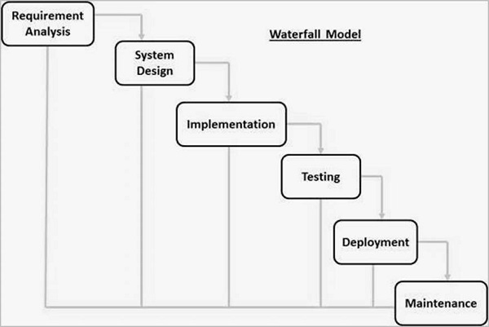

*Figure 1. Waterfall Method*

**Requirement Analysis**

In this phase, the proponents brainstormed an idea that resulted in the production of the study. After that, the proponents researched and gathered data that might be needed. The target client where was able to manage and help them. The proponents established an idea that would make the transaction easier and fast. The proponents conducted an interview that helped determine their future system by gathering concrete and established information from the Zarate Piggery farm manager.

**System Design**

The proponents provided the prototype for the system at Zarate Piggery Farm. The system design phase determined how the system may look, wherein the developer takes place in the process for each model together with interfaces and functions for where to be created and designed by specific software. Client uses manual transaction before thus proponent proposes a light weight and fast transaction system.

**Implementation**

Sales Monitoring and Management System with SMS Notification of Zarate Piggery Farm may help the customer book their reservation and help the Zarate piggery farm generate their reports, such as sales monitoring data. The system will not require any internet, as it runs. The developer will use C# as a programming language, and Sql for the database. This phase is a debugging phase for the assurance of the system before its deployment; everything has to be accurate and precise.

**Testing**

Testing is an important stage in prototyping. Before the deployment, proponents will provide a test plan to set proper deployment. The goal is to find issues and areas of improvement as soon as possible. The program needs to ensure the assurance of the criteria expected for the Zarate piggery farm system.

**Deployment**

During deployment, the proponent will set the system at the Zarate piggery farm. This will be deployed with complete functionality from the test beforehand. When all requirements are met, the system is ready for deployment. The proponent will also implement dry run testing to illustrate the function and show the systems’ process. Moreover, proponents shall ensure all the records that may need in the future.

**Maintenance**

The SDLC's six-phase is Maintenance, in which the proponents meet all the requirements and the succession of deployment, the system admin, and the Zarate piggery farm will maintain the system. The staff and admin are those are in charge of monitoring all data and transactions receive. In addition, the insurance of the database will be updated monthly by the proponents, who will assure that all data once transfer and are processed to their assign table to secure the data without causing any trouble/error.

**REQUIREMENT ANALYSIS**

*Table 01*: Hardware Requirements

|  |  |  |
| --- | --- | --- |
| **Hardware** | **Minimum Requirements** | **Recommend** |
| Processor | AMD PRO A10-8770 R7, 10 COMPUTE CORES 4C+6G 3.50 GHz | AMD PRO A10-8770 R7, 10 COMPUTE CORES 4C+6G 3.50 GHz |
| Motherboard | [GIGABYTE GA-A320M-S2H](https://buildmypc.net/component-details/motherboard/B079NYQQJJ) | [GIGABYTE GA-A320M-S2H](https://buildmypc.net/component-details/motherboard/B079NYQQJJ) |
| Memory | 4.00 GB | 8.00 GB |
| Storage | 500 GB | 500 GB |
| Monitor | 14" FHD (1366 x 768) | 24" UHD (1920 x 1080) |

**Software Requirements**

*Table 02*: Software Requirements

|  |  |
| --- | --- |
| Name of Software | Specification |
| Operating System | Microsoft Windows 10 Home OEM 64-bit |
| Database | Sql Server 2014 Management Studio |
| IDE | Visual Studio 2015 |

**Peopleware Requirements**

*Table 03*: Peopleware Requirements

|  |  |  |
| --- | --- | --- |
| User | Role | Access |
| Manager/Owner | Admin | - Front-End and Back-End  - Manage Admin Page  - Manage Users Accounts  - Print Reports  - View Requests  - Manage Requests |
| Secretary | User | - Front-End and Back-End  - Manage Entry  - Manage Report  - View Requests  - Manage Requests |

**NETWORK TOPOLOGY**

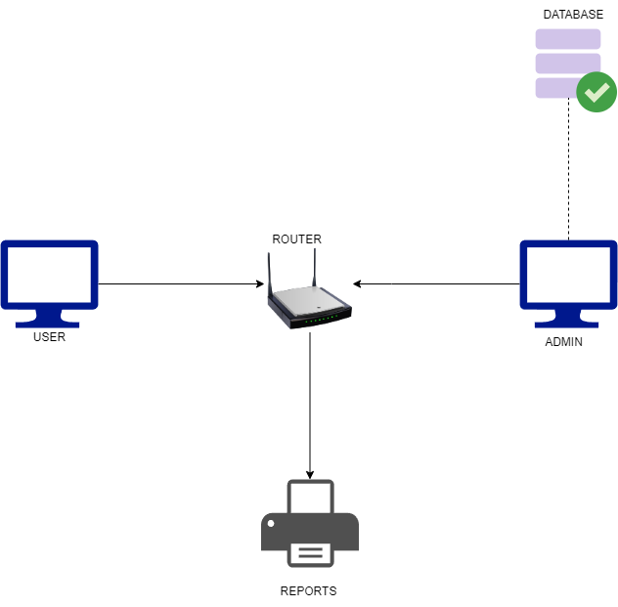

*Figure 2. Network Topology*

**SYSTEM FLOWCHART for ________________**

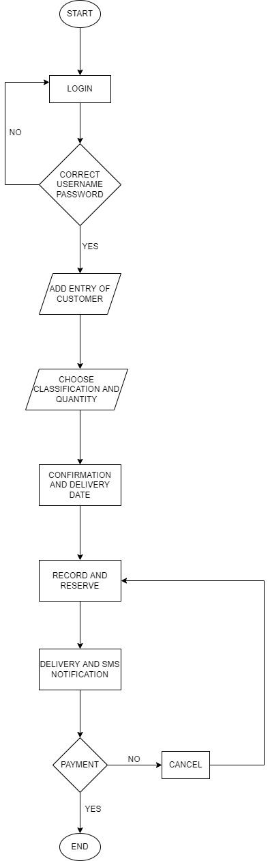

*Figure 3. Flowchart*

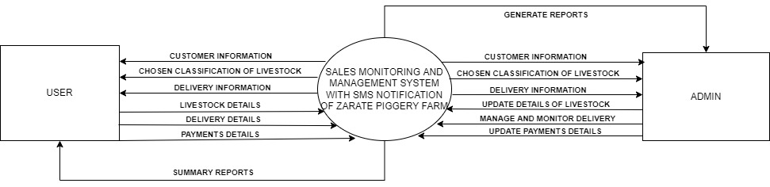**0 - LEVEL DATA FLOW DIAGRAM**

Customers info – user to system

Select classification of livestock – user to system

*Figure 4. 0 Level Diagram*

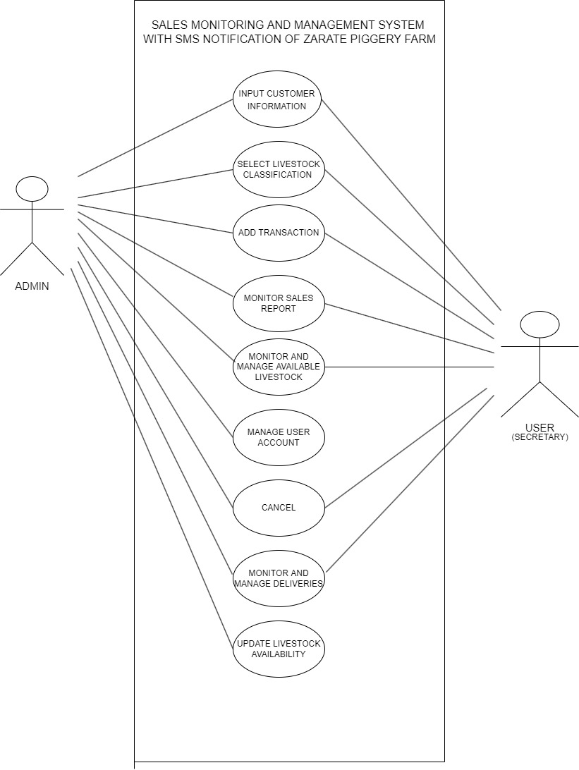**USE CASE DIAGRAM**

**Cancel?**

Generate reports

*Figure 5. Use Case Diagram*

**ACTIVTY DIAGRAM**

SECRETARY

ADMIN

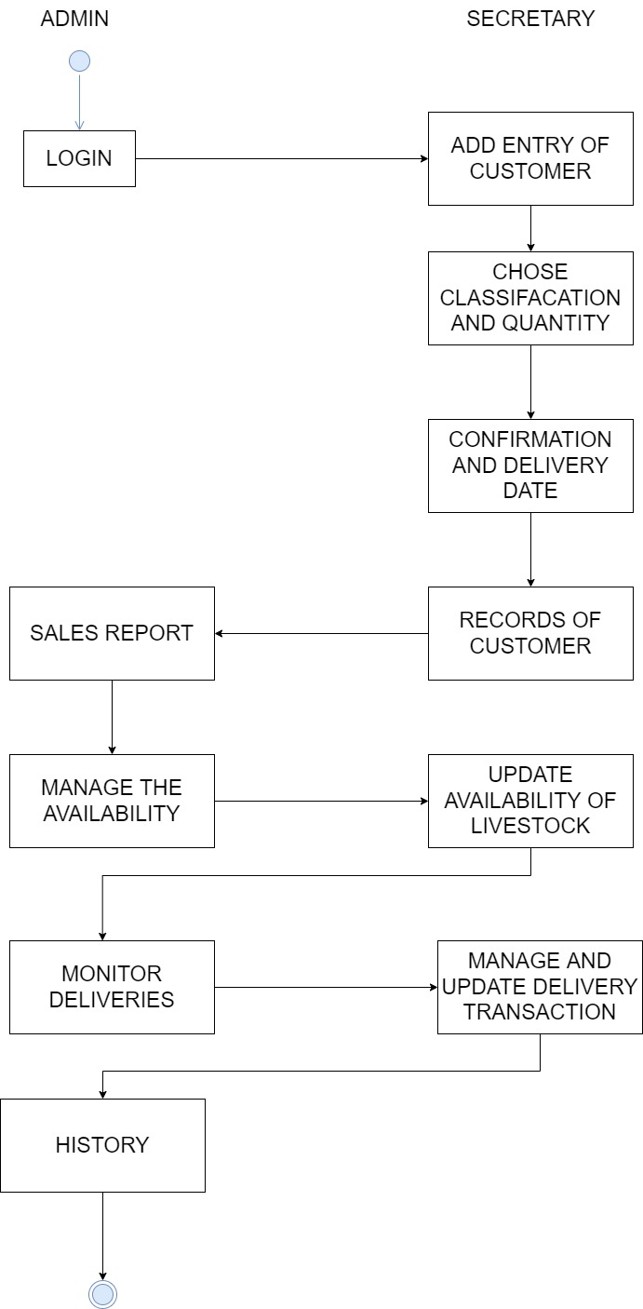

*Figure 6. Activity Diagram*

**PERT CHART**

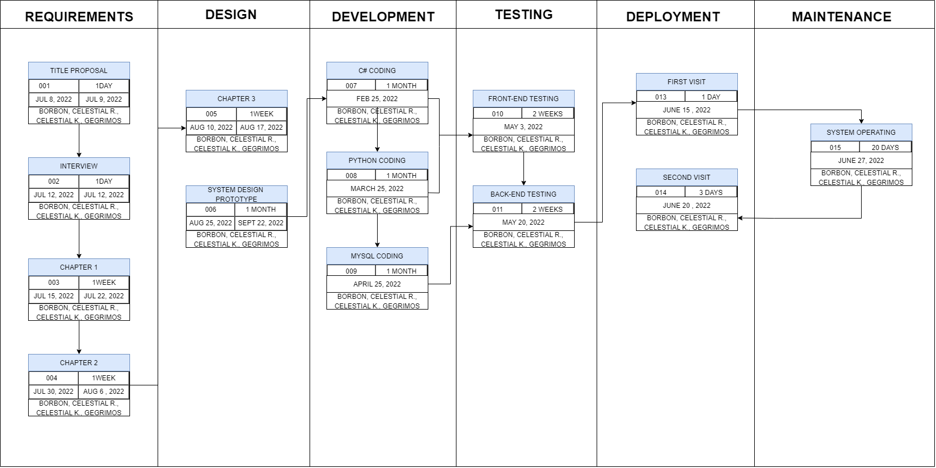

*Figure 9. Pert Chart*