**ECEn 240 Circuits Laboratory**

***Lab 6 – LINE BUFFER AMP***

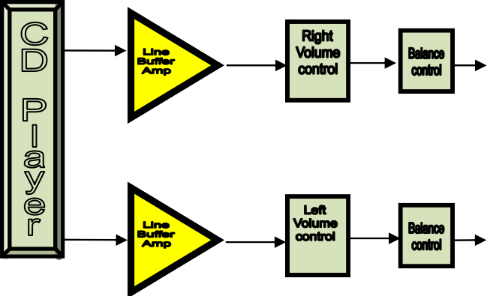

# PRELIMINARY PROJECT OVERVIEW

**Purpose**

**Objectives**

The purpose of this laboratory is to build and implement per spec a line buffer amplifier. Quantify the buffer amps normal & maximum operating characteristics. This will be integrated with the volume and balance controls for the stereo amplifier system you built in previous labs.

* Discuss Buffer Amp Design Specifications.
* Discuss the LF347 IC specified maximum operating limits.
* Perform Gain and Frequency Response analysis with LT Spice.
* Measure actual Input Impedance, Gain, Freq and Clipping characteristics.
* Integrate into the stereo system and demonstrate its performance for pass off.

**Design Specifications**

Input impedance: **> 10kΩ**

Voltage Gain: **-3**, nominal

Frequency response: flat **3 dB** from **20Hz to 20kHz**

Maximum input signal level: **8Vpp**

Power Supply: **14 VDC**

**Equipment List**

Stereo amplifier chassis (one per team) CD player or MP3 player

ADCOM external stereo power amplifier and speakers LF347 operational amplifier and fixed resistors (from kit) Signal generator, DMM, power supply, and oscilloscope

**Discussion**

Although we were able to get by with no amplifier stages in the previous labs other than a power amp, there are several good reasons to include a line buffer amplifier ahead of the volume and tone controls. **First**, high quality stereo amplifiers present very high input impedances (~1-20MegΩ) to the external signal source components. For example, the line-in impedance of the ADCOM amplifier you use in room 426 CB is ≈ 2.2MegΩ.

This high impedance **reduces loading on the output stage of the signal source**. Driving the volume control directly with the line-in signal is a low class design.

**Secondly**, **because of losses due to signal processing** we would like to **boost the signal level a little for our internal processing** so that we have plenty of signal to drive the final amplifier stage to full output level.

Explain **two** benefits of Line Buffer amp in your note book.

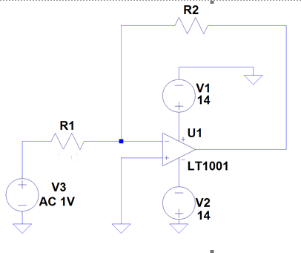

# Analysis & Experimental Procedures

Include your line buffer schematic from LT Spice, with component values in your write-up (if you saved this schematic from Lab 6 then print – otherwise draw again.)

Also, include a hand drawn **schematic diagram** of the stereo system components created so far with the Buffer amplifier integrated into it - similar to Figure 2 but as a schematic diagram (**not** a block diagram like figure 2).

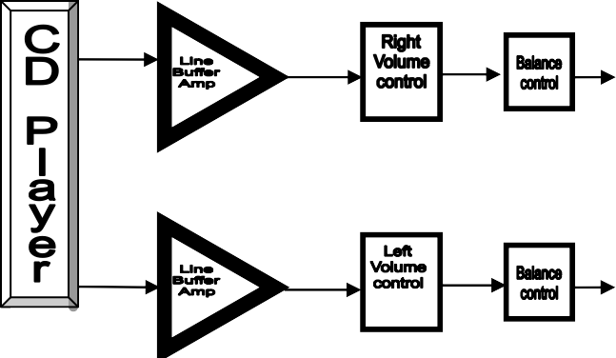

**Figure 2-** *Block Diagram*

**Input Impedance & Virtual Short Analysis**

We will be implementing a two channel buffer amplifier stage that meets the stated specifications. It will be connected between the line-in signal and the volume control. The Buffer Amp was designed in Lab 6 and in this lab you will take measurements to verify the circuit meets the design specifications.

First calculate your input impedance and verify that it is greater than 10k*Ω*. Remember that the inverting input of an op amp is a virtual ground in the inverting amplifier configuration.

Next, use the dual power supply to power the buffer amps that you constructed on your breadboard. Take careful note of the maximum voltage ratings below and give yourself at least a 20% margin.

**Figure 1. *Op-Amp Connections***

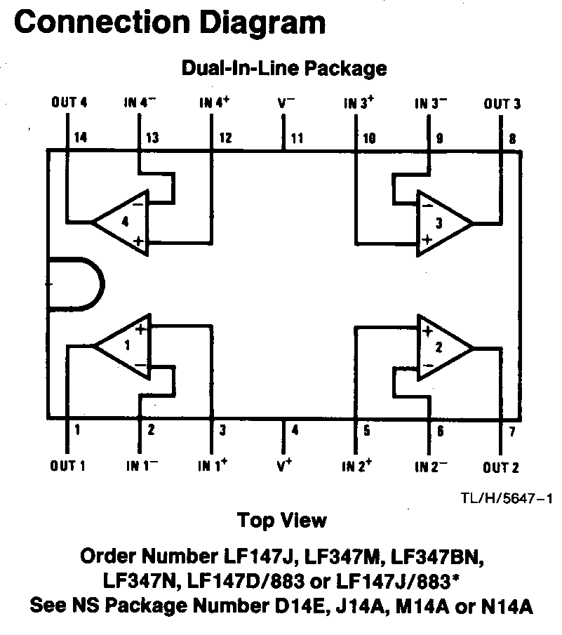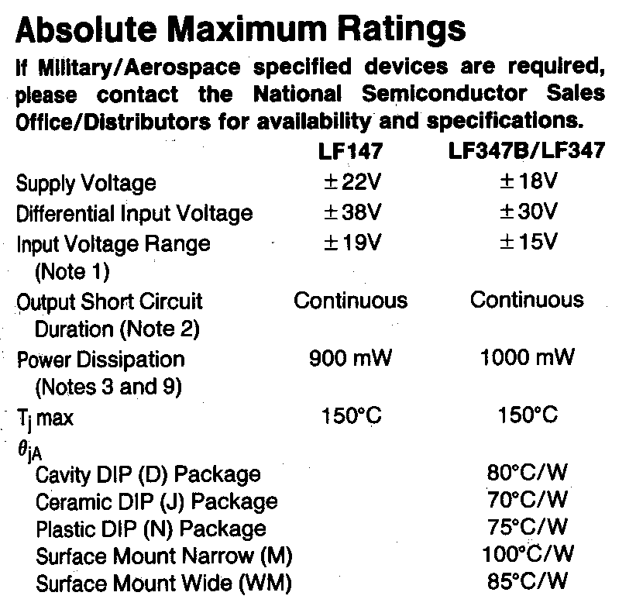

Set the Power Supply to Series Mode and adjust each side to **VDC,** then turn it OFF. Next connect the three Power Supply cables to the Stereo DC Inputs.

Measure the input impedance (resistance) as seen from the **Leftin**

using your DMM and record the value in Table 1. This measurement should be made with the power supply (14VDC) turned off.

Did you meet the input specification?

|  |  |
| --- | --- |
| **POWER STATE** | **Input Impedance** |
| **14VDC pwr *ON *** | 11.94 kΩ |
| **14VDC *OFF*, vol full cw **** | 2.22 MΩ |
| ***Buffer Thèvenin equivalent*** | 11.94 kΩ |

**Table 1** - Input Impedance Data

***Before continuing have a TA review your Table 1: data.***

As seen from **the Input,** what is the **Thèvenin equivalent** of your buffer Amp circuit, (with power ON)? What is your R**S**? *Explain the correlation between these two values.

With the power on, the Thevenin equilvalent is around 12k Ohms, which is the same as my Rs. This is because when power is on, the virtual short applies and we get 12 Ohms, whereas we would get something much higher (2.2M Ohms) if the power was off and there was no virtual short.

**Simulate/ Predict**

Print a copy of the Lab 5 frequency response plot of the line buffer amplifier (from Lab 5, Segment 2. Re-draw the schematic and re-simulate if needed.) **Mark** your simulation with the **upper and lower frequency spec limits and corner frequency**. Analyze the performance and discuss if your simulation results meet the buffer specifications. Include the marked plot in your write up.

**Gain Analysis**

DC power: **14VDC** (Set Power Supply to Series Mode with each side at 14 V) Function Gen: **1Vpp** sine wave at 2 kHz, connect to left and right buffer inputs.

(Should the output be Hi Z or 50 ohms?) Oscilloscope: Measure the left and right Buffer outputs and compute the gain.

Record in Table 2. It is easier to setup and start at 2kHz than 20Hz because the scopes have a harder time with low frequencies. Repeat at 20, 200, 20k, 200k & 2 Meg Hz.

Using the data from Table 2 enter these values onto your Bode plot printout for both Left & Right channels.

Record this question and its answer in your lab notebook: **Does the observed gain response match the Design Spec gain? (**If not change the Rf or Rs value until it is in spec.) Show your computations for at least one frequency.

***Table 2*. *Line Buffer Amplifier Gain Data***

|  |  |  |  |  |
| --- | --- | --- | --- | --- |
| **Fun.Gen. @**  **Sine - 1Vpp** | **Frequency X**  **@** | **Vin** | **Vout** | **Gain** |
| measured 1Vpp (not2V) | measured | Computed Vout/ Vin |
| **Right Channel** | 20 Hz | 1.07V | 3.34V | -3.12 |
| 200 Hz | 1.07V | 3.34V | -3.12 |
| 2k Hz | 1.07V | 3.30V | -3.08 |
| 20k Hz | 1.05V | 3.26V | -3.10 |
| 200k Hz | 1.05V | 3.18V | -3.02 |
| 2Meg Hz | 1.05V | 640mV | -0.61 |
| **Left Channel** | 20 Hz | 1.09V | 3.42V | -3.13 |
| 200 Hz | 1.09V | 3.42V | -3.13 |
|  |  |  |  |
| 2kHz | 1.06V | 3.34V | -3.15 |
| 20k Hz | 1.05V | 3.30V | -3.14 |
|  |  |  |  |
| 200k Hz | 1.05V | 3.26V | -3.10 |
| 2Meg Hz | 1.05V | 680mV | -0.65 |
| ***Vin = 1Vpp*** | ***fc* Analysis** measured | | ***fc*** *=705 kHz* | |

**Frequency Performance Analysis**

Verify that the frequency response of your constructed circuit is within spec, (flat within 3dB from 20 Hz to 20 kHz).

Find the **Corner Frequency, fc**, of your amplifier. To do this, first determine your maximum Vout from Table 2. Then **adjust the frequency** of the input signal until the output Vout = Vout,max * **1/√2** or (**.707** \***Voutmax**)**.** Enter this at the bottom of Table 2 and mark your measured corner frequency on your Bode plot.

**Signal Clipping Analysis**

* 1. Measure your 14V **DC** rails from the + to the – terminals using the DMM.

Record this in Table 3

* 1. Estimate the **max Vout** peak-peak signal given the DC rail voltage. Refer to Figure 2.

**Explain the connection between** a) and b).

* 1. Compute the **max Vin** p-p signal level without signal clipping.

Simply divide the max **Vout** estimated by your Gain. max **Vout ÷ Gain =** max **Vin**

28V/3 = 9.33

*Show your computations*

* 1. Measure max Vin undistorted. Set function generator at 2 kHz, increase the **Vin** amplitude until you notice **Vout** distortion or clipping. Record this **maximum Vin** input voltage that **doesn’t** cause **clipping** and the resulting max undistorted **Vout .**

## Too much Vin or Gain can cause clipping.

***+14V 0V***

***-14V***

**Figure 3** – Clipping and Distortion

Include some graphical representation of clipping in your write up.

## Table 3. Line Buffer Amplifier Data

|  |  |  |  |  |  |
| --- | --- | --- | --- | --- | --- |
| **F.G. Signal**  **@ 2 kHz** | **DC rails**  a)  *measured* | **max Vout pp**  b)  *estimated* | **max Vin**  undistorted  c)  *computed* | **max Vin**  undistorted  d)  *measured* | **max Vout**  undistorted  d)  *measured* |
| **Max Buff Input Vpp @ Max**  **Non-Distorted Output** | 28V | 28V | 8.95V | 7.62V | 25.3V |

Do your Table 3 measurements meet spec? Show that your line buffer amplifier meets spec? Compare the maximum input specification to your line buffer amp’s maximum input with an undistorted output.

Yes, the max Vin measured is within 5% of the specific 8Vpp.

**Final Performance Evaluation**

**Solder:** Once you have verified your circuit operates within spec with the resistor values you selected you will transfer those resistors from the breadboard to your PCB Daughter Board and solder them in. Do not solder the LF347, just plug it in. Solder the grounds to the non-inverting input pins per your schematic. This is done on the bottom of the daughter PCB as shown below on the right.

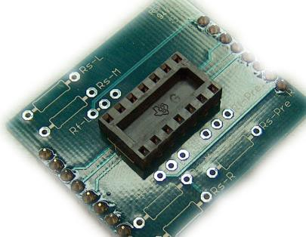 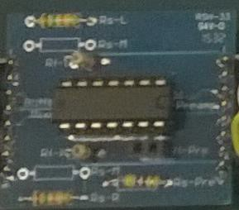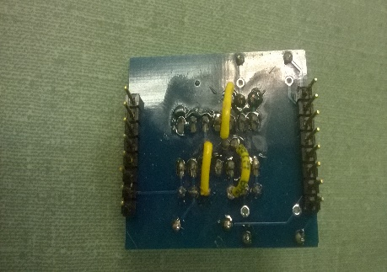

**Integrate:** a) Insert your soldered Daughter Board into the Buffer position on the Mother Board as show in Figure 3.

1. Connect from the In jack on the front panel to the buffer input header for both the left and right channels.
2. Connect both channels of the buffer output to the Master Volume inputs.
3. Make sure the Volume output is properly connected to the Balance pot input and that the Balance output is connected to the output Header.

**Figure 4 Integrated Buffer Amp**

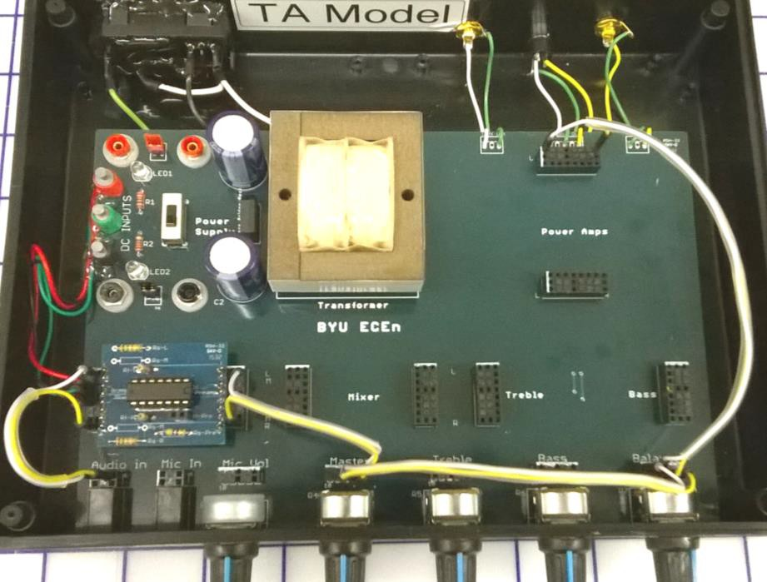

**Out**

**d)**

**a)**

**b)**

**c)**

**d)**

**In**

1. Connect the Power Supply cables to the DC Inputs on the chassis. (The DC Inputs on the chassis are shown on the upper right in Figure 3.)
2. Connect the CD player and external power amplifier to your system and evaluate its performance.

**TA Pass Off**

Demonstrate the following to a TA to obtain a signoff:

* + The integrated system’s performance from f) above.
  + Your drawn schematic of this integrated stereo system
  + Good, clean solder joints on your buffer amp

# Conclusion

Write a couple of paragraphs of conclusion for your lab experience. Note if you were able to meet the specifications and if you had to make any changes to meet them.

What debug and redesign procedures did you need to perform to get it to work?

In this conclusion, or elsewhere in the body of your write up, make sure you included how your circuit performed compared to the following specifications:

# Input Impedance Gain

**Frequency Response Clipping** (max input voltage)

Discuss any additional implications that you may have observed. Note anything that you learned unexpectedly.